Cardiac cycle:
- It is the events which take place during one heart beat (systole & diastole) and are repeated during the next. (Note: Systole & diastole are referred to (تستخدم لـ) the ventricle in general).
- The time for it is 0.8 sec when the heart rate is 75 beats/min. (Note: The relation between Heart rate and times is inversely proportional (علاقة عكسية)
i.e. ⬆heart rate leads to ⬇cardiac cycle time)

Systole = Contraction ➔ Pumping the blood (ضخ الدم)
Diastole= Relaxation ➔ Filling of the ventricle (تعبئة القلب)

Phases of Cardiac Cycle:

Electrical Events:
ECG (ElectroCardioGram)

Mechanical Events:
Heart Sounds
Pressure Changes
Volume Changes

Important note: Electrical changes are coming before mechanical changes.

Phases (systole and diastole) in the cardiac cycle (0.8 sec):

In the atria:
- Atrial Systole: 0.1 sec
- Atrial Diastole: 0.7 sec
TOTAL = 0.8 sec

In the ventricle:
- Ventricluar systole: 0.3 sec
- Ventricular diastole: 0.5 sec.
TOTAL = 0.8 sec

Atrial diastole | Atrial diastole | Atrial diastole | Atrial diastole | Atrial diastole | Atrial diastole | Atrial diastole | Atrial systole
Ventricular systole | Ventricular systole | Ventricular systole | Ventricular diastole | Ventricular diastole | Ventricular diastole | Ventricular diastole | Ventricular diastole

Notes:
- Atrial contraction (systole) happens in the time of ventricular relaxation (diastole).
- Ventricular contraction (systole) happens in the time of atrial relaxation (diastole).
- The right and left atria contract & relax at the same time.
- The right and left ventricles contract & relax at the same time.

Explaining the Phases of the Cardiac Cycle: (listed in order)

Ventricular Systole (0.3 sec):

Isovolumetric Contraction:
  - All valves are closed.
  - Atria & Ventricles have the same volume.
  - Beginning of ventricular contraction.
  - We hear S₁ because of closure of AV valves at the beginning of ventricular systole.
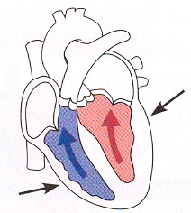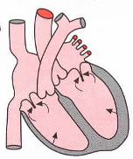

Ejection Phase (Semilunar Valves open):
Because of ventricular systole, most of the blood in the ventricles is pumped into the arteries (via من خلال the aorta).

Ejection consists of 2 parts:
  - Rapid: at the first third of pumping.
  - Slow: at the last 2/3 of pumping.
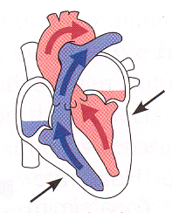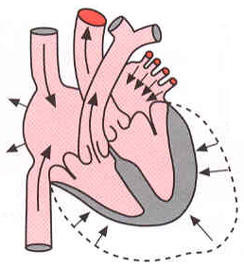

*Protodiastolic:
(Ventricles relaxed + semilunar valves still open).

Ventricular Diastole (0.5 sec):

Isovolumetric relaxation:
  - All valves are closed.
  - Atria & Ventricles have the same volume.
  - Beginning of ventricular relaxation.
  - We hear S₂ because of closure of semilunar valves at the beginning of ventricular diastole.
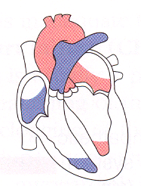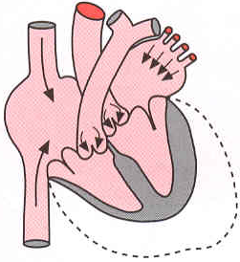

Filling phase: (AV valves open)
In the filling phase, blood from atria goes to the ventricles.

It consists of 3 parts:
  - Rapid: because of gravity & pressure.
  - Slow: because of falling of pressure.
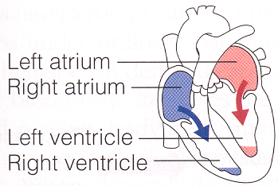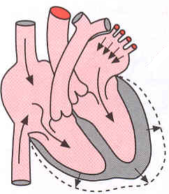
  - Last rapid: due to atrial systole (0.1 sec)
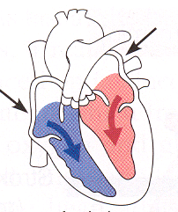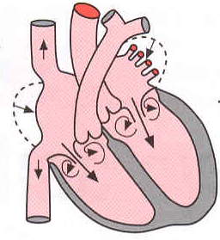
Note: 70-75% of blood comes to ventricles without atrial systole (only 25-30% due to atrial systole).

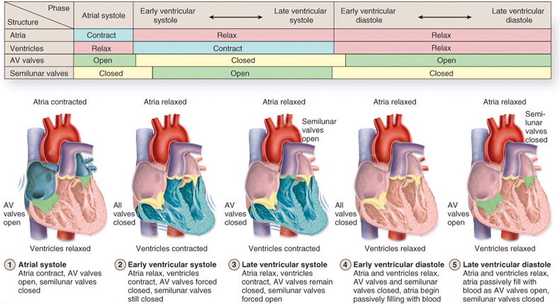
Question: In the above diagram, what is meant by early ventricular systole & diastole?

Heart sounds
There are four heart sounds:
- Audible (يمكن سماعها): S₁ – S_{2.}
- Inaudible (لا يمكن سماعها): S₃ – S₄
Because the frequency must be above 40 Hz to be audible.

Explanation of the heart sound:

S₁:
- Audible heart sound.
- Due to closure of AV valves.
- At the beginning of ventricular systole.
- 50 Hz (LUB), 0.14 sec
- If we listen to 2 of it (LUBLUB) then it is always pathological (مرضي). This condition is called splitting of the first heart sound.

S₂:
- Audible heart sound.
- Due to closure of semilunar valves.
- At the end of ventricular systole.
- 80 Hz (DUB), 0.11 Sec.
- Louder & shorter than the first heart sound (SHORT & SHARP).
- If we listen to 2 of it (DUBDUB) it may be physiological (during inspiration) or pathological. This condition is called splitting of the second heart sound

S₃:
- Inaudible heart sound in normal situations.
- Rush of blood causes the vibration
- Due to rapid filling at the beginning of middle 3rd of ventricular diastole.
- <30 Hz , 0.1 Sec.
- If we listen to S₃ it may be physiological in young people only (Pathological if heard in young people).

S₄:
- Inaudible heart sound.
- Rush of blood causes the vibration
- Due to atrial contraction (late period of diastole).
- <20 Hz, <0.1 sec
- Happens just before S₁.
- If we listen to S₄ it may be physiological in old people only (Pathological if heard in old people).

Introduction to ECG:
- ECG (Electrocardiogram) is used to record the electricity of the heart
- Its components:
  - P: due to atrial depolarization
  - QRS: due to ventricular depolarization
  - T: due to ventricular repolarization.
- It can be plotted along with a Phonocardiogram (PCG), which records the sound of the heart.

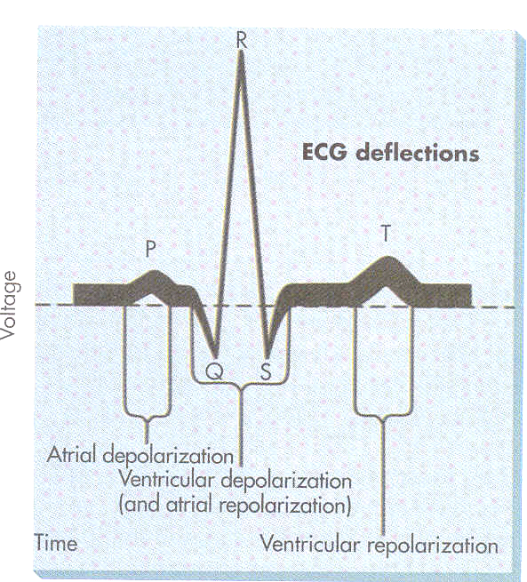

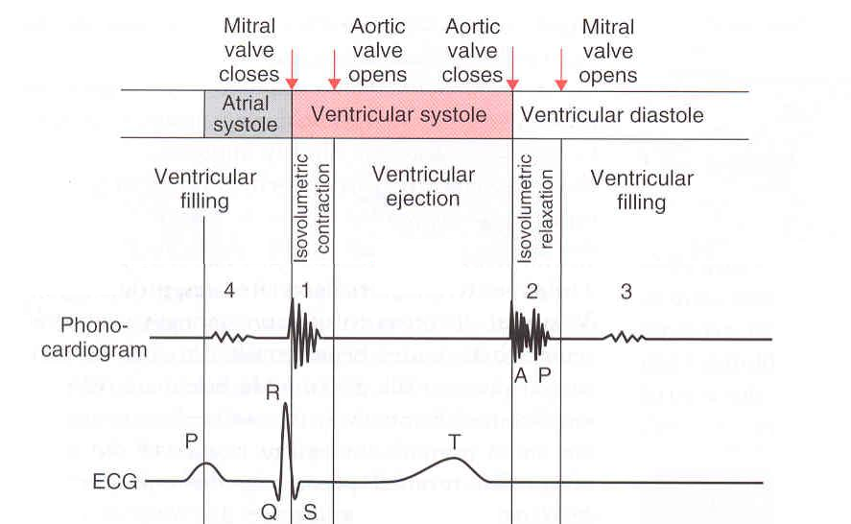

Murmurs
Abnormal heart sounds because of stenosis (the valve is not opening properly) , incompetence (the valve is not closing properly), or other causes (there are systolic & diastolic murmurs).

Where to auscultate (listen)?
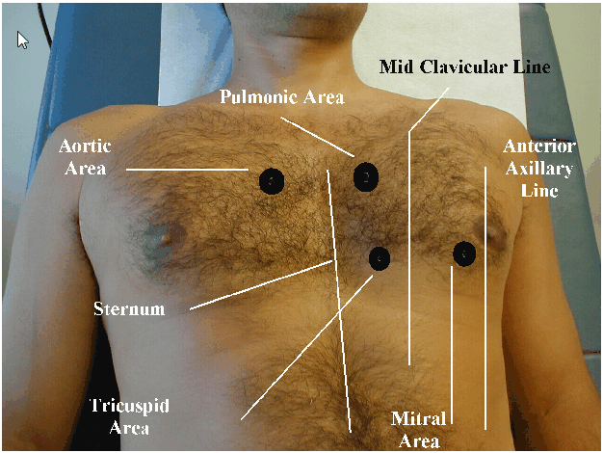
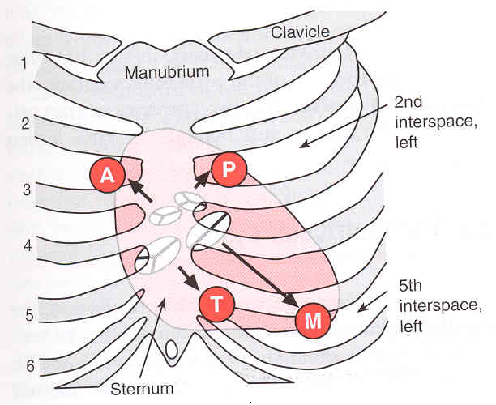
A: Aortic Area, In the right 2nd intercoastal space.
P: Pulmonary area, In the left 2nd intercoastal.
T: Tricuspid area, Just left o the below of sternum.
M: Mitral area, In the 5th intercoastal space.

Pressure changes during cardiac cycle

Right Atrium
- Pressure = 0-8 mmHg (some books write 2-8)

Explanation of the phases:
  - A wave: due to right atrial contraction
  - C wave: due to bulging of tricuspid valve into the atrium (which one?) during isovolumetric contraction.
  - V wave: increased pressure in right atrium due to filling of atrium with blood when the tricuspid valve is closed.

Applications of the phases:
  - In case of atria not contracting there will be no A wave.
  - In case of stenosis, the A wave will increase.
- The very low pressure of the atrium is to allow receiving blood from veins (which have very low pressure).

Left Atrium
- Pressure = 0-8 mmHg (some books write 2-8)
- Very low pressure to receive blood from pulmonary veins (which have very low pressure).

Left Ventricle

Pressure =
  - Systole= 120 mmHg (very high to pump blood to the whole body)
  - Diastole= 2-10 mmHg (very low to allow blood to go passively from atria to ventricle)

Aorta

Pressure =
  - Systole= 120 mmHg
  - Diastole= 80 mmHg

Explanation of the phases:
  - Anacrotic limb (Ana means up): It happens during the rapid ejection phase.
  - Dicrotic notch: due to closure of aortic valve (and the pressure rises a little)
  - Dicrotic limb: due to elastic recoil of the arterial wall. Pressure is maintained to 80 mmHg 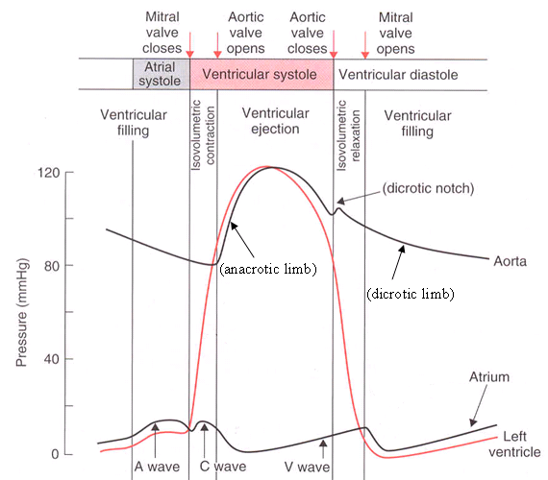

Right Ventricle

Pressure =
  - Systole= 25 mmHg
  - Diastole= 2-8 mmHg
- The systolic pressure is low because pumping is made directly to the lungs (not like the ventricle which has to pump blood all over the body).
- The right ventricle is 3-5 times thinner than the left ventricle.

Pulmonary Artery
- Pressure =
  - Systole= 25 mmHg
  - Diastole= 10 mmHg
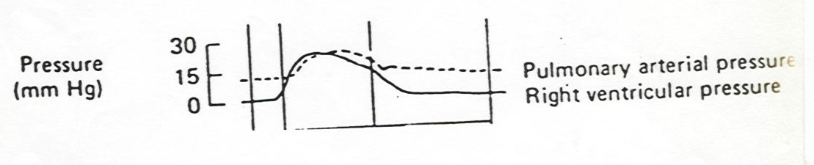

(Ventricular) Volume changes during cardiac cycle
- End Diastolic Volume (EDV): Volume of blood in each ventricle at the end of diastole.
It is about 110 – 120 ml.
- End Systolic Volume (ESV): Volume of blood in each ventricle at the end of Systole. It is about 40 to 50 ml.
- Stroke Volume (SV): It is a volume of blood pumped out by each ventricle per beat. It is about 70 ml.
Stroke volume (SV) = EDV – ESV
- Ejection fraction (EF): is the percentage of ventricular end diastolic volume (EDV) which is ejected with each stroke.
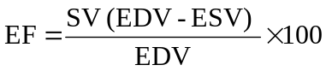 e.g. 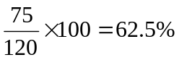

Where:
SV= Stroke Volume
EDV= End Diastolic Volume,
ESV= End Systolic Volume

  - Normal Ejection fraction is 60-65%.
  - Ejection fraction is a good index of ventricular function (below 20% is severe).
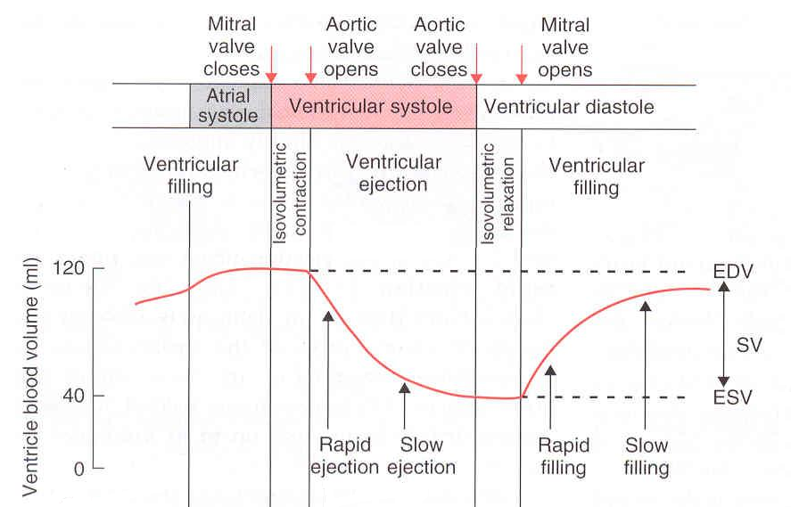
Figures combining all the events in cardiac cycle


