Medical Biochemistry Summary
Girls | Boys
Organizer: Sheikha Alrajebah | Leader: AbdulAziz U. Joury
Beshair Alotaibi  Kawthar Alhussaini  Amany Aledrees  Gadeer Hani Radwan  Sheikha Alrajebah | AbdulAziz Sagga  Batel Al-Toraigy  Yahea Aseeri
Edited and reviewed by:  Amani Ali Al-Bijadi  Rowayda Mishiddi  Sheikha Alrajebah | Typed by:  Amer Alameen‏  Majid Al-Roeadi  AbdulAllah Bin Masoud
By Biochemistry Team 428

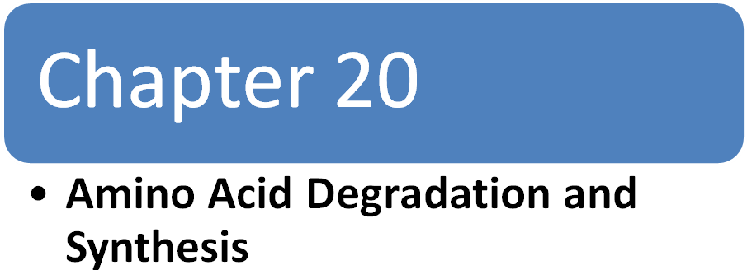

Amino Acid Degradation and Synthesis

I: overview:
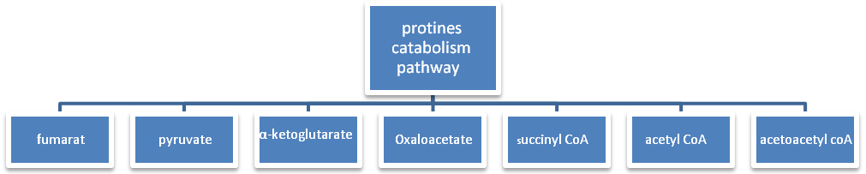

Glucose keton body

- The compounds which give rise to be glucose are glucogenic amino acids.
- The compounds which give rise to keton bodies are ketogenic amino acids.
- The glucogenic amino acids are classified in in fig. 20.2
- The amino acids are two types:
- Essential amino acids:- are the amino acids that can NOT be synthesized by the body, instead, they are provided by the diet.
- Non-essential amino acids:- are the amino acids that can be synthesized by the body or from the diet.
- Cysteine and tyrosine are Non-essential amino acids, but they are provided by essential amino acids .cysteine is synthesized from methionine, and tyrosine from phenylalanine (so, if methionine and phenylalanine are not provided in the diet, the NON-essential amino acids, cysteine and tyrosine, become essential as well).

II: glucogenic and ketogenic amino acids:
Glucogenic amino acids:
- They are 14 amino acids which are “pure” glucogenic amino acids, and 4 amino acids which are both glucogenic and ketogenic.
- They are converted to pyruvate or 4 compounds involved in Krebs cycle (explained in I: overview).
- These compounds give rise to glucose in liver, muscle, and other glucogenic tissue, or to glycogen in liver and kidney.

Ketogenic amino acids:
- The Leucine and Lysine are the only “pure” ketogenic amino acids
- Also, 4 amino acids are both glucogenic and ketogenic.
N.B:- acetyl CoA NEVER give rise to glucose.

III: catabolism of the carbon skeleton of amino acids:-

A: amino acid that form oxaloacetate:
- Asparagines is hydrolyzed by asparginase , the results are ammonia & aspartate.
- Aspartate loses it’s amino group by transamination to form oxaloacetate. (fig.3)
- Leukemic cells need aspargine to provide it’s growth, they take aspargine from blood.
Asparginase is the treatment of choice to stop leukemic cell growth, because asparginase convert aspargine to aspartate (lower aspargine levels in blood).

B: amino acid that form α-keto glutarate:-
Glutamine:
-It’s converted to glutamate by glutaminase.
-glutaminase is found in liver, muscle, and kidneys.
Glutamate:
-glutamate is converted to α-ketoglutarate either by transamination or oxidative deamination.
Proline:
-oxidized to glutamate.
Arginine:
-cleaved by arginase to produce ornithine, which is converted to α-keto glutarate.
N.B:- the urea cycle occurs only in liver, because arginase is only found in liver, and it is the last enzyme in urea cycle.

Histidine:
-histidine is oxidatively deaminated by histidase to urocanic acid.
-urocanic acid will form N-formiminoglutamate “FIGIu”.
-FIGlu donate it’s formimino group to tetrahydrofolate & glutamate.

*FIGIu excretion test were used to diagnose deficiency of folic acid (not used any more).
*mechanism:- the patient take large amount of histidine which will form FIGIu in large amounts,also.
*If the folic acid (which is the source of tetrahydro folate) is deficient, the FIGIu will be excreted in large amounts in urine.
amino acids that form α-keto glutarate:-

glutamine

glutaminase (transamination)

Histidine histidase urocanic acid FIGI glutamate oxidative deamination αketoglutarate

NH3 THF 5-formimio
THF (oxidation)

ornithine

urea

proline

arginine

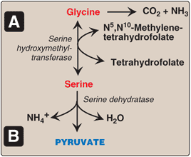
C: amino acids that form pyruvate:
Alanine:
-by transamination to pyruvate.

Serine:
Either:-
*converted by serine hydroxyl methyl transferase to
glycine & N5-N10methyltetrahydrofolate.
*Converted by serine dehydratase to pyruvate.

Glycine:
Either:- *converted to serine by adition of methyl group from N5N10methyltetrahydrofolate.
*oxidized to Co2 & NH3

Cystine:
NADH NAD

Cystine reduced cysteine (desulforation) pyruvate

SH2

Oxidized

SO4 PAPS

*PAPS serve as an activated sulfate donor

Threonine :
Either: - *convert to pyruvate directly
*become succinyl CoA
(glucogenic by two ways)

Tryptophan:
-can be converted to pyruvate “later on”
N.B:- tryptophan is both glucogenic & ketogenic.

E: amino acids that form fumarate:- Phenyl alanine & tyrosine:
-phenyl alanine converted to tyrosine by phenylalanine hydroxylase.
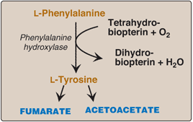
-this is the first reaction in the catabolism of phenyl alanine
-both phenyl alanine & tyrosine are glucogenic and ketogenic.
They give fumarate and acetoacetate.

F: amino acids that form succinyl CoA:
Methionine:
-will be discussed below
Valine & isolucine:
-these two amino acids are branched , and will generate propionyl CoA.
-propionyl CoA convert to succinyl CoA.
N.B:- propionyl CoA is generated by catabolism of : *certain amino acids.
*odd number fatty acids.

Theronine:-

theronine α-ketobutyrate propionyl CoA succinyl CoA

Methionine:
-it is sulfur-containing amino acid. (look at the figure in the next page)

Synthesis of SAM:
*methionine condense with ATP to form SAM (S-adenosyl methionine)
*SAM has high energy bond ”between methyl group & sulfur”.
*SAM has NO phosphate group.

Activated methyl group:
*SAM serve as active methyl donor in the body.
*e.x:- SAM can donate it’s methyl group to NE to form E.
*the result of this donation (or any other donation) is SAH (S-adenosyl homocysteine).
*this reaction is irreversible because of the lost energy when the methyl group has been transfered.

Hydrolysis of SAH:
*SAH is hydrolyzed to homocysteine and adenosine.
*homocysteine has two fates (depending on the levels of methionine):
-If the amount of methionine is deficient:
Homocysteine may be re-methylated to methionine.
-If the amount of methionine is adequate:
Homocysteine may enter the transsulforation pathway , which will convert it to cysteine.
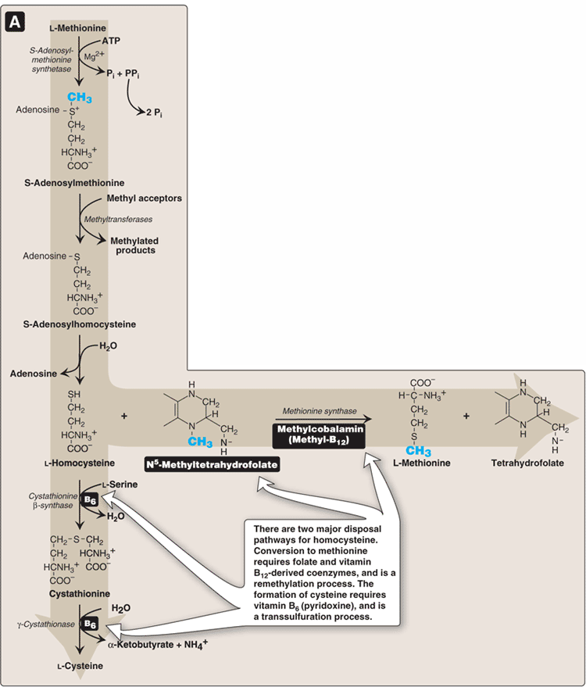

a) resynthesis of methionine:
- Homocysteine accept methyl group N⁵- methyl THF
- The reaching requires methyl cabal amine “co-enzyme derived from B₁₂ “.
N.B: Four amino acids need THF " derived from folic acid as co-enzyme in their metabolism:
1) Histidine 2) Serine 3) Glycire 4) Methimine

b) Synthesis of Cysteine:
- Homocysteine with serine to form Cystathionine, by enzyme called Cystathionine –synthase.
- Cystathionine is hydrolyzed by cystathinase to form cysteine.

4) Relationship of homocysteine and vascular disease:

- Elevated level of homocysdeine promote:
Oxidative damage and endothelial dysfunction.
- This may cause some vascular disease.
- People with low level of 3 vitamine " B₆ , B ₁₂ and folic acid has high chance to get vascular disease.
- Supplementation with these vitamine are good b reduce the level of homocysteine. "treatment of vascular diseases".
-Classic HomoCystinuria:
- A disorder with high level of homocyteine because of deficiency of cystathionine synthase.
- Patients have premature vascular disease.
- Spinal bifida:
- a defect in neural tube of the fetus, because of high level of homocystein in pregnant women.
- Supplementation with folate “folic acid " reduce his risk of such defect.

F) Other amino acids that form suceinyl CoA:
- Have been discussed with E.

G) Amino acids that form acetyl Cop or aceto acetyl CoA:

Leusine | Isoleucine | Leusine | Tyrosine | Phenylalanine | Tryptophan | Lysine

Acetoacetyl CoA
Acetoacetate
Acetyl CoA

H) Catabolism of branched-chain amino acids:
- Branched –chain amino acids are:
- Leucine, Valine and Isoleucine.
- They have similar route of catabolism.
N.B: These branched amino acids are essential.

Branched – chain A. A

Transamination
Oxidative decarboxylation
End products

Corresponding
α - Ketoacids

Branched – chain α - ketoacid dehydrogenase coenzyme: NAD, FAD , CoA, TPP, and lipoic acid

Corresponding
Acetyl CoA

Corresponding
Acetyl CoA

FAD- linked Dehydrogenahom

End Product:
Leucine “ketogenic”:- its catabolism results: acetoacetate, acetyl CoA.
Valine "glucogenic" : - its catabolism give rise to: Succinyl CoA.
Isoleucin " glucogenic and ketogenic" : The end products are: acetyl CoA + succinyl CoA.
IV-Role of Folic acid in Amino Acid Metabolism:-
- The folic acid is important in metabolism of four amino acid:
Histidine, Glycine, Serine and Methionine.
N. B: Tetrahydrofolate is vitamine derived from folic acid.

V- Biosynthesis of non-essential amino acid:-

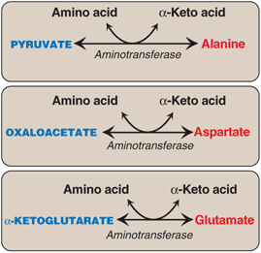
Posttranslational modification: In corporation of some amino acids "hydroxyproline and hydroxylysine" into protein, then it will modified.
A. Synthesis of α – Keto acids:
- These three amino acids are synthesized by transfer of an amino group to their α-keto acid.
- These transamination reactions are the most direct of biosynthetic pathway.

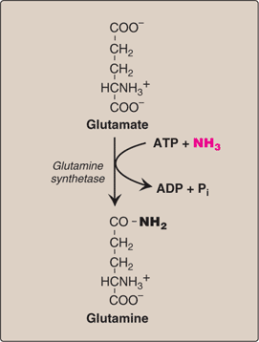
N.B. Glutamate can be synthe sized by oxidative deamination by glutamate dehydrogenase
B. Synthesis by amidation:
1) Glutamine:
* It is synthesized from glutamate.
* This reaction requires ATP.
* This reaction also serves as a major mechanism for detoxification of ammonia in brain and liver.
2) Asparagines:
* It is formed from aspartate by asparagine synthetase .
* The amide donor is glutamine.
* This reaction requires ATP.
* Liver has two different enzymes, and they have opposite function, why?!
- These enzymes are glutamiuose and glutamine synthe ase.
- Liver use glutaminase for:
* hydrolyze the glutamine which is transported by blood from peripheral tissue to liver.
* This enzyme hydrolyzes glutamine to glutamate and NH₃.
- The other enzyme is glutamine synthetase, used for:-
*Synthesis of glutamine "by liver”, and it will be transported by blood to kidney.
- The Kidney hydrolyzes it to glutamate + NH₃.
- NH₃ is used in acid –base balance in kidney.

C. Proline:
- Glutamate is converted to proline by cyclization and reduction reaction.
D. Serine, glycine and cysteine:
1) Serine:
Produced by 3-phosphoglycerate “intermediate in glycolysis"
2) Glycine:
- Synthesized from serine by removal of a hydroxylmethyl group.
- This reaction is catalyzed by serine hydroxylmethyl transferase.
3) Cysteine:
Methionire homo Cysteine Cystein
E. Tyrosine:
- Phenylalanine by phenylalanine hydroxylase converted to tyrosine.
- This reaction requires O₂ + tetra hydrobiopterin “BH4”.

VI. Metabolic defects in amino acid metabolism:

Mutation in gene result abnormal protein abnormal enzyme.
Phenylketonuria:

- Is the most common and important disease of amino acid metabolism.
- Caused by deficiency in phenylalanine hydroxylase.
- Is characterized by accumulation of phenylalanine, and deficiency of tyrosine.
- It may caused by deficiency of other enzymes.
- BH₄ is used as co-enzyme of:
Phenylalanine hydroxylates, hydroxylase, tyrosine hydroxylase, tryptophon hydroxylase.
- The last two enzyme produce neuro transmitters “serotonin and catecholamine”.
- Treatment of this disorder by decrease phenylalanine in diet does not reverse the CNS, because of deficiency in neurotransmitter.a
- Replacement therapy with BH₄ or L-DOPA and 5-hydroxytryptophan improve clinical outcome in these variant forms of phenylalaninemia, although the response is unpredictable.

1. Characteristics of Classic PKU
a. Elevated Phenylalanine
- Phenylalanine will increase in concentration in tissue, plasma, and urine.
- Phenyl lactate, phenyl acetate, and phenyl pyruvate will elevate in PKU.
- These metabolites give urine a characteristic mousey odor.
b. CNS Symptoms:
- Mental retardation
- Tremor
- Failure to walk or talk
- Microcephaly
- Seizures
- Failure to grow
- Hyperactivity
- Patient with untreated PKU shows symptom of mental retardation by age of one year.
c. Hypopigmentation
- Deficiency of pigmentation in “hair, skin, and eye.”
- Elevated phenylalanine will competitively inhibit the tyrosinase.
- Hydroxylation of tyrosine by tyrosinase is first step in melanin synthesis.
2. Neonatal screening and diagnosis of PKU
- This diagnosis is important because PKU is treatable by dietary means.
- Infants with PKU show normal level of blood phenylalanine, because placenta clears the excess of amount of phenylalanine in infant’s blood.
- To detect the normal level of phenylalanine in blood, we give to newborn protein, feeding.
- After 24 – 48 hours, we measure the blood phenylalanine.
3. Antenatal diagnosis of PKU:
- Classic PKU can be caused by any of 400 mutations in gene that codes for phenylalanine hydroxylase.
- The mutation varies among population.
- The disease is doubly heterozygous “different mutation in each allele”.
- The deficient is located in chromosome 12.
- RFLP analysis can be used to carry out prenatal diagnosis.
- RFLP a restriction fragment length polymorphism is a genetic variant that can be examined by clearing DNA into fragments.
- Antenatal diagnosis is by sampling of fetal cell from:
- Amniotic fluid.
- Chorionic villus

PKU Treatment:

- Most of natural proteins contain phenylalanine. So, you can’t give the PKU patient a diet free of phenylalanine, CO₂ this will lead to mental retardation.
- But you should give the patient phenylalanine with restricted amounts.
- The earlier the treatment is started, the more damage can be prevented.
- The treatment must begin during first 7 – 10 days of life to avoid mental retardation.
- High doses of phenylalanine (essential) could lead to: poor growth, and neurologic symptoms.
- PKU patients, they can’t synthesize tyrosine from phenylalanine so, it becomes essential amino acid that must given through diet.
- If you stop the treatment before 8 years, then you will have a patient with low IQ test (Mental Retardation).
- So, life-long restriction of dietary phenylalanine is recommended.
- PKU patients – advised to stay away from aspartame – contain a lot of phenylalanine.

Maternal PKU
When women with PKU who are not on a low-phenylalanine diet [meaning that she got married and stopped the treatment then, phenylalanine becomes high in blood] get pregnant

Offspring is affected with Maternal PKU

Symptoms (Signs)

- Microcephaly
- Metal Retardation
- Congenital Heart Abnormalities in Fetus

  - Some of these responses develop in first months of pregnancy
  - She has to have a controlled diet of phenylalanine and maintain this control as long as she able to be pregnant (treatment must be maintained throughout pregnancy).

Disorder | Kind of  Inheritance | Enzyme Deficient | Accumulation  of | Characteristics | Treatment
PKU | Autosomal  Recessive  “1:15,000” | Phenylalanine  Hydroxylase or  other enzymes | Phenylalanine | - Elevated phenyl- alanine.  - CNS symptoms.  - Hypo- pigmentation | - Have been explained
Tyrosinemia  Type “1” | Autosomal  Recessive | Fumaryl aceto- acetate hydrolase | Fumeryl acetoacetate | - Liver failure  - Renal tubular  acidosis | - Dietary restriction  of phenylalanine  and tyrosine
Malpe Syrup  Urine Disease  “MSUD” | Autosomal  Recessive  “1:185,000” | Branched-chain  α-keto acids  dehydrogenase | - Branched  chain amino  acids “valine  leucine, and  isoleucine”  - Corresponding  α-keto acids | 1. Severe metabolic  acidosis.  2. Malpe syrup odor  to the urine  3. Mental retardation | - Should be treated  in first few days  - Like limited amount  amount of branched  chain amino acids  - These amino acids  are importance in  normal growth and  development
Albinism | Autosomal  Recessive  Autosomal  Dominant  t-linken | Tyrosinase | -- | 1. Absence of  pigment of hair,  eye, skin  2. Vision defect  3. Photophobia | --
Homocystinuria | Autosomal  recessive | Cysta thionine β  synthase | Homocysteine  and methionine | 1. Ectopia  2. Skeletal  abnormality  3. Premature arterial  disease  4. Osteoporosis  5. Mental retardation  * These characteris- tics in homozygous  enzyme deficiency. | - Dietary restriction of  methionine  - Supplementation  with vitamin B₆, B₁₂,  and folate.
Alkaptonuria | Autosomal  recessive | Homogentisic acid oxidase | Homogentisic acid  This compbined  produced in de-  hydrative pathway  of tyrosine | 1. Homogentisic  aciduria  2. Large joint  arthritis  3. Black ochronotic  pigmentation of  cartilage and  collagenous tissue | - Asymptomatic till age  40.  - Dietary restriction of  phenyl alanine and  tyrosine  - Alkaptonuria associated  with arthridis.

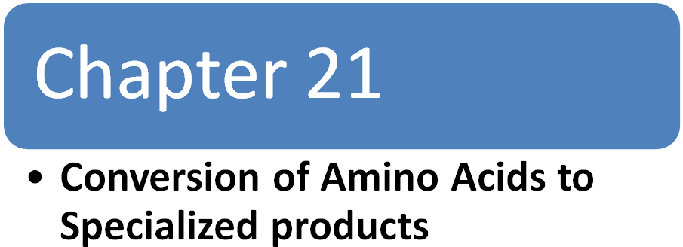

Conversion of Amino Acids to Specialized products

I-Overview
Amino Acids (serve as) Protein

Precursors of many nitrogen-containing compounds

e.g. porphyrins, Creatine, neurotransmitters, hormones, purines, and pyrimidines.

II. Porphyrin Metabolism

Porphyrins Structure:
- Cyclic compounds contain tetrapyrrole ring (4 rings) that are linkage by methenyl bridges.
- Bind tightly to a metal ions, usually Fe2+ or Fe3+ (reduced or oxidized).
- As it bind to a different metal ions it has a different name each time, for example when the tetrapyrrol ring bind to iron (Fe2+, ferrous) it’s called “heme” or “protoporphyrin XI”.
- Heme: the prosthetic group for hemeproteins such as: hemoglobin, myoglobin, the cytochromes, catalase, and tryptophan pyrrolase. Heme is the most prevalent metalloporphyrin in humans.
- Hemeproteins: are made of apoprotein + prosthetic group “heme”.
Porphyrins Side chains: Different porphyrins vary in the nature of the side chains that are attached to each of the four pyrrole rings.
- Uroporphyrin contains acetate (–CH2–COO-) and propionate (–CH2–CH2–COO-) side chains.
- Coproporphyrin contains methyl (–CH3) and propionate groups.
- Protoporphyrin IX (and heme) contains vinyl (–CH=CH2), methyl, and propionate groups. [Note: The methyl and vinyl groups are produced by decarboxylation of acetate and propionate side chains, respectively.]
Distribution (order) of side chains: By Roman numerals I to IV.

Only Type III porphyrins contain an asymmetric substitution on ring D. [Note: Protoporphyrin IX is a member of the Type III series.] (See the figure below)

Porphyrinogens: They are porphyrin precursors. They are reduced, colorless form, and serve as intermediates in the synthesis of porphyrin. e.g. uroporphyrinogen in heme biosynthesis.

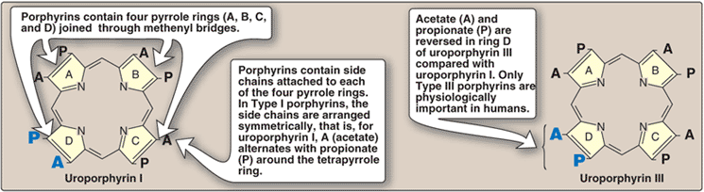

Figure 21.2 Structures of uroporphyrin I and uroporphyrin III. A = acetate and P = propionate.

Biosynthesis of Heme:
The major sites of heme biosynthesis are the liver and erythrocyte producing cell of bone marrow .
Erythrocyte producing cells | Liver
-they synthesize hemoglobin  -rate of synthesis: relatively constant matching rate of globin synthesis.  -heme synthesis is under control of:  EPO “ erythropoietin hormone from liver”, & intracellular iron | -It synthesizes heme proteins as cytochrome p450.  -rate of synthesis: variable (depend on the demand for heme protein and the cellular heme pool)  -rate limiting step is formation of  δ aminolevulinic acid (ALA)

1-the initial reaction & the last 3 steps in the formation of porphrins occurs in the mitochondria
2-Intermediate steps occurs in the cytosol.
3-Mature Red blood cells lack mitochondria and are unable to synthesize heme.
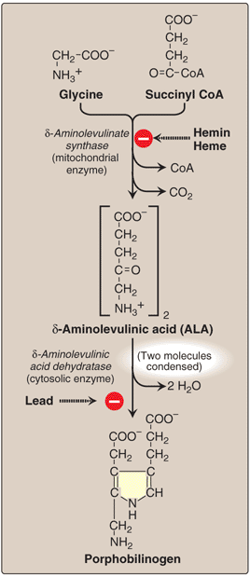
1-Formation of δ-aminolevulinic acid (ALA):
1-all carbons and nitrogen atoms of the porphyrin molecule providede by two simple building blocks: glycin ,succinyl coA.

[Note= Glycin is a nonessential Amino Acid, and Succinyl CoA is an Intermediate in TCA cycle].

2-glycin+succinyl CoA condensed to form ALA with the enzyme
“ALA synthase “And co enzyme “pyridoxal phosphate”

3-this is the committed step and the rate controlling step in the hepatic (liver) porphyrin biosynthesis.

End product inhibition by hemin:

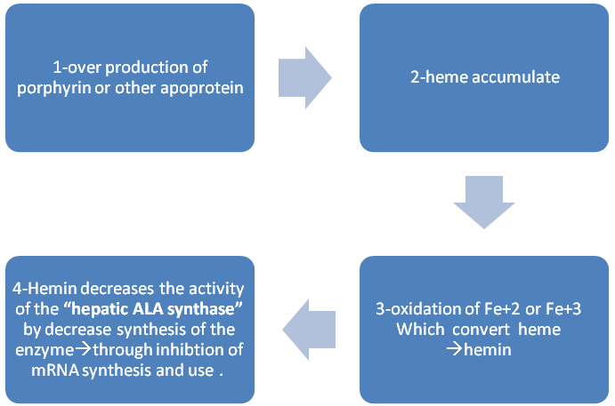

- Erythroid cell: heme synthesis is under the control of erythropiotin and availability of intracellular iron.

b- Effect of drugs on ALA synthase activity:
1-administration of any large amount of drugs:
- griseofulvin (antifungal agent)
- hydantoins
- phenobarbital(anticonvulsant used to treat epilipsy)
- Result in a significant increase in hepatic ALA synthase activity.
2-These drugs are metabolized by microsomal cytochrome p450 monooxygenase system—a heme protein oxidase system found in liver.
In response to these drugs:
1-the synthesis of cytochrom p450 proteins increases {heme is component of cytochrom p450 protein}
2-leading to enhanced consumption of heme
3-causes decrease in the concentration of heme in liver cells
4-the lower intracellular heme concentrations leads to an increase in synthesis ALA synthase (derepression)
5-promotes a crossponding increase in ALA synthase
2-formation of porphobilinogen: (see the above figure)
1-condensation of two molecules of ALA to form porphobilinogen by
“ALA dehydratase”
2- 2 molecules of H2O are produced.
3-“AlA dehydratase” is extremely sensitive to inhibition by heavy metal ions (lead).
4- This inhibition responsible for the elevation in ALA and anemia is seen in lead poisining.

3-Formation of uroporphyrinogen:
1-the condensation of four porphobilinogens
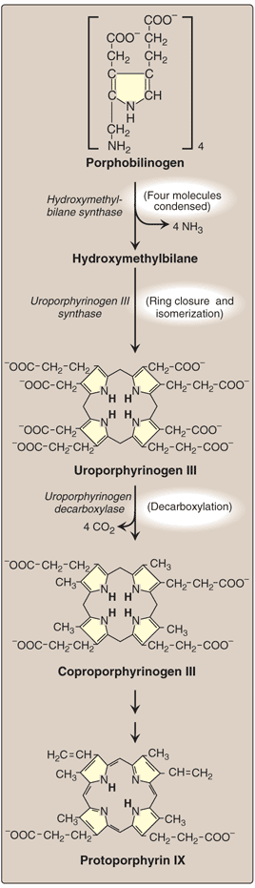
produces the linear tetrapyrrole (hydroxymethylbilane).
2-hydroxymethylbilane which is isomerized and cyclized
by “uroporphyrinogen III synthase” to produce the
asymmetric uroporphyrinogen III .

3-This cyclic tetrapyrrole undergoes decarboxylation of
Its acetate groups generating coproporphyrinogen III.

-these reactions occur in the cytosol

4-formation of heme:
1-coproporphyrinogen III enters the mitochondrion and two propionate sides are decarboxylated to vinyl groups→generating protoporphyrinogen IX (still not active).

2- protoporphyringen IX is oxidized to protoporphyrin IX ( the active form).
3-the introduction of iron as (Fe+2) into protoporphyrin IX occurs spontaneously.
4- The rate is enhanced by “ferrochelatase”, an enzyme which is like ALA dehydratase is inhibited by lead.
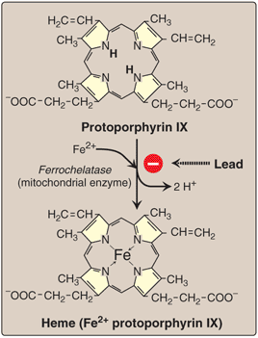

Porphyrias
- They are rare defects in heme synthesis ,resulting in accumulation and increased excretion of
porphyrins or its precursors.
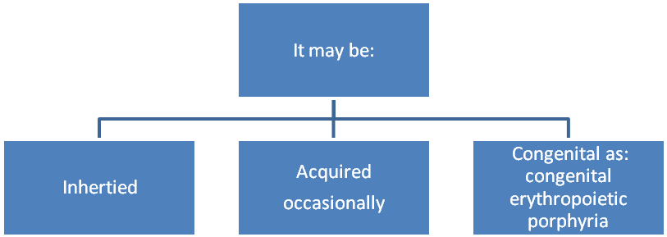
- All porphyrias are inherited as: autosomal dominant disorders except: The Congenital erythropoietic porphyria which is genetically recessive disease.
- The mutations that cause the porphyrias are heterogenous(not all are at the same DNA locus ).
- Nearly every affected family has its own mutation.
- Each porphyria results in the accumulation of a unique pattern of intermediates caused by the deficiency of an enzyme in the heme synthetic pathway.
- "porphyria" refers to the purple color caused by pigment –like porphyrins in the urine of patients with defects in heme synthesis.
Clinical manifestations:
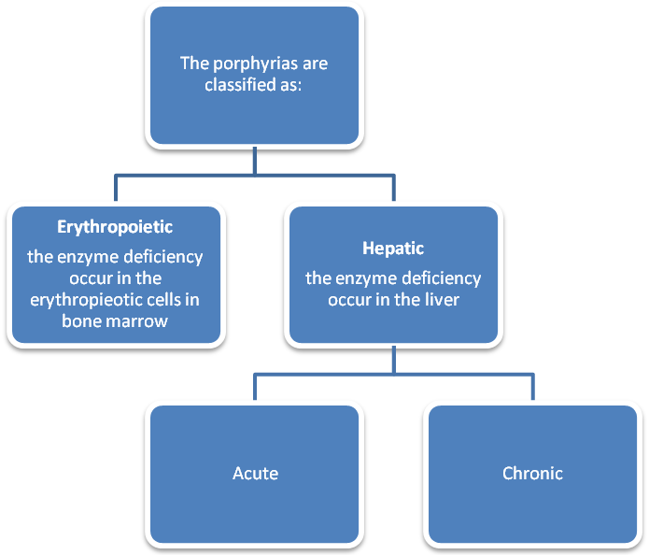

- Individuals with an enzyme defect leading to accumulation of tetrapyrrole intermediates show photosensitivity.
- That is, their skin itches and burns (pruritis) when exposed to visible light.
- These symptoms thought to be a result of the porphyrin –mediated formation of
superoxide radicals from oxygen.
- These reactive oxygen species can:
1) oxidatively damage membranes.
2)cause the release of destructive enzymes.
- Destruction of cellular components leads to→ photosensitivity.
Chronic porphyria: “Porphyria cutanea tarda”
- It is the most common porphyria.
- It is a chronic disease of liver and erythroid tissues.
- Caused by a deficiency in “uroporphyrinogen decarboxylase”.
- Clinical expression of the enzyme deficiency is influenced by various factors, such as:
- Hepatic iron overload.
- Exposure to sun light.
- Presence of hepatitis B or C or HIV infections.
- Patients are photosensitive.
- Clinical onset is typically during fourth or fifth decade.
- Pophyrin accumulation leads to:
- Cutaneous symptoms.
- The red to brown color of urine in natural light and pink to red in fluorescent one.
Acute hepatic porphyrias:
- Includes:
- Acute intermittent
- Hereditary coproporphyria.
- Variegate porphyria
- An acute disease caused by a deficiency in “hydroxymethylbilane synthase”.
- Are characterized by acute attacks of :
- Gastrointestinal.
- Neurological / psychiatric.
- Cardiovascular symptoms.
- Porphyrias leading to accumulationof ALA and porphobilinogen ,such as Acute intermittent porphyria,cause abdominal pain and neuropsychiatric disturbances
- The symptoms are often precipitated by administration of drugs such as:barbiturates and ethanol which induce synthesis of the heme-containing cytochromeP450microsomal drug oxidation system→amount of available heme→ promotes the increased synthesis of ALA synthase.
- Urine darkens on exposure tolight and air.
- Patients are not photosensitive.
Erythropoietic porphyrias:
- Includes:
- cogenital erythropoietic porphyria
- . Erythropoietic protoporphyria.
- Is caused by a deficiency in uroporphyrinogen lll synthase.
- Uroporphyrinogen l and coproporphyrinogen l accumulate in urine.
- Are characterized by skin rashes and blisters that appear in early childhood.
- Are complicated by cholestatic liver cirrhosis and progressive hepatic failure.
- Patients are photosensitive.
Increased ALA synthase activity:
- One common feature of porphyrias is a decreased synthesis of heme.
- In the liverheme normally functions as a repressor of ALA synthase.
- The absence of this end product results in an increase in the synthesis of ALA synthase(derepression).
- This cause an increase synthesis of intermediates that occur prior to the genetic block.
- The accumulation of these toxic intermediates is the major pathophysiology of the porphyrias.

Treatment:
- During acute porphyria attacks,patients require medical support, particulary treatment for pain and vomiting.
- The severity of symptoms can be diminished by: intravevous injection of hemin which the synthesis of ALA synthase.
- Avoidance of sunlight and ingestion of β-carotene (a free-radical scavenger) are also helpful.
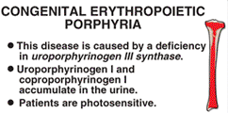
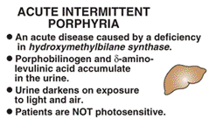

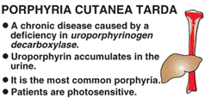

Other Nitrogen Containing Compounds:

A-catecholamines:
- Dopamine
- Norepinephrine
- Epinephrine
Are biologically active (biogenic ) amines that are collectively termed CATECHOLAMINES .
- Dopamine & Norepinephrine function as:
Neurotransmitters in the brain and the autonomic nervous system.
- Norepiniephrine & Epinephrine are also synthesized in the “ adrenal medulla “ .

Function :
- Norepiniphrine & Epinephrine are released from storage vesicles in adrenal medulla, in response to fright, exercise, cold, and low levels of blood glucose.
- Outside the nervous system; norepinephrine & its methylated derivative, epinephrine, act as regulators of carbohydrate and lipid metabolism.
- They increase the degradation of glycogen and triacylglycerol, as well as increase blood pressure and the output of heart.
These effects are part of coordinated response to prepare the individual for emergencies, and are often called the “fight-or-flight” reaction.
Synthesis of catecholamines:
- Catecholamines are synthesized from tyrosine as shown in the Figure below:
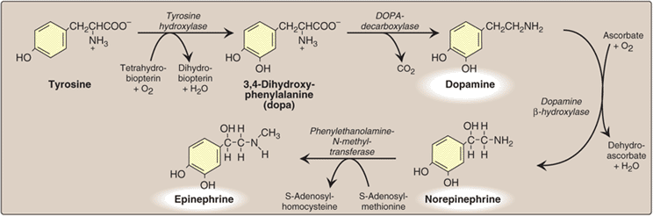

2
3

1

4

- Tyrosine is first hydroxylated by tyrosine hydroxylase to form 3,4-dihydroxyphenyl-alanine. ( DOPA )
1
- This reaction also needs “tetrahydrobiopterin” and O2.
- Tetrahydrobiopterin is abundant in the :
Central nervous system, the sympathetic ganglia, and the adrenal medulla.
- This reaction is the rate- limiting step of the pathway .

- (DOPA) is decarboxylated in a reaction requiring pyridoxal phosphate to form dopamine.
2
3
- Dopamine is hydroxylated by the copper- containing dopamine β-hydroxylase to yield norepinephrine.

- Epinephrine is formed from Norepinephrine by an N-methylation reaction using S- adenosylmethionine (SAM) as the methyl donor.
4

Parkinson disease:
- A neurodegenerative movement disorder.
- Due to insufficient dopamine production as a result of the idiopathic loss of dopamine- producing cells in brain.
- Administration of L- DOPA (levodopa) is the most common treatment.

Degradation of catecholamine:
- The catecholamine is inactivated by:
- Oxidative deamination catalyzed by monoamine oxidase (MAO),
- And by O-methylation carried out by catechol-O- methyl- transferase (COMT).
- if you start with MAO first then COMT or if you did the opposite which is starting with COMT then MAO, you’ll get the same result.
- The metabolic products of this reaction are excreted in the urine as;
- vanillylmandelic acid from epinephrine & norepinephrine.
- homovanillic acid from dopamine.

MAO inhibitore :
- MAO is found in neural and other tissues, such as the gut & liver.
- In the neuron, this enzyme functions;
- As a “safety valve “to oxidatively deaminate,
- and inactivate any excess neurotransmitter molecules (norepinephrine , dopamine or serotonin ) that may leak out of synaptic vesicles when the neuron is at rest .
- The MAO inhibitors may irreversibly or reversibly inactivate the enzyme, permitting neurotransmitter molecules to escape degradation and, therefore, to both accumulate within the presynaptic neuron and to leak into the synaptic space.
- This causes activation of norepinephrine & serotonin receptors, and may be responsible for the antidepressant action of these drugs.

B-Creatine:
Creatine phosphate (phosphocreatine)
1-found in: muscle as high-energy compound (reversibly donate phosphate to ADP to give ATP).
2- It provide small but rapidly mobilized reserve of high-energy phosphates use to maintain the intracellular level of ATP during the 1st few minutes of intense muscular contraction.
Note = the amount of creatine phosphate in the body is proportional to the muscle mass.

1-Sythsis:
1. glycine + guandino groub of arginine + methyl groub from SAM.
2. Creatine reversibly phosphorylated by creatin kinase using ATP.
- creatine kinase in plasma indicate tissue damage(diagnosis of myocardial infarction[ck]).
2-degradedation:
- Creatine + creatine phosphate cyclize spontaneously at slow but constant rate forming Creatinine which is execrated in urine.
- Amount of creatinine excreted is proportional to the total creatine phosphate content of the body. And this can be use to estimate muscle mass.
- When muscle mass ➔ creatinine content of all the urine (falls).
- When Blood creatinine ➔ it is a sensitive indicator of kidney malfunction. Because creatinine normally is rapidly removed from the blood & excreted.
- Typical adult male excretes about 15 mmol/day of creatinine.

C- Histamine:
- Histamine is a chemical messenger that mediate a wide range of cellular responses, Including:
- Allergic & inflammatory reaction
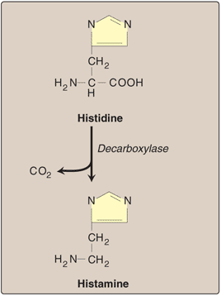
- Gastric acid secretion
- And possibly neurotransmission in parts of the brain.

- A powerful vasodilator, histamine is Formed by:
decarboxylation of histidine in a reaction requiring pyridoxal phosphate.

- It is secreted by mast cells as a result of allergic reaction or trauma.
- Histamine has no clinical applications, BUT agents that interfere with the action of histamine have important therapeutic applications.
D-Serotonin (5-hydroxytryptamine)
- Synthesized & stored in several sites in the body.
- Largest amount in cells of intestinal mucosa.
- Smaller amounts in CNS (function: neurotransmitter) & in platelets.
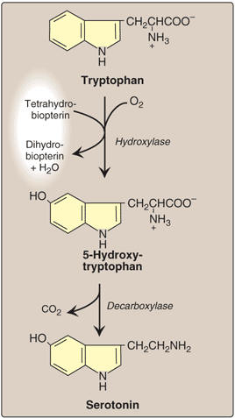
Synthesis:

Degradation:
Serotonin is degraded by MAO.

Physiologic roles:
- Pain perception.
- Affective disorders.
- Regulation of: sleep + temperature + blood pressure.

E-Melanin:
- It is pigment occurs in several tissues particularly eye, hair and skin.
- Synthesis: from tyrosine in epidermis by pigment-forming cells (melanocytes).
- Function: protect underlying cells from harmful effects of sunlight.
- Defect in melanin production→ albinism. The most common form is due to defects in copper-containing tyroinase.

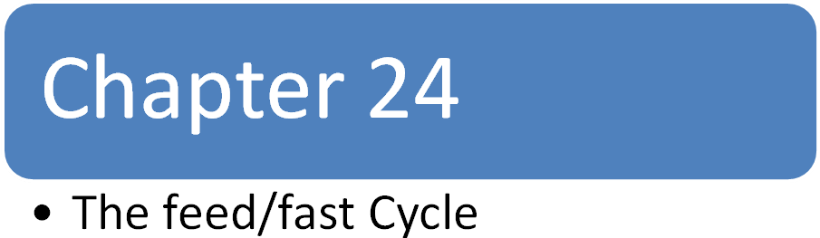

I: Overview of the absorptive state:
- 2-4 hrs after ingestion of a normal meal.
- During this period:
- A.A (amino acid) increase in plasma
- Glucose increase in plasma
- TAG increase in plasma

- Fed state = well-fed state = absorptive state
- When insulin increase and glucagon decrease

Glucose increase

In Beta Cells of the pancreas … the glucose is the most important stimulus for Insulin production.
In anabolic state: “the absorptive state”
Increase synthesis of TAG and glycogen replenish fuel stores
Increase synthesis of protein.

Insulin Is anabolic.. Why? because it enhances
- Protein synthesis
- AA synthesis
- Fat synthesis

It makes all the tissues to USE the glucose during the well-fed state
(Insulin increases glucose utilization)

- Liver – Brain – Muscle – Adipose tissue
USE glucose for fuel

II: Enzymatic Change in the Fed state
Mechanism | Response time
Availability of substrate | Minutes
Allosteric activators & inhibitors | minutes
Covalent modification of enzymes (de/Phosphorylation) | Minutes to hours
Induction – repression of enzyme synthesis | Hours - days

- Note: allosteric regulation works on the rate limiting enzymes.

- Allosteric effect:
Involve rate-limiting reactions
For example:

- In glycolysis.
Increase glycolysis
Increase fructose 2, 6- bisphosphate
Which is an allosteric activator for?
- Phosphofructokinase
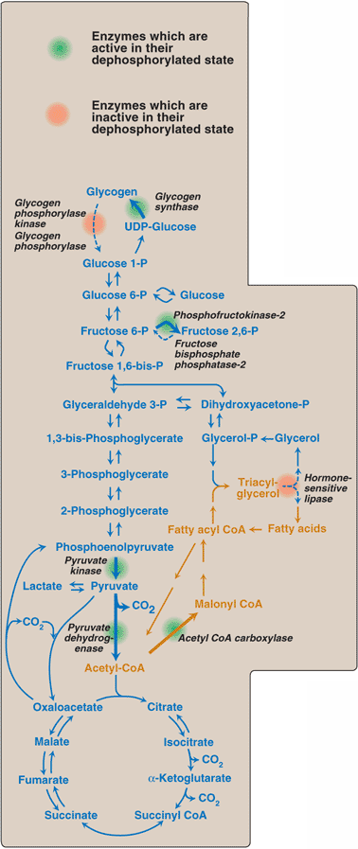
- In gluconeogenesis
Decrease Gluconeogeneisis
Gluconeogenesis is inhibited by:
fructose 2,6-bisphosphate → allosteric inhibitor
- of fructose 1,6-bisphosphatase

- Regulation of Enzymes by Covalent Modification:

- this process also known by:
Phosphorylation/dephosphorylation (look at the figure➔)

- Occurs by addition or removal of (P) from specific
Serine, Threonine or Tyrosine.

- In the fed state most of the enzymes are active
in the dephosphorylated form. EXCEPT 3:

    - Glycogen Phosphorylase
    - Glycogen Phosphorylase kinase
    - Hormone-sensitive lipase (adipose tissue)

These 3 are inactive when Dephosphorylated.

C. Induction and Repression of Enzyme synthesis:
  - This works on changing the total population of
active sites rather than Influence the efficiency of the
enzyme.

  - This occurs for enzymes needed for only one stage
- in fed state
Insulin increase → Acetyl CoA carboxylase increase
Insulin increase → HMG-CoA reductase increase

III: Liver: Nutrient Distribution Center
During the absorptive state, the liver takes up carbohydrates, lipids and most of AA’s

- Carbohydrates metabolism:

Liver is a Glucose-Producing rather than Glucose-Using (consumer) tissue. (It produces more than it uses)

- after a meal rich in carbohydrates :
Liver becomes a net consumer of glucose, (for every 100gm of glucose, 60gm will be used.

- This increased usage of glucose is NOT because of glucose transport, but is because of:
- increased glucose phosphorylation:

In hepatocytes:
Normally, high level of glucose → glucokinase ( phosphorylation of glucose ) → glucose-6-phosphate
- glucokinase is not inhibited by high levels of glucose 6 phosphate.
- BUT in the Postabsorptive state:
- Glucokinase does not work because of the hepatic glucose levels are low... & glucokinase has low affinity < high Km> for glucose.

- glucokinase responds to high levels of glucose in BLOOD because it has high Km & Low affinity.

- increased glycogen synthesis:

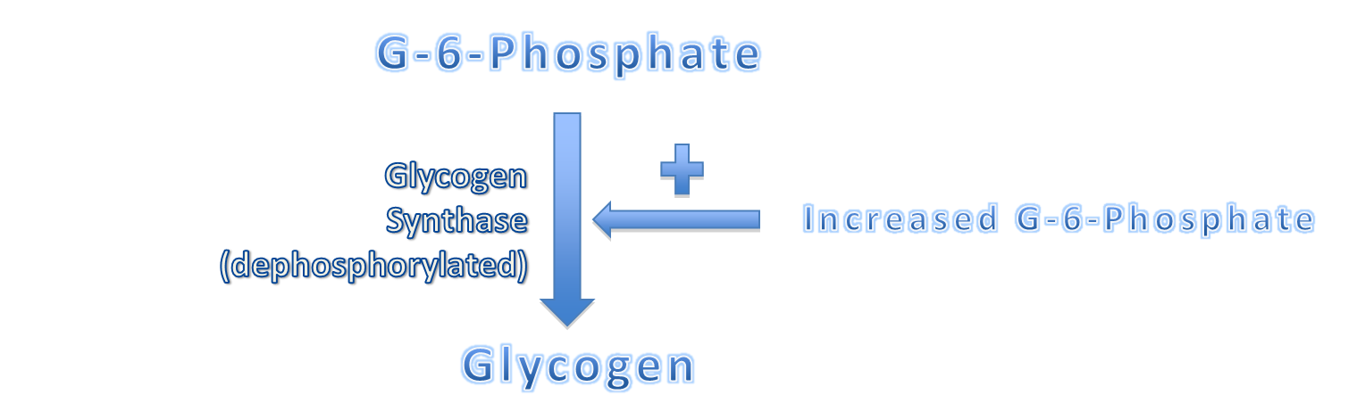

- Glycogen synthase is active by:
Dephosphorylation & increase availability of G-6-phosphate.

- Increased activity for Hexose Monophosphate Pathway (HMP) :
- This pathway consumes (use) 5-10% of glucose.
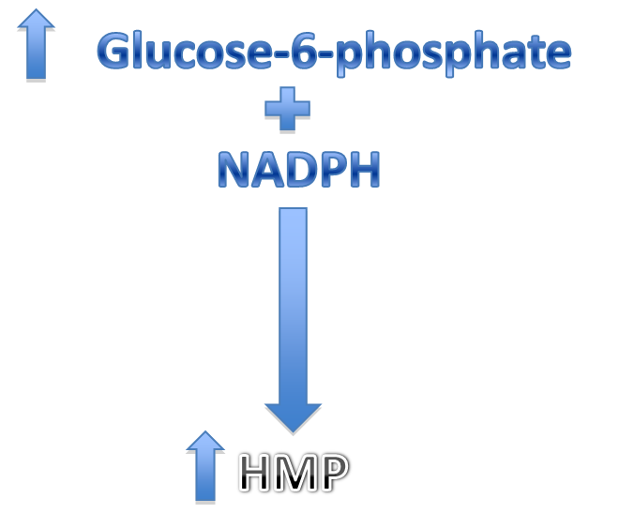
- In fed state >>

- increased glycolysis:
- after carbohydrate-rich meal:
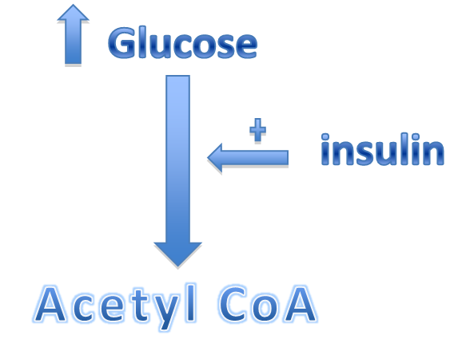

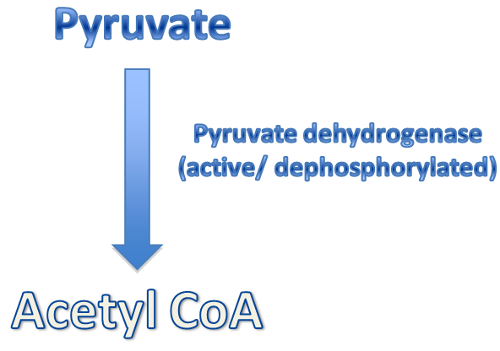
- also:



- decreased gluconeogenesis:
-during absorptive state:
- glycolysis (increase)
- Gluconeogenesis (decrease)
- pyruvate carboxylase catalyzes the first step in gluconeogenesis.
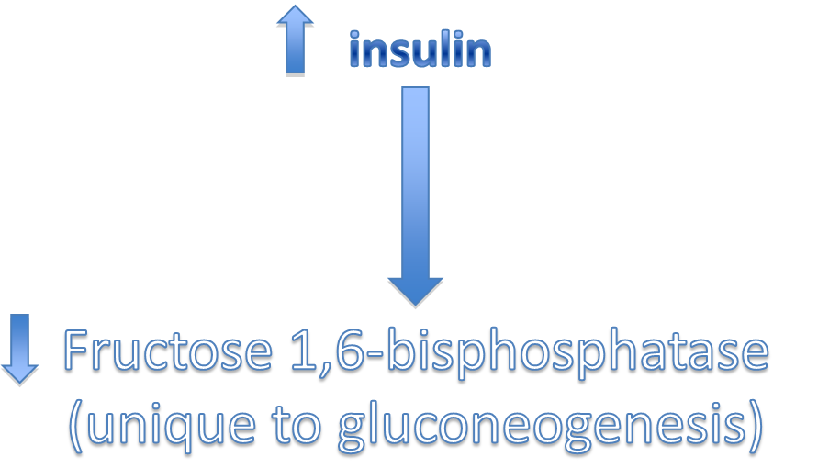
- But it is largely inactive because of low Acetyl CoA.

- Fat Metabolism

- the most 2 important places where fatty acids are synthesized are:
Liver & Lactating mammary gland.
- increased fatty acid synthesis:
De novo synthesis occurs in absorptive state.

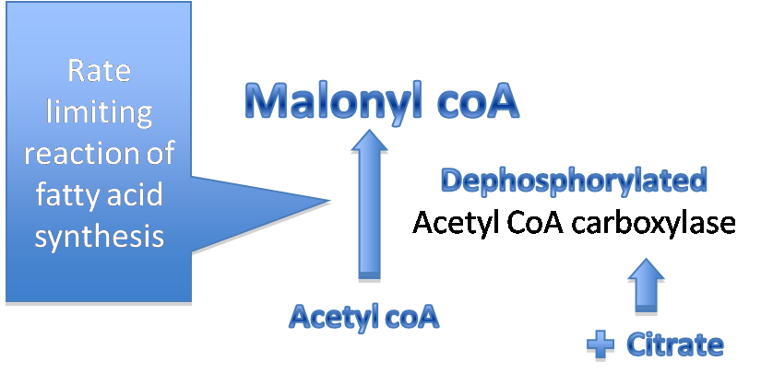

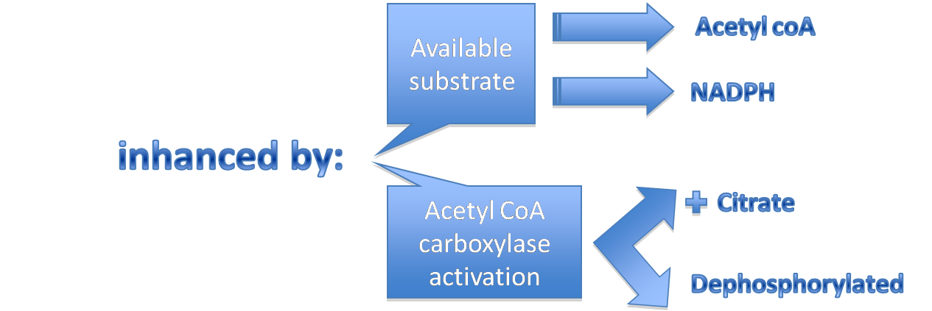

- increased TAG synthesis:
- chylomicron → formed in intestine
- VLDL → in liver
The backbone of TAG is
G-3-Phosphate
(from glycolysis)
Increase fatty acyl CoA
Lead TO
Increase TGA synthesis

The liver package TAG into VLDL , used by extrahepatic tissues ( adipose & muscles)

k

- Amino Acids Metabolism:

1. Increased AA degradation:
- in postabsorptive state:
AA >> ‘in liver’ >> protein

The skeleton is oxidized in liver to:
- acetyl CoA
- pyruvate
- TCA intermediates
Surplus AA are not stored, but either:
- released in BLOOD
- Deamination

- The branched AA (leucine, isoleucine, valine)
The liver cannot metabolize them but Muscles can.

2) Increased protein synthesis:
- There is a transient increase in protein synthesis during absorptive state, in order to replace any degraded protein.
- But proteins are not stored like the same amount of glycogen or TAG.

- Adipose Tissue: Energy Storage Depot
- Adipose tissue is second to the liver in its ability to distribute fuel molecules.
- In a 70 kg man, adipose tissue weight half the total muscle mass, which here = 14 kg.
- In obese it is about 70% of the body weight.
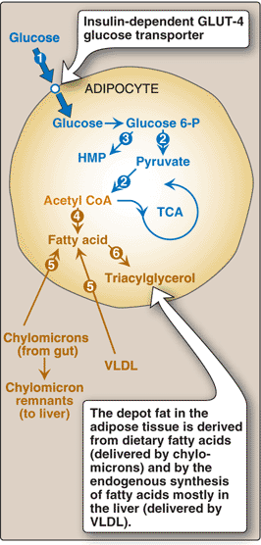
- The entire volume of adipocyte is occupied by TAG droplet.

A. Carbohydrate metabolism
Increased glucose transport:
Glucose transport into adipocytes is very sensitive to the concentration of insulin in the blood.

Increased glycolysis:
- The increased intracellular availability of glucose increases the rate of glycolysis.
- In adipose tissue, glycolysis supply glycerol phosphate for TAG synthesis.
Increased activity in the HMP:
- Adipose tissue use glucose in the HMP, thereby producing NADPH, which is essential for fat synthesis.
- In humans, de novo synthesis of fatty acid is not a major source of fatty acids in adipose tissue.

B. Fat metabolism
Increased synthesis of fatty acids:
De novo synthesis of fatty acids from acetyl CoA in adipose tissue is not the major source, except when re-feeding a previously fasted human.
Most of the fatty acids added to the lipid stores of adipocytes are provided by dietary fat (in the form of chylomicrons), with a lesser amount is supplied by VLDL from the liver.

Increased TAG synthesis:
- After consumption of a lipid-containing meal, hydrolysis by using the enzyme “lipoprotein lipase”, of the TAG of chylomicrons and VLDL provides fatty acids.
- Because adipocytes lack glycerol kinase, glycerol 3-phosphate must come from the metabolism of glucose.
- Thus, in the well fed state, elevated levels of glucose and insulin favor storage of TAG.

Decreased TAG degradation:
Elevated insulin favors the dephosphorylated (inactive) state of hormone-sensitive lipase. TAG degradation is thus inhibited in the well-fed state.

V. Resting Skeletal Muscle
- The skeletal muscle is unique in her response to changes in the demand of ATP.
- At rest, muscle use about 30% of the oxygen consumption of the body.
- During vigorous exercise, its use up to 90% of the total oxygen consumption.
- Skeletal muscle is an oxidative tissue.
- Heart muscle differs from skeletal muscle in three important ways:
- The heart is continuously active, whereas skeletal muscle contracts in respond to demand.
- The heart has a completely aerobic metabolism.
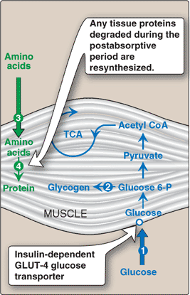
- The heart contains negligible (very low) energy stores, such as glycogen or lipid. Thus, any interruption of the vascular supply, for example, as occurs during a myocardial infarction, results in rapid death of the myocardial cells. Heart muscle uses glucose, free fatty acids, and ketone bodies as fuels.

A. Carbohydrate metabolism
Increased glucose transport:
The increase in plasma glucose and insulin after a carbohydrate-rich meal leads to an increase in glucose transport into muscle cells.
Glucose is phosphorylated to glucose 6-phosphate by hexokinase, and metabolized to provide the energy needs of the cells. This contrasts with the postabsorptive state in which ketone bodies and fatty acids are the major fuels of resting muscle.

Increased glycogen synthesis:
The increased insulin to glucagon ratio and the availability of glucose 6-phosphate favor glycogen synthesis, particularly if glycogen stores have been depleted as a result of exercise

B. Fat metabolism
Fatty acids are released from chylomicrons and VLDL by the action of lipoprotein lipase. However, fatty acids are of secondary importance as a fuel for muscle during the well-fed state, in which glucose is the primary source of energy.

C. Amino acid metabolism
Increased protein synthesis:
A spurt (increase) in amino acid uptake and protein synthesis occurs in the absorptive period after ingestion of a meal containing protein.

Increased uptake of branched-chain amino acids:
- Muscle is the principal site for degradation of branched-chain amino acids.
- The branched chain amino acids, leucine, isoleucine, and valine, escape metabolism by the liver, and are taken up by muscle, where they are used for protein synthesis and as sources of energy.

VI. Brain
- Brain is only 2% of the adult weight.
- The brain uses a consistent 20% of the oxygen consumption of the body at rest.
- A special priority is given to the brain fuel needs, because its control the whole body functions.
- To provide energy, substrates must be able to cross the endothelial cells that line the blood vessels in the brain “blood-brain barrier”.
- Normally, glucose serves as the primary fuel.
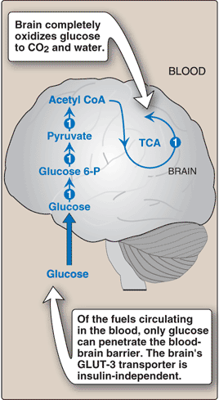
- If blood glucose levels fall below approximately 30 mg/100 ml cerebral function is impaired. If the hypoglycemia occurs for even a short time, severe and potentially irreversible brain damage may occur.
- However, that ketone bodies play a significant role as a fuel during a fast.

A. Carbohydrate metabolism
In the well-fed state, the brain uses glucose exclusively as a fuel, completely oxidizing approximately 140 g/day to carbon dioxide and water.
The brain contains no significant stores of glycogen and is, therefore, completely dependent on the availability of blood glucose.

B. Fat metabolism
The brain has no significant stores of TAG, and the oxidation of fatty acids obtained from blood makes little contribution to energy production because fatty acids do not efficiently cross the blood-brain barrier.

VII: Overview of Fasting
Fasting will cause decrease insulin to glucagon ratio, which will decrease substrate availability that makes postabsorpative (fasting) period catabolic and characterized by degradation of TAG, glycogen, & proteins.
Exchange of substrate between liver, adipose, muscle, & brain is guided by:
1) The need of glucose to glucose-requiring tissues (brain, RBC…)
2)The need to mobilize fatty acids from adipose to other tissues, and the formation of ketone bodies.

a. Fuel Stores
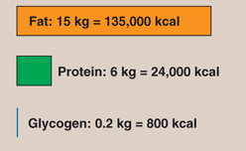

Metabolic fuels present in a 70-kg man at the beginning of a fast. Fat stores are sufficient to meet energy needs for about three months.

- Only one third of body proteins are used as energy source because it has other important functions as: structural components, enzymes…

b. Enzymatic change in fasting
Flow of intermediates is controlled by four mechanisms: availability of the substrate, allostric regulation, covalent modification, & induction repression of enzyme synthesis.

In fasting, most enzymes are phosphorylated (activated). In fasting, substrates are provided from breakdown of tissues. (e.g. lipolysis releases fatty acids, glycerol from adipose, proteolysis releases amino acids from the muscle)

VIII. Liver in Fasting:
Primary role of liver in fasting is to provide glucose of other energy sources molecules to the body tissues.

Carbohydrate metabolism:
Presence of glucose 6-phosphate allows production of free glucose by two mechanisms:

1) glycogenolysis (glycogen degradation):
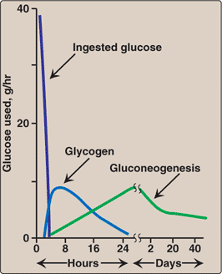
If glucose level declines, it will cause increase secretion of glucagon & decrease secretion of insulin. This will cause rapid mobilization of liver glycogen (80g). It’s depleted after 10-18 hours of fasting. So, glycogenolysis is a transient response to early fasting.

2) gluconeogenesis:
The carbon skeleton needed is provided by amino acids from muscle, lactate form muscle, & glycerol from adipose tissue.

Gluconeogenesis is favored by this mechanism:
- After 4-6 hours of ingestion a meal, glucagon level increases
- This will cause increase production of phosphoenolpyruvate carboxykinase
- This will will decrease levels of fructose 2,6-bisphosphate which work as inhibitor of fructose 1,6-bisphosphatase
- Increased level of fructose 1,6-bisphosphatase (by decrease the inhibitor) will favors gluconeogenesis.
- This mechanism will become fully active as glycogen is deplted.
Acetyl CoA produced by fatty acid oxidation is an allostric activator of pyruvate carboxylase (inhibitor of pyruvate dehydrogenase) and this will pushes pyruvate to gluconeogenesis.

Fat metabolism:

1. Increased fatty acid oxidation:
Oxidation of fatty acid from adipose tissue is a major source of energy for the liver.
Beta-oxidation occurs, the following mechanism:
- Activated protein kinase phosphorylates (inactivates) acetyl CoA carboxylase, which converts acetyl CoA to malonyl CoA, & causes fall in malonyl CoA.
- This fall in malonyl CoA removes the brake on carnitine palmitoyl transferase-1 (CPT-1)
Fatty acid has three main functions:
1) For hepatocytes as a fuel
2) To provide energy for gluconeogenesis
3) To provide energy for ketogenesis.
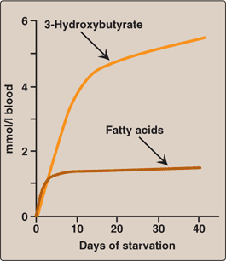
2. Increased synthesis of ketone bodies:
It's favored when the concentration of acetyl CaA exceeds the oxidative capacity of TCA cycle. Ketone bodies can be used as fuel by all the tissues (even the brain) except the liver; this reduces the need for gluconeogenesis from amino acids carbon skeleton, thus preserving essential protein. Ketone bodies appear in blood & urine from the second day of fasting because they're water-soluble.

IX. Adipose tissue in fasting

A. Carbohydrate Metabolism
- Decrease glucose transport into adipocyte, because of decrease insulin.
- Decrease fatty acid + TAG synthesis.

B. Fat Metabolism:
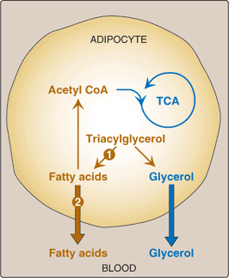
1. Increase degradation of TAG and increased release of fatty acids:
1. Sympathetic nerve ending release catecholamine “especially norepinephren” to stimulate adipocyte TAG degradation.
2. Pancreas also secretes glucagons to same aim.
3. The phosphorylated form of hormone sensitive lipase “active” degrades TAG into fatty acid and glycerol.
4. Fatty acid may release into the blood and bound to albumin, or it may enter the Krebs cycle to get energy important to adipocyte.
5. Glycerol should release into blood, to use as glucogenic precursor to liver.

2. Decrease uptake of fatty acids
- Lipoprotein lipase activity of adipose tissue is low.
- This is because of a decrease insulin level.
- Hint= Insulin increases the synthesis of lipoprotein lipase.
- Also, TAG of lipoproteins is not available for TAG synthesis in adipocyte.

X. Resting skeletal muscle in fasting:
- Resting muscle use fatty acid as a source of energy.
- Exercising muscle use its glycogen stores as a source of energy.
- As glycogen reserve are depleted, free fatty acids become dominant source of energy.

Carbohydrate Metabolism
- Insulin dependent GLUT-4 is needed for entry of glucose to skeletal muscles.
- Low insulin in blood → Decrease level of glucose transport into muscle → decrease glucose (carbohydrates) metabolism.

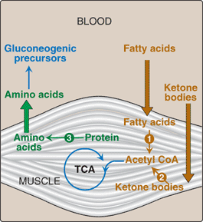
B. Lipid Metabolism
- During first two weeks of fasting, muscle use fatty acid and ketone bodies as source of energy.
- After three weeks, muscle decreases its use of ketone bodies and use fatty acid exclusively.
- This leads to increase use of ketone bodies by brain with decrease use of glucose.
- Glucose comes from gluconeogenesis by liver which use amino acid from the muscle.

C. Protein Metabolism
- Protein of muscle will degraded to result amino acids, which are used in gluconeogenesis by liver.
- The most important glucogenic “which send by liver” are glutamine and alanine.
- Muscle can catabolize the branched chain amino acids ( lead to glutamine & alanine ).

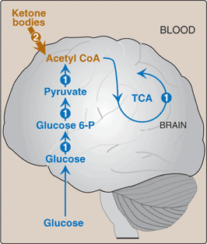
XI. Brain in fasting
- In first day of fasting, brain use only glucose as a source of energy.
- This glucose is provided by liver.
- Liver use glucogenic precursor such as amino acids and glycerol to synthesis glucose.
- In prolonged fasting, brain use ketone bodies and decrease its demand of glucose.

