**FOUNDATION BLOCK**

**BLOOD GROUPS and TRANSFUSION LECTURES**

**Objectives of Lecture 5:**

The student should

1. Identify the ABO Blood groups system
2. Recognize ABO antigens, antibodies and their genetic inheritance
3. Identify Rhesus Antigens
4. Identify procedure of blood group typing
5. Recognize transfusion reaction
6. Recognize Rhesus immune response
7. Recognize hazard of blood transfusion

**BLOOD GROUPS**

* + The chief blood groups are: A-B-O and Rh (Rhesus)
* Blood groups are antigen (glycoprotein) on the surface of RBC
* The ABO system depends on whether the RBC contain one, both or neither of the two blood antigens A & B.
* Four main ABO groups were known A, B, AB, O
* Anti-A & Anti-B are naturally occurring antibodies; Not present at birth and appear between second and eight month due to antigen in food.

|  |  |  |  |
| --- | --- | --- | --- |
| **%**  **Europe** | **Agglutinin**  **(Antibody)** | **Agglutinogen**  **(Antigen)** | **Blood Group** |
| **41%**  **9%**  **3%**  **47%** | **Anti-B**  **Anti-A**  **No antibodies**  **Anti-A & anti-B** | **A**  **B**  **A & B**  **-** | **A**  **B**  **AB**  **O** |

**Genetic determination of the ABO antigens**

* Two genes are inherited from each parent
* Blood group genotype:
  + A genotype is AA or AO
  + B genotype is BB or BO
  + O genotype is OO
  + AB genotype is AB
* Genotype of child is important in paternal dispute
* Frequency of ABO has an ethnic variation

**Transfusion reaction**

* If a person with blood group A transfused with blood of group B, the anti-B in his plasma will agglutinate the transfused cell (B)
* The clumped cells plug small blood vessels and might cause an immediate hemolysis and this is what call transfusion reaction

**Blood group typing**

* Before transfusion blood the donor and recipient should be typed to now their group
* A drop of blood is mixed with ant-A and ant-B & Rh then inspected for agglutination blood group is determined according to table below
* A cross matching, which is the direct mixing of donor cells with recipients serum then look for reaction to care for minor unknown blood groups

|  |  |  |  |
| --- | --- | --- | --- |
| **Blood group** | **Blood+ Anti A** | **Blood+**  **Anti-B** | **Rh** |
| **O** | **-** | **-** | **+/-** |
| **A** | **+** | **-** | **+/-** |
| **B** | **-** | **+** | **+/-** |
| **AB** | **+** | **+** | **+/-** |

**Rhesus Blood types**

* Depend on the presence of the Rhesus antigen (D) on the surface of RBC. Presence of antigen D (Rh+ve); absence of D (Rh–ve)
* Other Rhesus antigens are: C, D,E, c, d, & e commonest D
* Rh+ve people are 85% of population in European and 100% in Africa
* When a Rh-ve person is transfused with Rh+ve blood he will develop Anti-D antibody in circulation (not naturally present), which will attack RH+ve cells on other transfusion
* Anti D antibodies can be acquired by:
  + Transfusion of Rh-ve individual with Rh+ve blood
  + Rh-ve mothers having a Rh+ve baby due to blood mixing at delivery time.

**Hemolytic disease of the newborn** (Erythroblastosis Fetalis)

* Rh-ve mother pregnant with her first Rh+ve baby, the mother will develop Anti-D at the time of delivary (First child escape)
* Second Rh+ve child, already formed anti D (IgG) cross the placenta and destroy baby’s RBC leading to haemolytic disease of new born (haemolytic anaemia, erythroblastosis foetalis,)
* If the mother is transfused with Rh+ve blood before, first child will be affected.
* This reaction could be prevented by giving the mother an injection of Anti D at delivery of first baby
* Replace baby blood with Rh-ve several times

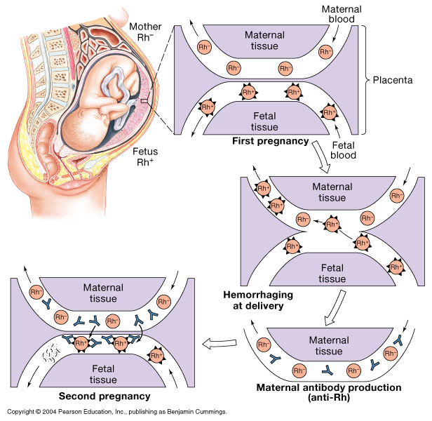

**Complication of blood transfusion**

1. Incompatible blood transfusion: Immediate or delayed reaction, Haemolysis, allergic, fever
2. Transmission of diseases; malaria, syphilis, viral hepatitis & Aids
3. Kidney failure (tubules blocked By Hb)

**Platelets and Coagulation**

**Objective of lecture 6**

The student should

1. Recognize platelets synthesis and function
2. Identify steps of Haemostasis
3. Recognize the role of vasoconstriction in haemostasis
4. Recognize the role of Platelets Plug in haemostasis
5. Identify steps of clot formation (intrinsic & externsic pathway)
6. Recognize thrombin function
7. Recognize Fibrinolysis mechanism and the function of plasmin

**Platelets & Megakaryocyte (Thrombocytes)**

* + Platelets are round disc formed in bone marrow from stem cells → Promegakaryocyte → megakaryocyte → breaking pieces of cytoplasm (platelets)
  + Platelet count = 150x103-300x103/ml and their life span 8-12 days
  + Active cells contain contractile protein, and a high calcium storage and rich in ATP
  + Coated by a glycoprotein layer which prevent its sticking to normal endothelial cells
  + Functions is to Adhere to injured site of blood vessel to stop bleeding and Secretes substances which are important for clot formation

**Haemostasis:**

It’s the mechanisms that prevent blood loss

* 1. Vasoconstriction
  2. Platelet plug
  3. Blood clot

**Vasoconstriction:** Immediately After injury a localize constriction of blood vessels occur caused by:

* 1. Hurmoral factors: local release of thromboxane A2 by platelets, systemic release of adrenaline
  2. Nervous factors
  3. Myogenic contraction

**Platelet Plug**

* Platelet came in contact with exposed collagen from injured endothelial, platelets swells and contract to release several substances such as 5HT, ADP, thromboxane A2
* The released substances increases the stickiness of platelets leading to platelets aggregation and plugging of the cut vessel
* These substances are also vasoconstrictor
  + **Activated platelets** secret: 5HT → vasoconstriction; ADP → aggregator; Platlet phospholipid (PF3) needed for clot formation; Thromboxane A2 (TXA2) is a prostaglandin formed from arachidonic acid causes vasoconstriction and aggregator. Inhibited by aspirin

**Blood coagulation (clot formation)**

* A series of biochemical reaction leads to the formation of blood clot within few second after injury
* This reaction leads to the activation of thrombin enzyme from inactive form prothrombin
* Thrombin will change fibrinogen (plasma protein synthesized in the liver) to fibrin (insoluble protein)
* Prothrombin (inactive thrombin) is activated by a long intrinsic or short extrinsic pathways
* Activation cascade reaction involve 12 clotting factors, circulating in inactive precursor forms

**Clotting Factors**

|  |  |
| --- | --- |
| **Names** | **Factors** |
| **Fibrinogen**  **Prothrombin**  **Thromboplastin**  **Calcium**  **Labile factor**  **Stable factor**  **Antihemophilic factor**  **Antihemophilic factor B**  **Stuart-Power factor**  **Plasma thromboplastin antecedent (PTA)**  **Hagman factor**  **Fibrin stablizing factors** | **I**  **II**  **III**  **IV**  **V**  **VII**  **VIII**  **IX**  **X**  **XI**  **XII**  **XIII** |

**Intrinsic pathway**

* The trigger for intrinsic pathway for clot formation is the activation of factor 12 (XII) when blood come in contact with foreign surface. Such as injured blood vessel or glass.
* Activate factor 12 (XIIa) will activate 11 (XI), activated factor 11 (Xla) will activate 9 (IX), activated factor 9 (IXa) plus factor 5 (VIII) plus platelet phospholipid plus Ca will activate factor 10 (X)
* Following this step the pathway is common for both

**Extrinsic pathway**

* Is triggered by material released from damaged tissues (**tissue thromboplastin**)
* tissue thromboplastin + factor 7 (VII) plus Ca will activate factor 10 ( X)

**Common pathway**

* Activated factor 10 (Xa) plus factor 5 (V) plus Platlet factor 3 (PF3) plus Ca ( **prothrombin activator**) it is a proteolytic enzyme activate prothrombin to thrombin
* Thrombin act on fibrinogen to make it insoluble thread like fibrin
* Factor 13 (XIII) plus Ca → make the fibrin clot stable and strong

|  |  |
| --- | --- |
| **Exterinsic pathway** | **Intrinsic Pathway** |
| **Tissue factor**  **↓**  **↓ VII,Ca**  **↓**  **↓**  **Xa ← X** | **Contact activation**  **↓**  **XII →XIIa**  **↓**  **XI →XIa**  **↓**  **IX → IXa**  **↓VIII, Ca,P**  **X → Xa** |
| **Xa**  **↓**  **↓ V, Ca, P**  **Prothrombin (II) →** **Thrombin (IIa)**  **↓**  **Fibrinogen (I) →** **Fibrin (soluble)**  **↓ XIII, Ca**  **insoluble fibrin** | |

**Coagulation**

* Both pathway are needed for normal haemostasis
* Both pathways are activated when blood come in contact with tissues outside blood vessel
* Thrombin is important factor in both
* Extrinsic pathway is faster (15 sec) while intrinsic may take up to 1-6 min

Thrombin

* Thrombin is essential in platelet morphological changes to form primary plug
* Thrombin beside fibrin formation also stimulate platelet to release ADP & thromboxaneA2 stimulate further platelets aggregation
* Activate factor V

**Fibrinolysis**

* Formed blood clot can either become fibrous or dissolve
* Fibrinolysis (dissolving) = Break down of fibrin by naturally occurring enzyme plasmin therfore prevent intravascular blocking
* There is balance between clotting and fibrinolysis
  + Excess clotting → blocking of Blood Vessels
  + Excess fibrinolysis → tendency for bleeding
* Plasmin is present in the blood in inactive form plasminogen
* Plasmin is activated by tissue plasminogen activators (t-PA) in blood.
* Plasmin digest intra & extra vascular deposit of Fibrin → fibrin degradation products (FDP)
* Unwanted effect of plasmin is the digestion of clotting factors
* Plasmin is controlled by:
  + Tissue Plasminogen Activator Inhibitor (TPAI)
  + Antiplasmin from the liver
  + Tissue Plasminogen Activator (TPA) is used to activate plasminogen to dissolve coronary clots