CELL INJURY, CELLULAR ACCUMULATIONS,
CALCIFICATION AND CELLULAR
ADAPTATIONS TO INJURY

DR. AMMAR C. ALRIKABI
Associate Professor
Department of Pathology
King Khalid University Hospital and King Saud University

Introduction
Cell injury may be reversible (sublethal) or irreversible (lethal). Many causes may result in reversible injury initially, but if severely injured, the cell may be unable to recover and cell death (necrosis or apoptosis) follows.
Processes involved in cell injury
- Causes of cell injury
The causes of both reversible and irreversible cell injury are similar. Many of those listed below may result initially in reversible injury. If the injury is of sufficient severity, e.g. length of exposure to radiation or reduced oxygen supply, the cell reaches a "point of no return" and irreversible injury culminating in cell death will occur.
Possible causes include:
- Hypoxia, e.g. myocardial ischaemia (reduced blood flow to, and therefore oxygenation of the heart) as a result of coronary artery atherosclerosis.
- Immunological, e.g. thyroid damage caused by autoantibodies (antibodies produced by the body against its own tissues).
- Infection, e.g. bacterial, viral, fungal infections, etc. (e.g. tuberculosis infection of the lung).
- Genetic, e.g. Duchenne muscular dystrophy.
- Chemical, e.g. acid damage to oesophageal mucosa (accidental or deliberate).

- Mechanisms of cell injury

The structure and metabolic function of the cell are interdependent. Therefore, although an injurious agent may target a particular aspect of cell structure or function, this will rapidly lead to wide-ranging secondary effects. Recognized mechanisms of cell injury include:

- Cell membrane damage
- Complement-mediated cell membrane lysis via the membrane attack complex (MAC)
- Bacterial toxins
- Free radicals

- Mitochondrial damage leading to inadequate aerobic respiration
- Hypoxia (lack of oxygen)
- Cyanide poisoning
- Ribosomal damage leading to altered protein synthesis
- Alcohol in liver cells
- Antibiotics in bacteria

- Nuclear change
- Viruses
- Radiation
- Free radicals

Free radicals and cell membrane damage

Free radicals are highly reactive atoms which have an unpaired electron in an outer orbital. They can be produced in cells in response to a variety of processes, including radiation, normal metabolic oxidation reactions and drug metabolism processes. The most important free radicals are derived from oxygen, e.g. superoxide and hydroxyl ions. Free radicals can injure cells by generating chain reactions, producing further free radicals, which cause cell membrane damage by cross-linking of proteins and by critical alterations of lipids.

- Consequences of cell injury

The consequences of cell injury depend on both the cell and the injurious agent. Certain features of cells make them more vulnerable to serious sequelae of cell injury.

Cell features
Specialization. Cells that are enzyme rich, nucleated or have specialized organelles within the cytoplasm may be more vulnerable. The presence of specialized proteins within the cell may make it prone to certain types of injurious agent.
Cell state. Cells that have an inadequate supply of oxygen, hormones or growth factors or lack essential nutrients may be more prone to injury.
Regenerative ability. The potential of a cell population to enter the cell cycle and divide is important in the response of tissues to injury. Damaged areas in tissues made up of cells which can divided will quickly be restored to normal, while populations of permanent cells will be incapable of regeneration.
Injury features
In addition, the character of the injury will also affect the severity of the damage.
Type of injury. The injury may be ischaemic, toxic, chemical, etc. Different cells will be more susceptible to some injurious agents than others (e.g. heart muscle cells are more susceptible to oxygen depletion than connective tissue cells).
Exposure time. The length of time of exposure to a toxin or reduced oxygen concentration will affect the change of a cell surviving the insult, even for those cells relatively resistant to the damaging agent.
Severity. The ability to survive an injury will also depend upon its severity, e.g. is the lack of oxygen partial (hypoxia) or complete (anoxia).

- Irreversible cell injury
When does reversible injury become irreversible? The exact "point of no return" from reversible to irreversible cell injury (leading to cell death) has not yet been defined, although severe mitochondrial damage and cell membrane destruction via free radical generation have been proposed. The light microscopical changes seen in injured cells are well described.
Early changes. These are reversible and include:
- Cytoplasmic swelling and vacuolation.
- Mitochondrial and endoplasmic reticulum swelling.
- Clumping of nuclear chromatin.

Late changes. These are irreversible and include:

- Densities in mitochondrial matrix.
- Cell membrane disruption.
- Nuclear shrinkage (pyknosis).
- Nuclear dissolution (karyolysis).
- Nuclear break up (karyorrhexis).
- Lysosome rupture.
Cell death
Autolysis
Autolysis is the death of individual cells and tissues after the death of the whole organism. The cells are degraded by the post-mortem release of digestive enzymes from the cytoplasmic lysosomes.
Apoptosis
It is now known that cell death encompasses a spectrum of cellular processes. At one end of the spectrum, there is necrosis where the accidental death of a large number of cell causes an inflammatory response. At the opposite end of the spectrum is apoptosis. This form of cell death occurs in physiological and embryological processes and appears to be a phenomenon whereby tissues control cell population numbers (sometimes called programmed cell death) or pathological processes (inflammation, cancers) in an attempt by the body to arrest cell proliferation and tissue damage.
During apoptosis, the cell activates genes which code for new proteins, many of which contribute to the cell's own death. The enzyme endonuclease is produced or activated, causing DNA fragmentation. In contrast to necrosis, apoptotic cells remain viable and their membrane pumps continue to function until the terminal stage of the process. During apoptosis, the cell shrinks, the nuclear chromatin condenses and the cell breaks into a large number of "apoptotic bodies". These can be disposed of by phagocytosis, either by macrophages or uniquely by neighboring normal cells. Phagocytes recognize apoptotic cells by the new membrane signals which they express. It is important to note that apoptosis does not provoke an inflammatory response.
Physiological apoptosis. This can occur in a number of situations:
- Embryogenesis: formation of digits.
- Menstrual cycle: endometrial cell loss.
- Breast feeding: reversal of changes in the lactating breast once breast feeding is finished.
- Immune cell development: deletion of immune cells (T cells) that may react with the body's own tissues.
Pathological apoptosis. Individual cell death occurs in a number of pathological conditions:
- Tumours (often accompanied by necrosis).
- Atrophy (virtually never accompanied by necrosis).
- Viral illness (e.g. hepatitis – individual hepatocytes can be seen in apoptotic forms).
The control of apoptosis is crucial in the process of neoplasia. Some genes involved in cancer formation (e.g. the bcl-2 oncogene) seem to be able to switch off apoptosis, allowing cells to live forever.
Apoptosis
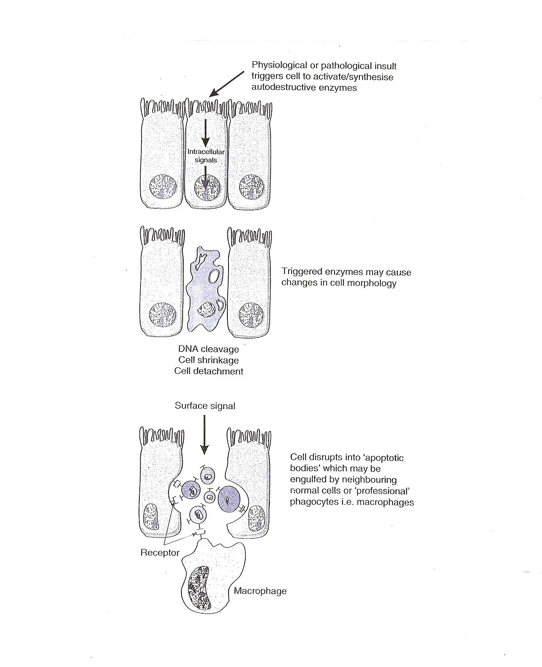
Necrosis

Necrosis is defined as the morphological changes that result from cell death within living tissues. In necrosis, death of a large number of cells in one area occurs, as opposed to the selective cell death of apoptosis. These changes occur because of digestion and denaturation of cellular proteins. In fact, the final appearance of the necrotic area will depend on the balance between these two processes. There are several forms of necrosis.

Diagrammatic comparison of necrosis and apoptosis
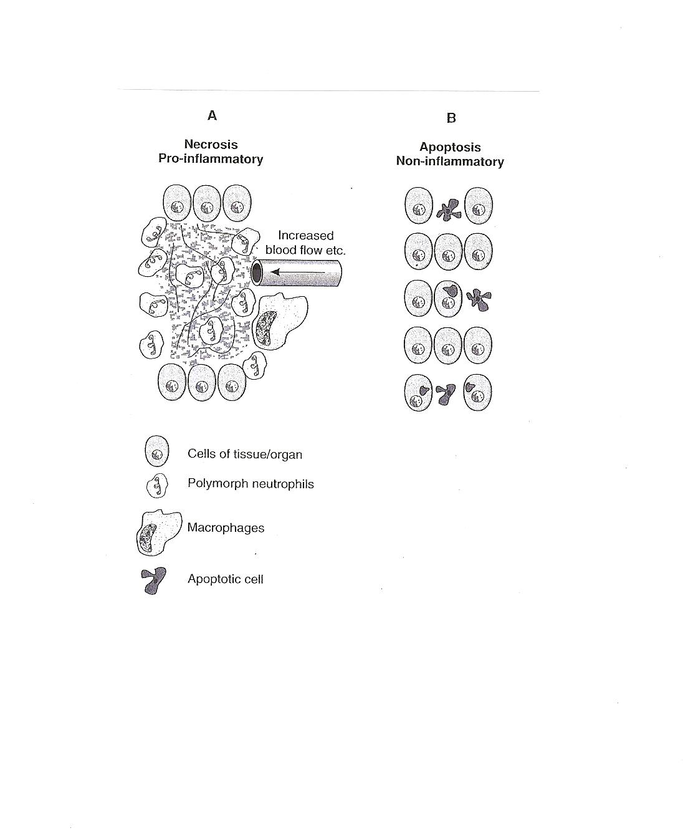
The results of cell death can include:
- Cessation of function of a tissue or organ.
- Release of cellular enzymes, these can sometimes be detected in the blood and used as markers of the extent or timing of damage to a particular organ, e.g. cardiac enzyme after myocardial infarction.
- Initiation of the inflammatory response (vital reaction).

Types of necrosis

There are five main types of necrosis:

- Coagulative
- Caseous
- Liquefaction
- Fat
- Gangrenous
Coagulative necrosis. Denaturation of intracellular protein (analogous to boiling the white of an egg) leads to the pale firm nature of the tissues affected. The cells show the microscopic features of cell death but the general architecture of the tissue and cell ghosts remain discernible for a short time. Coagulative necrosis is typically seen in the kidney and heart and is usually caused by ischaemia.
Caseous necrosis. This type of cell death is only seen in tuberculosis (TB). The creamy white appearance of the dead tissue is probably a result of the accumulation of partly digested waxy lipid cell wall components of the TB organisms. The tissue architecture is completely destroyed.
Liquefaction necrosis. This results from release of hydrolytic lysosomal enzymes and leads to an accumulation of semi-fluid tissue. It is usually seen in the brain.
Fat necrosis. This can result from direct trauma (common in the fatty tissues of the female breast) or enzyme released from the diseased pancreas. Adipocytes rupture and the released fat undergoes lipolysis catalyzed by lipases. Macrophages ingest the oily material and a giant cell inflammatory reaction may follow. Another consequence is the combination of calcium with the released fatty acids.
Gangrenous necrosis (gangrene). This life-threatening condition occurs when Coagulative necrosis of tissue is associated with superadded infection by putrefactive bacteria. These are usually anaerobic gram-positive Clostridia spp. Derived from the gut or soil which thrive in conditions of low oxygen tension. Gangrenous tissue is foul smelling and black. The bacteria produce toxins which destroy collagen and enable the infection to spread rapidly. If fermentation occurs, gas gangrene ensues and infection can become systemic (i.e. reach the bloodstream, septicaemia). The commonest clinical situation is gangrene of the lower limb caused by poor blood supply and superimposed bacterial infection. This is a life-threatening emergency and the limb should be amputated.
Degeneration
Nowadays, degeneration is used to describe pathological processes which result in deterioration (often with destruction) of tissues and organs. Therefore, osteoarthritis is an example of degenerative joint disease in which gradual destruction and deterioration of the bones and joint occurs. Alzheimer's disease is an example of a degenerative neurological disease where there is a progressive deterioration in brain function. Other pathological terms in skin and renal pathology imply degeneration of tissues. An example would be the UV-induced degeneration of the connective tissue in skin solar elastosis.
Accumulation
Cells may accumulate pigments or other substances as a result of a variety of different pathological or physiological processes. The accumulations can be classified as endogenous or exogenous.
Fatty change
Fatty change represents accumulation of triglyceride in cells and is usually an early indicator of cell stress and reversible injury. The most common cells in which fatty change is seen are in the liver, which has a central role in fat metabolism. Excessive alcohol consumption is a common cause of this, but there are other causes. In the liver, fatty accumulation occurs when cell damage compromises the ability of the hepatocyte to bind fat to protein and transport it through the cell. Fatty change is also seen in cardiac muscle cells as a result of severe anaemia or starvation (anorexia nervosa).

Haemosiderin
Haemosiderin is a golden yellow to brown pigment found in lysosomes within the cell cytoplasm. It is composed of aggregates of partially degraded ferritin, which is protein-covered ferric oxide and phosphate. When there is an excess of iron, e.g. when there is a breakdown of red blood cells or haemorrhage, haemosiderin accumulates in cells. It can be visualized using the Prussian blue reaction, when haemosiderin appears dark blue.
Primary haemochromatosis is an inherited disease in which there is excessive accumulation of iron and widespread deposition of haemosiderin in the tissues, especially the liver, pancreas and skin. The iron is toxic to the tissues and leads to fibrosis of the liver (cirrhosis) and pancreas (leading to diabetes mellitus).
Melanin
Melanin is the brown/black pigment which is normally present in the cytoplasm of cells in the basal cell layer of the epidermis, called melanocytes. Melanin is derived from tyrosine, stored in melanosomes and distributed to the other epidermal cells. The function of melanin is to block harmful UV rays from the epidermal nuclei. Melanin may accumulate in excessive quantities in benign or malignant melanocytic neoplasms and its presence is a useful diagnostic feature melanocytic lesions. In inflammatory skin lesions, where the epidermis is damaged, melanin may be released from injured basal cells and taken up by dermal macrophages. This gives rise to post-inflammatory pigmentation of the skin. Melanin can be identified in tissue sections by the use of the Masson-Fontana stain.
Lipofuscin
This is the yellow/brown "wear-and-tear" pigment seen in atrophic tissues, particularly in heart muscle.
Other pigments and dyes
Pigments and insoluble substances may enter the body from a variety of sources. They may be toxic and produce inflammatory tissue reactions or they may be relatively inert. Indian ink pigments produce effective tattoos because they are engulfed by dermal macrophages which become immobilized and permanently deposited. Inhaled substances such as coal dust and silica are engulfed by pulmonary macrophages. Although pure carbon is inert, silica and coal dust are toxic and ultimately cause serious lung fibrosis (pneumoconiosis).
Calcification
There are two main types of calcification:
- Dystrophic.
- Metastatic.

Dystrophic calcification

This type of calcification occurs within diseased tissues. The plasma calcium and phosphate levels are normal. The exact mechanism by which dystrophic calcification occurs is not known. The best examples include calcification within foci of old tuberculosis and in atheromatous plaques. In both these cases, the calcification can often be seen, incidentally, on radiographs.

Metastatic calcification

Metastatic calcification often occurs in normal tissues as a consequence of raised plasma calcium concentrations (hypercalcaemia). Common causes of hypercalcaemia include widespread metastatic cancer in the bones , hyperparathyroidism and multiple myeloma. Hypervitaminosis D (excess intake of vitamin D) may also cause hypercalcaemia.

Cellular adaptation

The normal growth and development of cells is under complex genetic and environmental control. Cellular adaptations, such as atrophy, hypertrophy and some types of hyperplasia remain controlled by normal mechanisms and are reversible.

The Four Main Types of Cell Adaptations
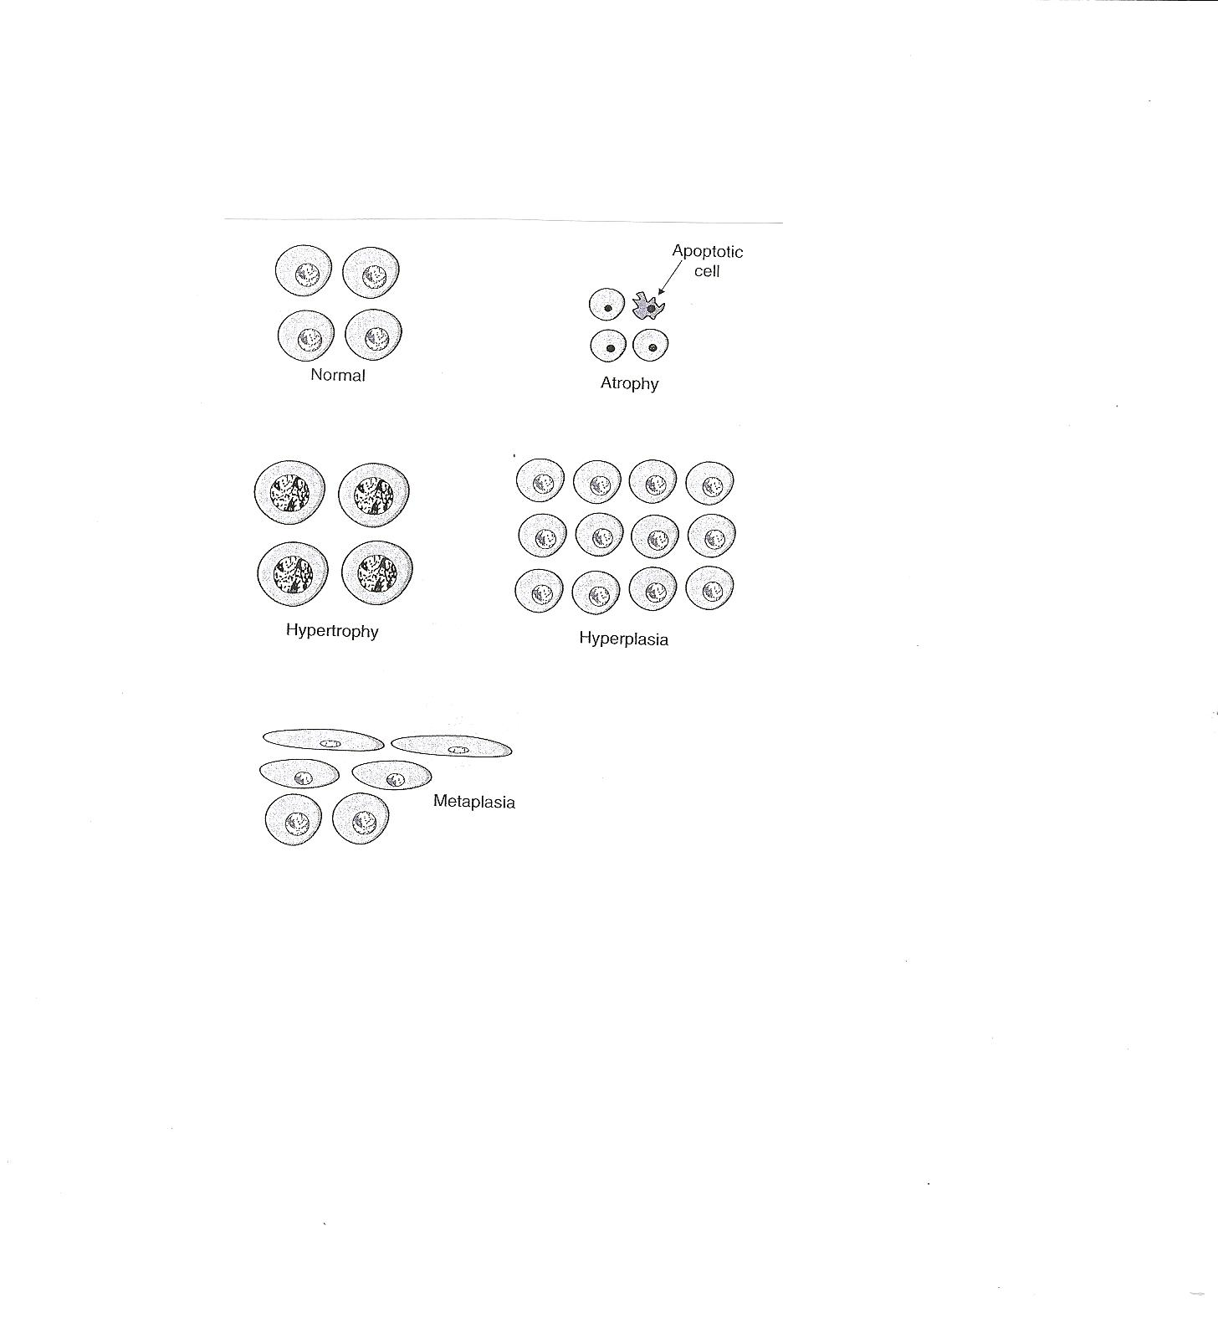
There are four main adaptive cellular states are:

- Atrophy: shrinkage of an organ as a result of decreased cell size (and cell number).
- Hypertrophy: enlargement of an organ as a result of increased cell size.
- Hyperplasia: enlargement of an organ through an increase in cell number.
- Metaplasia: the replacement of one differentiated cell type by another in a tissue or organ.

Atrophy

Atrophy is defined as the shrinkage of a cell by loss of the cell substance, which leads to a reduction in size of the whole organ. The cell retreats to a smaller size at which survival is still possible and sequesters its internal structures. In many cases of atrophy, individual cells may undergo apoptosis.

Physiological situations leading to atrophy:

- Reduction/loss of endocrine stimulation, e.g. shrinkage of testes and ovaries with age.

Pathological causes of atrophy:

- Denervation, e.g. wasting of muscle caused by a lack of nerve stimulation, for example in poliomyelitis.
- Reduced blood supply, e.g. shrinkage of brain caused by atherosclerosis of carotid arteries.
- Inadequate nutrition, e.g. wasting of muscles and major organs in starvation.
- Decreased workload (disuse) e.g. wasting of muscles and bone (osteoporosis) after immobilization of a bone fracture in a plaster cast.

Cell structural components are reduced in atrophy:

- Less mitochondria.
- Less endoplasmic reticulum.
- Fewer myofilaments.
The metabolic rate is reduced:
- Less amino acid uptake.
- Less oxygen consumption.
- Less protein synthesis.
In atrophy, there is an increase in the number of autophagic vacuoles (intracellular dustbins) which contain fragments of intracellular debris awaiting destruction. Lipofuscin granules are yellow/brown in color and represent non-digestible fragments of lipids and phospholipids combined with protein within autophagic vacuoles. They are commonly seen in ageing liver and myocardial cells.

Hypertrophy
Bodybuilders and athletes provide the best example of hypertrophy: muscle hypertrophy in response to increased workload. Individual cells increase in size as a result of an increase in their structural components leading to an overall increase in the size of the organ. Protein synthesis increases and its effect is enhanced by a decrease in protein degradation. Hypertrophy is mainly seen in cells which have no capacity for mitotic division, e.g. cardiac and skeletal muscle cells (permanent cells). The limiting factor for the eventual muscle size is the nutrient and blood supply available for oxidative phosphorylation.
Physiological causes of hypertrophy:
- Increased workload, e.g. the bodybuilder's skeletal muscle.
- Hormone stimulation, e.g. the pregnant uterus (smooth muscle hypertrophy).
Pathological causes of hypertrophy:
- Increased resistance e.g. cardiac muscle hypertrophy as a result of working against an increased peripheral resistance in hypertension (high blood pressure).
- Physical obstruction, e.g. bladder smooth muscle hypertrophy in outflow obstruction caused by an enlarged prostate gland.
Muscle cells
Hypertrophic muscle cells show:
- Increased membrane synthesis.
- Increased amounts of ATP.
- Increased enzyme activity.
- Increased myofilaments.
Endoplasmic reticulum
Hypertrophy of smooth endoplasmic reticulum, i.e. hypertrophy at the subcellular level, can also occur. Drugs such as phenobarbatone cause an increase in the activity of the mixed function oxidase system of liver cells, which results in increased metabolism of other agents. In some instances, this is therapeutically beneficial, in others, it can lead to poisoning of the liver cells by toxic metabolites.
Hyperplasia
Enlarged, hyperplastic tissues or organs show an increase in the number of their constituent cells. Tissues such as skin, gut epithelium and bone marrow normally have a high rate of cell turnover and are, therefore, the common sites for hyperplastic growth. Cardiac and skeletal muscle and neurons cannot undergo hyperplasia because they are permanent cells and cannot enter the cell cycle. Endocrine organs often undergo hyperplasia in response to excessive hormonal stimulation.
Physiological causes of hyperplasia:
- Hormonal, e.g. the female breast at puberty, the pregnant uterus and the proliferative endometrium in the first half of the menstrual cycle.
- Cell loss, e.g. regeneration of the liver after partial hepatectomy and regeneration of squamous epithelium in superficial skin wound healing.

Pathological causes of hyperplasia:

- Hormonal e.g. the endometrium in post-menopausal women taking estrogen-only hormone replacement therapy.
- Cell destruction e.g. ulcerative colitis the colonic mucosa undergoes repeated ulceration (destruction), regeneration and hyperplasia.
Pathological hyperplasia usually occurs in tissues which are exposed to inappropriate hormonal stimulation or to repeated episodes of inflammation, destruction and regeneration. It may progress to uncontrolled cell growth (Neoplasia), or it may remain a reversible phenomenon. Since most tissues contain labile and stable and permanent cells, hyperplasia without hypertrophy is uncommon.
Metaplasia
This is usually seen in epithelial tissues and is a reversible change in which one differentiated, adult cell type is replaced by another. The most common type of metaplasia is the replacement of glandular or transitional epithelium by simpler and more robust squamous epithelium. Examples of this are:
- Bronchial (pseudo-stratified, ciliated columnar) epithelium changes to squamous epithelium in smokers.
- Transitional bladder epithelium changes to squamous epithelium in people with bladder stones and infection.

Metaplasia probably occurs at the level of the stem cell, which differentiates into the new type of epithelium. Metaplasia is often seen next to neoplastic epithelium, indicating that although this adaptive response is potentially reversible, continued insult to the cells may cause uncontrolled growth and the development of cancer.

