BLOOD PRACTICAL – 1
COMPLETE BLOOD COUNT

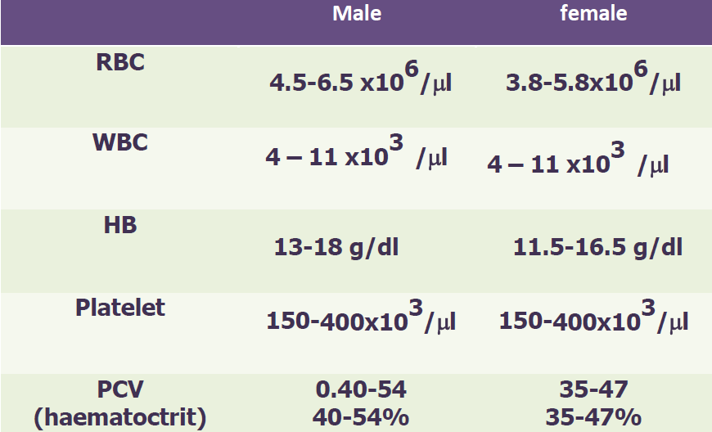

CALCULATION OF RED BLOOD CELL INDICES
- MEAN CELL VOLUME (MCV)
This is the volume of an average red blood cell measured in femtoliters (fl).
$$MCV=Packed Cell Volume x\frac{10}{RBC Count}$$
MCV of a normal person ranges from 78 – 98 fl.
If MCV is low, it means that red blood cells are small in size and they are called microcytes. But if MCV is high, it means that red blood cells are large in size and they are called macrocytes.
- MEAN CELL HEMOGLOBIN (MCH)
This is the weight of hemoglobin in an average red blood cell measured in picograms (pg).
$$MCH=Hemoglobin Concentration x\frac{10}{RBC Count}$$
MCH of a normal person ranges from 27 – 32 pg.
High value of MCH tell us that red blood cells are hyperchromic and low value of MCH will be seen if red blood cells are hypochromic.
- MEAN CELL HEMOGLOBIN CONCENTRATION (MCHC)
This is the concentration of hemoglobin per 100 ml of red blood cell measured in grams/deciliters (g/dl).
$$MCHC=Hemoglobin Concentration x\frac{100}{Packed Cell Volume}$$
MCHC of a normal person ranges from 32 – 36 g/dl.
Value of MCHC below normal suggests Iron deficiency Anemia.

Classification of anemia
✓ Macrocytic means:-
- The RBCs are larger than normal
- MCV is higher than normal
✓ Microcytic means :-
- The RBCs are smaller than normal
- MCV is lower than normal
✓ Hypocromic means :-
- Less hemoglobin in each RBC
- MCH , MCHC are lower than normal
 Macrocytic hypochromic anaemia due to vitamin B12,folic acid deficiency
 Microcytic hypochromic anaemia due to iron deficiency
If the MCV is higher than normal MCH,MCHC are normal and the it called is normal (Macrocytic normochromic anemia)
IMPORTANT TERMINOLOGY
POLYCYTHEMIA: Increased red blood cell count above normal.
ANAEMIA: Reduced ability of blood to carry Oxygen due to either decreased red blood cell count and/or hemoglobin concentration.
LEUCOCYTOSIS: Increased white blood cell count above normal.
LEUCOPENIA: Decreased white blood cell count below normal.
THROMBOCYTOSIS: Increased platelets count above normal.
THROMBOCYTOPENIA: Decreased platelets count below normal.

QUESTIONS AND PROBLEMS
- What is the clinical importance of knowing the red blood cell indices?
They help to determine the type of anemia a patient is suffering from.
- Discuss briefly the etiological classification of Anemia?
TYPE OF ANEMIA | CAUSE
Hemorrhagic Anemia | loss of blood
Aplastic Anemia | Bone marrow suppression by drugs or radiations etc.
Nutritional Anemias | Deficiency of Iron, folic acid, Vitamin B12
Hemolytic Anemia | Increased destruction of RBCs such as sickle cell disease

- An examination of the blood of 2 adult males (A and B) provided the following data:
SUBJECT “A” SUBJECT “B”
RBC COUNT 3.6 X 10⁶ / mm³ 2.5 X 10⁶ / mm³
Hb Concentration 7.2 g/dl 8 g/dl
Packed Cell Volume 25% 25%
- Calculate MCV, MCH and MCHC for each of these subjects.
SUBJECT “A” | SUBJECT “B”
MCV = 25 x 10 /3.6 = 69.4 fl  MCH = 7.2 x 10 / 3.6 = 20 pg  MCHC = 7.2 x 100 / 25 = 28.8 g/dl | MCV = 25 x 10 /2.5 = 100 fl  MCH = 8 x 10 / 2.5 = 32 pg  MCHC = 8 x 100 / 25 = 32 g/dl

- What are the abnormalities encountered in these men. What are the possible causes of these abnormalities?
Subject “A” Microcytic hypochromic anemia (Iron deficiency anemia)
Subject “B” Macrocytic normochromic anemia (Megaloblastic anemia or Pernicious anemia)
ERYTHROCYTE SEDIMENTATION RATE (E.S.R.)
.
- What is the clinical significance of E.S.R.?
- This is a non-specific indicator of presence of a disease.
- This is a useful prognostic tool.

- What conditions are associated with an increased E.S.R.?
- Infections
- Connective tissue disorders
- Inflammatory disorders
- Malignancies
- Anemia
- Pregnancy

BLOOD PRACTICAL – 2
DIFFERENTIAL LEUCOCYTE COUNT
.

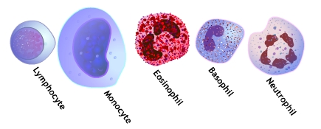
QUESTIONS AND PROBLEMS
- Describe the histological features of different types of white blood cells?
Neutrophils:
Eosinophils:
Basophils:
Lymphocytes:
Monocytes:
- What are the normal values of each different type of white blood cells?
NEUTROPHILS 50 – 70 %
EOSINOPHILS 1 – 3 %
BASOPHILS 0.4 – 1 %
MONOCYTES 4 – 6 %
LYMPHOCYTE 25 – 35 %
- Under what conditions are the percentages of the various types of white blood cells increased?
NEUTROPHILS will increase in acute bacterial or fungal infections.
EOSINOPHILS will increases in parasitic infections and allergies.
BASOPHILS will increase in allergies and malignancies.
MONOCYTES will increase in chronic infections.
LYMPHOCYTE will increase in acute viral infections and malignancies.

BLOOD PRACTICAL – 3
BLOOD GROUPS, BLEEDING & CLOTTING TIME

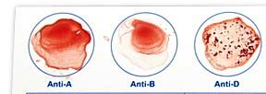 O +ve

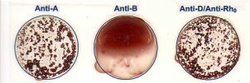 A +ve

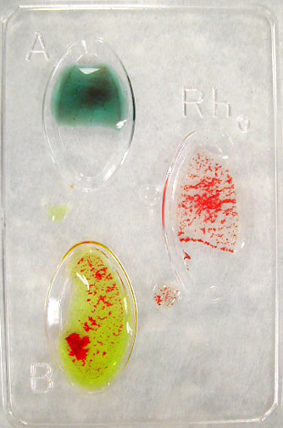 B+ve

QUESTIONS AND PROBLEMS
- What are the agglutinogens and agglutinins found in people with different blood groups in ABO system?

BLOOD GROUP | AGGLUTINOGENS | AGGLUTININS
A | A | Anti – B antibodies
B | B | Anti – A antibodies
AB | A, B | No antibodies
O | No Antigens | Both Anti-A and Anti-B antibodies

- How the different blood groups can donate or receive blood among them during blood transfusion?

Blood Group | Can give blood to | Can receive blood from
AB ⁺ | AB⁺ | All blood groups
AB ⁻ | AB⁻, AB⁺ | AB⁻, A⁻, B⁻, 0⁻
A⁺ | A⁺, AB⁺ | A⁺, A⁻, 0⁺, 0⁻
A ⁻ | A⁻, A⁺, AB⁻, AB⁺ | A⁻, 0⁻
B⁺ | B⁺, AB⁺ | B⁺, B⁻, 0⁺, 0⁻
B⁻ | B⁻, B⁺, AB⁻, AB⁺ | B⁻, 0⁻
0⁺ | 0⁺, A⁺, B⁺, AB⁺ | 0⁺, 0⁻
0 ⁻ | All blood groups | 0⁻

- What is hemolytic disease of the newborn?
Hemolytic disease of the newborn (HDN) is a blood disorder in a fetus or newborn infant. HDN may develop when a mother and her unborn baby have different blood types (called "incompatibility"). The mother produces substances called antibodies that attack the developing baby's red blood cells. The most common form of HDN is ABO incompatibility, which is usually not very severe. The least common form is Rh incompatibility, which can almost always be prevented. When this form does occur, it can cause very severe anemia in the baby.
- Under what circumstances can Rh incompatibility develop and how?

باختصار اذا الام سالب والولد موجب تصير هالمشكلة
Rh incompatibility is a condition that develops when a pregnant woman has Rh-negative blood and the baby in her womb has Rh-positive blood inherited from the Rh-positive father.
During pregnancy, red blood cells from the unborn baby can cross into the mother's bloodstream through the placenta. Because the mother is Rh-negative, her immune system treats Rh-positive fetal cells as if they were a foreign substance and makes antibodies against the fetal blood cells. These anti-Rh antibodies may cross back through the placenta into the developing baby and destroy the baby's circulating red blood cells. When red blood cells are broken down, they make bilirubin. This causes an infant to become jaundiced. Because it takes time for the mother to develop antibodies, firstborn infants are often not affected unless the mother had past miscarriages or abortions that sensitized her immune system. However, all children she has afterwards who are also Rh-positive may be affected.

- How it is treated?

Infants with severe Rh incompatibility may be treated with exchange transfusion after birth or intrauterine transfusion before birth.

- How it is prevented?
Special immune globulins, called RhoGAM (anti-D antibodies), are used to prevent RH incompatibility in mothers who are Rh-negative. If the father of the infant is Rh-positive or if his blood type cannot be confirmed, the mother is given an injection of RhoGAM during the second trimester. If the baby is Rh-positive, the mother will get a second injection within a few days after delivery.
These injections prevent the development of antibodies against Rh-positive blood.

QUESTIONS AND PROBLEMS
- What is the normal range of clotting time?
3 – 10 minutes
- What are the clinical conditions in which the clotting time is greater than normal?
Hemophilia due to deficiency in factor viii and ix
QUESTIONS AND PROBLEMS
- What is the normal range of bleeding time?
2 – 5 minutes
- Which blood cells deficiency may prolong the bleeding time?
Platelets
- Name one condition in which bleeding time is prolonged (increased)?
Thrombocytopenia

