Pharmacology L#6: DRUGS USED IN GOUT

Introduction:
Note: it is a good idea to study the purine metabolism lecture in biochemistry before going through the pharmacology.
Gout is a metabolic disease where there are recurrent episodes of acute arthritis. This is due the deposition of monosodium urate crystals in joints and cartilage. Gout is associated with hyperuricemia ( elevated uric acid in blood).
To understand the types of drugs used in gout we must have an idea about the stages of this pathologic condition (try to understand the stages rather that memorizing them):
- Assymptomatic tissue deposition: in this stage the uric acid in the blood starts depositing in the joint, but there are no symptoms or inflammation.
- Accute attacks: in this stage, monosodium urate crystals are phagocytosed and the patient suffers from acute inflammation.
- Intercritical segments: after the acute inflammation has stopped, the patient is fine but the problem is that most patients get other attacks soon ( 6- 24 months usually)
- Chronic gout: the difference between this stage and the intercritical stage is that the patient here has got many attacks that have caused damage to the joint, which causes arthritis.

Overview of the drugs used in gout

The drugs that are used in gout could be arranged into two groups:
- Drugs that are used in the acute attacks: these drugs basically aim on stopping the inflammation and releaving the patient’s symptoms.
- Drugs that are used in chronic gout or the time between the acute attacks: these drugs aim to decrease the blood’s uric acid levels to prevent monosodium urate crystals deposition in joint, and hence to prevent other attacks.
How can we decrease the blood’s uric acid?
- Change the diet by (for example) decreasing meat consumption.
- Decrease uric acid production (Xanthene Oxidase inhibitors)
- Increase the rate of excretion of uric acid (Uricosuric drugs & Uricases)
With this background we can go into the details of the lecture and talk about the different drugs used in gout.

Acute gout attacks management

Colchicine

Colchicine is a plant alkaloid that has been used for a long time to treat gouty arthritis, so it is specific for gout.
Mechanism of Action: (look at the figure while reading this):
Colchicine binds to the tubulin protein. Normally, many pieces of the tubulin protein come together (polymerized) and create microtubules. Microtubules help the leukocytes in walking and phagocytosis; so colchicine will stop the migrating and phagocytosis of the nuetrophils and macrophages. This will help in stopping the inflammation. In addition, colchecine inhibits the formation of leukotrienes and TNF- alpha.
Side effects:
We must appreciate the fact that colchicine affects cell mitosis, and the cells that divide a lot are going to be affected.
How does it affect mitosis? Tubulin protein creates microtubules as we discussed and these microtubules are important for mitosis as they create the spindle fibers and the cytoskeleton of the new cells.
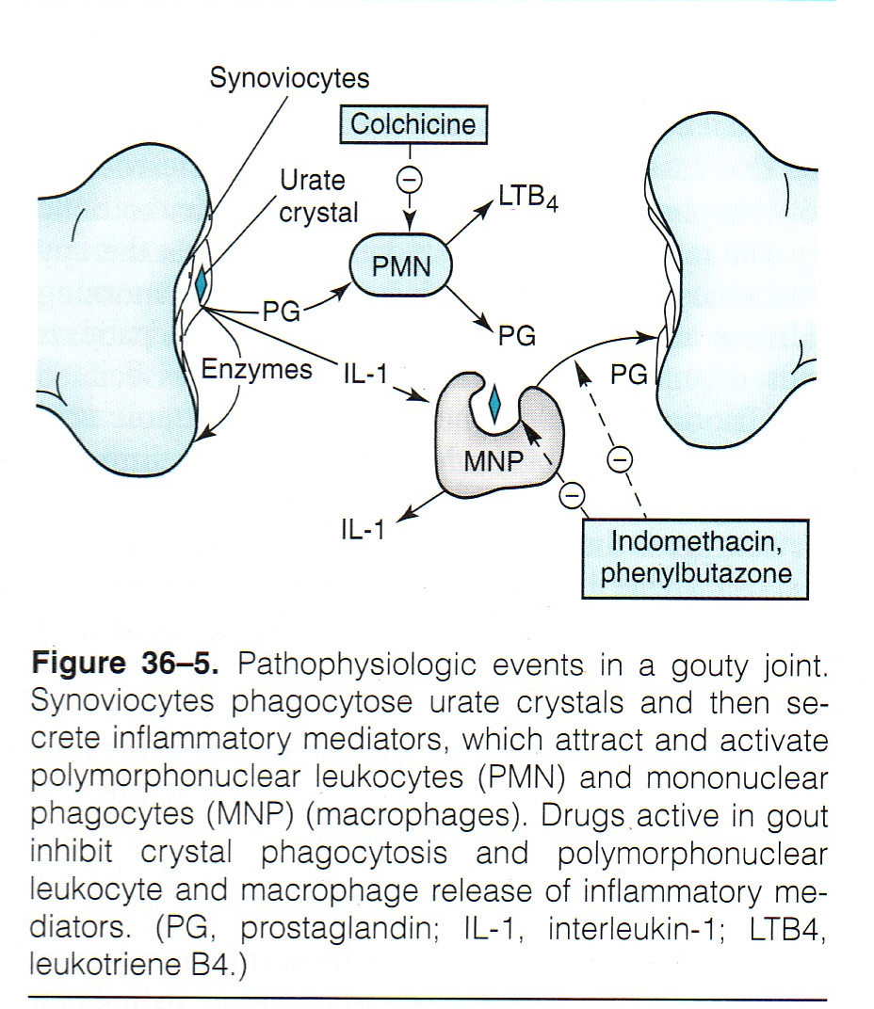

Side effects of colchicine:
1) Severe diarrhea: there are stem cells in the GI (which divide a lot), and since colchicine is given orally, these cells are very much affected and this causes diarrhea.
2) Alopecia (hair loss) & Bone marrow suppression: both are for the same reason. Note that these happen with chronic use of colchicine.
3) CNS depression, burning pain in the throat and bloody diarrhea are all side effects of acute intoxication (over dose)
Contraindications: Colchicine isn’t given in patients with GI diseases, renal impairments, hepatitis, or during pregnancy.

Note:
- Notice from the mechanism of action that this drug has NO analgesic effect; it does not work as NSAIDs.
- It is also used, in small doses, in the intercritical segments (between the attacks), as it has proved to decrease the risk of other attacks.
As we have mentioned, colchicine has been used for a very long time, but since we don’t want the patient to stay in the toilet the whole day (because the drug’s side effects), some other drugs were used to manage acute gout attacks, such as NSAIDs.

NSAIDs

NSAIDs are now the first choice in acute gout attacks.
Mechanism of action:
- Inhibit inflammation and pain.
- Inhibit urate crystals phagocytosis
- Recall from the NSAIDs lecture that paracetamol works centrally and therefore it is not used in gout.
Aspirin: In low doses, aspirin competes with uric acid on excretion and may cause gout. However, it is used to treat chronic gout but in large doses because in large doses, it increases the excretion.

Corticosteroids

Steroids stop the inflammation but because they have lots of side effects, they are only used in severe cases.

Prevention of recurrent attacks

Now we move to the other group of drugs which are used in between the attacks and they lower the risk of new attacks. These drugs are used to lower the blood’s uric acid levels; and this is done by decreasing the synthesis of uric acid or increasing the excretion of uric acid.
Note that some foods effect uric acid levels and we shall mention them quickly because they are not important as we are studying pharmacology: red meats, alcohol, and seafood should be avoided.
Before starting this section, we should go through the conditions that may cause hyperuricemia:
- Large cell turnover: in cancer patients receiving chemotherapy.
- Patients with impaired renal function: kidneys can’t excrete the uric acid.
- Remember that most cases of hyperuricemia are idiopathic (unknown cause)

Decrease Uric Acid production: Xanthine Oxidase Inhibitors

Purines Hypoxanthine Xanthene Uric Acid (these arrows in red are done by Xanthene Oxidase)
When XO is blocked, Hypoxanthene and Xanthene are removed by the kidneys and uric acid is not formed.

Allopurinol

Pharmacokinetics: It is metabolized by the liver (by Xanthene Oxidase) and then switched to its active form, which is called oxypurinol. So it inhibits what activated it. وكم علمته الرماية فلما إشتد ساعده رماني
Side effects: exacerbate (worsen) acute gout attacks, diarrhea, maculopopular skin rash, nausea, fever, and headache.
Drug interactions:
Remember from the foundation block that xanthene oxidase has other functions in the liver such as metabolizing other drugs. If XO was blocked, some drugs will bnot be metabolized and will be active for a longer time:
- 6- mercarptopurine & azathioprine (anti-cancer medications): the drug dose should be decreased.
- Warfarin: warfarin is an anticoagulant, and its dose should be decreased as well
- Ampicillin: increases the frequency of skin rashes (ampicillin is an antibiotic)

Febuxostat
Memory aid:
Fubuxostat:
XO: Xanthene Oxidase
Stat: as in static: inhibitor.
Side effects:
- Increased number of acute gout attacks in the beginning.
- Elevates liver enzyme: because it is metabolized by the liver.
- Headache, nausea, diarrhea, and numbness of arms and legs.
Allopurinol vs Fubuxostat:
Allopurinol | Febuxostat
Metabolized by XO to its active form: that is why it is called Purine XO inhibitor | Not activated by XO: non-Purine XO inhibitor
Febuxostat is safer for kidney impaired patients as it is metabolized by the liver.
Skin rash as a side effect | Ususally no skin rash

Uricosuric drugs: increase uric acid excretion

These drugs include probenecid & sulfinpyrazone. As we mentioned earlier, asprin – at high doses- could act like these drugs.
Mechanism of action: These drugs block the active transport of uric acid in the proximal tubules of the kidney. Patients should consume lots of liquids and keep the urine at alkaline pH to increase uric acid excretion.
Drug reactions: Probenecid prolongs the effect of antibiotics such as penicillin. Why? http://www.youtube.com/watch?v=YYE7yrIqsPg’
Probenecid also causes nephritic syndrome where the kidney releases proteins in the urine and this causes edema.
Contraindications (when not to prescribe these drugs):
- UT stones and impaired renal function
- Recent gout attacks
- When low doses of aspirin are used
Adverse effects:
- Could cause recurrent acute gout attacks
- Risk of uric acid stones: because the urine is saturated with uric acid. The patient should drink lots of water to avoid this.
- GIT upset & allergic rash

Uricase Enzymes: Increase Uric acid excretion
Memory aid: Pegloticase
This drug is modified from mammalian uricase enzyme.
Peg= pic= mammal= mammalian enzyme= modified uricase.

Pegloticase

This drug breaks down uric acid into allantoin which is easier to excrete.
Usually the last choice for management of gout and it is given intravenously (IV).
Note: When other drugs do not work in treating gout, we call it refractory gout.
Side effects:
- Anaphylaxis
- Infusion reaction (due to IV)
- Gout flare
- Nephrolithiases (kidney stones)
- Headache
- Arthralgia (joint pain), and muscle spasm.

Wish you the BEST of luck
Done by: Mohammad AlKharraz

