DIURESIS PRACTICAL
OBJECTIVES:
- To measure the volumes and determine the compositions of urine excreted by volunteers who have:
  - Taken no fluids for several hours (fasting or control subjects).
  - Drunken 1 liter of water.
  - Drunken 1 liter of isotonic saline.
  - Taken 1 tablet of Lasix 40 mg (a diuretic drug).

- To be able to discuss the mechanisms by which the body:
  - Conserves fluids and sodium if neither food nor water is taken.
  - Excretes more water when extracellular fluids are diluted by the ingestion of water.
  - Slowly eliminates sodium and water when the extracellular fluid volume is increased without altering its osmolality.
  - Excretes large quantities of both water and sodium after taking Lasix tablet.
METHODS AND OBSERVATIONS:
Several students have volunteered to take an active part in this practical class. None of them have taken fluids or food after 8:00 am.
- THOSE ACTING AS CONTROLS (TAKING NO FLUIDS):

  - Emptied their bladders at 8:00 am and discarded the urine.
  - From 8:00 they are restricted to take any fluids and they are asked to provide various urine samples for analysis at 10:00 am, 12:00 noon, 2:00 pm and 3:00 pm.
We will find in these subjects that each subsequent urine sample is lesser in volume and darker yellow in color that shows the kidneys try to conserve water in fasting state.

- THOSE DRINKING 1 LITER OF WATER

  - Emptied their bladder at 10:00 am and discarded the urine.
  - At 12:00 noon emptied their bladder again, but this time they measured its volume and provided a sample for analysis. This sample will be pre-experimental sample.
  - Drank 1 liter of water immediately after providing the pre-experimental sample.
  - Were then asked to empty their bladders and provide post-experimental samples every half an hour after drinking water until 3:00 pm.
We will find in these subjects that urine volume will be about the same in the first post-experimental sample as of the pre-experimental sample, but then will increase dramatically in the subsequent samples and will again decrease back to the level of pre-experimental sample in the last samples. It means that the healthy kidneys get rid of this 1 liter of water ingested by these volunteers in 3 hours and the mechanism starts after 30 minutes, as shown by the following graph:

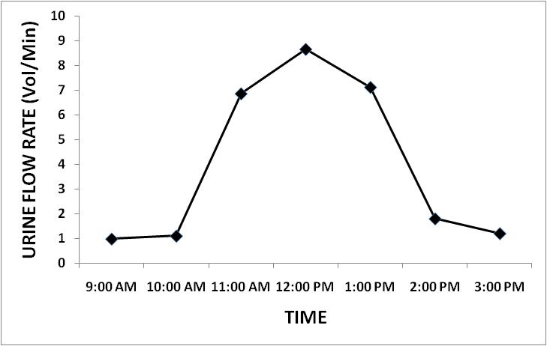

However sodium excretion in these volunteers will remain constant as shown by the following graph:
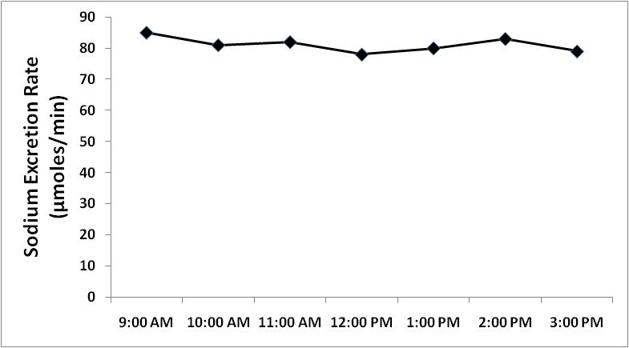

- THOSE DRINKING 1 LITER OF ISOTONIC SALINE

  - Emptied their bladder at 7:00 am and discarded the urine.
  - At 9:00 am emptied their bladder again, but this time they measured its volume and provided a sample for analysis. This sample will be pre-experimental sample.
  - Drank 1 liter of 0.9% saline (isotonic saline) immediately after providing the pre-experimental sample.
  - Were then asked to empty their bladders and provide post-experimental samples every hour after drinking saline until 3:00 pm.
We will find in these subjects that urine volume and osmolality will remain slightly increased in the post-experimental samples as compared to pre-experimental samples. It means that the kidneys are trying to get rid of this extra sodium chloride and water that has been ingested by these volunteers, but slowly. As a matter of fact, it will take 24 hours to excrete 1 liter of isotonic saline ingested by them. You can see the slightly increased urine volume and sodium excretion in the following graphs:
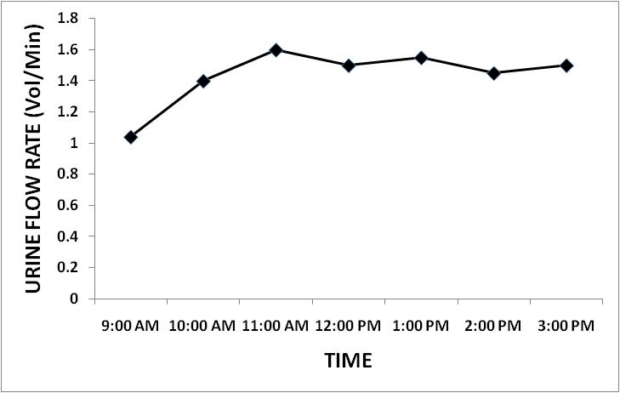
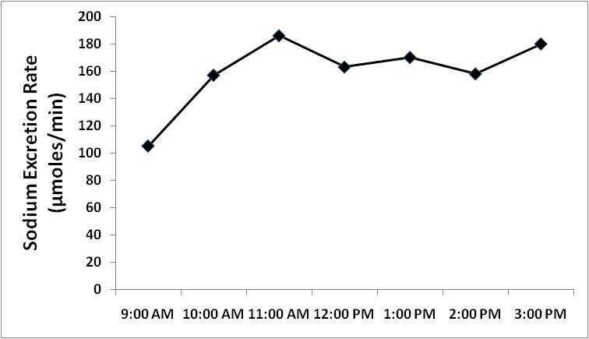
- THOSE TAKING 1 TABLET OF LASIX

  - Emptied their bladder at 8:00 am and discarded the urine.
  - At 10:00 am emptied their bladder again, but this time they measured its volume and provided a sample for analysis. This sample will be pre-experimental sample.
  - Swallowed a Lasix (Furosemide) tablet 40 mg with the help of 25 ml of water immediately after providing the pre-experimental sample.
  - Were then asked to empty their bladders and provide post-experimental samples every hour after taking Lasix until 12:00 noon and then every half an hour until 3:00 pm.

We will find in these subjects that urine volume and osmolality dramatically increased after 1 hour of taking Lasix tablet and remained increased for further duration of experiment. What we know about the effect of Lasix is that it usually starts 1-2 hours after ingesting it and lasts for 4-6 hours. Because in this experiment both urine volume and osmolality will increase, this type of dieresis is called OSMOTIC DIURESIS, while the diuresis that occurred in those subjects who drank water is called WATER DIURESIS, as the increase in the urine volume was not accompanied by simultaneous increase in urine osmolality in those subjects. You can see the changes in urine volume and sodium excretion in these subjects taking Lasix tablet in the following graphs:

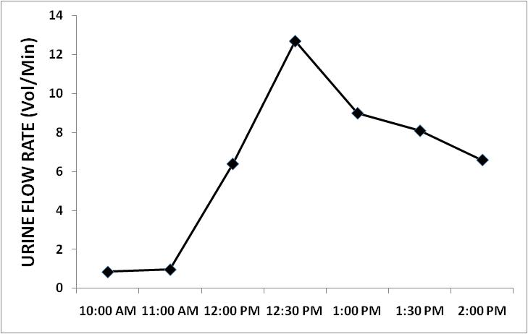

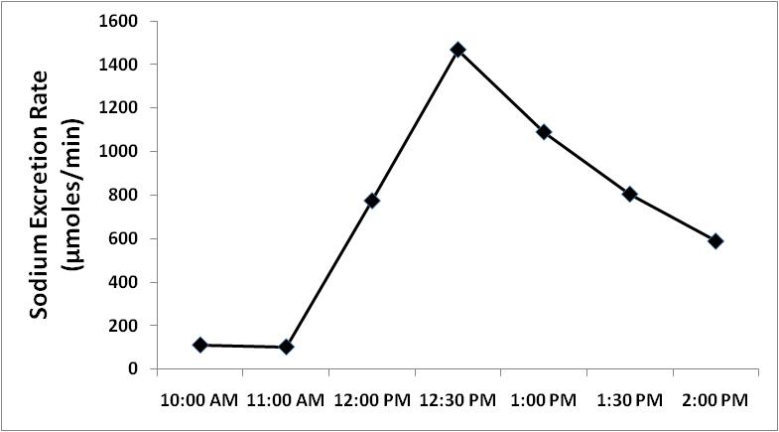

The following is a sample table that we fill out during these experiments:
SAMPLE NO. | 1 | 2 | 3 | 4 | 5 | 6 | 7
COLLECTION TIME  (minutes) | 120 | 30 | 30 | 30 | 30 | 30 | 30
VOLUME OF URINE  (ml) | 118 | 33 | 200 | 280 | 240 | 60 | 50
URINE FLOW RATE  (ml / min) | 0.98 | 1.1 | 6.66 | 9.33 | 8 | 2 | 1.66
SODIUM CONCENTRATION  (mmoles/liter) | 87 | 65 | 12 | 10 | 8 | 30 | 40
TOTAL SODIUM EXCRETION  (mmoles) | 10.3 | 2.2 | 2.4 | 2.8 | 1.9 | 1.8 | 2.00
SODIUM EXCRETION RATE (µmoles/min) | 85.6 | 71.5 | 80 | 93.3 | 64 | 60 | 66.7

- The sample no.1 is the pre-experimental sample and the remaining samples are post-experimental samples.
- The sodium concentration is obtained by an analyzer machine which is called flame photometer.
- Total sodium excretion is obtained by applying following equation:
$$Sodium excretion=\frac{Sodium concentration x Volume of urine}{1000}$$
- Sodium excretion rate is obtained by applying the following equation:
$$Sodium excretion rate=\frac{Sodium concentration x Volume of urine}{Time}$$

- On the next page, you will find the results of actual experiments performed on 3 subjects who volunteered to drink 1 litre of water, 1 litre of isotonic saline and take 1 tablet of Lasix respectively.
- Then on the following pages are given the mechanisms by which the body responds to each stimulus given to these several volunteers.
