

**King Saud University**

**College of Medicine**

**Medical Education Department**

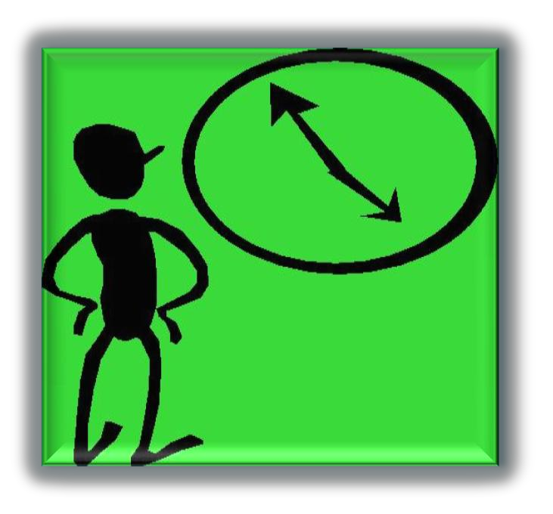

**Learning Skills**

**COURSE BOOK AND STUDENT GUIDE**

(Academic year 1437-1438)

***College of Medicine, King Saud University***

**Copyright Statement**

*This material is protected by copyright laws. For any other purposes other than teaching and*

*research in the King Saud University, no part may be reproduced or copied in any form or by any means without prior permission of the King Saud University.*

*© King Saud University, Saudi Arabia, 2013.*

**WELCOME ADDRESS**

***Dear Students,***

***We are pleased to welcome you in the college of Medicine, Learning Skills.***

***We hope you will find this course both useful and enjoyable.***

|  |  |  |
| --- | --- | --- |
| ***Contents*** | ***Topic*** | ***PageNO.*** |
| *1* | *Generalinformation* | *4* |
| *2* | Introductionandcoursedescription | *4* |
| 3 | Goals andObjectives ofthecourse | *5* |
| *4* | TeachingandLearningMethods | 5 |
| *5* | Contents andspecificobjectives | *6* |
| *6* | Assessmentofstudents &courseevaluation | *9* |
| *7* | *Recommendedresources* | *9* |
| *8* | *Appendix(portfolio)* | *11* |
| *9* | *Sessions Schedule* | *18* |

**GENERAL INFORMATION**

Course Title: Learning Skills

Course Code & Number: SKLL 101

Credit Hour: 2

Course Duration: Longitudinal over both semister

Course Dates: 19 September 2016 to the end of semester 2017

**Course Committee**

Dr. Hamza Abdulghani Chairman

Dr. Mahmoud Salah Member

Mr. Tauseef Ahmad Member

tauseefala@gmail.com

Ms. Ruqaiah Zabarah  Course Secretary

[maesimplys@yahoo.com](mailto:maesimplys@yahoo.com)

Tel : 4699170

**Introduction and course description:**

The learning skills are critical determinants of success in a learner-centered model. It is important for medical students to develop the sound of learning habits which will help them to successfullycontinue in their professional life. These habits include the identification of their learning needs,selection of what to learn as well as reflect on their learning experience. It is essential tofamiliarize students with the university environment and enable them reach to an optimum level ofthe attitude, knowledge and skill required for the profession.

This "learning skills" course aimed to facilitate the process of the transition of the students into

academic teaching and learning culture through specific learning skills and self motivation to

succeed in their academic studies.

**Goals and Objectives of the Learning Skills’ Course**

*By the end of the course the students must be able to:*

▪Be familiar with university, academic organization and student support systems.

▪Outline the educational approach at the College.

▪Utilize available resources effectively.

▪Identify principles of adult learning.

▪Identify different learning styles, and explain their own styles.

▪Improve skills of reading for understanding and comprehension.

▪Explain the concepts, principles and practice the process of learning in small group.

▪Explain group dynamics and behavior that affect the group process.

▪Create learning objectives that are reasonable and obtainable for his learning plan.

▪Take responsibility about their learning as an independent learner.

▪Enumerate the principles of evidence-based practice and demonstrate the skill of

information gathering and management.

▪Manage their time and set his priorities.

▪Communicate effectively with patients and their peers

▪Demonstrate professional behavior expected from medical students.

▪Recognize symptoms of stress and develop the ability to handle their stress and anxiety

appropriately.

▪Describe the different methods of self, peers, tutors and program evaluation.

**Teaching and Learning Modes:**

In an integrated curriculum like our curriculum, we use a wide range of teaching and learning

strategies to ensure that learning meets the different needs of the students. These strategies include:

•Small group discussion; role play, video presentation

•Tutorial/seminars

•Lectures/exercise

•Including learning portfolio which is a proved tool to help the students to integrate their

learning and increases the students’ responsibilit y for managing their own learning and

finding learning opportunities and developing their patents.

**Contents and specific objectives**

**A)Contents**

1.Orientation to curriculum content, regulation student support system and resource

utilization.

2.Rationales and principles of learning in a small group.

3.Process of problem/case-based learning. Role of a tutor and other group members

4.Introduction to evidence-based medicine and information gathering and management.

5.Deep v/s superficial learning.

6.Professional medical students.

7.Self-directed learning skills and construction of learning issues.

8.Learning skills in the class room.

9.Presentation skills.

10.Communication skills.

11.Time management.

12.Stress management.

13.Program evaluation and constructive feedback.

**B) Specific Objectives of each session:**

**Session-1: Orientation to Learning Skills course and other curriculum contents, regulation student support system and resource utilization.**

*By the end of the session the students should be able to:*

1. Get oriented and explore the content, teaching / learning and assessment methods of learning skills course.

2. Explore their expectation to participate in making the course more towards student-

centered

3.Demonstrate the understanding of the description, key topics and the main theme of the

course.

4.Explore and clarify their concerns about the courses.

5.Localize different facilities available for them like students' support system, library,

internet access, cafeteria and so forth.

6.Enumerate the different section in library which will help them in using library

7.Apply the searching abilities to search some topics or subject in medical data- base.

**Session-2: Blackboard training.**

*By the end of the session thestudents should be able to:*

1. Explore the content of Blackboard learning management system and it configuration
2. Enumerate the different uses of Blackboard.
3. Log on the system to look for its utilization.

**Session-3: Become a PBL Student Year 1**

*By the end of the session the students should be able to:*

1.Explain the rational of learning in a small group

2.Enumerate the principles of small group.

3.Explain the dynamic of small.

4.Identify their roles in a small group.

5.Demonstrate the ability to conduct their roles effectively.

6.Use communication skills effectively to maintain group dynamics.

7.Develop skills in working as a team.

**Session-4: Time Management:**

*By the end of the session the students should be able to:*

1.Identify the importance of TM

2.Plan our schedules effectively

3.Enumerate Time wasters

4.Identify procrastination signs & tackle it

**Session-5: Learning how to learn**

*By the end of the session the students should be able to:*

1.To define “Learning” & learning principles.

2.To compare and contrast undergraduate versus secondary school learning.

3.To identify different types of learning

4.To apply these learning principles to our daily learning activities

**Session-6: Introduction to Evidence-based Medicine (EBM)**

*By the end of the session the students should be able to:*

1.Demonstrates an understanding of evidence-based approach.

2.Use all research sources of EBM Database.

3.Differentiate between primary and secondary data sources.

4.Demonstrate the positive attitudes towards its application to daily clinical practice.

**Session 7:Stress Management**

*By the end of the session the students should be able to:*

1.Define stress

2.Identify the types of stress

3.Explain the mechanisms of stress

4.Identify the relation of stress and our health

5.Enumerate the stress management strategies

**Session-8: Introduction to Medical Search Using Medline**

*By the end of the session the students should be able to:*

1.Objectives of literature search

2.Methods of finding relevant literature?

3.Electronic Journals (Features/Advantages)

4.Database management (Reference Manager)

**Session-9: Professionalism & Ethics in Medical Education**

*By the end of the session the students should be able to:*

1.Define Professionalism.

2.Identify some professional & unprofessional behaviors.

3.Recognize as an important part of the curriculum.

**Session-10: Communication skills:**

*By the end of the session the students should be able to:*

1.Understand the principles of effective communication.

2.Differentiate between active and passive communication.

3.Demonstrate the ability to effectively use verbal, non-verbal communication and body

language.

4.Work with some scenarios/pre-recorded video of communication skills by analyzing and

giving comments and feedback.

5.Role play &/or record their own video in safe environment, in small group and give and

receive feedback by peers and tutors.

**Other Topics will be added as as tutorials:**

**Assessment of students & course evaluation:**

Introduction of learning portfolio at the beginning will be an important step for evaluation of

overall progress of students.

Assessment Methods and scores will be applied through Portfolio for time management and other assessment tools (see the guidelines in ***appendix 1***) in

Written Assignment 30% (Time Management)

Short Answer Questions 40% (for all topics)

Other assignments 30% for other topics

**Course Evaluation**

The course evaluation uses the following three data sources:

1.Student Feedback

2.Tutor Feedback

3.Student Results

**Recommended Resources:**

1. Abdulghani HA, A Al-Drees AA, S Khalil MS, Ahmad F,Ponnamperuma GG, Amin A. What Factors Determine Academic Achievement in High Achieving Undergraduate Medical Students: A Qualitative Study. Med Teach 2014, 36: S43–S48.
2. Schmidt HG: Foundations of problem-based learning: some explanatory notes. Medical

Education 27:422-432, 1993

1. Barr RD and Tagg J: From teaching to learning- a new paradigm for undergraduate

education. Change, Nov/Dec. 1995: 13-25 (also available online at

http://critical.tamucc.edu/-blalock/readings/tch2learn.htm)

1. Abbat&Abbat. Teaching for better learning. 29ndedition. 1992. WHO Publication.

ISBN:9241544422.

**ASSIGNMENTS**

**STUDY SKILLS**

**COURSE**

**“STUDENT PORTFOLIO GUIDE”**

**Dear Students,**

We hope that you enjoyed the “Foundation Block” in your first year of Medical College. You were also introduced to an interesting new course called “Learning Skills” in the first term and now we would like you to apply and assess yourself on the different topics which were taught. The assessment of this course (as it was discussed earlier) is about writing the “Portfolios”.

The purpose of the portfolios is to assess your understanding of the topic, how you apply it in practical life and what you learn from your reflection on it.

***What are portfolios?***

A portfolio is a collection of students work, which provides evidence of achievement of knowledge, skill, appropriate attitudes & professional growth, through a process of self-reflection over a period of time.

Reason for using portfolios for assessment purpose include the impact they have in driving student learning and their ability to measure outcomes such as professionalism that are difficult to assess using traditional methods

**The “learning skills” course include the following topics**

**1.** SMALL GROUP TEACHING AND LEARNING.

2. HOW TO LEARN: GENERAL PRINCIPLES

3. TIME MANAGEMENT

4. DR - PT COMMUNICATION SKILLS: GENERAL PRINCIPLES

5. STRESS MANAGEMENT

6. PROFESSIONALISM IN MEDICAL EDUCATION

7. INTRODUCTION TO MEDICAL SEARCH USING MED-LINE

8. INTRODUCTION TO EVIDENCE – BASED MEDICINE (EBM)

All the completed “Portfolio” assignments should be submitted in English using computer word processor.

1. You have to submit one portfolio assignment about “Time management”
2. The other topics will be assessed as short answer question. The idea is to apply these topics in your daily activities

The “Time Management” assignment has two parts:

a) Significance and your own understanding of the topic. It would include the introduction and the background of the topic.

b) Reflection and critical thinking on the subject. This part encompasses the practical aspects of the topic and you are required to elaborate with real life examples and personal experiences. How you have applied these skills in your real life.

1. The assignment should be around 500 words long.
2. The submission date for the assignment is 30th December 2016 or before.
3. Good quality, well written assignment is expected from you, which will help you get higher grades in the evaluation. Cut and past from internet is not allowed
4. It is recommended that you read the rubric (criteria for the assignments) on the next page that might help you in designing your portfolio.

**Rubric for portfolio entries**

|  |  |  |  |  |
| --- | --- | --- | --- | --- |
| **Grade** | **Presentation and Format** | **Contents and Teaching Philosophy** | | **Reflection/Critique** |
| Excellent | Portfolio contains a cover page with name and contact information, dividers are visible and readable along with the Table of contents | All required items are included with a significant number of additions. The student is able to describe an educational vision about the topic with a clear philosophy. No grammatical or spelling errors. | | * The student is able to give relevant examples from his/her own experience and how they have improved their work/learning based on the learning of the topic. * The student has also given concrete evidence of application of the gained knowledge, from their own experience. * Reflections illustrate the ability to effectively critique work and to suggest constructive practical alternatives. |
| * Very Good | Portfolio contains a cover page with name and contact information but with an incomplete table of contents. | All required items are included with a few additions; the student is not able to explain his philosophy clearly about the topic adequately. And there are a few grammatical/spelling errors | | * The student has given relevant examples from his/her practical life and has explained the application of that example too with some evidence. * Reflection illustrates the ability to critique work and to suggest constructive practical alternative. |
| * Good | Portfolio contains a cover page but lacks clarity and some elements are missing. | All required items are included but no additions. Vague philosophy about the topic presented. Many grammatical /spelling errors | * The student has given relevant examples from his/her practical life but is unable to explain the application of that example properly with incomplete evidence of application of knowledge. * Reflections illustrate an attempt to critique work and to suggest alternative. | |
| * Poor | The cover page is missing and there is no table of contents | A significant number of required items are missing. The student has not presented his/her own philosophy about the topic. Numerous grammatical/spelling errors. | * Student has given irrelevant/remotely relevant examples. And absolutely no evidence of application of the knowledge gained. * Reflection illustrates a minimal ability to critique work. | |

**TOPIC -: TIME MANAGEMENT**

**Presenters: Dr. Sahmood salah**

**Dr. Sahar**

**Themes of the topic:**

1. Importance of time management.
2. Time wasters.
3. Planning our schedule effectively.
4. Procrastination identification and tackling.

**TASK:**

**The assignment is on “Time management” and the objective of this assignment is to assess your “time management” skills.**

1. You are required to prepare a one week comprehensive schedule of a first year medical student, from a Saturday to a Friday. Hence make a timetable which should include the time spent at the college as well as the after-college hours.
2. Reflect on the experience and write what you have learnt from making a timetable and then applying it. You can also mention the things that went well and what you would have changed if you were given another chance.