الرجوع للعمل وحده لا يغني عن الرجوع للمصادر الأساسية

Introduction to Pathology

Objectives:
- Understands the role of pathology and its various subspecialties in the diagnostic process with special emphasis on histopathology and cytology.
- Understands the meaning of the terminology used during the study of disease like etiology, pathogenesis, prognosis, sequelae, symptoms, signs, incidence, etc.
- Role of diagnostic pathology in disease management.
- Be aware of some of the principle techniques used in pathology like light microscopy, cytology, immunohistochemistry and molecular pathology.
- Have basic knowledge of the definition of autopsy and its indications.

Definitions: blue
Examples: green
Doctor’s note: red
Extra explanation: grey
Diseases names: Highlight

Definition of Pathology

WHAT’S PATHOLOGY?

Pathology: (pathos, suffering) disease(-ology) study(science). (The study of a disease). It is the study of changes which occur in cells and tissues as a result of any injury to the cell or tissue.
Also known as the study of a disease process and how it occurs.
Another definition: It involves the investigation(بحث) of the causes of disease and the associated(ترابط) changes at the levels of cells, tissues and organs.
It also provides a link between biological sciences and the practice of medicine.
Etymology: is the origin or root of the word. Many medical terminologies are derived from smaller words called origins.
For example: phagocytosis could be divided to the following origins: phago: means to devour (eat), cyto: means cell, sis: means the process of. Together they give the meaning which is the process of eating cell
یعني بعض الكلمات الطبیة تكون مكونة من أكثر من كلمة في كلمة واحدة فتؤدي إلى المعنى الكامل. من مقطع وكل مقطع له معنى مُستقل، تُجمع المقاطع. فيسهل علينا التنبؤ ومعرفة المعنى.

Disease: (a dysfunction) اختلال وظيفي)) is defined as an abnormality in structure or function of any part of the body.
- We can classify disease into 3 parts:
Disease

Physiological Dysfunction
- Is somatic pain or problem. always the pain will be in specific organ. If a patient with pain in his abdomen, the symptoms could be: mass, pain or bleeding in his abdominal region. It can be caused by an obvious structural
(تغير غير طبيعي واضح في احدى تراكيب الجسم)
Like abnormality (broken bone, tumor). (ورم)-
مثال اخر: (أتاك شخص یشتكي ألم في بطنه أو إصبع رجله او منطقة معينة من جسمه).
Anatomical Dysfunction.
Psychological Dysfunction
- Is mental or imaginary problem. when you examine the patient and you find nothing wrong with his body, but when you talk to him he says: " يادكتور أنا كل يوم أسبح مع الجن او اطير مع الملائكة و الناس تتكلم علي ويتأمرون علي.
- it can be less defined (غير واضحة في مظهر وتراكيب الجسم)
(. anorexia nervosa) فقدان الشهية)) a psychiatric illness in which patients starveيحرم نفسه من الاكل)) themselves or use other techniques such as vomiting or taking laxatives (مسهلات) to induce weight loss. (to lose weight). we study this disease in neurology (طب الامراض العصبية) and psychiatryالطب النفسي)).
.

PARTS OF PATHOLOGY:
The following are the 5 major aspects studied as part of pathology of any disease:

2. Etiology
1. Epidemiology
3. Pathogenesis

5. Clinical features (signs and symptoms)
4. Morphologic changes

Epidemiology

-It is Study of the occurrence(وجود) and distribution (توزیع) of diseases in a population.
- It is the study of the patterns(انماط) , causes, and effects of disease conditions in various populations.

• Epidemiology studies provide information regarding the following factors:

- Sex (gender) (الجنس): في امراض تصيب النساء ولا تصيب الرجال والعكس
Example: If a female has a difficulty in urination, we don't say that she has an enlargement in the prostate (only in male) . * a physician should think of the most common diseases first and rule them out before considering rare diseases. For example, when a female comes with a blood clotting problem, hemophilia shouldn’t be the first thing to come up as a diagnosis because it is very rare in females.

- Ageالعمر) ) : الامراض الي تصيب الاطفال غير عن الي تصيب المراهقين وتختلف عن من في مرحلة الشيخوخة
Example: Always ask the age to exclude the non suitable diagnosis. When a young man is having frequent urination we shouldn’t think of prostate cancer directly as it usually affects older men.

- Race (العرق):تختلف الامراض في كل عرق .. فالعرق الاسيوي نختلف امراضه عن الافريقي وعن الاوروبي
- Occupation طبيعة العمل)):
Example:
- Workers in asbestos industry can have:
- Disease like asbestosis ((تلًيف.
- Tumor like mesotheliomas (ورم خبيث).
- Workers in aniline dye industry can have:
- Urinary bladder cancer.

- Hardwood workers can have:
- Nasal cancer.

- Geographic locationالمنطقة الجغرافية)) :which part of the world a particular disease is common in.
- underdeveloped countriesالدول النائية)) has more malnutritionسوء تغذية)) and infections like tuberculosis. مرض السل))
- developed countries (الدول المتقدمة) have more cardiac problems, obesity related diseases. (malaria in Africa).
- Example: patient from Bangladesh with fever said: "I have a fever that comes and goes for two months". We should consider that he has tuberculosis. 80% of the case you could be right, because this disease is prevalent in Bangladesh.

- Socioeconomic strataالطبقات الاجتماعية و الاقتصادية)):
The social and financial status of the people affect by a particular disease.

- Prevalence (انتشار المرض):
the total number of cases in any time. Meaning that this disease is always present in this place.
Example: tuberculosis(السٌل) and Diabetes mellitusالسكري)) are prevalent in Saudi
Arabia; they are found through out the year and have been here for a long time.

- Incidence مدى تأثير المرض)):
is the number of new cases of a particular disease in a particular population in a particular period of time
(: restricted to period of time & geographic region) يعني لازم يكون في مكان وزمن محدد في فترة معينة
Example: during last Hajj period, there has been an increased incidence of influenza virus because it was crowded in Mecca.

- Factors which affect incidence and prevalence:
- Time
- Place
- Person

- Sequalea (المضاعفات):
is the complication or the consequence of a disease.

- Prognosis التنبؤ)):
is the expected outcome of the disease based on severity of any disease.

- Morbidity نسبة انتشار المرض)):
a measurement of sickness or disease within a geographical location.
- is the presence of illness?

- Mortality rate معدل الوفيات )) :
is a measure of the number of people dead in a particular population due a particular period of time. Mortality rate can be calculated for any particular disease e.g. mortality rates are high for people with high grade cancers.

- To investigate the extent of a disease in a community (عشان عارفين بمدى انتشار المرض في المجتمع)

- To study natural pattern/history and prognosis of disease.
(نعرف انماط التشخيص وكيف نقدر نتنبأ بالمرض)

- To identify causes and risk factors.
(عشان نعرف الاسباب وايش هي عوامل الخطورة في هذا المرض )

- To provide good health care based on the findings.
(عشان نوفر العناية الصحية من المضاعفات اللي عرفناها عن هذا المرض)

- To recommend and assist in various health programmes to prevent or treat disease (preventive and therapeutic measures), e.g. immunizations and screening programs for different disease etc..)
عشان ناخذ التدابير الوقائية و العلاجية مثل : التطعيمات والفحوصات لمرض معين مثل : سرطان الثدي ))
- To evaluate all health care facilities and programs (عشان نقيم كل مرافق وبرامج الرعاية الصحية)

- Provide information on public health in order to help the health care system and develop health policies.
عشان نقدم معلومات عن الصحة العامة إذا أحد سألنا ونساعد في نظام الرعایة الصحیة ونطور السیاسات الصحیة))
WHAT IS THE PURPOSES OR IMPORTANCE OF EPIDEMIOLOGY?

.

Etiology - Classification of disease

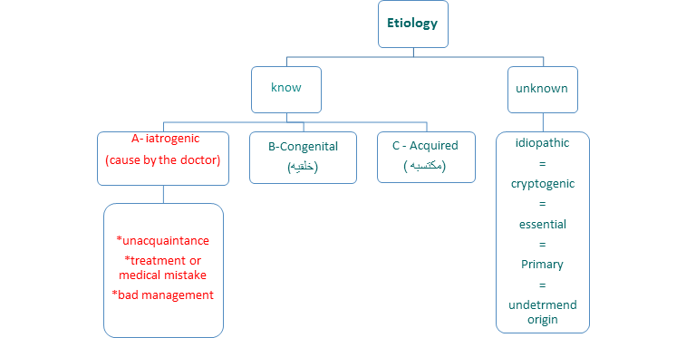
Etiology means the direct cause of the disease

Note: probably the disease has more than one reason

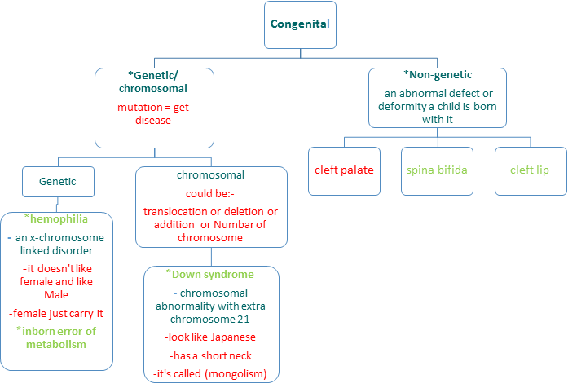
B- congenital Disease: is a condition existing at birth or before birth, or that develops during the first month of life.

Note :
- Gene is part of chromosome
- Not all congenital disease are genetic: down syndrome and cleft palate are both congenital, but down syndrome is genetic and cleft palate is non- genetic

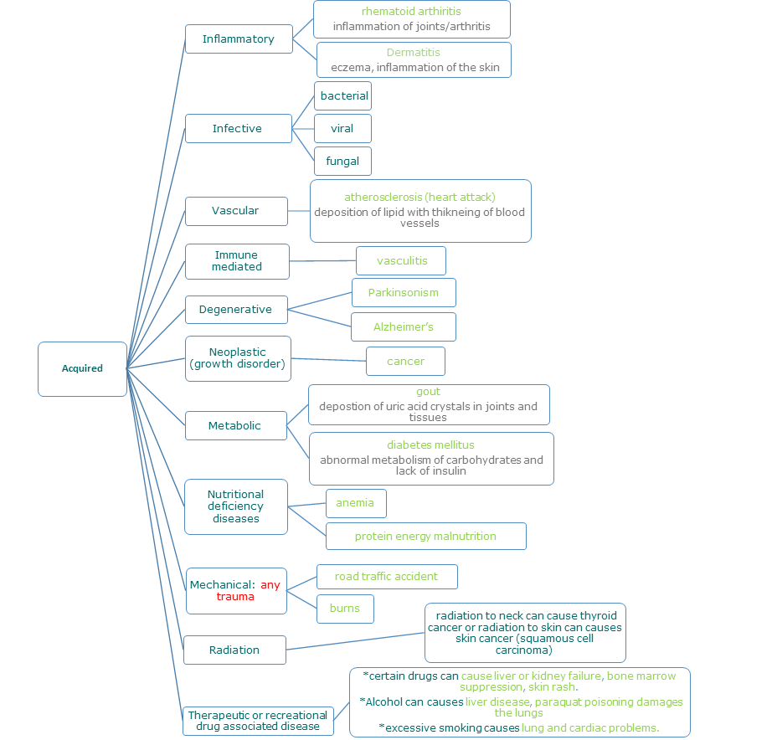
C - Acquired Diseases

Note: - Inflammatory could be by bacterial, viral, fungal or other things, Infective just bacteria, viral, fungal.
Pathogenesis
(ألية تطور المرض)

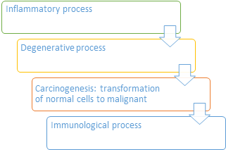
Pathogenesis: it is the steps that take place in the body once the problem begins (whatever it may be) that finally lead to tissue injury (pathological manifestations).

 | Example:
( | - (Squamous Metaplasia → Dysplasia (pre cancer) → lung Cancer).

-Pathogenesis leads to morphologic changes (changes in the gross or microscopic appearance of human tissue).

Note:
- genesis start of pathology.
- When something develops from normal to abnormal, the sequence of it called Pathogenesis.

Morphologic changes((التغيرات الشكلية و الظاهرية:( in group of cells change not one)
-The morphologic changes are the structural changes that take place in cells or tissues due to any disease.
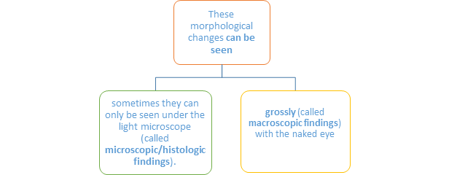
Example:
جدري الماء (Chickenpox)
ممكن بالعين المجردة نشوف تغير وهو ظهور الحبوب وتحت الميكروسكوب نشوف تغير في الخلايا.

CLINICAL FEATURES (FUNCTIONAL ALTERATIONS) (التغيرات الوظيفية)
When an organ is damaged by a disease, the normal function of that organ is affected and this will lead to the development certain clinical changes called signs & symptoms.
- clinical features: is the combination of signs and symptoms.

 | Signs  (physician discovery) | Symptom  ( patient experience)
definition | are findings discovered by the physician during examination of the patient.  Basically it is what the doctor will find on examining the  patient. | is something experienced and reported by the patient.  Basically it is what the patient will tell the doctor.
Examples | - doctor finds a swelling somewhere  - or doctor find a liver or spleen enlargement while examining the abdomen etc. | - ‘I am feeling tired’  - ‘I have a headache’  - ‘I have a pain in my stomach’ etc.
THEREFORE IN MEDICINE DISEASES ARE STUDIED UNDER THE FOLLOWING HEADINGS:
PATHOLOGY
↓
Epidemiology
↓
Etiology
↓
Pathogenesis
↓
Morphologic changes
↓
Clinical features.

1- Definition.
2- Epidemiology of disease.
3-Etiology.
4- Pathogenesis and pathophysiology.
5- Morphology: it is divided into
Gross/ macroscopic- visible to the naked eye.
6-Microscopic: visible under a microscope.
7- Clinical features/presentation: signs and symptoms.
8- Differential diagnosis: is there any other alternative diagnosis/diagnoses with similar findings
9- Treatment and management
10- Prognosis (التنبؤ بالمرض)

How to study disease?

COURSE OF DISEASE (مسار المرض)
The course of a disease is the different stages in the natural history or progression of a disease in the absence of any intervention.
The different stages in the natural history or course of a disease especially infectious are as follows:
(a)
Exposure(التعرض)
to causative agents or risk factors
(B)
* latent period (فترة الكمون): between exposure and onset of disease.
*incubation (induction) period (فترة الحضانه):
The time period from the exposure to the development of signs or symptoms
(D)
Outcome and consequences of disease: Following clinical onset, disease may follow any of the following trends:
(c)
Onset of disease (بداية المرض):
the beginning of signs or symptoms.

Recovery / resolution of disease without complication or sequelae. Person is back to normal health.

The disease recovery but with sequelae.
Development of complications
Death.

THE DIAGNOSTIC PROCESS

Any patient going to a clinic meets clinician who will:

1- take history and do clinical examination.

2- He may ask for radiological and pathological examination in order to come to a diagnosis.

•The common pathological examinations are:
blood, urine and stool tests.
•Sometimes the patient is also asked to undergo: cytopathology or a histopathology test or other special pathological tests in order to obtain an accurate diagnosis.

pathology plays an essential role in the diagnosis of a disease and management and treatment of patient.
THE ROLE OF PATHOLOGIST

Types of treatment:

1-drugs.

2-surgery.

3-counseling. (التناصح)

Branches of Pathology

Histology | Histopathology
Normal Cells | Abnormal Cells

Cytology | Histology
Studies cells | Studies Tissue

Histopathology
Study of tissue under a light microscope.
Procedure:
1. Obtain tissue through biopsy
2. Preserve in formalin (to avoid decomposition) 3. Tissue is then processed and the end result is
thin slices of stained tissue
-Most commonly used stain is Hematoxylin and Eosin.
4. The pathologist will then look under the microscope and give a diagnosis.
Exception:
Frozen Section: when an instant diagnosis is needed, tissue is processed rapidly to give results in 20 minutes.
Ex. during surgery

Cytopathology
- The study of the cells’ morphology to make a diagnosis.
Purpose:
- Screening for Cancer Ex. cervical cytology to detect Carcinoma in the cervix
- Diagnosing Cancer
Procedure:
- Fine-Needle Aspiration Cytology (FNAC): cells are obtained by aspiration (suction) of cells from a tumor mass or organ using a needle. Cells are then placed on slide and studied under microscope.
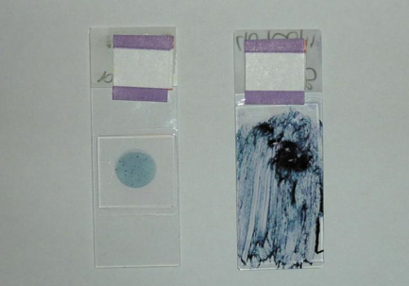
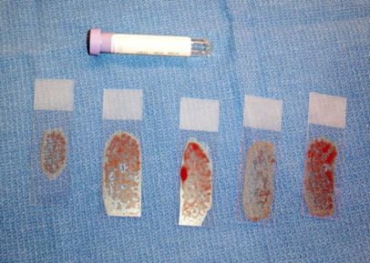
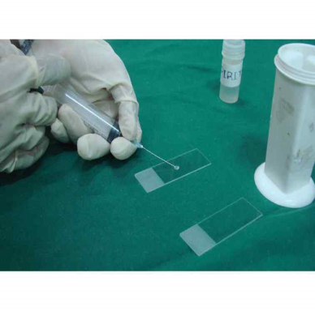
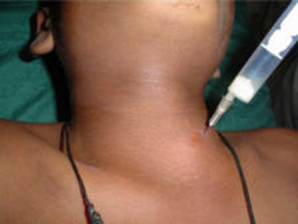

2.Exfoliative (scraping off) Cytology:
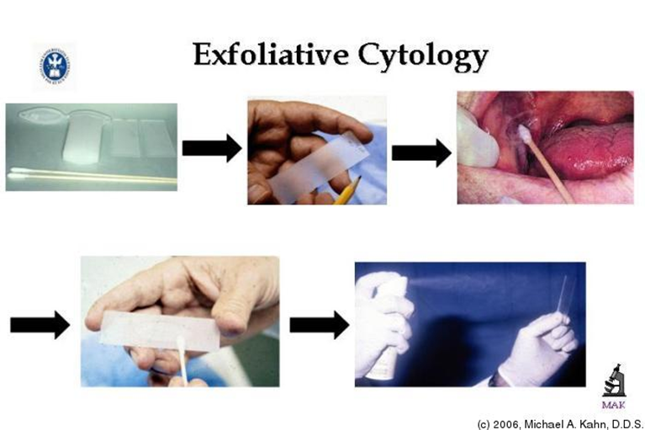
Cells are either scrapped from any mucosa (ex. cervix) using a spatula or cells exfoliate and collect in nearby fluid (ex. urine)

** Doctor chooses between Cytopathology and Histopathology based on the disease.
**Cytopathology is preferable because it’s easier, faster, and cheaper.
AUTOPSY= (necropsy) = (postmortem)
(فتح الجثة بعد الوفاة)
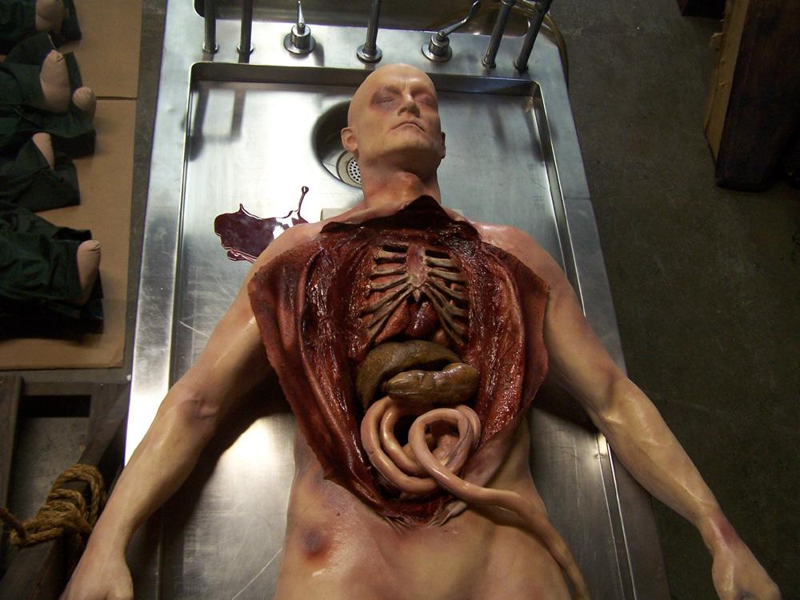
- Autopsy:
Is a sub-specialty of pathology, which involves examining a dead body

- An autopsy is done to:

➢ The main reason: Determine the cause of death in any of the following situations:
* Homicidal.(مقتول)
* Suicidal.(منتحر)
* Accidental.(حادث)
* To identify the disease.
➢ To provide useful information about various disease.
➢ Research.
➢ A tool to educate students and surgeons.
➢ Audit the clinical diagnosis.
➢ Forensic pathology (legal purposes): is the application of pathology to the legal system.

*Who does the autopsy?
-The pathologist.
SOME INSTRUMENTS IN PATHOLOGY

- There are different diagnostic instruments used in pathology.
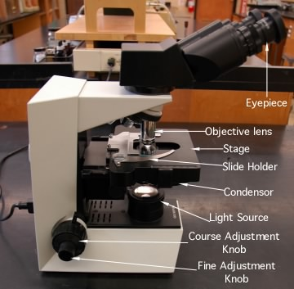

Light microscope

Immunofluorescent
microscope

Electron microscope

Uses a special blue filter and a fluorescent dye (appears green) on to identify various antigens in a tissue. It is used in diagnosing immunological diseases.

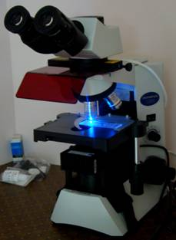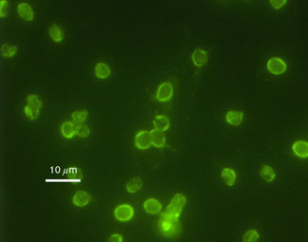
Magnifies up to two million times, which is much higher than a light microscope. It enables us to see cell structure like mitochondria, endoplasmic reticulum, viral particles etc. It is also called as ultra structural studies. It is an expensive technique.

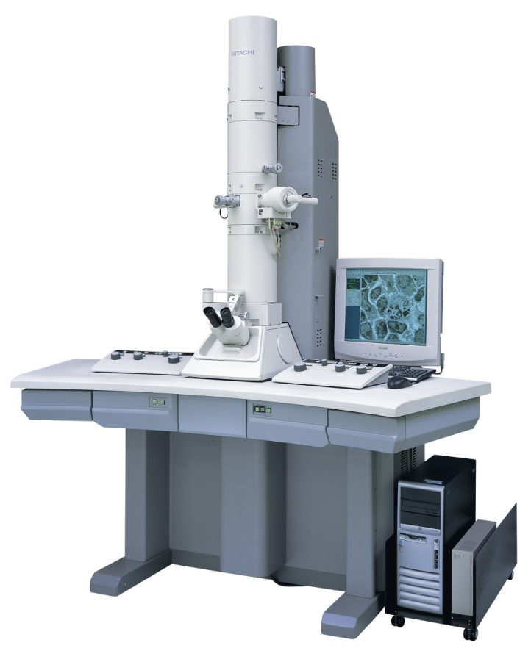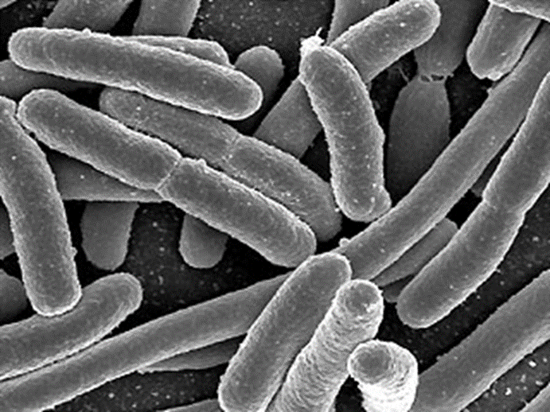
White light

MCQs

- Used in immunological
disease diagnostic:
a) Electron microscope.
b) Light microscope.
c) Immunofluorescent microscope.
d) None of the above.

- A subspecialty that involves examining a dead body:
a) Toxicology.
b) Immunology.
c) Chemical pathology.
d) Autopsy.

- The most expensive technique is:
- Electron microscope.
b) Light microscope.
c) Immunofluorescent microscope.
d) None of the above.

- Fine Needle Aspiration is one of the method of:
- Autopsy
- Cytopathology
- Cytogenesis
- Immunology

- Anemia considered as :
- Nutritional deficiency
- Infective
- Inflammatory
- Genetic

- Cleft lip and palate considers as :
- Genetic
- Non genetic
- Degenerative
- Infective

- What the patient tell the doctor called:
- Sign
- Symptom
- Prognosis
- Etiology

- Part of pathology which study of tissue biopsied from the body:
- Cytopathology
- Immunology
- Histopathology
- microbiology

Best Wishes and Good Luck

Team Leaders:
Team members:
نهال بياري
نجد الذيب
منيرة الزايد
عاتكة القاضي
غادة الهدلق
أثير الرشيد
امال الشبي
حنين السبكي
دعاء وليد
رانيا العيسى
رنيم الغامدي
ريما الشايع
غادة المزروع
فاطمة الطاسان
لمى التميمي
نجود العنزي
الدانة المتعب
غادة المهنا
دينا النويصر

أشواق الماجد – فهد الزهراني
عبد العزيز الحسيني
فيصل الغربي
عبد العزيز القحطاني
عبد الله الطويرقي
عبد الله عسيري
عبد الله ابو عمارة
عصام الشهراني
فهد العسكر
فارس الجعفر
محمد حكمي
محمد المنيع
مؤيد الثقفي
معتز إبراهيم
سلطان المالكي
تركي العوبثاني
وليد المجلد
وليد محمد

For any suggestions or questions
contact us :
Pathology436@gmail.com
Twitter: @pathology436

