Musculoskeletal Block

Pathology Practical

Pathology Team 436

Case #1
Duchenne Muscular Dystrophy (DMD)

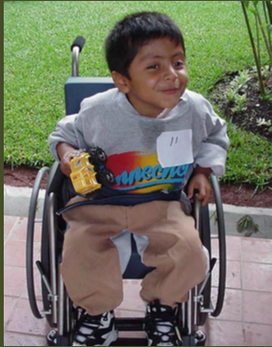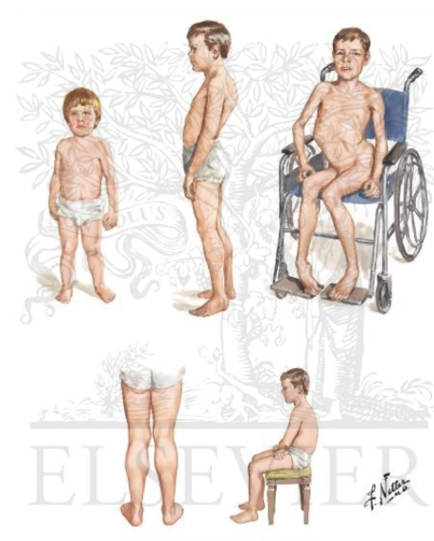 | 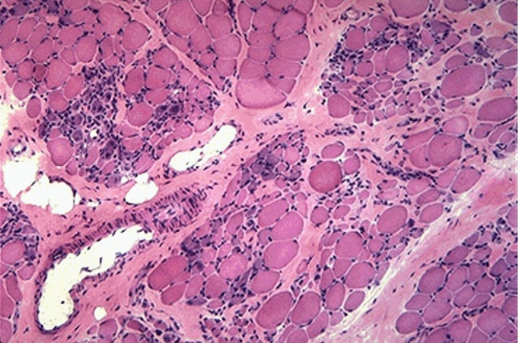
- Gross picture :  - Difficulty in walking  - Poor balance  - Frequent falls | - Microscopic picture :  - Variation in muscle fiber size.  - Increased endomysial connective tissue.  - Regenerating fibers (blue tint)

In DMD : Dystrophin, an intracellular protein, forms an interface between the cytoskeletal proteins and a group of transmembrane proteins.

Case :
A 3 - year- old boy presented to his paediatrician with complaint of his parents from difficulty in walking , poor balance , and frequent falls.
- Laboratory investigation:
- Elevated “Creatine kinase” .

- Muscle biopsy:
- Absence of dystrophin by western blot analysis.” What is your provisional diagnosis?”
#Case2
Dermatomyositis

A 52-year-old woman presents with 6-month history of progressive muscle weakness and a skin rash.
Physical examination is remarkable for a diffuse purple/red discoloration of the skin over her cheeks, nose, and eyelids. Examination confirms proximal muscle weakness.
Laboratory findings show an increase in creatine kinase (10 times the normal).
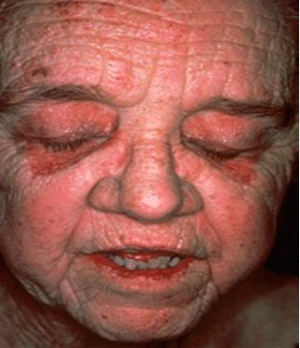
(it’s an autoimmune disease)
Gross Picture :
1-Serological test that is usually abnormal ,
are high CK (creatine kinase) and increased anti
nuclear antibodies (ANA).
2-Clinically: Purple/red colored discoloration
mainly around eyelids.
3-Can be associated with internal malignancies
including a primary in lung ,ovary and stomach.

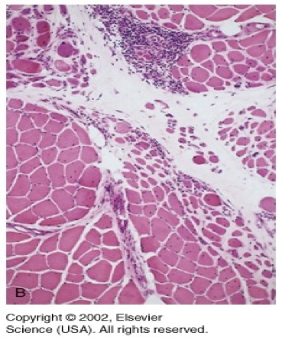

Microscopically: (very important)
1-Perifascicular (around the vesicle) atrophy
of muscle fibers.
2-Chronic inflammation.

#Case 3
NON INFECTIOUS ARTHRITIS : Osteoarthritis

Case : An obese 56-year-old woman presented with bilateral localized pain to her knees, hands and difficulty in walking .

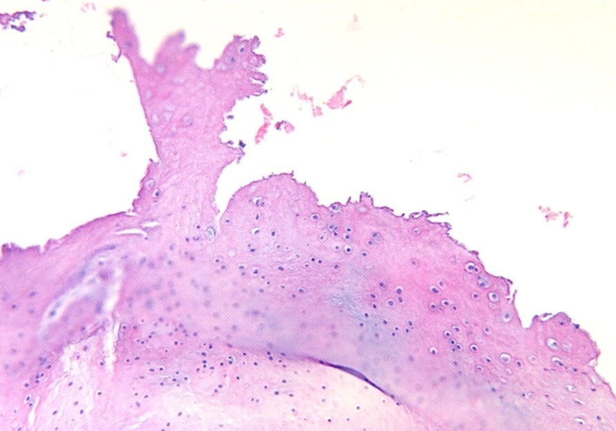
Osteoarthritis - LPF Histologic description
1) bony outgrowths (osteophyte) Mushroom-shaped at the margins of the cartilage .
2) Absence of inflammation

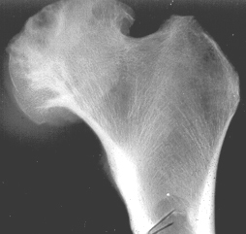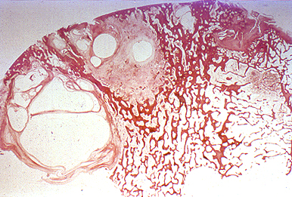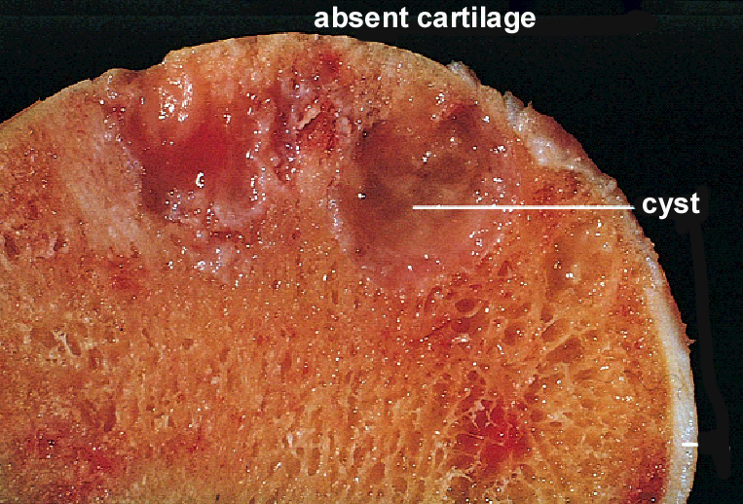

Microscopic picture:

- Osteoarthritis is a degenerative disorder.
- Treatment: joint replacement
- Arthritis is inflammation in joints

Osteoarthritis - Gross
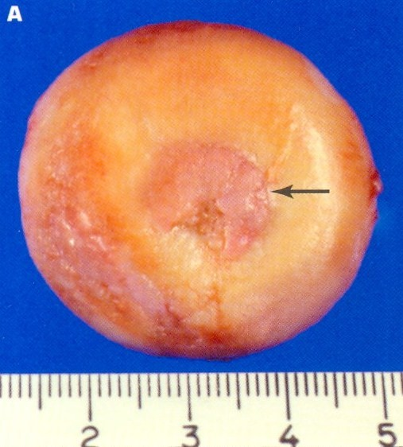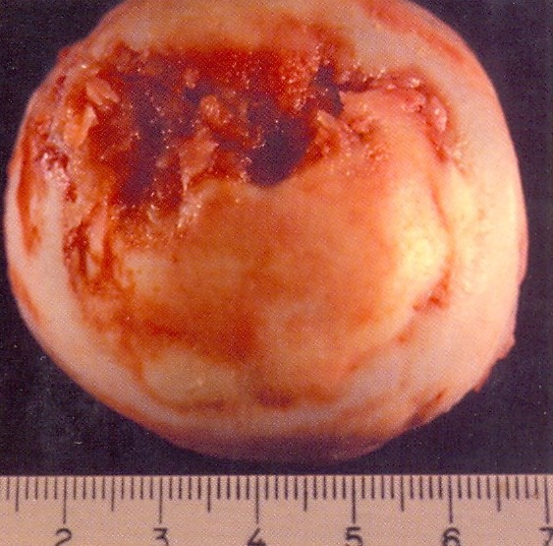
1) Progressive erosion of articular cartilage.
2) eburnated articular surface.
3) Subchondral cyst.
4) residual articular cartilage.

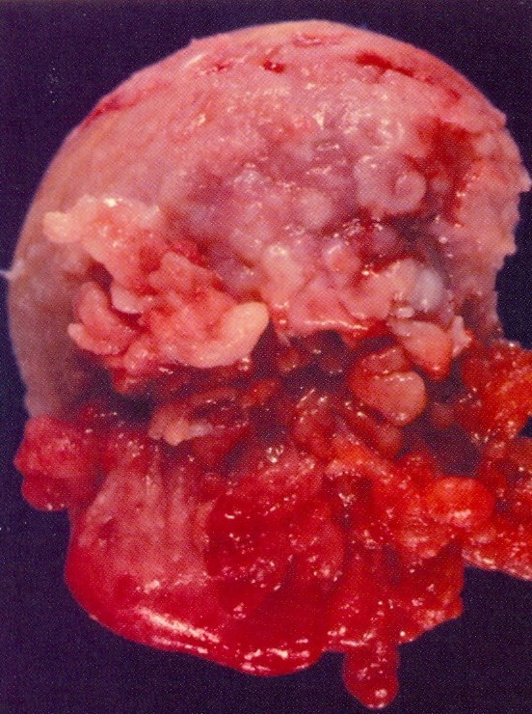
#Case4 Rheumatoid Arthritis :
A 45 year old woman complains of low grade fever ,
Malaise and stiffness in her joint every morning .

- Gross picture :
- Affecting the head of the femur.
- The synovium becomes edematous, thickened
and hyperplastic and transforming its
smooth contour to one covered by
delicate and bulbous fronds .
- Serological tests which are somewhat
specific for this disease :
- Rheumatoid factor (RF)
- Antibodies to citrullinated peptides
in the serum .
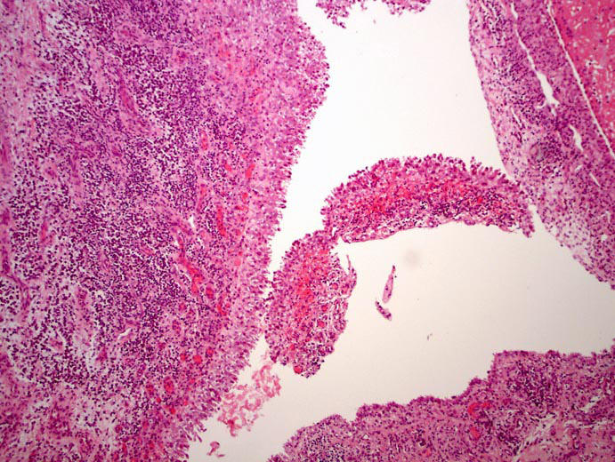
- C-Reactive protein (CRP) and ESR (Non specific)

Hyperplastic Synovium - LPF
Hyperplastic synovial lining with villous like projections

Hyperplastic synovium with underlying plasma cells and lymphocytes including many congested blood vessels in Rheumatoid arthritis .
Hyperplastic Synovium - HPF

#Case4 part2 , Gout
Gout is a syndrome caused by the inflammatory response to tissue deposition of monosodium urate crystals (MSU).
Gross picture :

- Severe gout in the fingers resulting in large, hard deposits of crystals of uric acid.
- These deposits are called Tophi (توفي )
- secondary inflammation.
- Swelling, Redness and oedema.

polarized microscopy

- Needle-shaped monosodium uric acid crystals.
- acutely inflamed joint.
Gouty Arthritis can be secondary to
- Leukaemia
- Chronic renal diseases
- post chemotherapy
- drugs like thiazide diuretics.
Syndrome which is responsible for the inherited form of gouty arthritis is:
Lesh-Nyhan ( ليش يا نيهان ) syndrome due to lack of HGPRT( HuG PaRTy) enzyme.
Osteomyelitis Case # 5

A 22- year- old male presented with localized pain above his right knee joint with recurrent fever. Later, he had a discharging sinuses from the skin overlying the right knee.
- What is the most likely diagnosis ?

Acute Osteomyelitis –Lpf Chronic Osteomyelitis-Lpf

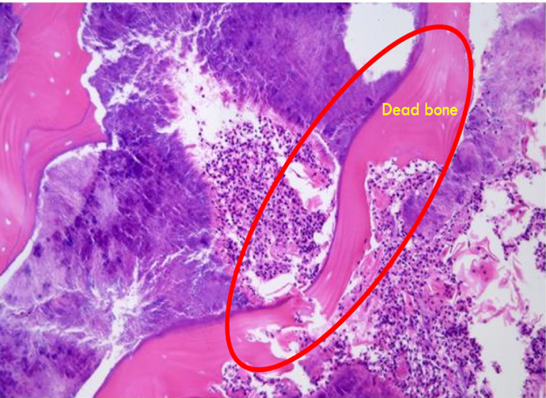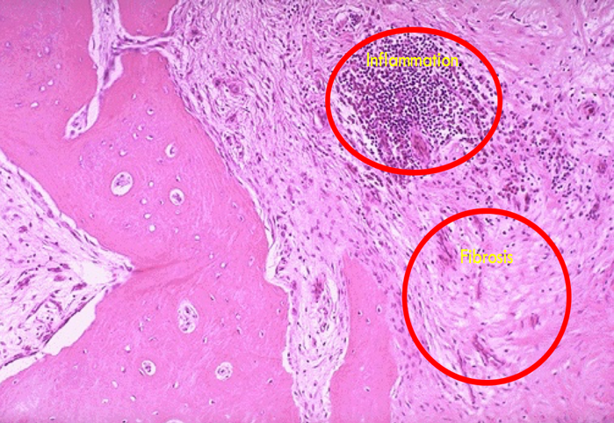
Sequestrae surrounded by :
1-Fibrosis of the marrow space .
2-Chronic inflammatory cells .
3-bone destruction with remodeling .
Sequestrae surrounded by :
1-colonies of bacteria .
2-purulent infiltrate .

The drainage tract in the subosteal shell of viable new bone (involucrum) reveals the inner native necrotic cortex (sequestrum)
(sequestrum) = out
involucrum = new
----------------------------
- Bacterial most often
  - Staphylococcus
  - Salmonella
    - Sickle Cell Disease
  - Tuberculosis
    - Spine first
------------------------------
- The sickle cells disease is related to what type of infections? Salmonella

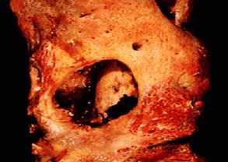

#case 6 Tuberculous arthritis

- case: A 30 -year-old debilitated man presented to the orthopedic clinic with increasing swelling and pain in right knee joint, low grade fever, marked elevation of sedimentation rate. The patient has history of coughing up blood , fever , chills , night sweats , weight loss , pallor and often tendency to fatigue very easily . “the biopsy is taken from the synovium” .

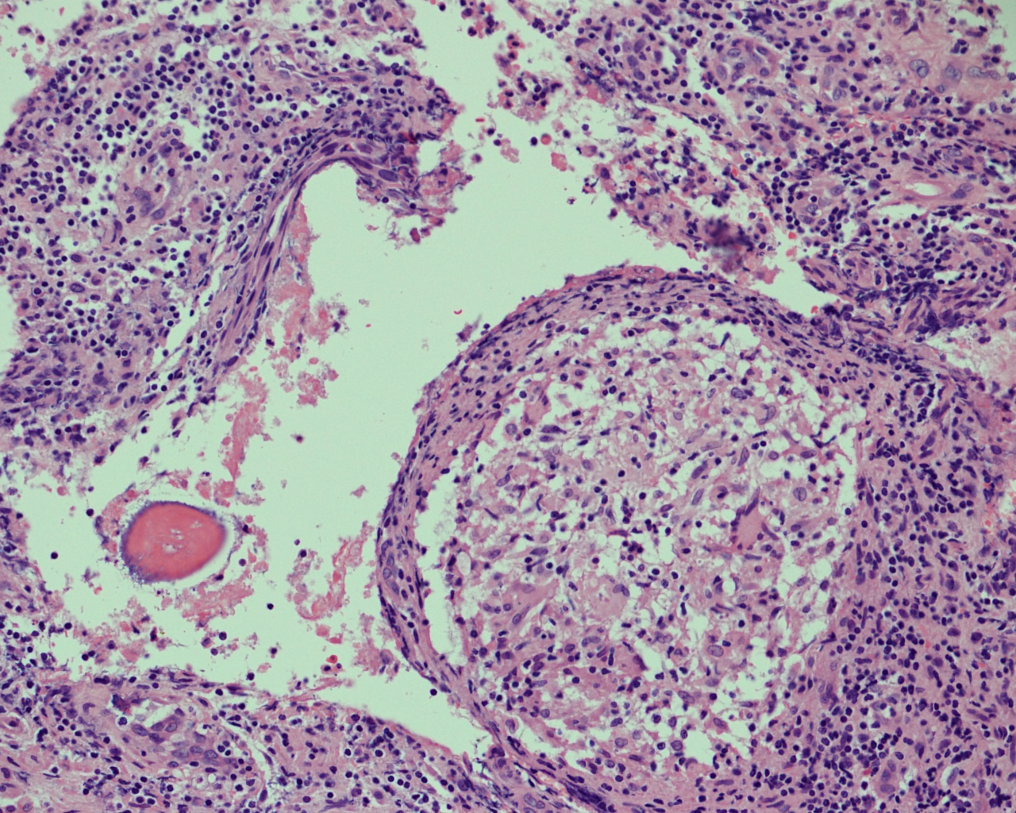
It shows granuloma formation with Epithelioid like cells , langhans-type giant cells , and rim of lymphocytes .

Foreign body –type giant cll
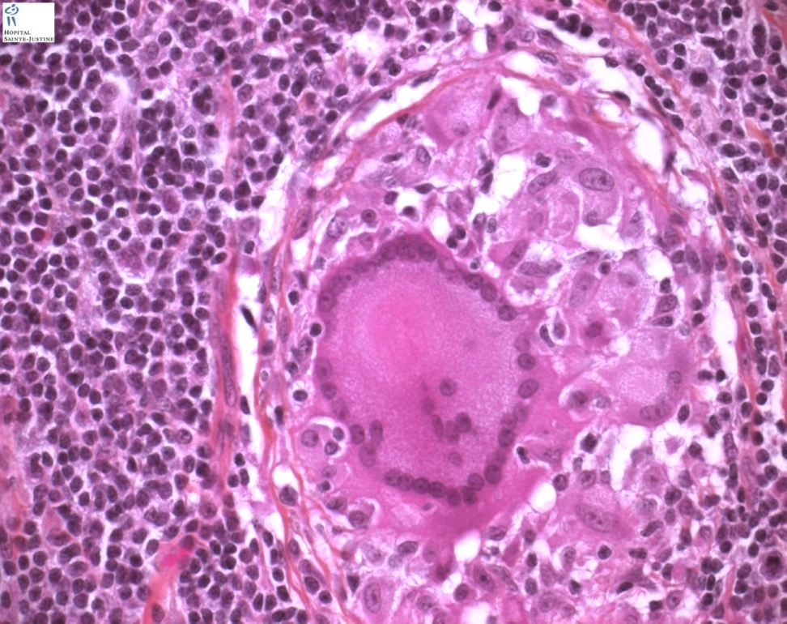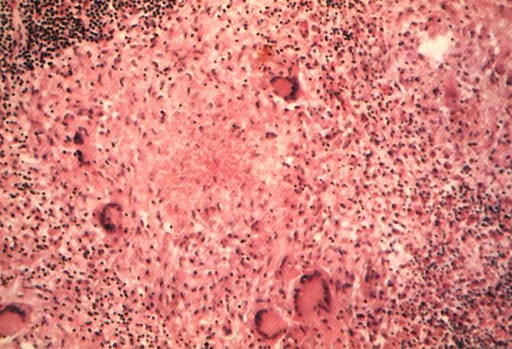
Rim of lymphocytes
Langhans cell
Foreign body type giant cell
Epitheliod macropha-ge
Caseous necrosis
Langhans-type giant cell
- Epithelioid cells fuse to form giant cells containing 20 or more nuclei. The nuclei arranged either peripherally (Langhans-type giant cell) or haphazardly (foreign body-type giant cell). These giant cells can be found either at the periphery or the center of the granuloma.

Section of bone shows granuloma formation with epithelioid like cells ,
langhans-type giant cells and rim of lymphocytes

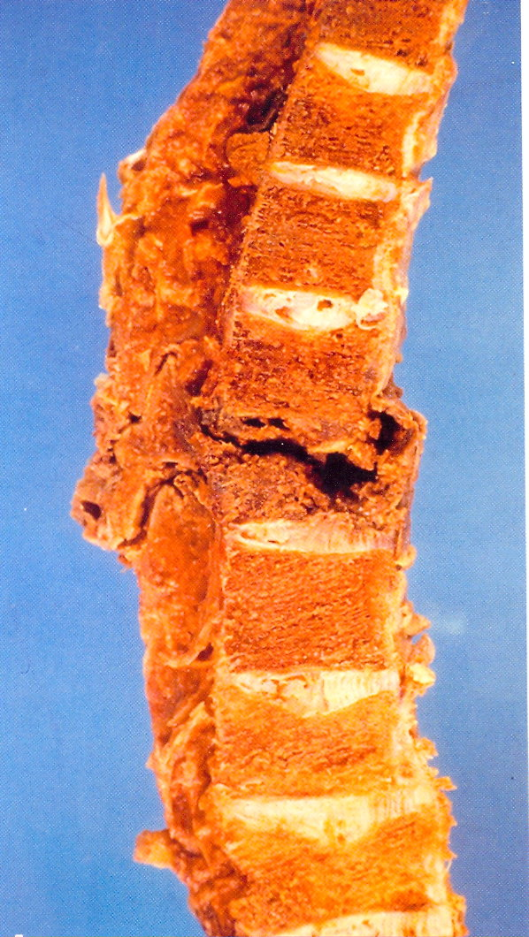
Granulomatous necrosis of vertebral column .
Gross pathology of T.B Osteomyelitis
of the vertebral Column (Pott’s Disease)

T Gross pathology of T.B Osteomyelitis
of the vertebral Column (Pott’s Disease)
he patient has a history of:
- coughing up blood
- fever and chills
- night sweats
- weight loss
- Pallor
and often a tendency to fatigue very easily.

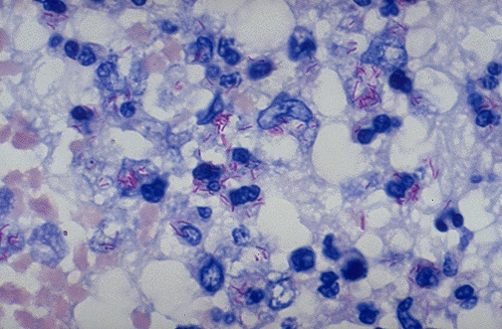
A stain for Acid Fast Bacilli (AFB stain) also called Zeil Nelson stain is done to find the mycobacteria . The mycobacteria stain as red rods, as seen here at high magnification.
Molecular test → PCR (Polymerase chain reaction) is also done for acid fast bacilli

#Case7 Bone tumors “Chondroma”
-OsteoChondroma Exostosis-

gross Picture :

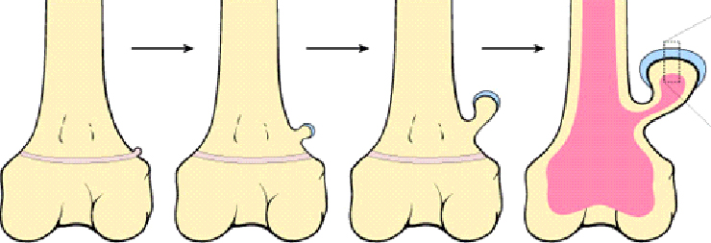

- The solitary osteochondroma is the most common benign bone tumors
- Seen in patients aged from 10-30 years
- Arise during skeletal growth
- Equally in males and females
- Etiology is unknown

case:

A 16 -year-old male was found to have a small swelling protruding from upper part of his leg with local pain .

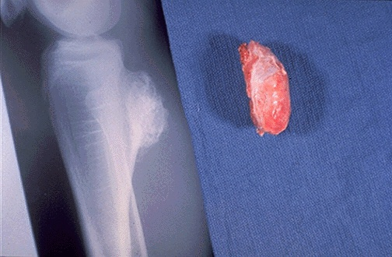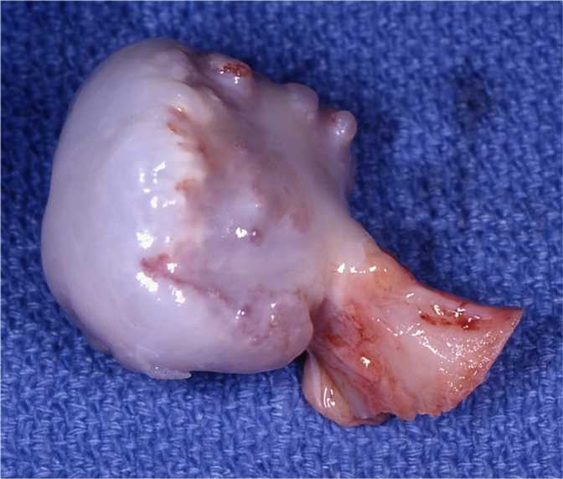
A B

Gross & X-ray :
- Most are solitary (both A and B)
- Incidental lesions that may be excised if they cause local pain. (A )
- Osteocartilagenous protrusion arising from the upper tibial bone (X-ray )
- one stalk and overlying membrane on cartilage cap. ( B)

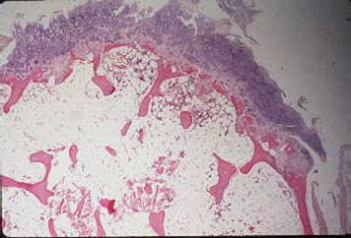
bone
Cartilaginous layer
Fibrous cap

The microscopic appearance:
- Benign cartilaginous cap in the 1st layer.
- Bony Cortex in the lower left side .

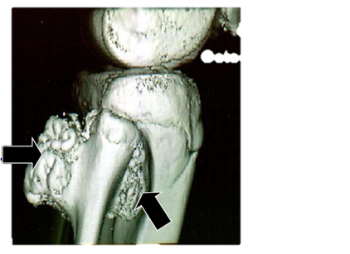
Possible complication : -
Chondrosarcoma may occur if these lesions are multiple

Prognosis is excellent
MRI picture showing :
two osteochondromatous exostosis which are arising from the upper third of fibula .

Case #8

- An 18-year-old female presented to the rheumatology clinic with 2 months history of pain and swelling in her upper thigh with weight loss.

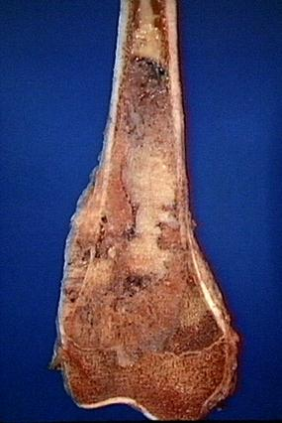
Malignant tumor:
- Necrosis
- Intramedullary irregular bone .
- Inflated cortex.
- Metaphysis and epiphysis of tibia.
The tan-white tumor fills most of the medullary cavity of the metaphysis and proximal diaphysis.
It has infiltrated through the cortex, lifted the periosteum, and formed soft tissue masses on both sides of the bone.
- Malignant tumor of mesenchymal origin
- 2nd most common primary bone tumor
- RB gene mutation is seen in 60% of these cases.
- In elderly patient, paget’s disease and previous radiation exposure are predisposing factors.
- Classical radiological feature seen is CODMAN triangle

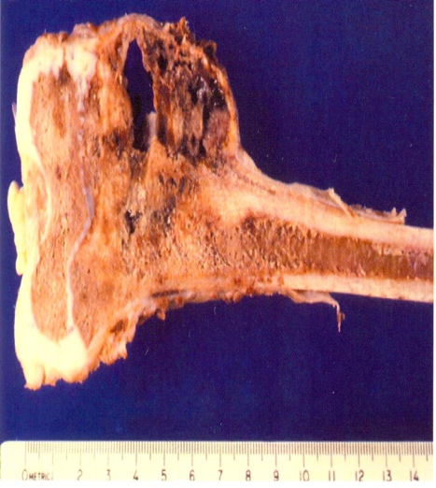
Conventional Osteosarcoma - Gross
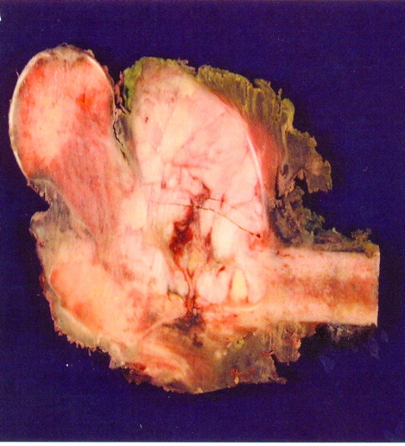

- Mixture of osteoid, fibrous, cartilaginous, necrotic, hemorrhagic, cystic areas
Osteosarcoma - LPF

- Pleomorphic and hyperchromatic nuclei of malignant cells.
- Osteoid formation by the tumor cells.

Osteosarcoma - HPF

- Malignant osteoid producing Spindle cells, giant cells.
- Abnormal Mitosis
- Prominent nuclei.
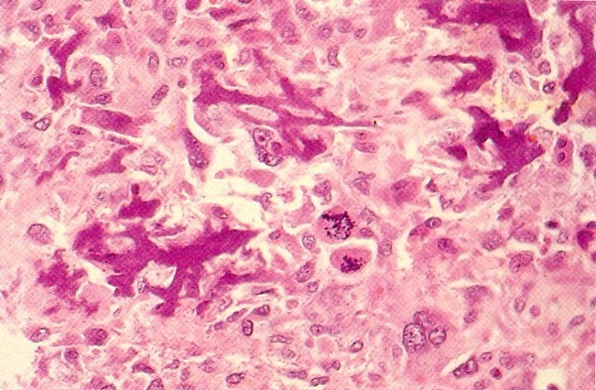
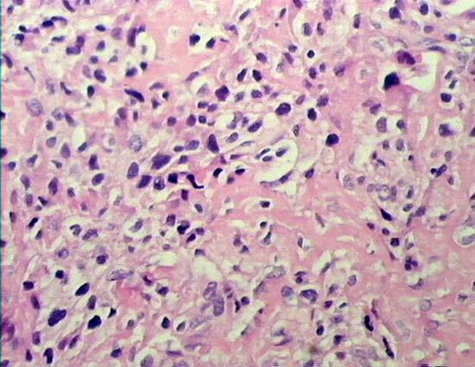

Team leader :
Thank you

Haneen Alsubki

Team Members :

Ameera Niazy

Reem Alshathri

Ghada Alskait

Reema alotaibi

Ghada alhadlaq

Najd altheeb

Lama alfozan

Muneera aldufayan

Yara aldaigi

