King Saud University
College of Medicine
Medical Education Department

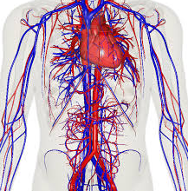

STUDENT’S GIUDE OF CLINICAL SKILLS

CARDIOVASCULAR BLOCK
CVS 113
YEAR 1

2016-2017
(1437-1438)
King Saud University
College of Medicine
Medical Education Department

STUDENT’S GUIDE OF CLINICAL SKILLS
Cardiovascular System Block
(CVS 113)
(Academic year 1437-1438)
YEAR 1

Copyright Statement

This material is protected by copyright laws. For any other purposes other than teaching and research in the King Saud University, no part may be reproduced or copied in any form or by any means without prior permission of the King Saud University.
© King Saud University, Saudi Arabia, 2016.

TABLE OF CONTENTS
Introduction and Rationale | 4
Objectives of the Clinical Skills | 5
Teaching and Learning Modes | 6
Mode of Assessment | 6
Learning Resources | 7
Academic Support Team | 8
Checklists | 9
Student’s guideline during clinical skills teaching | 16
Schedule of Clinical Skills | 17

Skills lab Committee
Dr Mona Suliman
Dr Sami Nassar
Dr Mahmoud Salah
Dr Sahar Mostafa
Dr Nordin Pumbaya
Dr Milda Hani Eid
Mr. Chadi Diab

Checklists revised by Dr Nahla Azzam (Department of Medicine)

Introduction and rationale:

Early students’ clinical exposure to skills is essential for systematically learning and developing clinical skills appropriate to working in a clinical environment, and application of skills when they move onto their clinical rotations.
The transition from preclinical to clinical training is huge for the students and several studies have documented that the transition is quite stressful. (O’Brien et al., 2007).
We aim from the clinical skills to do a smooth transition in clinical skills from preclinical to clinical years.
The clinical skills took in consideration the requirement of SaudiMed for the graduates of Saudi medical students through integration with the different blocks and courses.
The clinical skills will be learnt through spiral approach system to gradually increase students’ confidence in performance when interacting with patients during their clinical years.

The aims of early Clinical Skills Teaching:
- improvement in the students’ knowledge and competence to perform examinations
- Increased student’s perceived levels of confidence.
- Enrichment of the safe environment that helps in bridging the gap between the preclinical and clinical years in medical undergraduate education. (Swamy et al., 2013)

Objectives of the clinical skills:
By the end of this block the students should be able to know and show how:
- locating (via anatomical landmarks) and commenting on the strength (volume) of the following pulses: Radial, Brachial, Carotid, Popliteal, Dorsalis Pedis, Posterior Tibial
- Describe the rate and rhythm of the radial and carotid pulses
- To demonstrate the pulsation of the normal JVP
- Demonstrate the surface anatomy for auscultation of mitral, tricuspid, aortic and pulmonary valves.
- Accurately locate the normal apex beat, and report on its location by standard anatomical landmarks
- Show how to examine the heart
- To take a history related to cardiac symptoms.
W1 | CVS examination 1: (pulses, JVP)
W2 | CVS Examination 2: (heart)
W3 | Take a history related to cardiac symptoms
W4 | Midyear vacation
W5 | OSCE for Respiratory and CVS blocks

Week 1: CVS examination 1: (Examination of pulses, JVP)
Objectives: By the end of the session the students should:
- locating (via anatomical landmarks) and commenting on the strength (volume) of the following pulses: Radial, Brachial, Carotid, Popliteal, Dorsalis Pedis, Posterior Tibial
- Describe the rate and rhythm of the radial and carotid pulses
- To demonstrate the pulsation of the normal JVP

Week 2: CVS examination 1: (Examination of the heart)
Objectives: By the end of the session the students should:
- Show how to communicate with the patient (SP)
- Show how to take a history from patients presented with cough

Week 3: To take a history related to cardiac symptoms.
Objectives: By the end of the session the students should:
- Know how to communicate with the patient with heart symptoms
- Show how to take a history related to the heart symptoms.

Teaching and Learning Modes:
- The clinical skills will be learnt by hands on the different clinical skills.
- The tutor will do a demo in front of students, and then each student is expected to do by himself
- The tutor will give feedback to the students according to the provided checklists.

Mode of assessment: 5 marks
The marks will be the student’s performance on OSCE.

Learning Resources:
- The clinical skills tutor
- The clinical skill lab facilities during SDL (need to be arranged with the clinical skill staff in advance)
- The provided checklists
- Recommended reference textbooks and website:
- Physical Exam by Barbara Bates
- Current Medical Diagnosis
- Current Surgical Diagnosis

Website:

-Martindales Clinical Examination (martindalecenter.com)

Academic Support Team  CHAIRPERSON : Dr. Ahmad Ben Nasser  Physiology Department  Extension :  Mobile : / Bleep :  Email : |  | CO-CHAIR :  Department  Extension :  Mobile : / Bleep :  Email :
MEMBERS | DEPARTMENT | CONTACTS | E-MAIL ADDRESS
Mr Chadi Diab | Clinical skills | Extension : 92829 | chadi79diab@hotmail.com
Dr. Milda | Clinical skills | Extension : 92587  Mobile : | dr.milda@hotmail.com
Dr. Nur | Clinical skills | Extension : 92589  Mobile : | dr.strange@ymail.com
Dr. Sahar Mostafa | Clinical skills | Extension: 56526 | samoustafa@yahoo.com

Checklists
Week 1: Cardiovascular Examination (Pulses and JVP)

OBJECTIVE: To conduct a complete Cardiovascular Examination.
MATERIALS: Well illuminated examination room, examination table, stethoscope, penlight, rulers and ophthalmoscope.

D: Appropriately done PD: Partially done ND: Not done/Incorrectly done

 | STEP/TASK | D | PD | ND
 | Preparation
a. | Introduce yourself to the patient.
b. | Confirm patient’s ID.
c. | Explain the procedure and reassure the patient.
d. | Get patient’s consent.
e. | Wash hands.
f. | Prepare the necessary materials.
g. | Show the patient each object and allow him/her to touch them to reduce any fear of being hurt during the examination.
h. | Position the patient in a 45 degree sitting position and uncover his/her upper body.
 | General Examination
 | General inspection
1. | Observe the patient's general appearance (age, state of health, nutritional status and any other obvious signs e.g. jaundice, cyanosis, dyspnea).
 | Hands and pulse
2. | Pick up the patient’s hand; inspect and examine (Temperature, Color, Nail clubbing, Nail splinter hemorrhage, Nail signs of iron deficiency).
3. | Take the patient’s radial pulse (Determine the Rate, Rhythm and the Character of the pulse,  Radio-radial delay, Collapsing pulse).  JHHKHJH
 | Blood pressure
4. | Take his/her blood pressure (Lying and standing or sitting-postural hypotension).
 | Face
5. | Inspect the patient’s face (sclera, pupils, malar rush, mouth, palate, dentition).
 | Neck
6. | Assess the jugular venous pressure (JVP) and the jugular venous pulse form:  • Ask the patient to turn his head slightly to one side.  • Look at the internal jugular vein medial to the clavicular head of sternocleidomastoid.  • Assuming that the patient is at 45 degrees, the vertical height of the jugular distension from the sternal angle should be no greater than 4 cm.  •Assess for Hepatojugular reflux.
7. | Locate the carotid pulse and assess its character.
 | Precordium
8. | Inspect the patient’s chest (scars, deformity, apex beat, abnormal pulsation and pacemaker).
9. | Palpate (apex beat, thrills, abnormal impulses).
Sources and References:

A. Books

1. Bates' guide to physical examination and history-taking
Lynn S.Bickley - Peter G.Szilagyi - Barbara Bates - Wolters Kluwer Health/Lippincott Williams & Wilkins – 2013
2. Clinical Examination: A Systematic Guide to Physical Diagnosis
Simon O'Connor - Nicholas Joseph.Talley - Elsevier – 2014

B. Websites
1. OSCE Skills
http://www.osceskills.com/

Cardiovascular Examination
Week 2: Examination of the heart

Cardiovascular Examination
 | STEP/TASK | D | PD | ND
 | Examination
A. | Auscultation of the heart
1. | Place your stethoscope’s diaphragm on auscultation areas and listen for: Heart sounds, additional sounds, murmurs, and pericardial rub.  General auscultation areas:  • Aortic area - right second intercostal space near the sternum.  • Pulmonary area - left second intercostal space near the sternum.  • Tricuspid area - left third, fourth, and fifth intercostal spaces near the sternum. • Mitral area - left fifth intercostal space, in the mid-clavicular line.
2. | Ask the patient to turn onto his left side and to hold his breath in expiration.  Using the stethoscope's bell, listen in the mitral area for the mid diastolic murmur of mitral stenosis.
3. | Ask the patient to bend forward and to hold his breath in expiration.  Using the stethoscope’s diaphragm, listen at the left sternal edge in the fourth intercostal space for the mid-diastolic murmur of aortic regurgitation.
4. | Listen over the carotid arteries for any bruits.
B. | Back (patient is in sitting forward position)
5. | Inspect the patient’s back (scars, deformity).
6. | Percuss his/her back (pleural effusion).
7. | Auscultate for inspiratory crackles (left ventricular failure).
C. | Abdomen (patient is laying down)
8. | Inspect the patient’s abdomen (scars, deformity).
9. | Palpate his/her abdomen for hepatomegaly (right ventricular failure), pulsatile liver (tricuspid regurgitation), splenomegaly (endocarditis) and aortic aneurysm.
10. | Ballot the kidneys and listen for any renal artery bruits.
D. | Legs (patient is laying supine)
11. | Examine all peripheral pulses bilaterally.  • Femoral pulses. • Popliteal pulses. • Posterior tibial pulses.• Dorsalis Pedi’s pulses
12. | Look for peripheral vascular disease, peripheral edema and clubbing of the toes.
13. | Cover the patient up.
E. | Eyes
14. | Examine the retina with an ophthalmoscope.
 | After the examination
15. | Ensure that the patient is comfortable.
16. | Make explanations to the patient, answer his/her questions and discuss management plan.
17. | If necessary, order diagnostic investigations.
18. | Dispose of sharps and waste material according to infection control standards.
19. | Wash hands.
20. | Document the procedure.

Auscultation areas of the heart *

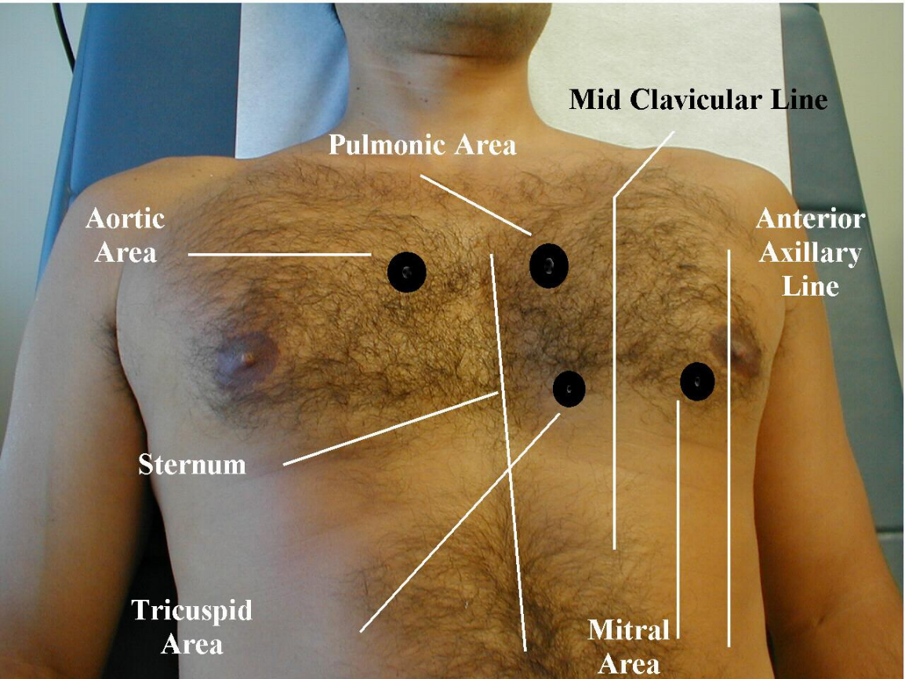

Sources and References:
A. Books
1. Bates' guide to physical examination and history-taking
Lynn S.Bickley - Peter G.Szilagyi - Barbara Bates - Wolters Kluwer Health/Lippincott Williams & Wilkins – 2013
2. Clinical Examination: A Systematic Guide to Physical Diagnosis
Simon O'Connor - Nicholas Joseph.Talley - Elsevier – 2014
B. Websites
1. OSCE Skills
http://www.osceskills.com/

King Saud University
College of Medicine
Department of Medical Education
Riyadh, KSA

Week 3: Cardiovascular History Taking
- OBJECTIVE: To take an ideal history related to CVS signs and symptoms.
MATERIALS: there will be standardized patent to take the history from him.

D: Appropriately done PD: Partially done ND: Not done/Incorrectly done
 | STEP/TASK | D | PD | ND
 | Introduce yourself to the patient.
1. | Personal data
 | Name, Age, Gender, Nationality, Occupation.
2. | Chief complain
 | Short statement of the problem that brought the PT, better recorded in the patient’s own words.
3. | History of presenting illness.
Onset (acute, subacute, chronic and insidious), Duration, Course of the condition (static, progressive, or relapsing and remitting), Aggravating & Reliving Factors, and Associated symptoms: such as Pain (Chest pain, Dyspnoea, Paroxysmal nocturnal dyspnea Palpitations, Syncope / Dizziness, intermittent claudication , Oedema, Oedema & fever.)
*Pain should be further defined in terms of the following: Location, Radiation, Quality, Severity, and Aggravating & Reliving Factors.
4. | Past Medical History
 | Same situation before, angina, stroke & peripheral vascular disease.
 | Chronic disease (DM, HTN …)
 | History of hospitalization : Admission, Surgery, Blood Transfusion
5. | Family & Social History
 | Same situation in the family, chronic disease (DM, HTM), congenital & hereditary diseases, history of stroke or transient ischemic attack.
 | Marital status, No. of children, housing status, job status & environment / conclude: socioeconomic status. History of travelling.
 | Habits: smoking, drinking Alcohol, using prohibited substances.
6. | Drug history:
 | Any recent medication, long term medication, Allergies, Herbal Medication.
7. | Systemic review:
 | CNS , RES, GIT, UT, MS
 | SUMMRY

King Saud University
College of Medicine
Department of Medical Education
Riyadh, KSA

Simulated Patient Case Script
chest pain
Your role in this session is to role-play a patient with chest pain.
Chest pain: is very important as a symptom of heart disease but is sometimes difficult to evaluate. Location: usually in the front of the chest (retrosternal) but can also radiate to the upper abdomen, neck, jaw, left arm or left shoulder.
Trigger
You have applied to your GP with a presenting symptom of chest pain.
You also feel the pain into your left arm.
Wait for the Doctor’s (student) questions, and answer them based on the provided list below.
(If you face any unexpected questions, try to skip that question with a suitable phrase like:
"I have not recognized" "I did not pay attention" "I don't know" and inform the faculty about that/those questions). Please do not forget to add the gestures and mimics related to your scenario.

Personal and Social History: name, age, gender, occupation – Please use as your own.
Single, job, nationality, living with parents.

What is your Chief Complain? "I have been having Chest Pain lately."

Possible questions and answers about your present complaint:

1-Can you tell me more about it?
About six months ago I started having this pain (a squeezing, pressure sensation) in my chest. It was right under the breastbone (patient hold right fist to breastbone), and only lasted a few minutes. It happened two or three times when I was angry with my son, and then it went away.

2-Has the pain happened at other times?" or "Have you noticed anything different recently?" or similar open question?
For the last month the pain has been more frequent. We went to shopping and I had one pain in the mall. We had a flat tire on the way back and I had the pain then (while changing the tire).

3-Is there anything else you can tell me?" or "Have you had any other symptoms?"
For the last few nights the pain has awakened me, and it seems to be worse. I can feel it in my left arm. I got up and took some pain killer, but they did not seem to help. Last night I broke out in a sweat and the pain lasted about 30 minutes.

4-If asked another vague open question, like "Is there anything else you can tell me about it?" respond with something reflective like:
"I don't know what you want" or "What do you want me to tell you?"

*Responses to Specific Questions:

5-Has anyone in your family had heart trouble?
My father had a heart attack and died when he was 40.
6-Do you smoke? Yes. One to two packs a day since I was in my 20's.
7-How many pillows do you sleep on? I sleep on one pillow.
8-Have you noticed any changes in bowl habits? Or black stools? Or blood in your stools? No.
9-Have you ever noticed the pain after a meal? No. A meal doesn't bring on the attack.
10-How far can you walk or how many flights of stairs can you climb before you have the pain?
I can walk about 2 blocks before the pain occurs. I haven't walked up any flights of stairs since this problem began.
Respond NO to the following:
Nausea
Vomiting
Difficulty swallowing
Cough
Shortness of breath
Weight loss noticed
Heart racing (palpitations)
Fever
Past history of hypertension
Past history of high cholesterol
Swelling of ankles or feet awakening with a mouth full of bitter tasting fluid (regurgitation)

Past medical history: Nothing specific, No important disease history, No operation, No current medication, No allergy.

Family history: Mother & siblings are healthy and alive, no major history of disease.

Sources and References:
A. Books
1. Bates' guide to physical examination and history-taking
Lynn S.Bickley - Peter G.Szilagyi - Barbara Bates - Wolters Kluwer Health/Lippincott Williams & Wilkins – 2013
2. Clinical Examination: A Systematic Guide to Physical Diagnosis
Simon O'Connor - Nicholas Joseph.Talley - Elsevier – 2014
3. Current medical diagnosis & treatment
Stephen J.McPhee - Maxine A.Papadakis - McGraw-Hill Medical - 2012
B. Websites
1. OSCE Skills
http://www.osceskills.com/

Student’s Guidelines of CSL

- All students are required to wear their school uniforms, all white or scrub suits plus white coat.
- All students are expected to read about the topic basics before coming to the session so as to be able to comprehend the steps of the skills or the procedure.
- The students are expected to come to the sessions regularly and on time. Students late by more than 10 minutes will not be allowed to join so as not to disturb the ongoing session
- No student will be allowed to leave the session in between and before time
- The students are expected to keep their mobile phones on silent mode while in the session.
- The students are required to sign the attendance sheets posted on their respective rooms, in addition to their log books.
- All the students should carry their log books during the sessions and get it signed by the assigned tutor after the session. In case any student forgets to bring his log book along, he should request the assigned tutor to record his name and year until he gets the log book for the signature the next day.
- All students are expected to practice the skills on an individual basis. For some sessions where individual practice is not feasible due to time and other constraints, groups of students should be asked to perform the skill in a collective manner.
- At the end of each session the tutor should make sure that the student is able to do all the steps correctly, observe him while practicing and assess his performance where necessary.

Clinical skills schedule
Sunday | Monday | Tuesday | Wednesday | Thursday
8:00 - 10:00am | 8:00 - 10:00am | 8:00 - 10:00 am | 8:00 - 10:00 am | 8:00 - 10:00 am
10-12 am | 10-12 am | 10 - 12am | 10-12am | 10:00 - 12:00 am  Clinical skills  YEAR 1  Females
Lunch  12:00 – 1:00pm | Lunch  12:00 – 1:00pm | Lunch  12:00 – 1:00pm | Lunch  12:00 – 1:00pm | Lunch  12:00 – 1:00pm
1:00-3:00 pm  Clinical skills  YEAR 1  Group A | 1:00-3:00 pm  Clinical skills  YEAR 1  Group B | 1:00-3:00 pm | 1:00-3:00 pm | 1:00-3:00 pm

