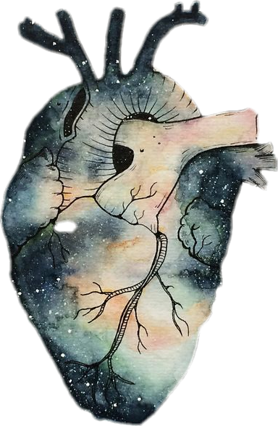

**Thromboembolism**



**Objectives:**

1. Understand the basic pathology of thrombogenesis and the risk factors for development of venous and arterial thrombosis.
2. Know the types of emboli and to able disrcibe the causes and pathology each one.

Black: Doctor’s slides.

Red: important!

Green: Doctor’s notes.

Grey: Extra.

Purple: Female’s slides.

Blue: Male’s slides.

**Thrombosis: تجلط**

<https://www.youtube.com/watch?v=aW6WscFqli8>

It is a process by which a thrombus is formed. It represents hemostasis in the intact vascular system.

A thrombus is a solid mass (blood clot) made up of blood constituents which develops in artery or vein. Also it could be inside the heart.

It is intravascular coagulation of blood and it often causes significant interruption to blood flow.

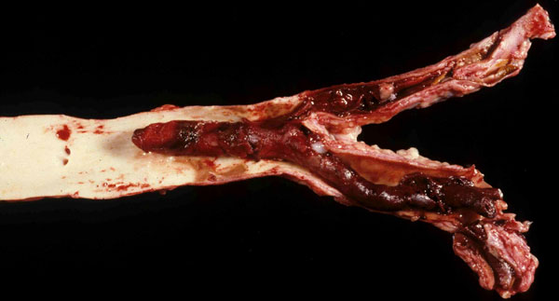

*هذي الثلاث أشياء تُسمى بهذا الإسم، مهم جدًا تعرفونها

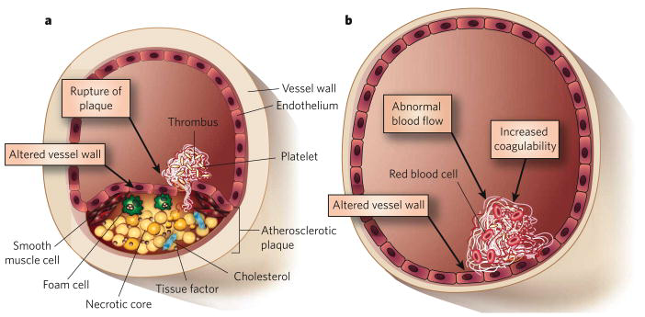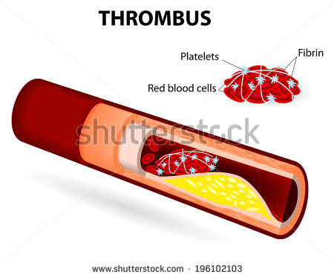**Pathogenesis:**

**Extra**

Three primary influences called as **Virchow triad* (كل واحد يؤدي الى الاخر)**  predispose to thrombus formation:

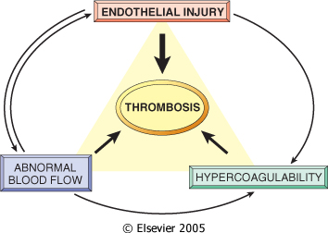**1. Endothelial injury. ) the most important)**

**2. Stasis [1]or turbulence[2]* of blood flow.**

**3. Blood hypercoagulability.**

It results from interaction of platelets, damaged endothelial cells and the coagulation cascade. All three are component of the hemostatic process.

Turbulence: changing the pathway of blood and platelet will be in the edge of lumen

**Few components of hemostatic process:**

**-Platelets** maintain the integrity of the vascular endotheliumand participate in endothelial repair through the contribution of PDGF[3]. They form platelets plugs and **promotes coagulation Cascade** through the platelet phospholipid complex.

**-Endothelial cells** are resistant to thrombogenic influence of platelets and coagulation proteins. **Intact endothelial cells oppose coagulation** after injury. They are thromboresistant.

**-Coagulation cascade** is **a major contributor to thrombosis**. It is a serious of enzymatic conversions turning, inactive proenzymes into activated enzymes, and resulting in the formation of thrombin. Thrombin then converts the soluble plasma protein *fibrinogen* into the insoluble protein *fibrin.* And **fibrin is a constituent of the thrombus**.

**-Fibrinolysis ( thrombus dissolution):** activation of the clotting cascade induces cogulation, and it also triggers the Fibrinolytic cascade that limits the size of the final clot. Its runs concurrently with thrombogenesis. Fibrinolytic cascade restores blood flow in vessels occluded by a thrombus and facilitates healing after inflamation and injury. This is accomplished by generation of *plasmin*. The inactive proenzyme *plasminogen* is converted to active ***plasmin* then splits *fibrin****.*

**&**

**Fibrinogen**

**Fibrin**

**ENDOTHELIAL CELLS**

* The endothelium is a single cell thick lining of endothelial cells and it is the inner lining of the entire cardiovascular system (arteries, veins and capillaries) and the lymphatic system.
* It is in direct contact with the blood/lymph and the cells circulating in it.
* Endothelial structural and functional integrity is fundamental to the maintenance of vessel wall homeostasis and normal circulatory function.

Splits

**2. Anti-thrombotic**

(Antithrombin 3, protein c, protein S)

**Fbrinolysis**

**Generation of plasmin**

**1. Thrombotic**

(Platelets)

**Coagulation cascade**

**Formation of thrombin**

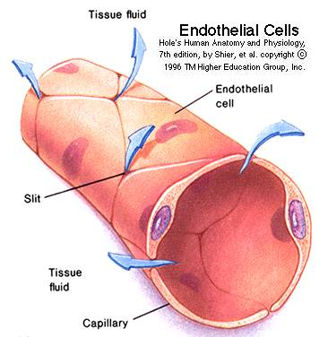

1. **Endothelial Injury**

* Endothelial Injury is a major cause of thrombosis in the heart or arteries.
* **The following conditions lead to endothelial dysfunction/injury:**
* **Hypertension.**
* **Scarred valves.** Like in RHD e.g.: mitral stenosis.
* **Bacterial endotoxins.**
* **Radiation.**
* **Hypercholesterolemia.**
* **Cigarette smoking.**
* **Endothelial injury leads to:**
* Exposure of subendothelial ECM i.e the basement membrane.
* Adhesion of platelets.
* Release of tissue factor and ultimately thrombosis.
* **Endothelial injury can** contribute to thrombosis in several clinical settings e.g:

1. Endocardial injury due to myocardial infarction.
2. Ulcerated plaques in atherosclerotic arteries.
3. Traumatic or inflammatory vascular injury.

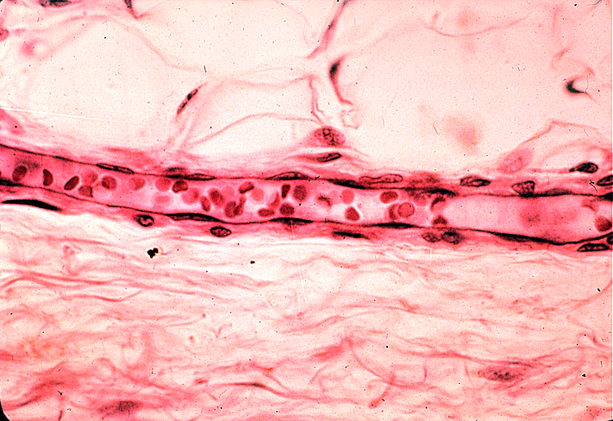

**2) Abnormal Blood Flow**

Disruption of laminar blood flow can bring platelets into contact with the endothelium and promote endothelial cell activation.

1. Stasis plays a major role in the development of venous thrombi.
2. Turbulence contributes to arterial and cardiac thrombosis by causing endothelial injury or dysfunction.

Abnormal blood flow contributes to thrombosis in several clinical settings:

* Ulcerated atherosclerotic plaques.
* Abnormal aortic and arterial dilations.
* Acute myocardial infarction.
* Mitral valve stenosis.
* Hyperviscosity syndromes.
* Sickle cell anemia.

**3) Hypercoagulability**

Definition: Any change of the coagulation pathways that predisposes to thrombosis

Hypercoagulability can be divided into:

* Primary (inherited) hypercoagulable states
* Secondary (acquired) hypercoagulable states

**Hypercoaguable States: قابلية الأشخاص للتجلط**

Hypercoagulability can be divided into:

1. **Primary (Genetic)**: (e.g. mutation in factor V gene or prothrombin gene, anti-thrombin III deficiency, protein C or S deficiencies, or fibrinolysis defects.
2. **Secondary (acquired):** they can be high risk or low risk.
   * + 1. **High risk for thrombosis:**

Dr. Sufia: You should know this list. Can show up in MCQs

* + - * + Prolonged bed rest or immobilization
        + Myocardial infarction, Atrial fibrillation
        + Tissue damage (surgery, fracture, burns)**
        + Cancer: release of procoagulant tumor products

**غالباً المريض بعد العملية الجراحية أو التعرض لكسر أو حرق يكون جالس لفترة طويلة وحركته تقل وهذا ممكن يسبب له:

DVT (Deep Vein Thrombosis)

* + - * + Prosthetic cardiac valves*
        + Heparin-induced thrombocytopenia
        + Disseminated intravascular coagulation*: Thrombin generation
        + Antiphospholipid antibody syndrome*[4] (lupus anticoagulant syndrome): Autoantibodies
      1. **Lower risk for thrombosis:**

Cardiomyopathy, Nephrotic syndrome, Hyperestrogenic states (pregnancy), Oral contraceptive use, Sickle cell anemia, Smoking.

**Thrombotic disorders:**

* Can be **anti-thrombotic (hemorrhagic),** leading to pathologic bleeding states such as hemophilia, Christmas disease and von Willebrand disease.
* Can also be **prothrombotic**, leading to hypercoagulability with pathologic thrombosis e.g. hereditary thrombophilia and antiphospholipid antibody syndrome.

**Hereditary Thrombophilia**

* Is a **prothrombotic** familial syndrome.
* Charecterized by recurrent venous thrombosis and thromboembolism.
* Can be caused by deficiency of antithrombotic proteins including antithrombin 3, protein C, and protein S.
* **Factor V Leiden thrombophilia**is a genetically inherited **prothrombotic** disorder of blood. Factor V. Leiden is a mutated form of human factor V that causes an increase in blood clotting (hypercoagulability).

**Antiphospholipid antibody syndrome**

* Is a **prothrombotic** disorder characterized by autoantibodies directed against a number of protein antigens that form complexes with phospholipids
* Is characterized by recurrent venous and arterial thromboembolism, fetal loss, thrombocytopenia and a variety of neurological manifestations.
* Patients have prolonged partial thromboplastin time (PTT).
* It is sometimes associated Systemic Lupus Erythematosus and so this antibody is also known as lupus anticoagulant.

**Disseminated intravascular coagulation**

Is both prothrombotic and antithrombotic disorder characterized by widespread thrombosis and hemorrhage resulting from the consumption of platelets and coagulation factors.

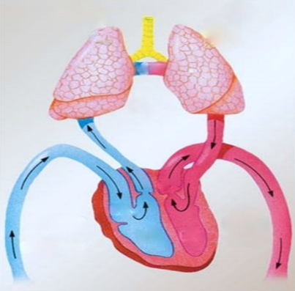**Morphology of thrombus:**

* Thrombi may develop anywhere in the cardiovascular system, the cardiac chambers, valve cusps, arteries, veins, or capillaries. They vary in size and shape, depending on the site of origin.
* Arterial or cardiac thrombi [5]*usually begin at a site of endothelial injury* (e.g., atherosclerotic plaque) or turbulence (vessel bifurcation).
* Venous thrombi characteristically occur in *sites of stasis.*
* Arterial thrombi grow in a retrograde direction [6]from the point of attachment (i.e. toward the heart). Venous thrombi extend in the direction of blood flow (i.e. toward the heart).
* The propagating tail of either thrombi may not be well attached (particularly in veins) is prone to fragmentation, creating an **embolus**.
* A thrombus is made up of fibrin, platelets and red blood cell and few inflammatory cells.
* When formed in the heart or aorta, thrombi may have grossly (and microscopically) apparent laminations, called **lines of Zahn**; these are produced by alternating pale layers of platelets admixed with some fibrin and darker layers containing more red cells.
* When arterial thrombi arise in heart chambers or in the aortic lumen they are termed **mural thrombi**. Abnormal myocardial contraction or endomyocardial injury promotes cardiac mural thrombi.

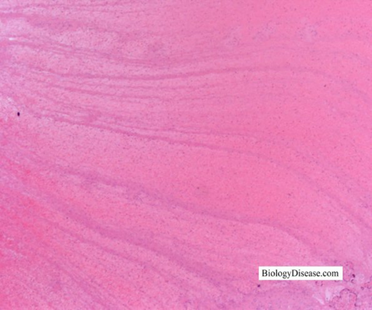**Lines of Zahn**

The aim of any thrombus is to go towards the heart.

*

*

*

red cells

platelets with fibrin

*

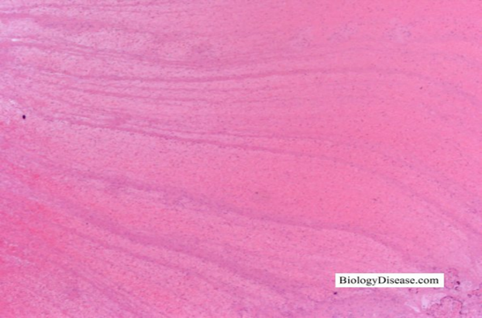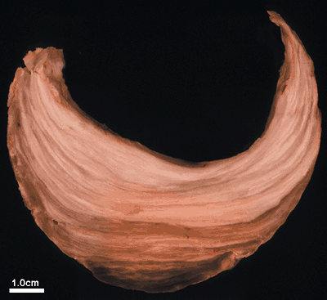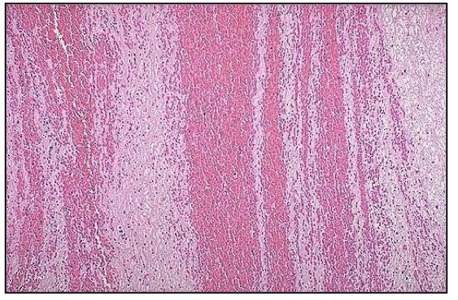

The trigger ‘cause’ here is usually either Endothelial injury Or turbulence blood flow.

**Arterial thrombi:**

* Are usually **occlusive**.
* Most common sites in descending order **are coronary, cerebral, and femoral arteries.**
* It is usually superimposed on an atherosclerotic plaque and are firmly adherent to the injured arterial wall (mural).
* **Gray-white** and friable.

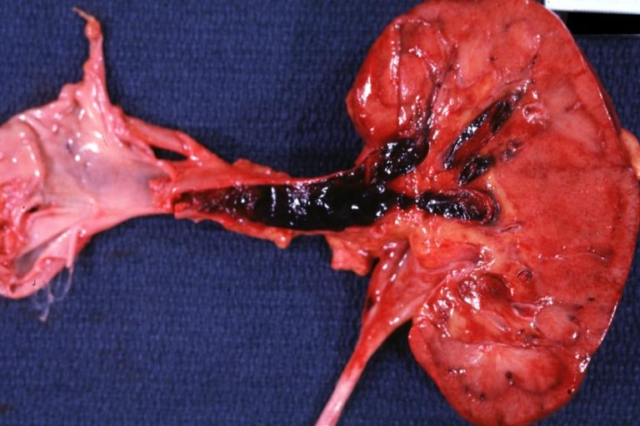**Venous thrombosis:**

The usual cause is stasis blood flow.

* Also, called **phlebothrombosis**, is almost invariably occlusive.
* The thrombus often takes the shape of the vein.
* Because these thrombi form in a relatively static environment, they contain **more enmeshed erythrocytes** and are therefore known as **red, or stasis thrombi.**
* Phlebothrombosis most commonly affects the veins of **the lower extremities (90% of cases).**

لازم الثرومبس تكون لاصقة بجدار الوعاء الدموي دااائمًا.

**Postmortem clots:**

At autopsy, postmortem clots may be confused for venous thrombi.

Postmortem clots are gelatinous with a dark red dependent portion where red cells have settled by gravity and a yellow chicken fat supernatant resembling melted and clotted chicken fat. They are not attached to the underlying wall.

Thrombi are firmer, almost always have a point of attachment, and on transection reveal vague strands of pale gray fibrin.

تقريبًا نفس المذكور تحت عند الأولاد مع شوية زيادة تفاصيل، الدكتور مرتب الزبدة في نقاط أوضح :)

طيب ليش بعد الوفاة تكون الجلطة من فوق صفراء ومن تحت حمراء؟ هنا الفكرة نفس الشخص لما ينتحر ويعلّق نفسه بحبل، الدم بيصير تحت "الجزء السفلي من الجسم أحمر" ونص الجسم يكون أفتح شوي بينما الجزء العلوي من الجسم تمامًا يكون أبيض "مافي دم", ليش صار كذا؟ بسبب الجاذبية الأرضية. فصارت خلايا الدم الحمراء تحت فوقها البيضاء وأعلى شيء البلازما. أما الشخص الحي يكون يتحرك فما نشوف تغيّر اللون هذا.

**Venous thrombus**

**Postmortem clots**

1. Rubbery and gelatinous.
2. dark red in one side and yellow in the other.
3. Not attached to the vessel wall.
4. Firm.
5. Rich admixture of RBCs and

appear red.

1. 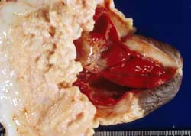Attached to the vessel wall.



**Thrombi on Heart Valves:**

د.صوفيا: هنا المهم تعرفون اللي بالبولد بس :)

Thrombi on Heart Valves are called as vegetations.

**Are infective or sterile:**

1. **Infective vegetations**: Bacterial or fungal blood-borne infections may result in the development of large thrombotic masses on heart valves, called as **vegetations (infective endocarditis)**.
2. **Sterile vegetations:** can also develop on noninfected valves in patients with hypercoagulable states, so-called **nonbacterial thrombotic endocarditis**. . Also called Marantic endocarditis.

Less commonly, noninfective, **verrucous (Libman-Sacks)** **endocarditis** attributable to elevated levels of circulating immune complexes may occur in patients with systemic lupus erythematosus.

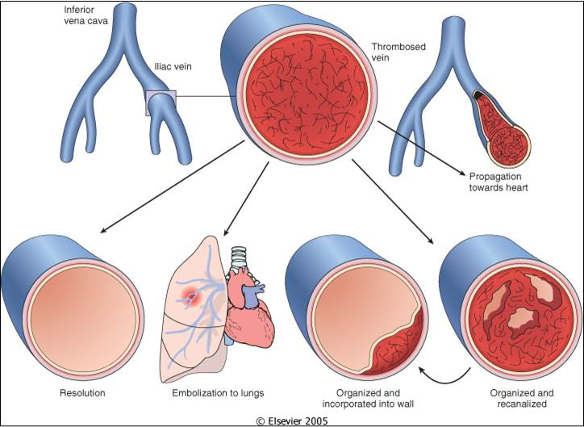

**Fate of Thrombus:**

* Resolution.
* Propagationتنتشر . ‘Grows towards the heart’
* Embolism. ‘travel with blood stream and block the vessel which it is stuck in’
* Organization and recanalization.
* Organization and incorporation into the wall.

‘Thrombus and inside it blood vessels are formed “angiogenesis take place” making wals and channels in that to pass the blood. Finally all these channels merge and forms a large channel and this thrombus gets push to the side. So, first organization and recanalization then organization and incorporation.’

****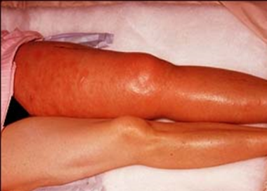**Deep vein thrombosis & Thrombophlebitis:**

<https://www.youtube.com/watch?v=2vVqBjk-oqQ>

* Venous thrombosis often arises in the deep veins of the legs and then it is called **deep vein thrombosis (DVT).**
* Such thrombi (DVT) *more often embolize to the lungs and give rise ‘to pulmonary embolism with resultant’ pulmonary infarction.*
* Can *cause local pain and edema*.
* DVTs are asymptomatic in approximately 50% of affected individuals and are recognized only in retrospect after embolization.
* They occur with stasis or in hypercoagulable states.
* Often associated with inflammation and then it is termed thrombophlebitis.
* Common in deep the larger leg veins—at or above the knee (e.g., popliteal, femoral, and iliac veins.

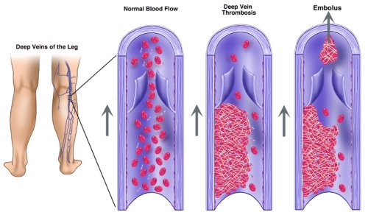**Deep vein thrombosis:**

Common predisposing factors for DVT (are included in the hypercoagulable status table):

1. **Bed rest and immobilization.**
2. **Congestive heart failure** (a cause of impaired venous return).
3. **Trauma, surgery, and burns.**
4. **Pregnancy:**

* The potential for amniotic fluid infusion into the circulation at the time of delivery can cause thrombogenesis.
* Late pregnancy and the postpartum period are also associated with systemic hypercoagulability.

1. **Tumors.**
2. **Advanced age.**

**Clinical effects of thrombosis:**

* It depends on the site of thrombosis.
* Thrombi are significant because:
* They cause obstruction of arteries and veins
* They are potential sources of emboli
* Venous thrombi have capacity to embolize to the lungs and can cause death.
* Arterial thrombi can cause vascular obstruction at critical sites and cause serious consequence e.g. ischemia and necrosis

**Embolism:**

* An embolus is a **detached** intravascular solid, liquid, or gaseous mass that is carried by the blood to a site distant from its point of origin.
* Almost all emboli represent some part of a dislodged thrombus, hence the commonly used term thromboembolism.
* The emboli ultimately lodge in vessels too small to permit further passage, resulting in partial or complete vascular occlusion leading to ischemic necrosis of distal tissue (infarction). To the organ its supply.
* Depending on the site of origin, emboli may lodge in the pulmonary or systemic circulations. Emboli impaction cause partial or complete vascular occlusion.

**Types of embolism:**

1. Pulmonary thromboembolism. 2. Systemic thromboembolism.

3. Fat embolism. 4. Air embolism.

5. Amniotic fluid embolism.

**1. Pulmonary Thromboembolism:**

* Here the embolus get lodged in the pulmonary vasculature.
* In more than 95% of cases, venous emboli originate from deep leg vein thrombi above the level of the knee.
* Depending on size of embolus, it may occlude main pulmonary artery, or impact across the bifurcation (saddle embolus),

or pass out into the smaller, branching arterioles of the pulmonary circulation.

* Rarely, embolus may pass through an interatrial or interventricular defect to gain access to the systemic circulation (paradoxical embolism). موجود عند بعض الناس اللي عندهم ثقب "فتحة" بالقلب بين الجهة اليمين واليسار "البُطينين" فبكذا تصير تمر الإمبولس بدون ما تجي الرئة وتعلق هناك.
* Most pulmonary emboli (60% to 80%) are *clinically silent because they are small*. Sudden death, right heart failure (cor pulmonale), *occurs when 60% or more* of the pulmonary circulation is obstructed with emboli.
* Embolic obstruction of small end -arteriolar pulmonary branches may result in infarction.

**2. Systemic Thromboembolism:**

* Refers to emboli traveling within the arterial circulation.
* Most (80%) arise from intracardiac mural thrombi because of myocardial infarction.
* The major sites for arteriolar embolization are the lower extremities (75%) and the brain (10%).
* Arterial emboli usually cause infarction of tissues supplied by the artery.

(The consequences of systemic emboli depend on the extent of collateral vascular supply in the affected tissue, the tissue's vulnerability to ischemia, and the caliber of the vessel occluded).

**3. Fat Embolism:**

* Microscopic fat globules may be found in the circulation after fractures of long bones (which have fatty marrow) or, rarely, in soft tissue trauma and burns.
* Fat is released by marrow or adipose tissue injury and enters the circulation through rupture of the blood vessels and act as an embolus.
* ***Fat embolism syndrome*** is characterized by pulmonary insufficiency, neurologic symptoms, anemia, and thrombocytopenia.

Less than 10% of patients with fat embolism have any clinical findings.

**4. Air Embolism:**

* Gas bubbles within the circulation can obstruct vascular flow (and cause distal ischemic injury) acting as thrombotic masses. Bubbles may coalesce to form frothy masses sufficiently large to occlude major vessels.
* Air may enter the circulation during obstetric procedures or as a consequence of chest wall injury.
* An excess of 100 cc [7]is required to have a clinical effect.

**- Decompression sickness:** “a particular form of gas embolism”

* Occurs when individuals are exposed to sudden changes in atmospheric pressure.
* Scuba and deep sea divers, underwater construction workers and individuals in unpressurized aircraft in rapid ascent are all at risk.
* When air is breathed at high pressure (e.g. during a deep-sea dive), increased amounts of gas (particularly ***nitrogen***) become dissolved in the blood and tissues. If the diver then ascends (depressurizes) too rapidly, the nitrogen expands in the tissues and bubbles out of solution in the blood to form gas emboli.
* Symptoms: ‘Grecian Bend’ i.e. joint/muscle pain and ‘chokes’ i.e. respiratory distress.
* Treatment: placing the individual in a compression chamber where the barometric pressure may be raised, thus forcing the gas bubbles back into solution followed by subsequent slow decompression.
* A more chronic form of decompression sickness is called caisson disease in which, persistence of gas emboli in the skeletal system leads to multiple foci of ischemic necrosis; the more common sites are the heads of the femurs, tibia, and humeri.

**5. AMNIOTIC FLUID EMBOLISM:**

* A grave and uncommon complication of labor and the immediate postpartum period, caused by infusion of amniotic fluid or fetal tissue into the maternal circulation via a tear in the placental membranes or rupture of uterine veins.
* Characterized by sudden severe dyspnea, cyanosis, and hypotensive shock, followed by seizures and coma.
* If the patient survives the initial crisis, pulmonary edema develops, along with disseminated intravascular coagulation, owing to release of thrombogenic substances from amniotic.
* Microscopy: presence in the pulmonary microcirculation of squamous cells shed from fetal skin, lanugo hair, fat from vernix caseosa (material coating the skin of newborn), and mucin derived from the fetal respiratory or gastrointestinal tract. Marked pulmonary edema and diffuse alveolar damage are also present. Systemic fibrin thrombi indicative of DIC can also be seen.

"اللهم لا سهل إلا ما جعلته سهلًا و أنت تجعل الحزن إذا شئت سهلًا"

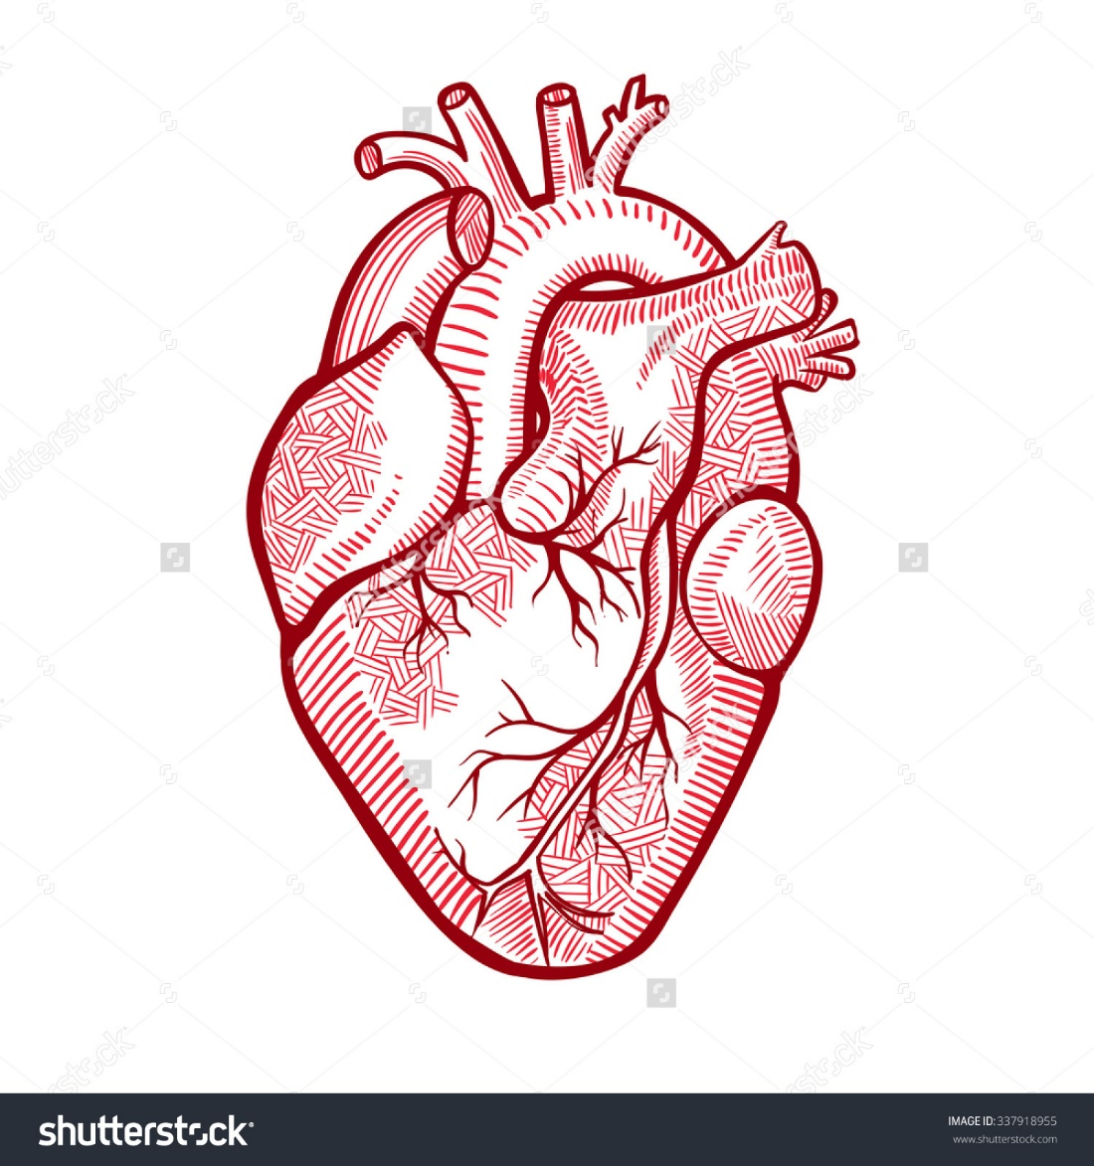

**القادة**

**نوره عبدالله السهلي عبدالعزيز عبدالله العنقري**

**الأعضاء**

[**MCQs**](https://1drv.ms/p/s!AtGQas5JeJTggQQbY3-xGfgmNmHQ)**:** [**https://onedrive.live.com/view.aspx?resid=E0947849CE6A90D1!132&ithint=file%2cpptx&app=PowerPoint&authkey=!ABtjf7EZ-CY2YdA**](https://onedrive.live.com/view.aspx?resid=E0947849CE6A90D1!132&ithint=file%2cpptx&app=PowerPoint&authkey=!ABtjf7EZ-CY2YdA)

**يزيد عبيد الله المطيري عبدالعزيز علي ال محمد**

**عبدالعزيز هاني القرموشي ريان محمد القرني**

**عبدالرحمن عمران العمراني مـبشر الاسمـــري**

**عبدالكريم محمد الحربي عبدالله بن أحمد العيدان**

**سعود الشنيفي محمد عبدالعزيز الدعيج**

**طلال الطخيم**

[**Editing File**](https://onedrive.live.com/view.aspx?resid=E0947849CE6A90D1!120&ithint=file%2cpptx&app=PowerPoint&authkey=!ALNSNNVHKfyykhY)

**Email:** pathology436@outlook.com **Twitter:** @pathology436

1. A slowing or stoppage of the normal flow of a bodily fluid.
2. Sudden, violent or unsteady movement of water or air.
3. Platelets-derived growth factor is one of numerous factors, or proteins that regulate cell growth and division.
4. *not important
5. Develop in heart chambers.
6. Is the motion in the direction opposite to the movement of something “here it is against blood flow”
7. A cubic centimeter is a commonly used unit of volume. In injections.