6. Vasculitis

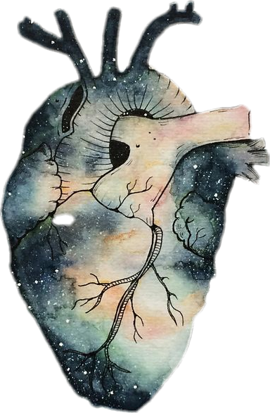
Black: Doctor’s slides.
Red: important!
Green: Doctor’s notes.
Grey: Extra.
Bold black: New terminology.
Purple: Female’s slides.
Blue: Male’s slides.
Objectives:
1- Understand the basic pathology of thrombogenesis and the risk factors for development of deep vein thrombosis.
2- Know the types of embolus than can occur and the pathology of pulmonary embolism.
3- Know the common causes of vasculitis with special emphasis on the clinic-pathological features and mechanism of: A. Giant cell arteritis. B. Polyarteritis nodosa.
C. Wegener's granulomatosis. D. Cutaneous hypersensitivity vasculitis and Henoch Schonlein purpura.
Normal Artery
Giant-Cell (Temporal) Arteritis
Vasculitis
Physical or chemical injury

It is inflammation of vessel walls with many possible symptoms
Effects of vacuities

Most common type
Definition
Definition

Causes
Vasculitis can be classified according to the size of the vessel, which is affected.
Vasculitis can be classified according to the size of the vessel which is affected.
Causes

Infection
(If it is caused by infection, it is usually seen in immunocompromised patients with fungal infection)

It is usually immune mediated
*Immune complex deposition¹.
*Antineutrophil cytoplasmic antibodies (ANCAs)²
*Anti-endothelial cell antibodies³ .
* Autoreactive⁴ T cells.
(Usually treated by rheumatologist)⁵

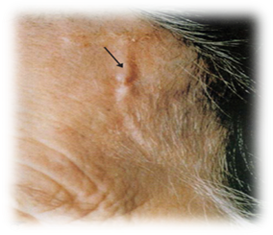
Giant-Cell (Temporal) Arteritis:
Most common type of vasculitis. Chronic, granulomatous inflammation of large to small arteries, especially in head particularly the branches of the carotid artery (temporal artery and branches of the ophthalmic artery).
¹ Hypersensitivity type III.
² A group of autoantibodies, mainly of the IgG type, against antigens in the cytoplasm of neutrophil granulocytes.
³ Cross- reaction antigens (Molecular Mimicry).
⁴ Exhibiting an immune response against the body's own antigens.
⁵ Rheumatologists deal with many clinical problems including autoimmune diseases.

- Patients more than 50yrs of age. Female: Male = 2:1.
- Involvement is segmental*next page in green , acute and chronic

j
*Only section of the artery that are affected – not the entire artery. that means if you can’t see any affected tissue you can’t for sure exclude the disease, because it is possible that you took unaffected section of blood vessel. It also means that when biopsy is done, you have to take a long section of artery.

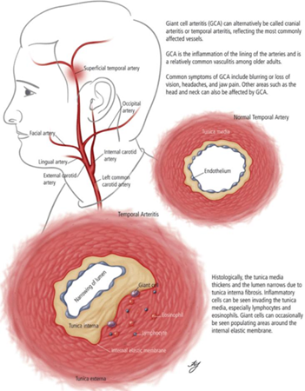
Clinical feature:
The course of carotid artery
Symptoms:
- fever, facial pain or headache, often most intense along the course of the superficial temporal artery.
- Thickened and painful temporal artery. (temporal artery which is a branches of carotid artery, always associated with headache)
- Jaw pain. (If the effected artery is facial a. which is a branch of carotid artery)
- Visual problems and acute vision loss. ‘may lead to sudden blindness’ (ophthalamic artery).
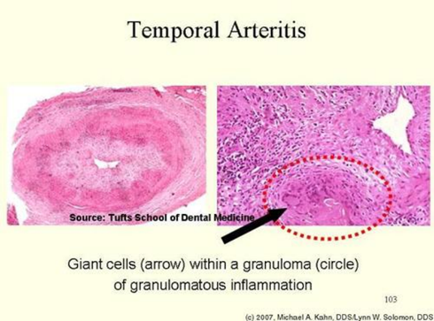
Morphology:
- Granulomatous inflammation (with collection of histiocytes) of the blood vessel wall.
- Giant cells.
- Disruption and fragmentation of internal elastic lamina.
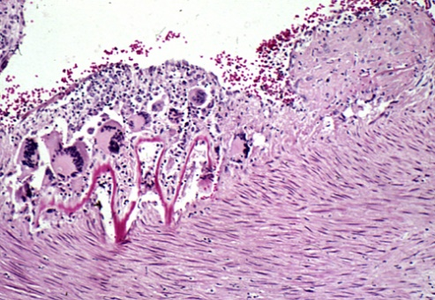
- Proliferation of the intima (which lead to increase the thickness) with associated occlusion of the lumen.
- The healed stage reveals collagenous thickening of the vessel wall and the artery is transformed into a fibrous cord.

Diagnosis and treatment:
The diagnosis depends on biopsy (we take it from the artery) and histologic confirmation. Treatment: corticosteroids (to weaken immune response –as we said that the main cause of vacuities in general is autoimmunity)
Dr. Ahmed -----You should now about Giant-Cell Arteritis: the patient presents with headache, blindness, affect the temporal artery mainly, Granulomatous, segmental, more common in female and older age.

Polyarteritis Nodosa (PAN)
- Cutaneous only or systemic
- Disease of young adults.
- There is segmental necrotizing inflammation of arteries
of medium to small size, in any organ (especially kidney&skin) except the lungs.
- Most frequently kidneys (most common), heart, liver, and gastrointestinal tract.
- Polyarteritis nodosa has been associated with hepatitis B or hepatitis C virus infection.

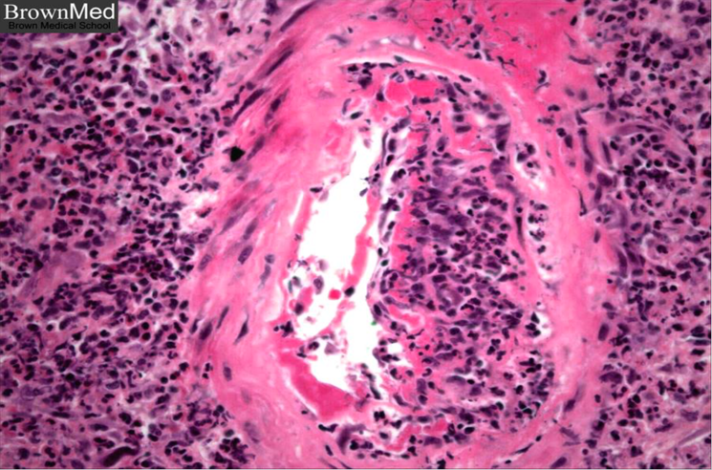
Polyarteritis nodosa with segmental inflammation and fibrinoid necrosis and occlusion of the lumen of this artery. Note that part of the vessel wall at the left side is uninvolved

- Clinical manifestations result from ischemia and infarction of affected tissues and organs.
- Weakening of the arterial wall due to the inflammatory process may cause aneurysmal dilation or localized rupture.
- Fever, weight loss, abdominal pain and melena (bloody stool), muscular pain and neuritis.
- Renal arterial involvement is often prominent and is a major cause of death.
- Particularly characteristic of PAN is that all the different stages of activity (i.e. active and chronic stages) may coexist in same artery or in different artery at the same time.
- Fatal if untreated, but steroids and cyclophosphamide are curative⁶.

Wegener granulomatosis
Is a necrotizing vasculitis characterized by the triad of:
- necrotizing granulomas of the upper and lower respiratory tract.
- necrotizing or granulomatous vasculitis of small to medium-sized vessels.
- renal disease in the form of necrotizing, crescentic, glomerulonephritis.

- Males are affected more often than females, at an average age of about 40 years
- C-ANCAs (Antineutrophilic Cytoplasmic Antibodies) is positive in serum of more than 95% of patients.
- Persistent pneumonitis, chronic sinusitis, mucosal ulcerations of the nasopharynx, and evidence of renal disease.
Untreated: fatal - may lead to death within 2 years if not treated.
If the patient present with these triad do the serology test for C-ANCAs then take a biopsy to confirm the diagnosis for Wegener granulomatosis

6.علاجي
- Wegener granulomatosis: palatal destruction
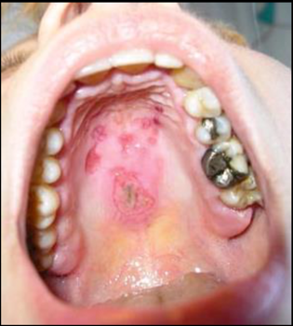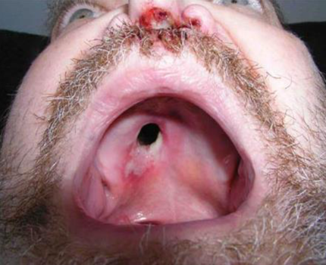
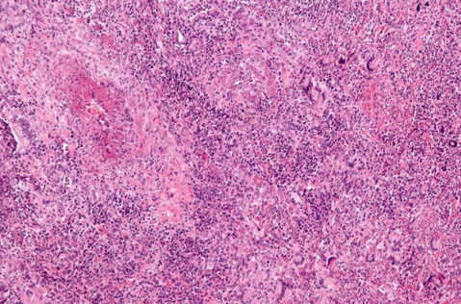
- WG microscopically:
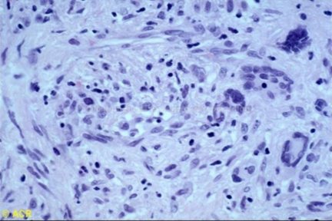
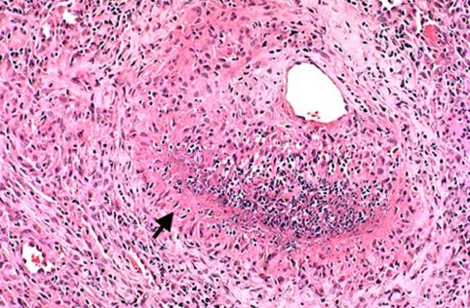

Microscopic polyangitis \ polyarteritis:
It is a systemic small vessel vasculitis associated with glomerulonephritis.
- P-ANCA⁷ is characteristically present.
- In the past, it has been confused with leukocytoclastic vasculitis.

Churg-Strauss syndrome (additional reading):
- Eosinophil-rich and granulomatous inflammation involving the respiratory tract and necrotizing vasculitis affecting small vessels.
- Associated with asthma and blood eosinophilia. And also associated with p-ANCAs1.

Cutaneous leukocytoclastic or hypersensitivity vasculitis (angiitis):
Leukocytoclastic: Leukocyto= White blood cells, clastic=fragmentation (karyorrhexis)

- Necrotizing vasculitis of arterioles, capillaries, venules.
- Inflammation of small blood vessels (commonly seen in the dermis of skin), characterized by palpable⁸ purpura⁹.
- Can be cutaneous or systemic.
- It is the most common vasculitis seen in clinical practice.
- Leukocytoclasis refers to the nuclear debris (karyorrhexis) of infiltrating neutrophils in and around the vessels.
- All lesions tend to be of the same age¹⁰.
- It affects many organs e.g. skin (most common), mucous membranes, lungs, brain, heart, GI, kidneys and muscle.

7. Anti-neutrophil cytoplasmic antibodies test
8.واضح
9. Condition of red or purple discolored spots on the skin that do not blanch on applying pressure.
10. All chronic or all acute

- Skin biopsy is often diagnostic.
- Histologically there is infiltration of vessel wall with neutrophils, which become fragmented called as leukocytoclasia or nuclear dust.
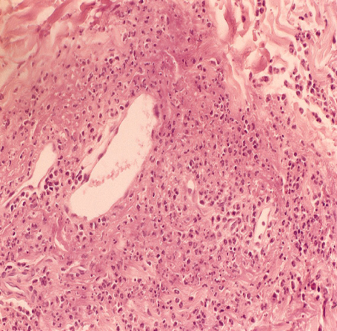
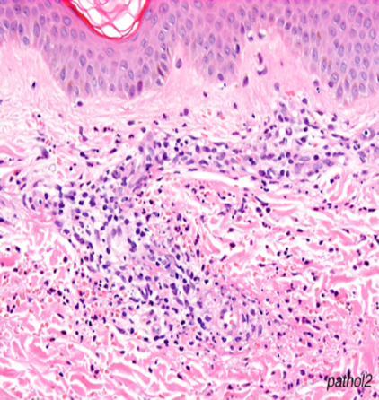
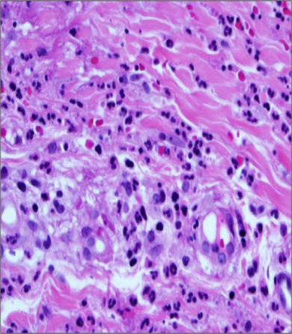
Leukocytoclastic vasculitis in a skin biopsy showing fragmentation of neutrophil nuclei in and around vessel walls.

Hencoch- Schonlein purpura (HSP):
- Is IgA- mediated autoimmune systemic disease, in which the small vessels show leukocytoclastic (hypersensitivity) vasculitis.
- It causes skin purpura, arthritis, abdominal pain, gastrointestinal bleeding, orchitis¹¹ and nephritis.
- The etiology is unknown.
- Serum level of IgA are high.
- IgA and C3 (complement component) are deposited on arterioles, capillaries and venules.
You will see it in pediatric patient more than adult

¹¹.إلتهاب الخصية
Thromboangiitis obliterans (Buerger disease):
- It is characterized by segmental, thrombosing, acute and chronic inflammation of medium-sized and small arteries, principally of the leg and hands (tibial and radial arteries), with occasional secondary extension into adjacent veins and nerves.
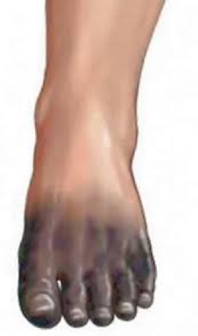
- Occurs almost exclusively in heavy smokers of cigarettes, usually beginning before age 35.
- Tobacco either leads to direct toxicity to endothelium, or induces an immune response.
- Clinical features include:
- pain in the affect hand or foot induced by exercise (called instep claudication¹²).
- Patients can have pain even at rest, due to the neural involvement.
- Chronic ulcerations of the toes, or fingers may appear followed in time by gangrene.

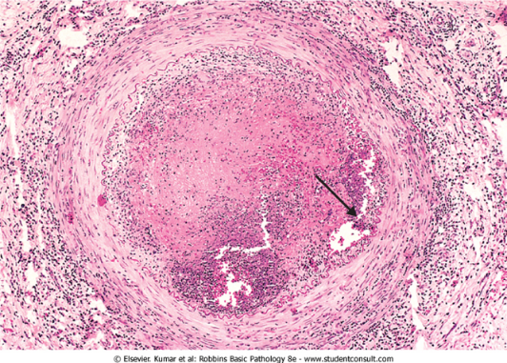
- Abstinence from cigarette smoking in the early stages of the disease brings relief from further attacks.
- Microscopically, there is acute and chronic inflammation, accompanied by luminal thrombosis.
- The inflammatory process extends into adjacent veins and nerves (rare with other forms of vasculitis).
- And in time all three structures become encased in fibrous tissue.
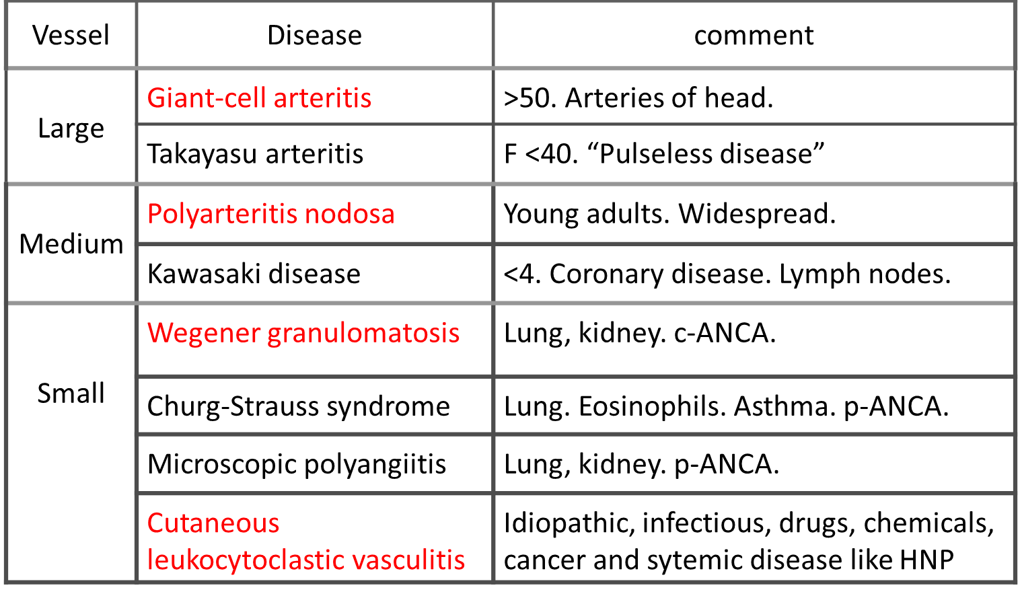

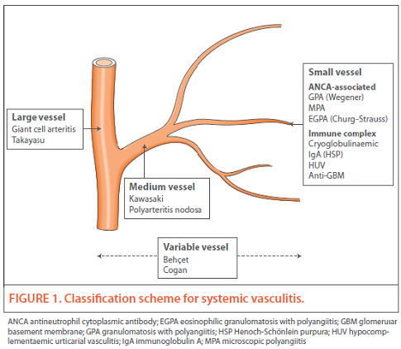

12. Claudication: pain induced by insufficient blood flow during exercise. Instep: the raised middle part of the top of your foot.
"اللهم لا سهل إلا ما جعلته سهلًا و أنت تجعل الحزن إذا شئت سهلًا"
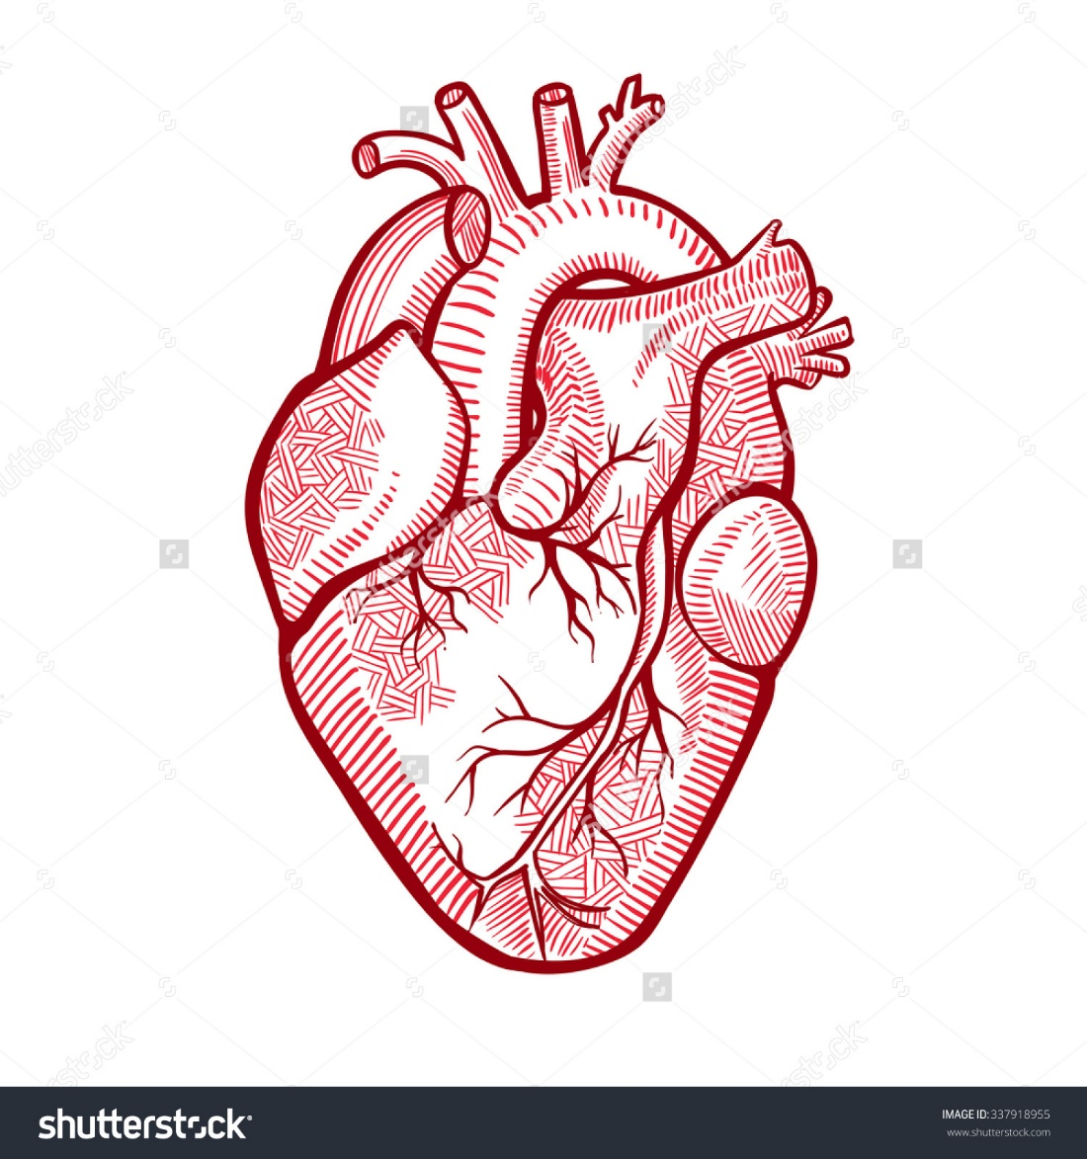

MCQs: https://onedrive.live.com/view.aspx?resid=E0947849CE6A90D1!132&ithint=file%2cpptx&app=PowerPoint&authkey=!ABtjf7EZ-CY2YdA

Editing File
Email: pathology436@outlook.com Twitter: @pathology436

القادة
عبدالعزيز عبدالله العنقري نوره عبدالله السهلي
الأعضاء

آمال الشيبي نجد الذيب
دينا النويصر غادة المزروع
أشواق الماجد ريما الشايع
منيرة الضفيان رنيم الغامدي
عبدالعزيز ال محمد

