King Saud University
College of Medicine
Medical Education Department

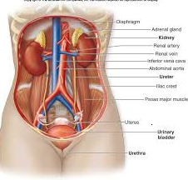

TUTOR’S GUIDE OF CLINICAL SKILLS
Renal Block
(Renal 114)
YEAR 1
2016-2017
(1437-1438)

King Saud University
College of Medicine
Medical Education Department

Renal Block
(Renal 114)
(Academic year 1437-1438)
Year 1

Copyright Statement

This material is protected by copyright laws. For any other purposes other than teaching and research in the King Saud University, no part may be reproduced or copied in any form or by any means without prior permission of the King Saud University.
© King Saud University, Saudi Arabia, 2016.

TABLE OF CONTENTS
Introduction and Rationale | 4
Objectives of the Clinical Skills | 5
Teaching and Learning Modes | 6
Mode of Assessment | 6
Learning Resources | 6
Academic Support Team | 7
OSCE Template | 8-13
Checklists | 14-28
Tutor (Instructors) Guidelines During Clinical Skills Teaching | 29
Schedule of Clinical Skills | 30

Skills lab Committee
Dr Mona Suliman
Dr Sami Nassar
Dr Mahmoud Salah
Dr Sahar Mostafa
Dr Nordin Pumbaya
Mr. Chadi Diab
Dr Milda Hani Eid

Checklists revised by Dr Nahla Azzam (Department of Medicine)

Introduction and rationale:

Early students’ clinical exposure to skills is essential for systematically learning and developing clinical skills appropriate to working in a clinical environment, and application of skills when they move onto their clinical rotations.
The transition from preclinical to clinical training is huge for the students and several studies have documented that the transition is quite stressful. (O’Brien et al., 2007).
We aim from the clinical skills to do a smooth transition in clinical skills from preclinical to clinical years.
The clinical skills took in consideration the requirement of SaudiMed for the graduates of Saudi medical students through integration with the different blocks and courses.
The clinical skills will be learnt through spiral approach system to gradually increase students’ confidence in performance when interacting with patients during their clinical years.

The aims of early clinical skills teaching:
- improvement in the students’ knowledge and competence to perform examinations
- Increased student’s perceived levels of confidence.
- Enrichment of the safe environment that helps in bridging the gap between the preclinical and clinical years in medical undergraduate education. (Swamy et al., 2013)
Objectives of the Clinical Skills:
RENAL 114
By the end of this course the students should be able to know and show how:
- To take a history related to renal symptoms
- To recognize the different types of catheters
- Show how to insert the folly’s catheter
- To perform the renal examination

Tutorials (3 hours):
W1 | Take a history related to renal symptoms
W2 | Recognize different types of catheters/ insert the folly’s catheter
W3 | Renal examination
W4 | OSCE

Week 1: Take a history related to renal symptoms
Objectives: By the end of the session the students should:
- Show how to take a history related to renal symptoms from simulated patient
- Show a good communication with patient
Week 2: Catheter
Objectives: By the end of the session the students should:
- Recognize different types of catheters
- Show how to insert Folly’s catheter on a manikin

Week 3: Renal examination.
Objectives: By the end of the session the students should:
- Show how to perform renal examination on simulated patient

Teaching and Learning Modes:
- The clinical skills will be learnt by hands on the different clinical skills.
- The tutor will do a demo in front of students, and then each student is expected to do by himself
- The tutor will give feedback to the students according to the provided checklists
Mode of assessment: 5 marks
The marks will be the student’s performance on OSCE.

Learning Resources:
- The clinical skills tutor
- The clinical skill lab facilities during SDL (need to be arranged with the clinical skill staff in advance)
- The provided checklists
- Recommended reference textbooks and website:
- Physical Exam by Barbara Bates
- Current Medical Diagnosis
- Current Surgical Diagnosis

Website:
-Martindales Clinical Examination (martindalecenter.com)

Academic Support Team  CHAIRPERSON : Dr. Malak Al Hazmi  Pathology Department  Extension :  Mobile : / Bleep :  Email : |  | CO-CHAIR :  Department  Extension :  Mobile : / Bleep :  Email :
MEMBERS | DEPARTMENT | CONTACTS | E-MAIL ADDRESS
Mr Chadi Diab | Clinical skills | Extension : 92829 | chadi79diab@hotmail.com
Dr. Milda | Clinical skills | Extension : 92587  Mobile : | dr.milda@hotmail.com
Dr. Nur | Clinical skills | Extension : 92589  Mobile : | dr.strange@ymail.com
Dr. Sahar Mostafa | Clinical skills | Extension: 56526 | samoustafa@yahoo.com

OSCE template

Sheet 1
College of Medicine
Department of Medical Education
Objective Structured Clinical Examination

(Information for student)

Patient Brief Record (A brief background of the patient or the condition):

TASK TO BE PERFORMED BY THE CANDIDATE:

Station Duration: (for example 5 minutes or ……..)

Any other special instructions:

Sheet 2
College of Medicine
Department of Medical Education
Objective Structured Clinical Examination

Patient’s Scenario/ Instructions to Patient
A brief description of the condition or case to be portrayed;
• Tasks to be performed by the candidate;
• The role of the simulated patients;
• The opening statement, if any, by the simulated patients;
• Expected questions from the candidate and suggested answers;
• The demeanor of the simulated patients;
• List of dos and don’ts.

Sheet 3
Instructions to Examiners
Depending on the case, typical instructions to the examiners may include:
• The nature of the stations;
• The tasks to be performed by the candidate;
• The findings of the patient/mannequins;
• The expected level of competency required to pass the station;
• The difficulty level of the station;
• The role of examiners during the OSCE.

Sheet 4
College of Medicine
Department of Medical Education
Objective Structured Clinical Examination

Candidates Name:
2 | 1 | 0
Marking schedule (Select the domain according to the station objective/s only)
- Professional behavior

- Data Gathering

- Examination

- Management

Grades % Total

Passed Borderline Failed

Sheet 5

College of Medicine
Department of Medical Education
Objective Structured Clinical Examination

REQUIREMENTS

- Number of Cases
- Number of Examiners
- Number of Role players
- Instruments
- Place/Rooms

Sheet 6
List of requirements for the OSCE station

Cases | Requirements | Remarks
Case 1
Case 2
Case 3
Case 4
Case 5
Case 6
Case 7
Case 8
Case 9
Case 10

Checklists

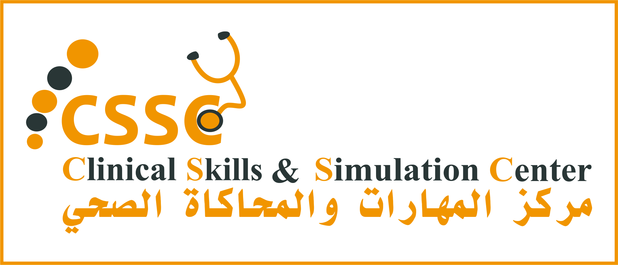
King Saud University
College of Medicine
Department of Medical Education
Riyadh, KSA

Week 1: Renal History Taking
- OBJECTIVE: To take an ideal history related to Renal signs and symptoms.
MATERIALS: there will be standardized patient to take the history from.

D: Appropriately done PD: Partially done ND: Not done/Incorrectly done
 | STEP/TASK | D | PD | ND
 | Introduce yourself to the patient.
1. | Personal data
 | Name, Age, Gender, Nationality, Occupation.
2. | Chief complain
 | Short statement of the problem that brought the PT, better recorded in the patient’s own words.
3. | History of presenting illness.
Onset (acute, subacute, chronic and insidious), Duration, Course of the condition (static, progressive, or relapsing and remitting), Aggravating & Reliving Factors, and Associated symptoms: such as Pain (Dysuria, Pyuria, Dyspnea, Lethargy, Syncope / Dizziness, Oedema, fever.)
*Pain should be further defined in terms of the following: Location, Radiation, Quality, Severity, and Aggravating & Reliving Factors.
4. | Past Medical History
 | Same situation before, Loin or flank pain & peripheral vascular disease.
 | Chronic disease (DM, HTN …), recurrent UTI.
 | History of hospitalization : Admission, Surgery, Blood Transfusion.
5. | Family & Social History
 | Same situation in the family, chronic disease (DM, HTM), congenital & hereditary diseases.
 | Marital status, No. of children, housing status, job status & environment / conclude: socioeconomic status. History of travelling.
 | Habits: smoking, drinking Alcohol, using prohibited substances.
6. | Drug history:
 | Any recent medication, long term medication, Allergies, Herbal Medication.
7. | Systemic review:
 | CNS , RES, GIT, UT, Endocrine,Muskulo-Skeletal
 | SUMMRY

Sources and References:

Books

1. Bates' guide to physical examination and history-taking
Lynn S.Bickley - Peter G.Szilagyi - Barbara Bates - Wolters Kluwer Health/Lippincott Williams & Wilkins – 2013
2. Clinical Examination: A Systematic Guide to Physical Diagnosis
Simon O'Connor - Nicholas Joseph.Talley - Elsevier – 2014
3. Current medical diagnosis & treatment
Stephen J.McPhee - Maxine A.Papadakis - McGraw-Hill Medical - 2012

SP CASE SCRIPT (Pyelonephritis)
Your role in this session is to role-play a patient with Kidney infection.
Pyelonephritis is an inflammation of the kidney tissue, calyces, and renal pelvis.^{[1]} It is commonly caused by bacterial infection that has spread up the urinary tract or travelled through the bloodstream to the kidneys.^{[2]}
Trigger
You have applied to your GP with a chief complaint of Rightt loin pain
Wait for the Doctor’s (student) questions and answer them based on the provided list below:
Personal and Social History; name, age, gender, occupation – Use as your own.
Single, living with parents. No alcohol and tobacco use.

Possible questions about the present complaint:
- When did you first notice this problem? When did it start?
I started noticing it around 2-3 days ago.
- How do you describe the pain? Pain is vague like discomfort on my lower back more on the right side.
- Is there pain on urination? Feels like there is burning sensation on urination.
- How many times you are going to urinate?
At least 4-5 times a day.
- Can you tell me more about your urine (color, odor, volume)?
Color (yellow to orange, darker than usual), Odor (strange odor I can not describe), Volume (seems the same amount).
- Do you have urgency (do you have problems to reach the bathroom on time)
No, I don’t have (urgency).

- How about your appetite/eating habit?
My appetite seems to have decreasaed.
- Did you have fever? I feel like having chills but did not take my temperature
- Have you seen any other health care professional about these problems?
No, I haven't seen a doctor for a while.
- Do you have any additional complaint?
I feel a little bit tired. Sometimes I feel nauseated
- Have you noticed anything that makes these problems better or worse?
No. I didn’t recognize anything particular.
- Are you on any medication?
No.

Past medical history: No important disease history. No operation. Noted episodes of Hospitalization during childhood due to fever.
Family history: Parents are healthy and alive, no major disease history.
Clinical Skills Guide
History Taking
Learning Objectives
- To understand main components of medical history taking and interview
- To describe general features of medical history including present illness, past medical history, family history.

THE SEQUENCE OF THE INTERVIEW
- Greeting the patient and establishing rapport
- Inviting the patient’s story
- Establishing the agenda for the interview
- Expanding and clarifying the patient’s story; generating and testing diagnostic hypotheses
- Creating a shared understanding of the problem(s)
- Negotiating a plan (includes further evaluation, treatment, and patient education)
- Planning for follow-up and closing the interview.

THE TECHNIQUES OF SKILLED INTERVIEWING
_ Active listening
_ Adaptive questioning
_ Nonverbal communication
_ Facilitation
_ Echoing
_ Empathic responses
_ Validation
_ Reassurance
_ Summarization
_ Highlighting transitions

EXPLORING THE PATIENT’S PERSPECTIVE
_ The patient’s thoughts about the nature and the cause of the problem
_ The patient’s feelings, especially fears, about the problem
_ The patient’s expectations of the clinician and health care
_ The effect of the problem on the patient’s life
_ Prior personal or family experiences that are similar
_ Therapeutic responses the patient has already tried

ADAPTIVE QUESTIONING: OPTIONS FOR CLARIFYING THE PATIENT’S STORY
_ Directed questioning—from general to specific
_ Questioning to elicit a graded response
_ Asking a series of questions, one at a time
_ Offering multiple choices for answers
_ Clarifying what the patient means

THE FORMAT OF THE COMPREHENSIVE HEALTH HISTORY

Identifying Data
Such as age, gender, occupation, marital status

Source and Reliability of History
Usually the patient, but can be family member, friend, letter of referral, or the medical record
Varies according to the patient’s memory, trust, and mood
Chief Complaint
The one or more symptoms or concerns causing the patient to seek care

THE SEVEN ATTRIBUTES OF A SYMPTOM
1. Location. Where is it? Does it radiate?
2. Quality. What is it like?
3. Quantity or severity. How bad is it? (For pain, ask for a rating on a scale of 1 to 10.)
4. Timing. When did (does) it start? How long did (does) it last? How often did (does) it come?
5. Setting in which it occurs. Include environmental factors, personal activities, emotional reactions, or other circumstances that may have contributed to the illness.
6. Remitting or exacerbating factors. Does anything make it better or worse?
7. Associated manifestations. Have you noticed anything else that accompanies it?

Symptom description mnemonic: OPQRST-AAA
One tool that some clinicians find helpful is using the mnemonic OPQRST-AAA to elicit the details
of a pain complaint. With minimal modifications this mnemonic is easily adaptable to other
symptoms (fever, cough, dizziness etc.) The exact content of the mnemonic varies with different
sources, but one rendering is:

O - Onset
P - position/pattern (or provocation/palliation, also represented below as A - aggravating/alleviating)
Q - Quality
R - Radiation
S - severity (or site)
T - timing
A - aggravating/alleviating factors
A - associated symptoms
A - attributions/adaptations

History of Present Illness
Amplifies the Chief Complaint, describes how each symptom developed
Includes patient’s thoughts and feelings about the illness
May include medications, allergies, habits of smoking and alcohol, since these are frequently pertinent to the present illness

Past Medical History
Lists childhood illnesses
Lists adult illnesses with dates for at least four categories: medical; surgical; obstetric/gynecologic; and psychiatric. Includes health maintenance practices such as: immunizations, screening tests, lifestyle issues, and home safety

Family History
Outlines or diagrams of age and health, or age and cause of death of siblings, parents, and grandparents
Documents presence or absence of specific illnesses in family, such as hypertension, coronary artery disease, etc.

Personal and Social History
Describes educational level, family of origin, current household, personal interests, and lifestyle

Review of systems
Differential Diagnosis/ Impression
Sources and References:

A. Books

1. Bates' guide to physical examination and history-taking
Lynn S.Bickley - Peter G.Szilagyi - Barbara Bates - Wolters Kluwer Health/Lippincott Williams & Wilkins – 2013
2. Clinical Examination: A Systematic Guide to Physical Diagnosis
Simon O'Connor - Nicholas Joseph.Talley - Elsevier – 2014
3. Current medical diagnosis & treatment
Stephen J.McPhee - Maxine A.Papadakis - McGraw-Hill Medical - 2012

Week 2: Urinary Catheterization (Female) OBJECTIVE: To perform a proper female urinary catheterization with Foley Catheter.
MATERIALS: Well illuminated examination room, examination table, clean glove, sterile glove, foam body cleanser or cleanse wipes, Foley catheter, sterile tray, sterile underpad, sterile fenestrated drape, antiseptic solution (povidone iodine etc.), betadine swabs, sterile cotton balls/sterile gauze, forceps, sterile lubricant, sterile lidocaine, syringe, sterile water, drainage bag, dressing tape.

D: Appropriately done PD: Partially done ND: Not done/Incorrectly done
 | STEP/TASK | D | PD | ND
 | Preparation
1. | Introduce yourself to the patient.
2. | Confirm patient’s ID.
3. | Explain the procedure and reassure the patient.
4. | Get patient’s consent.
5. | Wash hands.
6. | Prepare the necessary materials in a tray (check and ensure the integrity and the sterility).
7. | Position the patient in a lying position; uncover her lower body with legs apart- knees bending and groin exposed (maintain the patient’s privacy and dignity).
(Consider washing the patient’s genital area before the procedure if visibly soiled. After putting on clean gloves, wash patient’s genital area thoroughly with foam body cleanser or cleanse wipes. Remove gloves and wash hands).
 | Procedure
8. | Put on sterile gloves and use strict sterile technique for the foley insertion procedure.
9. | Take the sterile underpad and place it (plastic side down) beneath the patient.
10. | Take the sterile fenestrated drape and position it around the patient’s genitalia.
11. | Draw up 5 ml sterile water into a syringe (if pre-filled syringe is not provided with the pack).
12. | Dispense the lubricating gel into the tray, pour antiseptic solution over three cotton balls.
13. | Remove the plastic sleeve from the catheter, lock the sterile water syringe into the port and check the integrity of the retention balloon. Place the catheter on the sterile site.
14. | Separate the labia using the non-dominant hand and visualize the meatus.
Do not touch any sterile material with this hand for the rest of the procedure.
15. | Grasp one cotton ball with the forceps, wipe one side of the labia from top to bottom and discard the cotton ball away from the sterile field. Repeat on the opposite side and then wipe down the middle using the third cotton ball.
16. | Using the dominant (sterile) hand, handle the catheter, cover the tip of the catheter with lubricant.
17. | Insert the lubricated catheter firmly into the meatus and gently advance it until you see the urine in the catheter/drainage bag.
18. | Once a stream of urine is obtained, advance catheter 3-4 cm. More and inject 5 ml of sterile water to inflate the catheter's balloon (ensure that this does not cause the patient any pain).
19. | Gently retract the catheter until a resistance is felt.
20. | Attach the catheter bag and hang it to the bed.
21. | Remove the gloves.
22. | Tape the catheter to the thigh.
 | After the procedure
23. | Ensure that the patient is comfortable.
24. | Make explanations to the patient, answer his questions and discuss management plan.
25. | Dispose of sharps and waste material according to infection control standards.
26. | Wash hands.
27. | Document the procedure.

This document is available at https://www.facebook.com/groups/173907012758220/files/

Urinary Catheterization (Male)
OBJECTIVE: To perform a proper male urinary catheterization with Foley Catheter.
MATERIALS: Well illuminated examination room, examination table, clean gloves, sterile gloves, foam body cleanser or cleanse wipes, Foley catheter, sterile tray, sterile underpad, sterile fenestrated drape, antiseptic solution (povidone iodine etc.), betadine swabs, sterile cotton balls/sterile gauze, forceps, sterile lubricant, sterile lidocaine, syringe, sterile water, drainage bag, dressing tape.

D: Appropriately done PD: Partially done ND: Not done/Incorrectly done
 | STEP/TASK | D | PD | ND
 | Preparation
1. | Introduce yourself to the patient.
2. | Confirm patient’s ID.
3. | Explain the procedure and reassure the patient.
4. | Get patient’s consent.
5. | Wash hands.
6. | Prepare the necessary materials in a tray (check and ensure the integrity and the sterility).
7. | Position the patient in a lying position; uncover his lower body with legs apart and groin exposed (maintain the patient’s privacy and dignity).
(Consider washing the patient’s genital area before the procedure if visibly soiled. After putting on clean gloves, wash patient’s genital area thoroughly with foam body cleanser or cleanse wipes. Remove gloves and wash hands).
 | Procedure
8. | Put on sterile gloves and use strict sterile technique for the foley insertion procedure.
9. | Take the sterile underpad and place it (plastic side down) beneath the patient.
10. | Take the sterile fenestrated drape and position it around the patient’s genitalia.
11. | Draw up 5 ml sterile water into a syringe (if pre-filled syringe is not provided with the pack). (Draw up 5 ml. sterile lidocaine if you consider to use such as patients with enlarge prostates).
12. | Dispense the lubricating gel into the tray, pour antiseptic solution over three cotton balls.
13. | Remove the plastic sleeve from the catheter, lock the sterile water syringe into the port and check the integrity of the retention balloon. Place the catheter on the sterile site.
14. | Retract the foreskin, if present, hold the shaft of the penis with the non-dominant hand.  (You may Inject 3-5 ml. sterile lidocaine into the urethra and firmly pinch the end of the penis for 1-2 minutes to retain the lidocaine with in the urethra.)
Do not touch any sterile material with this hand for the rest of the procedure.
15. | Using a circular motion, wipe the glans from the meatus outward three times with three different cotton balls/swabs.
16. | Using the dominant (sterile) hand, handle the catheter, cover the tip of the catheter with lubricant.
17. | Grasp the penis in an upright position and insert the lubricated catheter firmly into the meatus and gently advance it until you see the urine in the catheter/drainage bag.
18. | Once a stream of urine is obtained, advance catheter 3-4 cm. More and inject 5 ml of sterile water to inflate the catheter's balloon (ensure that this does not cause the patient any pain).
19. | Gently retract the catheter until a resistance is felt.
20. | Attach the catheter bag and hang it to the bed.
21. | If the foreskin was retracted, reposition it after placement.
22. | Remove the gloves.
23. | Tape the catheter to the thigh.
 | After the procedure
24. | Ensure that the patient is comfortable.
25. | Make explanations to the patient, answer his questions and discuss management plan.
26. | Dispose of sharps and waste material according to infection control standards.
27. | Wash hands.
28. | Document the procedure.

References:

A. Books

1. Bates' guide to physical examination and history-taking
Lynn S.Bickley - Peter G.Szilagyi - Barbara Bates - Wolters Kluwer Health/Lippincott Williams & Wilkins – 2013
2. Clinical Examination: A Systematic Guide to Physical Diagnosis
Simon O'Connor - Nicholas Joseph.Talley - Elsevier – 2014
3. Current medical diagnosis & treatment
Stephen J.McPhee - Maxine A.Papadakis - McGraw-Hill Medical - 2012

B. Websites
1. OSCE Skills
http://www.osceskills.com/

Types and sizes of catheters
Diameters:
- 5Fr, 6fr, 8fr 10fr, 12fr, 14fr, 16fr, 18fr, 20fr, 22fr, 24fr, 26fr.
- The higher the number the larger the diameter of the catheter.
- 1Fr. = 3mm (i.e. a 24fr. catheter is 8mm in diameter)

Types:
1-Straight Catheters -single use catheters

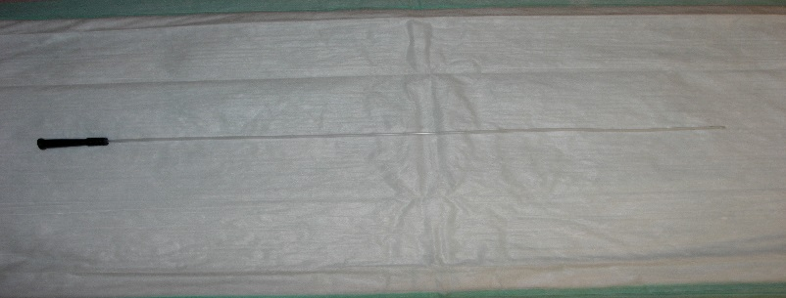

- Have a single lumen with a small 1¼ cm opening.

2- Two (2)-way Foley catheters (retention catheters)

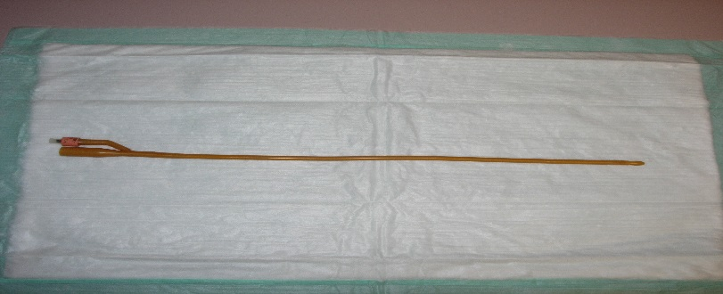

- Have an inflatable balloon that encircles the tip near the lumen or opening of the catheter.

3-Curved or Coude

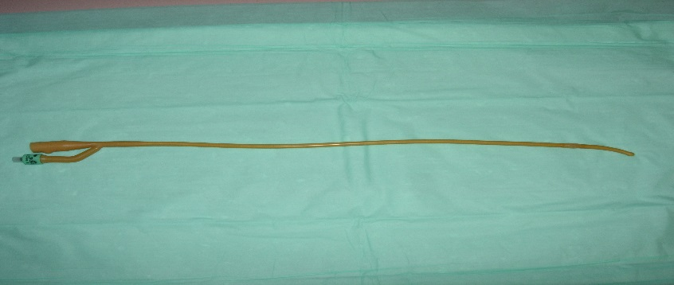

- Catheters have a rounded curved tip (elbowed) used in older male patients with enlarged prostates which partially obstruct the urethra.

4- Three (3)-way Foley catheter

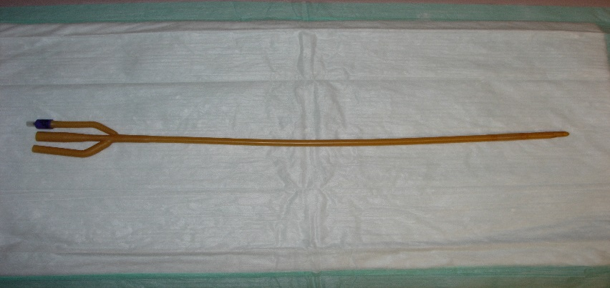

- Often called retention catheter, they have 2 or 3 lumens that encircle the body of the catheter. One lumen drains the urine through the catheter into a collection bag. The second lumen holds the sterile water when the catheter is inflated and is also used to deflate the balloon. The third lumen maybe used to instill medications into the bladder or provide a route for continuous bladder irrigation.

Sources and References:
A. Books

1. Bates' guide to physical examination and history-taking
Lynn S.Bickley - Peter G.Szilagyi - Barbara Bates - Wolters Kluwer Health/Lippincott Williams & Wilkins – 2013
2. Clinical Examination: A Systematic Guide to Physical Diagnosis
Simon O'Connor - Nicholas Joseph.Talley - Elsevier – 2014

B. Web Sites:
1. Queens University, School of Medicine
https://meds.queensu.ca/central/assets/modules/ts-urinary-catheterization/types_and_sizes_of_catheters.html

King Saud University
College of Medicine
Department of Medical Education
Riyadh, KSA

Week 3: Renal Examination

OBJECTIVE: To conduct a complete Renal Examination.
MATERIALS: Well illuminated examination room, examination table and stethoscope.

D: Appropriately done PD: Partially done ND: Not done/Incorrectly done
 | STEP/TASK | D | PD | ND
 | Preparation
 | Introduce yourself to the patient and Confirm patient’s ID.
 | Explain the procedure , reassure the patient and get patient’s consent.
 | Wash hands.
 | Position the patient in a lying flat position with the head resting a on a single pillow and uncover his/her upper body.
 | Examination
 | General inspection
 | Observe the patient's general appearance (age, state of health, nutritional status and any other obvious signs e.g. wasting, jaundice, pigmentation, dyspnea).
 | Hands
Pick up the patient’s hand; inspect and examine (Temperature, Color, Nail )
Nail signs: clubbing, leuconychia–hypoalbuminaemia, koilonychia–iron deficiency.
Arms: arterio-venous fistula
Pulse: rate ,rhythm and volume
Measure the blood pressure for hypertension
 | Test for flapping tremor (uremia)
 | Face
 | Inspect the patient’s face (yellow tinge in uremia, periorbital edema in nephritic syndrome, conjunctival pallor in EPO def).
 | Neck
Examine the neck for lymphadenopathy.
JVP for fluid overload
 | Chest
Inspect the patient’s chest.
Heart sounds. Distant heart sound , pericardial Rub (uremic pericarditis)
Lungs Bilateral basal crackles (pulmonary edema)
 | Abdomen (should exposed from the nipples to the symphhsis)
 | Inspect the patient’s abdomen for (contours, any obvious distension, localized masses, scars, and skin changes).
 | Palpation of the Abdomen
 | Light palpation - Begin by examining the segment furthest away from any pain or discomfort and systematically palpate the four quadrants and the umbilical area. Look for tenderness, guarding, and any masses.
 | Deep palpation - Describe and localize any masses in the four quadrants of the abdomen.
 | STEP/TASK | D | PD | ND
 | Examination
 | Palpation of the Kidneys - Position the patient close to the edge of the bed and ballot each kidney using the technique of deep bimanual palpation. Left hand always underneath, ask patient to breath out and press up into renal angle with left hand (index and middle fingers) and press down with your right hand – as patient breaths in you may feel the kidney between your hands. Ballot it with your left hand.
 | Percussion of the abdomen
Percuss the suprapubic area for undue dullness (bladder distension).
If the abdomen appears distended, test for shifting dullness (ascites).
 | Auscultation of the abdomen
• Auscultate in the mid-abdomen for abdominal sounds.
(Listen for 30 seconds to conclude that they are normal, hyperactive, hypoactive or absent).
• Listen over the abdominal aorta for aortic bruits (arteriosclerosis or aneurysm).
• Listen for renal artery bruits 2.5 cm above and lateral to the umbilicus (renal artery stenosis).
18 | Lower limb
 | Look for lower limb pitting oedema
 | After the examination
 | Ensure that the patient is comfortable.
 | Make explanations to the patient, answer his/her questions and discuss management plan. If appropriate, order diagnostic investigations (e.g. ultrasound scan, CBC, LFTs, etc.).
 | Wash hands and document the procedure.

References:
A. Books
1. Bates' guide to physical examination and history-taking
Lynn S.Bickley - Peter G.Szilagyi - Barbara Bates - Wolters Kluwer Health/Lippincott Williams & Wilkins
– 2013

2. Clinical Examination: A Systematic Guide to Physical Diagnosis
Simon O'Connor - Nicholas Joseph.Talley - Elsevier – 2014

3. Current medical diagnosis & treatment
Stephen J.McPhee - Maxine A.Papadakis - McGraw-Hill Medical – 2012

B. Websites
1. OSCE Skills
http://www.osceskills.com/
Tutor Guidelines of CSL
- Tutors are expected to be on their stations at least 15 minutes before the scheduled session time in order to check the availability of all equipment needed at the station.
- Professional attire must be worn by them at all times.
- In case a tutor cannot come for an assigned session due to any reason, prior written permission from the unit supervisor together with obtaining a replacement tutor for that session should be sought.
- It is expected of the unit secretary in conjunction with the unit supervisor to send the complete weekly schedule at least 1 week prior to the beginning of the next week in order to allow the tutors to make the necessary preparations for the session.
- The tutor should make sure that all the equipment needed for the skill is in proper working order.
- The tutor session should start with a brief introduction 15 minutes about the session followed by the actual demonstration of the procedure or skill which should be followed by a complete summary of all events.
- After demonstration by the tutor, the students should be given a chance to practice on an individual basis wherever applicable. The primary purpose of the clinical skills sessions is to let students practice in a safe environment under the guidance of a skilled tutor.
- At the end of each session the tutor should make sure to sign the log book of each student.

Clinical skills schedule
Sunday | Monday | Tuesday | Wednesday | Thursday
8:00 - 10:00am | 8:00 - 10:00am | 8:00 - 10:00 am | 8:00 - 10:00 am | 8:00 - 10:00 am
10-12 am | 10-12 am | 10 - 12am | 10-12am | 10:00 - 12:00 am  Clinical skills  YEAR 1  Females
Lunch  12:00 – 1:00pm | Lunch  12:00 – 1:00pm | Lunch  12:00 – 1:00pm | Lunch  12:00 – 1:00pm | Lunch  12:00 – 1:00pm
1:00-3:00 pm  Clinical skills  YEAR 1  Group A | 1:00-3:00 pm  Clinical skills  YEAR 1  Group B | 1:00-3:00 pm | 1:00-3:00 pm | 1:00-3:00 pm

