**Acute kidney injury**

Black: Doctor’s slides.

Red: important!

Green: Doctor’s notes.

Grey: Extra.

Purple: Female’s slides.

Blue: Male’s slides.

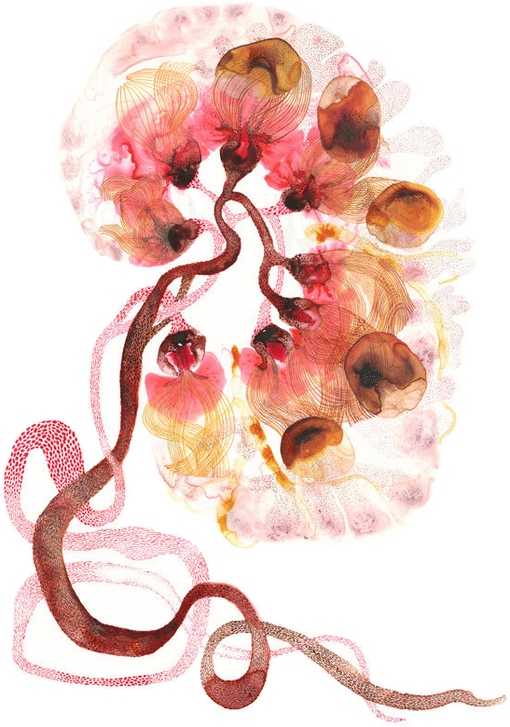



**Objectives:**

1. Introduction to the renal pathology.
2. Acute Kidney Injury.
3. Definition, Types, Clinical Overview, Causes.
4. Pathological findings.
5. Differential Diagnosis.

- Some important definitions for renal pathology:

|  |  |
| --- | --- |
| **Oliguria** | It is decreased urine output (less than 400cc /24h) |
| **Non-Oliguri** | Urine output is not decreased (greater than 400cc /24h). |
| **Anuria** | It is no urine outflow (less than 50cc/24h). |
| **Azotemia** | Elevated **B**lood **U**rea **N**itrogen (**BUN**) not from an intrinsic renal disease. |
| **Uremia** | It is azotemia + clinical manifestations + systemic biochemical abnormalities. |

Some drugs (aminoglycosides) could cause renal injury without affecting the renal output.

|  |  |  |
| --- | --- | --- |
| * Anorexia[1]. | * Pruritis[2]. | * Neuropathy. |
| * Renal failure. | * Nausea and vomiting | * Pericarditis. |
| * Dysgeusia[3]. | * Dyspnea. | * Lethargy[4]. |

- Examples of clinical manifestation of UREMIA[5]?

- What is **acute kidney injury** **(acute renal failure)**?

Acute kidney injury is defined as a sudden decline in renal function. (Within hours to days).

- What are Acute renal failiare (ARF) constitutes[6]?

|  |  |  |
| --- | --- | --- |
| * Acid-basedisturbance. | * Increased Scr[7]. | * Electrolyte and mineral disorders. (K→cardiac arrest). |
| * Derangement of extracellular fluid balance. | | * Accumulation of nitrogenous waste products. |

- Etiology:

1. Outpatients: the most common cause is Prerenal. (shock , crushing , thrmbosis)
2. Inpatients: the most common cause is Intrarenal. (**A**cute **T**ubular **N**ecrosis) (Hallmark)*
3. Obstruction happens to both with approximately same percentage. (due to prostate hypertrophy, tumor or stones)

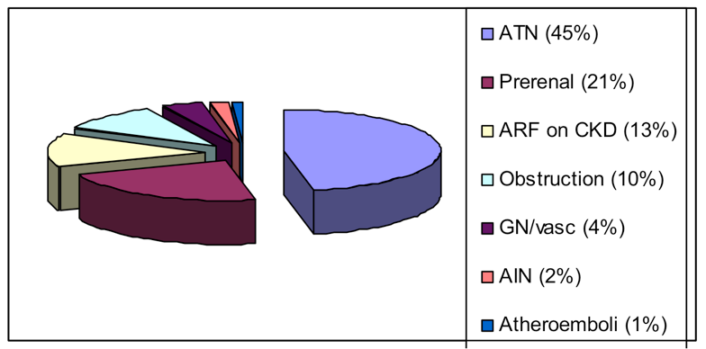

**\***

**Inpatient**

**Outpatient**

- Mortality Of ARF?

Despite technical progress in the management of acute renal failure over the last 50 years, mortality rates seem to have remained around 50%. (Must be treated immediately).

- Predictors[8] of Dialysis in Acute Kidney Injury: **IMPORTANT**

* Oliguria: ‘effect not cause’
  + Less than 400cc​/24hr 85%​will require dialysis
  + 500 - 400cc​/24hr 30-40% ​will require dialysis.
* Mechanical ventilation. ⦁ Acute myocardial infarction.
* Arrhythmia (K+ Level up). ⦁ Hypoalbuminemia.
* ICU stay.
* Multisystem organ failure.

**1- Pre-renal[9]:**

Glomerular filtration rate is directly proportional to renal blood flow. Therefore, any condition that decreases renal blood flow would cause a decrease in **(GFR)** → **azotemia.**

Decreased renal blood flow could be due to:

1. Hypotension:

Shock (septic, cardiogenic, hypovolemic, medication).

1. Vascular pathology:

* Renal artery compromise.
* Abdominal aortic aneurysm ‘AAA’ may apply pressure on renal artery → decreasing blood flow to kidneys.
* Atheroemboli.
* Vasculitis.

1. Third spacing[10].

• Bowel obstruction, cirrhosis[11], nephrotic syndrome, major surgery

1. Volume depletion:

Loss of fluids, for example:

* + GI losses: vomiting, diarrhea
  + Skin losses: burns, sweat
  + Renal losses: DKA[12], DI[13], Addison’s, Na wasting.

1. Drug induced:

NSAID, CsA[14], FK506[15], ACE[16], ARB[17].

How?

AgII normally constricts efferent arterioles of the glomerular capsule → increased pressure in the glomerular capillaries → increase GFR.

If the patient is on angiotensin converting enzyme inhibitor (ACE I) there will be decreased AgII → decreased constriction of efferent arteriole → decreased pressure in glomerular capillaries → decreased GFR.

* In prerenal azotemia there is decreased renal perfusion with *no damage* to the kidney parenchymal cells (in the beginning).
* **There is a continuum from prerenal physiology to ischemic pathology. leading to necrosis**

In addition, decreased blood flow → Decrease in GFR → ischemia to the nephrons → necrosis of the kidney’s cells after hours. So, all the 3 causes are connected to each other. Post and Pre lead to Intra.

الكلية لما ما يوصلها دم كويس هذا البري رينال cause . بعدين بيصير إنترا رينال لأن الكلية بتسوي Acute tubular necrosis.

**2- Intrarenal ARF:**

Happens from the kidney itself, due to problem in one or more of the four elements, which are: tubules, glomeruli, blood vessels and interstitium.

First in the tubules:

Acute Tubular injury (necrosis): ‘most common cause of intrarenal’ Is a clinicopathological entity defined by:

1- Acute renal failure. 2- Tubular injury/necrosis.

It’s characterized by damaged tubular epithelial cells and acute renal failure. Also, **granular casts** and tubular cells are observed in the urine, and it is the most common cause of acute renal failure.

How is it described based on Clinicopathological entity?

- Pathologically: Destruction of tubular epithelial cell (Acute tubular necrosis).

- Clinically: Acute suppression of renal function (no urine or below 400 ml/24h)..

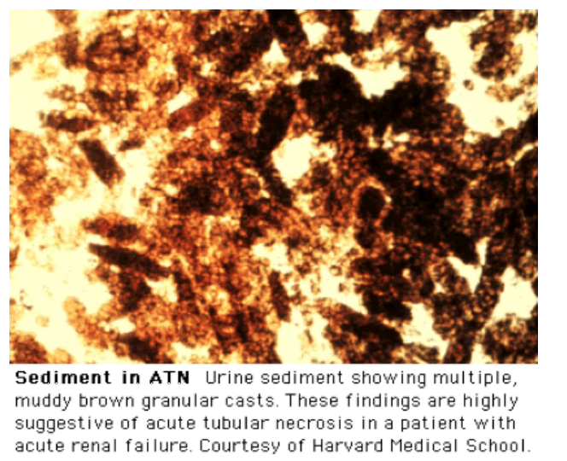

What are granular casts? Granular cast is a type of urinary cast. Urinary casts are cylindrical structures produced by the kidney and present in the urine in certain disease states. They form in the distal convoluted tubule and collecting ducts of nephrons, then dislodge and pass into the urine, where they can be detected by microscopy.

Etiology of ATN:

Patchy areas are affected.

1- Ischemia:

a) Shock. B) sepsis. C) incompatible blood transfusion. D)thrombotic disease.

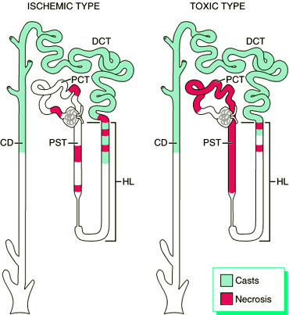2- Tubular Toxins: Proximal tubules are most affected (IMPORTANT)

A) Antimicrobials: Aminoglycosides, vancomycin, foscarnet, pentamidin, amphotericin B.

B) Chemotherapeutics: Cisplatin, mitomycin C, ifosfamide.

C) Immunotherapy: IVIG[18].

D) Complex Sugars: Maltose, sucrose, mannitol.

E) Heavy metals.

F) Sepsis, hypoxia.

G) Radiocontrast agents. عشان كذا قبله لازم نسوي تحليل وظائف الكلى.

We have two types of toxins:

A- Endogenous: Produced by our own body. For example:

1- Crush injury[19]: Caused by **Myoglobin,** which is found normally in skeletal muscles.

How can it cause injury to the tubular cells? Crush injury (E.g. car accident or a wall falling on their leg) → rhabdomyolysis → release of large amounts of myoglobin → accumulation of it in the kidney → acute kidney injury (renal failure).

**\*\***

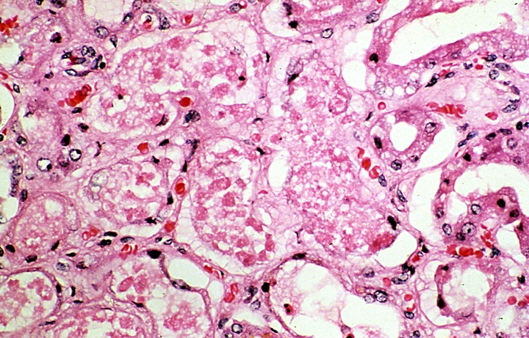2- Hemoglobinopathy.

B- Exogenous: Drugs, Radiocontrast dye, Metals.

**Another form ATI. Here patient have Multiple myeloma and it is a cancer formed by malignant plasma cells. These cells secretions accumulate in the tubules.

**ATI** **(keywords):** Damaged tubular epithelial cells, Granular casts in urine, caused by Ischemia or toxins, elevated creatinine, hyperkalemia due to decrease the renal excretion, it is reversible but requires supportive dialysis.

**3- Postrenal[20] ARF:** Results when urine flow is obstructed.

*Examples: include kidney stones, BPH (Benign Prostatic Hyperplasia), tumors, etc.

How? When there is obstruction to urine flow → pressure will back up to the Bowman’s space. → Increase in the hydrostatic pressure in Bowman’s space.

The hydrostatic pressure of Bowman’s space opposes GFR → the net result is decreased GFR.

- Other causes of acute kidney injury:

A. **RPGN** (Rapidly Progressive Glomerulonephritis): A syndrome defined by the loss of renal function over days to weeks due to acute glomerulonephritis.

We see **Crescents[21]** formation in the glomeruli.

B. Diffuse renal vascular diseases, such as microscopic polyangiitis and thrombotic microangiopathies.

C. Acute drug induced allergic interstitial nephritis.

Congenital and Cystic Renal Diseases: Homework

* + 1. **Cystic renal dysplasia:** Commonest cystic renal disease in children. Caused by disorganized renal development.
* Can be unilateral or bilateral.
* Often associated with poorly formed ureter.
* Rarely part of a syndrome.
  + 1. **Autosomal dominant polycystic kidney disease:** Progressive distention of kidney by enlarging cysts. About 10% require dialysis/ transplantation. 1-2 cases per 1000 live births. Usually present in adults.
* Caused by mutation in two genes PKD1 (85% of cases: chromosome 16) and PKD2 (155 cases, chromosome 4) (also PKD3 in rare cases). 10% new mutations.
* Maybe associated with cysts in liver, pancreas, spleen and cerebral/ coronary artery and aneurysms.
  + 1. **Autosomal recessive polycystic kidney disease:** Rare, 1 case per 20,000 live births.
* Gene on chromosome 6.
* Liver is always affected.
* Large kidneys at birth (may cause death soon after birth due to renal failure).

Glumeruli: necrosis, crescents.

Tubules: ischemia, pigments, toxins **AKI**

Vesseles: vasculitis, necrosis in the wall

Interstitium: inflammation due to drugs (acute interstitial nephritis)

Structure ‘intrarenal’: cause → result.

- On Routine what do we do? We take a small biopsy and do **immunofluorescence** (we look for the antigen)

If I want to see if this patient has IgA in his glomeruli, I will bring Anti-IgA + A material that can fluoresce under the florescence microscopy. And finally, I watch the reaction happen between IgA (from the biopsy) + it’s anti-IgA. Even when I wash the slide it won’t go away.

Why do we use immunofluorescence?

1. Specific. (I know what I’m looking for IgA, IgG, IgM, etc.)

2. I know exactly where it’s located.

3. What kind of deposition we have.

- We can also use stains in **histology** like: H&E, PAS[22], Silver, Trichrome[23].

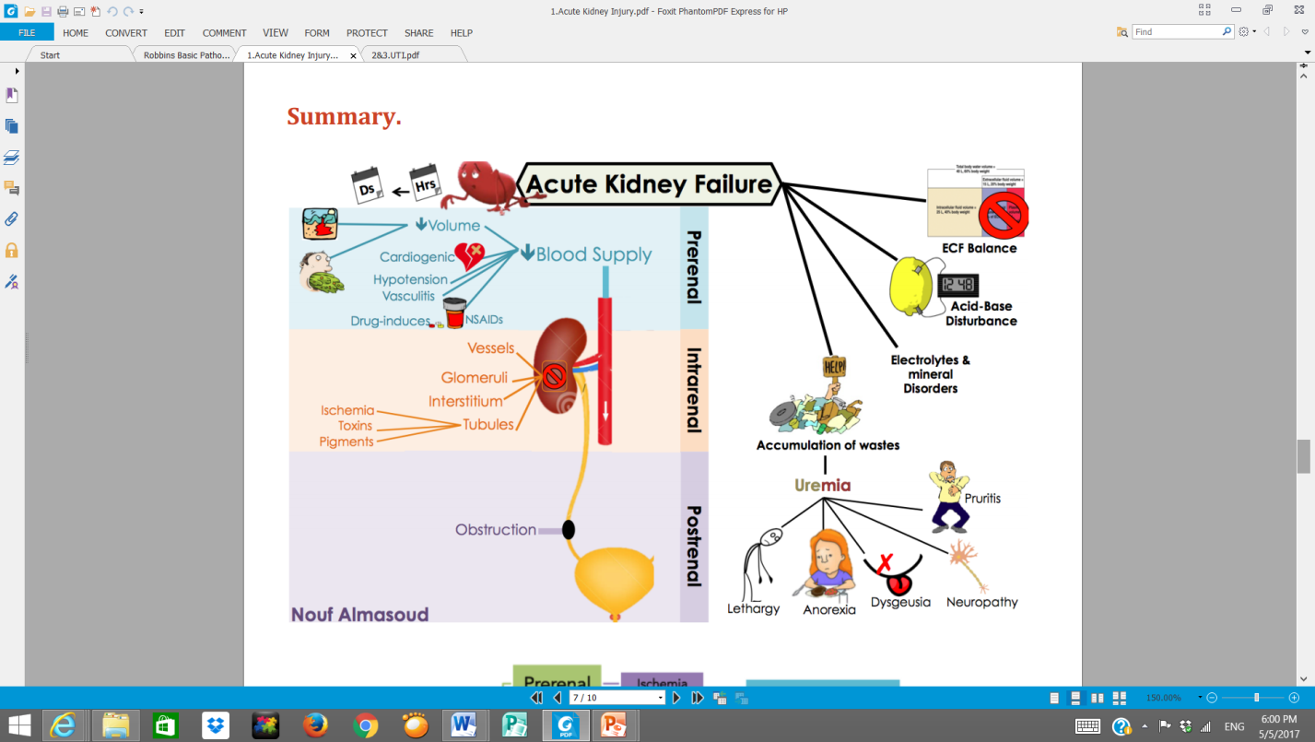- Electromicroscope.

"اللهم لا سهل إلا ما جعلته سهلًا و أنت تجعل الحزن إذا شئت سهلًا"

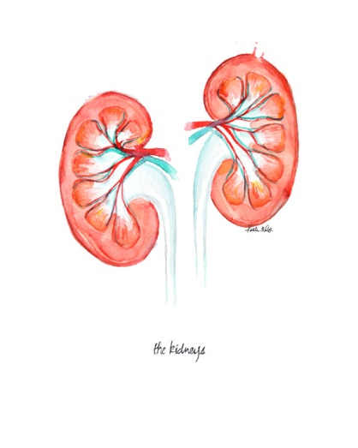

**القادة**

**نوره عبدالله السهلي عبدالعزيز عبدالله العنقري**

**الأعضاء**



**أثير الرشيد يزيد المطيري**

**حنين السبكي عبدالعزيز ال محمد**

**دينا النويصر**

[**Editing File**](https://onedrive.live.com/view.aspx?resid=E0947849CE6A90D1!120&ithint=file%2cpptx&app=PowerPoint&authkey=!ALNSNNVHKfyykhY)

**Email:** pathology436@outlook.com **Twitter:** @pathology436

1. Loss of appetite for food.
2. Itch.
3. Distortion of the sense of taste.
4. Tiredness.
5. high levels of both urea , creatinine.
6. Make up, form.
7. serum creatinine.
8. Criteria to start Dialysis.
9. Before-kidney.
10. Fluid that isn’t circulating (Something that got out from the blood flow) → might lead to edema
11. a chronic disease of the liver marked by degeneration of cells, inflammation, and fibrous thickening of tissue
12. Diabetic ketoacidosis.
13. Diabetic insipiduse.
14. Immunosuppressive drugs.
15. Immunosuppressive drugs.
16. Angiotensin converting enzyme inhibitors.
17. Angiotensin II receptor blockers.
18. Intravenous immunoglobulin.
19. Any injury that leads to crushing muscles
20. After-Kidney
21. Two or more layers of proliferating cells in Bowman’s space and are a hallmark of inflammatory glomerulonephritis and a histologic marker of sever glomerular injury.
22. Periodic acid–Schiff.
23. Masson's Trichrome.