Nephrotic Syndromes

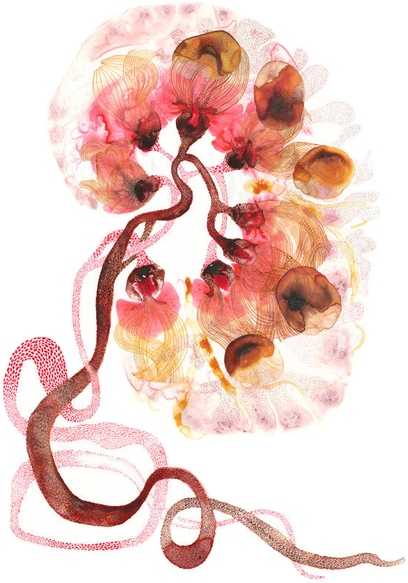

Objectives:

- Recognize the five-major renal clinical syndromes.
- Describe the main differential pathological diagnosis for each syndrome.
- Perform a clinico-pathological correlation.
- Describe the patterns of injury of each syndrome.

Black: Doctor’s slides.
Red: important!
Green: Doctor’s notes.
Grey: Extra.
Purple: Female’s slides.
Blue: Male’s slides.

Glomerular diseases:
- A biopsy is a must for diagnosis; unlike UTIs.
- Proteinuria occurs if and only if there is an effacement of podocyte.
- No hematuria or hypertension in nephrotic syndrome.
- nephrotic patients are prone to infection (protein loss).
https://www.youtube.com/watch?v=iAQkxTwnDWQ&feature=youtu.be

Nephrotic syndrome:
Includes a group of conditions characterized by increased basement membrane permeability, permitting the urinary loss of plasma proteins, particularly low-weight proteins such as albumin.

Clinical manifestations:

In all diverse causes of the nephrotic syndrome there is a derangement in the capillary walls of the glomeruli that results in increased permeability to plasma proteins $→$ allows protein to escape from the plasma into the glomerular filtrate $→$extremely heavy proteinuria, serum albumin is decreased$→$hypoalbuminemia and a drop in plasma colloid osmotic pressure. $→$ Increased release of renin from renal juxtaglomerular cells$→$Renin in turn stimulates the angiotensin-aldosterone axis$→$promotes the retention of salt and water by the kidney. At the onset, there is little or no: azotemia, hematuria, or hypertension.

    - Heavy proteinuria = proteins in urine = loss of 3,5 g/day
    - Not accompanied by increased urinary red cells or white cells. (No increased cells or no cells)
    - Hypoalbuminemia is often marked by Serum concentration of less than 3g/100 ML
    - Generalized edema results from decreased plasma colloid or oncotic pressure. ‘swelling eye’
    - Hyperlipidemia and hypercholesterolemia are caused by increased hepatic lipoprotein synthesis. (fatty casts)
Nephrotic syndrome can be caused intrinsically by:
1-minimal change disease. 2-FSGS. 3-membranous glomerulonephritis.
And systemically by: 1-diabetic nephropathy 2-renal amyloidosis 3-Lupus nephropathy
    - Hypocalcemea.

https://www.youtube.com/watch?v=4Y4PWTXjyEc

1. Minimal change GN (lipoid nephrosis):

    - Most common cause of nephrotic syndrome in children most commonly between the ages of 1 – 7 yrs.
    - Light microscopy (LM) $→$ normal-appearing glomeruli.
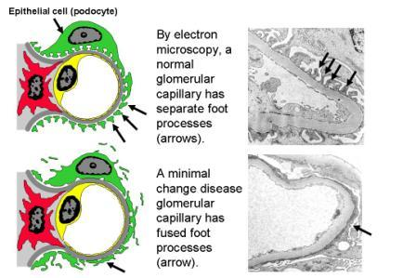
    - Electron microscopy (EM) $→$ normal except for the diffuse (effacement of epithelial foot processes*) *it presents in all Nephrotic syndromes.
    - Immunofluorescence(IF) → normal
    - Most often this condition responds well to corticosteroid therapy. More than 90% of children
    - The protein loss usually is confined to the smaller plasma proteins, chiefly albumin (selective proteinuria).
Extra

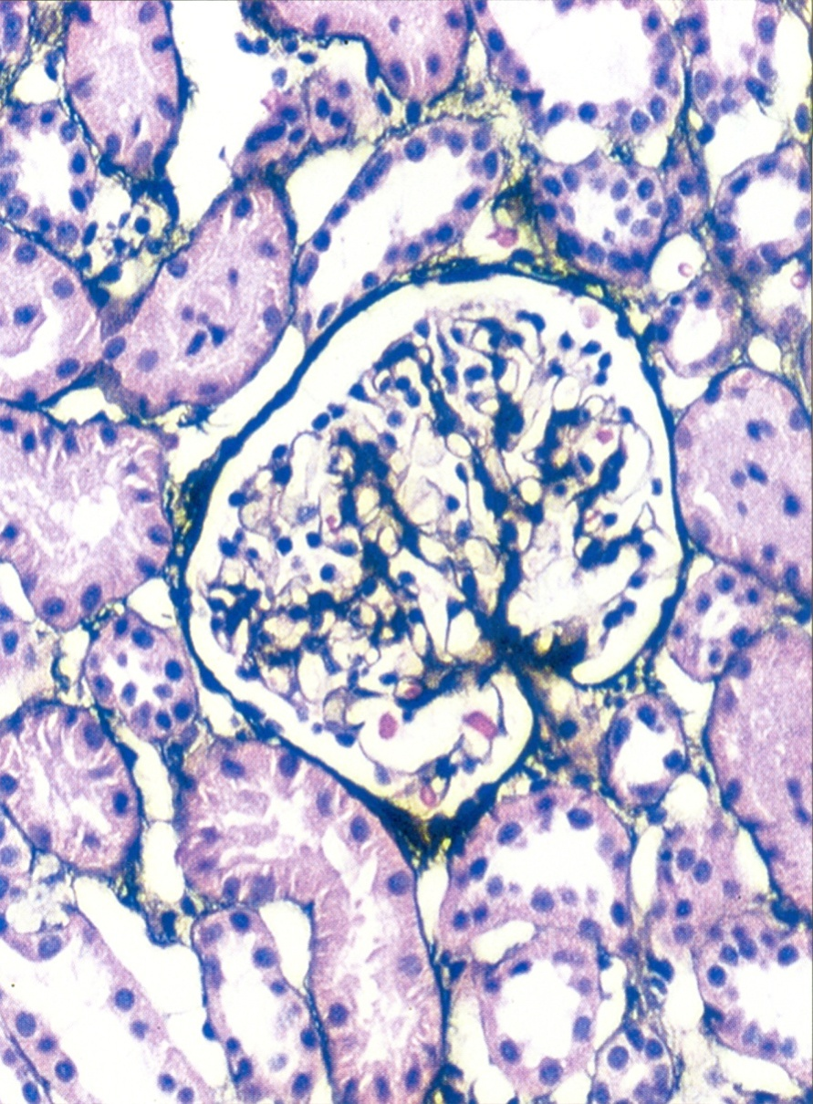
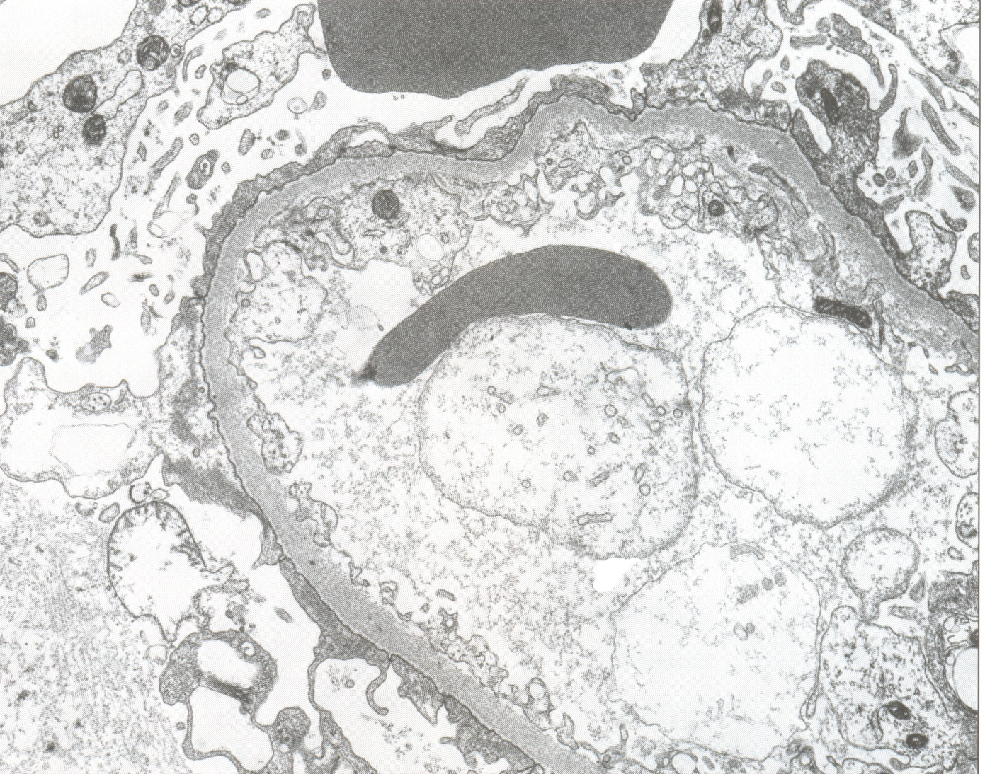
Extensive foot process effacement (lost) and microvillous transformation of visceral epithelial cells

Glomeruli appear unremarkable by light microscopy, and in young patients there is no tubulionterstial fibrosis, as in this patient.

https://www.youtube.com/watch?v=l7ZyAmGA98w&index=8&list=PLY33uf2n4e6P2hFA1_fxu-4IeTIDvwoDP
2. Focal segmental glomerulosclerosis(FSGS):

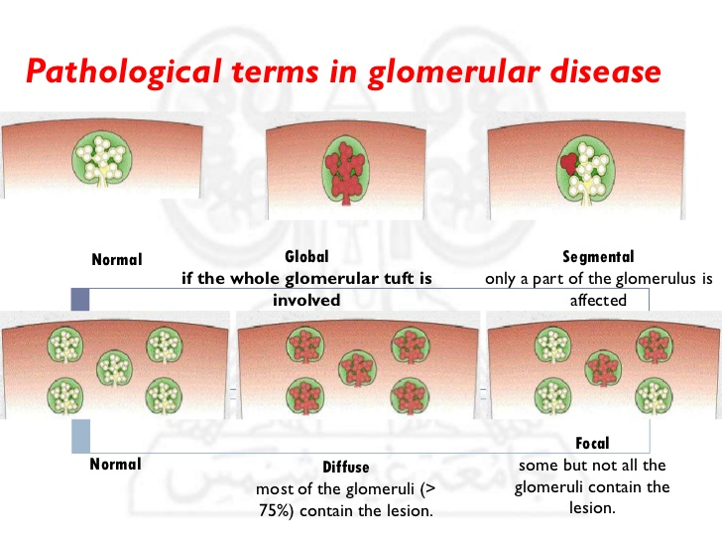
It's characterized histologically by sclerosis affecting some glomeruli (focal involvement) and involving only segments of each affected glomerulus (segmental involvement).
    - Injury to the podocytes is thought to represent the initiating event of primary FSGS.
    - Proteinuria is nonselective; and in general, the response to corticosteroid therapy is poor.

    - FSGS may be primary (idiopathic) or secondary to one of the following conditions:

- In association with other conditions, such as HIV nephropathy or heroin nephropathy.
- As a secondary event in other forms of GN (e.g., IgA nephropathy).
- As a maladaptation to nephron loss.
- In inherited or congenital forms. Autosomal dominant forms are associated with mutations in cytoskeletal proteins and podocin, both of which are required for the integrity of podocytes. In addition, a sequence variant in the apolipoprotein L1 gene (APOL1) on chromosome 22 appears to be strongly associated with an increased risk of FSGS and renal failure in individuals of African descent.
- No immune complex deposits, Negative Immunofluorescence (normal).

- The typical segmental sclerotic lesion in FSGS is characterized by:
- Obliteration of capillary loops.
- Increased mesangial matrix, without deposits and with Diffuse foot process effacement by EM.
- Deposition of Hyaline masses (Hyalinosis)​.
- Lipid droplets.
- Focal Deposition of IgM and complement are seen in IF.

- FSGS Initially affects Juxta-Medullary Glomeruli. In progression of the disease leads to global sclerosis of the glomeruli with pronounced tubular atrophy and interstitial firosis.

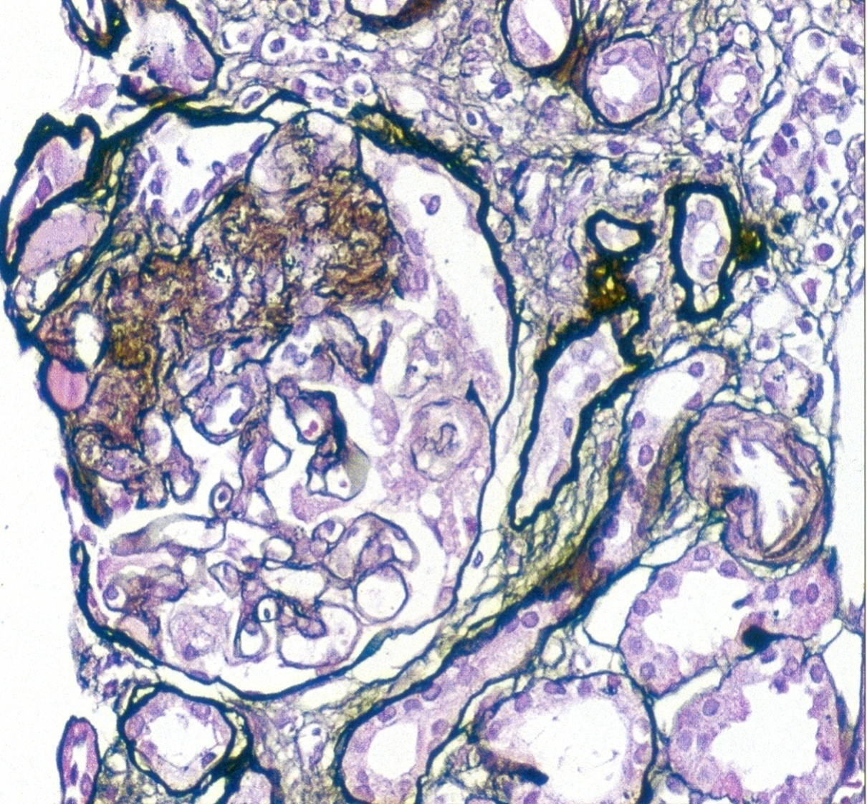
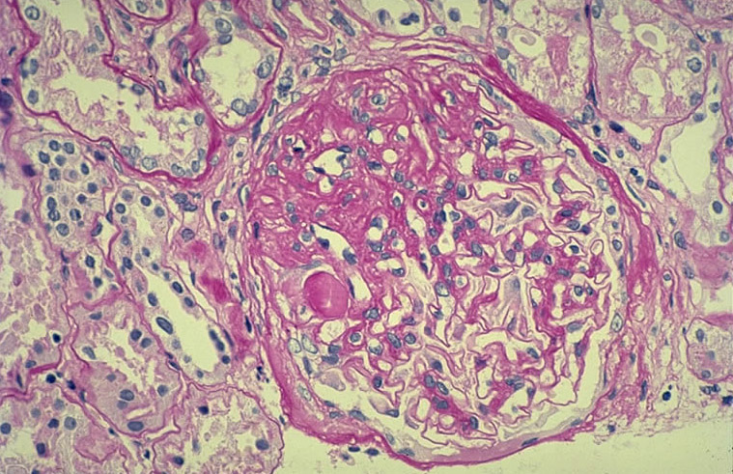
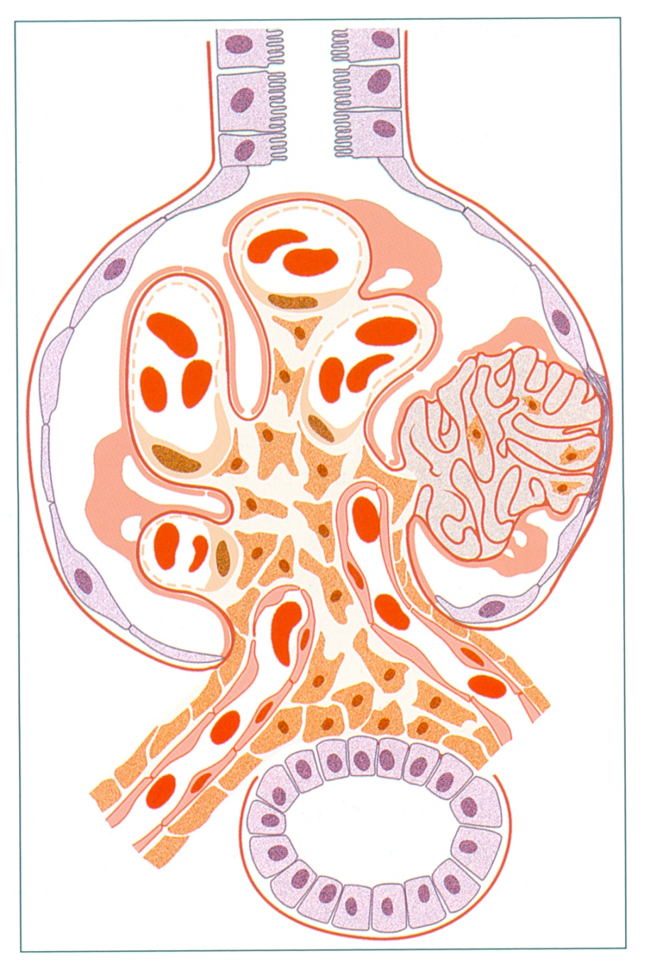
- collapsing glomerulopathy: It is characterized by collapse of the glomerular tuft and podocyte hyperplasia. This is a more severe manifestation of FSGS that may be idiopathic
or associated with HIV infection, drug-induced toxicities, and
some microvascular injuries.
https://www.youtube.com/watch?v=zucxZw069kw&list=PLY33uf2n4e6P2hFA1_fxu-4IeTIDvwoDP&index=9

3. Membranous Nephropathy or glomerulonephritis:
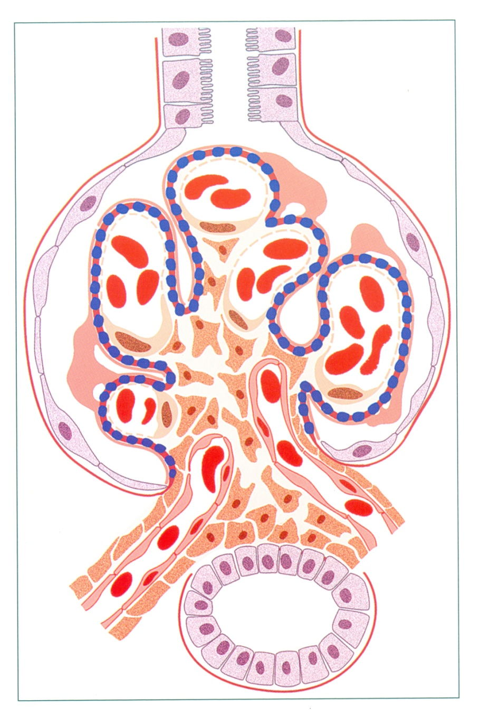
- An immune complex disease of an unknown etiology. Which is immune response against phospholipase A_{2.}
    - It is a slowly progressive disease, characterized morphologically by the presence of subepithelial immunoglobulin-containing deposits along the GBM.
    - Most common cause of Nephrotic Syndrome in Adults between 30-60 years old.

    - LM:​glomeruli may appear normal especially in early stage of the disease, but in severe cases we will see diffuse thickening of the capillary wall by the same method.
    - EM: ​we can see subepithelial deposits which is the cause of thickening of the capillary wall. The subepithelial deposits is separated by small spike-like​ protrusion of GBM matrix. ‘spike and dome pattern’ Dome = immune complex. Spikes: basement membrane.
- The spikes ​are ​formed as a reaction to the deposits, which can be visualized by silver stain.
EM: spikes = white. Deposits = dark. Deposits Don’t stain with silver ‘not appears’.
- In about 85% of cases, membranous nephropathy is caused by autoantibodies that cross-react with antigens expressed by podocytes. In the remainder (secondary membranous nephropathy), it occurs secondary to other disorders, including:
- Infection (chronic hepatitis B, syphilis, malaria).
- Malignant tumors, particularly carcinoma of the lung, colon, and melanoma.
- Systemic lupus erythematosus. Class 5
- Exposure to inorganic salts (gold, mercury).
- some drugs (penicillamine, captopril, nonsteroidal anti-inflammatory agents)

- Membranous glomerulonephritis is a slowly progressive disorder that shows little response to steroid therapy.

- Immunofluorescence microscopy in membranous nephropathy showing diffuse, granular IgG deposition along the capillary walls.
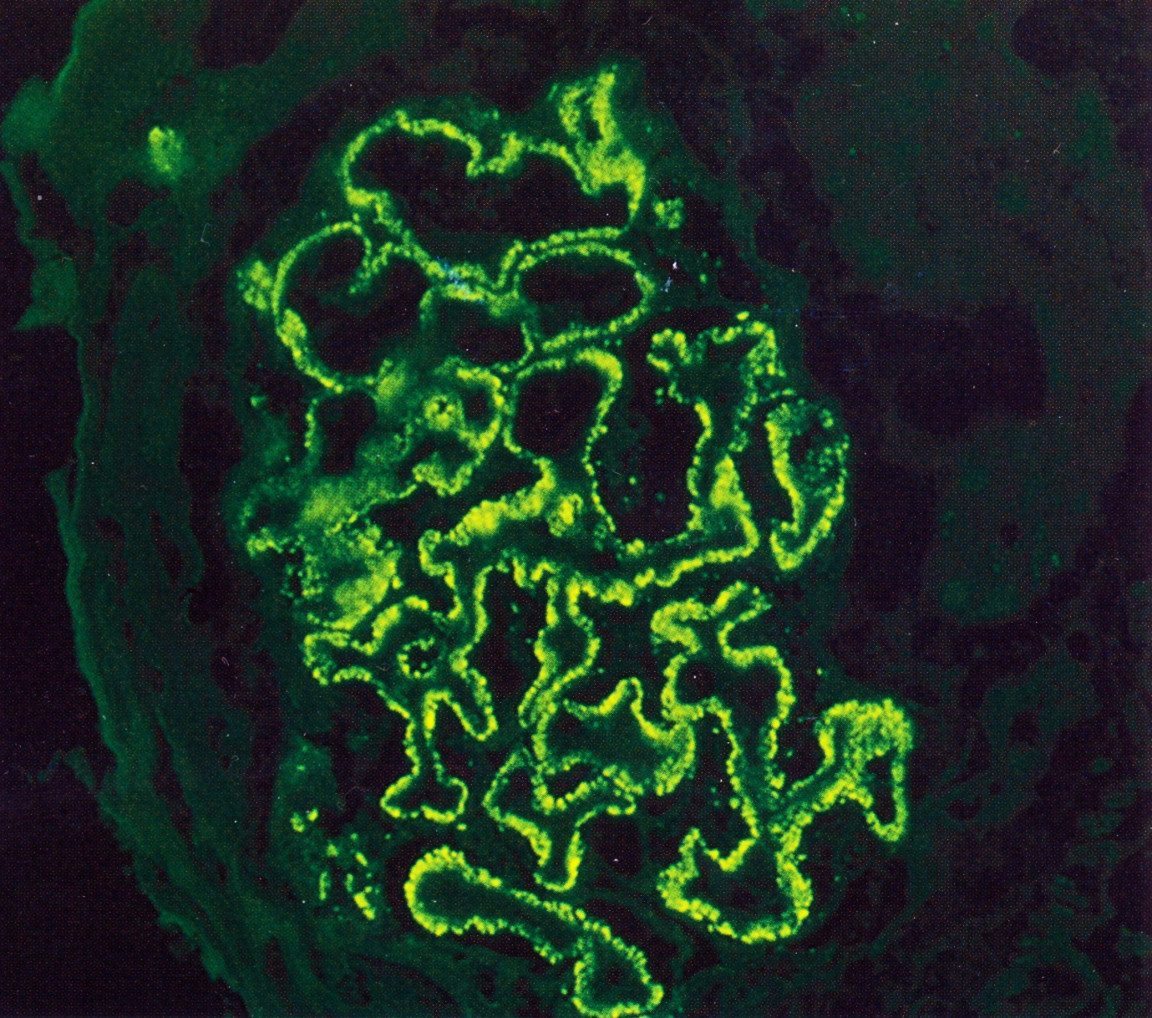
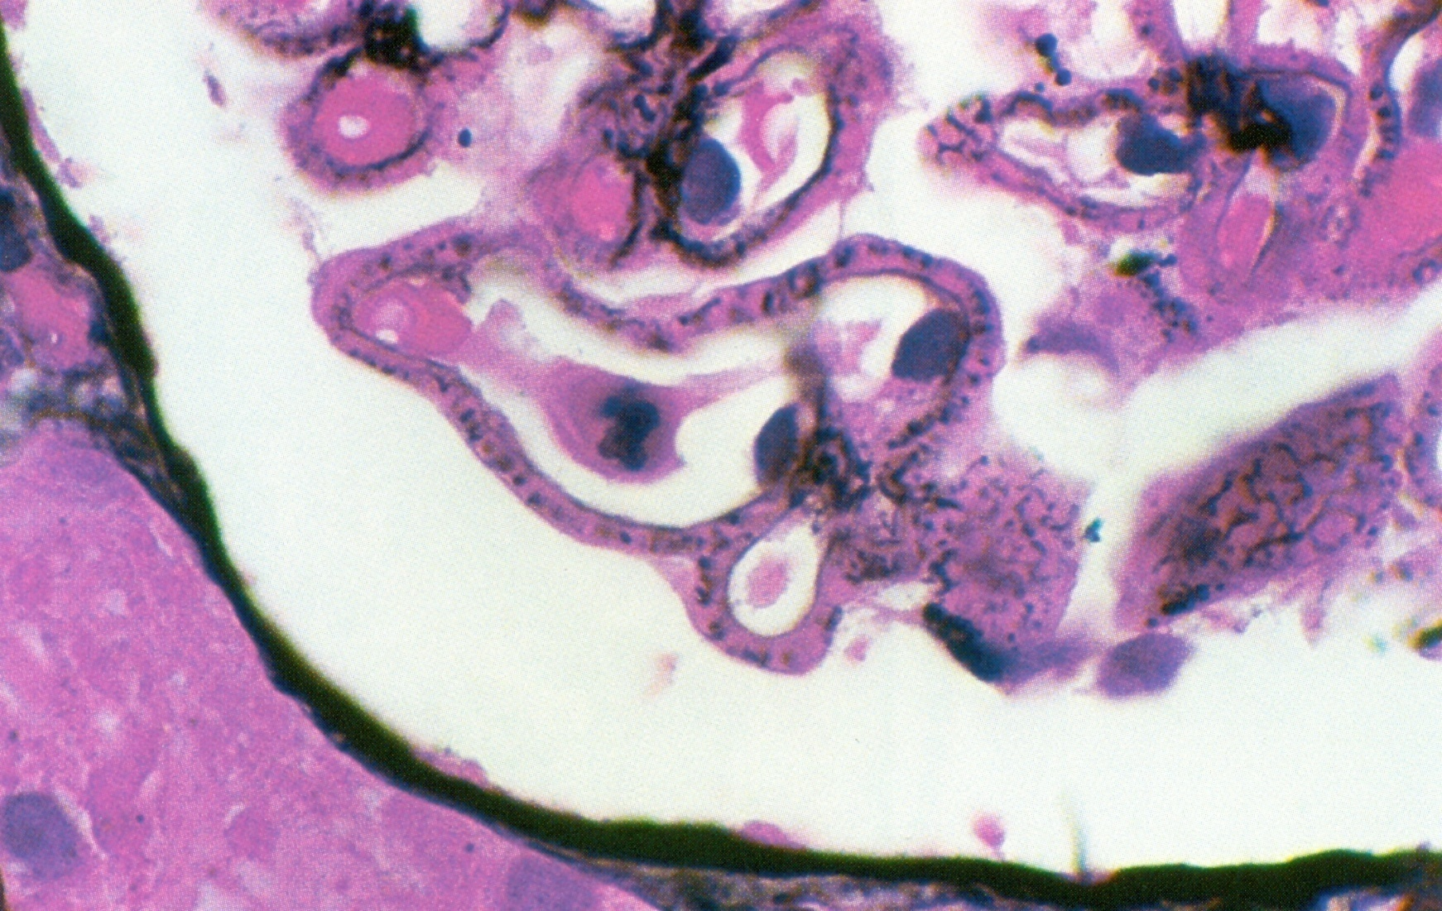

There are well-developed spikes and holes in tangential sections in stage-2 membranous glomerulopathy.

There is an evenly distributed granular capillary loop pattern of positively in membranous glomerulopathy

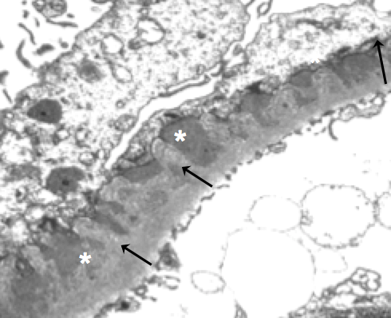
Extra
Extra
Normal glomeruli ,the GBM is thin and no electron dense deposits are present

Glomerulonephritis, New basement membrane (arrows) is growing between the deposits(stars), leading to a spike appearance on silver stain.

Diabetic nephropathy: (nodular diabetic glomerulosclerosis)

The lesions in diabetic nephropathy are characterized by arteriolar hyalinization, mesangial matrix expansion and glomerular basement thickening.

  - Diabetic nephropathy usually associated with diabetic retinopathy (eyes abnormalities).
    - Electron microscopy demonstrates striking increase in thickness of the glomerular basement membrane. Thickening of vascular basement membrane is one of the earliest morphologic changes in diabetes mellitus (long standing non-controlled diabetes).

    - An increase in mesangial matrix with time results in two characteristic morphologic patterns:
      - Diffuse glomerulosclerosis is marked by a diffusely distributed increase in mesangial matrix.
      - Nodular glomerulosclerosis is marked by nodular accumulations of mesangial matrix material (Kimmelstiel-Wilson nodules)*.
*قبل يوصل المريض لهذه المرحلة (Kimmelstiel-Wilson nodules) لا يعتبر nephrotic لكن إذا وصل لها نصنفه المرض على طول nephrotic. In PAS stain we see the nodules

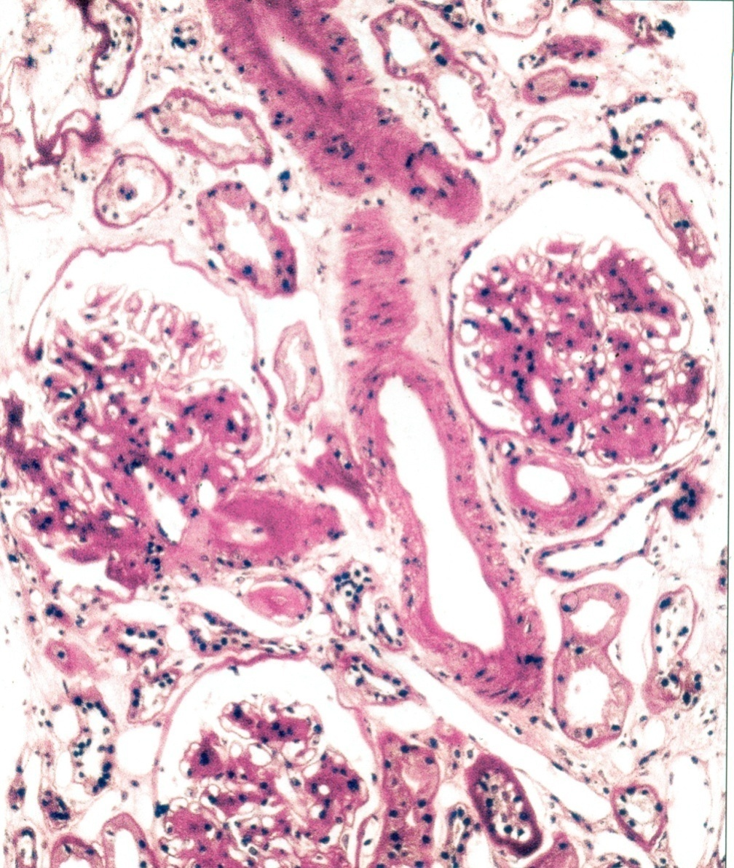
Immunofluorescence (IF) → Linear IgG (The previous diseases had granular immune complexes).

Diabetic nephropathy may manifest either as diffuse mesangial increase, or with nodular glomerulosclerosis as in this case.

The lesions in diabetic nephropathy are characterized by arteriolar hyalinization, mesangial matrix expansion and glomerular basement thickening.

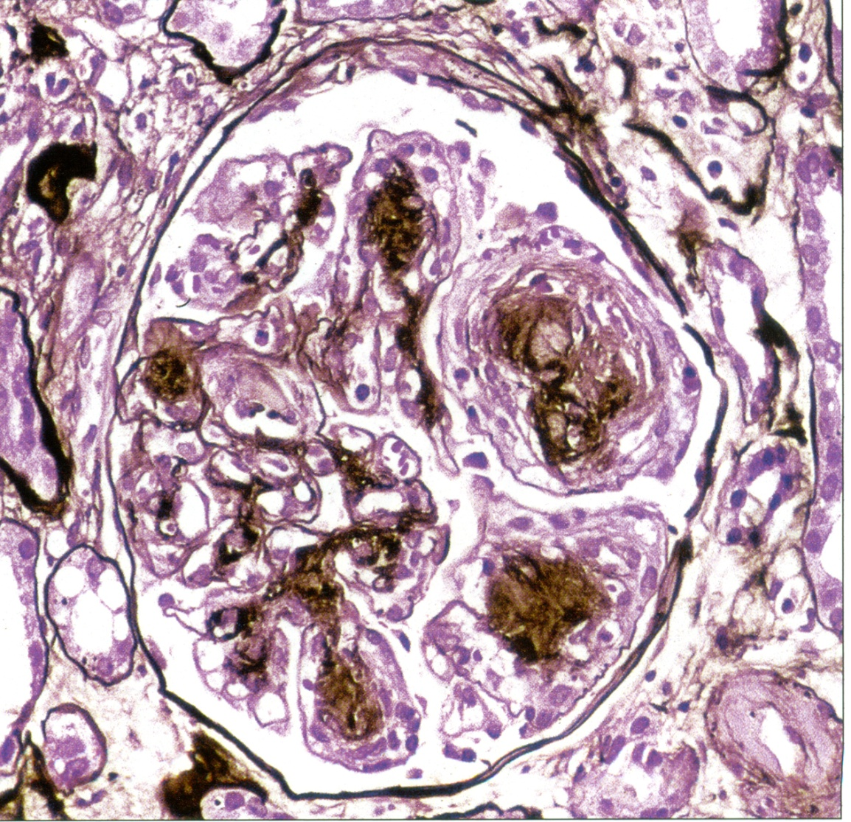
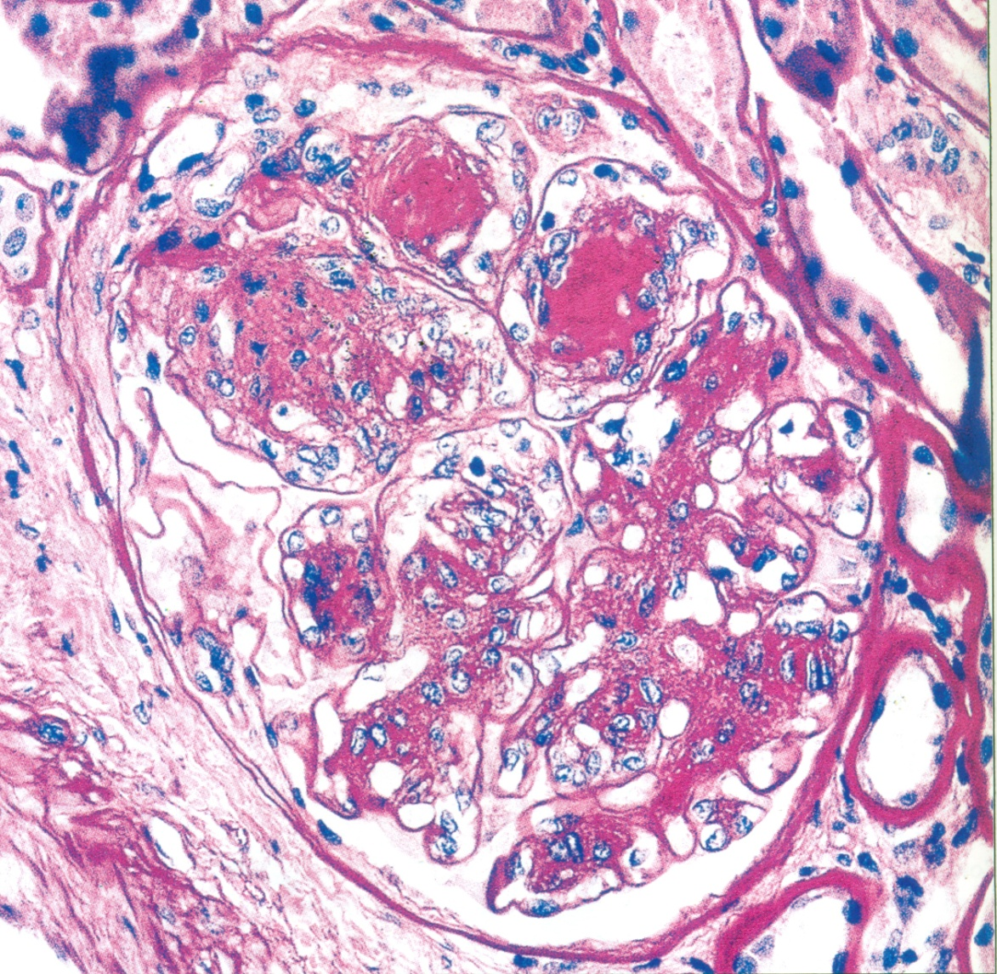

The lamellated appearance of the Kimmelstiel-Wilson nodule characteristic of the nodular sclerosis form of diabetic nephropathy is shown, along with arteriolar hyalinization (hyaline material not cells) and surrounding tubulointerstitial fibrosis.

Renal amyloidosis: “with Smokers”

    - Predominantly subendothelial and mesangial amyloid deposits are characteristic.
    - The amyloidosis can be identified by reactivity of amyloid with special stains (e.g. Congo Red*, crystal violet, thioflavin T) and by birefringence under polarized light. It is also demonstrated by a characteristic crisscross fibrillary pattern of amyloid by electron microscopy.

    - Most often, there are associations with chronic inflammatory diseases, such as rheumatoid arthritis or plasma cell tumors such as multiple myeloma.
*تقدر تكتشف المرض عن طريق صبغة ال Congo Red بعدين تسوي polarization ويطلعلك apple-green birefringence تحت الmicroscope وأيضا يعطيك ألوان مخلفة مع انكسار الضوء عن طريق تحريك العدسة للmicroscope

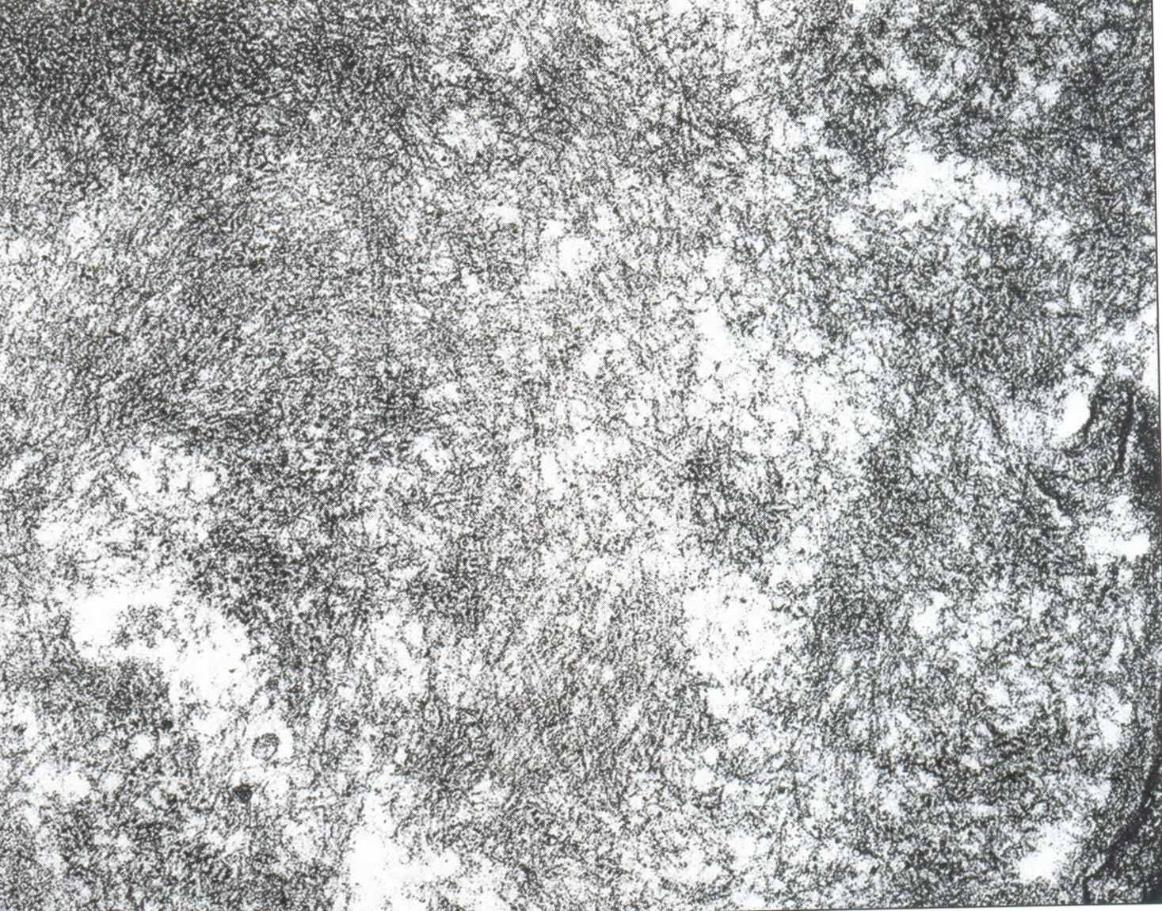
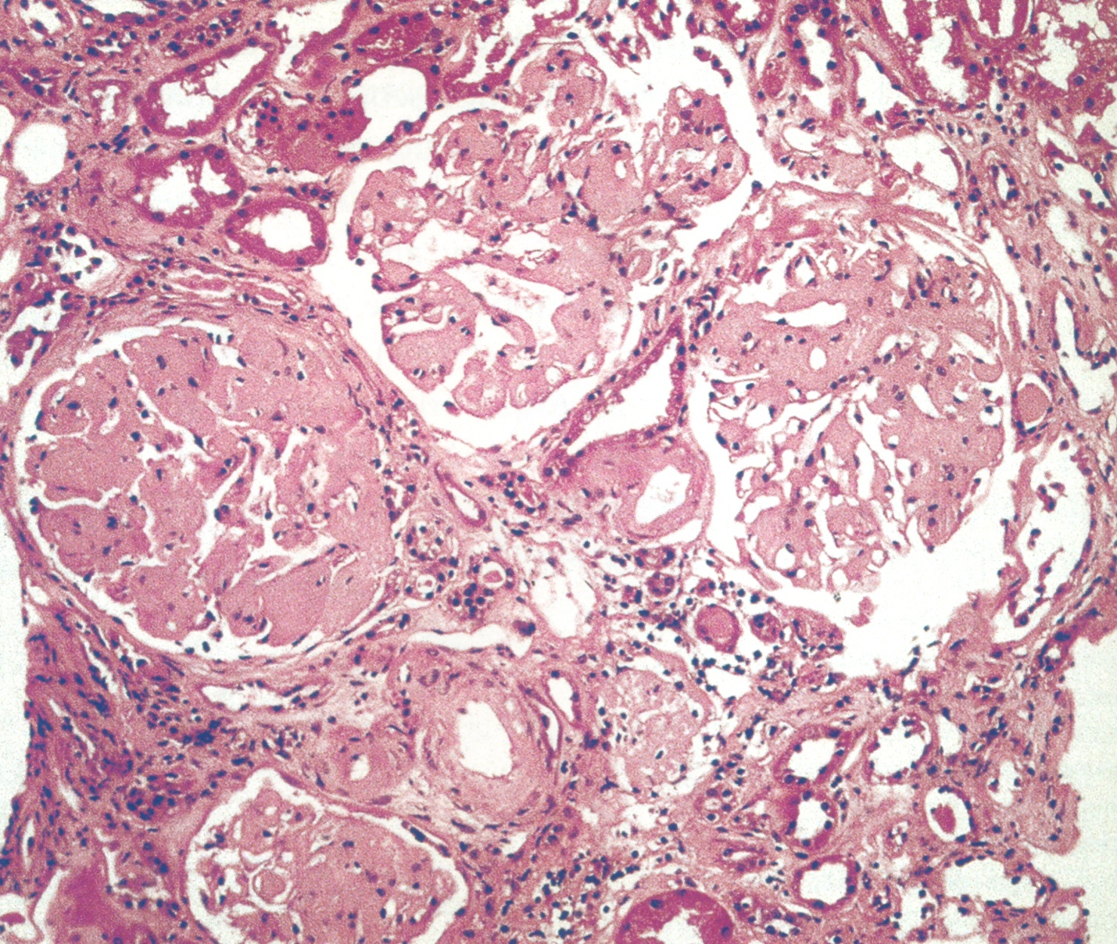
Randomly oriented, 8-10nm fibrils, typical of amyloid within the mesangium.

Massive amyloid deposits are present in glomeruli and arterioles

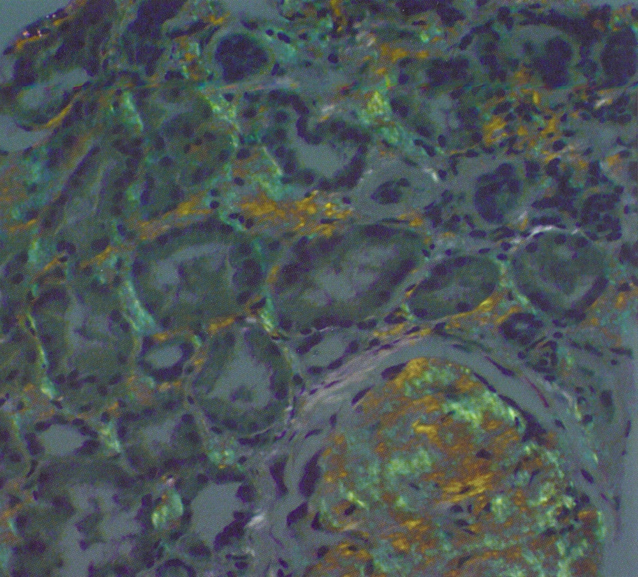
Tubular involvement with amyloid is verified by apple-green birefringence under polarized light.

Lupus nephropathy:

- SLE is an inflammation of the kidney; SLE can also damage the skin, joints, nervous system and virtually any organ or system in the body because antibodies act against DNA. It is an autoimmune and systemic disease.
- These antibodies accumulate in subendothelial.

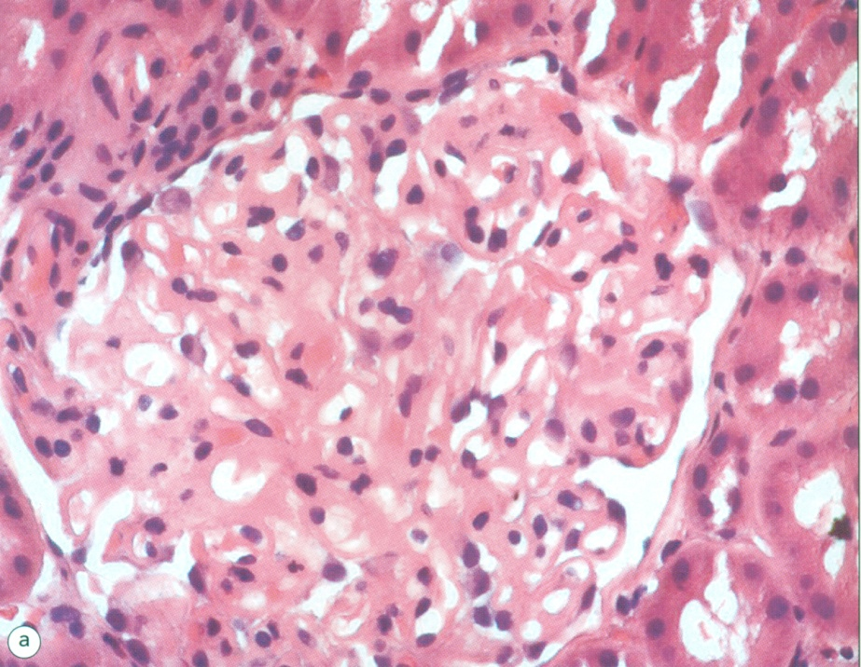
a) Class V lesion or lupus membranous glomerulopathy. There is diffuse thickening of the peripheral capillary walls associated with an increase in mesangial matrix.

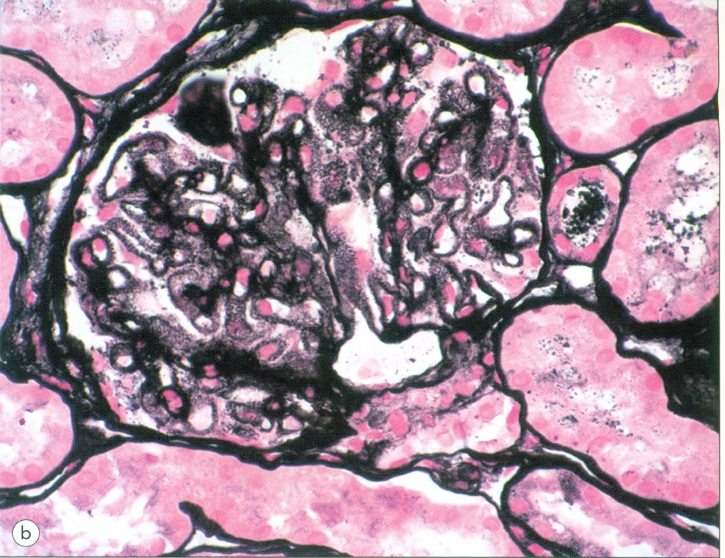
(b) Silver methenamine (jones) stains reveal a spike and dome pattern to be present along the peripheral capillary loops where the wall of the capillaries cut tangentially; there is a moth-eaten appearance of the capillary wall.

Membranous lupus glomerulonephritis*:

In class 5, the patients have severe nephrotic syndrome
and there is thickening of the capillary walls due to
deposition of basement membrane like material as well
as immune complexes.

* يشبه تماما ال Membranous glomerulonephritis ولكن يختلف عنه في التسميه Secondary Membranous glomerulonephritis لأن المريض عنده lupus بالإضافة يختلف في full house" immunofluorescence"
"Full house" immunofluorescence: This means quite simply that all five major immunofluorescent stains on a renal biopsy (IgM, IgG, IgA, C3, and C1q) are all positive.
بينما ال Membranous glomerulonephritisيظهر فيه فقط immunoglobulin G (IgG) or C3

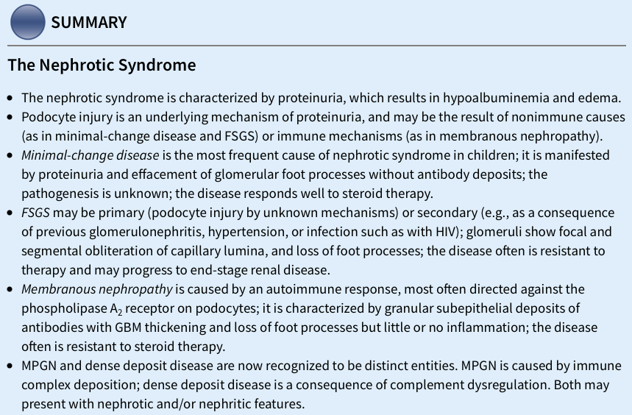
"اللهم لا سهل إلا ما جعلته سهلًا و أنت تجعل الحزن إذا شئت سهلًا"
عبدالعزيز علي آل محمد يزيد عبيد الله المطيري
ريان محمد القرني عبدالكريم محمد الحربي
عبدالله بن أحمد العيدان ريما الشايع
لمى التميمي

القادة
نوره عبدالله السهلي عبدالعزيز عبدالله العنقري
الأعضاء

Editing File
Email: pathology436@outlook.com Twitter: @pathology436

To allow
A disturbance (اختلال) of the regular order or arrangement.
a podocyte reaction to injury or damage characterized by flattening of foot processes while the frequency of filtration slits is reduced, giving the appearance of a continuous cytoplasmic sheet covering the glomerular basement membrane.
Antibodies tagged (labeled) with fluorochrome are used to localize.
Haedening of the tissue.
سوء تكيّف
is a protein component of the filtration slits of podocytes
Glomerular basement membrane
transmitting light unequally in different directions. (انكسار الضوء)

