Nephritic Syndrome

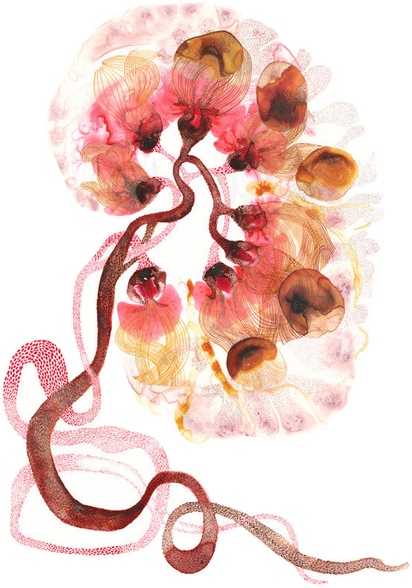

Objectives:

- Recognize the five-major renal clinical syndromes.
- Describe the main differential pathological diagnosis for each syndrome.
- Perform a clinico-pathological correlation.
- Describe the patterns of injury of each syndrome.

Black: Doctor’s slides.
Red: important!
Green: Doctor’s notes.
Grey: Extra.
Purple: Female’s slides.
Blue: Male’s slides.

Nephritic Syndrome

Pathogenesis:
  - Inflammation → severe injury to the capillaries → filtration of blood cells → red blood cells casts in urine = grossly visible hematuria.
  - GBM is blocked by inflammatory cells, RBC’s & proteins → less filtration → oliguria → fluid retention → hypertension & azotemia.
  - loss of proteins is less than in nephrotic syndrome because of the blockage of the GFM → less edema.
  - Because of the decreased filtration → activation of RAAS system → even more hypertension!

Clinical manifestations:
- Hematuria.
  - Dysmorphic RBCs + red cells cast.
  - Smoky brown color (tea color).
- Oliguria and Azotemia.
- Hypertension: Due to fluid retention and renin release .
- Mild edema and Proteinuria.

There are 2 Major (Primary) diseases that cause Nephritic Syndrome:
Acute post-infectious (post-streptococcal) glomerulonephritis:
One of the frequently occurring glomerular disorders. It caused by glomerular deposition of immune complexes resulting in proliferation of glomerular cells and infiltration of leukocytes, especially neutrophils.

The classic case of post-streptococcal GN develops in a child: 1 to 4 weeks after they recover from a group A streptococcal infection (e.g pharyngitis). Only certain "nephritogenic" strains of
- Hemolytic streptococci evoke glomerular disease.
- In most cases the initial infection is localized to the pharynx or skin.
- sometimes it’s due to endogenous antigen like in case of SLE class 3 or 4.
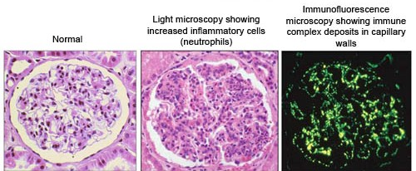

EM: Sub-endothelial Hump.
LM: Increased cellularity* caused by proliferation and swelling of endothelial and mesangial cells and by infiltrating neutrophils and monocytes. (Sometimes there is necrosis of capillary wall).
Immunofluorescence studies: reveal scattered granular deposits of IgG and complement within the capillary walls and mesangial areas.
*“HYPERCELLULAR” (Seen only in post-infection and lupus nephritis class 3 &4)

IgA Nephropathy:

This condition usually affects children and young adults and begins as episode of gross hematuria that occurs within 1 or 2 days of nonspecific upper respiratory tract infection.

- IgA nephropathy is one of the most common causes of recurrent microscopic or gross hematuria and is the most common granular disease revealed by renal biopsy worldwide.

Hallmark of the disease: deposition of IgA in the mesangium.

The lesions in IgA nephropathy vary a lot → glomeruli may be normal or may show mesangial cells and matrix increase ‘widening’ and segmental inflammation.
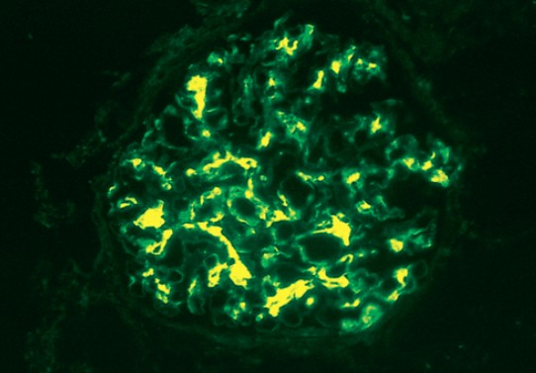
- The characteristic immunofluorescence picture is of mesangial deposition of IgA, often with C3 and properdin and smaller amounts of IgG or IgM.

- EM confirms the presence of electron dense deposits in the mesangium. The deposits may extend to the sub-endothelial area of adjacent capillary wall.

Chronic nephritic syndrome:

  - Azotemia.
  - Active urine sediment (variable).
  - Proteinuria (variable).
  - Past history of RPGN, nephrotic syndrome, nephritic syndrome.
  - Hypertension.

Asymptomatic hematuria/proteinuria
Hereditary Nephritis (Alport syndrome):

Alport syndrome or hereditary nephritis is a genetic disorder characterized by glomerulonephritis, end-stage kidney disease, and hearing loss. Alport syndrome can also affect the eyes, causing eye abnormalities. They have problem in hearing.
- GBM is composed of collagen IV, this collagen type is mutated in Alport syndrome.

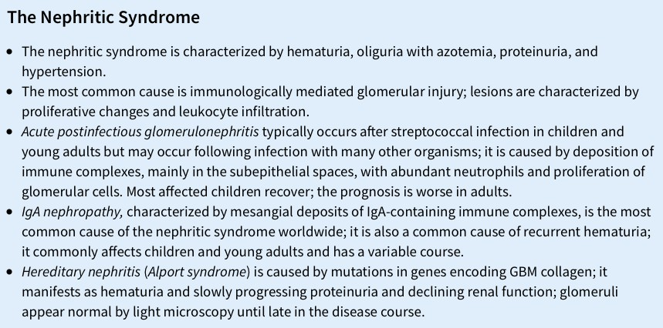
In the glomeruli there is alternating areas of extreme thinning of the glomerular basement membrane (~120 nm) with thick, irregular areas with basket weaving are shown.

MembranoProliferative GlomeruloNephritis (MPGN):

This Group can present as Nephrotic and/or Nephritic Syndromes.
Microscopic finding: hematuria (red cell casts), proteinuria <1 gram/24 hours, normal renal function.

Membranoproliferative glomerulonephritis (MPGN)
GLOMERULAR DISEASE | CLINICOPATHOLOGIC FINING
Type 1 MPGN | Most common type of MPGN: nephrotic presentation (60% of cases) some cases have nephritic presentation. Association: HBV, HBC and SLE  MORPHOLOGY:  1: glomerular are large with lobular appearance.  2: EM: sub-endothelial immune complexes (deposits). IF: granular IgG + C3  3: GBM is thickened.  4: proliferation of the mesangium causes “tram track” double contour, by splitting of the GBM.  - Does not respond to corticosteroid & majority progress to Chronic renal failure.
Type 2 MPGN | Associate with C3 nephritic factor (C3NeF) < (autoantibody that bind to C3 convertase prevent the degradation of C3 Convertase, causing sustained activation of the C3 alternative pathway, resulting in very low c3 level)  Diffuse intramembranous deposits (dense deposit disease) ‘DDD’:  - EM shows tram tracks. LM shows Ribbon-like.  - Does not respond to corticosteroid. Majority progress to Chronic renal failure.  - Granular C3 is present NO IgG.
Type 3 MPGN | It is Rare and doesn’t include in our objectives.

Type 1 MPGN
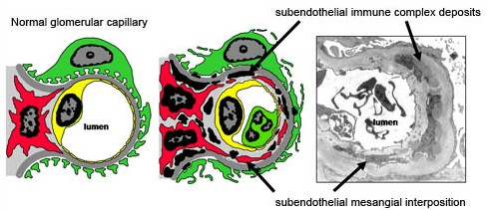
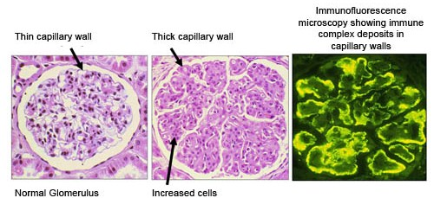

LM shows TramTrack Appearance,

In EM: You will find Discrete immune complexes in the mesangium and sub-endothelial space
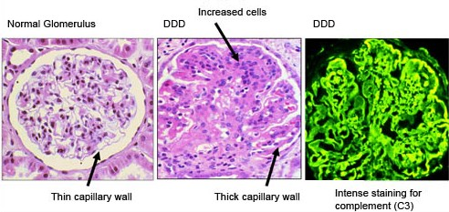
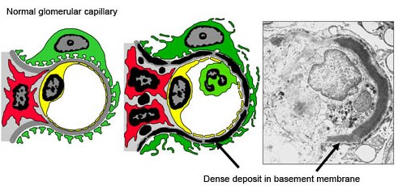
Type 2 MPGN
When viewed under the microscope, continuous, dense ribbon-like deposits are found along the basement membranes of the glomeruli, tubules, and Bowman’s capsule.

Rapidly Progressive Glomerulonephritis:

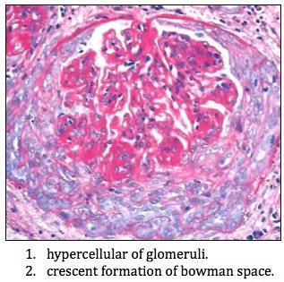
It is rapid deterioration of renal function which severe renal failure develops rapidly within weeks and months. It can be Idiopathic (primary) or glomerulonephritis.
Laboratory findings typical of the nephritic syndrome.
- Prognosis is poor with rapid progression to renal failure.

What is glomerular crescent?
Proliferation of parietal epithelial cells lining Bowman's capsule in the kidney; may protrude into Bowman's space and eventually lead to destruction of the glomerulus. Crescent: proliferative parietal cells + macrophages.

There are 3 Groups that cause RPGN. Mostly Autoimmune Diseases:
  - Type I: Anti-Glomerular Basement Membrane (GBM) Antibody-Mediated Crescentic Glomerulonephritis.
  - Type II: Immune Complex-Mediated Crescentic Glomerulonephritis.
  - Type III: Pauci immune (ANCA-associated).

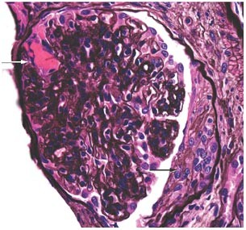
Anti-Glomerular Basement Membrane (Anti-GBM) Antibody-Mediated Crescentic Glomerulonephritis:
Characterized by linear deposition of IgG and C3 on the GBM.
- Hemoptysis associated with lung Disease (GoodPasture Syndrome) and you can see necrosis and crescent formation.

GoodPasture Syndrome:

Antibodies bind also in the pulmonary alveolar capillary basement membranes leading to bleeding from the lungs.

Immune Complex-Mediated Crescentic Glomerulonephritis:

Associated with: Post Streptococcal, SLE and IgA Nephropathy.
Characteristic by granular (lumpy-bumpy) pattern of staining of the GBM for immunoglobulin & complement.

Pauci immune (ANCA-associated):
The lack of anti-GBM antibodies and usually associated with ANCA such as Vasculitis. (ANCA-associated): microscopic form of polyarteritis nodosa, Wegener's granulomatosis, Churg-Strauss syndrome, Drug-induced vasculitides.

Wegener's granulomatosis
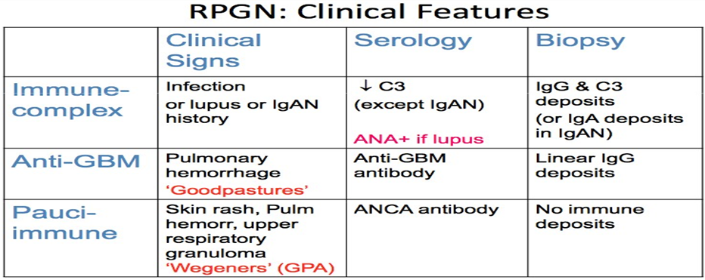
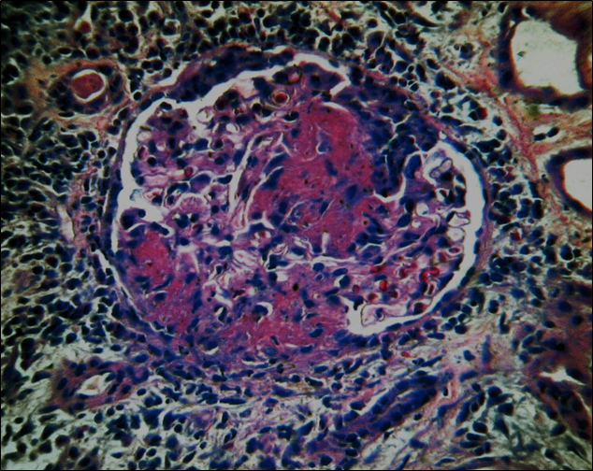
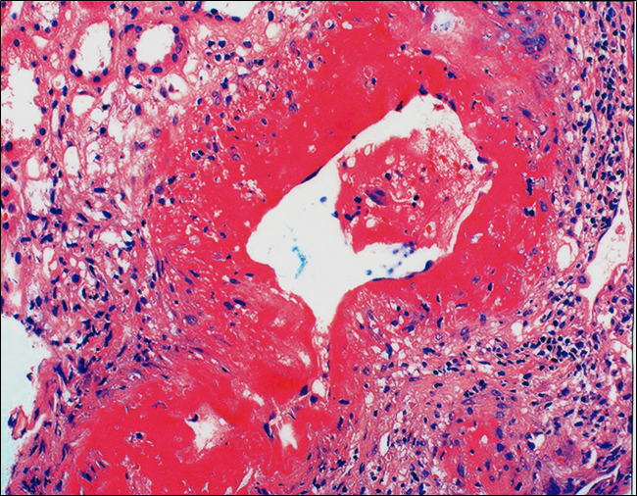
Vessel with transmural necrosis involving the vessels circumferentially with a significant inflammatory infiltrate with mixed polymorphonuclear leukocytes and mononuclear cells.

Glomerulus demonstrating focal and segmental necrosis with adhesion to Bowman’s capsule and proliferation of parietal epithelium
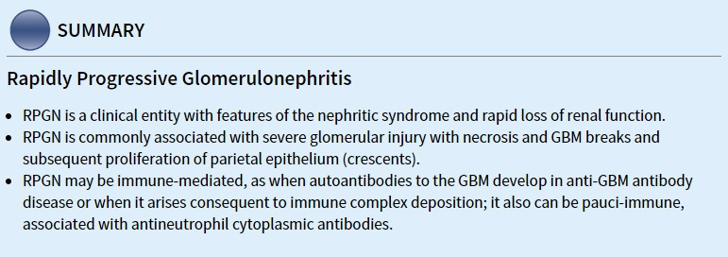
Chronic Renal Failure: Global sclerosis + interstitial fibrosis.

Chronic kidney disease (End stage renal disease - ESRD) is the result of progressive scarring resulting from any type of kidney disease.

  - Kidney disease → function of the remaining intact nephrons are maladapted to such changes occurred by the disease → Chronic Renal Failure (ESRD) → uremia.

Uremic syndrome manifestation:

- Skin manifestations → pruritus, uremic "frost"(ﺻﻘﻴﻊ) skin.
- Cardiac manifestations → uremic pericarditis fluid around the pericardium
- Neurological manifestations → peripheral neuropathy (lethargy)
- Pulmonary complications → pneumonitis and hemorrhage.
- Hematopoietic manifestations → anemia, bleeding diathesis.
- Skeletal abnormalities → renal osteodystrophy (secondary hyperparathyroidism)
- Other → metabolic imbalances (acid-base disorders)

Pathogenesis of uremic syndrome: toxins that cannot be removed
Uremic "Toxins" → Middle molecules → The "Trade off" hypothesis.

Treatment of End Stage Renal Disease:
  - Supportive therapy.
  - Dialysis.
  - Renal transplantation.

Chronic renal failure is characterized by: Symmetrically contracted kidneys, diffusely granular surfaces, tubular atrophy, arteriolar sclerosis, obliteration of the glomeruli and interstitial fibrosis.

Clinical course: the patient presents with proteinuria, hypertension, azotemia. Death to uremia is the role unless the patient has treated with dialysis or transplantation.

"اللهم لا سهل إلا ما جعلته سهلًا و أنت تجعل الحزن إذا شئت سهلًا"

Thanks to 434 pathology team
عبدالعزيز علي آل محمد يزيد عبيد الله المطيري
ريان محمد القرني عبدالكريم محمد الحربي
عبدالله بن أحمد العيدان ريما الشايع
لمى التميمي

Editing File
Email: pathology436@outlook.com Twitter: @pathology436
القادة
نوره عبدالله السهلي عبدالعزيز عبدالله العنقري
الأعضاء

It also called diffuse proliferative glomerulonephritis.
Hepatitis B, C
مظهر سكة القطار
Immune complexes are combinations of antigens and antibodies which bind to each other and then become lodged in the kidney. This activates the immune system, which causes inflammation and damage to the kidney itself.
Anti-neutrophil cytoplasmic antibody.
any molecule with an atomic mass between 350 and 2000 daltons. These molecules accumulate in the body fluids of patients with uremia
provides an explanation for some of the disorders of the uraemic syndrome.

