Tumors of the kidney

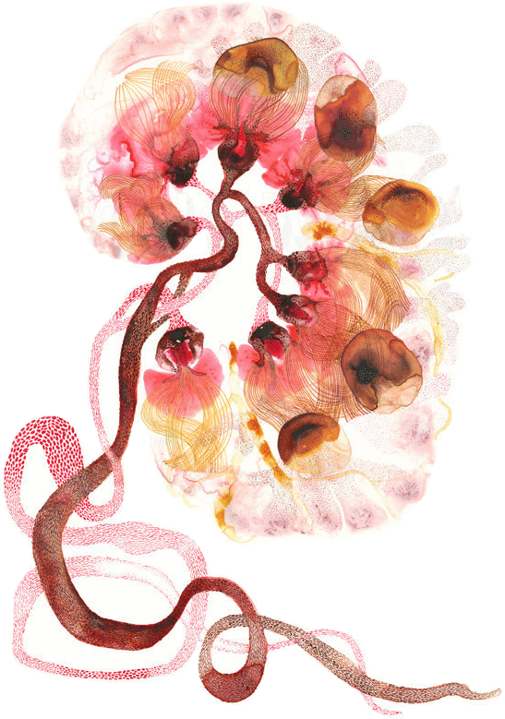
Black: Doctor’s slides. Red: important!
Green: Doctor’s notes. Grey: Extra.
Purple: Female’s slides.

Blue: Male’s slides.

Objectives:

Recognize the benign tumors of the kidney.

- Describe renal cell carcinoma and Wilms tumor.

Recognize transitional cell and squamous.

Carcinoma of the urinary bladder.

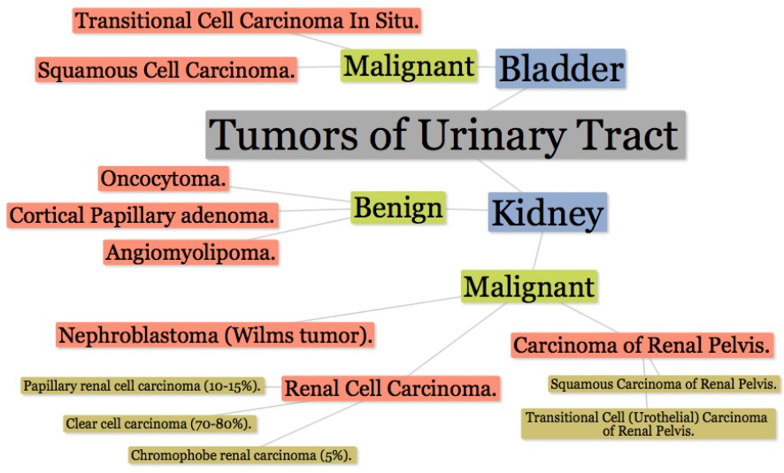
Team 434

Benign tumors of the kidney:

- Adenoma: Adenoma = gland + benign
- This tumor is most often small and asymptomatic. It is derived from renal tubules.
- It may be a precursor lesion to renal carcinoma.
- It occurs in the cortex of the kidney and the outcomes are usually good.

Kidney with ischemic atrophy also bears very small subcapsular adenomas near to each pole.

Histology of a subcapsular papillary adenoma shows tubules arranged in a papillary fashion.

- Angiomyolipoma:
Angiomyolipoma:
angio = blood vessel.
myo = smooth muscle.
lipoma = lipid.

It is often associated with the tuberous sclerosis syndrome.

- Oncocytoma:

It’s a benign tumor that arises from the intercalated cells of collecting ducts. These tumors are associated with genetic changes (loss of chromosomes 1, 14, and Y).

Malignant tumors of the kidney:
Neoplasms of the Renal Parenchyma:

- Renal cell carcinoma (renal adenocarcinoma; hypernephroma).
- Nephroblastoma (Wilms tumor).
- Transitional cell (urothelial) carcinoma.

Tumors of the lower urinary tract are about twice as common as renal cell carcinomas.
The most common malignant tumor of the kidney is renal cell carcinoma, followed in frequency by nephroblastoma (Wilms tumor) and by primary tumors of the calyces and pelvis.

Renal cell carcinoma:

Etiology:
It is more common in men, occurs most often from 50-70 years of age and may be occult.

Risk factors:
Cigarette smokers, hypertensive, obese patients and those who have had occupational exposure to cadmium.

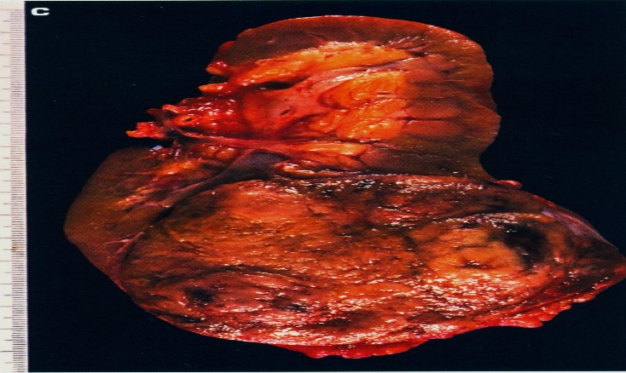
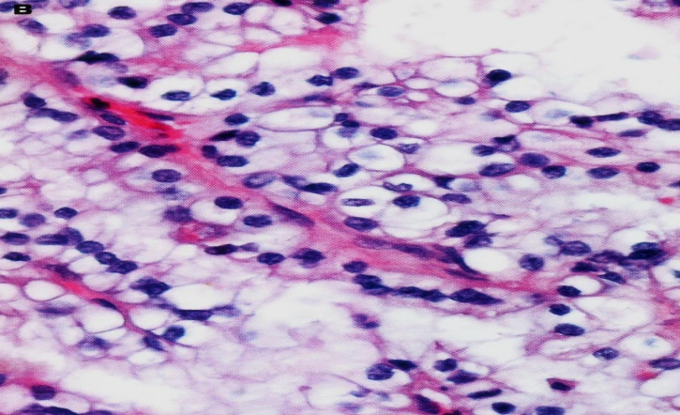

(hypernephroma, Grawitz tumor) is spreading into perirenal adipose tissue.

Typical lobulated, whorled, tan-colored cut surface of renal cell carcinoma.

Pathogenesis:

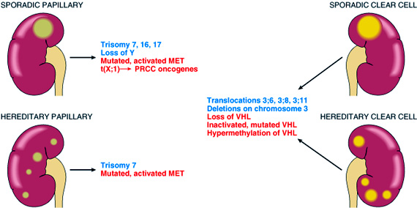
- it is associated with gene deletions in chromosome 3, it can also be associated with
Von Hippel-Lindau disease (VHL) which is caused by alterations in a gene localized in chromosomes 3.
- The carcinoma originates in renal tubules. Most often it arises in one of the renal poles, frequently the upper pole.
- Frequently the tumor invades renal veins or the vena cava and can extend up the vena cava.

Classification:

- Clear cell carcinoma (70-80%).
- Papillary renal cell carcinoma (10-15%).
- Chromophobe renal carcinoma (5%).

- Clear cell carcinoma:

Gross | Microscopic
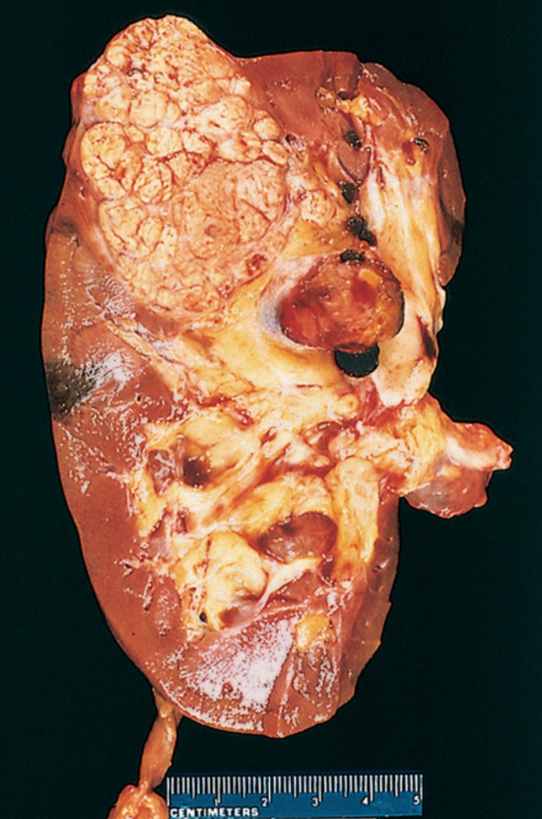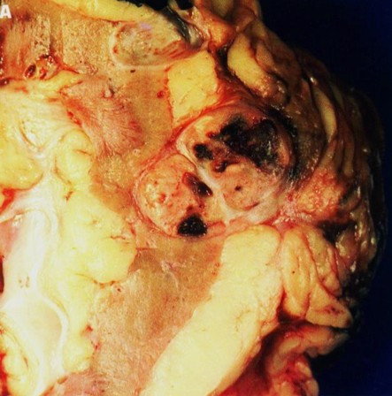 | 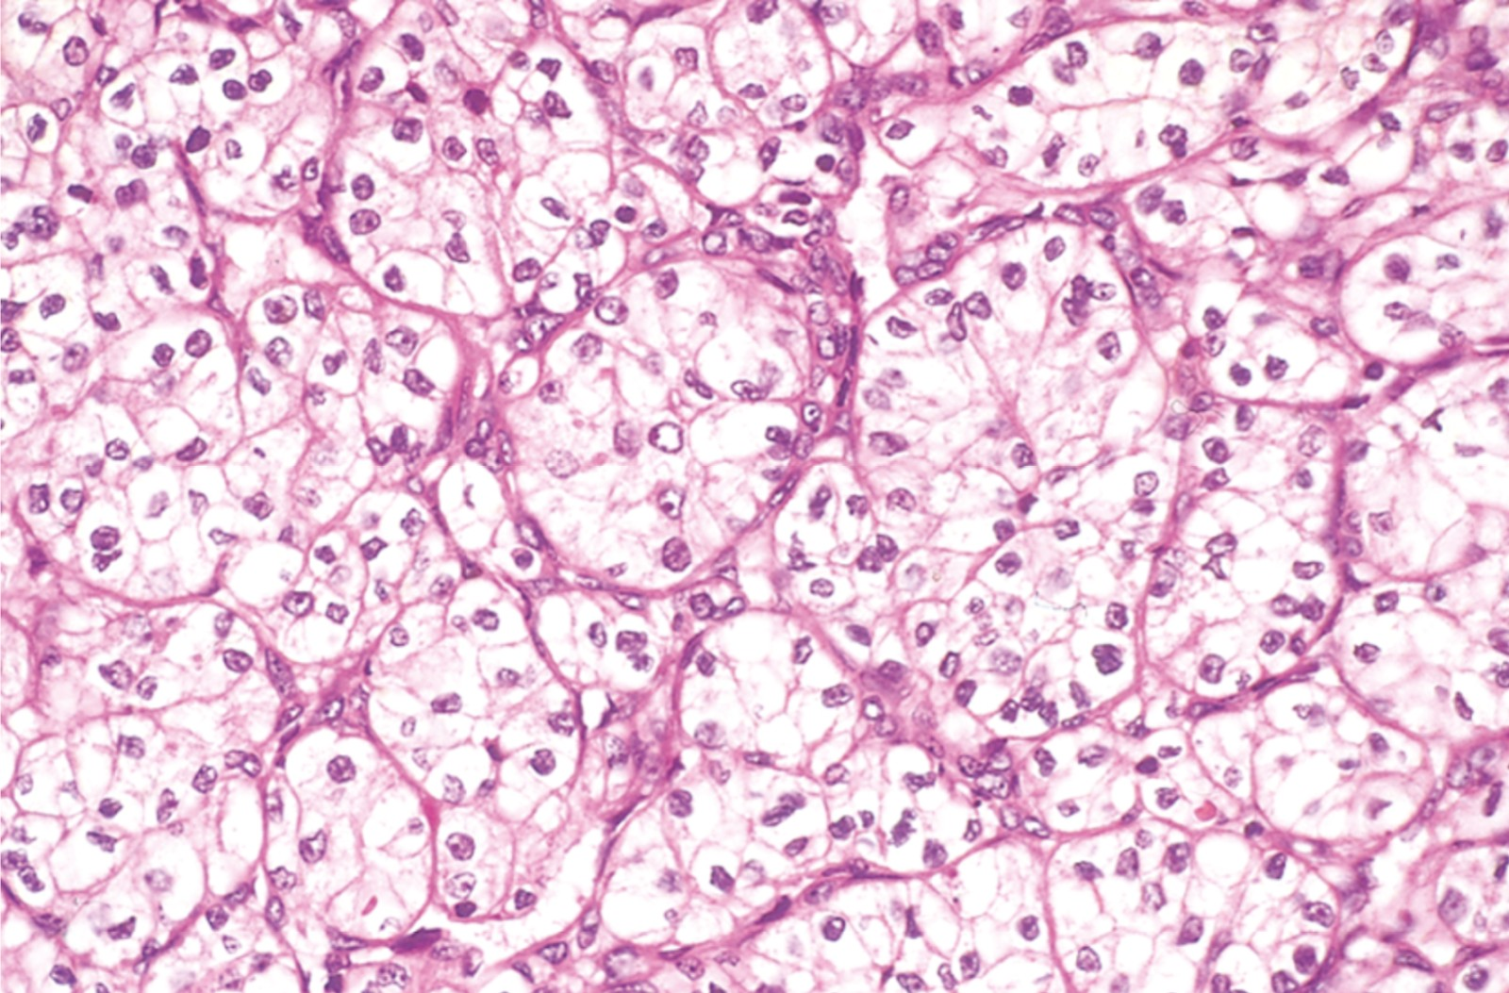
- May arise anywhere in the kidney (Mostly poles).  - Solitary3 unilateral and large lesions (spherical masses).  - Marginated.  - Composed of yellow-gray-white tissues that distorts the renal outline.  - Foci of hemorrhagic discoloration.  - Grey-white necrosis.  - Invasion of the renal vein.  - thin fibrovasculer septa. | - Depending on the amounts of lipid and glycogen present, the tumor cells may appear almost vacuolated or may be solid.  - Nuclei are small and round.  - Clear cells with clear or granular pink cytoplasm. (Clear renal cell)  - Spreading into perirenal adipose tissue.  - translocation or deletion or loss of VHL

- Papillary renal cell carcinoma:

Clinical presentation:

- Fever.
- Hematuria.
- Flank pain.
- Mass.
- Polycythemia.

- Exhibit papilla formation with fibrovascular cores.
- They tend to be bilateral and multiple.
- most common cytogenetic abnormalities are trisomies 7, 16 and 17.
- Easily metastasize.
- Pink cytoplasm.

Chromophobe Renal Carcinomas:

The least common.
- They arise from intercalated cells of collecting ducts.
- Tumor cells stain more darkly, so they are less clear than cells in clear cell carcinomas.
- Shows extreme hypodiploidy, by losing entire chromosomes, including chromosomes 1, 2, 6, 10, 13, 17, and 21.
- Grossly, they tend to be tan-brown.
- Have a goof prognosis.

Wilms tumor (nephroblastoma):
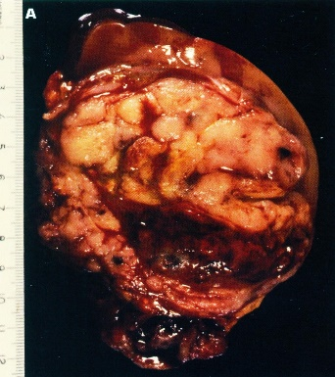
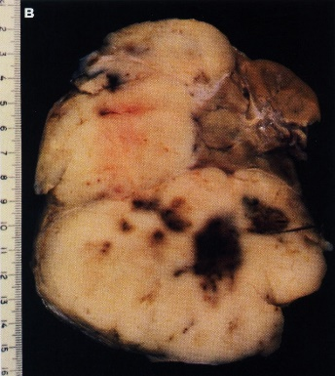
This Wilms’ tumor appears whiter due to formalin fixation and has extended beyond the confines of the kidney
Solid, bulging, fleshy tan-white, partially necrotic tumor has replaced much of the kidney and is encompassed by a thin rim of renal tissue.

Etiology:

- This cancer is the most common renal malignancy of early childhood.
- Incidence peaks in children 2-4 years of age. Inherited as an autosomal dominant trait.

Pathogenesis (mutated genes):
- Originates from primitive metanephric tissue (derived from the mesoderm).
- Often associated with deletions of the short arm of chromosome 11. The WT-1 and WT-2 genes localized to this chromosome are cancer suppressor genes.
- The disease can be part of WAGR syndrome (i.e., Wilms tumor, aniridia, enital abnormalities, and mental retardation)→ deletion of WT1.
- Denys-Drash syndrome (DDS) approximately 90% → deletion of WT1.
- Beckwith-Wiedemann syndrome (BWS), enlargement of individual body organs → deletion of WT2 (11p15.5)

The prognosis is very good with a combination of nephrectomy and chemotherapy.

Morphology:

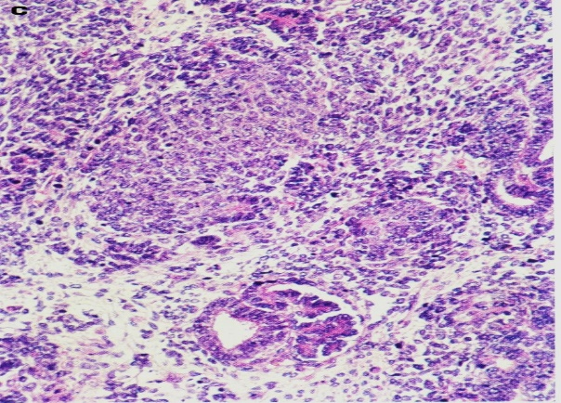
- Characteristics are varied with immature stoma, primitive tubules and glomeruli, and mesenchymal elements such as fibrous connective tissue and cartilage bone.

- In most lesions, triphasic combination of blastemal, stromal and epithelial cell types is observed.

- The tumor is large, solitary, and well-circumscribed mass.
- the tumor is soft, homogenous, and tan to gray, with occasional
- foci of hemorrhage, cystic degeneration, and necrosis.
Histology shows hypercellular areas comprising undifferentiated blastema, loose stroma with undifferentiated glomeruloid body.

- Nephrogenic rests are precursor lesions of Wilms tumors.

Presenting Features:

Most often, the presenting feature is palpable flank mass, which may extend across the midline and down to the pelvis (often huge).

Less often, the patient will present with fever, abdominal pain, hematuria, or intestinal obstruction as a result of pressure from tumor.

Transitional cell (Urothelial) carcinoma:

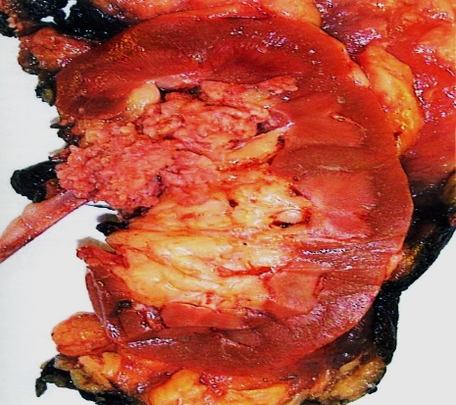
This cancer is the most common tumor of the urinary collecting system but can occur elsewhere thus it’s central not peripheral. It’s often multifocal in origin. Malignant tumor arising from the transitional cells.
- In the renal pelvis, transitional cell carcinoma has been associated with phenacetin abuse.
- This carcinoma is likely to recur after removal.
- Most often, the presenting feature is hematuria.
- There is tendency to spend by local extension to surrounding tissues.
- Associated toxic exposures may sometimes be involved, including the following:
Papillary urothelial (transitional cell) carcinoma of renal pelvis. Note the exophytic, multifronded nature of the tumor.
- Industrial exposure to benzidine or 𝛃-naphthylamine, which is an
- aniline dye.
- Cigarette smoking.
- Long term treatment with cyclophosphamide

Malignant tumors of the bladder:

- More common in male.

- Transitional Cell Carcinoma In Situ (90%).
- Squamous Cell Carcinoma (3-7%).

Pathogenesis:

- first pathway: The tumor is initiated by deletions of tumor-suppressor genes on 9p and 9q →
formation of superficial papillary tumors → may then acquire TP53 mutations → invasion.
- second pathway: Initiated by TP53 mutations → carcinoma in situ → loss of chromosome 9
→ invasion.

Morphology:

- Undifferentiated tumor.
- Could be invasive or noninvasive.

Clinical Features:
- All bladder tumors present with gross painless hematuria.
- Patients with urothelial tumors, have a tendency to develop new tumors after excision, and recurrences may exhibit a higher grade.

Treatment:
- Depends on tumor grade and stage and on whether the lesion is flat or papillary.

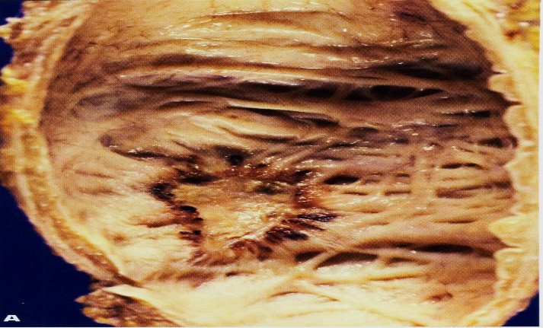
Transitional Cell Carcinoma In Situ:

Most common bladder cancer in adult males, rare and non-familial.

Urothelial (transitional cell) carcinoma in situ of the urinary bladder if untreated, up to 75% of cases go on to invasive cancer.

Squamous Cell Carcinoma:

- They typically show extensive keratinization.
- Associated with chronic bladder irritation and infection.

Risk factor:

Schistosoma haematobium infections in areas where it is endemic, such as Egypt.
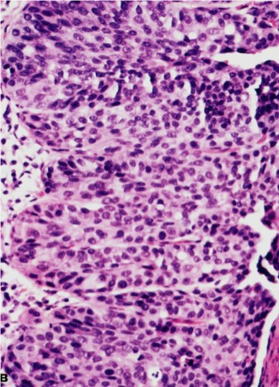
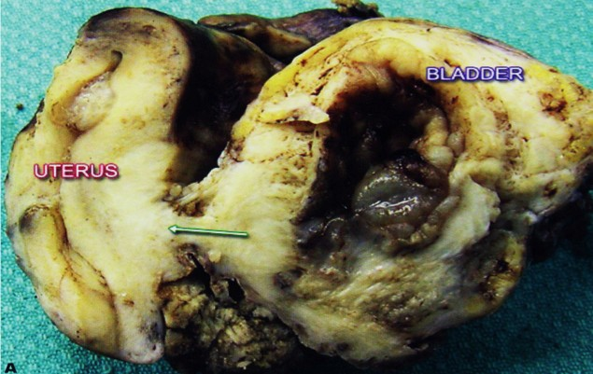
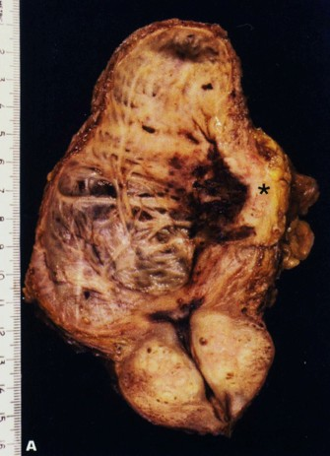
Invasive urothelial carcinoma of the bladder is invading the muscle coat on the right side of the picture.

Histology of carcinoma in situ (surface is to the right).

The invasion of the tumor up to the uterus.

Invasive urothelial carcinoma of the bladder is invading the muscle coat on the right side of the picture.

Poorly differentiated urothelial carcinoma.
The invasion of the tumor up to the uterus
Box II. Grading and staging of bladder transitional cell carcinoma (TNM):
Grade | Definition
G1 | Well differentiated
G2 | Moderately differentiated
G3 | Poorly differentiated/undifferentiated
Stage | Definition
Tis | In situ carcinoma
Ta | Non-invasive, papillary tumor
T1 | Tumor invades subepithelial connective tissue
T2 | Tumor invades muscularis propia
T3 | Tumor invades beyond muscularis propia
T4 | Tumor invades prostate, uterus, vagina or pelvic wall/abdominal wall
N1 | Single lymph node metastases ($≤$2cm)
N2 | Single metastasis (>2cm) or multiple metastases ($≤$5cm)
N3 | Multiple metastases (>5cm)
The prognosis of TCC of the bladder depends largely on the grade and the stage of tumor but most patients with metastases bladder TCC die within five years of diagnosis.
435 Summary
"اللهم لا سهل إلا ما جعلته سهلًا و أنت تجعل الحزن إذا شئت سهلًا"

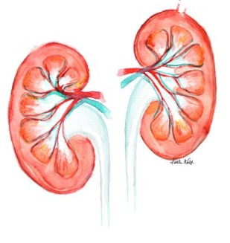

Editing File
Email: pathology436@outlook.com Twitter: @pathology436

القادة

نوره عبدالله السهلي عبدالعزيز عبدالله العنقري

الأعضاء

عبدالله المانع حمد الحسون
باسل المفلح عبدالله الجماح
غادة المزروع

¹ A rare, multi-system genetic disease that causes benign tumors to grow in the brain and on other vital organs such as the kidneys, heart, eyes, lungs, and skin. It usually affects the central nervous system and results in a combination of symptoms including seizures, developmental delay, behavioral problems, skin abnormalities, and kidney disease.
Is a disease which results from a mutation in the von Hippel–Lindau tumor suppressor gene on chromosome 3p25
A fragment of embryonic tissue in the kidney retained after the period of embryonic development

