Kidney allograft

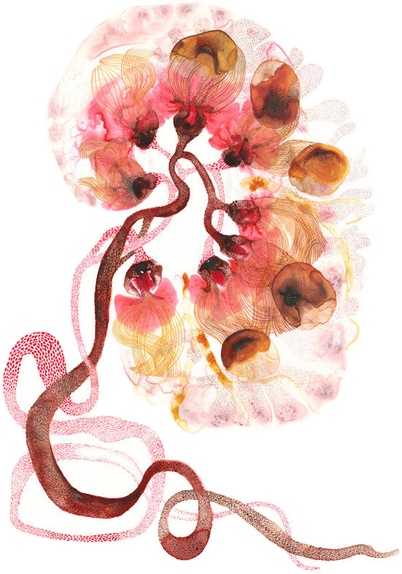

Objectives:

- Recognize the concept of renal allograft.

- Describe the pathology of rejection

- Differentiate between acute and chronic rejection.

- Recognize the principal infections inherent to renal transplantation.

- Recognize acute and chronic drug toxicity.

Black: Doctor’s slides. Red: important!
Green: Doctor’s notes. Grey: Extra.
Purple: Female’s slides.

Blue: Male’s slides.

Introduction

The best treatment for kidney failure is transplantation (better than dialysis). Because the new kidney will be able to produce hormones & have a normal function.
The word Allograft refers to the transplantation of organs within the same species (human to human), while Xenograft refer to transplantation between different species (animals to human).
- A major barrier to transplantation is the process of rejection, in which the recipient's immune system recognizes the graft as being foreign and attacks it.
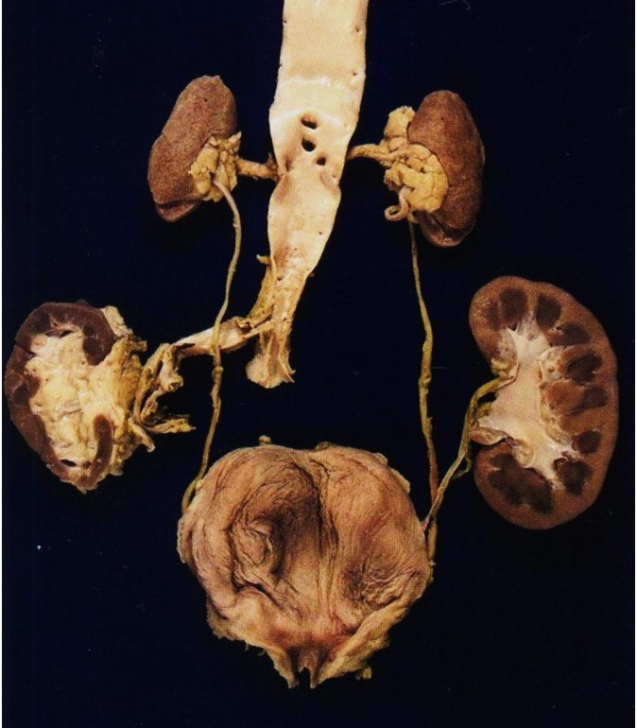

Notice that this patient has 4 kidneys, the upper two are the end-stage native kidneys in normal position. The atrophic first donor kidney (lower left), and the larger second donor kidney (lower right).
End-stage kidneys don’t have to be removed, unless the patient is on dialysis because they will be prone to develop renal cell carcinoma or amyloidosis. So in this case they are removed.

Complications that may happen to transplanted kidney:
  - Rejection.
  - No rejection:
    - Infection (due to immunosuppressant drugs).
    - Drug toxicity.
    - Ischemia (anastomosis was not very will in surgery).
    - Recurrence of original disease (E.g MPGN, FSGS).
    - De novo GN.

Types of Renal Transplant Rejection:

- Normal.
- Hyperacute Rejection → Circulating antibodies attack the allograft immediately (antibody mediated).
- Accelerated acute rejection.
- Borderline changes (very mild acute rejection).
- Acute Rejection (T-cell or Antibody-mediated). -days to weeks-
- Chronic Rejection.

Before we discuss the types of rejection, we should know the difference between T-Cell-mediated rejection & antibody-mediated rejection. Robbins page 137

1- T-Cell-Mediated Rejection:

Cytotoxic T lymphocytes kill cell in grafted tissue → parenchymal and endothelial cells death → Thrombosis and graft ischemia → cytokines secrete CD4 + T cells → accumulation of lymphocyte and activate macrophages → Graft Destruction (Tubulointerstitial inflammation).

2- Antibody-Mediated Rejection: Homework

Antibody directed against Graft MHC → activation of complement and recruitment of leukocytes → Vascular injury and endothelial damage → Thrombosis and ischemia → Graft Destruction.

Immune Recognition of AlloGraft:

Rejection of allograft is a response mainly to MHC molecules. MHC molecules are is a set of cell surface molecules encoded by a large gene family which controls a major part of the immune system. They are recognized by T-cells.

1- Hyperacute Rejection:
Rejection occurs within minute to few hours after transplantation in presensitized host and typically recognized by the surgeon just after the vascular anastomosis is completed.

It occurs if preformed anti-donor antibodies are present in the circulation of the host before transplantation, for example:
  - In individual is exposed to foreign HLA (on platelets or leukocytes) from previous blood transfusions
  - Or such antibodies also may be present in a patient who has previously rejected an organ transplant.
Now matching and other mechanisms are used to avoid this.

Morphology after rejection: Cyanotic, mottled and flaccid and may excrete only a few drops of bloody fluid.

Under microscopy: Widespread acute arteritis and arteriolitis, vessel thrombosis and fibrinoid necrosis.
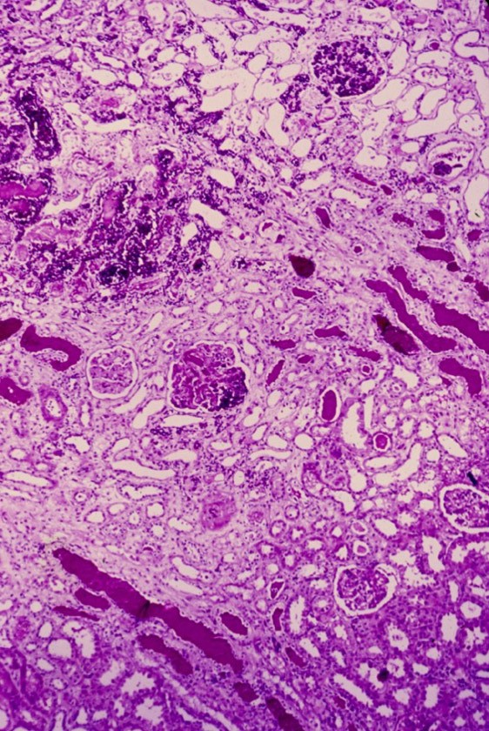
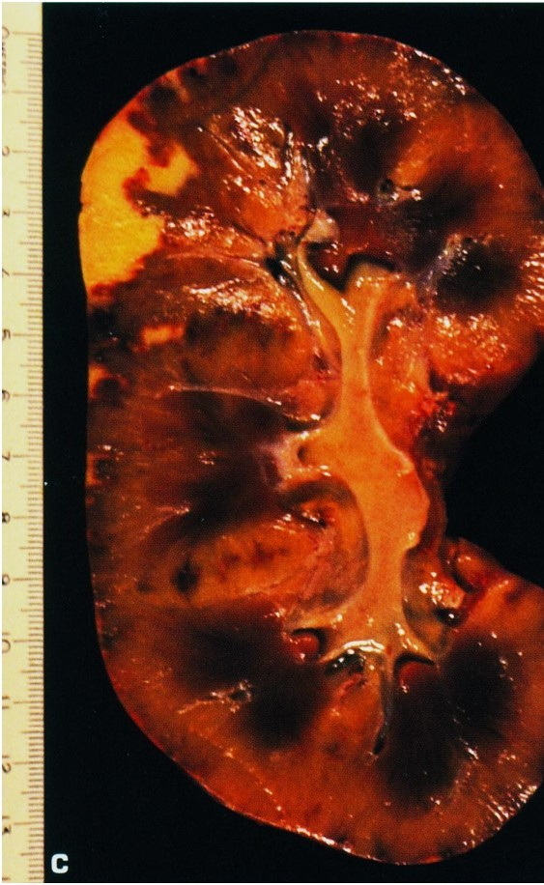
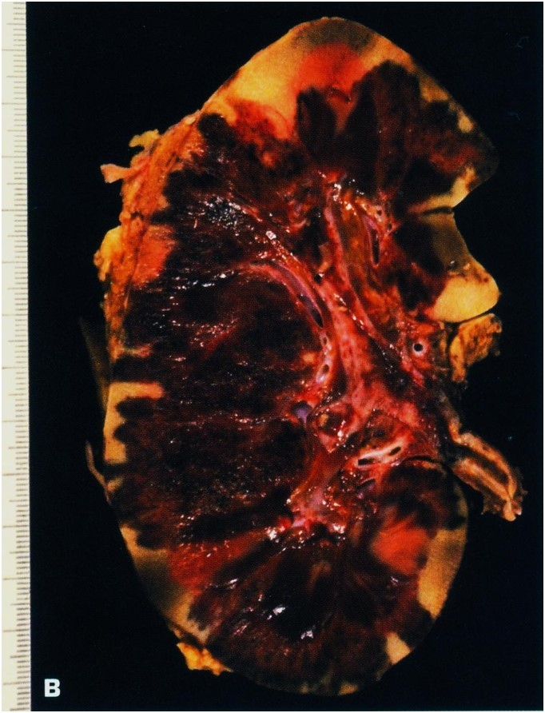

Subtotal renal infarction due to hyperacute (antibody-mediated) rejection.
Severe acute rejection of donor kidney, Focal infarcts are present.
Hyperacute Rejection under LM.

2- Accelerated acute rejection:
It occurs within hours or days and the patient may have previous unsuccessful graft.
- Caused by cellular or humoral immune mechanism.

3- Borderline changes (very mild acute rejection):

It does not reach to acute rejection but it is not normal at the same time (Suspicious). You may see interstitial inflammation with few tubulitis with no intimal arteritis.
Borderline is acute T cell mediated rejection; there is tubular interstitial inflammation and increased Creatinine.
Borderline changes (Suspicious for Acute Rejection).

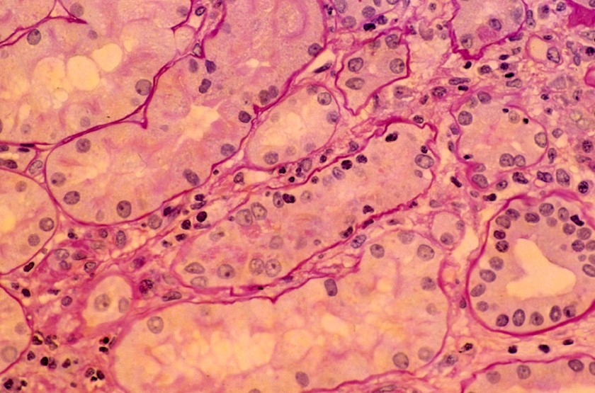

4- Acute rejection:

May occur within days to weeks and it can cause by either humoral OR cellular immune response.

- Acute cellular rejection: T cells will destroy parenchyma by cytotoxic and inflammatory cells.

- Acute humoral rejection: Antibody damage graft vasculature.
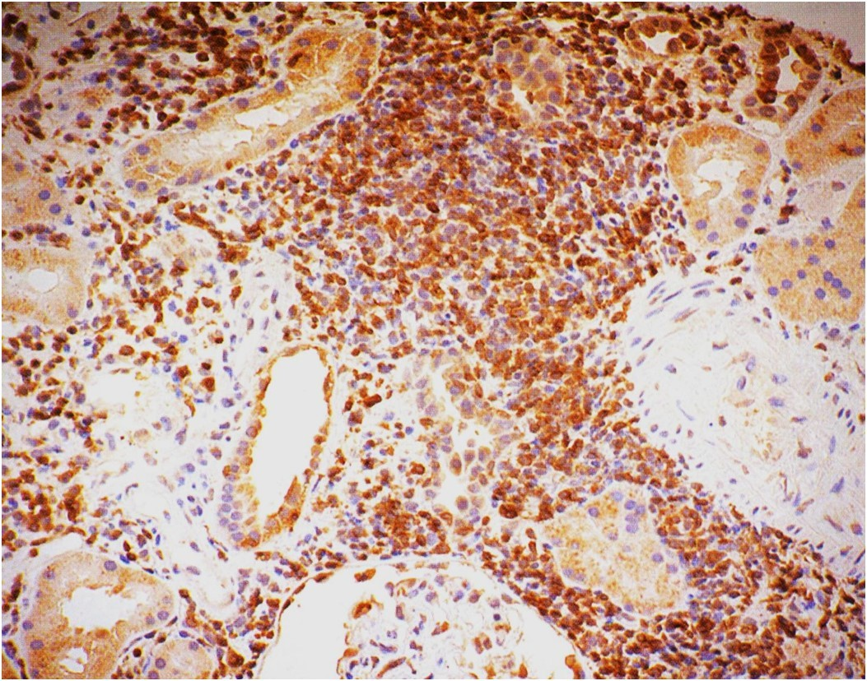
The interstitial infiltrate consists of T cells mainly.

The Banff classification in acute rejection
Grade I* | A | Mononuclear interstitial inflammation (>25%). Moderate tubulitis. (5 to 10). |  | 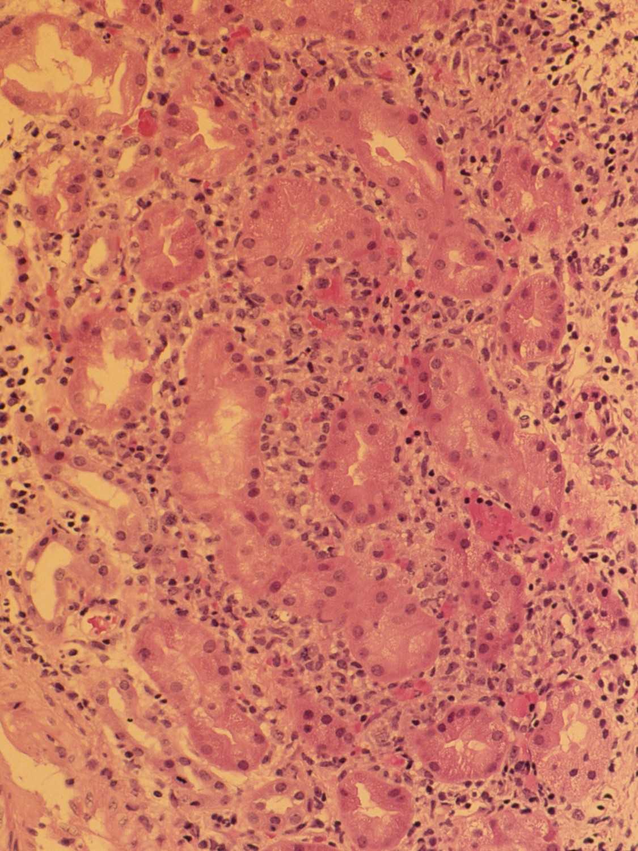
 | B | Mononuclear interstitial inflammation (>25%).  Severe tubulitis (>10). |  | 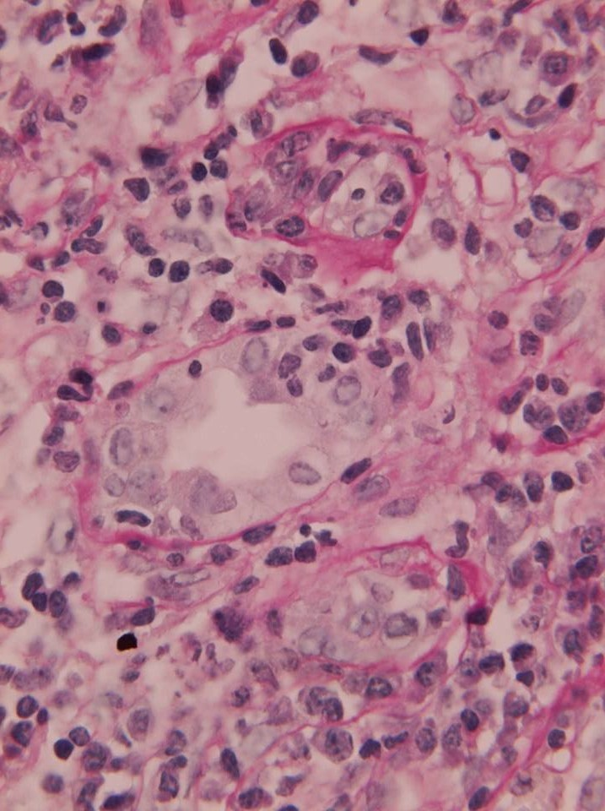
Grade II^ | A | Mild to Moderate intimal arteritis. |  | 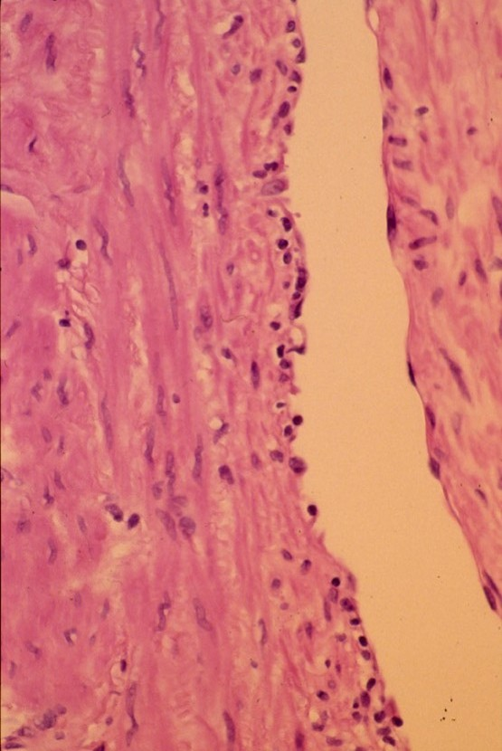
 | B | Severe intimal arteritis.
Grade III** |  | Transmural arteritis and/or fibrinoid necrosis.
**Acute Grade III can be T cell mediated or antibodies mediated rejection.
^Grade II, it’s not important to know about the tubular interstitial state because the blood vessels it selves are affected.
*Acute grade I&II are T cell mediated.

5- Chronic Rejection:

Patients present with chronic rejection late after transplantation (months to years). In those patients there will be elevation in serum creatinine (which is an index in impaired renal function). Chronic rejection is characterized by:

  - Vascular Sclerosis: Changes in arteries and arterioles which exhibit intimal smooth muscle cell proliferation and extracellular matrix synthesis. The vascular changes may be caused by cytokines that is secreted by T cells.
  - Vascular changes and lesions compromise vascular perfusion resulting in ISCHEMIA which is manifested by loss or hyalanization of glomeruli & interstitial fibrosis, tubular atrophy.
  - Loss in renal parenchyma.

The Banff classification in chronic rejection:
- Grade I (Mild).
- Grade II (Moderate).
- Grade III (Severe).

  - Normal, Suspicious → No Treatment (We measure creatinine level if it’s high we treats the patient, if it’s normal we follow him up).
Chronic Allograft Nephropathy:
1- Tubular interstitial atrophy (fibrosis).
2- Proliferation of fibroblast in the wall of blood vessels, thickening of the walls.
  - Grade I → Treat if clinical signs +.
  - Grade II → Treat.
  - Grade III → Treat or Abandon.
  - Cyclosporine toxicity → Reduce Cyclosporine.
  - Acute Tubular Necrosis → Await recovery or treat.
  - Chronic rejection → Temporize.

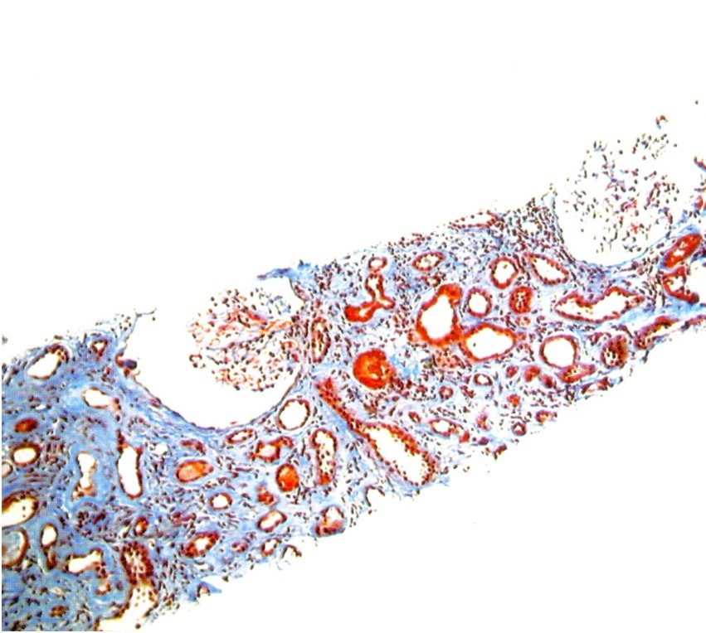
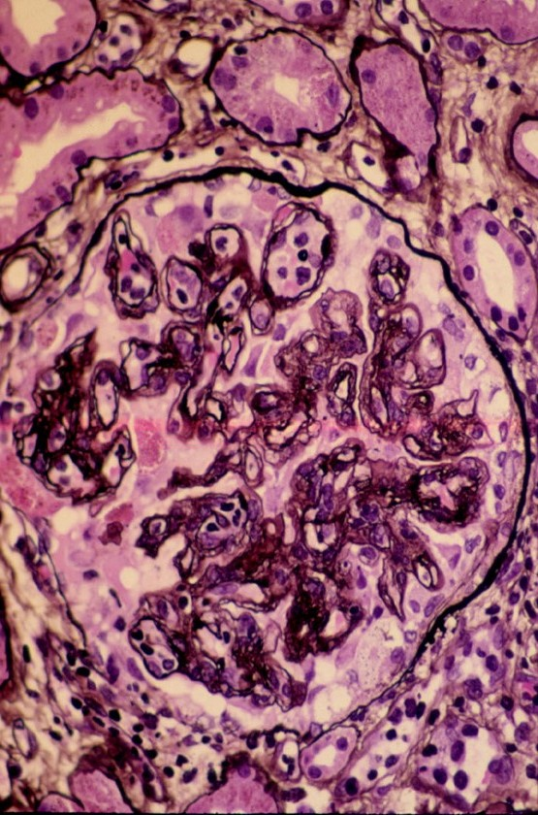
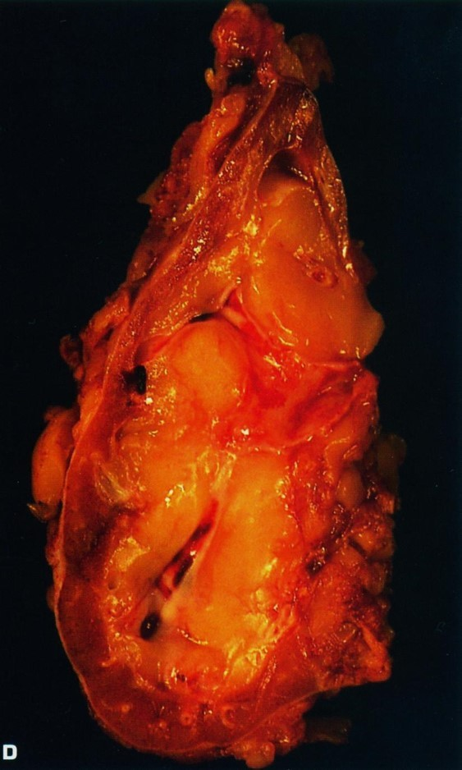
Severe chronic rejection, (graft arteriopathy).
Note the severe parenchymal atrophy and the thick-walled arteries.
An example of Grade II-III is characterized by a diffuse increase in interstitial tissue and marked tubular atrophy as seen on this trichrome stain
Frequent double contours along the glomerular capillary loops

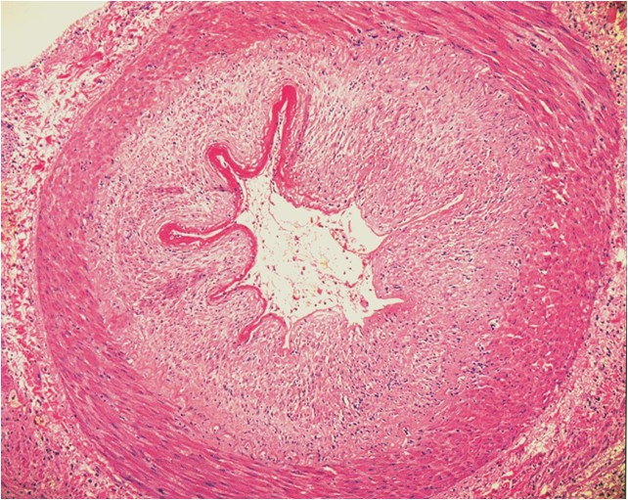
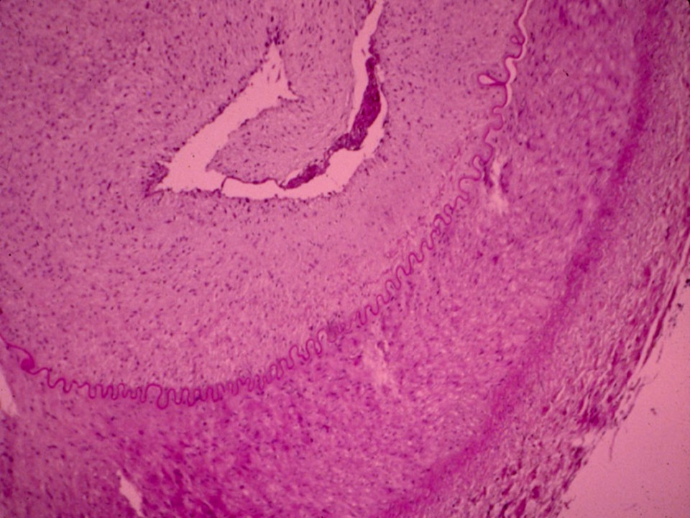
The classical lesion of chronic transplant vasculopathy is a circumferential proliferation of myointimal cells with an intact internal elastic lamina.
Chronic vasculopathy related to acute rejection

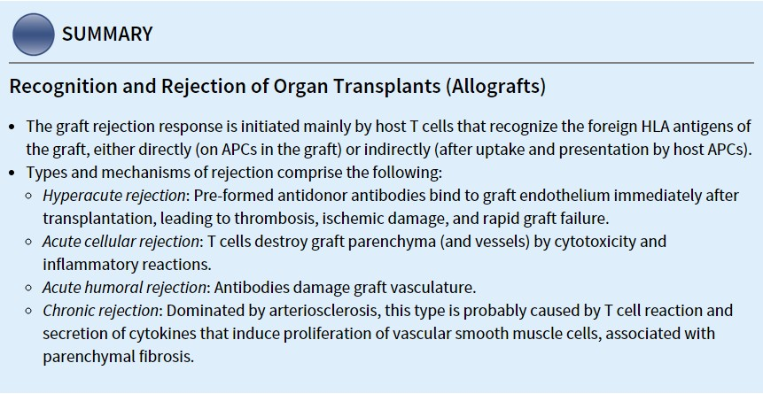

Drug Toxicity:
The immunosuppressant *Cyclosporine* drugs used with transplantation is toxic to the kidneys (dose must be adjusted if its toxicity occurs).

- It’s difficult to differentiate between drug toxicity and chronic rejection.

Drugs Toxicity | Biopsy | Comment
Acute Drugs Toxicity | Isometric vacuoles in the tubular epithelial cells. | That means you should adjacent the dose (it is too high).
Chronic Drugs Toxicity | - Nodular hyaline in the wall of blood vessel.  - Interstitial fibrosis | -

- Ischemia may cause isometric vacuoles also so we should check the drug level in the blood to know the etiology whether it’s ischemia or drug toxicity.
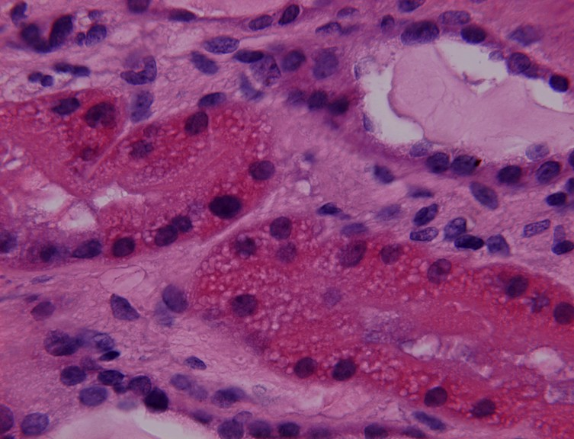
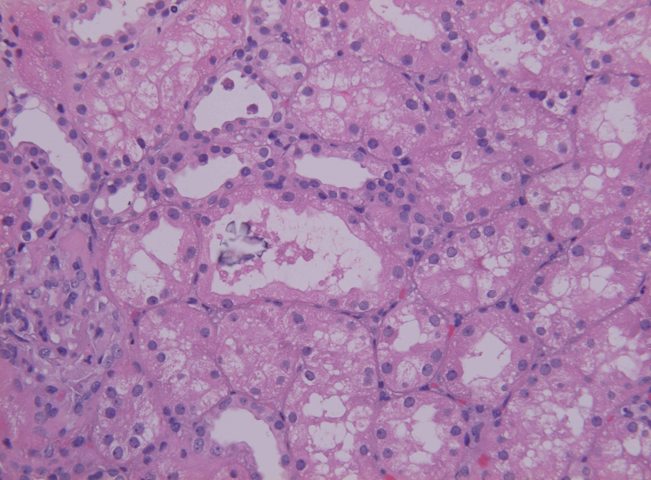
Nodular hyaline in the wall of blood vessel and Interstitial fibrosis (chronic Drug Toxic).
Right picture: Calcification of necrotic tissue in the tubules.

Infections:
That may happen due to high dose of immunosuppressant drugs. (means the body id susceptible to any organism *No defense by the immune system*)
In case of infection, we decrease immunosuppressant.

Viral infections:

Virus | Biopsy | Comment
Cytomegalovirus (cmv) | - Increases the cells size in all part of the kidney.  - Inflammatory cells infiltrate | With high dose, make sure there is no increase in the cells size.
Polyomavirus (sv40) | Glassy nuclei | Only infect the kidney mainly DCT.  Special stains is used for investigation

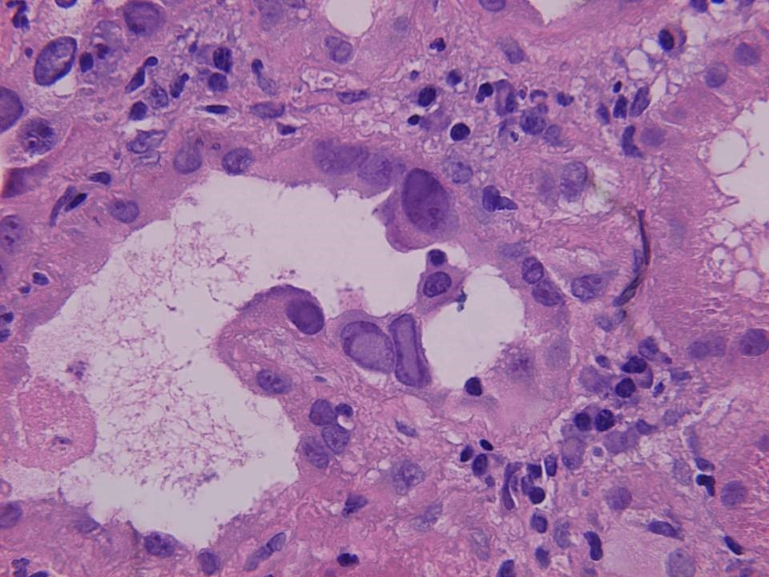
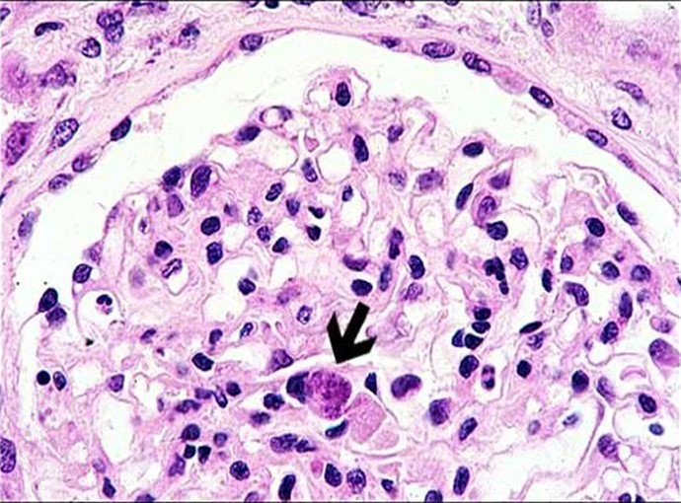
- Polyomavirus is in the tubules, parietal cells of Bowman’s.
- Cytomegalovirus is anywhere *not specific*.
Arrow: Cell infected by cytomegalovirus.

- Conclusion:
The Banff classification has proposed a schema for interpretation and gradation of the histological findings in renal allograft biopsies that can be used as an indication for therapeutic consequences and expected graft survival.

"اللهم لا سهل إلا ما جعلته سهلًا و أنت تجعل الحزن إذا شئت سهلًا"

Thanks to 434 pathology team
مساعد النويصر عصام الشهراني
روان الوادعي
Editing File
Email: pathology436@outlook.com Twitter: @pathology436
القادة
نوره عبدالله السهلي عبدالعزيز عبدالله العنقري
الأعضاء

يعني إن جسم المريض مكوّن أجسام مضادة من قبل عملية الزراعة فبمجرد ما تنحط الكلية الجديدة الأجسام هذه الجاهزة تهاجم الكلية
زرقاء
مبقعة
رخوة
theory or plan

