BLOOD PRACTICAL – 1
Memorize the values because it’s so important
"الكلام بالهايلايت السماوي غير مطلوب، فقط للقراءة والفهم لأنها تعتبرعملية للتطبيق المباشر "
COMPLETE BLOOD COUNT
OBJECTIVES:
At the end of session, the students should be familiar with:
- The procedures used for taking both capillary and venous blood.
- The methods used to measure the different hematological values.
- The normal values recorded when making these measurements.
- The Red Blood Cell Indices (MCV, MCH and MCHC)
EQUIPMENTS:
- COULTER ANALYZER
- EDTA TUBES
- LANCETS
- TOURNIQUET
- ALCOHOL SWABS
- HEPARINIZED CAPILLARY TUBES
- PLASTICINE
- CENTRIFUGE MACHINE
- MICRO-HEMATOCRIT READER
PROCEDURE:
MEASUREMENT OF HEMATOCRIT OR PACKED CELL VOLUME (PCV):
We need to draw blood from capillaries in order to measure Hematocrit (PCV) using micro-hematocrit reader.
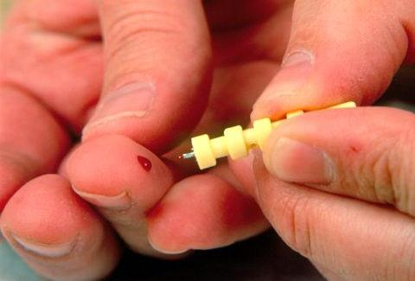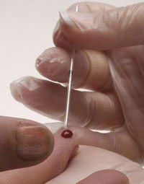
- Clean the area of the skin of a finger-tip or an ear lobe with a sterilized alcohol swab.
- Prick the skin using the pen lancet.
- Discard the first drop of blood, because it is mixed with tissue fluid.
- Allow the second drop of blood to be formed and allow it to become large enough to fill 75% of the heparinized capillary tube by the capillary action when it is brought closer to the blood. Apply only gentle pressure beneath the pricked skin to help the flow of blood, because if more pronounced pressure is exerted, blood is likely to be diluted with interstitial fluid.
- Seal one end of the capillary tube with plasticine.
- Repeat above steps 1 – 5 to collect several capillary blood samples.
- Put all the capillary blood samples in a centrifuge machine for 5 minutes at the speed of 3000-4000 RPM to separate plasma from cells.
- Once centrifuged, take one of the capillary blood samples to see the cells have been packed at the bottom of the tube and the light-weight clear plasma visible above the cells.
- The packed cell volume or Hematocrit can then be determined as a percentage of the total volume using Hematocrit reader.

MEASUREMENT OF BLOOD CELL COUNTS BY USING COULTER ANALYZER
We need to draw blood from a superficial vein in order to analyze the blood for various hematological values using Coulter Analyzer.
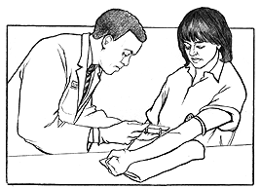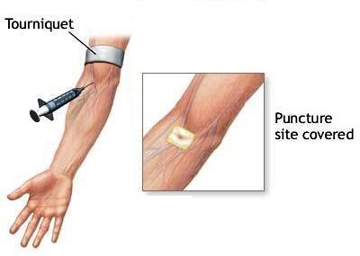
- Clean the area of the skin to be pricked. Usually the blood is drawn from median Cubital Vein in front of the elbow joint to collect venous sample.
- Apply the tourniquet above the elbow joint to impede the flow of venous blood towards the heart for a while.
- Use a disposable syringe to draw the blood from the vein.
- Immediately transfer the collected blood from the syringe to EDTA anti-coagulated tube to prevent blood from clotting.
- Activate the Coulter analyzer machine and a probe will move across and down into aspirate position. The aspiration syringe draws 12 µl of whole blood into the probe.
- The Coulter Analyzer makes the necessary dilutions with the reagents automatically and accurately counts and measures the sizes of cells by detecting and measuring changes in electrical resistance when a particle (such as cell) in the conductive liquid passes through a small aperture. As each cell goes through the aperture, it impedes the current and causes a measurable pulse. The number of pulses signals the number of particles. The height of each pulse is proportional to the volume of that cell.
- Finally all the hematological values are reported and printed.

CALCULATION OF RED BLOOD CELL INDICES
- MEAN CELL VOLUME (MCV)
This is the volume of an average red blood cell measured in femtoliters (fl).
$$MCV=Packed Cell Volume x\frac{10}{RBC Count}$$
MCV of a normal person ranges from 78 – 98 fl.
If MCV is low, it means that red blood cells are small in size and they are called microcytes. But if MCV is high, it means that red blood cells are large in size and they are called macrocytes.
- MEAN CELL HEMOGLOBIN (MCH)
This is the weight of hemoglobin in an average red blood cell measured in picograms (pg).
$$MCH=Hemoglobin Concentration x\frac{10}{RBC Count}$$
MCH of a normal person ranges from 27 – 32 pg.
High value of MCH tell us that red blood cells are hyperchromic and low value of MCH will be seen if red blood cells are hypochromic.
- MEAN CELL HEMOGLOBIN CONCENTRATION (MCHC)
This is the concentration of hemoglobin per 100 ml of red blood cell measured in grams/deciliters (g/dl).
$$MCHC=Hemoglobin Concentration x\frac{100}{Packed Cell Volume}$$
MCHC of a normal person ranges from 32 – 36 g/dl.
Value of MCHC below normal suggests Iron deficiency Anemia.
IMPORTANT TERMINOLOGY
POLYCYTHEMIA: Increased red blood cell count above normal.
ANAEMIA: Reduced ability of blood to carry Oxygen due to either decreased red blood cell count and/or hemoglobin concentration.
LEUCOCYTOSIS: Increased white blood cell count above normal.
LEUCOPENIA: Decreased white blood cell count below normal.
THROMBOCYTOSIS: Increased platelets count above normal.
THROMBOCYTOPENIA: Decreased platelets count below normal.

QUESTIONS AND PROBLEMS
- What is the clinical importance of knowing the red blood cell indices?
They help to determine the type of anemia a patient is suffering from.
- Discuss briefly the etiological classification of Anemia?
TYPE OF ANEMIA | CAUSE
Hemorrhagic Anemia | loss of blood
Aplastic Anemia | Bone marrow suppression by drugs or radiations etc.
Nutritional Anemias | Deficiency of Iron, folic acid, Vitamin B12
Hemolytic Anemia | Increased destruction of RBCs such as sickle cell disease

- An examination of the blood of 2 adult males (A and B) provided the following data:
SUBJECT “A” SUBJECT “B”
RBC COUNT 3.6 X 10⁶ / mm³ 2.5 X 10⁶ / mm³
Hb Concentration 7.2 g/dl 8 g/dl
Packed Cell Volume 25% 25%
- Calculate MCV, MCH and MCHC for each of these subjects.
SUBJECT “A” | SUBJECT “B”
MCV = 25 x 10 /3.6 = 69.4 fl  MCH = 7.2 x 10 / 3.6 = 20 pg  MCHC = 7.2 x 100 / 25 = 28.8 g/dl | MCV = 25 x 10 /2.5 = 100 fl  MCH = 8 x 10 / 2.5 = 32 pg  MCHC = 8 x 100 / 25 = 32 g/dl

- What are the abnormalities encountered in these men. What are the possible causes of these abnormalities?
Subject “A” Microcytic hypochromic anemia (Iron deficiency anemia)
Subject “B” Macrocytic normochromic anemia (Megaloblastic anemia or Pernicious anemia)
ERYTHROCYTE SEDIMENTATION RATE (E.S.R.)
EQUIPMENT
- WESTERGREN’S SEDIMENTATION APPARATUS
- ANTICOAGULANT EDTA TUBE
- DISPOSABLE STERILE SYRINGES AND NEEDLES
PROCEDURE
- Using a sterile syringe, draw 1.6 ml of blood from a suitable vein.
- Transfer the blood to a test tube containing EDTA to prevent clotting.
- Fill the Westergren’s tube with blood upto the zero mark.
- Place the tube upright in the stand and leave like this for one hour.
- Note down the depth of the column of clear plasma at the top of red blood cells in the tube after one hour. This will be E.S.R. reading.
Normally the value of E.S.R. ranges from 0mm to 7 mm and it is slightly higher in females than males due to less number of red blood cells.
QUESTIONS AND PROBLEMS
- What is meant by rouleaux formation?
When red blood cells are stacked together in long chains because of their biconcave disc like surfaces sticking to each other, it is called Rouleaux formation.
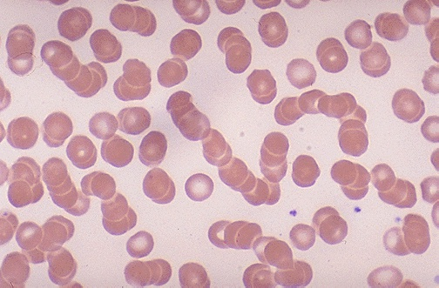
- Why does rapid rouleaux formation increase the E.S.R.?
Rouleaux formation becomes rapid when plasma protein concentration is high and because of this E.S.R. also becomes increased.
- What is the clinical significance of E.S.R.?
- This is a non-specific indicator of presence of a disease.
- This is a useful prognostic tool.

- What conditions are associated with an increased E.S.R.?
- Infections
- Connective tissue disorders
- Inflammatory disorders
- Malignancies
- Anemia
- Pregnancy

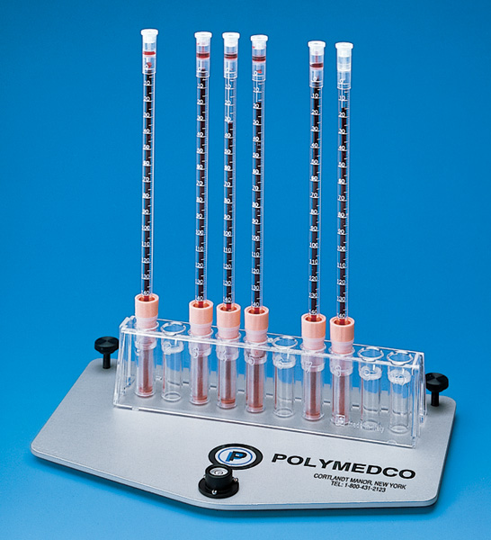

WESTERGREN’S TUBES

BLOOD PRACTICAL – 2
DIFFERENTIAL LEUCOCYTE COUNT
OBJECTIVES:
At the end of session, the students should be able to:
- Identify the different types of white blood cells under the microscope.
- Describe the normal values expected for the differential leucocyte count.
- Understand the use of the differential leucocyte count in the diagnosis of disease processes.
EQUIPMENTS:
- ELECTRON MICROSCOPE WITH AN OIL IMMERSION OBJECTIVE
- MINERAL OR CEDARWOOD OIL
- WRIGHT’S STAIN
- MICROSCOPE SLIDES
PROCEDURE:
- Prepare a stained blood film with the help of Wright’s stain.
- Set the stained blood film under the oil immersion objective in an electron microscope.
- Identify various types of white blood cells according to their histological characteristics.
“types of WBCs on this picture are so important”
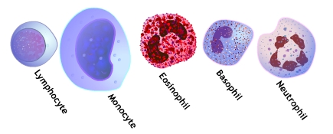
QUESTIONS AND PROBLEMS
- Describe the histological features of different types of white blood cells?
Neutrophils:
- Most commonly seen white blood cells in the circulating blood.
- They have small cytoplasmic granules and a complex, multilobed nucleus.
- The granules take a neutral (purple or pink) color with various stains such as Wright’s stain.
Eosinophils:
- Less common in the bloodstream than neutrophils.
- They are characterized by a dumbbell-shaped Nucleus (bi-lobed) and large, prominent, red (eosinophilic) granules.
Basophils:
- The rarest of all white blood cells found in the blood.
- It is a large cell filled with prominent blue (basophilic) granules. These large granules contain Heparin, an anticoagulant, and Histamine, which increases the permeability of capillary walls. The nucleus is somewhat hidden behind these large granules.
Lymphocytes:
- Small, spherical cells with large, round nucleus in each of them.
- The cytoplasm of these cells does not contain any granules.
- The Nucleus occupies most of the volume of the cell, leaving only a thin crescent of Cytoplasm around it.
Monocytes:
- Easily the largest of all white blood cells in size.
- The cytoplasm of these cells does not contain any granules.
- They possess a large, horseshoe-shaped (kidney-shaped) Nucleus.

- What are the normal values of each different type of white blood cells?
NEUTROPHILS 50 – 70 %
EOSINOPHILS 1 – 3 %
BASOPHILS 0.4 – 1 %
MONOCYTES 4 – 6 %
LYMPHOCYTE 25 – 35 %
- Under what conditions are the percentages of the various types of white blood cells increased?
NEUTROPHILS will increase in acute bacterial or fungal infections.
EOSINOPHILS will increases in parasitic infections and allergies.
BASOPHILS will increase in allergies and malignancies.
MONOCYTES will increase in chronic infections.
LYMPHOCYTE will increase in acute viral infections and malignancies.

- What stains are used in the preparation of blood films?
- Leishman’s stain
- Wright’s stain

BLOOD PRACTICAL – 3
BLOOD GROUPS, BLEEDING & CLOTTING TIME
OBJECTIVES:
At the end of session, the students should be able to:
- Understand and practice the method used in determining blood groups.
- Be familiar with the ABO and Rh systems of blood grouping and explain their importance in blood transfusion.
- Discuss the normal ranges of bleeding time and clotting time and determine their own values experimentally.
- Recognize the importance of bleeding time and clotting time in hemostasis.
EXPERIMENT 1 – DETERMINATION OF BLOOD GROUPS:
EQUIPMENTS:
- HIGH TITER ANTI-A, ANTI-B AND ANTI-D SERA
- A MICROSCOPE
- TOOTH PICKS
- MICROSCOPE SLIDES
- ALCOHOL SWAB
- LANCET
PROCEDURE:
- Take 3 microscope slides and label them clearly as “A”, “B” and “D”.
- Sterilize the fingertip with an alcohol swab.
- Prick the finger using a lancet and place one drop of blood in each of the 3 microscope slides.
- Quickly add a drop of anti-A, anti-B and anti-D sera to slides labeled as “A”, “B” and “D” respectively.
- Stir the mixture on each slide with the help of different pieces of tooth picks for a minute or two.
- Examine the mixtures carefully for the signs of red blood cell agglutination. When red blood cells clump together (agglutination), they have a speckled or peppered appearance. If there is a doubt, examine the slides using the low power of a microscope.
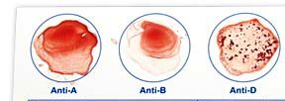 O +ve

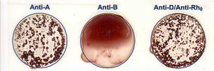 A +ve
“Might come as identify the type of blood group”

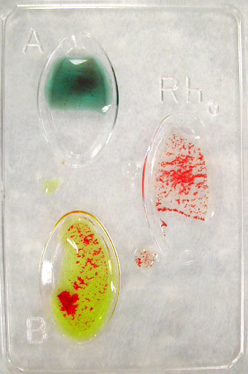 B +ve
QUESTIONS AND PROBLEMS
- What are the agglutinogens and agglutinins found in people with different blood groups in ABO system?

BLOOD GROUP | AGGLUTINOGENS | AGGLUTININS
A | A | Anti – B antibodies
B | B | Anti – A antibodies
AB | A, B | No antibodies
O | No Antigens | Both Anti-A and Anti-B antibodies

- How the different blood groups can donate or receive blood among them during blood transfusion?

Blood Group | Can give blood to | Can receive blood from
AB ⁺ | AB⁺ | All blood groups
AB ⁻ | AB⁻, AB⁺ | AB⁻, A⁻, B⁻, 0⁻
A⁺ | A⁺, AB⁺ | A⁺, A⁻, 0⁺, 0⁻
A ⁻ | A⁻, A⁺, AB⁻, AB⁺ | A⁻, 0⁻
B⁺ | B⁺, AB⁺ | B⁺, B⁻, 0⁺, 0⁻
B⁻ | B⁻, B⁺, AB⁻, AB⁺ | B⁻, 0⁻
0⁺ | 0⁺, A⁺, B⁺, AB⁺ | 0⁺, 0⁻
0 ⁻ | All blood groups | 0⁻

- What other blood group systems do exist other than classical ABO and Rh groups systems?
More than 30 blood group systems have been identified other than classical ABO and Rh groups such as MNS system, Kell System, Lewis System etc.
- What is the distribution of the ABO and Rh blood groups in Saudi Arabia?
O+ | 48%
A+ | 24%
B+ | 17%
AB+ | 4%
O- | 4%
A- | 2%
B- | 1%
AB- | 0.23%
From the above table, we can easily conclude that about 93 % of Saudi population is Rh +ve and only about 7% is Rh –ve. The most common blood group in ABO system is O, followed by A, then B and the least common is AB among Saudis.

- How does this distribution differ from that found in rest of the world?
Almost the same distribution is seen in Europe and America as in Saudi Arabia. The blood group “B” is more prevalent than blood group “A” in some Asian countries.
- What is hemolytic disease of the newborn?
Hemolytic disease of the newborn (HDN) is a blood disorder in a fetus or newborn infant. HDN may develop when a mother and her unborn baby have different blood types (called "incompatibility"). The mother produces substances called antibodies that attack the developing baby's red blood cells. The most common form of HDN is ABO incompatibility, which is usually not very severe. The least common form is Rh incompatibility, which can almost always be prevented. When this form does occur, it can cause very severe anemia in the baby.
- Under what circumstances can Rh incompatibility develop and how?
Rh incompatibility is a condition that develops when a pregnant woman has Rh-negative blood and the baby in her womb has Rh-positive blood inherited from the Rh-positive father.
During pregnancy, red blood cells from the unborn baby can cross into the mother's bloodstream through the placenta. Because the mother is Rh-negative, her immune system treats Rh-positive fetal cells as if they were a foreign substance and makes antibodies against the fetal blood cells. These anti-Rh antibodies may cross back through the placenta into the developing baby and destroy the baby's circulating red blood cells. When red blood cells are broken down, they make bilirubin. This causes an infant to become jaundiced. Because it takes time for the mother to develop antibodies, firstborn infants are often not affected unless the mother had past miscarriages or abortions that sensitized her immune system. However, all children she has afterwards who are also Rh-positive may be affected.

- How it is treated?
Infants with mild Rh incompatibility may be treated with:
- Drugs used to treat allergic reactions (antihistamines)
- Drugs used to treat swelling and allergies (steroids)
- Feeding and fluids (hydration)
- Fluids given through a vein (intravenously)
- Light therapy using bilirubin lights
- Medicines to raise blood pressure if it drops too low
Infants with severe Rh incompatibility may be treated with exchange transfusion after birth or intrauterine transfusion before birth.

- How it is prevented?
Special immune globulins, called RhoGAM (anti-D antibodies), are used to prevent RH incompatibility in mothers who are Rh-negative. If the father of the infant is Rh-positive or if his blood type cannot be confirmed, the mother is given an injection of RhoGAM during the second trimester. If the baby is Rh-positive, the mother will get a second injection within a few days after delivery.
These injections prevent the development of antibodies against Rh-positive blood.

EXPERIMENT 2 – DETERMINATION OF clotting time:
EQUIPMENTS:
- CAPILLARY TUBES
- A PETRI-DISH
- ALCOHOL SWABS
- LANCETS
- PLASTICINE
- A WATER BATH SET AT 37⁰C
- A WATCH

PROCEDURE:
- Prick a finger of the subject observing the usual precautions and note the time at which the prick is made.
- Wipe away the first drop of blood.
- Then while the blood is still freely flowing, place one end of the capillary tube on it and let the tube fill with it by the capillary action.
- Close both ends of this filled capillary tube with the plasticine.
- Place this capillary tube in the water bath.
- Repeat all the above steps with many capillary tubes.
- Two minutes after making the prick, break a capillary tube and separate the two halves slowly and look for a thread like clot between the two broken halves of the tube.
- Repeat step 7 at 30 seconds interval with the remaining tubes until you see a thread-like clot between the broken halves of one of the capillary tubes.
- Note the time. The time from pricking the finger to the appearance of the clot is the clotting time.

QUESTIONS AND PROBLEMS
- What is the normal range of clotting time?
3 – 10 minutes
- What are the clinical conditions in which the clotting time is greater than normal?
Hemophilia
- Name the substances which are used as anti-coagulants.
- Heparin
- Warfarin
- Calcium Oxalate
- Sodium Citrate
- EDTA (Ethylene Diamine Tetra-butyric Acid)
- What is the clinical significance of the clotting time?
- Before surgery
- Diagnosis of bleeding disorders
- What is the source of heparin in the body?
- Mast cells
- Basophils
- Liver
- Lungs

EXPERIMENT 3 – DETERMINATION OF THE BLEEDing time:
EQUIPMENTS:
- BLOTTING PAPER
- A STOP WATCH
- ALCOHOL SWABS
- LANCETS

PROCEDURE:
- Prick a finger of the subject observing the usual precautions and note the time at which the prick is made. (The pricked skin should not be touched until the experiment is over.)
- Apply a piece of filter paper (blotting paper) to the emerging drop of blood from the pricked skin every 30 seconds until the bleeding stops.
- Note the time when the bleeding stops. The time from pricking the finger to the stop of bleeding is the bleeding time.

QUESTIONS AND PROBLEMS
- What is the normal range of bleeding time?
2 – 5 minutes
- Which blood cells deficiency may prolong the bleeding time?
Platelets
- Name one condition in which bleeding time is prolonged (increased)?
Thrombocytopenia

