Shoulder Joint
Flexion | Extension | Abduction |  |  | Adduction | Rotation
 | 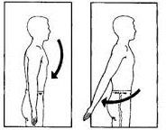 | 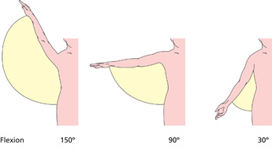  15º |  |  | 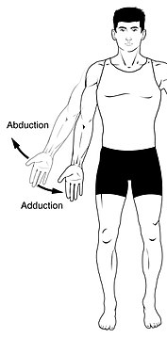 | 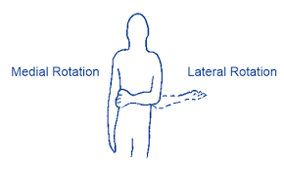
Pectoralis Major(Clavicular head)  Biceps Brachii (short head)  Coracobrachialis  Deltoid(Anterior fibers) | Latissimus Dorsi  Deltoid(Posterior fibers)  Teres Major | More than 90º :  Trapezius | 15-90º:  Deltoid(Middle fibers) | 0-15º:  Supraspinatus | Latissimus Dorsi  Pectoralis Major  Coracobrachialis  Teres Major | Medial  Latissimus Dorsi  Pectoralis Major  Deltoid (Anterior fibers)  Teres Major  Subscapularis | Lateral  Deltoid (Posterior fibers)  Infraspinatus  Teres Minor

Elbow Joint & Forearm
Flexion | Extension | Pronation | Supination
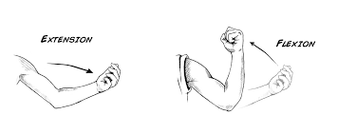 |  | 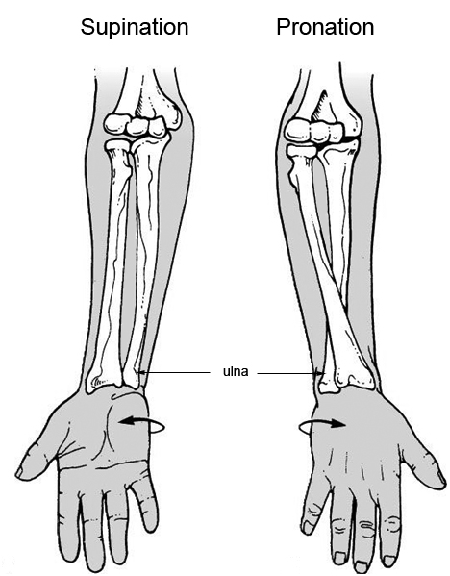
Biceps Brachii  Brachialis  Pronator Teres  Brachioradials | Triceps Brachii | Pronator Teres  Pronator Quadratus (Prime mover)  Brachioradials ** MID-PRONE** | Biceps Brachii  Supinator
Wrist Joint
Flexion | Extension | Abduction  (Radial Deviation) | Adduction  (Ulnar Deviation)
Flexor Carpi Radialis  Palmaris Longus  Flexor Carpi Ulnaris  Flexor Digitorum Superficialis | Extensor Carpi  Radialis Longus | Flexor Carpi Radialis  Extensor Carpi Radialis Longus | Flexor Carpi Ulnaris

Hip Joint
Flexion | Extension | Abduction | Adduction | Rotation
 |  |  |  | 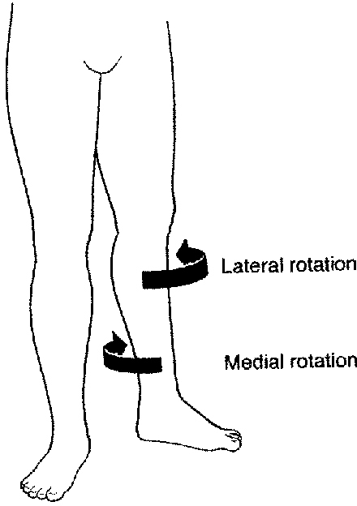
(Anterior Compartment of thigh)  Sartorius  Pectineus  Psoas major  Iliacus | (gluteal region)  Gluteus maximus  (Posterior Compartment of thigh “Hamstring muscles”)  Biceps femoris  Semitendinosus  semimembranosus  adductor magnus | (Anterior Compartment of thigh)  Sartorius  (gluteal region)  Gluteus minimus  Gluteus medius | (Anterior Compartment of thigh)  Pectineus  (Medial Compartment of thigh)  Adductor longus  Adductor brevis  Adductor magnus  Gracilis | Lateral:  Sartorius  Gluteus maximus  Superior & inferior Gemelli  Piriformis  Quadratus femoris | Medial:  Gluteus minimus  Gluteus medius

Knee Joint
Flexion | Extension | Rotation
 |  | Medial | Lateral
MAINLY:  (Posterior Compartment of thigh “Hamstring muscles”)  Biceps femoris  Semitendinosus  Semimembranosus  “All Hamstring muscles EXPECT adductor magnus”  ASSISTED BY:  (Anterior Compartment of thigh)  Sartorius  (Medial Compartment of thigh)  Gracilis  (posterior Compartment of leg “Superficial group”)  Gastrocnemius  Plantaris  (posterior Compartment of leg “Deep group”)  Popliteus | (Anterior Compartment of thigh “Quadriceps femoris”)  Rectus femoris  Vastus intermedius  Vastus medialis  Vastus lateralis | MAINLY:  (Posterior Compartment of thigh “Hamstring muscles”)  Semitendinosus  semimembranosus  ASSISTED BY:  (Anterior Compartment of thigh)  Sartorius  (Medial Compartment of thigh)  Gracilis | (Posterior Compartment of thigh “Hamstring muscles”)  Biceps femoris

Ankle Joint
Plantarflexion = Flexion of the ankle joint | Dorsiflexion = Extension of the ankle joint
(Lateral Compartment of leg)  peroneus longus  peroneus brevis  (posterior Compartment of leg “Superficial group”)  Gastrocnemius  Plantaris  Soleus  (posterior Compartment of leg “Deep group”)  Flexor digitorum longus  Flexor hallucis longus  Tibialis posterior | (Anterior Compartment of leg)  Tibialis Anterior  Extensor Hallucius Longus  Extensor Digitorum Longus  Peroneus Tertius

Tarsal Joint
Inversion | Eversion
(Anterior Compartment of leg)  Tibialis Anterior  Extensor Hallucius Longus | (Anterior Compartment of leg)  Peroneus Tertius  (Lateral Compartment of leg)  peroneus longus  peroneus brevis  (posterior Compartment of leg “Deep group”)  Tibialis posterior

