
Pharmcodynamic
Pharmacology Notes
- Hard working edited by PharmPill team 426 ( 2nd notes)

pharmacodynamic :
It is a branch of pharmacology that deals with the mechanism of action and
pharmacological effects.

Mechanism of drug action :
Normal body functions are mediated through control systems that involve

- Chemo transmitters: like acetylcholine ,adrenaline
- local hormones : prostaglandins
- Enzymes : angiotension converting enzymes
- Carrier molecules : proteins
- Receptors : adrenergic ,cholinergic, histamine
- DNA

►MOST OF THE DRUGS ACT BY INFLUENCING THESE BODYS CONTROL MECHANISMS.
►majority of the drugs act by binding to some specialized constituent of the cell to alter its function selectively.

►These drugs are biologically selective and structurally specific.

►A small modification to alter chemical structure may profoundly alter their effect.

Main targets where drugs act :

- Receptors
- Ion channels
- enzymes
- carrier molecules
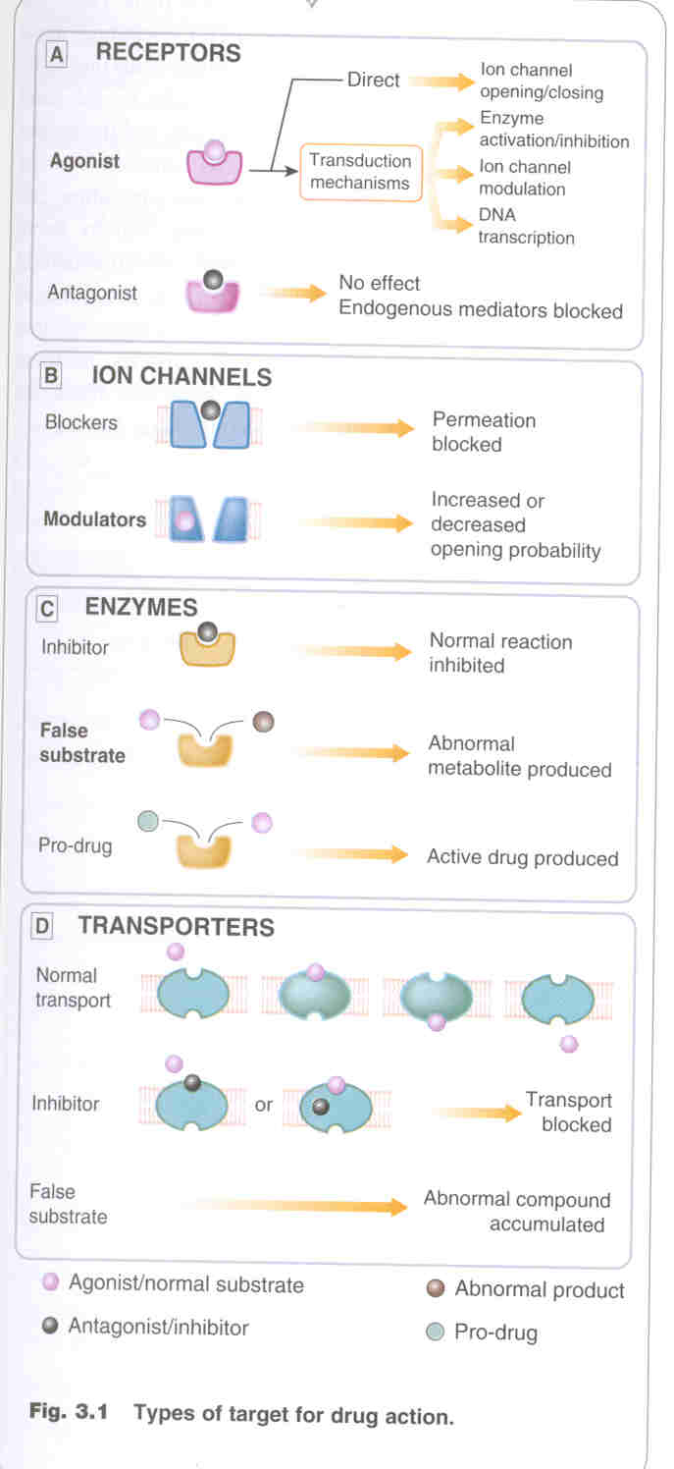
Pharmacology
1

Broadly speaking drugs can act through two main mechanisms :
Pharmacology Notes
- Hard working edited by PharmPill team 426 ( 2nd notes)

»Receptor mediated (generally specific and selective)
▪ type I through ion channels
▪ type II through G-protein
▪ type III through enzyme tyrosin kinase
▪ type IV through DNA

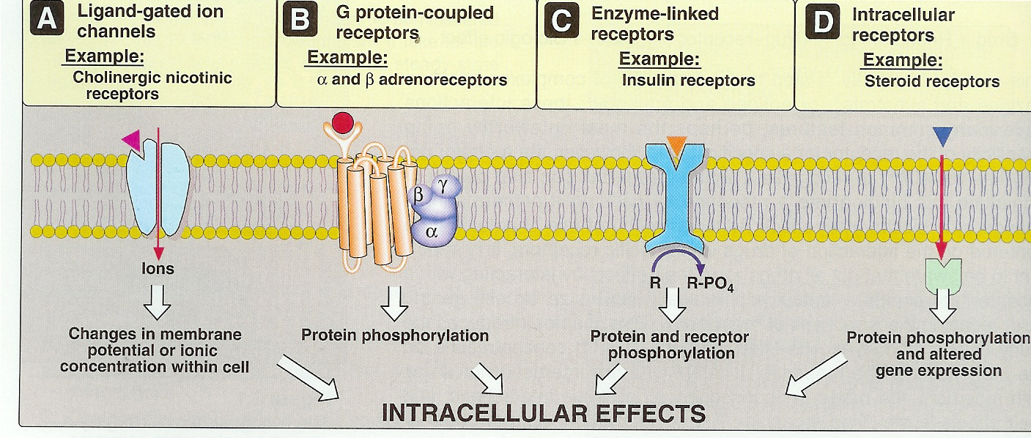

» Non-Receptor Mediated:

1) Drugs which can directly open or block ion channels.
e.g : verapamil ,procainamide, benzodiazepines

2) drugs which act on enzyme pump as NaK /Atpase pump
eg. Digoxin

3) Drugs which can either inhibit or increase or block the release and uptake of the neurotransmitter
eg. Amphatamine , bretylium ,imipramine

4) Drugs which prevent the inactivation of the n.transmitter by inactivating the enzyme
eg.neostigmine ,physostigmine.

5) Drugs which chemically binds to other drugs and neutralize them or inhibit their absorption
eg.tetracyclines with Iron preparation and antacids

6) Drugs which produces physiochemical changes
eg. general anesthetics ,osmotic diuretics

7) Drugs which inhibits growth of microsomes
eg.antibiotics , antifungal , antiviral

8) Drugs which act directly on DNA
eg anticancer drugs

9) Adsorbants and stimulants
eg. purgatives
Pharmacology
2

These targets may be present at :
Pharmacology Notes
- Hard working edited by PharmPill team 426 ( 2nd notes)
▪ cell membrane
▪ metabolic process with in the cell
▪ out side the cell

■ At cell membrane :
a) act on specific receptor
e.g adrenergic receptors ,cholinergic receptors ,histamine receptors
b) interfere with selective passage of ions across cell membrane
e.g Calcium and sodium channels
c) Interact with membrane bound enzymes and pumps
e.g. ATP-ase pump by cardiac glycosides
d) Physio chemical interactions
eg. Genral aneesthetics.

■ on metabolic process with in cell
a) Enzyme inhibition
eg. MAO by phenalzine ,Cholinestrase by Pyridostimine
b) Inhibition of transport process
that carry substances across the cell membrane
eg. Blockade of and ion transport in renal tubule cell by probenecid can be used to delay excretion of Pencillin.
c) Incorporation in to large molecules
eg. 5-flourouracil an anticancer drug incorporated to mRNA in place of uracil.
d) Anti microbial agents :
They alter metabolic process unique to micro-organism

■ act outside the cell
a) Direct chemical interaction
e.g.. Antacids
b) Osmosis
e.g.. Purgatives (magnesium sulphate) ,Diuretics (Mannitol))

Receptors:
  - Is a special constituent of the cell that binds the drug and mediate its pharmacological actions.
  - It is found at:
  - cell membrane.
  - Nucleus.
  - Cytoplasm.

Drug - receptor interaction :
- drug binds receptor and will activate (agonist)
- or bind and produce no action They reduce the chance of transmitter or agonist binding to receptor, and there by oppose their action. (antagonist )

Pharmacology
3

Sequence of events in Drug-Receptor interaction :
Pharmacology Notes
- Hard working edited by PharmPill team 426 ( 2nd notes)
1. Attraction between Drug and Receptor (recognition)

2. Interaction between Drug and Receptor (affinity) like lock and key

3. Occupation of receptor (dependant on binding forces)

4. Biological action ( change in receptor function) i.e. activity

Binding Forces: ( how drug bind with the receptor )

A) NON COVALENT BONDS ( Reversible),weak :
1. Ionic Bond
Electrostatic attraction between oppositely charged ions

2. Hydrogen bond
Hydrogen bridge between two electronegative groups

3. Van-der waal Bond (weakest )=electrostatic bond
Attractive forces between two neutral atoms

B. COVALENT BONDS. (Irreversible ), strong:
Sharing of a pair of electrons by two bonded atoms ( uncommon), prolong effect

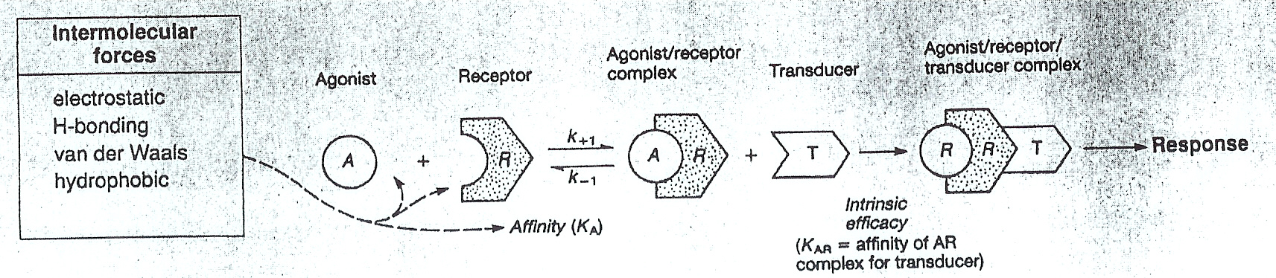

◙ Note :
» The number of bonds and level of perfection of fit determines the affinity of drug for that receptor

» the greater the number of bond and more the perfect is fit ,the higher is the affinity.

Pharmacology
4

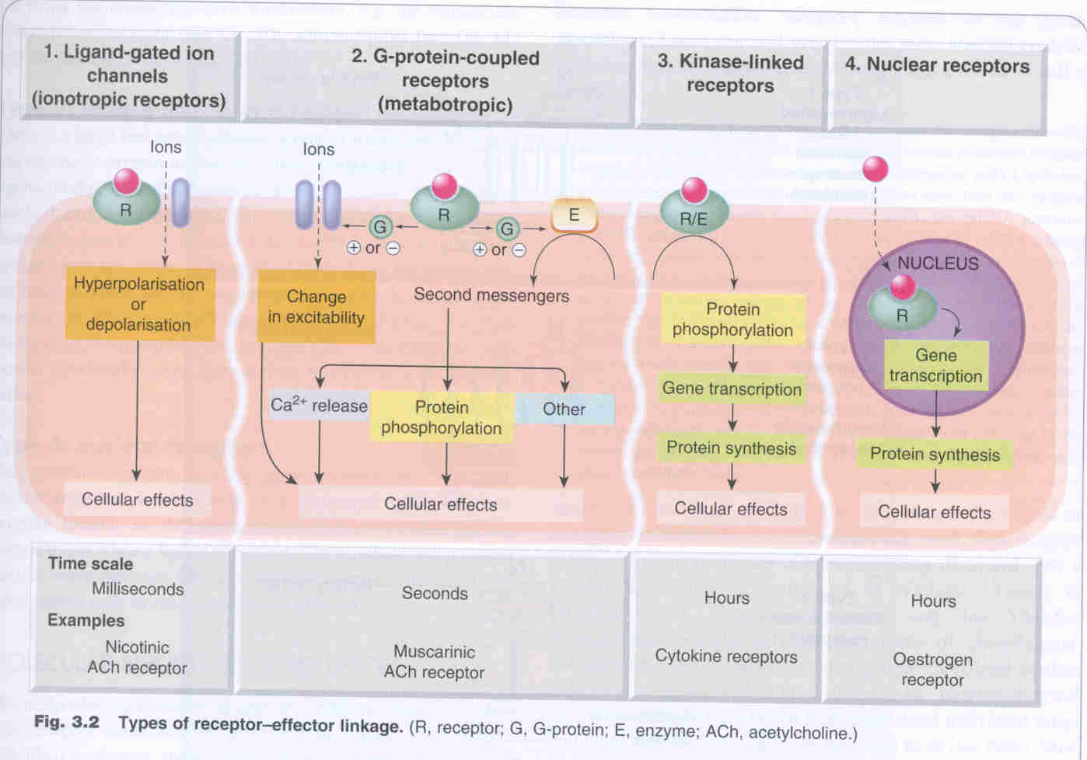
Pharmacology Notes
- Hard working edited by PharmPill team 426 ( 2nd notes)
Types of Receptors:

1. LINKED TO ION CHANNELS

2. LINKED VIA G-PROTEINS TO MEMBRANE

3. LINKED DIRECTLY TO TYROSINE KINASE

4. LINKED TO DNA
INTERACTION

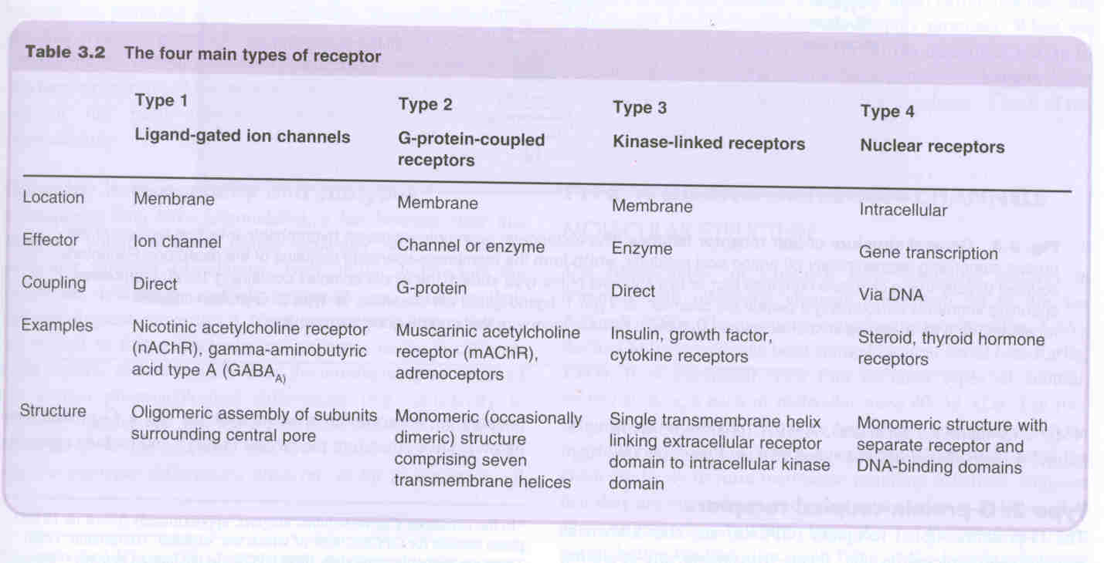
Pharmacology
5

1.Receptors linked to (ligand- gated) ION channels :
Pharmacology Notes
- Hard working edited by PharmPill team 426 ( 2nd notes)

► Directly related to ion channel
► located at cell membrane
► involved in fast synaptic transmission
► response occurs in a millisecond ,i-e ligand binding and channel opining.
► eg. nicotinic receptor ,glutamate receptors

2. G-Protein coupled receptors :

► present at cell membrane
► They constitute the largest family
► response is through enzyme and/ or ion channel
► involved in rapid transduction
► response generated in seconds
► eg. mAch( muscarinic) receptor ,adrenergic receptors ,domamine receptors , serotonin receptors, opiate receptors and others

G-proteins (mechanism)
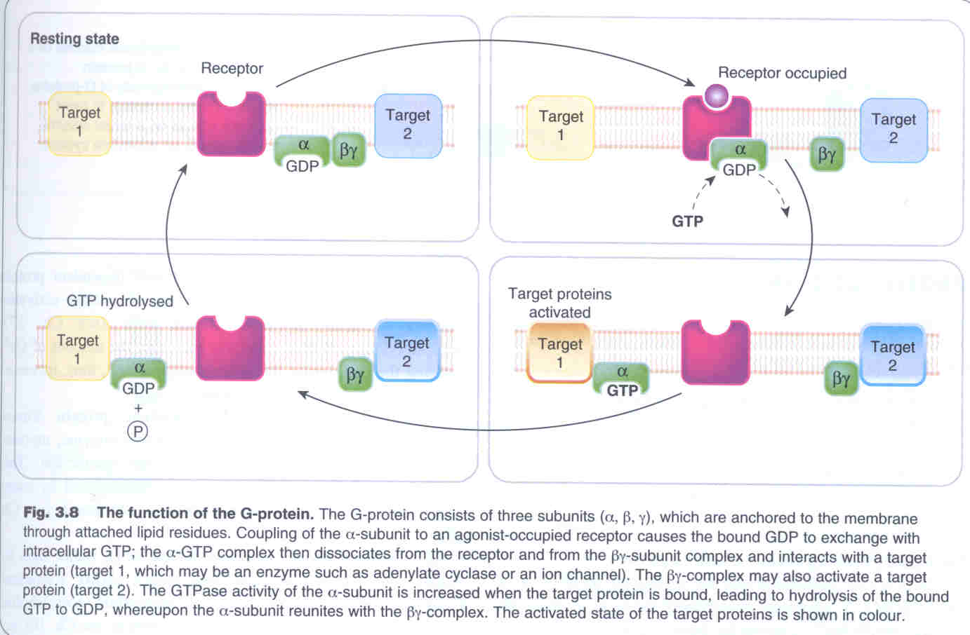
▫ They are called G-protein because of their interaction with guanine nucleotides GTP and GDP.

▫ it intervenes receptors and the effector enzymes or ion channels.

▫ they comprise of three sub units (αβγ) the α-sub unit possess GTPase activity

▫ when drug (agonist) binds to receptor → confirmational change occurs → affinity for trimer increases → their occurs dissociation of α-sub unit (active) which is free to activate an effector( a membrane enzyme or ion channel.in some cases βγ sub unit may alsobe the activator

▫ GTP replaces GDP and activates G-protein and causes α-sub unit to dissociate from βγ (α-GTP complex- an active form) and is then free to activate an effector (a membrane enzyme or ion channel). in some cases the βγ- may also be the activator.

▫ Cycle is completed when α-subunit with enzymic activity hydrolysis the bound GTP to GDP and GDP bound α-sub unit dissociates from the effector and recombines with βγ domains.

▫ This whole process results in amplification effect because binding of agonist to receptor causes activation of numerous G-protein, which in turn can each ,via association with effector ,produce many molecules of product.
Pharmacology
6

Target for G-protein :
Pharmacology Notes
- Hard working edited by PharmPill team 426 ( 2nd notes)
G-Protein either interact with ion channels or second messengers.

►Ion-channels: G-protein may activate ion channel directly eg. Muscarinic receptors in heart are linked to K+ channel that open directly upon interaction with
G-protein causing slowing down of heart rate.
►Second messengers: 3 types of second messenger systems exist as targets of G-proteins.

A) Adenylyl cyclase/cyclic AMP system:

( the following points in gray are more chemistry)
▫ many types of G- proteins exists , this is probably due to variability of α-subunit. Gs and Gi /Go ,cause stimulation and inhibition ,respectively of the target enzyme anenylyl cyclase. This explains why muscarinc Ach receptors and β-adrenoceptors located in heart produce opposite effect.

▫ Adenylyl cyclase catalysis the conversion of ATP to cAMP with in cells. This cAMP in turn causes activation of certain protein kinases ,the enzyme that phosphorylates serine and threonine residue in various proteins, there by producing either activation or inactivation of proteins.

▫ this can lead to conversion of inactive phosphorylase active phosphorylase.

▫ As activation of β1-adrenergic receptors in cardiac muscle results in activation of cAMP dependent protein kinase A, which phosphorylates and opens voltage operated calcium channels ,this increases calcium level in cell and results in increased rate and F.O.C. In contrast to activation of β2 adrenergic receptors found in smooth muscles cause activation of protein kinase and phosphrylation but inactivation of other enzyme (myosin light kinase) needed for contraction.

▫ Receptors linked to Gi inhibit adenylyl cyclase and reduce cAMP production

In brief : adenyl cyclyase catalyse the conversion of ATP to cAMP. this cAMP causes activation of protein kinase A, which phosphorylate serine/threonine residue of the protein .

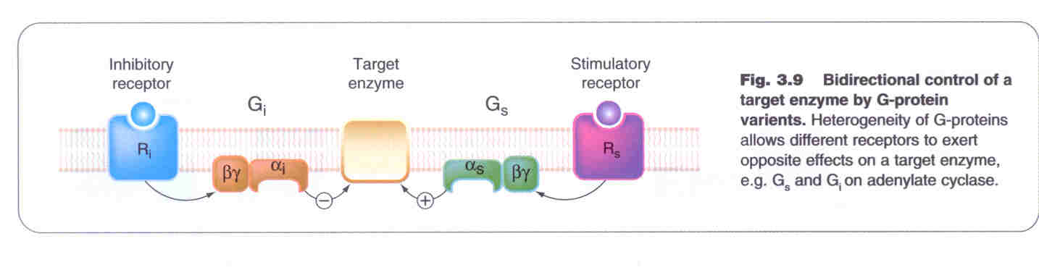
B) Guanylyl cyclase system
G.cyclase catalyses the conversion of GTP to cGMP. This cyclic GMP causes activation of protein kinaseG ,which phosphorylates contractile proteins and ion channels.
Pharmacology
7

C) Phospholipase C/ Inositol phophate system
Pharmacology Notes
- Hard working edited by PharmPill team 426 ( 2nd notes)

i) IP3 binds to membrane of endoplasmic reticulum, opening calcium channels , and thus increase intracellular calcium concentration 10-100 folds, this increase results to smooth muscle contraction , increased exocrine secretions, and increased hormone or transmitter release, increase in rate and force of contraction of heart.

ii) DAG which remain associated with the membrane causes protein kinase -C to move from cytosol to membrane where DAG can regulate its activity.
There are six type of protein kinase- C with 50 or more targets such as
Release of hormones and neurotransmitters , Smooth muscle contraction , Inflammation , Ion transport, and others.

3. tyrosin kinase linked receptor :
▫ These are involved in regulation of growth and response to metabolic signals

▫ The response time of enzyme initiated transduction is slow( minutes)
eg. Insulin receptors
platelate derived growth factors

▫ Activation of Tyrosine linked receptors results in autophophorylation of tryrosine residue leading to activation of path ways involving protein kinase.
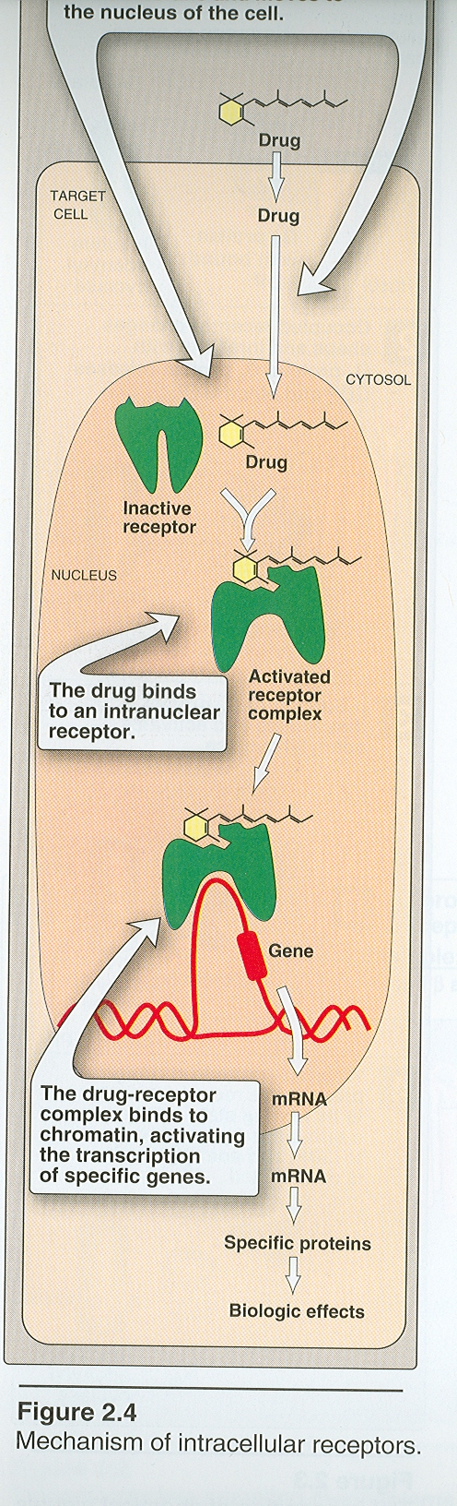
4. DNA linked receptor :
▫ Corticosteroids ,thyroid hormones, retinoic acid ,and vit-D, they inter act receptor at DNA level.

▫ As receptors are intracellular so agonist must pass through cell membrane to reach receptors.

▫ Receptor –agonist complex are then transported to nucleus.

▫ There complex binds to specific DNA sequence .As a result there is increased or decreased in protein synthesis.

▫ The process is much slower (hours) and usually last longer

Pharmacology
8

Pharmacology Notes
- Hard working edited by PharmPill team 426 ( 2nd notes)

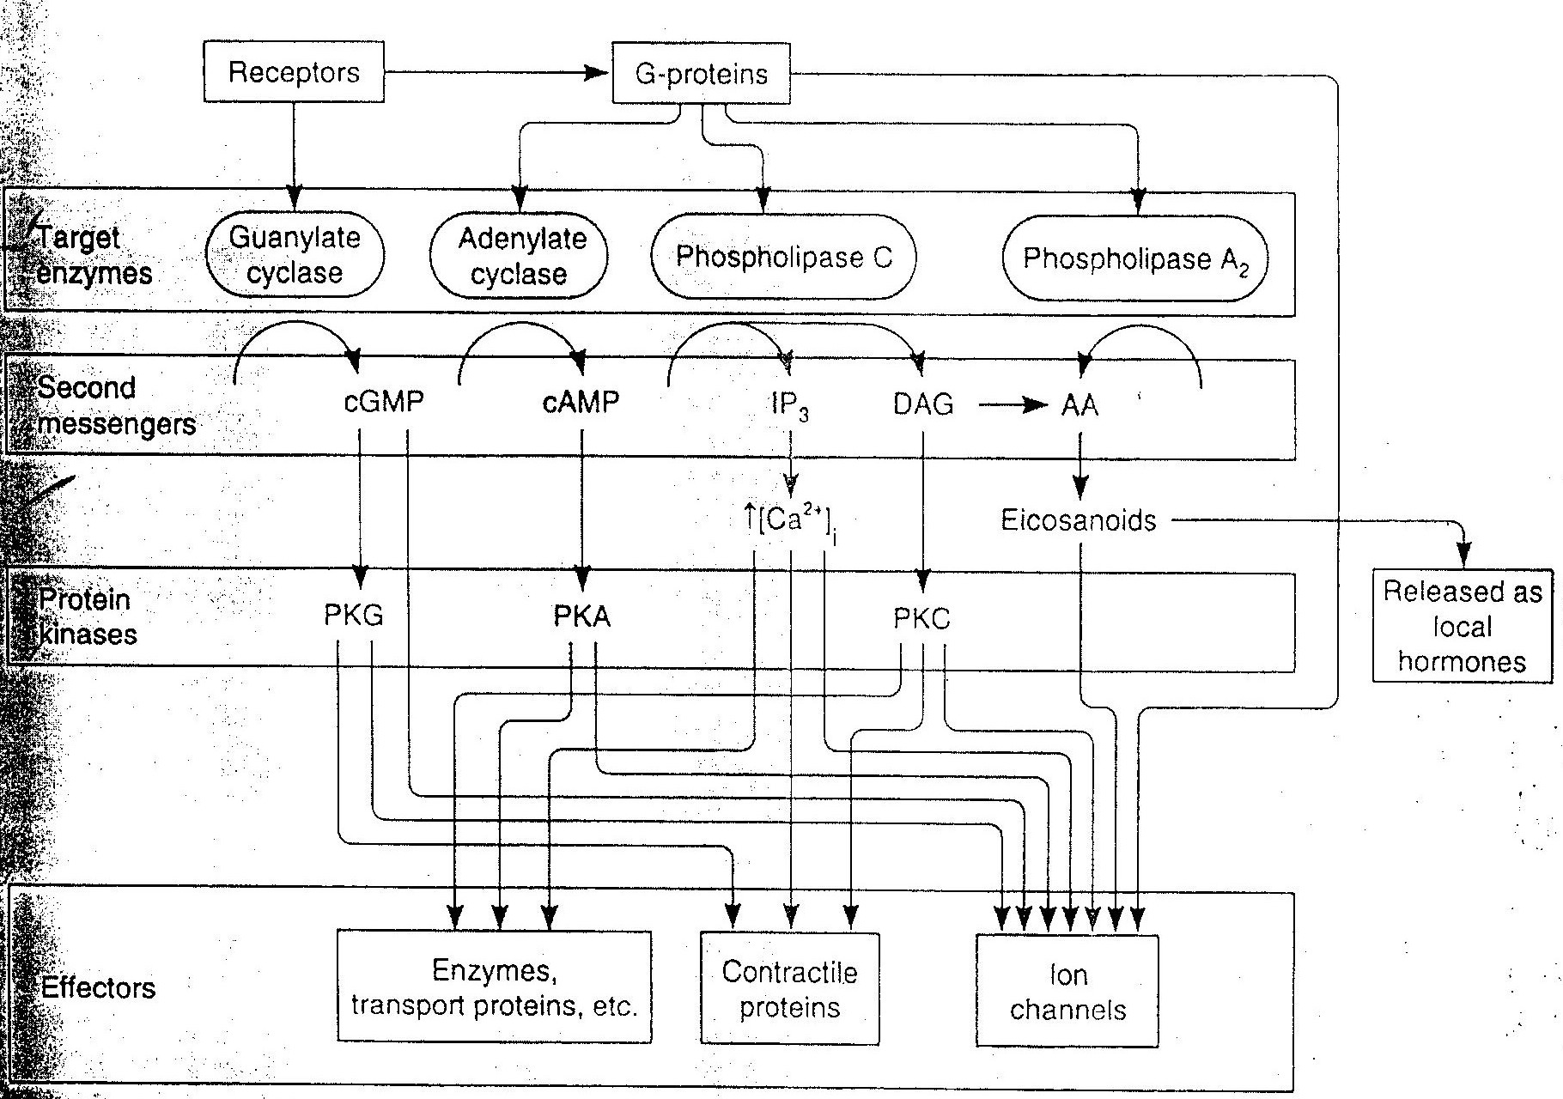
Pharmacology
9

