VIBRIO

Widespread in nature, mainly in water: one species, V.cholerae, is the cause of cholera.

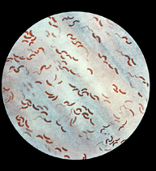

VIBRIO CHOLERAE
Habitat: water contaminated with feces of patients or carriers.

Laboratory characteristics
Morphology and staining: Gram-negative slender bacilli, sometimes coma shaped with pointed end. Often arrange in pairs or short chains, giving a spiral appearance. Actively motile by one long polar flagellum; non-capsulate; non-sporing.

Culture: aerobe; grows readily in ordinary media as glistening colonies over a wide temperature range (optimum 37˚C).
Growth is inhibited at acid pH (optimum pH for growth is alkaline, pH 8.0-8.8).

Enrichment medium: alkaline peptone water (pH 8.6) promotes the rapid growth of V.cholerae from mixtures of other bacteria, e.g. fecal samples.

Selective medium: TCBS medium- thiosulphate citrate bile sucrose agar, pH 8.6.

Observe: for large yellow sucrose fermenting colonies after incubation for 18-24 h. Enterobacteria may grow, but growth is inhibited and the colonies are small.

Identification: by slide agglutination of suspect colonies with specific anti-sera.
Biochemical reactions:
- Oxidase positive
- Fermentation of sucrose and mannose, but not arabinose
- Using API 20E system gives a characteristic biochemical profile.

Antigenic structure:
O antigens: 139 O serogroups are recognized. Epidemic cholera is caused by V. cholerae serogroup O1, which is divided into three serotypes, Ogawa, Inaba, and Hikojima. However, antigenic structure may change within the human gut.

Biotypes: two biotypes of V.cholerae O1, classical and E1 T or biotype
Phage typing: is limited value in epidemiological studies.
Toxins: endotoxins (cell-wall lipopolysaccharides) and toxins are recognized. The enterotoxin is an exotoxin, which stimulates persistent and excessive secretion of isotonic fluid by intestinal mucosa.

Pathogenicity

V.cholerae O1 is the cause of cholera in humans, a febrile diarrhoeal illness which often severe.
In acute disease, vibrios are present in enormous numbers- about 10⁸/ml of feces.

In 1992 a serious out-break of cholera-like diarrhoeal disease in Bangladesh was caused by V.cholera 0139.
Strains in serogroups 02-0138-non-cholera vibrios- may be associated with a milder diarrhoeal illness.

Viability: readily killed by heat and drying; dies in polluted water but may survive in clean stagnant water (especially if alkaline) or seawater for 1-2 weeks.

Antibiotic sensitivity
Sensitive to macrolides (e.g. erythromycin), ciprofloxacin and aminoglycoside antibiotics.
Strains resistant to tetracycline, ampicillin and co-trimoxazole have emerged in cholera-endemic areas.

VIBRIO PARAHAEMOLYTICUS

V.parahaemolyticus is a halophilic (i.e. Salt tolerant) marine vibrio isolated from shellfish, particularly in countries with warm coastal water, eg South East Asia.

It causes an acute gastroenteritis in which vibrios are excreted in large numbers in the stools. Fecal samples plated on TCBS agar yield large blue-green colonies which fails to ferment sucrose.

CAMPYLOBACTER

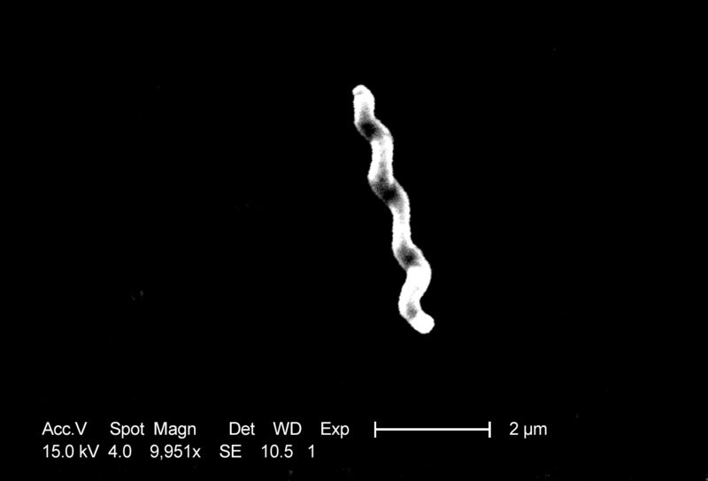

Strictly microaerophilic vibrios. Species that cause human or animal diarrhoeal illness are thermophilic, growing best at 43˚C.

The main human pathogenic is C.jejuni.
Other species occasionally found in human gastrintestinal disease include C.coli and C.lari

Habitat: various animal species, including chicken, domestic animals and seagulls (C.lari).

Laboratory characteristics
Morphology and staining: small, Gram-negative, curved or spiral rods. Highly motile, by single flagellum at one or both poles.

Culture: microaerophilic; grow best in an atmosphere containing a mixture of 7% oxygen and 10-15% carbon dioxide, with the reminder an inert gas (nitrogen or hydrogen).

Growth takes place at 37˚C but optimal temperature for C.jejuni is 43˚C.

Selective medium: lysed blood agar with vancomycin, polymyxin and trimethoprim.

Incubate: for 24-48 h at 43˚C under microaerophilic conditions.

Observe effuse colonies that look like spreading fluid droplets.

Identification: by gram-film appearance, motility, growth temperature requirements (25˚C: no growth; 37˚C: growth; 43˚C: enhanced growth).

Campylobacters are oxidase positive.

Antibiotic sensitivity
Most strains are sensitive to macrolides (erythromycin): resistant strains usually sensitive to ciprofloxacin and chloramphenicol.

HELICOBACTER

- Helicobacter pylori (formerly known as C.pylori or C.pyloridis) is found closely associated with gastric mucosa and causes chronic active gastritis: it plays a role in gastric and duodenal ulceration and probably also gastric cancer.

- Laboratory characteristics
- Morphology and staining small, Gram-negative, spiral rods, motile by polar flagella.
- Culture: on blood or chocolate agar in a moist microaerophilic atmosphere. For isolation from clinical specimens, use campylobacter selective medium. Small colonies grow after 3-7 days at 37˚C.
- Biochemical reactions: catalase-positive; oxidase-positive; strongly urease-positive.
- Typing: a variety of nucleic acid methods have been developed, but there is no agreed typing scheme.

- Antibiotic sensitivity
- In vitro H.pylori is sensitive to amoxycillin, tetracycline, metronidazole, macrolides (clarithromycin) and bismuth salts.
- However, in vivo their efficacy is often poor due to the low pH of the stomach, their failure to penetrate the gastric mucus and the low concentration of antibiotic obtained in the mucosa of the stomach.

- For that several eradication regiment have been used:

- Triple therapies:
- One-week combination of Omeprazole, Clarithromycin and Tinidazole the rate of eradication was 95%-100%.
- 10 days’ combination of Ranitidine Bismuth citrate, Amoxycillin and Clarithromycin with eradication rate of no more than 75%.
- 10 days combination of Ranitidine Bismuth citrate, Clarithromycin and metronidazole with an eradication rate of 90%.
- One-week combination of Omeprazole, Amoxycillin and metronidazole the rate of eradication was 96%-( very cost effective).

- Quadruple Therapies:
7days regimen of combination of Omeprazole, Amoxycillin , metronidazole and proton pump inhibitor (PPI) have shown to increase the eradication rate up to 98%. Unfortunately it was followed by side effects such as vaginal candidiasis in 10%of women and Pseudomembranous colitis in 11% of patients.

