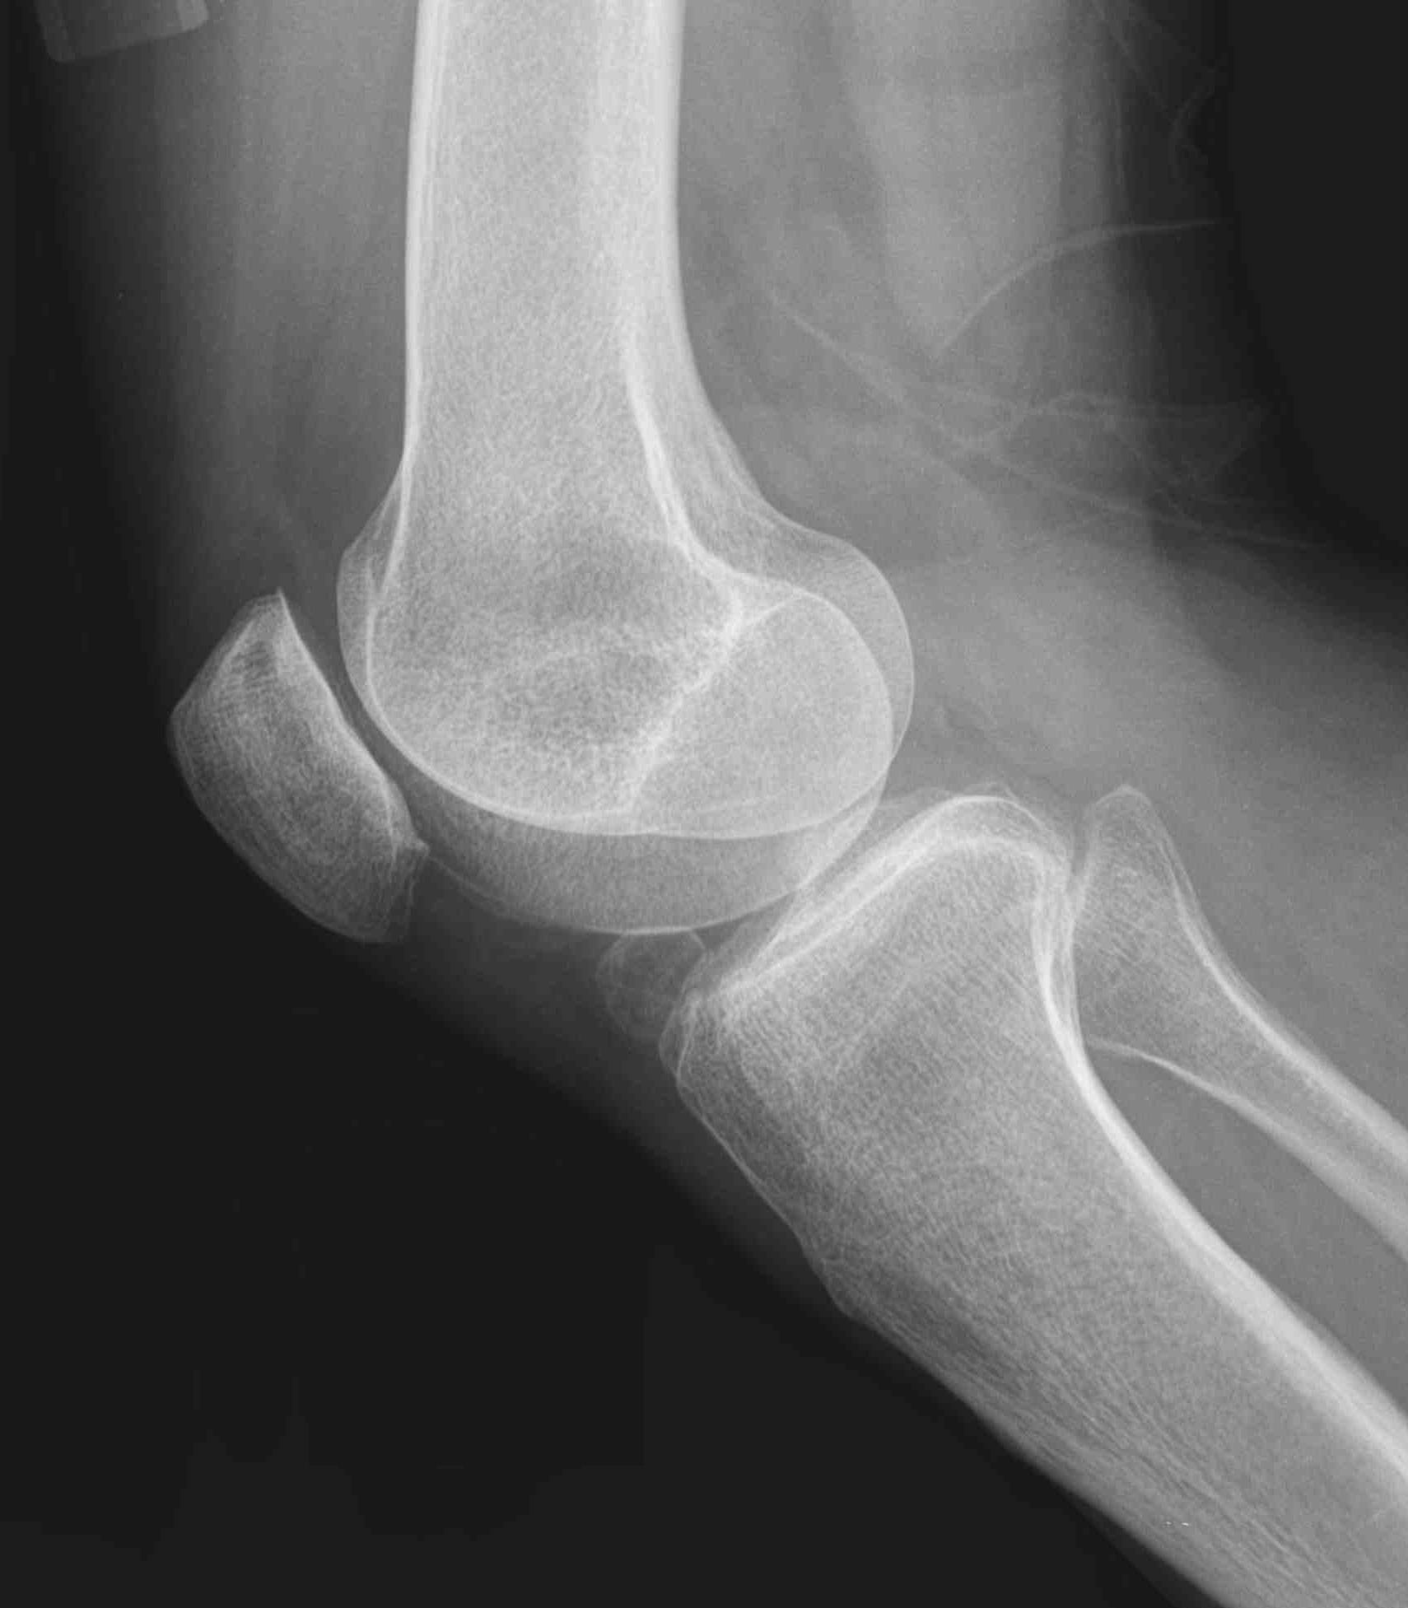
By:
Dr.Hisham AlKhalidi
Converted to Word: Albara Marwa

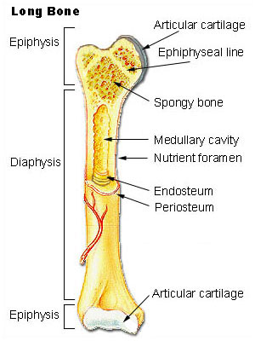
Normal Bone

Metaphysis is the growing part of a long bone between the diaphysis and the epiphysis (most common site of primary bone tumors)

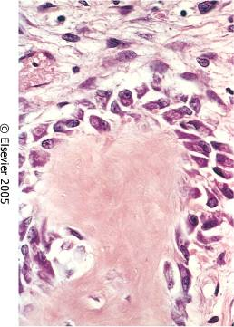
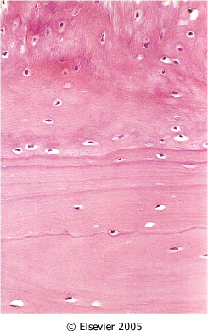

OSTEOMYELITIS
the most common etiologic agents are pyogenic bacteria and Mycobacterium tuberculosis

- Overall, Staphylococcus aureus is the most frequent causal organism
- Escherichia coli and group B streptococci are important causes of acute osteomyelitis in neonates
- Mixed bacterial infections can be seen in the setting of direct spread during surgery or open fractures
- Salmonella common in sickle cell patients
- In 50% of the cases no organisms can be isolated

Characteristics
- Sites of involvement:
  - Influenced by the vascular circulation, which varies with age
- Neonates: the metaphyseal vessels penetrate the growth plate, resulting in frequent infection of the metaphysis, epiphysis or both
- In children: metaphyseal
- Adults: epiphyses and subchondral regions

Stages (Based On clinical duration of disease) :
  - Acute
  - Sub acute
  - Chronic

SEQUENCE OF INFECTION:
- Once localized in bone, the bacteria proliferate and induce an acute inflammatory reaction and cause cell death
- Pathological changes
- Necrosis of the bone within first 48hrs
- Spread of bacteria and inflammation within the shaft of the bone and may percolate through the haversian systems to reach the periosteum
- In children ,the periosteum is loosely attached to the cortex; therefore sizable subperiosteal abscess formation occurs
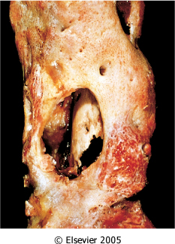
- Further ischemia and bone necrosis occurs
- Dead pieces of bone are known as the sequestrum
- Rupture of the periosteum→soft tissue abscess formation→draining sinuses
- In infants epiphyseal infection may spread to the adjacent joint and causes septic or suppurative arthritis; may lead to permanent disability
- After the first week chronic inflammatory cells become more numerous with the release of cytokines and deposition of new bone formation at the periphery
- New bone may be deposited as a sleeve of living tissue known as the Involucrum

Clinical Course:
- Fever ,chills, malaise, marked to intense throbbing pain over the affected region

Diagnosis;
- Sign/symptoms.
- X-ray
- Blood cultures
- Biopsy

- Combination of antibiotics and surgical drainage is usually curative (but may persist)

Complications
- Pathologic fracture
- Secondary amyloidosis
- Endocarditis
- Sepsis
- Squamous cell carcinoma
- Rarely sarcoma in the affected bone

Tuberculous osteomyelitis
- Usually blood borne and originates from a focus of active visceral disease
- Direct extension (e.g. from a pulmonary focus into a rib or from tracheobronchial nodes into adjacent vertebrae)
- Via draining lymphatics
- Pott disease is the involvement of spine
- Thoracic and lumber vertebrae followed by the knees and hips are the most common sites of skeletal involvement
- The infection breaks through the intervertebral discs and extends into the soft tissues forming abscesses

Clinical features and complications:
- Pain
- Fever & weight loss
- May form an inguinal mass, which represents a cold fluctuant psoas abscess
- Bone destruction
- Tuberculous arthritis
- Sinus tract formation
- Amyloidosis

Bone tumours
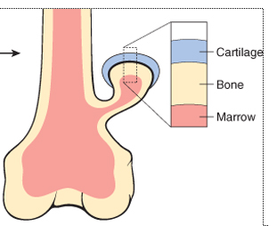
Classification of primary tumors involving bones:
- Bone Forming tumors
- Cartilage forming tumors
- Fibrous and fibro-osseous tumors
- Miscellaneous tumors

Osteochondromas
- Also called exostosis
- Most common benign bone tumor
- 50-75% males, mean age 10 years, usually age 20 years or less
- Common; solitary or multiple
- Slow growing, painful if impinges on nerve or stalk is broken; usually stops growing and ossifies at puberty
- Benign, but 1-2% of solitary tumors and 5-25% of multiple tumors undergo malignant transformation to chondrosarcoma

- Multiple hereditary exostosis: also called osteochondromatosis; autosomal dominant disorder.
- Sites: metaphysis, not medullary cavity; usually distal femur, proximal tibia, proximal humerus
- Xray: metaphyseal lesions grow in direction opposite to adjacent joint; cortex and medulla are continuous with underlying bone

- Gross: cartilage-capped bony outgrowth up to 10 attached to skeleton by bony stalk, not in medullary cavity; may have bursa around its head; cartilage cap usually regular and thin
- Secondary chondrosarcoma: if the tumor grows during adolescence, > 8 cm, irregular cartilaginous cap > 3 cm or lucent zones within lesion, invasion of surrounding tissue

Enchondroma
- Chondromas are benign tumors of hyaline cartilage. When they arise within the medulla, they are termed enchondromas
- Ages 20 - 50; they are typically solitary and located in the metaphyseal region of tubular bones, the favored sites being the short tubular bones of the hands and feet
- Enchondromas are gray-blue, translucent nodules usually smaller than 3 cm
- Microscopically, there is well-circumscribed hyaline matrix and cytologically benign chondrocytes
- Most enchondromas are detected as incidental findings
- On x-ray, the unmineralized nodules of cartilage produce well-circumscribed oval lucencies surrounded by thin rims of radiodense bone (O-ring sign)
- The growth potential of chondromas is limited, and most remain stable, although they can recur if incompletely excised
- Solitary chondromas rarely undergo malignant transformation, but those associated with enchondromatoses are at increased risk
- Maffucci syndrome is associated with an increased risk of developing other types of malignancies, including ovarian carcinomas and brain gliomas

Osteoid osteoma
- Benign bone tumors
- Osteoid Osteoma are by definition <2cm,usually occurs in teens and twenties
- Male to female 2:1
- Osteoid osteomas 50% involve femur and tibia
- Metaphysis
- Osteoid osteoma are painful lesions, occurs at night and relieved by aspirin
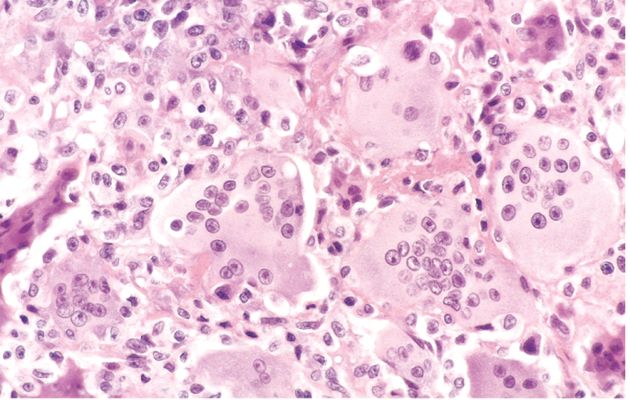
- The central area of the tumor, termed the nidus, is characteristically radiolucent but may become mineralized and sclerotic

Giant cell tumour of bone
- Multinucleated osteoclast-type giant cells
- Benign but locally aggressive, usually arising in individuals in their 20s to 40s
- The majority of GCTs arise in the epiphysis of long bones around the knee (causing arthritis-like)
- Lytic lesions that erode cortex

Osteosarcoma
- It is a malignant mesenchymal tumor in which the cancerous cells produce bone matrix
- It is the most common primary malignant bone tumor
- Bimodal age distribution 75% in patients less than 20 Years of age
- Smaller second group in elderly; frequently Complications of polyostotic Paget disease

Pathogenesis
- Mutations in retinoblastoma genes patients with hereditary retinoblastomas have several hundred- fold greater risk of subsequently developing osteosarcoma
- Mutations in p53 gene
- Overexpression of MDM2 genes

- Most commonly involves metaphysis of long bones
- Gross features: big bulky tumors, grey white often containing areas of hemorrhage and cystic degeneration
- Micro: pleomorphic tumor cells with large hyper chromatic nuclei ,mitotic figures Formation of pink homogenous bone formation is the most characteristic feature of osteogenic sarcoma

Predisposing conditions
including: Paget disease, bone infarcts and prior radiation.
- Male to female ratio 1.6:1
- A triangular shadow on x-ray between the cortex and raised periosteum (Codman triangle) is characteristic of osteosarcomas
- 50% occur about the knee
- After the age of 25, the incidence in flat bones and long bones is almost equal

Chondrosarcoma
- Malignant cartilage forming tumor that does not produce osteoid
- May arise from osteochondroma
- Divided into :
- conventional (central, peripheral, juxtacortical/periosteal) and
- variants (clear cell, dedifferentiation, mesenchymal, myxoid)

- Sites: large bones - pelvis, ribs, femur, humerus, vertebrae; unusual in hands, feet, jaw, skull
- Xray correlation:
- presume malignant if large tumor of long bones or grows rapidly during adolescence to 8 cm or more
- Have fluffy calcification, poorly defined margins, erosion or thickening of cortex; usually no periosteal new bone formation

- Treatment:
- since often implants in soft tissue after biopsy, wide en bloc excision advocated except for well differentiated tumors, which are amenable to conservative therapy
- Patients may have local recurrence or metastases up to 20 years later

- Micro:
- tumor cells produce cartilaginous matrix
- either well, moderate or poorly differentiated
- may have only minor or focal atypia, but consider malignant if malignant radiologic features
- no direct osteoid or bone formation by tumor cells (if present, classify as osteosarcoma)

