Heart Failure
It can result from any structural or functional cardiac disorders that impairs the ability of the ventricle to fill with or eject the blood to meet the body's metabolic needs at rest or during exercise.
Factors affecting cardiac output:
▪ Intrinsic factors which regulate myocardial contractility via Ca and ATP.
▪ Extrinsic factors including contractile arterioles and veins.
Pathophysiology of cardiac performance in HF:
- Intrinsic changes :
- Myocardial hypertrophy to maintain cardiac performance in the face of adverse effects such as a decrease in myocardial contractility
- Extrinsic changes:
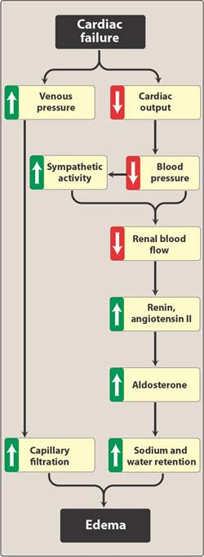
- Decrease in cardiac output decrease in renal blood flow increase renin release increase angiotensin II
a) Increase in afterload, preload, sympathetic discharge increase in cardiac output .
b) Remodeling: proliferation of connective tissue cells, abnormal myocardial cells .
High output failure:
Needs of the body are so great, even the increase in output is not sufficient as in hyperthyroidism, anemia, A-V shunt .
Clinical manifestation of HF:
-tachycardia , decrease exercise tolerance with muscular fatigue , dyspnea (pulmonary congestion) , peripheral edema , cardiomegaly .
Congestive heart failure (CHF):
-LHF, the most common due to left ventricular systolic (LVS) dysfunction.
-RHF, as after myocardial infarction (MI) , chronic obstructive pulmonary disease (COPD) .
Classifacation of HF:
- According to NYHA (New York Heart Association).
Class l: no limitations on ordinary activities & symptoms , occur only with greater than ordinary exercise .
Class ll: slight limitation of ordinary activities , that result in fatigue and palpitation .
Class lll: no symptoms at rest, fatigue occur with less than ordinary physical activity.
Class lV: associated with symptoms even at rest.
Drug used in treatment of HF:
Drug with +ve inotropic effect as: (effect on myocardial activity)
- cardiac glycosides.
- phosphodiesterase inhibitors.
- β-adrenoceptor agonist.
Drugs without +ve inotropic effect as: (no effect on myocardial activity)
1- Diuretics.
2- Aldosterone Antagonist.
3- ACEI & Angiotensin receptor blockers.
4- Vasodilators.
5- β-adrenoceptor blocker.
Vasodilators
▪ The choice of vasodilators is made according to signs and symptoms and hemodynamic changes.
- Selective venodilators such as the nitrate group is used when the main symptom is dyspnea due to pulmonary congestion
- Selective arteriodilators such as hydrolazine is used when the main complaint is rapid fatigue due to low cardiac output
- Non-selective vasodilators such as ACE inhibitors may also be used
Clinical Uses of Vasodilators in CHF
▪ To treat:
- Acute heart failure attending myocardial infarction
- Chronic heart failure due to diastolic dysfunction
- Chronic heart failure due to systolic dysfunction
- Long-term use of hydrolazine and isosorbide dinitrate can reduce damaging remodeling of the heart
ACE Inhibitors and Angiotensin II Receptor Blockers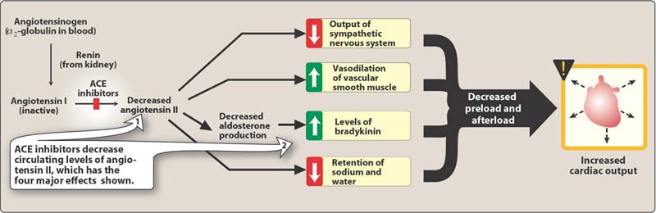
↓ afterload
Contraindicated for asthma patients because it causes brochospasm
↓ preload
↓ sympathetic activity
↓ remodeling →↓ mortality rate (aldosterone induces vascular and myocardial damage)
β-adrenoreceptor Blockers
▪ Antagonism; the enhancing action of sympathetic over-activity (including cardiac arrhythmias)
▪ Reduce mortality (reduce the remodeling changes through inhibition of the mitogenic activity of catecholamines)
▪ Inhibit rennin release
▪ Some of them have anti-oxidant activity
▪ E.g. carvedilol and metoprolol
Diuretics
▪ Reduce salt and water retention → ↓ ventricular preload and venous pressure
▪ Reduction of edema and its symptoms
▪ Reduction of cardiac size → improve cardiac performance
▪ Spironolactone has two benefits: potassium sparing effect and inhibit the action of aldosterone (It is given in advanced cases of heart failure)
β- Agonists
▪ Dopamine acts on α, β, and dopamine receptors
▪ It is used in acute LHF mainly in patients with impaired renal blood flow
▪ Dobutamine is a selective β1 agonist used in acute LHF
▪ Both dopamine and dobutamine are administered IV
▪ Adverse effects of both include:
- Tachycardia
- Angina due to ↑ in myocardial oxygen consumption
- Tachyphylaxis
B- Electrical Effects
a-autonomic effect:
Slow conduction through S.A node and A.V node → prolong conduction time between atrium and ventricles (prolong P-R interval in ECG )
Most important is its vagal effect
High dose will have intense sympathetic Effect (sympathetic Only appears at high dose) +different forms of arrhythmias
b-Direct effect:
Short duration of AP and refractory periods of both atrium and ventricles (increase entry of CA during plateau phase )
Shorten in Q-T interval
Toxic concentration → increase in automacity of ectopic focus >>> all forms of arrhythmias can be detected mainly in purkinje conducting system leading bigeminy rhythm in ECG
Bigeminy → on ECG,the first peak of P will be opposite to the second peak
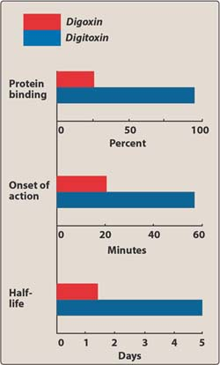
ECG changes with digitalis :
- Prolong PR interval in therapeutic dose
2- Short QT interval
3- Inverted T wave
4- Depressed ST segment
5- Bigeminal rhythm in high dose
6- second degree of AV block
2-Extra cardiac effects :
1-GIT :anorexia; nausea; vomiting; diarrhea
2-CNS : disorientation <hallucination < visual disturbances< agitation< convulsious
3- Gynecomastia
4- Kidney and diuretic effect a) improve renal function
b) inhibit Na+ reabsorption from P.C.T
Adverse effects:
- Heart (all forms of cardiac arrhythmias )
- GIT
- C.N.S
- SKIN → rash
- Gynecomastia
Contraindications:
1/Toxic myocarditis
2/Constrictive pericarditis
3/Cardioversion
*Digitalis is effective in heart failure due to hypertension, atherosclerosis or ischemic heart disease.
Factors which increase digitalis toxicity:
1/ Small lean body mass
2/Renal disease
3/ Thyroid disease
4/hypokalemia (potentiate the inhibiting action of digoxin on Na+/K+ ATPase and the abnormal cardiac automaticity).
5/ Hypomagnesemia (increased the risk of arrythmias)
6/Hypercalcemia (increased digoxin induce abnormal automaticity)
Treatment of digitalis toxicity:
*stop drug
*potassium therapy
*cholestyramine
*Atropine (A-V block)
*Lidocaine or phenytoin
*Fab antibodies in life-threatening or severe cases.
Clinical uses:
1/Congestive heart failure
2/ Atrial flutter or fibrillation, digitalis doesn’t return the rhythm back to normal.

*Digitalis should be avoided in arrhythmia with WDFF Parkison White Syndrome because it effects only the normal pathway.
Drug Interactions:
Diuretics-------hypokalemia (arrythmia)
Quinidine: increase plasma level of digitalis therapy
1/displaces from protein binding sites
2/ Renal clearance
Antibiotics that alter intestinal flora increase digoxin bioavailability.
Agents that release catecholamine sensitize myocardium to digitalis to induce arrhythmia.
Management of Chronic Heart Failure:
1/Reduce workload of the heart
a/limited activity
b/ reduce weight
c/ control hypertension
2/ Restrict Na
3/Diuretics
4/ACEI or receptor blockers
5/Digitalis
6/Beta-Blockers (class II-IV stable HF)
7/Vasodilation
Management of Acute Heart Failure:
1/Volume replacement
2/Diuretics
3/Positive Diuretic Drugs
4/Vasodilator
β-Agonist
Dopamine:
- Non selective acting on α , β1 and dopamine receptors
- For acute LHF mainly in patients with impaired renal BF
Dobutamine:
- Selective β1 agonist for acute HF
*Important Points:
Both are given IV with adverse effects:
- Tachycardia
- Angina due to increased myocardial oxygen consumption
- Tachyphylaxis
Phosphodiestrase Inhibitors
- Bipyridine (Amrinone, Milrinone)
** Milrinone is used more often than amrinone.
- They are active orally as well as parenterally , but are available in parenteral form.
- ** Which means it is only used in acute HF.
- Half life 3-6 hrs
- 10-40% excreted in urine.
Mechanism of action:
Inhibits phosphodiestrase enzyme (Isoenzyme 3) in cardiac and smooth muscle resulting in an increase in cyclicAMP.
In the heart the result is +ve introprism , in peripheral vasculature dilatation in both resistance and capacitance vessels leading in decrease in both after load and preload.
** Increase in intracellular Ca (↑ influx → myocardial contractility) + vasodilatation of venous capacitance.
Therapeutic uses:
- Used only IV for acute HF ( refractory cases) or
- An exacerbation of chronic HF
Adverse effects:
- Nausea , vomiting
- Arrhythmias ( less than digitalis)
- Thrombocytopnea
- Liver toxicity
- Milrinone less hepatotoxic and less bone marrow depression than Amrinone.
Digitalis (Cardiac Glycosides) :
- Origin: Plant origin – foxglove plant
- Chemistry :
- Steroid ( responsible for pharmacological action – set group)
- Lactone at position 17
- Sugar at position 3 ((changing))
B and C are responsible for Pharmacokinetics.

- Preparation : Most commonly used clinical preparation is digoxin.
Pharmacokinetics :
Ouabain Digoxin Digitoxin
Oral bioavailability 0 75 >90
Half-life 21 40 168
Plasma protein bind 0 20-40 >90
% metabolized 0 <40 >80
** A minor change in bioavailability will result in either toxicity or subtheraputic effect due to the drugs’ narrow therapeutic index.
** Digitoxin is metabolized in liver and excreted into gut through bile, forming cardioactive digoxin as a metabolite and unchanged digitoxin is reabsorbed by intestine ( enterohepatic circ) imp
** Digoxin excreted in kidney (must ensure proper renal function) 2/3 of it.
** Oubain excreted unchanged in kidney.
** 1) Main mechanism:
- At molecular level (NA/K pump inhibition) Direct.
- K outside and Na inside is a result of inhibition of Ca/ Na pump (means Na influx and Ca out flux) = increase intracellular level of Ca
2) Open of Ca channel → influx of Ca → increase intracellular Ca
3) Increase release of Ca from ER → increase level of intracellular level of Ca.
All together the lead to increase intracellular level of Ca = increase contraction
Pharmakodynamics:
- At the molecular level cardiac glycoside inhibit Na-K ATPase (Na pump)
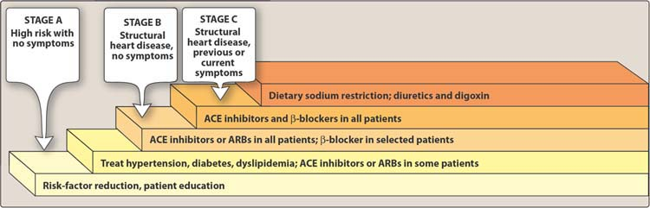
- Cardiac effects :
- Mechanical : increase myocardial contractility
- Electrical : Action potential changes and change on ECG
**Starred points.. and points in boxes are illustrations by the doctor..
They are not part of the lecture slides

