بسم الله الرحمن الرحيم
Heart failure

*describe the condition in which the cardiac output is insufficient to meet the circulatory needs of the body at rest or during exercise.

*factors affect cardiac output:
*intrinsic factors which regulate myocardial contractility via ca+& ATP
*extrinsic factor including contractile state of arteriole & veins e.g preload or afterload pressure
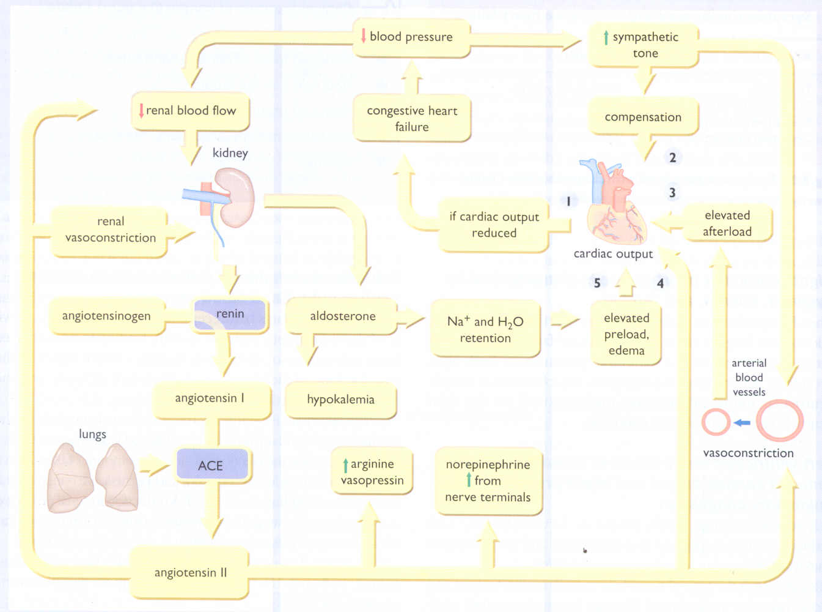

*pathophysiology of cardiac performance in heart failure:
1- Intrinsic changes: (compensatory mechanism)
* Myocardial hypertrophy to maintain cardiac performance in the face of adverse effects as decrease in myocardial contractility.
Here there is abnormal proliferation of C.T NOT muscle not contractile decompensation
2- Extrinsic change
* Decrease renal blood flow decrease in cardiac output Increase rennin release &increase angiotinsin 11release aldosterone salt water retention increase preload + VC (increase afterload) + increase remodeling.
* increase sympathetic activity:
1- Increase in after load, preload& sympathetic discharge increase C.O.P
2- remodeling: proliferation of connective tissue cells, abnormal myocardial cells

*High output failure: (type from heart failure)
*needs of the body are so great, even the increase in output is not sufficient as in hyperthyroidism, beriberi, A.V shock.

*clinical manifestation of heart failure:
*tachycardia
* exercise tolerance with rapid muscular fatigue أول حاجة تخوف العيان
* Peripheral& pulmonary edema dyspnoea
* cardiomegaly.
Heart failure classes:
Class 1: no limitation to the activity
Class 2: minimal limitation
Class 3: manifested with effort
Class 4: manifested at rest

*drugs used in treatment of heart failure:
*drugs with + inotropic effect as:
1- Cardiac glycosides.
2- phosphodiestrase inhibitor.
3- β adrenoceptors agonist.
* Drug without + inotropic effect: (no effect on myocardial contractility).
1- Diuretics
2- ACEI & angiotensin receptor blockers.
3- Vasodilator.
4- β adrenoceptor blocker.

Drug without + ionotropic effect

*vasodilators:

* The choise of vasodilators according to signs & symptoms & hemodynamic changes:
1- Selective venodilitor as nitrate group is used when the main symptoms is dyspnoea due to pulmonary congestion.
2-selective arteriodilitor as hydralazine is used when the main complain is rapid fatigue due to low cardiac output.
3- Non selective vasodilator as ACEI

*ACEI & angiotensin 11 receptor blockers:

- ↓After load
- ↓ Preload
- ↓Sympathetic activity
- ↓ remodeling ↓ mortality rate
These drugs are non selective vasodilators
They r very IMP drugs in treatment of HF

*β adrenoceptor blockers:

Activity of H.R & remodeling changes through inhibition the mitogenic - they ↓
Catecholamine (increase remodeling)
- Some of them have antioxidant activity.
- هذي المجموعة لها شروط محددة جدا للعلاج (class 2 HF )زي لما تكون الحالة stable & no complications
- قديما كان ممنوع تصرف في HF
Diuretics: *
- ↓Salt &water retention ventricular preload &venous pressure.
- Reduction of edema & its symptoms ↓
- Reduction of cardiac size improve cardiac performance
- spironolactone has two benefits: k+ sparing effect &inhibit the action of aldosterone (note: remodeling ↓)

Drugs with + inotropic action:
* β Agonist:
*Dopamine: acts on alpha, β1 &dopamine receptors
- used in acute (emergency) L.H.F (left heart failure) mainly in patients with impaired renal blood flow (it causes renal vasodilatation)
*Dobtamine:
- Selective β1 agonist used in acute L.H.F
- Both of them are given intravenously
- Adverse effect for both:
- Tachycardia B/c sympathetic activity.
- Angina due to in myocardial O2 consumption.
- tachyphlaxis ↓ response of heart to drug
) تكون أوضح مع (dubtamine
N.B both r given IV (may be infusion)

*phosphodiestrase inhibitors:
- Bipyridines (Amrinone, milrinone)
- They are active orally as well as parenterally, but are only available in parenteral form. (Note: it is effective orally but because toxic side effect we use prenatral form not used oral form) MCQ
- Half life 3-6 hrs.
- 10-40% excreted in urine.
(Note: Bipyridines used only in acute H.F not in chronic H.F)
*mechanism of action:
A) ↑ Myocardial contractility by:
1- ↑ Inward Ca++ flux in the heart
2- ↑ Intracellular Ca++ by moving it from its store in sarcoplasmic reticulum.

B) Vasodilator effect.
A &B through inhibition of phosphodiestrase enzyme (esp. isozyme 3) in cardiac & smooth muscles. Resulting in an ↑in cAMP & ↑ in contractility &
vasodiliting effects.
(Note: A action of enzyme on heart, B action of enzyme on blood vs.
( يعني راح يختلفaction على حسب site
*therapeutic uses:
- used only intravenously for acute heart failure
- For an exacerbation of chronic H.F.
*adverse effect:
Dangerous:
- Thrombocytopenia
- Liver toxicity
- milrinone less hepatotoxic & less bone marrow depression than amrinone
Others
- Nausea, vomiting
- Arrhythmias (less than digitalis).

*Digitalis (cardiac glycosides):
- Origin: plant origin from foxglove plant
- Chemistry: steroid nucleus.
- Preparations.
* Pharmacokinetics
:
digitoxin | digoxin | ouabain
>90 | 75 | 0 | Oral availability
168hrs | 40hrs | 21hrs | half-life
>90 | 20-40 | 0 | plasma protein binding
>80 extensive | <40 moderate | 0 | percentage metabolized

* digitoxin is metabolized in liver &excreted into the gut via bile. It form cardioactive metabolite (called digoxin) & unchanged digitoxin reabsorbed from intestine (enterohepatic circulation)
* digoxin is excreted via kidney (main route 2/3 of it)
*ouabain is excreted unchanged via kidney.

(note: long half life of digoxin bec. metabolized by liver to give active metabolite & Digtoxin b/c 1- active metabolite &2- unchanged form is excreted in GIT through bile & undergo enterohepatic circulation ).
N.B 10% of people have enteric bacteria which inactivate Digoxin this cause bioavailibility So we have to its dose BUT when they treated by antibiotic without telling doctor this will cause toxicity or loss of effect
N.B digoxin has low safety .

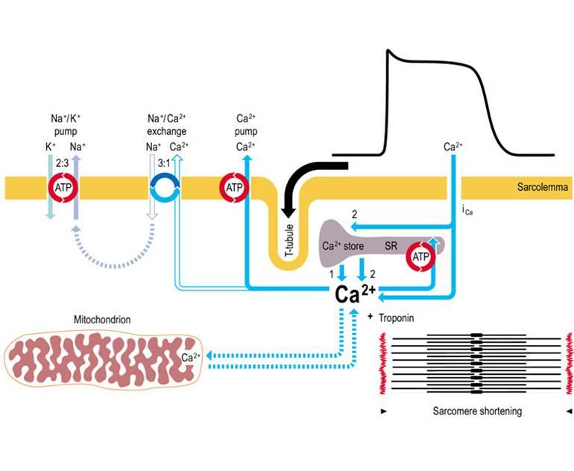

*Pharmacodynamic:
1-main mechanism at the molecular level cardiac glycoside inhibiting Na/K+ ATPase enz. (sodium pump) DIRECT
=K outside and Na inside this is result in indirect inhibition of Ca/Na pump(this pump mean Na influx and Ca outflux)=increase intracellular level of Ca
2-open of Ca chann. =influx of Ca = increase intracellular level of Ca
3-increase release of Ca from its store(ER)=increase level of intracellular level of Ca
(1-2-3)lead to increase intracellular level of Ca = increase contraction
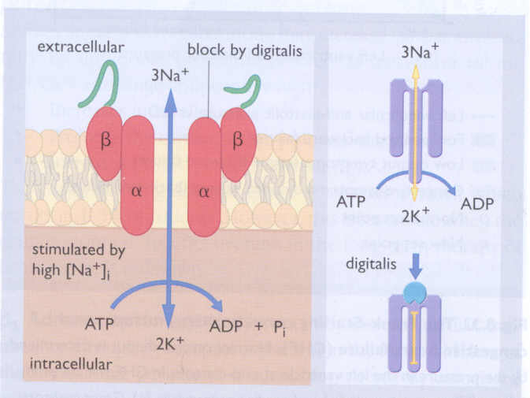

1) cardiac effect:
A-mechanical= (+)inotropic effect on the heart
B-electrical=see this effect on the ECG

1-indirect outonomic effect on the heart;
In therapeuric dose :
Cardioselective parasympathomemetic effect depressant effect on heart
Delayed action or Slow conduction through S.A.N=prolong time between atrium and ventricle (prolong P-R interval)
(parasymp =slow conduction SAN and AVN =prolong P-R interval)
In high dose:
Symp & para actions AV block in different degree b/c parasympathetic
(note: the symp effect appearance just in highly dose not in therapeutic dose, but parasymp in therapeutic dose )
(note: glycoside in autonomic effect mainly in atrium than ventricle)
N.B it has vagal stimulatory effect centrally even in therapeutic dose

2-direct effect on heart;
In therapeuric dose :
influx of Ca esp in plateau phase Short duration of AP and RP of both atrium and ventricle (short Q-T interval)
In high dose:
Short resting membrane potential excitation in abnormal site( ectopic focus) abnormal AP called after potential =delayed after depolarization
In digitalis toxicity =bigemenal rhythm in ECG(ectopic focus from pyrkinji system ) although all forms of arrhythmia can be happen.

*electrical effect:
-short Q-T interval
-toxic concentration=increase automatically of ectopic focus=all form of arrhythmia can be detected mainly in purkinji conducting system leading to bigemenal rhythm in ECG

*ECG change with digitalis:
-prolong P-R interval in therapeutic dose
-short Q-T interval in therapeutic dose
-depressed S-T segment in high dose
-bigemenal rhythm in high dose
-second degree of AV block in high dose
-delay after potential in high dose

2)extra cardiac effect : usually happen in high dose:
1-GIT=
it is early signs of toxicity & doctor should be aware of it
anorexia ,nausea, vomiting, diarrhea
2-CNS
disorientation(lack of concentration) ,hallucination, visual disturbance,agitation,convulsion
3-gynecomastia (milk from male):
unknown cause but may be by ;
1-central drug effect on hypothalamus
2-steriod ring of drug

4-kidney:
diuretic effect =(improve renal function)
inhibit Na reabsorption from PCT

*adverse effect;
-heart=all form of arrhythmia
-GIT=anorxia,vomiting.........etc
-CNS
-skin rash , allergy in high dose

*contraindication; any thing interfere with cardiac contractility
-toxic myocarditis
-constrictive pericarditis
-cardioversion=electrical shock to retain normal rhythm
electrical shock with digitalis=ventricular fibrillation
(digitalis effect on HF, if HF due to hypertension or atherosclerosis)

*factors induce digitalis toxicity;
1-lean body mass
(main store of digitalis is sk.ms. SO, old ages & thin people will have digitalis mainly free in plasma increase bioavailability)
2-renal disease adjust digoxin dose
3-thyroid disease
Hyperthyroidism Ca sensitivity + catabolism
Hypothyroidism basal metabolic rate metabolism of all drugs
BETTER to avoid prescribe it to uncontrolled thyroid functions
4-hypokalemia (e.g after administration of thiazide or loop diuretics)
potentate the inhibiting action of digoxin on Na/K pump and abnormal cardiac automatically
5-hypomagnesaemia=increase risk of arrhythmia (like K)
6-hypercalcimia=increase digoxin induce abnormal automatically

*treatment of digitalis toxicity;
-STOP drug
-K therapy=orally or I.V.
-cholestyramine=decrease absorption of cardiac glycoside
-atropine ( in AV block)
-lidocaine is the drug of choise then phenytoin= antiarrhythmic drug
(note: phenytoin=antiepileptic)
-fab antibody in threating or sever case

*clinical use of cardiac glycoside;
1-congestive HF
2-atrial flutter or fibrillation to protect the ventricle & avoid ventricular arrythmia
(note: digitalis not return the rhythm to normal BUT it will be less)
( digitalis should be avoided in arrhythmia with Wolff Parkinson white syndrome b/c it effect only the normal pathway)
( the Wolff Parkinson white syndrome=impulse from atrium to ventricle from another way not from normal way)

*drug interaction;
-diuretic hypokalemia arrhythmia
-quinidine (antimalaria) increase plasma level of digitalis through:
1-increase displacement from plasma protein
2-decrease renal clearance
-antibiotic
that alter intestinal flora increase digoxin bioavailability in about 10%
-agent that release catecholamine
sensitize myocardial to digitalis =increase arrhythmia

Management of acute HF:
1- Volume replacement.
2- Diuretics.
3- Positive ionotropic drugs.
4- Vasodilators.
5- Digitalis.
6- β blockers (class II-IV stable HF)
7- Vasodilators

Management of chronic heart failure:
1- Reduce work load of the heart.
a) limit activity.
b) reduce weight.
c) control hypertension.
2- Restrict sodium.
3- Diuretics
4- ACEI or receptor blockers

N.B pharmacological actions means ALL good & bad effects
Congestive HF: is defect in Lt & Rt

تمت بحمد الله

تمت بحمد الله هذه المذكرة بعد إضافة بعض الملاحظات والفيقرز عليها ,,,

ألف شكر لبنات 426 اللي كتبوها والله يعطيهم ألف عافيه ويكتبها في ميزان حسناتهم ,,.

لا تنسونا من صالح دعائكم ,,,

خالد الشهري ,,, صالح المطلق

