Anti-Diabetic Drugs

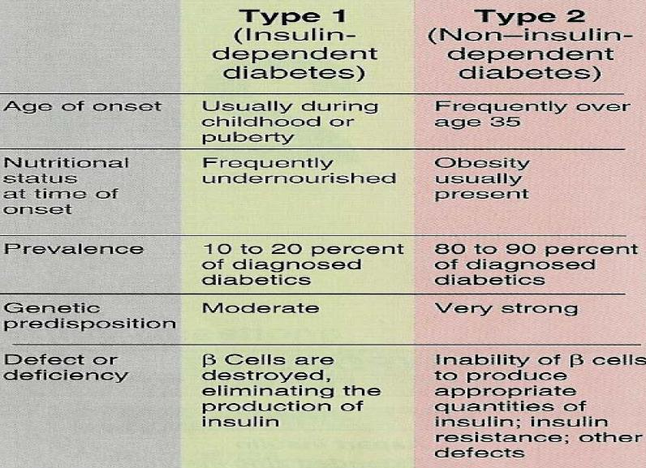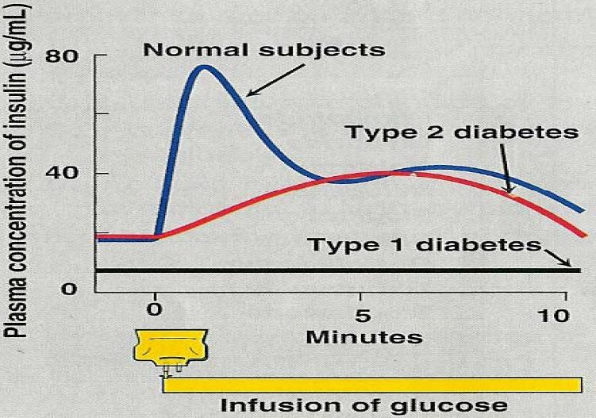Types of diabetes

#### Type II Diabetes

● Inadequate insulin secretion.

● Insulin resistance in target tissues

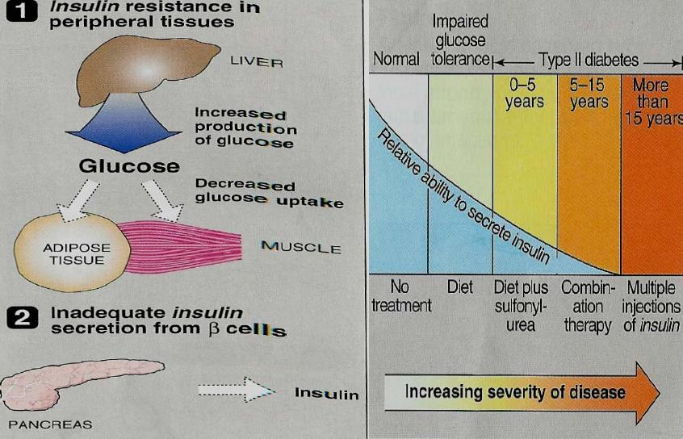

Complications of Diabetes

● Renal failure (Nephropathy)

● Blindness (Retinopathy)

● Neuropathy

Antidiabetics drugs

1. Insulin

2. Oral hypoglycemic drugs

# ORAL HYPOGLYCAEMIC DRUGS

1. Sulfonylurea drugs

2. Meglitinide analogues

3. Biguanides

4. alpha-glucosidase inhibitors.

5. Thiazolidinediones

Another classification of oral hypoglycemic drugs:

A) Insulinsecretagogues:

1. Sulfonylurea drugs

2. Meglitinide analogues

3. D-phenylalanine derivatives

b) Insulinsensitizers:

1.Biguanides

2. Thiazolidinediones or glitazones

c) Alpha glucosidase inhibitors

d) Gastrointestinal hormones

Insulin secretagogues

1) Sulphonylurea:

First generation

Tolbutamide

Tolazamide

Acetohexamide

Chlorpropamide

 Second Generation

Glipizide

Glyburide

(Glibenclamide)

Glimepiride

Mechanism of Action

● Stimulate insulin release from functioning B cells by blocking of ATP-sensitive K channels resulting in depolarization and calcium influx

● Reduction of serum glucagon concentration

● Increase tissue sensitivity to insulin

Pharmacokinetics

● Well absorbed orally

● Reach peak concentration after 2-4 hr.

● All are highly bound to plasma proteins.

● Duration of action is variable.

● Second generation has longer duration.

● Metabolized in liver

● Excreted in urine (elderly and renal disease).

● Cross placenta, stimulate fetal B cells to release insulin resulting in hypoglycemia at birth.

Insulin Secretagogues: Sulfonylurea

## First generation

Short: Tolbutamide (8 h)

Intermediate:   Tolazamide –Acetohexamide (20 h)

Long:  Chlorpropamide (60 h)

Tolbutamide

● Given in divided doses

● The Safest sulfonylureas for old patients

● No active metabolites

Tolazamide

● Active metabolites

● Slowly absorbed than others

Chlorpropamide

● Given as single morning dose (60 h).

● XXX hepatic-renal disease-old patients (prolonged hypoglycemia)

● Dilutional hyponatremia

● Hyperemic flush after alcohol ingestion

● No active metabolites

●Leukopenia, thrombocytopenia

## Second Generation

● More potent

● Have fewer adverse effects

● Have fewer drug interactions

● Has longer duration (24 h)

E.g. Glipizide, glyburide, glimepiride

Glipizide

● Has the shortest half life (2-4)

● Duration of action (10-16 h)

● No active metabolites

● Absorption is retarded with food

● Given in divided doses before meals

● Extended release preparation (Glucotrol XL) provides 24 h action ( a single morning dose)

Glyburide (Glibenclamide)

●Long acting (24 h)

● No active metabolite

Glimepiride

● The most potent

● Single morning dose is used (1 mg)

● Long acting (24 h)

● No active metabolite

Unwanted Effects

1-Hypoglycemia:

■ More in chlorpropamideand glibenclamide

■ Less in tolbutamide

■ More in elderly and patients with renal disease

2- Weight gain –increase appetite

3-GIT upset

4-Allergic skin rash

5-Bone marrow damage

6-Dilutional hyponatremia, water intoxication (Chlorpropamide) vasopressin effect

7-Disulfiram-like reaction with alcohol (chlorpropamide)

8-Tachyphylaxis (secondary failure)

Drug Interactions

Drugs Which Augment Hypoglycemic Effect:

● NSAI: Phenylbutazoneand salicylates

● Coumarin anticoagulants

● Alcohol

● Antibiotics: Sulphonamides, chloramphenical

● Antifungal Drugs: Fluconazole

### Agents Which Decrease Action of Sulphonylureas:

● Microsomal inducers

● Diuretics: Thiazide and Furosemide

● Corticosteroids

● Diazoxide

Contraindications

● Pregnancy (use insulin)

● Hepatic or renal insufficiency

Insulin Secretagogues: Meglitinide Analogues

● Are rapidly acting insulin secretagogues

● Repaglinide (Prandin)

● Nateglinide(Starlix)

Repaglinide

Mechanism of Action

● Stimulate insulin release from functioning B cells by modulating K efflux via blocking ATP-sensitive K channels resulting in depolarization and calcium influx

Pharmacokinetics of Repaglinide

● Orally, well absorbed

● Very fast onset of action, peak 1 h

● Short duration of action (4 h)

● Metabolized into inactive products in liver (CYP3A4)

● Excreted mainly in the bile

● Effective in early release of insulin after a meal (Post prandial glucose regulators)

● Taken just before meals

Uses of repaglinide

1. Regulation of post prandial glucose excursions

■ Monotherapy or combined therapy with metformin (*better than monotherapy*)

2. Patients allergic to sulfonylureas

Adverse effects of repaglinide

**less incidence than sulfonylureas**

● Hypoglycemia (meal is delayed)

● Weight gain

● Drug interactions

Drug Interactions

1. Enzyme inhibitorsas cimetidine, fluconazole, erythromycin

2. Enzyme inducersbarbiturates, rifampicin and phenytoin

3. Gemfibrozil augment action of repaglinide

Contraindications

Hepatic impairment

Insulin sensitizers: Biguanides

● Commercial name is Metformin

Mechanism of action

● Does not require functioning *B* cells

● Does not stimulate insulin release

● Increases peripheral glucose utilization (tissueglycolysis)

●Inhibits gluconeogenesis

● Impairs glucose absorption from GIT

● Increase glucose conversion to lactate

● Reduces plasma glucagon level

■ ↓LDL&VLDL

■ ↑HDL

Pharmacokinetics

● Orally

● NOT bound to serum protein

● NOT metabolized

● T ½3 hours

● Excreted unchanged in urine

Therapeutic Uses

● Has insulin sparing effect (insulin sensitizer)

● Obese patients with type II diabetes (with insulin resistance)

● Monotherapy or in combination

Advantages

● No hypoglycemia or weight gain (anorexia)  
 Adverse Effects

● Transient GIT disturbances (NVD)

● Lactic Acidosis:

■ Common in patients with Renal disease, Liver, Pulmonary or Cardiac disease

● Long term use interferes with B12 absorption

Contraindications

● Pregnancy

● Renal disease

● Liver disease

● Alcoholism

● Conditions predisposing to hypoxia as cardiopulmonary dysfunction

Insulin Sensitizers: Thiazolidinediones (Glitazones)

● Rosiglitazone (Avandia)

● Pioglitazone (Actos)

● Troglitazone (withdrawn due to hepatotoxicity)

Mechanism of action

**Activate nuclear receptors (peroxisome proliferator-activated receptor -γ) (PPAR-γ)**

● Increase sensitivity of target tissues to insulin

● Increase glucose uptake and utilization in muscle and adipose tissue

● Increase insulin sensitivity (decrease insulin resistance)

#### PPAR-γ

● Nuclear receptors

● Liver, skeletal muscles, Adipose tissue

● Control genes involved in glucose and lipid metabolism

● Increase insulin sensitivity in muscle and adipose tissue

● Decrease triglycerides

● Increases HDL  
Pharmacokinetics

● Orally (once daily dose)

● Highly bound to plasma albumins

● Slow onset of activity

● Half life 3-4 h

● Metabolized by CYP450

● Pioglitazone(Active metabolites)

● Excreted in urine & bile

● Triglyceride lowering effect is more with pioglitazonethan rosiglitazone   
 Indications

● Type II diabetes with insulin resistance

● Used either alone

● Combined with sulfonylurea, Biguanides or insulin

● Rosiglitazone should not be combined with insulin (Edema)

● Anovulatory women (polycystic ovarian syndrome)   
 Contraindications

● Heart failure

● Pregnancy

● Significant liver disease   
 Adverse Effects

● Fluid retention (Edema)

● Weight gain

● Headache

● Liver function tests for 1styear of therapy

● Failure of estrogen-containing oral contraceptives

α-GLUCOSIDASE INHIBITORS

● They include:

■ Acarbose (Precose)

■ Miglitol (Glyset)  
 ● Reversible inhibitors of intestinal α-glucosidases

● ↑ - glucosidases:degradation of oligosaccharides to monosaccharides

● Include sucrase, maltase, dextranase, glycoamylase

● Decrease postprandial digestion and absorption

● Decrease postprandial hyperglycemia

● Taken just before meals

● No hypoglycemia if used alone

Pharmacokinetics

Acarbose

● Poorly absorbed

● Metabolized by bacteria

● Excreted in urine

Miglitol

● Well absorbed, no systemic effects

● Excreted unchanged in urine

● 6 times more potent inhibitor for sucrose

Uses

● Type II diabetics

● Alone or combined with insulin or sulfonylurea

● Hypoglycemia may develop & treated by glucose Not sucrose)

Adverse Effects

● GIT: Flatulence, diarrhea, abdominal pain, bloating, increase in liver enzymes

Contraindications

● Inflammatory bowel disorders (IBD)

● Renal disease

● Hepatic disease (used with caution)

● Intestinal obstruction

Insulin

HISTORY:

● The hypoglycemic effects of pancreatic extract were first published by Kleinerin 1919

● The isolation of insulin in 1921 by Frederick Grant Banting and Charles H. Best ( in collaboration with JJR Macleod and James B. Collip) led to a revolution in the management of diabetes

Chemistry

● Polypeptide hormone MW 5808

● Contains 51 amino acids arranged in two chains A (21) & B (30) linked by two disulphide bridges

● B cells of pancreatic islets synthesize insulin from a single chain precursor called Proinsulin

● Proinsulin is hydrolyzed into insulin & a residual segment C-peptide

● Insulin and C-peptide are secreted in equimolaramounts in response to all insulin secretagogues

● Proinsulin might have mild hypoglycaemicaction but C-peptide is inactive

Storage

● Formed insulin is stored within B cell in the form of crystals consisting of 2 atoms of zinc and 6 molecules of insulinwhich is equal to 200 biologic units

● One milligram contains 28 units

Species of Insulin

Beef Insulin

■ Differs by 3 AA from human insulin (more antigenic). It is isolated and purified from beef insulin

Porcine Insulin

■ Differs by one AA. Now they usually mix 70% beef and 30% pork

Human Insulin

■ Recombinant DNA techniques

■ Less immunogenic

■ It contains a threoninemolecule , allows more rapid absorption and short duration of action

■Mixing with phosphate buffer reduces aggregation of regular insulin in infusion pumps

Mechanisms of Insulin Release



1. Stimulants of insulin secretion

● Glucose, mannose

● Vagalstimulation

● Glucose binds to glucoreceptorsin βcells→↑cAMP→Ca influx →insulin release by exocytosis

2. Amplifiers of glucose-induced insulin secretion

● Amino acids (arginine)

● Gastrointestinal Hormones

•Secretin

•Gastrin

•Cholecystokinin

● β-adrenergic agonists

3. inhibitors of insulin secretion

● α-sympathomimetics

● Somatostatin

● Drugs: Diazoxide

Insulin degradation

1. Basal level of insulin is 5-15 μU/ml

2. Half life of circulating insulin is 3-5 min.

2. Cleared by kidney & liver

Insulin receptors

● Present on cell membranes of most tissues

● Liver, muscle and adipose tissue

● Glycogen in liver and skeletal muscles

Pharmacodynamics

● Lowering of blood sugar by:

■ Utilization of glucose by peripheral tissues

■ Promoting synthesis and storage of glycogen in liver and skeletal muscles

I.Carbohydrate Metabolism:

● ↑glycogen synthesis (glycogen synthase)

● ↓gluconeogenesis.

● ↓glycogenolysis (liver)

● ↓Glycolysis (muscle)

● ↑glucose uptake & utilization

● ↑Conversion of carbohydrate to fats

II. Fat Metabolism:

Liver:

● ↑triglyceride synthesis

● Inhibits conversion of fatty acids to ketoacids

Adipose Tissue:

● ↑Triglycerides storage

● ↑Fatty Acids Synthesis

III. Protein Metabolism:

Liver:

● ↓Protein Catabolism

Muscle:

● ↑amino acids Uptake

●↑Protein Synthesis

● Increased glycogen synthesis

Types of Insulin Preparations

● Vary in onset and duration of action

Ultrashort acting

■ Very fast onset and short duration

Short acting (regular)

■ Fast onset and short duration

Intermediate acting

Long acting

■ Slow onset and long duration

Ultra-Short Rapid-Acting Insulin

1. Insulin Lispro, insulin aspart, insulin glulisine(injection)

2. Inhaled human insulin recombinant (inhaled)

3. Do not aggregate or form complexes

4. Fast onset of action (5-15 min)

5. Short durtionof action (3-5h)

6. Reach peak level after 1 h

**Insulin Lispro, insulin aspart, insulin glulisine**

● Clear solutions at neutral pH

● Monomericanalogue

● S.C. 5 min. before meals

● I.V. emergency (Insulin Lispro)

● Given 2-3 times/day

● Mimic the prandial mealtime release of insulin

**Insulin Lispro, insulin aspart, insulin glulisine**

● Have the lowest variability of absorption

● Preferred insulins for insulin infusion devices

Short acting insulin (Regular insulin)

**Regular humulinR –regular novolin R**

● Soluble crystalline zinc insulin (stability –shelf half life)

● Recombinant DNA technology

● Clear solutions at neutral pH

● Hexamericanalogue

● Onset of action 30-45 min (s.c.)

● Peak 2-4 h

● Duration 6-8 h

Uses

● I.V. emergency

■ Management of ketoacidosis

■ After surgery

■ During acute infection

● Given 2-3 times/day

● Control postprandial hyperglycemia & ketoacidosis

● Pregnancy

Intermediate acting insulin: Isophane (NPH) (Humulin N, NovolinN)

● NPH, a neutral protaminehagedornis combination of protamine& crystalline zinc insulin (1: 6 molecules). Proteolysis release insulin

● Turbid suspension at neutral pH, s.c. only

● Onset of action 1-2 h

● Peak serum level 5-7 h

● Duration of action 13-18 h

● 75/25 -70/30 -50/50 (NPH/regular)

Intermediate Acting Insulin: Lenteinsulin (Humulin L, NovolinL)

#### Mixture of

■ 30% semilenteinsulin (amorphous precipitate of insulin with zinc in acetate buffer)

■ 70% ultralenteinsulin (poorly soluble crystal of zinc insulin)

● Turbid suspension at neutral pH

● Slower onset of action 1-3 h than regular insulin

● Peak serum level 4-8 h

● Duration of action 13-20 h

● Lenteand NPH insulins are equivalent in activity

● Lenteand NPHare Not usedin emergencies

Long Acting Insulin: Insulin Glargine (lantus)

● Slower onset of action 2 h

● Clear solution BUT forms precipitate at injection site

● Given s.c.

● Peak 4-5 h

● Absorbed less rapidly than NPH & Lente insulin

● Prolonged duration of action (24 h)

● Once daily

# Insulin Preparations

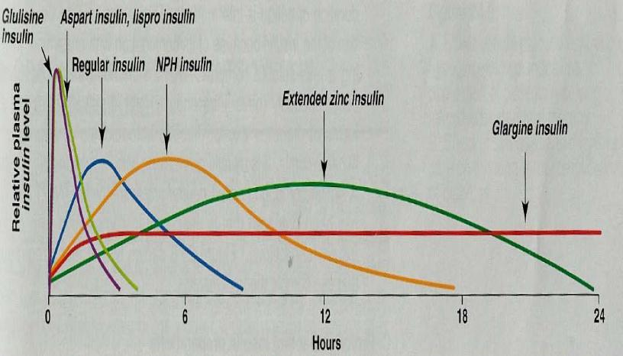

Routes of administrations of exogenous insulin

1. Given subcutaneously by syringes (arms, abdomen, thighs)

2. Portable pin injector

3. Continuous S.C. insulin infusion (pump)

4. Inhaled aerosols, transdermal, intranasal

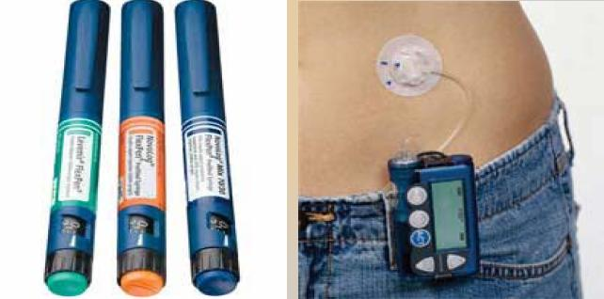

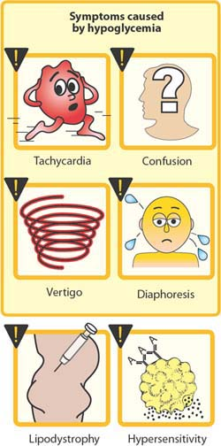

Adverse effects of Insulin Therapy:

● Hypoglycaemia manifested by:

■ Coma due to ↓blood glucose to the brain

■ ↑autonomic activity:

■ ↑sympathetic: Tachycardia, Sweating, Anxiety

■ ↑parasympathetic: Nausea, Vomiting

□ Treated by

¤ Sugar containing beverage or food.

¤ 20-50 ml of 50% glucose solution I.V. or glucagon 1 mg S.C. or I.M.

● Weight gain

● Hypersensitivity reactions

● Local reaction at injection site: Swelling, Erythema, Lipodystrophy

● Insulin resistance

● Hypokalemia