INTRODUCTION TO MACROCYTIC ANEMIA

Normal adult red cell values:
 | Male | Female
Hb(g/dl) | 13.5-17.5 | 11.5-15.5
PCV (%) | 40-52 | 36-48
Red cell cont | 4.5-6.5 | 3.9-5.6
MCH (pg) | 27-34
MCV (fl) | 80-95
MCHC (g/dl) | 30-35
Reticulocyte count | 25-125

Note:
- Hb , PCV and Red cell count are the only three values that differ in male with female.
- MCV "size of RBCs" : If less than 80, microcytic anemia occur
If more than 95 , macrocytic anemia occur
Between 80-95 normocytic normocronic aneamia
- MCH "concentration of Hb" : If less than 26, hypochromic anemia occur.
No hyperchromic condition.
- In children Hb is 15-21 because of the low O₂
- After birth phy jaundice happens
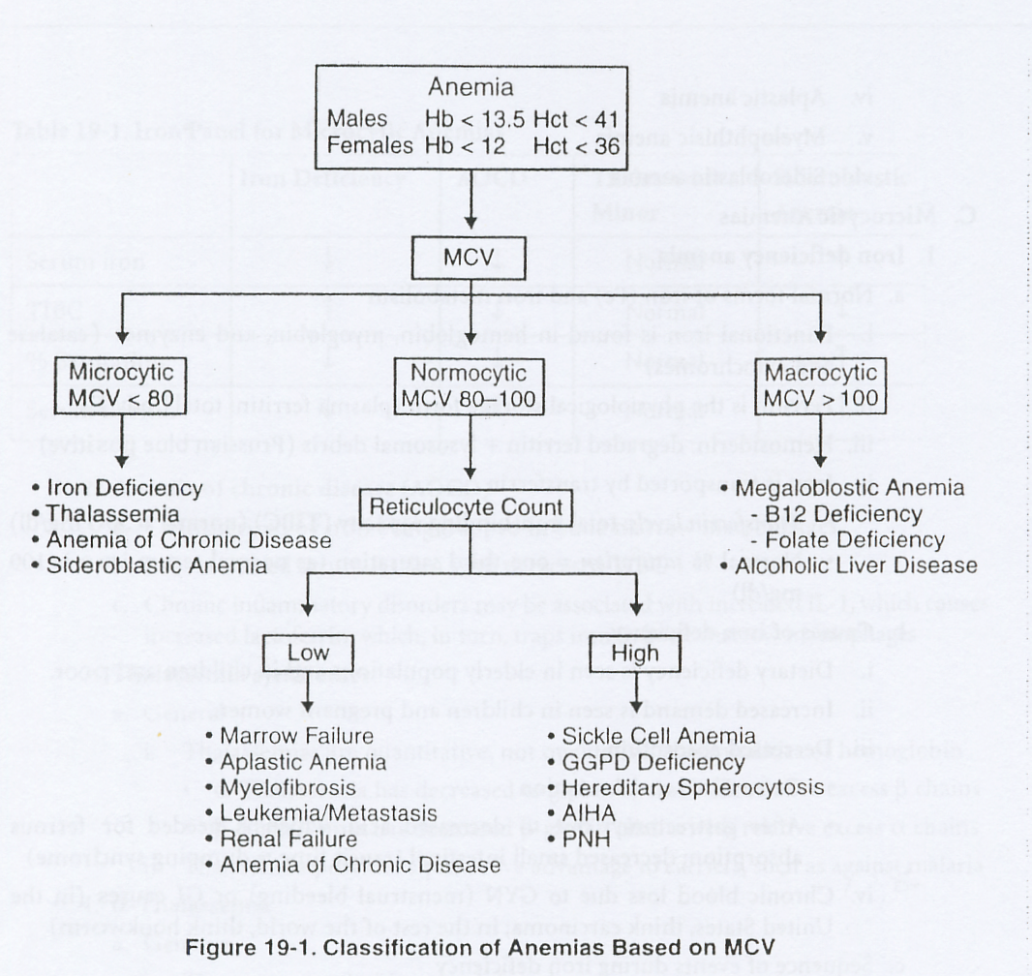

MACROCYTIC ANEMIA
- Large RBCs.
- Based on appearance of developing erythroblast ( with delayed nucleus maturation ) macroctic anemia is divided into :
Megaloblastic | Non – Megaloblastic
- Delay of nucleus maturation in bone marrow erythroblast  - Defect DNA synthesis due to Vit. B₁₂ or Folate deficiency | alcoholism, liver disease, aplastic anemia, reticlocytosis, hypothyroidism myeloma , pregnancy and newborn

-MEGALOBLASTIC ANEMIA:
- Not only RBCs and bone marrow becomes larger but all body cells because of the deficiency in Vit. B12 or Folate those are required in DNA synthesis.
- Anemia's characterized by delayed maturation of the nucleus compared to the cytoplasm.
- It s usually associated with neurological symptoms because of Vit. B12 role in the maintenance of myelin .

Laboratory findings:
- Anemia, macrocytic.
- Peripheral blood: macrocytosis, ovalocytosis. Imp. in this test to differentiate between small fragmented WBCs and platelets "don't miss up".
- Decrease WBC: with hypersegmented neutrophils "more than 5 lobes".
- Decrease platelets.
- Bone marrow: hyper cellular, Megaloblastic erythropoiesis – immature nuclei with normal hemoglobinization "hemoglobinization = cytoplasm".
- Increase bilirubin; increase Lactate dehydrogenase "LDH" due to marrow cell breakdown.
- Decrease serum B12 serum Folate and RBC Folate.

Vitamin B12:
- Source: food of animal origin.
- Absorption after combination with intrinsic factor (synthesized by gastric parietal cells), the complex is absorbed in the distal ileum.
- Transport: the absorbed Vit. B12 is attached to transcobalamin II which transports Vit. B12 to the bone marrow.
- Deficiency:
- Causes:
    - Dietary strict vegetarians.
    - Pernicious anemia: Gastric mucosa ( chief and parietal cells) destruction due to autoimmune disease lead to
- No intrinsic factor no B₁₂ absorption
- No HCL (achlorohydria) decrease iron absorption
    - Gastrectomy.
    - Intestinal disorders: e.g. chron's disease, ileac resection, parasites " fish tapeworm"
- Notes:
  - Deficiency takes 2 years at least to develop
  - It is not destroyed by heat " cooking"
  - Treatment: IM Vit B₁₂

Folate:
- Source: not synthesized in the body and thus obtained in diet only.
- Absorbed in the upper small intestine.
- Deficiency:
- Dietary.
- Mal-absorption.
- Increased requirements: e.g. pregnancy, hemolytic anemia.
- Drugs: e.g. anticonvulsant.

- Notes:
  - Deficiency takes only months to develop
  - Easly destroyed by heat
  - The requirement is increased in Pregnant and infant
  - The main defference between the Vit B₁₂ and Folate deficncy is that Folate don't have neurological symptoms
Clinical features: "MCQ"
- general: Pallor, lethargy, etc …. .
- Specific:
  - Jaundice.
  - Glossitis: painful.
  - Angular stomatitis.
  - Purpusa: due to thrombocytopenia.
  - Neuropathy: sensory and motor, especially in the lower limbs.
  - Neural tube defect.
  - Psychological impairment.
  - Ulceration of the tongue
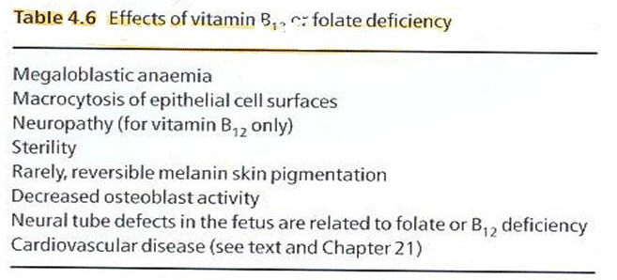
MEGALOBLASTIC ANEMIA
What is the cause?
Deficiency of vitamin B12 or Folate
How do these deficiencies lead to anemia?
Both vitamin 12 and Folate are necessary for DNA synthesis. Decreased DNA synthesis subsequently leads to decreased RBC production.
What is a Megaloblastic?
An erythroid precursor cell found in the bone marrow
What are typical lab findings?
Pancytopenia, decreased vitamin B12, decreased Folate
What is seen on histology?
Oval macrocytosis, hypersegmented neutrophils (> 5 lobes), and megaloblastic hyperplasia of bone marrow

FOLATE DEFICIENCY
What are some causes of Folate deficiency?
Poor diet, pregnancy, spme, drug effects, and Giardia lamblia infection
In which populations is diet-related Folate deficiency often found?
Chronic alcoholics and fad dieters
What drugs are associated with decreased Folate?
Phenytoin, oral contraceptives, and methotrexate
How does hemolytic anemia cause a relative deficiency of Folate?
The compensatory accelerated eythropoiesis uses up the body stores of Folate.
VITAMIN B12 DEFICIENCY
What is the most common cause?
Pernicious anemia
Define pernicious anemia.
An autoimmune disorder with failure of production of intrinsic factor (IF) due to
Anti-IF antibodies
How is IF related to vitamin B12?
IF is essential for the absorption of vitamin B12 in the distal ileum.
What are the 4 clinical findings of pernicious anemia?
1. Yellow skin .2 Stomatitis .3 Clossitis .
4Subacute combined degeneration of the spinal cord
How does subacute combined degeneration of the spinal cord manifest?
Ataxic gait, hyperrefiexia, and impaired vibratory and positional sensation
What abnormal antibodies are found?
Anti-IF and autiparietal cell antibodies
What are the results of a Schilling test?
Decreased vitamin B12 absorption corrected by adding IF
What type of gastritis is present?
Chronic fundal gastritis (Type A)
What feared entity may Type A gastritis progress to?
Gastric cancer
What are some other causes of vitamin B12 deficiency?
Intestinal bacterial overgrowth, gastric resection, vegetarian diet, intestinal malabsorption, D. latum infestation
What are 2 causes of excess bacteria in the intestine?
Broad-spectrum antibiotics and blind- loop syndrome

