HEMOGLOBIN SYNTHESIS

1 Overview
You know an idea about hemoglobin and its subtypes from biochemistry!
Hemoglobin contains 4 heme groups, each carrying 1 iron atom, and each iron atom binds to 1 O₂ molecule.
(1 hemoglobin 4 iron atoms) in contrast to transferritin (2 iron atoms)
- Our body Heamoglobin is
  - Hb A (major): containing 2 α and 2 β subunits (α₂β₂),
  - Hb A₂: delta subunits instead of β (α₂δ₂)
  - Hb F: gamma subunits instead of β (α ₂γ₂). It is a fetal hemoglobin that is present in adults in minor amounts.
  - Other Hemoglobins (Hb Gower1 and 2 and Portland) are present at different stages in embryonic and fetal life.
- Abnormal Hemoglobin
  - Hb S: mutation at position 6 of the β subunits
    - (glutamate valine)
  - Hb C: (glutamate lycine) also at position 6 mutation of β

Heamoglobinopathies
They are diseases caused by reduced or abnormal synthesis of hemoglobinn
- Synthesis of abnormal hemoglobin like sickle cell disease.
- Reduced rate of synthesis of normal alpha (α) or β globin chain (Alpha (α) and β thalassemia).

Epidemiology:
- Affects10% of the world's population.
- Occurs in tropical and subtropical areas.
- Beta (β) thalassemia is more common in the Mediterranean region.
- Alpha (α) thalassemia is more common in the Far East.

We will take thalassemia and sickle cell anemia.

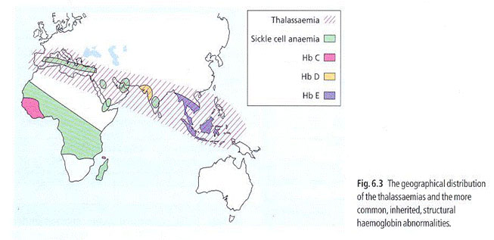
THALASSEMIA:
Thalassemias are a heterogenous group of genetic disorders, which result from a reduced rate of synthesis of α or β chains due to reduced, absent or depleted
Mode of inheritance: autosomal recessive

A- ALPHA THALASSEMIA:
- Caused by deletion of one or more of the 4 genes encoding for the α globin
- Since there are four copies of alpha (α) globin gene, the clinical severity depends on the numbers of genes missing.

HYDROPS FETALIS:
- There is loss of all 4 genes, so there is complete suppression of alpha (α) chains fetus incompatible with life intrauterine death.
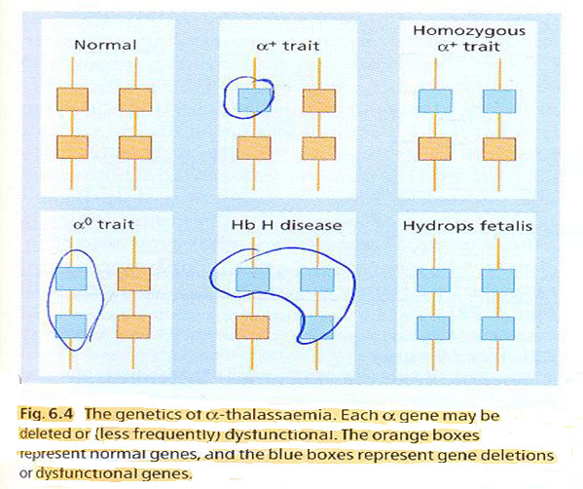

HEMOGLOBIN H DISEASE:
- There are 3 gene deletions. Moderately severe anemia 7 – 11 g / dL.
- Microcytic hypochromic anemia.
- Splenomegaly.
- Hb H is formed (composed of 4 beta chains - β₄) and can be seen in the peripheral blood by reticulocyte stain or can be detected by Hb electrophoresis.
- Henz body can be found
  - They are inclusions within RBCs composed of denatured Hb.

ALPHA THALASSEMIA TRAIT:
- Loss of 1 or 2 genes.
- No anemia but the RBC count is increased and there is microcytosis (decrease MCV) and hypochromia (decrease MCH). This is important in differentiation with iron deficiency anemia.
- Hemoglobin electrophoresis is normal.
- Diagnosis is based on α:β chain synthesis. Normal ratio is 1:1. It is reduced in α thalassemia and increased in β thalassemia.

B. BETA THALASSEMIA
- No B chain (β0) or small amounts (β+) are synthesized.
- Alpha (α) chain production in excess precipitate in RBCs hemolysis
- Production of gamma (γ) chains reduced severity of the disease by taking up the excess α chains
- The defect is gene mutation rather than a gene deletion (unlike α)
- HbF is increased especially in β0

Clinical features:
- Anemia: Severe, appears 3-6 month after birth (switch from γ to β chains).
- Hepatomegaly – Splenomegaly: due to hemolysis, extramedullary hematopoiesis and iron overload "see no. 5 for more".
- Jaundice: Due to hemolysis, liver damage.
- Bone expansion: due to marrow hyperplasia results in thalassemia facies, bossing of skull, and hair on end appearance on x –ray.

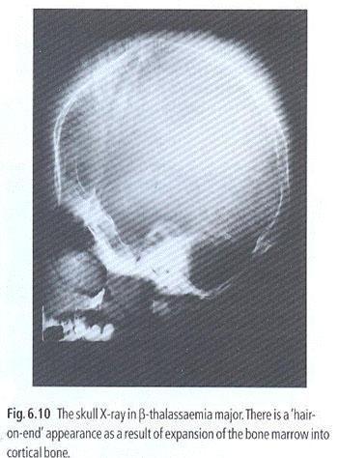
- Iron overload: due to hemolysis, increased absorption and multiple transfusions results in:
- Hepatomegaly and liver damage.
- Splenomegaly.
- Endocrine organs failure: growth failure, delayed puberty, diabetes mellitus, hypothyroidism.
- Cardiac complications: usual cause of death if not treated “arrhythmia due to accumulation of iron in heart”
Treatment: deforaxamine, or any method that kicks iron out of body.

- Increased susceptibility to infections: usually bacterial infection especially after splenectomy Pneumococcal, Meningococcal and Hemophilus. MCQ

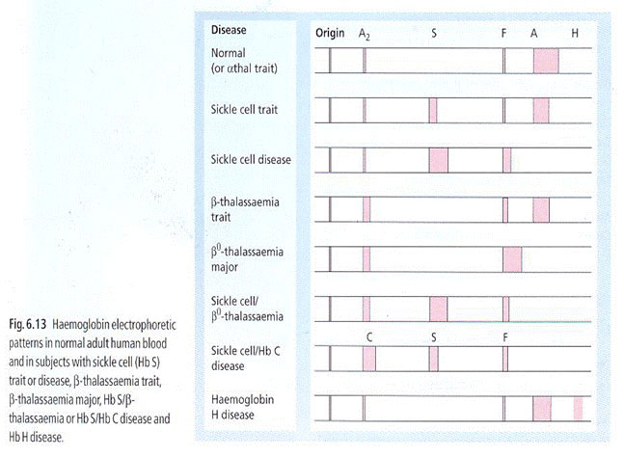

Lab diagnosis
- Anemia:
- Hypochromic microcytic (low MCH, low MCV).
- Reticulocytosis.
- On peripheral blood smear: nucleated RBC “normoblasts”, target cells, polychromasia, basophilic stippling.

- Hemoglobin Electrophoresis:
  - HbA: absent. MCQ
  - HbF: Increased.
  - HbA2: Normal, decreased, increased.
  - Α : Β globin chain ratio is increased.

Beta-THALASSEMIA TRAIT (THALASSEMIA MINOR):
- Common, symptomless.
- Laboratory findings:
  - Microcytosis (low MCV), Hypochromia (low MCH).
  - Mild anemia. “or no”
  - Increased RBC count.
  - Increased HbA2 level. > 3.5%
- It is important to diagnose the trait in pre-marital counseling and prenatal diagnosis, because if both parents with B thalassemia trait, 25% chance of a child with thalassemia Major.
- Prenatal diagnosis:
  - Chorionic villous sampling.
  - Amniotic fluid analysis.
  - Fetal blood sampling.

THALASSEMIA INTERMEDIA:
- Moderate severity, Hb7 -10 g / dL.
- caused by a variety of genetic defects e.g.:
  - Homozygous B thalassemia with increased HbF-gamma (γ).
  - Homozygous mild B thalassemia – mild defect in B chain synthesis.
  - Hemoglobin lepore: abnormal hemoglobin caused by crossover of the beta (B) and delta (δ) genes, causing partial deletion of both genes.

Sickle Cell Anemia
Sickle cell disease is a group of hemoglobin disorders in which there is an inherited defect in the beta–globin gene. It is a “qualitative” hemoglobin abnormality, unlike thalassemia which is quantitative.
- caused by a variety of genetic defects in the beta globin and instead of it form:
  - homozygous sickle cell anemia (Hb SS): the most common form. It is serious and fatal !
  - Double heterozygous Hb SC (rare)
  - Double heterozygote HbS B thalassemia. “less common”

Hemoglobin S
- The most common Hb Abnormality
- Substitution of valine for glutamate in position 6 in the B chain.
  - Hb a₂B(s)₂
- The hemoglobin becomes less soluble, and precipitate when O₂ is depleted cystic formation.

Pathogenesis:
Deoxygenated sickle hemoglobin polymerizes into long fibers. The RBCs sickle:
- Hemolysis due to fragility.
- Blockage of vessels → infarct.
- High viscosity.

Epidemiology:
- Widespread.
- 1/4 in West Africa. Protection against malaria is afforded by carrier state.
- In Saudi Arabia: common especially in Eastern Province, Jizan and Al-Ola area.

Factors affecting sickling
  - Oxygen tension
    - 50-60 mmHg for SS
    - 20-30 mmHg for AS
    - pH
    - Inhibited at Alkine
    - Exacerbated by acidification
  - concentration of HbS
  - presence of other Hb

Clinical Features
- Severe hemolytic anemia: however the symptoms are mild compared to the Hb level because HbS has a lower affinity for Q2 than A2. The symptoms are pallor, jaundice … etc. MCQ
- Crises: MCQ

  - Vasoocclusive:
    - Painful.
    - Precipitated by infection, acidosis, dehydration, pyrexia, deoxygenation, exposure to cold, pregnancy.
    - Organ infarcts e.g. bone (femoral head necrosis), lungs, spleen, liver, brain (stroke).
    - Painful dactylitis – small infarcts of the small bones of the hands and feet.
  - Visceral Crises (Sequestration):
    - Pooling of blood.
    - Sickling inside the organs e.g. spleen, liver and lungs (acute chest syndrome). MCQ
  - Aplastic Crises:
    - Due to parvovirus infection or folate deficiency.
    - Sudden fall in Hb, associated with decreased reticulocyte count.
  - Hemolytic Crises:
    - Increased rate of hemolysis.
    - Decreased Hb with increased reticulocyte count.
- Other:
  - Susceptibility to infection, e.g. Salmonella osteomyelitis. MCQ
  - Gall stones.
  - Liver damage.
  - Papillary necrosis of the kidney hematuria.
  - Leg ulcers.
  - Splenomegaly in early childhood and autosplenectomy in later life (asplenia). MCQ
  - Retinopathy.
  - Osteomylitis infection of bones lead to deformation hand foot syndrome

Factors predisposing crises:
      - Infection
      - Pyrexia
      - Exposure to cold
      - Dehydration
      - Pregnancy

Laboratory findings:
- Hb: Usually 6 -9 g /I.
- Peripheral blood smear: Sickle cells, target cells.
- Sickling test: Positive (test of solubility of Hb when deoxygenated). MCQ
- Hb electrophoresis: The predominant Hb is HbS. HbF (5 – 15%). Higher values of HbF associated with milder disease. MCQ

SICKLE CELL TRAIT:
- No anemia.
- Normal RBC morphology on peripheral blood smear.
- Very minimal infarction e.g. kidney hematuria. MCQ
- HbS level = 25 – 45%.
- Sickling increase when exposed to O2 e.g. anesthesia, pregnancy, high altitude.

