**Hemoflagellates**

[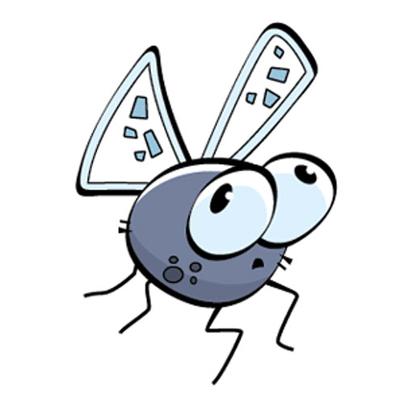](http://www.google.com.sa/url?sa=i&rct=j&q=&esrc=s&source=images&cd=&cad=rja&uact=8&ved=0ahUKEwjIuuiJgPnJAhWDaxQKHS_YDd8QjRwIBw&url=http://cliparts.co/clipart/2840577&psig=AFQjCNE2oCSPycSbeus1xNb0RB5nQPaccg&ust=1451201243652370)

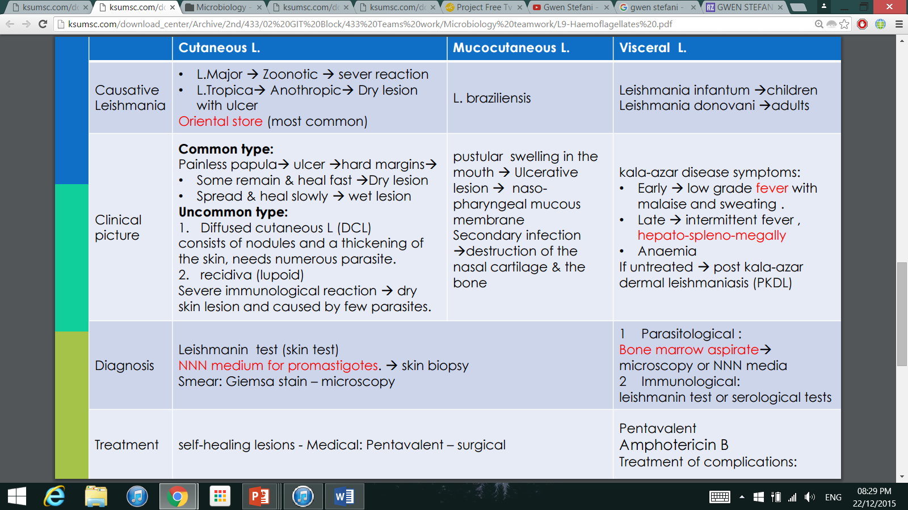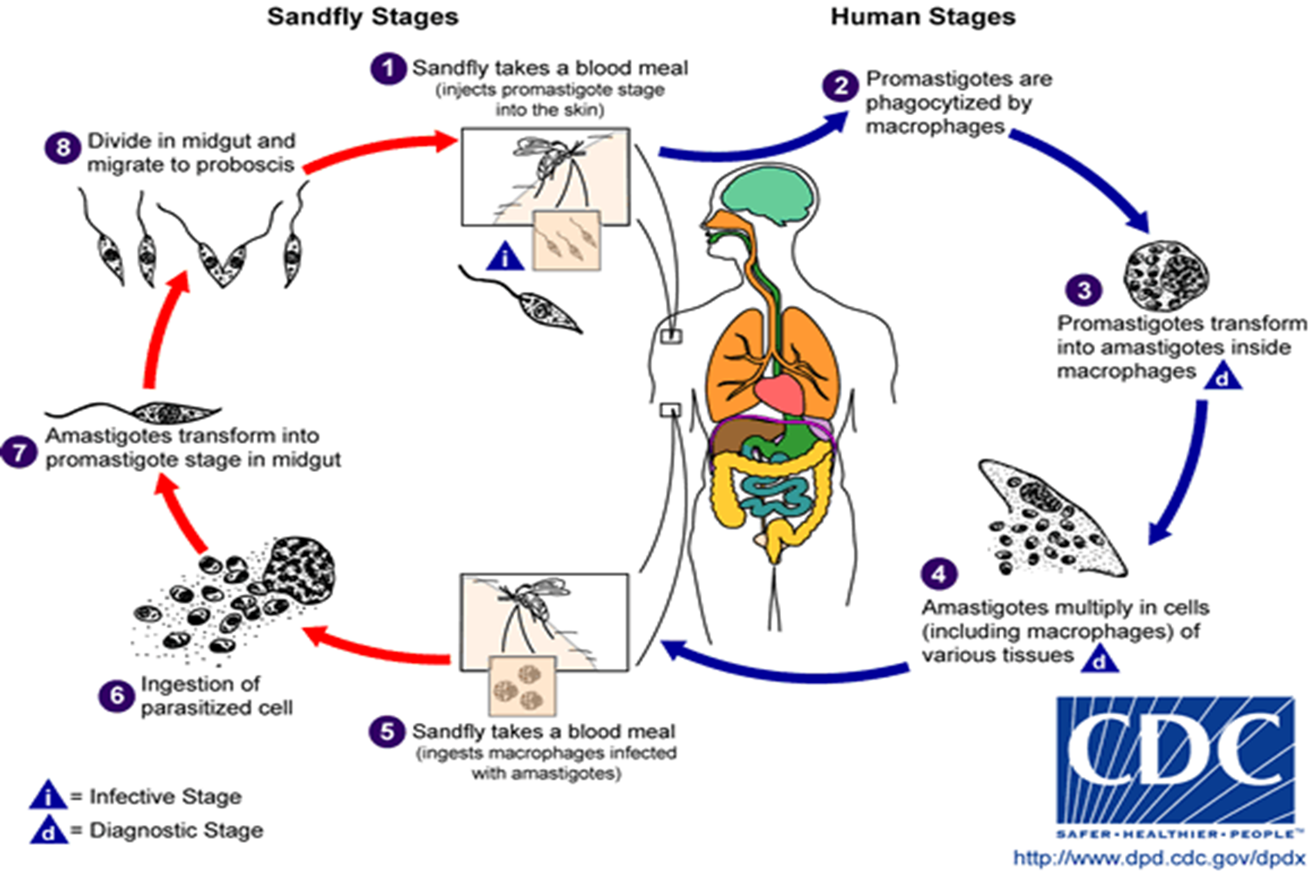

Leishmania

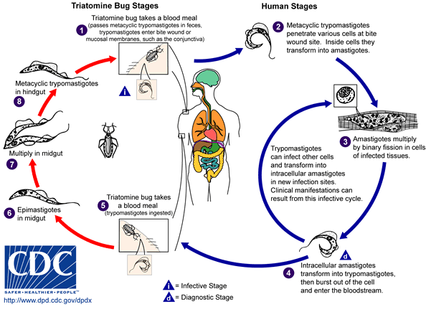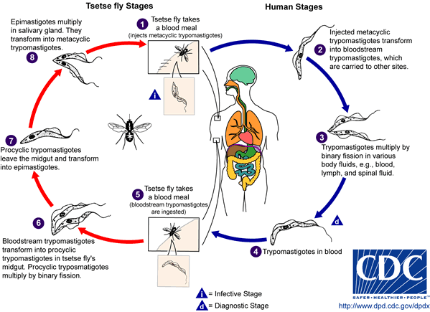

**AMERICAN TRYPANOSOMIASIS LIFE CYCLE:**

**AFRICAN TRYPANOSOMIASIS LIFE CYCLE:**

