1. Which of the following is supplied by the femoral nerve?

A. Extensors of hip.

B. Skin of dorsum of foot.

C. Hamstrings.

D. Extensors of knee.

2. Injury of common peroneal nerve leads to:

A. Loss of dorsiflexion of ankle.

B. Loss of inversion of foot.

C. Loss of extension of knee.

D. Loss of flexion of toes.

3. What are the nerve roots of the Femoral Nerve?

A. L2 to L4

B. L2 to L5

C. L1 to L4

D. L2 & L3

5. Related to which muscle does the Femoral Nerve arise?

A. Pectineus

B. Sartorius

C. Psoas Major

D. Rectus Abdominis

6. What is the position of the femoral nerve in relation to the femoral artery?

A. Lateral

B. Medial

C. Above

D. Below

7. Which of the following is not an intracranial branch of the facial nerve?

1. Nerve to stapedius
2. Greater petrosal nerve
3. Chorda tympani
4. Buccal nerve

8. The maxillary nerve exits the cranium through which structure?

1. Foramen ovale
2. Foramen spinosum
3. Superior orbital fissure
4. Foramen rotundum

9. Which of the following movement is lost when the tibial nerve is injured?

A. Extension of knee.

B. Planter flexion of ankle

C. Dorsiflexion of ankle

D. extension of toes

10. What happen If the sciatic nerve get injured ?

A. wasting of the muscles below the knee

B. Loss of extension of knee

C. Sensation is lost below the knee, Except the medial side

D. 1-3

11. What is the function of the hypoglossal nerve?

1. Somatic sensory
2. Visceral sensory
3. Visceral motor
4. Somatic motor

13. One of them is branch of femoral nerve?

A. Iliohypogastric

B. Ilioinguinal

C. Genitofemoral

D. Nerve to iliacus

14. The middle of the three meninges is the _.

* 1. dura mater
  2. pia mater
  3. arachnoid mater
  4. ligamentum denticulatum

15. Through which structure does the vestibulocochlear nerve exit the cranium?

1. Hypoglossal canal
2. Foramen rotundum
3. Jugular foramen
4. Internal acoustic meatus

16. The connection between the third and fourth ventricle is called the _____.

A) interventricular foramen

B) cerebral aqueduct

C) Interventricular foramen

D) hypothalamus

17. The cerebral hemispheres are connected by the _____.

A) longitudinal fissure

B) cortex

C) corpus callosum

D) brain stem

18. CN ____ is responsible for balance.

A. VIII

B. VII

C. XI

D. X

19. Which of these is not a symptom of cauda equina syndrome?

1. Reduced anal tone
2. Retention of urine and faeces
3. Upper limb anaesthesia
4. Incontinence

20. Bell's Palsy is associated with which nerve?

A. Trigeminal

B. Vagus

C. Accessory

D. Facial

21. Which of the following is NOT purely sensory?

A. I

B. II

C. III

D. VIII

22. Which cranial nerve is responsible for taste on the posterior part of the tongue?

A. Facial

B. Glossopharyngeal

C. Hypoglossal

23. Which nerve is responsible for taste on the anterior 2/3s of the tongue?

A. Hypoglossal

B. Glossopharyngeal

C. Facial

24. Which cranial nerve does not come from the pons?

A. VII

B. VIII

C. VI

D. II

25. Which CN is responsible for mastication?

A. V

B. VII

C. VIII

D. I

26. Which group of muscles atrophies in carpal tunnel syndrome?

1. Hypothenar eminence
2. Thenar eminence
3. Anterior forearm
4. Posterior forearm

27. Which area does the ulnar nerve provide cutaneous innervation to?

1. Lateral one and a half fingers
2. Medial one and a half fingers
3. Anterior forearm
4. Posterior forearm

28. What deformity occurs if the ulnar nerve is injured at the wrist?

1. Hand of benediction
2. Ulnar claw
3. Waiter's tip
4. Wrist drop

29. The long thoracic nerve innervates which muscle?

1. Anterior scalene
2. Middle scalene
3. Serratus anterior
4. Teres major
5. Subscapularis

30. During a motorcycle accident, an 18-year-old male landed on the right lateral side of his rib cage with his right upper limb abducted. In the hospital he was found to have "winging" of the right scapula. Which nerve was likely damaged in the accident?

1. Accessory
2. Long thoracic
3. Phrenic
4. Vagus

31. Which arteries supply the most lateral portions of the cerebrum?

1. Anterior cerebral arteries
2. Middle cerebral arteries
3. Posterior cerebral arteries
4. Basilar artery

32. Which structure separates the frontal and parietal lobes from the temporal lobe?

1. Central sulcus
2. Precentral gyrus
3. Lateral sulcus
4. Postcentral gyrus

33. Which retinal fibres are present in the left optic tract?

1. Left temporal and left nasal
2. Left temporal and right nasal
3. Right temporal and right nasal
4. Right temporal and left nasal

34. The axillary nerve arises directly from which part of the brachial plexus?

1. inferior trunk
2. lateral cord
3. medial cord
4. posterior cord

35. Which of these conditions is a pituitary adenoma most likely to cause?

1. Exophthalmos
2. Uveitis
3. Bitemporal hemianopia
4. Glaucoma

36. Which group of muscles does the musculocutaneous nerve innervate?

1. Anterior forearm
2. Posterior forearm
3. Anterior arm
4. Posterior arm

37. What structure separates the cerebellum from the occipital and temporal lobes?

1. Tentorium cerebelli
2. Longitudinal fissure
3. Falx cerebri
4. Fourth ventricle

38. From where does the superior cerebellar artery originate?

1. Internal carotid artery
2. Anterior communicating artery
3. Basilar artery
4. Posterior communicating

39. The internal acoustic meatus is part of which bone of the skull?

1. Sphenoid
2. Temporal
3. Parietal
4. Occipital

40. Which of the following muscles is innervated by the glossopharyngeal nerve?

1. Stylohyoid
2. Sternohyoid
3. Stylopharyngeus
4. Omohyoid

41. Which branch of the trigeminal nerve carries motor fibres?

1. Opthalmic
2. Maxillary
3. Mandibular
4. All of the above

42. Where is cerebrospinal fluid produced?

1. Cerebral aqueduct
2. Central spinal canal
3. Choroid plexus
4. Subarachnoid cisterns

43. The corticobulbar tracts provide innervation to the musculature of which region of the body?

1. Head and neck
2. Upper limbs
3. Lower limbs
4. Neck

44. Which tracts carry unconscious proprioceptive information?

1. Spinocerebellar tracts
2. Anterior spinothalmic tract
3. Lateral spinothalmic tract

45. Third order neurones of the medial lemniscal pathway ascend from which structure to terminate in the sensory cortex?

1. Cuneate nucleus
2. Gracile nucleus
3. Ventral posterolateral nucleus of the thalmus
4. None of the above

46. What carries sensory info regarding pain and temperature?

1. Gracilis Fasciculus
2. Spinothalamic
3. Spinocerebellar
4. Tectospinal

47.

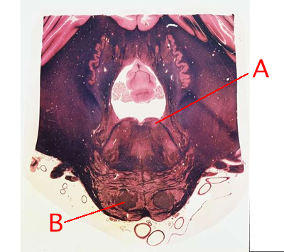

48.

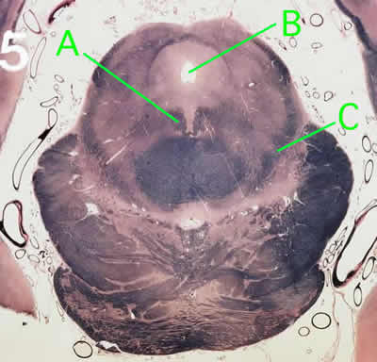

A Identify this structure.

B Identify this space

C Which modality is carried by this structure?

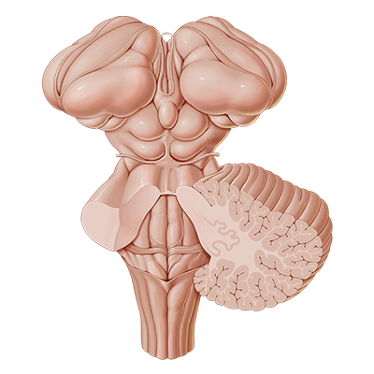



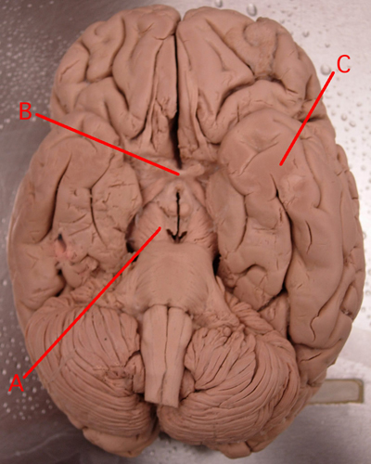

A) Name this part

B) Identify this area, and tell the effect of its lesion

C) Name this gyrus

