COLLEGE OF MEDICINE
Department of Medical Education
Curriculum Development & Research Unit

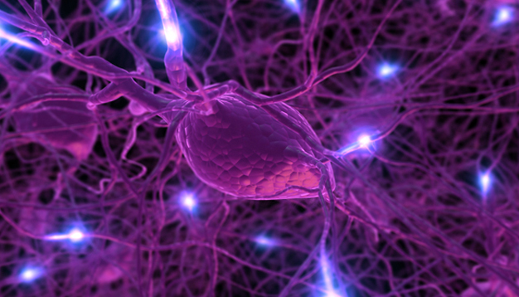

STUDENT'S BOOK

NEUROPSYCHIATRY
BLOCK
YEAR 2

2016-2017
(1437-1438)

COLLEGE OF MEDICINE
Department of Medical Education
Curriculum Development & Research Unit

THE NEUROPSYCHIATRY BLOCK

Year Two

BLOCK BOOK AND STUDENT GUIDE

Male Group A

( 18 September 2016 to 24 November 2016)

(2016-2017) 1437-1438

Copyright Statement

This material is protected by copyright laws. For any other purposes other than teaching and research in the King Saud University, no part may be reproduced or copied in any form or by any means without prior permission of the King Saud University.

© King Saud University, Saudi Arabia, 2013.

A message from the Dean
We are pleased with your progress in the medical program and your achievements. Being a first year medical students is a great opportunity for you to consolidate what you have learnt in the preparatory year and prepares you for the clinical skills and competencies needed in the clinical years. The Department of Medical Education through its different units is working hard to create an integrated and innovative curriculum that builds on the changes introduced in the preclinical years and enforces best teaching/learning approaches in the design of the new medical curriculum. As you are aware, the College of Medicine at King Saud University is one of the best colleges not just in the Kingdom of Saudi Arabia but proved to be one of the best in the gulf region, and the Middle East. It also has its international influence among the best colleges of medicine worldwide. This makes us proud of our achievements and provides you with an insight about the quality of teaching and research that we have reached and our continuous work to maintain our standards.
Therefore, the medical curriculum aims at preparing you and equipping you with the best training and clinical skills to become a medical graduate that fulfils the highest international standards. Therefore, the focus of the curriculum is to enhance a number of skills such as case-based learning, critical thinking, self-directed learning, deep understanding of concepts, application of knowledge learnt, and how to make decisions on the basis of evidence. The curriculum also aims at enhancing your skills in areas such as professionalism, e-learning, task-based learning, and preparing you for life-long learning. The design of the curriculum encourages small group learning, use of cases for discussion, lectures, student-led seminars, bed-side teaching, task-based learning, use of multimedia and e–learning as modes for teaching and learning. The use of wide range of teaching and learning modes and small group discussion will help you to become active learners, and work with other students in your group as a team.
I wish you all the best during your academic year and would encourage all of you to get the best out of the teaching and learning opportunities provided to you during this year. Our teaching staff and clinicians would be very happy to help you on any issue that you need help with.

Professor Khalid A Fouda Neel
Dean, College of Medicine and the Supervisor of University Hospitals

A Message from the Vice Dean for Academic Affairs
It is my pleasure to welcome you all to the second year of Medicine. I would like to take this opportunity to congratulate you all on your success and achievements. There is no doubt that you have worked hard during the first year to adapt to the university system and our new integrated curriculum. In the mean time, we would like you to remember that success is not a destination, success is a journey and there will be many challenges during your journey of success. A successful person would turn these challenges into opportunities for success.
As you might be aware, our faculty under the leadership of our Dean is moving into an integrated curriculum that encourages small group learning and student-centered approaches for learning. To achieve these goals we have established the Department of Medical Education under the leadership of Dr Mona Soliman and his teams to develop the new integrated curriculum. The design of the new curriculum is focused on the students not the teachers. Our aim is to equip each of you with the current teaching and learning strategies that are used in the best universities worldwide and ensure that you will be an excellent medical doctor who will be committed to the profession and willing to serve patients in our country, our region, and wherever our government and our professional bodies would ask you for help.
On these bases, our aim is not just to graduate more doctors; our aim is to ensure that doctors graduating from our university are equipped with knowledge, skills, behavior, and competencies needed for best practice of medicine anywhere in the world. This goal makes a lot of responsibility from your end and we would like you to take this opportunity and work effectively to achieve your goals. Our academic and clinical staff are expert in their areas and very eager to help and support you to achieve your dreams. I would encourage you to ask for help when needed and our support team would work with you on any challenges you might face during the course. I wish you all the best.

Dr. Saleh Adhehri
Vice Dean for Academic Affairs
College of Medicine

A Message from the Neuropsychiatry Block Chair
I would like to take this opportunity to thank all of the faculty members of the basic and clinical medical sciences and the members of Department of Medical Education for their support and cooperation to make the Nervous System Block more revealing for the students. This eight week block is designed to integrate the basic concept of neurosciences between basic and clinical sciences. It will be based on small group discussion tutorials, lectures, essential practical introduction to clinical medicine of communication skills, professionalism and self learning sessions. This course includes knowledge and skills of all basic and clinical sciences related to the nervous system and also psychological disorders. The contents of this block will also help the students to come to the differential diagnosis of the neurological diseases and reach at the final conclusion. This course is designed to facilitate the students to enhance their knowledge, develop independent thinking, communication skills and leadership qualities. I believe that, this block will bring new optimism and an improved platform for the students to learn and enhance their knowledge and skills in better understanding of nervous system and associated diseases and their management. We welcome the feedback and constructive comments from the students as well as faculty members.

Professor Sultan Ayoub Meo
Neuropsychiatry Block Chair

TABLE OF CONTENTS
General Information | 8
Teaching staff | 9
List of the Problem – Based Learning Cases | 10
Objectives of the Neuropsychiatry Block | 11
Objectives of the lectures | 12-97
Academic Support Team | 98
Schedule of the Block (Male A) | 99-106
Plagiarism | 107
Assessment of Students in the Block | 108-109
Learning Resources | 110-114
Feedback to student on PBL Performance | 115
Assessment of student in PBL | 116
Students’ evaluation of their PBL tutor | 117
Student Rating of lecture | 118
Appendix | 119-129

General Information
Block Title | Neuropsychiatry Block
Block Code & Number | NEUR 222
Credit Hour | 12
Block Duration | 11 Weeks
Block Dates | 18th September to 24th November 2016
Block Chairman | Dr. Sultan Ayoub Meo
Block Co-Chair | Dr. Amro Al-Habib

Teaching Staff
Year 2 - Male Groups A

Department | Name | E-mail
Anatomy | Dr. Khaleel Ibrahim Alyahya | khaleelya@gmail.com
 | Dr. Essam Eldin Salama | Essamco58@gmail.com
 | Prof. Saeed Abuelmakarem | sabuelmakarem@ksu.edu.sa ,  saeedmakarem@hotmail.com
 | Dr. Mohammed Vohra | vohra@ksu.edu.sa
 | Prof. Ahmed Fathalla | ahmedfathalla@gmail.com
Histology | Dr. Aly Mohamed | alymahmed53@hotmail.com
Physiology | Dr. Shahid Basheer | bshahid@ksu.edu.sa
 | Prof. Sultan Meo Youb | sultanmeo@hotmail.com
 | Dr. Moustafa Kamal Memal | mustougha@hotmail.com
 | Dr. Salah El Malik | Salah.elmalik2@gmail.com
 | Dr. Laiche Djouhri | ldjouhri@ksu.edu.sa
Pharmacology | Prof. Abdulqader Al-Haider | aqahaider@hotmail.com
 | Dr. Osama Yousef | oymjahrasoul@hotmail.com
 | Prof. Mohammad Al-Humayyd | humayyd@yahoo.com
 | Dr. Ishfaq Bukhari | ishfaqbukhari@yahoo.com
 | Prof. Abdulrahman Al-Motrefi | motrefi@ksu.edu.sa
 | Dr. Abdulatif Al Mahesar | Almahesar57@hotmail.com
 | Dr. Shakir Alshahrari | sdalshireri@ksu.edu.sa
Pathology | Dr. Hisham Al-Khalidi | drhishamnaseej@hotmail.com
Microbiology | Dr. Ali Somily | ali.somily@gmail.com
 | Dr. Ahmed Al-Barrag | aalbarrag@ksu.edu.sa
 | Dr. Abdulkarim Al-Hetheel | aalhetheel@ksu.edu.sa  abdulkarimfahad@hotmail.com
Biochemistry | Dr. Usman Ghani | ugresearch@hotmail.com
 | Dr. Ahmed Mujamammi
Radiology | Prof. Ibrahim Al-Orini | alorini@ksu.com.sa
 | Dr. Sajjad Hussein | sajjadhussainmd@yahoo.com
 | Dr. Fahad Badir | Fbmbader@yahoo.com
Psychiatry | Dr. Fahad Al-Osaimi | fdso225@hotmail.com
 | Prof. Mohammad Alsughayir | malsughayir@ksu.edu.sa
 | Dr. Abdulrahman Al-Wahibi | abalwahibi@ksu.edu.sa
Professionalism | Prof. Samy Azer | sazer@ksu.edu.sa
 | Dr. Kamran Sattar | drkamransattar@gmail.com
 | Mr Ala Abualrub | aabualrub@ksu.edu.sa

List of the Problem-Based Learning Cases
The table below summarizes the PBL cases to be discussed in the Neuropsychiatry Block.
Week | Case Number | Case Title
W1 | NO CASE
W2 (Monday & Thursday) | Case 1 | “…I have difficulty in swallowing!”
W3 (Monday & Thursday) | Case 2 | “I feel unsteady”
W 4 | NO CASE
W5 (Monday & Thursday) | Case 3 |  | Case 3
W6 (Monday & Thursday) | Case 4 | “I have tremor”
W7 (Monday & Thursday) | Case 5 | “Absent from school”

Instructions:
The cases listed above will be discussed by students in their small groups. Each group is about 8 to 12 students. Each case will be discussed in two tutorials, on Sunday and Wednesday. Each tutorial is two hours long.
Attendance of Small Group Learning tutorials:
Students must attend all small group learning tutorials. If a student is not well she needs to provide a medical certificate from their family doctor. If a student misses out to attend four tutorials without acceptable reason, he/she might not be allowed to attend the final examination.
Students Roles in Small Group Learning Tutorials:
The design of the curriculum encourages small group discussion and student-centered learning. To achieve these goals there is a need for establishing good group dynamics, interpersonal skills, and effective communication. These elements will ensure that learning is an enjoyable process and rewarding to each member in the group. Therefore, students play a vital role in making a difference in their groups. To achieve these changes and improve your learning outcomes, we recommend that you use the paper by Professor Samy Azer, titled “Becoming a Student in a PBL Tutorial”, a copy is enclosed in the Appendix. Your continuous reflection on these tips and working on identifying your role in your group will help you in reaching these goals and building up your group.

Objectives of the Block

By the end of the course, the students should be able to:

- Understand the relationship between the anatomical structures of the different parts of the nervous system and their functions.

- Understand the pathology, microbiology, pathogenesis, and factors contributing to the development of common diseases affecting the nervous system.

- Use basic sciences to explain patient’s signs and symptoms, interpret investigation results, and provide justifications for the different views.

- Develop effective communication skills and explore biopsychosocial, and ethical issues in their assessment of their care.

- Use clinical cases to apply knowledge learnt, generate hypotheses, build an enquiry plan, and use evidence to refine their hypotheses, and justify their views.

- Design a management plan, and understand the pharmacological basis of drugs used in the management of common diseases affecting the nervous system.

- Master skills about professional development and professionalism in relation to the nervous system block.

- Develop basic clinical skills related to the nervous system.

Teaching and Learning Modes:
In an integrated curriculum like our curriculum, we use a wide range of teaching and learning strategies to ensure that learning meets the different needs of the students. These strategies include:
- Small group discussion
- Lectures
- Student-led seminars
- Practical classes.
- Clinical skills
- Independent learning
- Writing an essay or mini thesis.

Objectives of the Lectures
Title of the lecture: Organization of CNS

Lecturer’s name | Prof. Saeed Abuelmakarem
Department | Anatomy
Block | Neurpsychiatry Block
Email address | sabuelmakarem@ksu.edu.sa , saeedmakarem@hotmail.com

Objectives of the lecture:

At the end of the lecture, the students should be able to:

- List the divisions of the nervous system.
- Define the terms: receptors, effectors, grey matter, white matter, nucleus, ganglion, tract, nerve.
- Describe the development and derivatives of the neural tube.
- List the structures protecting the brain

Background:

The nervous system functions to detect changes in the internal and external environment and to bring about appropriate responses in muscles glands and organs. It is basically composed of specialized cells whose functions is to receive sensory stimuli and transmit them to the effector organs (muscles and glands)

Main concepts in the lecture:

- Central nervous system: brain, spinal cord
- Peripheral nervous system: receptors, sensory and motor neurons and nerves, ganglia
- Somatic and autonomic divisions
- Sympathetic and parasympathetic parts of autonomic nervous system
- Sensory (afferent) & motor (efferent) components
- Neurons & neuroglia
- Meninges, subarachnoid space and cerebrospinal fluid

Take home messages:

- Anatomical & functional division of the nervous system
- Structural organization of the nervous system
- Function of nervous system.

Further reading:

- Clinical Neuroanatomy by Richard S. Snell, 7th ed.
- Neuroanatomy by A.R. Crossman & D. Neary 3rd ed.

Title of the lecture: Anatomy of the spinal cord
Lecturer’s name | Dr. Khaleel Al Yahya
Department | Anatomy
Block | Neuropsychiatry Block
Email address | khaleelya@gmail.com

Objectives of the lecture:
At the end of the lecture, the students should be able to:

- Describe the external features of the spinal cord regarding position, beginning, termination, segments and enlargements.
- Define the terms “cauda equina” and “ filum terminal”.
- Describe the sites of exit of spinal nerves from vertebral column.
- Describe in brief the blood supply of the spinal cord.
- List the important nuclei in the grey matter of the spinal cord and identify their location.
- List the important tracts in the white matter of the spinal cord and identify their location and types of fibres.

Background:

The spinal cord is an important structure. From a functional connectional perspective it is very interesting. It receives afferent fibres from sensory receptors of the trunk and limbs, it controls movements of the trunk and limbs, and provides autonomic innervation for most of the viscera. The spinal cord provides connection between the cerebrum, the cerebellum, and brainstem.

Main concepts in the lecture:

During this lecture, students understand about the spinal cord, position, segments and enlargements, and its blood supply, the grey matter and the white matter of the spinal cord, and important nuclei and tracts, type of fibres, and the exit of spinal nerves from vertebral column.

Take home messages:

- The spinal cord; external features and its blood supply.
- The important nuclei in the grey matter, and important tracts in the white matter of the spinal cord
- The sites of exit of spinal nerves from vertebral column.

Further reading:

- Clinical Neuroanatomy by Richard S. Snell, 7th ed.
- Neuroanatomy by A.R. Crossman & D. Neary 3rd ed.
Title of the lecture: Sensory tracts (ascending) tracts
Lecturer’s name | Dr. Essam Salama
Department | Anatomy
Block | Neuropsychiatry Block
Email address | Essamco58@gmail.com

Objectives of the lecture:
At the end of the lecture, the students should be able to:

- Define the meaning of a nerve tract.
- Distinguish between the different types of tracts.
- Locate the position of each tract.
- Describe the sensory pathway.
- Identify the different sensory spinal tracts and their functions.
- Identify the course of each of these tracts.

Background:

All sensations arising from skin, connective tissues, voluntary muscles, periosteum, teeth, and so forth belong to the general somatic sensory system, more commonly referred to as the somatosensory system.
The general senses include light touch or tactile discrimination and sensation of pressure or deep touch, vibration, proprioception, pain and temperature.

Main concepts in the lecture:

During this lecture, students should understand that the somatosensory pathway consist of three neurones: the first order neuron is in the sensory ganglia, the second is in the spinal cord or brain stem or both and the third is in the thalamus.

Take home messages:

- Dorsal column tracts: (Gracile & Cuneate)
  - Function: Transmit
  - Proprioceptive (deep) sensations (sense of position, sense of movement, vibration sense).
  - Fine touch sensations (tactile localization, tactile discrimination, graphesthesia & stereognosis). These senses reach a conscious level (cerebral cortex).
- Spinothalmic tracts: Function: Transmit impulses concerned with specific sensory modalities: pain, temperature and touch, that reac a conscious level (cerebral cortex).
- Spinocerebellar tracts:
  - Function: Transmit impulses from tactile and stretch receptors (subcutaneous) to subconscious centers (cerebellum)-Muscle tone and coordination.

Further reading:

- Clinical Neuroanatomy by Richard S. Snell, 7th ed.
- Neuroanatomy by A.R. Crossman & D. Neary 3rd ed.
Title of the lecture: Embryological development of the spinal cord and vertebral column
Lecturer’s name | Prof. Ahmed Fathalla
Department | Anatomy
Block | Neuropsychiatry Block
Email address | ahmedfathalla@gmail.com

Objectives of the lecture:

At the end of the lecture, the students should be able to:

- Describe the layers of the neural tube forming the spinal cord (ependymal , mantle, and marginal).
- List the derivatives of basal and alar plates.
- Describe the development of the spinal ganglia, and derivatives of the neural crest.
- Describe the notochord and its significance.
- Describe the end stages of development of the vertebral column.
- List the main congenital anomalies of vertebral column (types of spina bifida with and without nervous tissue involvement).

Background:

The spinal cord is an important structure, its developmental perspective is very interesting. It starts development as a neural tube, that differentiates into three layers; ependymal , mantle, and marginal. The spinal cord is later differentiates into basal and alar plates; which give rise to the gray and white matters.
Differentiation of the neural crest, into important derivatives. The vertebral column, is mesodermal in origin; as part of the developing somites. The main congenital anomalies concerned the vertebral column is spina bifida and it connection with anomalies of the spinal cord.

Main concepts in the lecture:

During this lecture, students understand about the development of the neural tube and its derivatives; the spinal cord development and the neural crest derivatives. Development of the vertebral column from the developing somites. The main congenital anomalies of the vertebral column and it connection with anomalies of the spinal cord.

Take home messages:

- The neural tube development.
- The spinal cord development, and the important nuclei in the grey matter, and important tracts in the white matter.
- The development vertebral column, and the main congenital anomalies

Further reading:

- Moore Persaud, the developing human , clinically oriented embryology 7th edition.

Title of the lecture: Brachial plexus and lumbosacral plexus
Lecturer’s name | Dr. Mohammed Vohra
Department | Anatomy
Block | Neuropsychiatry Block
Email address | vohra@ksu.edu.sa

Objectives of the lecture:

At the end of the lecture, the students should be able to:

- Describe the formation of brachial plexus (site, roots & stages).
- List the main branches of brachial plexus.
- Describe the formation of lumbosacral plexus (site & root value).
- List the main branches of lumbosacral plexus.

Background:

The brachial plexus is the network of nerves, formed by the union of ventral rami of C5 through T1 spinal nerves. The lumbosacral plexus is formed by the ventral rami of L4,5, S1,2,3,4. It lies in the pelvis and gives branches supplying pelvis and lower limb.

Main concepts in the lecture:

During this lecture, students will understand the formation of brachial plexus, trunks, divisions, cords, nerves and their root values, various lesions of brachial plexus. Students will also understand the formation and distribution of the lumbosacral plexus.

Take home messages:

- Brachial Plexus: Ventral & dorsal roots, dorsal root ganglion, spinal nerve, ventral & dorsal rami, trunks, cords, divisions & nerves
- Erb’s Palsy
- Lumbosacral plexus: root values, branches & distribution.

Further reading:

- Clinical Neuroanatomy by Richard S. Snell, 7th ed.
- Neuroanatomy by A.R. Crossman & D. Neary 3rd ed.

Title of the lecture: Normal cells of the CNS
Lecturer’s name | Dr. Aly Mohamed
Department | Anatomy
Block | Neuropsychiatry Block
Email address | alymahmed53@hotmail.com

Objectives of the lecture:

At the end of the lecture, the students should be able to:

- Describe the microscopic structures of neurons in correlation with their functions.
- Classify neurons according to their shapes and branches.
- Describe the microscopic structure of neuroglia in correlation with their functions.

Background:

The nervous tissue contains neurons as well as their supporting cells; neuroglia. Neurons are considered the structural and functional units of the nervous system. However, the count of their supporting elements; neuroglia, is six to ten times more than the count of neurons.

Main concepts in the lecture:

Neurons: structure, classification, function
Neuroglia: structure, classification, function

Take home messages:

- Neurons: structure, classification, function
- Neuroglia: structure, classification, function

Further reading:

- Color Textbook of Histology. L.P. Gartner & J.L. Hiatt, 3rd edition, Chapter 9: Nervous Tissue, W.B. Saunders, London, New York.

Title of the lecture: Anatomy of the brainstem
Lecturer’s name | Prof. Ahmed Fathalla
Department | Anatomy
Block | Neuropsychiatry Block
Email address | ahmedfathalla@gmail.com

Objectives of the lecture:

At the end of the lecture, the students should be able to:

- List the components & functions of brain stem.
- Describe the site of brain stem.
- Describe the relations between these components & their connections to cerebellum.
- Describe the external features of both ventral & dorsal surfaces of brain stem.
- List cranial nerves emerging from brain stem & the site of emergence of each nerve.

Background:

The brain stem is an important structure. It is the pathway for ascending and descending tracts between the spinal cord and the higher centers in the forebrain. It contains Cranial Nerve Nuclei (111-x11), It is the Site of emergence of cranial nerves (3- 12), It contains Groups of nuclei & related fibers known as reticular formation.

Main concepts in the lecture:

During this lecture, students understand about brain stem, its components, external features, the attached cranial nerves & the connections to the cerebellum.

Take home messages:

- Brain stem (medulla oblongata, pons & mid brain):
- Levels
- External features ( for dorsal & ventral surfaces)
- Attached cranial nerves
- Contained cranial nuclei
- Connections to cerebellum

Further reading:

- Clinical Neuroanatomy by Richard S. Snell, 7th ed.
- Neuroanatomy by A.R. Crossman & D. Neary 3rd edition.

Title of the lecture: Anatomy of the cranial nerves IX and X
Lecturer’s name | Dr. Essam Salama
Department | Anatomy
Block | Neuropsychiatry Block
Email address | Essamco58@gmail.com

Objectives of the lecture:

At the end of the lecture, the students should be able to:

- Describe the component fibers of 9th & 10th cranial nerves.
- List the nuclei of the 9th & 10th nerves in the brain stem.
- Describe the course and relations of the 9th & 10th cranial nerves in the head & neck.
- List the branches of each of these 2 nerves.
- Describe how to test the integrity of these 2 nerves.
- Describe the effect of lesion of any of these 2 nerves.

Background:

The glossopharyngeal and vagus nerves arise from the medulla oblongata and carry special visceral motor, preganglionic parasympathetic and sensory fibers. All fibers enter and leave the medulla in a series of rootlets arranged in a longitudinal row posterior to the olive. They leave the cranial cavity through the jugular foramen

Main concepts in the lecture:

During this lecture, the students should understand the, deep origin, component fibers, distribution, function, effect of lesion of each of the glossopharyngeal and vagus nerves.
Also, the student will understand the reflexes and how to test the lesions of these two nerves.

Take home messages:

- Nuclei of the glossopharyngeal and vagus nerve.
- Course and branches of the glossopharyngeal and vagus nerves.
- Functions of these two nerves.
- Reflexes of these two nerves.
- 5. Testes for integrity of these two nerves.

Further reading:

- Clinical Neuroanatomy by Richard S. Snell, 7th ed.
- Neuroanatomy by A.R. Crossman & D. Neary 3rd edition.

Title of the lecture: Internal structures of the brain stem
Lecturer’s name | Dr. Mohammed Vohra
Department | Anatomy
Block | Neuropsychiatry Block
Email address | vohra@ksu.edu.sa

Objectives of the lecture:

At the end of the lecture, the students should be able to:
- Identify the structures present at each of the following level of brain stem
- The Closed Medulla
- The Mid Medulla
- The Open (rostral) Medulla
- The Pontomedullary junction
- The Mid-pontine
- The Caudal midbrain
- The Rostral midbrain

Background:

Inside the brain stem the anatomy can be studied only by looking at sections. Usually these are in the transverse plane and are stained by Weigert's technique, which colors myelinated fibers black. Areas occupied by grey matter (nuclei of the brain stem) are pale.

Main concepts in the lecture:

During this lecture, students identify the structures those appearing/disappearing/changing their shapes at different levels.
Closed medulla: Pyramidal decussation, Internal arcuate fibers
Open medulla: Inferior olivary nucleus
Pontomedullary junction: Abducens nucleus, Fibres of facial nerve
Mid-pontine level: Trigeminal nerve Pontine nuclei, Medial lemniscus
Caudal midbrain: Decussation of superior cerebellar peduncles
Rostral midbrain: Red nucleus, Oculomotor nerve

Take home messages:

- Medial leminiscus, Inferior olivary nucleus, Inferior cerebellar peduncle, Cochlear nuclei, Hypoglossal nuclei, Dorsal motor nucleus of the vagus, Vestibular nuclei, Nnucleus ambiguous, Medial longitudinal bundle, Spinal leminiscus, Solitary nucleus, & Reticular formation.

Further reading:

- Clinical Neuroanatomy by Richard S. Snell, 7th ed.
- Neuroanatomy by A.R. Crossman & D. Neary 3rd ed.

Title of the lecture: Anatomy of the cranial nerves XI and XII
Lecturer’s name | Dr. Essam Salama
Department | Anatomy
Block | Neuropsychiatry
Email address | Essamco58@gmail.com

Objectives of the lecture:

At the end of the lecture, the students should be able to:

- List the nuclei related to the 11th & 12th cranial nerves.
- Describe the type and location of each nucleus.
- Describe the emergence, intracranial course and foramina of exit for 11th & 12th cranial nerves.
- Describe the important relations of both nerves in the neck.
- Describe the branches and distribution of both nerves
- Describe the effects of lesion of accessory and hypoglossal nerves

Background:

There are12 pairs of cranial nerves that carry afferent and efferent fibres between the brain and the peripheral structures, principally of the head and neck. The cranial nerves are commonly damaged by trauma or disease, and testing for their integrity forms part of every neurological examination.

Main concepts in the lecture:

- Accessory nerve:
  - Type of nerve (functional components)
  - The cranial & spinal parts: their origin & course
  - Foramen of exit from skull.
  - Course and important relations in neck
  - Distribution
  - Effects of lesion
- Hypoglossal nerve:
  - Type of nerve (functional components)
  - Nucleus, origin & course
  - Foramen of exit from skull.
  - Course and important relations in neck, relation to C1 fibers
  - Distribution
  - Effects of lesion

Take home messages:

- The origin, course, relations and distribution of the 11th & 12th cranial nerves
- Functional components of both nerves
- Effect of lesion and how to test the integrity of each nerve

Further reading:
- Clinical Neuroanatomy by Richard S. Snell, 7th ed.
- Neuroanatomy by A.R. Crossman & D. Neary 3rd ed.

Title of the lecture: Anatomy of the ear
Lecturer’s name | Dr. Essam Salama
Department | Anatomy
Block | Neuropsychiatry Block
Email address | Essamco58@gmail.com

Objectives of the lecture:

At the end of the lecture, the students should be able to:

- List the parts of the ear: External, Middle (tympanic cavity) and Internal (labyrinth).
- Describe the parts of the external ear: the auricle and the external auditory meatus.
- Identify the walls of the middle ear : roof, floor and four walls (anterior, posterior, medial and lateral).
- Define the contents of the tympanic cavity:
- Ear ossicles,: (malleus, incus and stapes)
- Muscles, (tensor tympani and stapedius).
- Nerves (branches of facial and glossopharyngeal).
- List the parts of the inner ear, bony part filled with perilymph (Cochlea, vestibule and semicircular canals), in which is suspended the membranous part that filled with endolymph).
- List the organs of hearing and equilibrium.

Background:

The ear is an important structure.It is divided into the middle ear (tympanic cavity) which contains the ear ossicles, muscles and nerves and the inner ear (labyrinth) which contains the organs of hearing & equilibrium.

Main concepts in the lecture:

During this lecture, students understand about the parts of the ear (External, Middle (tympanic cavity) and Internal (labyrinth), the boundaries and contents of the tympanic cavity, the parts of the inner ear( bony part filled with perilymph & membranous part that filled with endolymph). The students also understand about organs of hearing and equilibrium.

Take home messages:

- External ear: auricle and external auditory meatus.
- Tympanic cavity: boundaries, connections & contents (ear ossicles, muscles & nerves).
- Bony Labyrinth: ((Cochlea, vestibule and semicircular canals).
- Membranous labyrinth.
- Organs of hearing & equilibrium.

Further reading:

- Snell clinical Anatomy by Systems, latest edition.
- Gray’s Anatomy for Students, latest edition.

Title of the lecture: Cranial nerve VIII
Lecturer’s name | Prof. Ahmed Fathalla
Department | Anatomy
Block | Neuropsychiatry Block
Email address | ahmedfathalla@gmail.com

Objectives of the lecture:

At the end of the lecture, the students should be able to:

- List the nuclei related to vestibular and cochlear nerves in the brain stem.
- Describe the type and site of each nucleus.
- Describe the vestibular pathways and its main connections.
- Describe the auditory pathway.

Background:

The vestibulocochlear nerve is the 8th cranial nerve. Its nuclei are situated in the pontomedullary region. It conducts hearing and equilibrium.

Main concepts in the lecture:

Vestibular nerve: origin, course.
Cochlear nerve: origin, course.

Take home messages:

- Vestibular pathway for equilibrium and important connections.
- Cochlear pathway for hearing.

Further reading:

- Clinical Neuroanatomy by Richard S. Snell, 7th ed.
- Neuroanatomy by A.R. Crossman & D. Neary 3rd ed.

Title of the lecture: Nerve supply of the face (cranial nerves V and VII)
Lecturer’s name | Prof. Saeed Abuelmakarem
Department | Anatomy
Block | Neuropsychiatry Block
Email address | sabuelmakarem@ksu.edu.sa saeedmakarem@hotmail.com

Objectives of the lecture:

At the end of the lecture, the students should be able to:

- List the nuclei related to trigeminal and facial nerves in the brain stem.
- Describe the type and site of each nucleus.
- Describe the site of emergence and course of trigeminal and facial nerves.
- Describe the sensory distribution of trigeminal nerve in the face.
- Describe the motor distribution of facial nerve in the face.
- Describe the main motor & sensory effects in case of lesion of trigeminal and facial nerves.

Background:

The face is supplied by both trigeminal and facial nerves. The trigeminal (5th cranial) nerve carries general sensations from the face. The facial (7th cranial) nerve supplies muscles of facial expression.

Main concepts in the lecture:

Trigeminal nerve: origin, course and supply.
Facial nerve: origin, course and supply.

Take home messages:

- Areas of supply of trigeminal nerve in face.
- Muscles of facial expression supplied by facial nerve.
- Effect of trigeminal nerve lesion.
- Effect of facial nerve lesion.

Further reading:

- Clinical Neuroanatomy by Richard S. Snell, 7th ed.
- Neuroanatomy by A.R. Crossman & D. Neary 3rd ed.
Title of the lecture: Anatomy of the eye globe and cranial nerve II
Lecturer’s name | Dr. Aly Mohamed
Department | Anatomy
Block | Neuropsychiatry Block
Email address | alymahmed53@hotmail.com

Objectives of the lecture:

At the end of the lecture, the students should be able to:

- Identify the microscopic structure of the outer coat of the eye
- Identify the microscopic structure of the middle coat of the eye
- Identify the microscopic structure of the inner coat of the eye
- Describe the microscopic structure of the cornea in correlation with function.
- Identify the microscopic structure of the retina in correlation with function.

Background:

The eye globe is formed of eye wall and eye contents
The eye wall consists of 3 coats
The eye contents include aqueous humor, lens, and vitreous humor
The optic nerve is the second cranial nerve. It carries the visual sensation.

Main concepts in the lecture:

Coats of the eye globe.
Layers of the retina.
Visual pathway.
Lesions of the different parts of the visual pathway.

Take home messages:

- Coats of the eye globe.
- Layers of the retina.
- Visual pathway.

Further reading:

- Color Textbook of Histology. L.P. Gartner & J.L. Hiatt, 3rd edition, Chapter 22: Special Senses; Eye, W.B. Saunders, London, New York.

Title of the lecture: Anatomy of the nose and olfactory nerve
Lecturer’s name | Dr. Mohammed Vohra
Department | Anatomy
Block | Neuropsychiatry Block
Email address | vohra@ksu.edu.sa

Objectives of the lecture:

At the end of the lecture, the students should be able to:

- Describe the structures forming the walls of the nasal cavity.
- List the main structures draining into the lateral wall of the nasal cavity.
- Differentiate between the respiratory and olfactory region of the nasal cavity.
- List the main sensory and blood supply of the nose.
- Describe the olfactory pathway.

Background:
The nose is an important structure. The nasal cavity has roof, floor, lateral and medial walls. The lateral wall is marked by 3 projections or conchae. The space below each concha is called meatus. The paranasal sinuses are cavities inside the skull bones . They are Lined with mucoperiosteum; filled with air; and it communicates with the nasal cavity.Their Function to decrease he skull weight and amplify the sound as we speak. Olfactory mucous is present in the roof, superior nasal concha, and upper part of nasal cavity. It is delicate and contains olfactory nerve cells for smell sensation.

Main concepts in the lecture:
During this lecture, the students understand about the nasal cavity, boundaries, openings of the paranasal sinuses, respiratory and olfactory mucosa and their functions and the pathway of smell sensation through the olfactory nerve.

Take home messages:
- Nasal cavity: lateral wall, medial wall (nasal septum).
- Paranasal sinuses: their openings and functions.
- Pathway of olfactory nerve.

Further reading:

- Clinical Neuroanatomy by Richard S. Snell, 7th edition..
- Neuroanatomy by A.R. Crossman & D. Neary 3rd edition.

Title of the lecture: Cranial nerves III, IV and VI
Lecturer’s name | Prof. Saeed Abuelmakarem
Department | Anatomy
Block | Neuropsychiatry Block
Email address | sabuelmakarem@ksu.edu.sa ,saeedmakarem@hotmail.com

Objectives of the lecture:

At the end of the lecture, the students should be able to:

- List the nuclei related to occulomotor trochlear, and abducent nerves in the brain stem.
- Describe the type and site of each nucleus.
- Describe the site of emergence and course of occulomotor trochlear, and abducent nerves.
- Describe the important relations of optic, occulomotor trochlear, and abducent nerves in the orbit.
- List the orbital muscles supplied by each of occulomotor trochlear, and abducent nerves.
- Describe the main motor effect in case of lesion of each of occulomotor trochlear, and abducent nerves.
- Describe the visual pathway and main lesions associated with it.

Background:

The cranial nerves concerned with vision(Cr II) and movement of the eye ( Cr III, IV, and VI) are important from the anatomical point of view concerning the deep nuclei in the brain stem, the site of emergence and course of each nerve, and there relation in the orbit. The distribution of each nerve
( Cr III, IV, and VI) for the ocular muscles, and the main motor effect in case of lesion of each. The visual pathway and main lesions associated with it.

Main concepts in the lecture:

During this lecture, students understand about the optic nerve and the visual pathway. The occulomotor, trochlear, and abducent nerves, the muscles concerned with eye movements.

Take home messages:

- The optic nerve, the visual pathway, and main lesions associated with it.
- The important nuclei related to ( Cr III, IV, and VI) in the brain stem.
- The important relations of optic, occulomotor, trochlear, and abducent nerves in the orbit
- The orbital muscles supplied by each of (Cr III, IV, and VI) nerves, and the main motor effect in case of lesion of each.

Further reading:

- Clinical Neuroanatomy by Richard S. Snell, 7th ed.
- Neuroanatomy by A.R. Crossman & D. Neary 3rd ed.

Title of the lecture: Anatomy of the cerebellum and the relevant connections
Lecturer’s name | Prof. Ahmed Fathalla
Department | Anatomy
Block / week | Neuropsychiatry Block / Week: 4
Email address | ahmedfathalla@gmail.com

Objectives of the lecture:
At the end of the lecture, the students should be able to:

- Describe the external features of the cerebellum (lobes, fissures).
- Describe briefly the internal structure of the cerebellum.
- List the cerebellar nuclei.
- Relate the anatomical to the functional subdivisions of the cerebellum.
- Describe the important connections of each subdivision.
- Describe briefly the main effects in case of lesion of the cerebellum.

Background:

The cerebellum is a part of hindbrain. It is connected to brain stem nuclei, thalamus and motor cortex. It has a role in equilibrium and in coordination of voluntary movements.

Main concepts in the lecture:

Subdivisions of cerebellum.
Important connections of each part of the cerebellum.

Take home messages:

- Anatomical and functional subdivisions of cerebellum.
- Correlation between both subdivisions in term of connections.

Further reading:

- Clinical Neuroanatomy by Richard S. Snell, 7th ed.
- Neuroanatomy by A.R. Crossman & D. Neary 3rd ed.
Title of the lecture: Anatomy of the cerebral hemispheres
Lecturer’s name | Dr. Essam Salama
Department | Anatomy
Block / week | Neuropsychiatry Block
Email address | Essamco58@gmail.com

Objectives of the lecture:
At the end of the lecture, the students should be able to:

- Describe the cerebral hemispheres: shape, surfaces and subdivision into lobes
- Identify the important sulci and gyri of each lobe
- Describe the internal structure of each hemisphere: cortex (grey matter), medulla (white matter), basal ganglia, lateral ventricle
- Describe the functional areas of the cerebral cortex.
- Describe different types of fibers in the hemisphere and their functions

Background:

The cerebrum is the largest and most highly developed part of the human brain. It is involved in several functions of the body including determining intelligence, thinking, perceiving, planning and organization, producing and understanding language, interpretation of sensory impulses & motor function.

Main concepts in the lecture:

Location of cerebrum and its relation to other parts of the brain
Functional importance of cerebrum
Lobes of cerebral hemisphere, and important gyri and sulci in each lobe
Internal structure of each hemisphere
Important functional areas of cerebral cortex
Different types of fibers in the medulla of each hemisphere and functions of each type.
Effect of lesions of cortex and white matter

Take home messages:

- Two hemispheres connected to each other by a band of fibers called the corpus callosum.
- Surfaces (superolateral, medial inferior) and lobes (frontal, parietal, temporal, occipital). Each lobe performs specific functions
- Internal structure of each hemisphere and the lateral ventricle.
- Important sulci and gyri, Brodmann’s mapping and functional cortical areas.
- Association, commissural and projection fibers

Further reading:

- Clinical Neuroanatomy by Richard S. Snell, 7th ed.
- Neuroanatomy by A.R. Crossman & D. Neary 3rd ed.
Title of the lecture: Embryology of the cerebral hemispheres and cerebellum
Lecturer’s name | Prof. Saeed Abuelmakarem
Department | Anatomy
Block | Neuropsychiatry Block
Email address | sabuelmakarem@ksu.edu.sa , saeedmakarem@hotmail.com

Objectives of the lecture:
At the end of the lecture, the students should be able to:

- Describe the formation of the neural tube.
- Describe the three and five vesicle stages of the neural tube development.
- List the derivatives of each of the brain vesicles.
- List the brain flexures (midbrain, cervical and pontine)
- Describe the development of the cerebrum and cerebellum.
- List the most common anomalies of brain development.

Background:

Formation of the neural tube is completed by about the middle of the fourth week of embryonic development. Its upper end dilates & shows 3 vesicle: Prosencephalon, Mesencephalon & Rhombencephalon.

Main concepts in the lecture:

During this lecture, the students should understand that:
By end of the 2nd week of development, three germ cell layers become established, ectoderm, mesoderm and endoderm. Each germ layer will give rise to particular tissues and organs in the adult. Formation of the neural plate, fold, groove and tube from the ectoderm. Formation of the brain vesicles and its derivatives.

Take home messages:

- Neural tube formation, brain vesicles and flexures.
- Transformation of the neural tube into the adult CNS.
- Derivatives of each brain vesicles.

Further reading:

- The Developing Human By Moore & Persaud (latest edition).
Title of the lecture: Cerebral blood circulation
Lecturer’s name | Dr. Khaleel Al Yahya
Department | Anatomy
Block | Neuropsychiatry Block
Email address | khaleelya@gmail.com

Objectives of the lecture:
At the end of the lecture, the students should be able to:

- Describe the course and branches of vertebra-basilar artery
- Describe the course and branches of internal carotid artery
- Describe the arterial supply of cerebrum
- List the components of Circle of Willis (circulus arteriosus)
- List the main veins draining the cerebrum

Background:

The entire blood supply of the brain and spinal cord depends on two sets of branches. The vertebral arteries arise from the subclavian arteries, and the internal carotid arteries are branches of the common carotid arteries. Conjoining the two major sources of cerebral vascular supply via the circle of Willis presumably improves the chances of any region of the brain continuing to receive blood if one of the major arteries becomes occluded The physiological demands served by the blood supply of the brain are particularly significant because neurons are more sensitive to oxygen deprivation than other kinds of cells with lower rates of metabolism Sustained loss of blood supply leads much more directly to death and degeneration of the deprived cells.

Main concepts in the lecture:

Origin, course, relations and branches of vertebral artery
Origin, course, relations and branches of basilar artery
Origin, course, relations and branches of internal carotid artery
Formation of Circle of Willis, its branches and distribution
Arteries supplying cerebrum, with a focus on arterial supply of cortical functional areas
Deep and superficial cerebral veins, and dural venous sinuses

Take home messages:

- Main sources of the arterial supply of cerebrum
- Arterial supply of cortical functional areas
- Significance of Circle of Willis
- Veins draining the cerebrum & dural venous sinuses

Further reading:

- Clinical Neuroanatomy by Richard S. Snell, 7th ed.
- Neuroanatomy by A.R. Crossman & D. Neary 3rd ed
Title of the lecture: Anatomy of the basal ganglia and connections
Lecturer’s name | Prof. Ahmed Fathalla
Department | Anatomy
Block | Neuropsychiatry Block
Email address | ahmedfathalla@gmail.com

Objectives of the lecture:
At the end of the lecture, the students should be able to:

- Describe the subdivisions of basal ganglia and state the function of each of them.
- Understand the important relations of corpus striatum (caudate & lentiform nuclei).
- Describe the important connections of corpus striatum.
- Describe briefly the main effects in cases of lesion of basal ganglia.

Background:

The term “basal ganglia’’ refers to interconnected nuclear masses of grey matter in the forebrain, deeply situated in the cerebral hemispheres, diencephalon, and midbrain. Their function are “extrapyramidal motor system” , they control posture and regulate voluntary movements. Abnormalities of basal ganglia: result in movement disorders such as Parkinsonism and Huntington diseases.

Main concepts in the lecture:

During the lecture, the students understand about basal ganglia, divisions, connections, normal functions and abnormalities.

Take home messages:

- The basal ganglia: Corpus striatum (in cerebral hemisphere), Subthalamic nucleus (in diencephalon), Substantia nigra (in midbrain).
- Normal functions and diseases.

Further reading:

- Clinical Neuroanatomy by Richard S. Snell, 7th ed.
- Neuroanatomy by A.R. Crossman & D. Neary 3rd ed.
Title of the lecture: Anatomy of the limbic system and thalamus
Lecturer’s name | Prof. Saeed Abuelmakarem
Department | Anatomy
Block | Neuropsychiatry Block
Email address | sabuelmakarem@ksu.edu.sa , saeedmakarem@hotmail.com

Objectives of the lecture:
At the end of the lecture, the students should be able to:

- Describe the important relations of the thalamus.
- Describe the subdivisions of the thalamus.
- List the function and important connections of each of the thalamic nuclei.
- Describe briefly the main effects in case of lesion of thalamus.
- List the main nuclei and tracts of limbic system.
- List the important connections between parts of limbic system.

Background:

The thalamus is formed of 2 oval masses of grey matter, below hypo- & subthalamus
It is divided into 3 main groups of nuclei: anterior, medial & lateral.
The anterior & medial groups are parts of limbic system.
The specific nuclei of the lateral group are related to sensory & motor areas of cerebral cortex.
The limbic system is formed of parts of CNS interconnected with fibers. It is concerned with memory, emotions & behavior.

Main concepts in the lecture:

During this lecture, students understand about the important relations of the thalamus, the subdivisions of the thalamus, the subdivisions of the thalamus, the function and important connections of each of the thalamic nuclei and the main effects in case of lesion of thalamus.
The students also understand about the main nuclei and tracts of limbic system and the important connections between parts of limbic system.

Take home messages:

- The thalamus: important relations, subdivisions, functions and connections of the main thalamic nuclei.
- Limbic system: the main nuclei and tracts and their functions, the important connections between parts of limbic system.

Further reading:

- Clinical Neuroanatomy by Richard S. Snell, 7th ed.
- Neuroanatomy by A.R. Crossman & D. Neary 3rd ed.
Title of the lecture: Anatomy of the meninges, CNS cavities and CSF circulation
Lecturer’s name | Dr. Essam Salama
Department | Anatomy
Block | Neuropsychiatry Block
Email address | Essamco58@gmail.com

Objectives of the lecture:
At the end of the lecture, the students should be able to:

- Describe the cerebral meninges & list the main dural folds.
- Describe the spinal meninges & locate the level of the termination of each of them.
- Describe the importance of the subarachnoid space.
- List the cavities of the CNS and locate the site of each of them.
- Describe the formation, circulation, drainage, and functions of the CSF.

Background:

The meninges are very important structures. It covers the cerebrum and the spinal cord to protect them. The subarachnoid space contains CSF, which is produced by the choroid plexus within the cerebral ventricles. The flow of CSF can be obstructed within the subarachnoid space by adhesions following head injury or meningitis. The obstruction of the flow of CSF leads to a rise in fluid pressure causing swelling of the ventricles (hydrocephalus).

Main concepts in the lecture:

During the lecture, students understand about the layers of meninges, function, cavities in the brain, circulation of CSF, its function and abnormalities.

Take home messages:

- Meninges: Dura mater, Arachnoid mater and Pia mater.
- Function of meninges.
- CSF formation, circulation and Ventricular cavities in the brain.
- CSF obstructions.

Further reading:

- Clinical Neuroanatomy by Richard S. Snell, 7th ed.
- Neuroanatomy by A.R. Crossman & D. Neary 3rd ed.

Title of the lecture: Ageing and changes in the brain
Lecturer’s name | Dr. Shahid Basheer
Department | Physiology
Block | Neuropsychiatry Block
Email address | bshahid@ksu.edu.sa

Objectives of the lecture:
At the end of this lecture the students should:

- Define Aging
- Enumerate theories of aging
- Describe body and brain changes in aging
- Describe memory changes in aging
- Explain carotid hypersensitivity

Background:

Aging is the progressive, universal decline first in functional reserve and then in function that occurs in organisms over time. Brain changes with are very important for clinicians to appreciate the differences between diseases states and physiological changes that occur with age.

Key Principles to be discussed:

Changes in appearance (gradual reduction in height and weight loss due to loss of muscle & bone mass)
- A lower metabolic rate
- Longer reaction times
- Declines in certain memory functions
- Declines in sexual activity and in women menopause
- A functional decline in audition, olfaction, and vision
- Dementia and delirium
- Carotid hypersensitivity

Take home messages:

- Aging is not a disease; however, the risk of developing disease is increased, often dramatically, as a function of age.

Key Words:

- Aging, Dementia, delirium, Carotid hypersensitivity, memory

Further Reading:

- Guyton & Hall Textbook of Medical Physiology 11th Ed.

 | Title of the lecture: Autoregulation of Cerebral Blood Flow
Lecturer’s name |  | Dr. Salah El Malik
Department |  | Physiology
Block / week |  | Neuropsychiatry Block
Email address |  | Salah.elmalik2@gmail.com

Objectives of the lecture:
At the end of this lecture the students should:

- Describe cerebral circulation & circle of Willis
- Explain main arteries that supply blood to brain
- Normal Rate of Cerebral Blood Flow
- Explain auto-regulation of cerebral blood flow
- Explain the factors effecting the cerebral blood flow
- Effects of impaired cerebral blood circulation

Background:

Cerebral blood flow (CBF) is the blood supply to the brain in a given time. The normal blood flow through the brain of an adult subject is about 50-65 ml/ 100 grams of brain tissue per minute. For the entire brain, this amount is 750-900 ml/min, or 15 per cent of the resting cardiac output. CBF is regulated to meet the brain's metabolic demands. CBF is highly related to metabolism of the tissue. Three metabolic factors have potent effects in controlling the CBF, these includes carbon dioxide concentration, hydrogen ion concentration and oxygen concentration. Ischemia results if blood flow to the brain is below 18 to 20 ml per 100 g per minute and tissue death occurs if flow dips below 8 to 10 ml per 100 g per minute.

Key principles to be discussed:

- During this lecture, students understand about the Circle of Willis, normal rate of cerebral blood flow, auto-regulation and factors effecting the regulation of cerebral blood flow.

Take home messages:

- Cerebral blood flow
- Circle of Willis
- Auto-regulation cerebral blood flow
- Factors regulating the cerebral blood flow

Key words:

- Cerebral blood flow, Circle of Willis, Auto-regulation, Factors regulating.

Further reading:
- Guyton and Hall Textbook of Medical Physiology, 12th Edition; Ganong's review of medical physiology, 23rd edition.
Title of the lecture: Functions of Cerebral Hemisphere
Lecturer’s name | Dr. Salah El Malik
Department | Physiology
Block / week | Neuropsychiatry Block
Email address | Salah.elmalik2@gmail.com

Objectives of the lecture:
At the end of this lecture the students should:

- Cerebral hemisphere is divided into four lobes by central sulcus and lateral sulcus. E,g frontal lobe, parietal lobe, temporal lobe and occipital lobe, students are required to know the terms categorical hemisphere and representational hemisphere and should be able to summarize the difference between these hemispheres.

Background:

They should are requested to know the function of each lobe. The frontal lobe lies in front of central sulcus and is mostly motor in functions, parietal lobe in most sensory, the temporal lobe is for auditory perception, language, memory small, the occipital cortex is required for visual processing.

Key principle to be discussed:

During their lecture the students should understand about primary motor cortex, premotor area and supplementary motor cortex, they are required to know about parental lobe and its somatossensory functions.
Take home message; area of body representation in motor and sensory cortex, higher intellectual functions of the pre frontal lobe. Functions of Broca’s area and comprehensive interpretative functions of the posterior superior temporal lobe to be understood.

Key words:

- motor area, somatosensory area I & II, Broca’s area, wernicke’s area, calcarine fissure.

Further reading:

- Gayton and Hall textbook of Medical Physiology 12th edition.
- Gamong’s review of Medical Physiology, 23rd edition.

Title of the lecture: Pain Modulation
Lecturer’s name | Dr. laiche Djouhri
Department | Physiology
Block / week | Neuropsychiatry Block
Email address | ldjouhri@ksu.edu.sa

Objectives of the lecture:
At the end of this lecture the students should:

- Intensity of the pain can be altered by various extrinsic and intrinsic mechanisms, extrinsic mechanism such as rubbing or shaking of an injured area. Or applying ice pack, or stimulation with an electric vibrator at the site of pain all gives some relief from pain, pain can be modulated by giving analgesic drugs e.g.morphine.

Background:

Pain modulation by medicines is a big developing field to control and reduce pain perception.

Key topics to be discussed:

Students should know gate-control hypothesis and role of body’s own morphines, the opaid peptides. To know about opioid receptors and are formed in the mid brain, brainstem and spinal cord.

Take home Messages:

- Students are required to know about descending pain ratifying pathway from brain. This inhibits in coming pain signals at the spinal cord level. It is also required to the brain’s opiate system e.g. endorphin and emkepalines.

Key words:

- Descending analgesic system, gate-control hypothesis, morphine & enkephalins.

Further reading:

- Gamong’s review of Medical Physiology, 23rd edition.

Title of the lecture: Pathophysiology and Epilepsy
Lecturer’s name | Dr. Salah El Malik
Department | Physiology
Block / week | Neuropsychiatry Block
Email address | Salah.elmalik2@gmail.com

Objectives of the lecture:
At the end of this lecture the students should:

- Define Epilepsy
- Etio-pathology of Epilepsy
- Types of Epilepsy
- Role of Genetic in Epilepsy
- Clinical Features
- Role of Electro Physiological tests in the diagnosis of Epilepsy

Take home messages:

- Epilepsy, types, pathophysiology, involvement of genetic in Epilepsy, clinical features and role of Electro physiological tests in the diagnosis of Epilepsy

Key Words:

- Epilepsy, types, pathophysiology

Further Reading:

- Guyton & Hall Textbook Of Medical Physiology 11th Ed
- Text of Medicine by Parveen and Kumar

Title of the lecture: Pathway proprioception
Lecturer’s name | Dr. laiche Djouhri
Department | Physiology
Block / week | Neuropsychiatry Block
Email address | ldjouhri@ksu.edu.sa

Objectives of the lecture:
At the end of this lecture the students should:

- To know the somatotopic organization of ascending sensory pathways
- To k now the types of receptors needed
- To know the names of tracts in dorsal column
- To understand the gracilus and cuneatus tracts with its functions.
- To know the role of spinocerebellar tracts.
- Role of cerebral cortex in perception of proprioceptive sensation.

Background:

To fully understand the sequence of events that takes place between the arrival of stimulus and its presentation to the central nervous system.

Key principles to be understand:

To fully understand the somatosensory system receptors involved, pathways that carry the information. Role of thalamus and somatosensory cortex in perception of somatosensory stimulus.

Take home Message:

- Somatosensory pathways
- Somatosensory area I & II and its functions
- Role of dorsal column and medial lemniscal system.

Key words:

- dorsal columns, medial lemniscus gracilus and cuneate tract romberg’s sign

Further reading:

- Gayton and Hall textbook of Medical Physiology 12th edition.

Title of the lecture: Photo transduction in light and dark
Lecturer’s name | Dr. Salah El Malik
Department | Physiology
Block / week | Neuropsychiatry Block
Email address | Salah.elmalik2@gmail.com

Objectives of the lecture:
At the end of this lecture the students should:

- Differentiate between rodes & cones concerning distribution and convergence on ganglion cells
- Contrast the phototransduction process for rods and cones in light and dark and the ionic basis of these responses
- List and compare functional properties of scotopic and photopic vision
- To know the visual cycle and rhodopsine regeneration

Background:

The potential changes that initiates action potentials in the retina generated by the action of light on photosensitive compounds in rods and cones. When light is absorbed by these substances, their structure changes, and this trigger a sequence of events that initiates neural activity.

Take home Message:

- Na+ channel in out segment of the rods and cones are open in the dark, so current flow from inner to outer segment. When light strikes the outer segment some of Na+ channels are closed and the cell is hyperpolarized.
- The retinal pigment epithelium provides crucially important support roles of photoreceptors including removal of cellular debris, and recycling of molecular substrates in the visual transduction cascades.
- The absorption of light by photopigment in rods and cones, triggers a phototransduction cascade that determines the rate at which glutamate is released from photoreceptor terminals.

Title of the lecture: Physiology of consciousness
Lecturer’s name | Dr. Shahid Basheer
Department | Physiology
Block / week | Neuropsychiatry Block
Email address | bshahid@ksu.edu.sa

Objectives of the lecture:
At the end of this lecture the students should:

- Define consciousness and explain the different states of consciousness .
- Explain what is meant by the “ Reticular Activating System ”( RAS)
- Define the location and function of the Bulboreticular Facilitatory Area .
- Describe how the interaction between the Bulboreticular Facilitatory Area , Thalamus and Cerebral Cortex subserves & sustains consciousness
- Explain how a medical person can differentiate between a conscious and unconscious person by means of outward behavior as and physical signs .
- Describe the role of EEG and evoked potentials in differentiating between a conscious person , a sleeping person , a comatose patient and brain dead patient

Further reading:

- Guyton and Hall Textbook of Medical Physiology, 12th Edition
- Ganong's review of medical physiology, 23rd edition

Title of the lecture: Physiology of hearing
Lecturer’s name | Dr. Laiche Djouhri
Department | Physiology
Block | Neuropsychiatry Block
Email address | ldjouhri@ksu.edu.sa

Objectives of the lecture:
At the end of this lecture the students should:

- Appreciate the functions of outer, middle and inner ear
- Describe nature of sound & its characteristics
- Function of semicircular canals& utricle& saccule.
- To understand the role of middle ear in sound transmission, magnification and tympanic reflex effect
- Recognize the function of hair cells of inner ear
- Differentiate between conductive and perceptive deafness

Title of the lecture: Physiology of sleep

Lecturer’s name | Dr. Shahid Basheer
Department | Physiology
Block | Neuropsychiatry Block
Email address | bshahid@ksu.edu.sa

Objectives of the lecture:
At the end of this lecture the students should:

- Explain the difference between sleep and coma.
- Define what is meant by NREM (non-rapid eye movement, SWS) and REM (rapid eye movement) sleep.
- Describe how NREM and REM sleep are distributed during a normal night sleep in the average adult human
- Describe the behavioral and autonomic features associated with NREM and REM sleep.
- Describe how the EEG, as a physiological tool, is being used to delineate in which stage of sleep (or wakefulness) a person is.
- Appreciate how the total sleep duration and different sleep stages vary with different ages in normal humans.
- Describe the current theories about the neural basis of sleep.

Title of the lecture: Physiology of basal ganglia & regulatory mechanisms
Lecturer’s name | Dr. Salah El Malik
Department | Physiology
Block | Neuropsychiatry Block
Email address | Salah.elmalik2@gmail.com

Objectives of the lecture:
At the end of this lecture the students should:

- Enumerate different nuclei of basal ganglia
- Know different neurotransmitters that have a role in basal ganglia functions
- Appreciate general functions of basal ganglia
- Physiological basis of basal ganglia disorders

Background :

Basal ganglia are important parts of extrapyramidal system. They are important in motor control of movements and cognition. An important disease related to these nuclei is Parkinson’s disease.

Key Principles to be discussed:

- Motor loop (putamen circuit) concerned with learned movment.
- Cognitive loop (Caudate circuit) concerned with cognitive control of sequences of motor pattern. Basically it is concerned with motor intentions.
  - (Note: cognition means thinking process using sensory input with information
  - already stored in memory.)
- Limbic loop: involved in giving motor expression to emotions like, smiling, aggressive or submissive posture.
- Occulomotor loop concerned with voluntary eye movement [ saccadic movement]

Keywords:

- Putamen circuit, Caudate circuit, Limbic loop, Occulomotor loop, Motor loop, Cognitive loop, Parkinson’s disease

Title of the lecture: Physiology of brain transmitters
Lecturer’s name | Dr. laiche Djouhri
Department | Physiology
Block / week | Neuropsychiatry Block
Email address | ldjouhri@ksu.edu.sa

Objectives of the lecture:
At the end of this lecture the studenst should:

- Be able to describe the main locations in the brain of the following transmitters , as well as their physiological functions ; and give examples of clinical conditions associated with their imbalance :

  - Acetylcholine (Ach) .
  - Norepinephrine (NE)
  - Glutamate .
  - GABA .
  - Serotonin .
  - Dopamine ( DA)

Title of the lecture: Physiology of color vision
Lecturer’s name | Dr. Salah El Malik
Department | Physiology
Block | Neuropsychiatry Block
Email address | Salah.elmalik2@gmail.com

Objectives of the lecture:
At the end of this lecture the students should:

- Identify and describe the mechanism of color vision and the three types of cones, including the range of spectral sensitivity and color blindness
- Describe the electrical responses produced by bipolar cells and ganglion cells and comment on the function of each
- Describe the topographic representation of the visual field within the primary and association visual cortex and describe the processing of information in the primary visual cortex

Background:

Human have three different kinds of cones that serve color vision and responding maximally to light at different wave length. Red, green and blue are called primary colors. Equal stimulation of red, green and blue cones give a sensation of seeing white.

Take home Message:

- Perception of the color of an object or light source result from a comparative assessment of the hue, saturation, and brightness of the direct or reflected light.

Title of the lecture: Physiology of motor tracts
Lecturer’s name | Dr. Salah El Malik
Department | Physiology
Block | Neuropsychiatry Block
Email address | Salah.elmalik2@gmail.com

Objectives of the lecture:
At the end of this lecture the students should:

- Appreciate what is upper motor neuron and lower motor neuron .
- The main differences between the pyramidal and extrapyramidal systems .
- explain the origin , course and functions of the following motor tracts ;
  - corticospinal.
  - tectospinal .
  - rubrospinal .
  - vestibulospinal .
  - reticulospinaql .
  - olivospinal.

Further reading:

Gayton and Hall textbook of Medical Physiology 13th edition.

Title of the lecture: Physiology of pain
Lecturer’s name | Dr. laiche Djouhri
Department | Physiology
Block | Neuropsychiatry Block
Email address | ldjouhri@ksu.edu.sa

Objectives of the lecture:
At the end of this lecture the students should:

- To know about the receptor of pain.
- The types of neuron responsible for conduction of impulses e.g A-delta and C- types.
- Two types of pain e.g fast and slow.
- Know the tracts involved and its functions.
- Know the role of thalamus and cortex in the perception of pain.

Background:

Pain is a protective mechanism. It is important to know pain fully in order to understand many diseases.

Key principles:

During the lecture students are required to understand about the pain e.g receptor, pathway, referred pain, neurotransmitters the required.

Take home Message:

To know about the tracts e.g lateral spinothalamic and spinoreticular tract and their functions.

Key words:

- Lateral spinothalamic tract, spino tract; culartract, phantom pain, analgesia, hyperalgesia and allodynia.

Further reading:

- Gayton and Hall textbook of Medical Physiology 12th edition.

Title of the lecture: Physiology of postural reflexes
Lecturer’s name | Dr. Salah El Malik
Department | Physiology
Block | Neuropsychiatry Block
Email address | Salah.elmalik2@gmail.com

Objectives of the lecture:
At the end of this lecture the students should:

- Postural reflexes are needed to keep the body in a proper position while standing, moving. When body posture is suddenly altered it is corrected by sevier reflexes. These reflexes are operating at spinal cord, medulla, mid-brain and cortical levels. To make the reflex movements smooth cerebellum, basal ganglia and vestibular apparatus are needed. Students are required to know posture-regulating parts of CNS.

Background:

For all reflexes to operate reflex are is needed and components of reflex are one receptor, afferent, spinal cord, efferent and muscle, all reflexes work when the normal tone in the muscle is present, there are supraspinal reflexes which regulates the muscle movements.

- Able to define human posture
- Explain/define the concepts of “ center of gravity ’’ and “ support base “.
- Explain what are postural reflexes and their overall function .
- Know the centers of integration of postural reflexes .
- Explain the structure and function of the vestibular apparatus ( utricle, saccule & semicircular canals ) in maintenance of balance
- Describe decorticate rigidity and decerbrate rigidity and explain the mechanisms underlying them .

Further reading;

- Gayton and Hall textbook of Medical Physiology 12th edition.
- Gamong’s review of Medical Physiology, 23rd edition.

Title of the lecture: Physiology of speech

Lecturer’s name | Dr. Salah El Malik
Department | Physiology
Block | Neuropsychiatry Block
Email address | Salah.elmalik2@gmail.com

Objectives of the lecture:
At the end of this lecture the students should:

- Describe brain speech areas as Broca’s, Wernicke’s and insula
- Explain sequence of events in speech production
- Explain speech disorders as aphasia with its types, dysarthria, and acalculia
- Explain difference between aphasia and dysarthria.

Background:

Speech is an important aspect of communication. It consist of three aspects which include sensory aspect of communication, central integration and motor aspect of communication. Speech defects are related to many diseases of nervous system.

Key Principles to be discussed:

We will discuss speech from three aspects;
- Sensory Aspects of Communication.
- Integration
- Motor Aspects of Communication.

A defect in any one of these lead to defective speech. We will also discuss difference between defective articulation and aphasia. Important speech disorders will be explained with regard to respective areas of brain like Broca's aphasia, Wernicke's aphasia, Conduction aphasia, Anomic aphasia, Global aphasia and Dyslexia.

Keywords:

- Wernicke’s area, Broca’s area, insula, aphasia, dysarthria, Broca's aphasia, Wernicke's aphasia, Conduction aphasia, Anomic aphasia, Global aphasia and Dyslexia.

Title of the lecture: Physiology of the brainstems

Lecturer’s name | Dr. Salah El Malik
Department | Physiology
Block | Neuropsychiatry Block
Email address | Salah.elmalik2@gmail.com

Objectives of the lecture:
At the end of this lecture the students should:

- Know what is brainstem
- What are its internal structures
- What are its functions
- What will happen if damaged e.g brain death.

Background:

The brainstems is the region of the brain that connects the cerebrum with spinal cord. The pons, motor and sensory nervous travel through the brainstem allowing for the relay of signals between the brain and spinal cord.

Key principles to be discussed:

They should know the fact that the brainstem coordinates motor control signals sent from the brain to the body. The brainstem also controls life supporting autonomic functions of the peripheral nervous system. It is essential to note that the cranial nerves 3 – 12 emerge from the brainstem. The main role of brainstem has integrative functions.

Take home Message:

- It is essential for consciousness, alertness, awareness, arousal, breathing, blood pressure regulation, heart rate control, pain sensitivity control.

Key words:

- Reticular formation, respiratory center cardio vascular center, brain death.

Further reading:

- Gamong’s review of Medical Physiology, 23rd edition.

Title of the lecture: Physiology of Synapses and Receptors
Lecturer’s name | Dr. Laiche Djouri
Department | Physiology
Block | Neuropsychiatry
Email address | ldjouhri@ksu.edu.sa

Objectives of the lecturer:
After the lecture, students should be able to:

- Define a synapse and describe the structure and function of chemical and electrical synapses.
- Define what neurotransmitters are, and how they are released and act on their receptors, and how they are removed.
- Differentiate between ionotropic receptors and metabotropic receptors
- Differentiate between postsynaptic and presynaptic inhibition, and between excitatory and inhibitory postsynaptic potentials (EPSPs and IPSPs).
- Describe properties of synapses and explain the nature of temporal and spatial summation.
- Appreciate that effectiveness of neurotransmitters can be modified by drugs and diseases.

Background:

The CNS contains more than 100 billion neurons. Information is transmitted from one neuron to another in the form of nerve action potentials (APs) (also called nerve impulses) through synapses. The synapse is the junction point from one neuron to the next. Some synapses transmit signals from one neuron to the next with ease, whereas others transmit signals only with difficulty. Also, facilitatory and inhibitory signals from other areas in the nervous system can control synaptic transmission, sometimes opening the synapses for transmission and at other times closing them. In addition, some postsynaptic neurons respond with large numbers of output impulses, and others respond with only a few. In other words, each nerve impulse impulse/AP may be: (1) blocked in its transmission from one neuron to the next, (2) changed from a single AP into repetitive APs, or (3) integrated with APs from other neurons to cause highly intricate patterns of impulses in successive neurons. All these functions can be classified as synaptic functions of neurons.

Key words:

Chemical synapses; Electrical synapses; Neurotransmitters; Presynaptic inhibition; Postsynaptic inhibition; Temporal summation; Spatial summation; Synaptic vesicles; Excitatory neurotransmitters; Inhibitory neurotransmitters; Ionotropic receptors; Metabotropic receptors.

Main concepts/principles in the lecture:

During the lecture, the term ``synapse`` will be defined and the types of synapses (chemical and electrical) will be discussed with examples of where they occur. In addition, the following swill also be discussed in some detail: neurotransmitters; presynaptic inhibition; postsynaptic inhibition; temporal summation; spatial summation; synaptic vesicles; excitatory neurotransmitters; inhibitory neurotransmitters; ionotropic receptors and metabotropic receptors. The followings are the main concepts that will be discussed in the lecture:

- Synapse: is a small gap, separating two neurons, that enables one neuron to pass an electrical or chemical signal to another neuron. There are 2 types: (1) chemical synapse: is a junction where the axon of a neuron terminates on the dendrites, the soma or the axon of another neuron. The cellular communication at chemical synapses is via secretion of neurotransmitters (NTs) and (2) electrical synapse: at this type of synapses the cellular communication is via current flowing through gap junctions which are communicating junctions or channels between two adjacent cells. As the name implies there is a gap between adjacent cells which are linked by small connecting tunnels formed by a protein known as connexon which is arranged in a tube like structure that extends through the thickness of the plasma membrane. The gap junction allows passage of electrical activity.
- At chemical synapses, the presynaptic neuron releases a chemical (neurotransmitter, NT) that enables the electrical signal (AP) to be transmitted to the postsynaptic neuron after binding to a specific protein receptor on the membrane of postsynaptic neuron. Thus chemical synapses enable the signal to be transmitted in one direction only (One-direction transmission). In contrast, signal transmission at electrical synapses (which are very rare in the brain and do not involve NT release from synaptic vesicles) is bidirectional.
- Although most synapses in the brain are chemical, electrical and chemical synapses may coexist and interact in the CNS. The bidirectional transmission of electrical synapses permits them to help coordinate the activities of large groups of interconnected neurons. For example, electrical synapses are useful in detecting the coincidence of simultaneous sub-threshold depolarizations within a group of interconnected neurons; this enables increased neuronal sensitivity and promotes synchronous firing of a group of interconnected neurons.
- At chemical synapses in the CNS, postsynaptic neurons can receive up to 20,000 synaptic input which is converted to a nerve impulse (AP) at axon hillock. The output signal travels by way of a single axon leaving the neuron to the axon terminal.
- The key feature of all chemical synapses is the presence of small, membrane-bounded organelles called synaptic vesicles within the presynaptic terminal. These spherical organelles are filled with one or more NTs, the chemical signals secreted from the presynaptic neuron, and it is these chemical agents acting as messengers between the communicating neurons that gives this type of synapse its name.
- The released NT binds and acts on specific receptor proteins on the post-synaptic membrane.
- There are 2 types of receptor proteins (NT receptors) on membrane of postsynaptic neurons. These are
  - Ionotropic receptors: these receptors contain two functional domains: an extracellular site that binds NTs, and a membrane-spanning domain that forms an ion channel. They directly gate ion channels and are also known as ligand-gated ion channels; they mediate rapid postsynaptic potentials (PSPs).
  - Metabotropic receptors: these are separated physically from the ion channel. They are monomeric proteins with an extracellular domain that contains a NT binding site and an intracellular domain that binds to G-proteins. They activate channels indirectly through activation of intermediate molecules called G-proteins. They act through second messenger systems and mediate slow postsynaptic potentials (PSPs).
- A given NT may activate both ionotropic and metabotropic receptors to produce both fast and slow PSPs at the same synapse.
- More than 40 important NTs have been discovered thus far. Some of the best known are acetylcholine (Ach), norepinephrine, epinephrine, histamine, gamma-aminobutyric acid (GABA), glycine, serotonin, and glutamate. Glutamate is the most widely NT in the CNS.
- The secretion of NTs is triggered by the influx of Ca²⁺ through voltage-gated Ca²⁺channels, which gives rise to a transient increase in Ca²⁺ concentration within the presynaptic terminal. The rise in Ca²⁺ concentration causes synaptic vesicles to fuse with the presynaptic plasma membrane and release their contents into the space (known as synaptic cleft) between the pre- and postsynaptic cells by a process known as exocytosis.
- Following exocytosis, NTs diffuse across the synaptic cleft and bind to specific receptors on the membrane of the postsynaptic neuron. The binding of NT to the receptors causes channels in the postsynaptic membrane to open (or sometimes to close), thus changing the ability of ions to flow into (or out of) the postsynaptic cells. The resulting neurotransmitter-induced current flow alters the conductance and (usually) the membrane potential of the postsynaptic neuron, increasing or decreasing the probability that the neuron will fire an action potential. In this way, information is transmitted from one neuron to another.
- The postsynaptic cell sums (or integrates) all of the EPSPs and IPSPs. Excitation of a single presynaptic terminal almost never excites the neuron because the amount of NT that is released by a single terminal to cause an EPSP is usually no greater than 0.5 to 1 millivolt, instead of the 10 to 20 millivolts normally required to reach threshold for excitation. However, many presynaptic terminals are usually stimulated at the same time and their effects can still summate;that is, they can add to one another until neuronal excitation does occur. This effect of summing simultaneous postsynaptic potentials by activating multiple terminals on widely spaced areas of the neuronal membrane is called spatial summation. Successive discharges from a single presynaptic terminal, if they occur rapidly enough, can add to one another; that is, they can “summate.” This type of summation is called temporal summation.
- Inhibitory and excitatory postsynaptic potentials can be summated simultaneously. If a neuron is being excited by an EPSP, an inhibitory signal from another source can often reduce the postsynaptic potential to less than threshold value for excitation, thus turning off the activity of the neuron.
- Presynaptic Inhibition: in addition to inhibition caused by inhibitory synapses operating at the postsynaptic neuronal membrane, which is called postsynaptic inhibition, another type of inhibition often occurs at the presynaptic terminals before the signal ever reaches the synapse. This type of inhibition is called presynaptic inhibition which is caused by release of an inhibitory NT. In most instances, the inhibitory transmitter substance is GABA. This release has a specific effect of opening anion channels, allowing large numbers of chloride ions to diffuse into the axon terminal. The negative charges of these ions inhibit synaptic transmission because they cancel much of the excitatory effect of the positively charged sodium ions that also enter the terminal when an action potential arrives. Presynaptic inhibition occurs in many of the sensory pathways in the nervous system.
- After performing their desired function, NTs are inactivated or removed by one of the following methods: a) Inactivation by enzymes, b) active pumping into synaptic knobs and c) diffusion away from the synaptic cleft.
- The effectiveness of synaptic transmission can be modified by drugs and diseases. There are many toxins, both animal and plant toxins that have potent actions on the nervous system, often interfering with synaptic transmission. Possible drug actions include:
  - Altering synthesis, storage or release of NTs.
  - Modifying NT interaction with post synaptic receptor. For example Strychnine competes with glycine; it combines with the glycine receptor & blocks it (no IPSPs).
  - Influencing NT reuptake or destruction. For example, Cocaine blocks the reuptake of Dopamine by binding competitively with dopamine reuptake transporters. This causes prolonged activation of pleasure pathway (euphoria). Prozac, an example of Selective Serotonin Reuptake Inhibitor (SSRIs) (depression), which is characterized by deficiency of serotonin (which is involved in neural pathways regulating mood & behavior).
  - Replacing a deficient NT with substitute NT. For example Levodopa (L-dopa), a precursor of dopamine (which crosses the blood-brain barrier, unlike dopamine) is used to replace the deficiency of dopamine in Parkinson’s disease. Once inside the brain, it is converted to dopamine and relieves the symptoms of the disease.
- There are some diseases such as Myasthenia Gravis (autoimmune disease in which antibodies are directed against the nicotinic acetylcholine (Ach) receptors on skeletal muscle fibers) that affect synaptic transmission. The hallmark of the disorder is muscle weakness, particularly during sustained activity. This condition can be improved by treatment with inhibitors of acetylcholinesterase, the enzyme that normally degrades Ach at the neuromuscular junction.

Take home Message:

- The CNS contains more than 100 billion neurons that, each minute, receive literally millions of bits of information in the form of nerve impulses/action potentials. Transmission and integration of this information occurs mainly at and through chemical synapses. Understanding the physiology of these and electrical synapses is essential for appreciating how the nervous system processes incoming information to produce appropriate responses. It is important to note that many drugs exert their actions by modulating synaptic transmission, and that many CNS diseases (e.g. Parkinson`s disease) are due to synaptic dysfunction.

Further reading:

- Gayton and Hall textbook of Medical Physiology 13th edition. Chapter 46

Title of the lecture: Physiology of the cerebellum
Lecturer’s name | Dr. Salah El Malik
Department | Physiology
Block | Neuropsychiatry Block
Email address | Salah.elmalik2@gmail.com

Objectives of the lecture:
At the end of this lecture the students should:

- Describe the divisions of the cerebellum
- Describe the functional divisions of the cerebellum (vestibulocerebellum, spinocerebellum and cerebrocerebellum).
- Understand cell types / nuclei of the cerebellum
- Understand the functions of cerebellum in regulation of movement, tone and balance.
- Understand the abnormalities associated with cerebellar disease: Cerebellar nystagmus , changes in muscle tone , ataxia , drunken gait , scanning speech , dysmetria (past-pointing), intention tremor , rebound phenomenon and diadochokinesia

Background:

The cerebellum provides major input to the corticospinal, rubrospinal, and other brainstem systems. Reticular and vestibular spinal systems also get an input from the cerebellum.
During this lecture, students understand about cerebellum, functional divisions, normal functions and abnormalities.

Take home messages:

- Cerebellum: Paleocerebellum, Neo cerebellum Archicerebellum and functions.
- Gross, fine movements and body balance.
- Normal functions and abnormalities of cerebellum

Key words:

- Cerebellum: Paleocerebellum, Neocerebellum Archicerebellum, Functions and
- Abnormalities

Further reading

- Guyton and Hall Textbook of Medical Physiology, 12th Edition
- Ganong's review of medical physiology, 23rd edition

Title of the lecture: Physiology of the eye and refraction
Lecturer’s name | Dr. Salah El Malik
Department | Physiology
Block | Neuropsychiatry Block
Email address | Salah.elmalik2@gmail.com

Objectives of the lecture:
At the end of this lecture the students should:

- Describe different components of the eye and function of each and understand the eye protection media
- Describe the refraction of light as it passes through the eye to the retina, identifying the refractive media of the eye
- Describe the refractive error that account for myopia, hypermetropia, presbyopia and astigmatism and their correction by eye glasses or contact lenses
- Know layers of retina, blind spot, and fovea centralis-explain the differing light sensitivities of the fovea, peripheral retina and optic disk

Background:

- Light is refracted at the anterior surface of the cornea and at the anterior and posterior surfaces of the lens, with total refractive power of 59 diopters when the lens is accommodated for distant vision.

Take home message:

- The bending of the light rays (refraction) allows one to focus an accurate image on to the retina.
- In hyperopia (far sightedness), the eye ball is too short and light rays come to a focus behind retina.
- In myopia (near sightedness), the eye ball is too long and light rays come to a focus in front of retina.
- Astigmatism is a common condition in which the curvature of the cornea is not uniform.
- Presbyopia is a loss of accommodation for near vision due loss of the elasticity of the lens.

Title of the lecture: Physiology of the proprioceptors in balance
Lecturer’s name | Dr. Laiche Djouhri
Department | Physiology
Block | Neuropsychiatry Block
Email address | ldjouhri@ksu.edu.sa

Objectives of the lecture:
At the end of this lecture the students should:

- To know about proprioceptors its definition and its role in body balance.
- The muscle spindles and their role in stretch reflex.
- The Golgi tendon organs and analyze their function as part of a feedback system that maintain muscle tone.
- Reciprocal innervations, inverse stretch reflex, clonus and lengthening reaction.

Key principles to be discussed:

Proprioceptors are essential to regulate the physical state of the body. This includes position, tendon and muscle sensation, pressure sensations from the bottom of the feet , proprioceptors plays a essential role in keeping the body in different anatomical position,

Take home Message:

- Students should know about muscle spindle and its role in keeping the body position normal.

Key words:

- Stretch reflex, muscle spindles, Golgi tendon organs, clonus

Further reading:

- Gamong’s review of Medical Physiology, 23rd edition.

Title of the lecture: Physiology of the sympathetic and parasympathetic nervous system
Lecturer’s name | Dr. Salah El Malik
Department | Physiology
Block | Neuropsychiatry Block
Email address | Salah.elmalik2@gmail.com

Objectives of the lecture:
Upon completion of this lecture, students should be able to understand:

- The anatomy of somatic and autonomic nervous system
- Sympathetic and parasympathetic nerves
- Pre and post ganglionic neurons
- Functions of sympathetic and parasympathetic nerves in head & neck, chest, abdomen and pelvis
- Neurotransmitters release at pre and post ganglionic sympathetic / parasympathetic nerves endings
- Various responses due to stimulation of the sympathetic / parasympathetic nervous system

Background:

The sympathetic and parasympathetic nervous system helps in the control of body's internal functions. Stress-as in the flight-or-fight response- is thought to counteract the parasympathetic system, which generally works to promote maintenance of the body at rest.

Key principles to be discussed:

During this lecture, students understand about anatomy and physiology of the sympathetic / parasympathetic nervous system, pre and post ganglionic neurons and functions of the sympathetic / parasympathetic nervous system.

Take home messages:

- Sympathetic / parasympathetic nervous system,
- Thoracolumbar
- Alarm reaction: Flight or fight response
- Cranio-sacral out flow
- Conservation of body energy

Key words:

ANS, Sympathetic nervous system, Thoracolumbar, Fight or flight response
Parasympathetic nervous system, Cranio sacral, energy restoration.

Further reading:

- Guyton and Hall Textbook of Medical Physiology, 12th Edition
- Ganong's review of medical physiology, 23rd edition
Title of the lecture: Physiology of the taste and smell
Lecturer’s name | Dr. Laiche Djouhri
Department | Physiology
Block | Neuropsychiatry Block
Email address | ldjouhri@ksu.edu.sa

Objectives of the lecture:
At the end of this lecture the students should:

- Appreciate the physiology of olfaction
- Describe the olfactory pathway
- Appreciate some pathophysiological conditions related to olfaction as anosmia, parosmia hypo and hyperosmia

Title of the Practical: Color Vision, light and accommodation reflex
Lecturer's name | Dr. Moustafa Kamal Memal
Department | Physiology
Block | Neuropsychiatry Block
Email address | mustougha@hotmail.com

Objectives of the Practical:
At the end of the session, the students should be able to:

- Perform the test for visual acuity using a Snellen's chart, list the common refractive errors and describe how they can be corrected.
- Perform the test for near vision using a Jaeger's chart.
- Perform the test for Astigmatism using Astigmatism chart and describe how it can be corrected.
- Determine one's near point.
- Demonstrate one's blind spot.
- Explain the mechanisms of accommodation with the help of Purkinje-Sanson images.
- Identify one’s color-vision defects using the Ishihara's colored charts.

Background:

Students should be familiar with the anatomy of the human eye ball, definition of visual acuity and the role of eye ball structures like cornea and lens to achieve the best visual acuity. Students must also have basic concepts about far vision and near vision, mechanism of accommodation and role of photoreceptors in the detection of color vision.

Main concepts in the lecture:

- The students will learn how to test visual acuity for far vision using Snellen’s chart.
- The students will learn how to test visual acuity for near vision using Jaegar’s chart.
- The students will learn about types of refractive errors and how to diagnose and correct them.
- The students will learn how to determine one’s near point using pin-head of a common pin.
- The students will learn about Astigmatism and how to diagnose and correct it.
- The students will learn how to locate and appreciate their own blind spot.
- The students will learn how to demonstrate the mechanism of accommodation using Purkinje-Sanson images.
- The students will learn how to identify the various color-vision defects with the help of Ishihara’s chart.

Conclusion:

The students will learn how to test visual acuity for far vision as well as for near vision, demonstrate the mechanism of accommodation, determine one’s near point, blind spot and color-vision defects and detect astigmatism.
Take home messages:

- What is visual acuity, far vision and near vision and how to test and correct any visual defects.
- What is astigmatism and how to detect and correct it.
- How to demonstrate the mechanism of accommodation and describe the concept of near point.
- How to determine color-vision defects and describe their various types.

Further reading:

- Zain’s Manual of Experimental Physiology Vol. 2, Experiment 12 and 13

Title of the Practical: Electromyography (EMG) & Motor Nerve Conduction Velocity (MNCV)
Lecturer’s name | Dr. Moustafa Kamal Memal
Department | Physiology
Block | Neuropsychiatry Block
Email address | mustougha@hotmail.com

Objectives of the Practical:
At the end of the session, the students should be able to:

- Acquire a skill to perform the EMG test
- Analyze the motor unit potentials and relate them to health and disease.
- Determine and calculate motor conduction velocities of peripheral nerves.

Background:

Students should be familiar with the anatomy and physiology of human motor system including upper and lower motor neurons, neuromuscular junction and the muscles innervated by those nerurons. Students must also be acquainted with some basic knowledge about action potentials, neuropathies, myopathies and neuro-muscular junction disorders and the clinical significance of calculating the motor nerve conduction velocity.

Main concepts in the lecture:

- The students will learn how to perform the procedure of EMG.
- The students will learn about the motor unit potentials (MUPs) and how they are produced.
- The students will learn to analyze the MUPs during rest, minimal stimulus and maximal stimulus.
- The students will learn the normal EMG pattern in a healthy individual.
- The students will learn how the EMG pattern changes in myopathic and neuropathic disorders.
- The students will learn how to demonstrate denervation hypersensitivity in neuropathies.
- The students will learn how to determine the motor nerve conduction velocity.
- The students will learn how the motor nerve conduction velocity helps to confirm the diagnosis.

Conclusion:

The students will learn how to perform EMG and how to interpret various EMG patterns to establish the correct diagnosis and then how to determine the motor nerve conduction velocity to further confirm the diagnosis.

Take home messages:

- What are the clinical uses of EMG and how to perform it?
- How the EMG pattern looks like in healthy individuals and in neuropathic or in myopathic individuals.
- How to calculate the motor nerve conduction velocity.
- How the motor nerve conduction velocity is affected in various neurogenic disorders.

Further reading:

- Zain’s Manual of Experimental Physiology Vol. 2, Experiment 11.

Title of the Practical: Audiometry
Lecturer's name: | Dr. Moustafa Kamal Memal
Department | Physiology
Block | Neuropsychiatry Block
Email address | mustougha@hotmail.com

Objectives of the Practical:
At the end of the session, the students should be able to:

- Determine the type, degree, and configuration of hearing loss.
- Describe the techniques of Tuning Fork tests.
- Plot the frequency-intensity recording in a procedure called audiometry and construct the audiograms.
- Interpret the audiograms.

Background:

Students should be familiar with the anatomy of the human ear, physiologic mechanism of hearing and some basic terminologies like air conduction, bone conduction, masking sound, pure tone, deafness etc. The students must also know the characteristics of sound like pitch and loudness and must have some basic concepts about the types of hearing disabilities and their causes.

Main concepts in the lecture:

- The students will learn how to perform tuning fork tests in a clinical setup.
- The students will learn the purpose of the tuning fork tests and their clinical importance.
- The students will learn how to perform the whole procedure of audiometry in a lab setup.
- The students will learn the requirements to perform an audiometry successfully.
- The students will learn how to plot an audiogram.
- The students will learn how to interpret an audiogram to reach to the correct diagnosis.
- The students will learn briefly about various conditions leading to deafness.

Conclusion:

The students will learn the purpose of the tuning fork tests and their clinical importance and how to perform the whole procedure of audiometry.

Take home messages:

- Purpose of the tuning fork tests and how to perform and relate them to the hearing loss.
- Clinical significance and the lab setup of audiometry
- How to plot and interpret an audiogram to suggest the diagnosis.

Further reading:

- Zain’s Manual of Experimental Physiology Vol. 2, Experiment 8 and 9.
Title of the lecture: Spasticity and increased muscle tone
Lecturer’s name | Dr. Salah El Malik
Department | Physiology
Block | Neuropsychiatry Block
Email address | Salah.elmalik2@gmail.com

Objectives of the lecture:
At the end of this lecture the students should:

- Appreciate that spasticity is an important conditions that is encountered in a broad spectrum of medical specialties such as neuropediatrics, adult neurology, orthopedics, rehabilitation medicine and others.
- Be able to define the term spasticity and understand that it occurs in medical conditions frequently encountered in the Kingdom such as stroke, multiple sclerosis, cerebral palsy, traumatic spinal cord and brain injury, cerebral and spinal tumors, spinal cord disc lesions; and in less common but important & preventable conditions such as tetanus and spinal cord infections such as tuberculosis of the spine.
- Explain the neurophysiological basis of clinical features associated with multiple sclerosis, cerebral palsy, traumatic spinal cord injury tuberculosis of the spine and tetanus.

Title of the lecture: Spinal cord functions and reflexes
Lecturer’s name | Dr. Laiche Djouhri
Department | Physiology
Block | Neuropsychiatry Block
Email address | ldjouhri@ksu.edu.sa

Objectives of the lecture:
At the end of this lecture the students should:

- Describe the general structure and function of the spinal cord
- Distinguish between the functional role of gray matter and white matter
- Classify reflexes into superficial and deep, and describe the components of a monosynaptic and a polysynaptic reflex arc.
- Compare and contrast the features of a stretch reflex, a Golgi tendon reflex, a withdrawal reflex, and a cross extensor reflex.
- Appreciate the clinical importance of reflexes (their use as a diagnostic tool for assessment of nervous system function).

Background:

The spinal cord is often considered as being only a station for relaying sensory information (nerve signals) from the periphery of the body to the brain, or motor information in the opposite direction from the brain back to the body. This notion is far from the truth because without the special neuronal circuits of the spinal cord simple motor tasks cannot be carried out. For example even the most complex motor control systems in the brain could not cause movements of the legs that are required in walking. In addition to its role in voluntary movement, the spinal cord plays a pivotal role in many reflexes (which are used every day by humans and animals for survival) including: (1) reflexes that withdraw portions of the body from painful objects, (2) reflexes that stiffen the legs to support the body against gravity, and (3) autonomic reflexes that control local blood vessels, gastrointestinal movements, or urinary excretion.

Key words:

gray matter, white matter, dorsal horn, ventral (anterior) horn, monosynaptic reflex, polysynaptic reflex, withdrawal reflex, and inverse stretch reflexes

Main concepts/principles in the lecture:

A good understanding of the anatomy of the spinal cord is essential for understanding the role of the spinal cord in reflexes and integrating sensory and motor information and the topics of neural pathways. Thus an overview of the gross anatomy as well as a cross section of the spinal cord will be provided before addressing other concepts as follows:
- Cross section of the spinal cord
  - The spinal cord consists of peripheral white matter and central gray matter.
  - White matter is organized into columns, which are subdivided into nerve tracts, or fasciculi, which carry action potentials to and from the brain.
  - Gray matter is divided into horns: (1) the dorsal horns contain sensory axons that synapse with interneurons as well as projection neurons that send sensory information to the brain, (2) the ventral horns contain the neuron cell bodies of somatic motor neurons (α-and γ-type), and (3) the lateral horns contain the neuron cell bodies of autonomic neurons.
  - The gray and white commissures connect each half of the spinal cord.
  - The dorsal root conveys sensory input into the spinal cord, and the ventral root conveys motor output away from the spinal cord.
  - Each segment of the spinal cord (at the level of each spinal nerve) has several million neurons in its gray matter. These are: (a) the dorsal horn sensory neurons that send information to higher levels of the CNS, (b) the anterior (ventral) motor neurons, and (c) interneurons.
- Spinal nerves
  - The are 31 pairs of spinal nerves (8 cervical, 12 thoracic, 5 lumbar, 5 sacral pairs, and 1 coccygeal pair )
  - Spinal nerve are mixed nerves containing sensory nerve fibers that carry sensory information from the periphery to the spinal cord; they enter the cord through the dorsal roots, as well as motor nerve fibers that carry motor commands to the target tissue such as muscles.
  - Each spinal nerve has a specific cutaneous (skin) distribution called dermatome.
- Reflexes
  - There are two types of reflexes: (1) simple (built-in or basic), and (2) acquired (which come from practice or learning)
  - The reflex arc is the basic functional unit of the nervous system. The components of the reflex arc are: (1) Sensory receptors which respond to stimuli and produce action potentials in sensory neurons, (2) Sensory (afferent) neurons that propagate action potentials to the spinal cord, (3) Integrative center (CNS) which include interneurons between the terminal of sensory neurons and motor neurons, (4) Efferent (motor) neuron which carry action potentials from the CNS to effector organs and (5) Effector (target tissue) such as muscles or glands that respond to the action potentials arriving from motor neurons.
  - Reflexes do not require conscious thought, and they produce a consistent and predictable result. They are homeostatic and are integrated within the brain and spinal cord. Higher brain centers can suppress or exaggerate reflexes.
  - There are many types of reflexes including: (1) Stretch Reflexes in which the sensory receptor is the muscle spindle, they are also known as myotatic reflexes (this type will be covered in another lecture), (2) Golgi Tendon Reflexes in which the sensory receptor is Golgi tendon organ; they are also called inverse stretch reflexes, and (3) withdrawal reflexes which are initiated by nociceptors in the skin, muscles or the viscera; they are also called flexor reflexes.

Take home Messages:
The spinal cord is not just a relay station that relays sensory information (in the form of nerve signals) from the periphery of the body to the brain, and motor information in the opposite direction from the brain back to the body, but it plays an essential role in integrating sensory and motor information and in reflexes which are used by humans and animals to survive every day. Also autonomic reflexes keep organ systems operating smoothly. Furthermore, any voluntary movement cannot occur without an intact spinal cord.

Further reading:

Gayton and Hall textbook of Medical Physiology 13th edition. Chapter 55

Title of the lecture: Stretch reflex and tendon jerks
Lecturer’s name | Dr. Laiche Djouhri
Department | Physiology
Block | Neuropsychiatry Block
Email address | ldjouhri@ksu.edu.sa

Objectives of the lecture:
At the end of this lecture the student should:

- Describe the structure, innervation and function of the muscle spindle
- Describe the components of monosynaptic muscle stretch reflexes, including the role of alpha (α) and gamma (γ) motorneurons
- Distinguish between a static and dynamic stretch reflex.
- Describe the spinal and supra-spinal regulation of the stretch reflex.
- Describe the structure and function of the Golgi tendon organ and the inverse stretch reflex
- Appreciate the clinical importance of the stretch reflexes

Background:

As described previously (see the outline of the lecture on Spinal cord functions and Reflexes), reflexes are used every day by humans and animals to survive. There are many of such reflexes, and some of them were discussed in a previous lecture in which it was pointed out that the reflex arc (loop that mediates reflex actions) is the basic functional unit of the nervous system. In this lecture the focus is on two well studies reflexes: (1) the Stretch Reflex in which the sensory receptor is the muscle spindle, and 2) Inverse Stretch Reflex in which the sensory receptor is the Golgi tendon organ.

Key words:
α-motorneuron, γ- motorneuron, musle spindle, Golgi tendon organ, group Ia afferent fibers, group Ib afferent fibers, monosynaptic reflex, inverse stretch reflex

Main concepts/principles in the lecture:

A good understanding of the structure of the muscle spindle and Golgi tendon organ is essential for understanding their roles in reflexes. Thus an overview of the structure and function of these important parts of the skeletal muscles will be provided as well as a detailed discussion of other concepts as follows:
- Muscle spindles
  - Are sensory receptors (spindle shape) within the belly of a muscle. They detect changes in the length of the muscle, i.e. they convey length information to the CNS via primary sensory neurons.
  - This information is important for determining the position of body part.
  - Muscle spindles are innervated by 2 types of afferent fibers:
    - primary (annulospiral) endings of type Ia afferent fibers which terminate on the non-contractile central portion of intrafusal fiber, and
    - secondary (flower-spray) endings of type II afferent fibers which terminate on the contractile end
- Muscle spindles are stimulated by stretching of their mid-portion. They can be excited in two ways: a) lengthening the whole muscle which stretches the mid-portion of the spindle and, therefore excites the receptor, b) contraction of the end portions of the spindle's intra-fusal fibers which result in stretching the mid-portions of the spindle and exciting the receptor during γ-efferent discharge.
- Group Ia and group II afferent fibers of a given muscle terminate directly on α-motor neurons supplying the extra-fusal fibers of the same muscle.
- Because the muscle spindle is in parallel with the extrafusal fibers of the muscle, when the muscle is passively stretched, the spindles are also stretched or the spindle is loaded. When the muscle spindle is stretched, its sensory endings are distorted and generator potentials are generated. These in turn cause generation of action potentials at a frequency proportional to the degree of stretching. This initiates reflex contraction of the extrafusal fibres in the same muscle. On the other hand, the spindle afferents stop firing when the muscle is made to contract (the spindle is unloaded).
- An important concept is the co-activation of α- and γ- motorneurons by descending pathways. The γ- motorneurons are much smaller than α-motorneuros but they are about one half as many. Activation of γ- motorneurons causes contraction of the end portions of the spindle's intra-fusal fibers which result in stretching the mid-portions of the spindle and exciting the receptor. This prevents the slackening of the spindle spindle during shortening of the whole muscle caused by α-motorneurons stimulation of the extrafusal fibers.
- Some of the afferent fibers ascend to the cerebellum (spino-cerebellum tracts) and to the cerebral cortex for conscious perception of sensation of position of limbs at joints (proprioception).
- Stretch reflex
  - Is triggered when a whole muscle is passively stretched. This triggers the contraction of the same muscle being stretched, and the response resists passive changes in muscle length. Thus, the reflex functions to oppose sudden changes in muscle length.
  - The classic example of the stretch reflex is the patellar-tendon or knee jerk reflex. During this reflex, both contraction of the muscle being stretched (quadriceps), and inhibition of the antagonistic (hamstring) muscle (through reciprocal innervation) occur simultaneously.
  - The primary function of the stretch reflex is to react to loads that tend to stretch the leg extensor muscles
  - Static stretch reflex: When the receptor portion of the muscle spindle is stretched slowly, the number of impulses transmitted from both the primary and the secondary endings increases almost directly in proportion to the degree of stretching and the endings continue to transmit these impulses for several minutes. This effect is called the static response of the spindle receptor.
  - Dynamic stretch reflex: When the length of the spindle receptor increases suddenly, the primary ending (but not the secondary ending) is stimulated powerfully. This stimulus of the primary ending is called the dynamic response, which means that the primary ending responds extremely actively to a rapid rate of change in spindle length.
- The Golgi tendon organ
  - Are netlike collections of nerve endings in a muscle tendon. There are 3-25 fibers per tendon
  - The Golgi tendon organ consists of sensory endings of fast conducting (myelinated) afferent fibers known as Ib fibers. These are entwined within bundles of connective tissue fibers that make up the tendon
- Inverse Stretch Reflex (Disynaptic Reflexes)
  - Up to a point, the harder a muscle is stretched, the stronger is the reflex contraction.
  - However, when the tension becomes great enough, contraction suddenly stops and muscle relaxes.
  - This relaxation in response to strong stretch is called the inverse stretch reflex or autogenic inhibition.
  - The receptor for inverse stretch reflex is in the Golgi tendon organ which consists

Take home Message:

The muscle stretch reflex is a monosynaptic reflex (where a type Ia proprioceptor nerve fiber synapses directly on anterior horn motor neurons that send motor nerve fibers back to the same muscle from which the muscle spindle fiber originated) is the simplest manifestation of muscle spindle function. An especially important function of the stretch reflex is its ability to prevent oscillation or jerkiness of body movements (a damping, or smoothing, function). The dynamic stretch reflex functions to oppose sudden changes in muscle length, whereas the static stretch reflex causes the degree of muscle contraction to remain reasonably constant.

Further reading:

- Gayton and Hall textbook of Medical Physiology 13th edition. Chapter 55

Title of the lecture: Upper and lower neuron lesions
Lecturer’s name | Dr. Laiche Djouhri
Department | Physiology
Block | Neuropsychiatry Block
Email address | ldjouhri@ksu.edu.sa

Objectives of the lecture:
At the end of this lecture the students should:

- What is upper motor neuron and lower motor neuron.
- What are its function.
- What effects are produced if damaged.

Background:

Motor word means movement and it requires upper and lower motor neuron to function. The example of upper motor neurons is corticospinal tract or pyramidal tract while all the peripheral motor nerves are lower motor neurons.

Key part to be discussed:

Lesion (damage) of upper motor neurons results in large loss of motor function (paralysis) increase in muscle tone, hyper reflexia, increased deep reflexes, and presence of babinski’s sign.
The lower motor neuron lesion results in limented loss of power, wasting (thioning of muscle) loss of muscle tone, decreased or absent deep reflexes.

Take home Message:

- The students should be able to differentiate the effects of upper and lower motors neuron lesion. They should also know the measuring of hemiplegia, monoplegia, paraplegia.

Key words:

- Paralysis, wasting muscle Babinski’s sign,

Further reading:

- Gayton and Hall textbook of Medical Physiology 12th edition.
- Gamong’s review of Medical Physiology, 23rd edition.

Title of the lecture: Vision, accommodation of the light pathways & effects of lesions
Lecturer’s name | Dr. Salah El Malik
Department | Physiology
Block | Neuropsychiatry Block
Email address | Salah.elmalik2@gmail.com

Objectives of the lecture:
At the end of this lecture the students should:

- Describe visual acuity
- Contrast photopic and scotopic vision
- To know visual pathway and field of vision
- Describe the process of accommodation reflex and its pathway, contrasting the refraction of light by the lens in near vision and in far vision
- Identify and describe pupillary light reflex and its pathway and relate these to clinical situations as argyl Robertson pupil
- Identify the lateral geniculate body and visual cortex

Background:

The eye is a complex sense organ that gathers information about the environment, and the brain interprets this information to form an image of what appears within the field of vision. The eye is optically equivalent to usual photographic camera. It has lens system, a variable aperture (pupil), and retina that corresponds to the film.

Take home Message:

- The receptive field of any neuron in the visual pathway is defined as the portion of the visual field to which the neuron responds.
- Only one small region of the retina, the fovea provides high visual acuity.
- Cone photoreceptors are specialized for high-acuity color vision under bright-light (photopic)conditions, whereas rod photoreceptors are more sensitive less acuity and specialized for dim-light (scotopic vision)
- The lens system of the eye has the ability to focus an image on the retina. The image is inverted and reverses, however the brain is trained to perceive it in upright position.
- To bring the diverging rays from close objects to a focus on the retina the curvature of the lens is increased a process called accommodation.

Title of the lecture: Microbiology of acute pyogenic meningitis
Lecturer’s names | Dr. Ali Somily
Department | Pathology
Block | Neuropsychiatry Block
Email address | ali.somily@gmail.com

Objectives of the lecturer:
- Define and know important facts about pyogenic meningitis.
- Know the epidemiology of acute pyogenic meningitis.
- Know the etiologic agents of acute pyogenic meningitis and common serotypes of the three main causative bacteria pathogens, causative agents according to the age of the patient, and other common circumstances.
- Know the clinical presentation of acute pyogenic meningitis case.
- Identify the microbiology of common etiologic agents including; morphology, pathogenesis, identification tests and complications.
- Know the diagnostic approaches to a meningitis case with emphasis on the lab identification, compare the findings of normal and abnormal CSF analysis.
- Know the management of acute pyogenic meningitis case with emphasis on rapid diagnosis and selection of empirical antimicrobial therapy to most common pathogens.
- Know the prevention using vaccination and prophylaxis of contacts against common etiologic agents.

Background:

Acute Bacterial meningitis is an important cause of mortality and morbidity particularly in neonates and children throughout the world.
The introduction of vaccines against the three important pathogens ( N.meningitidis, Hib, and S.pneumoniae) has changed the epidemiology of bacterial meningitis.
A case of suspected acute pyogenic meningitis is a medical emergency and needs urgent empirical antimicrobial treatment to prevent complications.
Knowledge on the pathogenesis neurological sequelae , diagnostic approaches ,treatment and prevention is needed.

Main concepts in the lecture:

Bacterial meningitis is an inflammation of the meninges affecting the Pia, Arachnoid and Subarachnoid space that happens in response to bacteria and its products. It is a worldwide diseases and an important cause of morbidity and mortality in neonates and children. The pathogens that have a special potential to cause meningitis include; N.meningitidis, S.pneumoniae,and H.influenzae type b ( Hib) ,E.oli and L .monocytogenes. The pathogenesis of meningitis is due to crossing the blood brain barrier through cerebral vasculature, by the infected phagocytes and by interactions with host receptors and release of bacterial toxins and stimulation of inflammatory responses. Host risk factors are important to be considered to know the possible etiologic agents.

Clinical presentation of meningitis differs between neonates, elderly children and adults and the most common presentation in older children and adults include; fever, headache, photophobia, nausea and vomiting, confusion or irritability.

Laboratory diagnosis is of paramount importance of a meningitis case. Lumbar puncture should be performed in patients with suspected meningitis (if no contraindications), blood culture should be performed as well .Gram stain and CSF analysis shows the causative bacteria and differential counts. Concentration of protein and glucose are helpful in the differential diagnosis of various forms of meningitis. Lab. identification of the causative bacteria is as well as the susceptibility testing must established for the selection of the optimum antimicrobial therapy recognition of pathogens with increasing resistance to antimicrobial drugs. Meningitis is a medical emergency and treatment must be empirical and parenteral against the common causative agents and the age of the patient.
Complications are common following untreated or partially treated meningitis including neurological sequelae and mortality most common following S.pneumoniae compared to other causative agents.
Prevention by vaccinations against the common causative bacteria and their impact on the reduction of the incidence of meningitis .Prophylaxis of contacts of N.meningitidis and H.influenzae.

The practical include microscopic appearance of N. meningitides, H.influenze, S.pneumoniae ,group B Streptococcus, and E.coli and the main morphologic and chemical tests used for identification.

Conclusion:

Acute pyogenic meningitis is a medical emergency that needs urgent empirical antimicrobial treatment to prevent complications.
It is an important cause of mortality and morbidity particularly in neonates and children throughout the world.
Commonly caused by the three common and pathogens ( N.meningitidis, Hib, and S.pneumoniae) .
Lab diagnosis by rapid analysis and culture of CSF sample is required.
Management of acute pyogenic meningitis case with empirical antimicrobial therapy that cover most common pathogens is important.
Prevention using vaccination and prophylaxis of contacts against common etiologic agents.

Take home messages:

- Acute pyogenic meningitis is an important cause of morbidity and mortality especially neonates and children worldwide.
- Three main etiologic agents of acute pyogenic meningitis and common serotypes.
- The important causes of meningitis in different age groups and other medical circumstances.
- Brief on common clinical presentations of acute pyogenic meningitis.
- Microbiology of common causative agents including; Gram stain, morphology, common serotypes, identification tests.
- Lab. diagnosis of acute meningitis including; specimen collection (CSF, and blood), macroscopic examination, microscopic examination ( WBC and differential counts, glucose ,and protein ) in comparison to normal CSF finding.
- Meningitis is a medical emergency need empirical parenteral antimicrobial agent to cover the most common causative agents according to the age of the patients and resistance patterns.
- Prevention by vaccination against common pathogens and prophylaxis of contacts.

Further reading:

- Sherries Medical Microbiology, an Introduction to Infectious Diseases. Latest edition, Kenneth Ryan and George Ray. Publisher: McGraw Hill. Chapter 67, page: 873-879.

Title of the lecture: Cerebral Tuberculosis and other chronic cerebral infections
Lecturer’s name | Dr. Ali Somily
Department | Pathology (Microbiology Unit)
Block | Neuropsychiatry Block
Email address | ali.somily@gmail.com

Objectives of the lecturer:
By the end of this lecture, the students should be able to:

- Differentiate between clinical presentation of acute and chronic cerebral and meningitis infection.
- Differentiate between the cerebrospinal fluid findings in acute and chronic meningitis.
- Know generally the different microbiological causes of chronic cerebral infection and meningitis.
- Know the details of the different bacterial causes of chronic meningitis specially tuberculosis and brucellosis.
- Differentiate between the clinical presentation and laboratory findings of tuberculous and Brucella meningitis.
- Know the basis of treatment of T.B and Brucella meningitis.

Background:

Chronic inflammation of meningitis (pia, arachnoid and dura) as well as cerebral tissue can produce profound neurological disability and maybe fatal if not treated.
Chronic meningitis has an insidious onset, with progression of signs and symptoms over a period of weeks. This is different from acute pyogenic meningitis and cerebral infection which has rapid onset of symptoms and sign in a period of days.
The chronic cerebral infection and meningitis are commonly diagnosed if the characteristic neurological syndrome exists for more than 4 weeks associated with inflammatory response in (CSF).
The causes of chronic inflammation of meningitis and cerebral tissue could be Bacterial, fungal or parasitic.

Main concepts in the lecture:

Clinical features of chronic cerebral and meninges infection. A insidious gradual onset with progression of symptoms and signs over a long period of more than 4 weeks. The symptoms include chronic head ache later, signs include hydrocephalus, cranial neuropathy with chronic memory impairment. These symptoms and signs differ from those of acute pyogenic meningitis which are characterized by acute onset of fever headache, stiff neck, vomiting, irritability and neurological dysfunction in days.
The symptoms and signs of chronic meningitis can exist in two forms. In the first one, the symptoms are chronic and persistent in the other, the symptoms are recurrent, and discrete episodes of illness.

Conclusion:

Symptoms and signs of chronic cerebral infection and meningitis infection. Causes of chronic cerebral infection and meningitis addressing mainly tuberculosis and brucella infections. Laboratory findings in cerebrospinal fluid and treatment of chronic infection and meningitis stressing on the tuberculosis and brucellosis cerebral infection and meningitis infection.

Take home messages:

- The clinical presentations of chronic cerebral and meningitis infection differ from those of acute infection in being of insidious onset and of chronic nature.
- The laboratory findings of CSF mainly show increased pressure, protein and the WBC, with mainly lymphocytes predominance. It is like aseptic meningitis where organisms are not easily detected by microscopy.
- The microbiological causes of these chronic infections maybe bacterial, fungal or parasitic.
- The bacterial cause are the most common and in Saudi the most important are tuberculosis and Brucellosis. Other bacterial causes include syphilis and Leptospirosis.
- Diagnosis is by clinical features and CSF finding mentioned above. Diagnosis can also done by culturing organisms or detection of microbial components by molecular methods like PCR.
- It is important to differentiate between tuberculosis and Brucella meningitis as treatment differ.

Further reading:

- Sherris, Medical Microbiology, Introduction to infectious diseases. Latest version.

Title of the lecture: Fungal infections of the CNS
Lecturer’s name | Dr. Ahmed Al Barrag
Department | Department of Pathology (Microbiology Unit)
Block | Neuropsychiatry Block
Email address | aalbarrag@ksu.edu.sa

Objectives of the lecturer:

- Acquire the basic knowledge about fungal meningitis and brain abscess and there clinical features.
- Know the main fungi that affect the central nervous system.
- Identify the clinical settings of such infections.
- Know the laboratory diagnosis, and treatment of these infections.

Background:

Central nervous system infections are both, diagnostic challenges and medical emergencies. This is because the delay in diagnosis and initiation of appropriate therapy will result in the high rate of mortality or in permanent, severe neurological damage.
Several fungal agents can cause CNS infections.
CNS fungal infections may primarily involve the meninges (i.e., meningitis), or may present as brain abscess.

Main concepts in the lecture:

Clinical Settings:
Fungal CNS infections are observed particularly in leukemia, allogeneic hemopoietic stem cell transplantation patients, AIDS patients and diabetic patients. However, fungi causing brain abscess in immunocompetent people has been reported in Saudi Arabia and other Middle East countries.

Pathogenesis:
Fungi reach the central nervous system by different mechanisms. Most commonly, from hematogenous spread, and local extension from the paranasal sinuses, the ear, or the orbits. Traumatic introduction can also occur by surgical procedures, head trauma, injections and lumbar punctures.

Etiology:
There are several fungi which can cause meningitis or brain abscess. The most common fungi include:
Cryptococcus neoformans
Candida species
Zygomycetes
Aspergillus species
Fuzarium species
Ramichloridium makckenzei and other black fungi

Clinical features:
Fungal meningitis is a life threatening disease and may be caused by a variety of fungi. Cryptococcus neoformans is one of the most common causes of fungal meningitis in HIV patients. In CNS infection with Zygomycetes, CNS involvement is higher and this fungal infection is also characterized by a high mortality rate and seen in patients with uncontrolled diabetes with KA. Rhinocerebral diseases, caused by Aspergillus and Zygomycetes occur by direct extension of sinus disease into the orbit, eye, optic nerve, and brain parenchyma including the frontal and temporal lobes. Ramichloridium mackenziei is a neurotropic black mold restricted to the Middle East causing cerebral phaeohyphomycosis. Brain abscess formation is the typical form.

Diagnosis:
In these conditions, diagnosis is very difficult and diagnosis can often be performed only through aggressive procedures.
Diagnosis is usually based on the analysis cerebrospinal fluid (CSF) samples, or biopsy tissue. Fungal smear and culture is usually performed to demonstrate the fungal elements and culture in laboratory media.
Serology testing is available for some fungi including Candida, Aspergillus and Cryptococcus. For example, cryptococcal antigen detection is important tool to diagnose Cryptococcal meningitis.

Treatment:
Treatment typically involves the administration of antifungal medication such as amphotericin B, Voriconazole, posaconazole and caspofungin. Often two drugs in combination initially. In many cases surgical debridement is necessary.

Conclusion:

Fungal CNS infections are a life threatening diseases. They may present as meningitis or brain abscess. They are caused by a variety of yeast and filamentous fungi. Mortality rate is high. Early diagnosis and initiation of appropriate therapy are very important in improving the management of the patients with fungal CNS infections

Take home messages:

- Fungal CNS infections can present as meningitis or brain abscess
- These infections are usually seen in immunocompromised patients.
- The infections can be acquired through hematogenous spread, local extension from the paranasal sinuses, the ear, or the orbits and trauma
- Early diagnosis and initiation of antifungal therapy is essential.

Further reading:

- Alhedaithy, S.S., Medical Mycology Lecture slides. 2009 (2nd Edition).
Title of the lecture: Microbiology of middle ear infection
Lecturer’s names | Dr. Ali Somily
Department | Pathology (Microbiology)
Block | Neuropsychiatry Block
Email address | ali.somily@gmail.com

Objectives of the lecture:

- Define and know the classification of middle ear infection (otitis media (OM))
- Know the epidemiology of OM
- Explain the pathogenesis and recognize the risk factors and clinical presentation of OM
- Define the microbiology of OM and list examples of common bacterial causes of different types of OM
- Identify the diagnostic approaches and emphasize on microbiological aspect of diagnosis
- Know the management of OM
- Recall common complications of OM.

Background:

OM is very common in childhood accompanying viral upper respiratory tract infection with three classes ( acute, serous & chronic)
Risk factors related to horizontal position of Eustachian tube , other anatomic abnormalities, obstruction and immune dysfunction.
Bacteria are the most common causes of acute OM.
Diagnosis and antimicrobial therapy are important to prevent serious complications.

Main concepts in the lecture:

The anatomy of middle ear is first revised and the function of Eustachian tube. Definition of OM is followed.OM is most common in children particularly in infancy period where 2/3 of cases occur during this age where it improves with age. The reason of this improvement is related to the position and function of Eustachian tube. OM is classified into acute, chronic and serous OM. Certain risk factors are associated with the development of OM related to Eustachian tube ,colonization with previous upper respiratory tract pathogens, allergy, congenital abnormalities such as cleft palate, obstruction due to adenoids or exposure to smoking.
Images of the anatomy of middle ear, acute, chronic and serous OM are shown.
The microbiology of OM is then discussed where bacteria is the most common cause of acute OM which commonly involve S.pneumoniae, H.influenzae, S.pyogenes, S.aureus and other Gram positive and Gram negative bacteria according to the age of the child. RSV is the common viral cause followed by Rhinovirus and Parainfluenza virus. The causative bacteria of chronic and serous OM which result due to unresolved acute infection is different where it is mixed Gram positive and Gram negative bacteria in 40% of cases which includes; coliforms and P.aeruginosa and anaerobic bacteria. In serous OM ,most of the effusion is sterile with few inflammatory cells and the organisms are similar to chronic OM. An illustration of the Gram stain and culture of the common causative bacteria is given including important identification tests. Clinically most patients with OM present with fever, irritability and pain. Pus and exudative discharge appear later. The diagnostic approaches include specimen collection through tempanometry, Gram stain and culture of the causative bacteria are emphasized. Management include antimicrobial therapy according to the causative bacteria and susceptibility testing. Serious complications can arise in inappropriately treated cases, mainly hearing loss , meningitis, brain abscess or others.

Conclusion:

Acute OM is acute inflammation of middle ear. It is common in infancy due to the position and function of Eustachian tube . There are certain risk factors associated with the development of OM. OM is classified into acute, serous and chronic OM. Bacteria are the most common causes .Chronic OM is due to unresolved acute infection. Clinical diagnosis and laboratory investigation of pus aspirated from the middle ear is important for diagnosis. Appropriate antimicrobial therapy according to susceptibility testing is indicated to prevent serious complications.

Take home messages:

- OM is a common disease in children particularly infants related to Eustachian tube anatomy and function
- OM can be acute, serous or chronic
- Risk factors include position of the Eustachian tube, allergy, anatomic abnormalities, obstruction and smoking.
- Common causes of acute OM :S.pneumniae, H.influenzae. Mixed Gram positive and Gram negative organisms and anaerobes in chronic and serous OM.
- Clinical presentation of acute OM are fever, earache and exudative discharge
- Unresolved acute infection can progress into chronic or serous OM.
- Diagnosis is clinical and through sampling ear discharge for culture and identification of the causative organisms.
- Management according to the susceptibility testing of the causative organisms.
- Complication include hearing loss, meningitis , brain abscess and others

Further reading:

- Sherrie’s Medical Microbiology, An Introduction To Infectious Diseases. Latest edition.
- Kenneth Ryan and George Ray. Publisher : McGraw Hill. Chapter 62, page:829-831.

Title of the lecture: Viral infections of the CNS
Lecturer’s name | Dr. Abdulkarim Al Hetheel
Department | Microbiology / Pathology
Block | Neuropsychiatry Block
Email address | aalhetheel@ksu.edu.sa , abdulkarimfahad@hotmail.com

Objectives of the lecture:
Know the different viral neurological diseases.

- Understand the details of the different acute viral infections of the CNS. (Meningitis, paralysis and encephalitis).
- Differentiate between the clinical presentation and cerebrospinal fluid finding in the viral meningitis (aseptic meningitis) and bacterial meningitis (septic meningitis).
- Know generally the common viruses causing aseptic meningitis with the focus on the most common causes of septic meningitis (enteroviruses & polioviruses) with regard to classification, structure, epidemiology pathogenesis, infections, clinical presentation, lab diagnosis and prevention.
- Know the different viruses causing encephalitis with the focus on herpes simplex encephalitis and rabies covering structure of the virus, epidemiology, pathogenesis, clinical presentation, lab diagnosis and prevention.
- Know general information of arboviruses and giving some example of arboviruses causing CNS infection.

Background:

Viral infections of the central nervous system (CNS) are not uncommon occurrences in clinical practice; however, the incidence of these cases is not well defined. Patients usually present with clinical features of aseptic meningitis and/or encephalitis of varying degrees of severity. The outcomes are also variable, depending on unclearly defined host- and organism-specific factors, ranging from generally benign, in cases of aseptic meningitis, to severe with neurological sequelae and even death in patients with encephalitis. The initial approach to the patient with suspected CNS infection requires an early recognition of the meningitis and/or encephalitis syndrome, and needs to include a rapid diagnostic evaluation coupled with concurrent antimicrobial and adjunctive therapy (eg, corticosteroids, when indicated).
Delay in the initiation of therapy introduces the potential for increased morbidity and mortality, such as in cases of herpes encephalitis.

Main concepts in the lecture:

Viral CNS infections have a wide spectrum of causes and clinical presentations.

Viral meningitis refers to meningitis caused by a viral infection. It is sometimes referred to as "aseptic meningitis" in contrast to septic meningitis caused by bacteria.
Aseptic meningitis is inflammation of the meninges with CSF lymphocytic pleocytosis and no cause apparent after routine CSF stains and cultures. Viruses are the most common cause. Other causes may be infectious or noninfectious. Symptoms include fever, headache, and meningeal signs. Viral aseptic meningitis is usually self-limited. Treatment is usually symptomatic. Viruses: Enteroviruses, including echovirus, coxsackievirus, and enteroviruses 68 through 71, cause most cases of aseptic meningitis .The next most common causes of viral meningitis are herpes simplex virus type 2 (HSV-2), HIV, and the arthropod-borne viruses. Mumps virus & poliovirus were common causes worldwide but have been minimized by vaccination.
Differentiating bacterial meningitis from aseptic meningitis: Because bacterial meningitis requires immediate treatment and aseptic meningitis usually does not, rapid identification of bacterial meningitis is important (and sometimes difficult).
CSF findings help make the distinction. CSF glucose is usually decreased and protein is elevated in bacterial meningitis but not in aseptic meningitis. CSF WBCs are predominantly lymphocytes in aseptic meningitis; even a few CSF neutrophils (which may, however, be present in early viral meningitis) should prompt consideration of early bacterial meningitis. However, several types of bacterial meningitis have CSF characteristics that are similar to those of aseptic meningitis; they include partially treated bacterial meningitis, Listeria meningitis and TB meningitis.
Enteroviral meningitis is the commonest cause of aseptic meningitis, with both epidemic and endemic patterns of disease. They are classified into echoviruses and coxsackieviruses and polioviruses. Human enteroviruses cause a wide variety of diseases including polio, aseptic meningitis and encephalitis, most commonly affecting children and transmitted predominantly through the faecal–oral route, entering the GI tract and spreading via the bloodstream to invade the CNS. Diagnosis can be confirmed by lumbar puncture and analysis of cerebrospinal fluid (CSF). Viral meningitis is characterized by an increased WBC count with a lymphocyte predominance, slightly elevated protein, and normal glucose. but can be moderately decreased in some cases of enteroviruses .Isolation of viruses (on cell culture) from CSF or stool is the gold standard for diagnosing enteroviruses causing meningitis; however, the procedure is slow, expensive and not always sensitive .Reverse transcriptase PCR (RT–PCR) assays for enteroviruses have been shown to be more sensitive (and rapid) than cultures of CSF. Most cases of viral meningitis are self-limited and require only symptomatic treatment. Hospitalization is not usually necessary.
Control of the spread of enteroviral meningitis can be decreased through basic hygiene techniques such as hand washing. Two types of vaccines are used to prevent polio {1- Salk, Killed polio vaccine. 2-Sabin, Live-attenuated polio vaccine}.
Encephalitis is an inflammation of the brain parenchyma lead to a complex, severe, neurological syndrome that is associated with significant morbidity and mortality. It presents as an alteration in consciousness, fever, headache, seizures, and/or focal neurologic signs.
Acute viral encephalitis may be caused by a wide range of viruses but the most important is herpes simplex encephalitis (HSE) because of its severity, especially if untreated. Imaging evaluation can provide support for the diagnosis by the demonstration of temporal lobe edema /hemorrhage on MRI .The diagnostic gold standard is the detection of HSV DNA in the CSF by PCR. Acyclovir is the treatment of choice.
Rabies is a fatal viral encephalitis. It is an RNA virus that is usually transmitted to humans through bites from rabid animals. It presents with 1 of 2 clinical features, encephalitic rabies and paralytic illness. The paralytic form is much less common. Negri bodies in corneal scraping & in autopsy specimens of the brain are diagnostic of rabies. Rabies cannot be treated; therefore, efforts must be focused on preventing the disease. Prevention measures are aimed at the animals that can transmit rabies or can include Pre-exposure prophylactic immunization & post-exposure treatment of a person.
Arthropod-borne viruses, i.e., arboviruses, are viruses that are maintained in nature through biological transmission between susceptible vertebrate hosts by blood feeding arthropods (mosquitoes and ticks). The majorities of human infections are asymptomatic or may result in a nonspecific flu-like syndrome. Infection may, however, lead to meningitis or encephalitis, with a fatal outcome or permanent neurologic sequelae. Arboviral encephalitis is a worldwide problem .Some examples of these viruses are discussed. Laboratory diagnosis of human arboviral encephalitis has changed greatly over the last few years with the advent of, such as ELISA & PCR. Arboviral encephalitis can be prevented in two major ways: personal protective measures and public health measures to reduce the population of infected mosquitoes in addition to Japanese encephalitis vaccine & Tick-borne encephalitis vaccine are available.

Conclusion:

This lecture covers the most common viral infections of CNS with the focus on details of Enteroviruses, Herpes simplex virus, Rabies virus, and West Nile virus.

Take home messages:

- Viral meningitis is a central nervous system infection characterized by signs and symptoms of meningeal inflammation in the absence of positive bacterial cultures.
- The causes of viral meningitis is broad: enterovirus is the most common cause.
- Viral meningitis is usually self-limited.
- Diagnosis is by lumbar puncture and CSF analysis. Viral PCR studies of the CSF are more sensitive than routine cultures.
- Two types of polio vaccines .each has advantages, disadvantages & special situation to use.
- The viral CNS infection caused by herpes virus is treatable, others are not.
- Rabies virus is usually transmitted to humans through bites from rabid animals, causes severe encephalitis. Recovery is extremely rare, but it is prevention by vaccination.
- Arboviral encephalitis is prevalent worldwide& it is transmitted by the bite of infected vector.

Further reading:

- Medical Microbiology and Immunology.
  - By: Warren Levinson, 10th Edition, 2008.
  - Published By: McGraw-Hill Co.
- Medical Microbiology.
  - By: David Greenwood Richard C.B. Slack John F Peutherer and Mike Barer, 17th Edition, 2007. Published By: Elsevier Limited.
Title of the lecture: Radiology of cerebral hemisphere
Lecturer’s name | Professor Ibrahim A. Alorainy
Department | Radiology
Block | Neuropsychiatry Block
Email address | alorini@ksu.com.sa

Objectives of the lecture:

- Understand the imaging planes of the brain
- Identify the anatomical structures of the cerebral hemispheres on radiological images on different planes
- Identify the location of different cerebral functions (motor/sensory/language) on radiological images on different planes
- Select the best plane for a particular cerebral anatomical structure

Background:

Gross anatomy of the cerebral hemispheres
Functional anatomy of the cerebral hemispheres

Main concepts in the lecture:

The lecture introduces the concept of cross-sectional imaging and how this helps to explore brain anatomy. The anatomical structures of the cerebral hemispheres are shown on axial, coronal, and sagittal planes then example of major anatomical landmarks are show on the three planes at the same time to give the student a sense of the 3-D imagination of cerebral anatomy. The functional anatomy is stressed all the way, including short explanation of the cerebral hemisphere blood supply.

Take home messages:

Detailed anatomical structures of cerebral hemispheres are identifiable on imaging.
Certain imaging planes show certain brain structures better.
Understanding brain anatomy in space (3-D imagination) is essential for utilization of brain imaging.

Further reading:

- Wayne State University, Radiologic Anatomy. Link: http://www.med.wayne.edu/diagRadiology/Anatomy_Modules/brain/brain.html
- W-radiology. Link: http://w-radiology.com/index.html
- Radiology Assistant. Link: http://www.radiologyassistant.nl/en/p48f4c4ccd9682/brain-anatomy.html

Title of the lecture: Cellular injury of the nervous system
Lecturer’s name | Dr.Hisham Al-Khalidi
Department | Pathology
Block | Neuropsychiatry Block
Email address | drhishamnaseej@hotmail.com

Objectives of the lecture:
At the end of this lecture the students should:

- Understand the role of the different constituents of CNS cells in the disease status.
- Compare the “trauma” and “injury” concepts.
- Explain the basic pathological descriptive terms used in CNS cellular injury and trauma.
- Correlate the different patterns of cellular injury with some important clinical examples.
- Analyze the clinical entities that result from CNS trauma.

Background:

The central nervous system cells are unique in many pathological aspects. A good example is the CNS cellular reaction to injury.
CNS trauma is very serious and crucial subject; considering the high rate of road traffic accidents in Saudi Arabia. Trauma to the brain and the spinal cord is a significant cause of death and disability (6000 deaths in 2009/ KSA traffic police statistics). Understanding classification of the CNS trauma patterns is of particular importance for any clinician regardless of his/ her specialty.

Key principles to be discussed:

Cellular aspects of injury:
The definition of and an example for each of the following terms:
Markers of Neuronal Injury: Acute neuronal injury, red neurons, spheroids, central chromatolysis, intracellular inclusions and dystrophic neuritis
Marker of Astrocytes reaction to injury: gemistocytic astrocytes, fibrillary astrocytes and Rosenthal fibers Microglia (microglial nodules and neuronphagia)

CNS trauma:
The rule of the severity and site of injury in deciding the outcome
Traumatic parenchymal Injuries: The definition of and an example for each of the following terms:
Contusion, laceration, diffuse axonal injury and concussion.
The classification of traumatic Vascular Injury entities, including the mechanisms and the clinical presentation of epidural Hematoma (with special emphasis on the lucid interval) and subdural Hematoma (with special emphasis on the pathological features).

Key principles to be covered by self-directed learning:

The definition of Corpora amylacea and its relation to CNS cellular injury.
The definition and an example for: Coup injury, countercoup injury.

Take home messages:

- The cellular constituents of the nervous system respond in different ways to various forms of injury.
- Physical injury to the brain can occur when the inside of the skull comes into forceful contact with the brain. If the head is able to move there may be contact between the skull and brain, both at the original point of contact (coup injury) and the opposite side where the brain eventually hits the skull as it moves within it (countercoup injury).
- Rapid displacement of the head and brain can lead to tearing of axons (diffuse axonal injury), which often causes immediate onset of severe and minimally reversible neurologic deficits.
- Tearing of blood vessels associated with trauma can lead to accumulation of blood in any of three spaces: epidural hematoma, subdural hematoma, or subarachnoid hemorrhage.

Key words:

- Cellular injury, neurons, glial cells, hemorrhage, epidural hematoma, subdural hematoma, subarachnoid hemorrhage, diffuse axonal injury, coup injury, countercoup injury, oligodendrocytes, ependymal cells, microglia, neuronophagia, acute neuronal injury, red neurons, spheroids, central chromatolysis, dystrophic neuritis, gemistocytic astrocyte, fibrillary astrocyte, Rosenthal fibers and Corpora amylacea.

Further reading:

- Vinay Kumar, Abul K. Abbas, Nelson Fausto, & Richard Mitchell, Robbins Basic Pathology, 8th Edition

Title of the lecture: Medication affecting the balance system
Lecturer’s name | Dr. Osama Yousef
Department | Pharmacology
Block | Neuropsychiatry Block
Email address | oymjahrasoul@hotmail.com

Objectives of the lecture:
At the end of this lecture the student should:

- Recognize causes and symptoms of balance disorders.
- Identify the transmitters involved in vestibular transmission
- Segregate classes of drugs used in the management protocols to control or prevent vertigo
- Identify drugs that can precipitate vertigo.

Title of the lecture: Drugs used in epilepsy 1 & 2
Lecturer’s name | Dr. Ishfaq Bukhari
Department | Pharmacology
Block | Neuropsychiatry Block
Email address | ishfaqbukhari@yahoo.com

Objectives of the lecture:
At the end of this lecture the student should:

- Describe types of epilepsy
- List the antiepileptic drugs
- Describe briefly the mechanism of action of and rationale of use of antiepileptic drugs.
- Enumerate the clinical uses of each drug
- Describe treatment of status epilepticus

Title of the lecture: Drugs used in anxiety & panic disorder
Lecturer’s name | Dr. Osama Yousef
Department | Pharmacology
Block | Neuropsychiatry Block
Email address | oymjahrasoul@hotmail.com

Objectives of the lecture:
At the end of this lecture the student should:

- Define different types of anxiety disorders
- Classify types of drugs used for treatment of anxiety
- Recognize the different characteristics of anti anxiety drugs

Title of the lecture: Drugs used in headache and migraine
Lecturer’s name | Dr. Ishfaq Bukhari
Department | Pharmacology
Block / week | Neuropsychiatry Block
Email address | ishfaqbukhari@gmail.com

Objectives of the lecture:
At the end of this lecture the student should:

- Differentiate between types of headache regarding their symptoms, signs and pathophysiology.
- Recognize drugs used to prevent migraine
- Identify drugs used to rescue and abort migraine
- Elaborate on the pharmacokinetics, dynamic and toxic profile of some of these drugs.

Title of the lecture: Drugs used in management of pain
Lecturer’s name | Dr. Osama Yousef
Department | Pharmacology
Block / week | Neuropsychiatry Block
Email address | oymjahrasoul@hotmail.com

Objectives of the lecture:
At the end of this lecture the student should:

- Revise how pain is perceived and modulated, emphasizing on neurotransmitters, receptors, channels involved
- Classify drugs used in management of pain
- Expand on pharmacology of opiates, patterns of classification, mechanism of action,indications, ADR,…etc.
detailing on morphine as an example.
- Compare in brief actions and indications of other opiate agonists and antagonists.

Title of the lecture: Drugs used in parkinsonism
Lecturer’s name | Dr. Shakir Alsharari
Department | Pharmacology
Block | Neuropsychiatry Block
Email address | sdalshireri@ksu.edu.sa

Objectives of the lecture:
At the end of this lecture the student should:

- Recognize the symptoms and pathophysiology of parkinsonism
- Understand the pharmacology of drugs used for treatment of parkinsonism

Title of the lecture: Drugs used in schizophrenia
Lecturer’s name | Professor Abdulrahman Al Motrefi
Department | Pharmacology
Block | Neuropsychiatry Block
Email address | motrefi@ksu.edu.sa

Objectives of the lecture:
At the end of this lecture the student should:

- List the classification of antipsychotic drugs used in schizophrenia.
- Describe briefly the mechanism of antipsychotic action of these drugs.
- Describe the pharmacological actions of antipsychotic drugs.
- Relate between pharmacological actions & adverse effects of antipsychotic drugs.
- Enumerate the clinical uses of antipsychotic drugs.
- Describe the advantages of atypical antipsychotic drugs over typical drugs.

Academic Support Team
The College of Medicine and the Department of Medical Education are working on ensuring that our students receive optimal support to their learning. The list of academics shown below represents the departments involved in the teaching and learning of this block. If a student needs help in their teaching and learning they might consult one academic from the list. She might email them and arrange a time to see them if needed, otherwise email might be of help.

Name | Department | Extension | Mobile | Email
Dr. Mona Soliman  (Chairman) | Medical Education | 70191 |  | msoliman1@ksu.edu.sa
Dr. Hamza Abdulghani  (Head of Examination Unit) | Medical Education | 99177 | 0505442859 | hamzaabg@gmail.com
Prof. Samy Azer  (Head of the Curriculum Development Unit) | Medical Education | 99178 | 0542307075 | sazer@ksu.edu.sa
Prof. Sultan Meo  (Block Chair) | Physiology | - | 0557640012 | sultanmeo@hotmail.com
Dr. Amro Al Habib  (Block Co-Chair) | Neuro Surgery | 90616 | 0506661582 | amro.alhabib@gmail.com
Prof. Ahmed Fathalla  (Committee Member) | Anatomy | 71314 | 0501562983 | ahmedfathala@gmail.com
Prof. Layla Ayadhi  (Committee Member) | Physiology | 71614 | 0504295974 | lyayadhi@ksu.edu.sa
Dr. Sumbul Fatma  (Committee Member) | Pathology  (Biochemistry Unit) | 71344 | 0598245851 | sumbulfatma@gmail.com
Dr. Hisham Al Khalidi  (Committee Member) | Pathology | 71890 | 0533408611 | drhishamnaseej@hotmail.com
Dr. Ishfaq Al Bukhari  (Committee Member) | (Pharmacology Unit) | 71325 | 0534591602 | ishfaqbukhari@yahoo.com;
Fawzia Al Otaibi  (Committee Member) | Pathology  (Microbiology Unit) | 71088 | 0553223309 | ofawzia@ksu.edu.sa

Schedule of the Block Male Group A

WEEK 1 – NEUROPSYCHIATRY BLOCK (Male Group A)
Week ( 1 ) Starting: 18/09/2016 to 22/09/2016
ANS, Spinal Cord & Peripheral Nerves
CHAIR PERSON: Prof. Sultan Ayoub Meo
Sunday  18 September 2016 | Monday  19 September 2016 | Tuesday  20 September 2016 | Wednesday  21 September 2016 | Thursday  22 September 2016
8:00 - 12:00 pm  Student activity | 8:00 - 9:00 am  Self-directed  Learning | 8:00 - 9:00 am  (Clinical Skills)  Dermatomes and myotomes and examination of the sensory system  Group A1 | 8:00 - 9:00am  Brachial plexus and lumbosacral plexus  (Anatomy)  Dr. Mohammed Vohra | Official Holiday for the National Day
 | 9:00 - 10:00 am  Anatomy of the spinal cord  (Anatomy)  Dr. Khaleel Al Yahya | 9:00 - 10:00 am  (Clinical Skills)  Dermatomes and myotomes and examination of the sensory system  Group A2 | 9:00 - 11:00am  Practical  Spinal cord  (Histology)  Prof. Ahmed Fathalla  All Staff
 | 10:00 – 11:00am  Self-Directed  Learning | 10:00 - 11:00am  Self-Directed  Learning
 | 11:00- 12:00 nn  Physiology of  synapses and receptors  (Physiology)  Dr. Laiche Djouhri | 11:00 - 12:00 nn  Sensory tracts  (Anatomy)  Dr. Essam Salama | 11:00 - 12:00 nn  Sympathetic& parasympathetic NS  (Physiology)  Dr. Laiche Djouhri
Lunch  12:00- 1:00 pm | Lunch  12:00- 1:00 pm | Lunch  12:00- 1:00 pm | Lunch  12:00- 1:00 pm
1:00 - 2:00 pm  Introduction to Neuropsychiatry Block  Prof. Sultan Meo & Committee Members | 1:00 -2:00pm  Normal cells of the CNS  (Histology)  Dr. Aly Mohamed | 1:00 - 3:00 pm  Salam | 1:00 – 2:00pm  Spinal cord Functions and Reflexes  (Physiology)  Dr. Laiche Djouhri
2:00 – 3:00pm  Organization of the Nervous System  (Anatomy)  Prof. Saeed Abuelmakarem | 2:00 – 3:00pm  Physiology of motor tracts  (Physiology)  Dr. Salah Elmalik |  | 2:00 – 3:00pm  Embryological development of the spinal cord and vertebral column  (Anatomy)  Prof. Ahmed Fathalla

WEEK 2 – NEUROPSYCHIATRY BLOCK (Male Group A)
Week ( 2 ) Starting: 25/09/2016 to 29/09/2016
Brainstem & Related Cranial Nerves

CHAIR PERSON : Prof. Sultan Ayoub Meo
Sunday  25 September 2016 |  | Monday  26 September 2016 |  | Tuesday  27 September 2016 | Wednesday  28 September 2016 | Thursday  29 September 2016
8:00 - 9:00 am  Anatomy of brainstem  (Anatomy)  Prof. Ahmed Fathalla |  | 8:00-10:00 am  Small Group Learning(PBL)  Case 1 Part 1 |  | 8:00-9:00am  (Clinical Skills)  Examination of cranial nerves  Group A1 | 8:00 - 9:00am  Anatomy of  CN XI & XII  (Anatomy)  Dr. Essam Salama | 8:00 -10:00 am  Small Group Learning(PBL)  Case 1 Part 2
9:00 - 10:00 am  Physiology of the brainstem  (Physiology)  Dr. Salah Elmalik |  |  |  | 9:00 - 10:00 am  (Clinical Skills)  Examination of cranial nerves  Group A2 | 9:00 - 10:00 am  Pathology of brain tumors –I  (Pathology)  Dr. Hisham Al-Khalidi
10:00 - 11:00am  Anatomy of  CN IX & X  (Anatomy)  Dr. Essam Salama |  | 10:00 -11:00am  Stretch reflex & tendon jerks  (Physiology)  Dr. Laiche Djouhri |  | 10:00 - 11:00am  Cellular injury of Nervous System  (Pathology)  Dr.Hisham Al-Khalidi | 10:00 - 11:00am  Radiology of brain stem and cerebellum  (Radiology)  (Dr. Sajjad Hussein | 10:00 - 11:00 am  Pathology of brain tumors –II  (Pathology)  Dr.Hisham Al-Khalidi
11:00- 12:00 nn  Internal structures of the brainstem  (Anatomy)  Dr. Mohammed Vohra |  | 11:00 - 12:00 nn  Spinal cord  (Radiology)  (Dr. Sajjad Hussein |  | 11:00 - 12:00 nn  Biochemistry of myelin  (Biochemistry)  Dr. Ahmed Mujamammi | 11:00 - 12:00 nn  Physiology of sleep  (Physiology)  Dr. Shahid Basheer | 11:00 - 12:00 nn  Pathology and pathogenesis of multiple sclerosis  (Pathology)  Dr.Hisham Al-Khalidi
Lunch  12:00- 1:00 pm |  | Lunch  12:00- 1:00 pm |  | Lunch  12:00- 1:00 pm | Lunch  12:00- 1:00 pm | Lunch  12:00- 1:00 pm
1:00 - 3:00 pm  Practical  Brainstem & CNs  (Anatomy)  Prof. Ahmed Fathalla  All Staff |  | 1:00 -3:00pm  Practical  EMG/nerve conduction  (Physiology)  Dr. Moustafa Kamal Memal  All Staff |  | 1:00 -3:00 pm  Salam | 1:00 – 3:00 pm  Practical  Neuropathology I  (Pathology)  Dr. Hisham Al-Khalidi | 1:00 - 3:00 pm  Practical  Brachial plexus and lumbosacral Plexus  (Anatomy)  Prof. Ahmed Fathalla  All Staff
WEEK 3 – NEUROPSYCHIATRY BLOCK (Male Group A)
Week ( 3 ) Starting: 02/10/2016 to 06/10/2016
Hearing & Special Senses
CHAIR PERSON : Prof. Sultan Ayoub Meo
Sunday  02 October 2016 | Monday  03 October 2016 |  | Tuesday  04 October 2016 |  | Wednesday  05 October 2016 |  | Thursday  06 October 2016
8:00 – 9:00 am  Anatomy of the Ear  (Anatomy)  Dr. Essam Salama | 8:00 - 10:00 am  Small Group Learning(PBL)  Case 2 Part 1 |  | 8:00 - 11:00 am  (Clinical Skills)  Ophthalmoscope examination and Examination of the motor system  (Introduction to Clinical Medicine) |  | 8:00 - 9:00 am  Cranial nerves: III, IV, VI  (Anatomy)  Prof. Saeed Abuelmakarem |  | 8:00 -10:00 am  Small Group Learning(PBL)  Case 2 Part 2
9:00 - 10:00 am  Cranial nerve number VIII  (Anatomy)  Prof. Ahmed Fathalla |  |  |  |  | 9:00 – 10:00am  Physiology of color vision  (Physiology)  Dr. Salah Elmalik
10:00 - 11:00am  Mechanism of hearing  (Physiology)  Dr. Laiche Djouhri | 10:00 - 11:00am  Nerve supply of the face (Cranial nerves V and VII)  (Anatomy)  Prof. Saeed Abuelmakarem |  |  |  | 10:00- 12:00nn  Practical  Audiometry  (Physiology)  Dr. Moustafa Kamal Memal  All Staff |  | 10:00 - 11:00am  Physiology of the eye & refraction  (Physiology)  Dr. Salah Elmalik
11:00- 12:00nn  Anatomy of the nose and olfactory nerve  (Anatomy)  Dr. Mohammed Vohra | 11:00 12:00nn  Vision,  Accommodation & the light pathways and effects of lesions  (Physiology)  Dr. Salah Elmalik |  | 11:00 12:00nn  Microbiology of middle ear infection  (Microbiology)  Prof. Ali Somily |  |  |  | 11:00- 12:00nn  Vitamin A  (Biochemistry)  Dr. Usman Ghani
Lunch  12:00- 1:00 pm | Lunch  12:00- 1:00 pm |  | Lunch  12:00- 1:00 pm |  | Lunch  12:00- 1:00 pm |  | Lunch  12:00- 1:00 pm
1:00 -3:00pm  Practical  Skull  (Anatomy)  Prof. Ahmed Fathalla  All Staff | 1:00 -2:00pm  Anatomy of the eye globe and  Cranial nerve II  (Anatomy)  Dr. Aly Mohamed |  | 1:00 -3:00pm  Salam |  | 1:00 - 2:00 pm  Physiology of taste and smell  (Physiology)  Dr. Laiche Djouhri |  | 1:00 - 2:00 pm  Self-directed  Learning
 | 2:00-3:00pm  Photo transduction in light and dark  (Physiology)  Dr. Salah Elmalik |  |  |  | 2:00-3:00pm  Physiology of consciousness  (Physiology)  Dr. Shahid Basheer |  | 2:00-3:00pm  Self-directed  Learning

WEEK 4 – NEUROPSYCHIATRY BLOCK (Male Group A)
Week ( 4 ) Starting: 09/10/2016 to 13/10/2016
The Balance System
CHAIR PERSON : Prof. Sultan Ayoub Meo
Sunday  09 October 2016 | Monday  10 October 2016 | Tuesday  11 October 2016 | Wednesday  12 October 2016 | Thursday  13 October 2016
8:00 - 9:00am  Physiology of the proprioceptors in Balance  (Physiology)  Dr. Laiche Djouhri | 8:00 - 9:00 am  Self-directed  learning | 8:00 - 9:00 am  Pharmacology of drugs acting on the eye  (Pharmacology)  ^{Dr AbduLatif Mahesar} | 8:00 - 9:00am  Physiology of postural reflexes  (Physiology)  Dr. Salah Elmalik | 8:00 - 9:00 am  Self-directed  learning
9:00 -10:00am  Physiology of inner ear in balanced  (Physiology)  Dr. Salah Elmalik | 9:00 – 10:00am  Physiology of the cerebellum  (Physiology)  Dr. Salah Elmalik | 9:00 – 10:00am  Self-directed  learning | 9:00 – 11:00am  Practical  Color Vision, light and accommodation reflex  (Physiology)  Dr. Moustafa Kamal Memal | 9:00 – 10:00am  Self-directed  learning
10:00 - 11:00 am  Anatomy of the cerebellum and the relevant connections  (Anatomy)  Prof. Ahmed Fathalla | 10:00 - 11:00 am  Medication affecting the balance system  (Pharmacology)  Dr. Osama Yousef | 10:00 - 12:00 pm  Accountability, integrity and altruism  (Professionalism)  Prof. Samy Azer |  | 10:00 - 11:00am  Self-directed  Learning
11:00- 12:00pnn  Self-directed  Learning | 11:00- 12:00nn  Self-directed  Learning |  | 11:00- 12:00nn  Self-directed  Learning | 11:00- 12:00nn  Ageing and changes in the brain  (Physiology)  Dr. Shahid Basheer
Lunch  12:00- 1:00 pm | Lunch  12:00- 1:00 pm | Lunch  12:00 – 1:00pm | Lunch  12:00- 1:00 pm | Lunch  12:00- 1:00 pm
1:00 - 3:00 pm  Overview and key elements of professionalism  (Professionalism)  Dr. Kamran Sattar | 1:00-2:00 pm  Self-directed  Learning | 1:00 - 3:00 pm  Salam | 1:00 - 2:00 pm  Self-directed  Learning | 1:00 - 2:00 pm  Self-directed  Learning
 | 2:00-3:00 pm  Self-directed  Learning |  | 2:00 - 3:00 pm  Self-directed  Learning | 2:00 - 3:00 pm  Self-directed  Learning

WEEK 5 – NEUROPSYCHIATRY BLOCK (Male Group A)
Week ( 5) Starting: 16/10/2016 to 20/10/2016
Cerebral Hemisphere & Blood Circulation
CHAIR PERSON : Prof. Sultan Ayoub Meo
Sunday  16 October 2016 | Monday  17 October 2016 | Tuesday  18 October 2016 | Wednesday  19 October 2016 | Thursday  20 October 2016
8:00 – 9:00 am  Anatomy of the cerebral hemispheres  (Anatomy)  Dr. Essam Salama | 8:00 - 10:00 am  Small Group Learning(PBL)  Case 3 Part 1 | 8:00-9:00am  (Clinical Skills)  History taking from a patient with a neurophysiological problem  Group A1 | 8:00 - 9:00am  Pain modulation  (Physiology)  Dr. laiche Djouhri | 8:00 -10:00 am  Small Group Learning(PBL)  Case 3 Part 2
9:00 – 10:00am  Embryology of the cerebral hemisphere and cerebellum  (Anatomy)  Prof. Saeed Abuelmakarem |  | 9:00 – 10:00am  (Clinical Skills)  History taking from a patient with a neurophysiological problem  Group A2 | 9:00 – 10:00am  Radiology of cerebral hemisphere  (Radiology)  Prof. Ibrahim Alorainy
10:00 - 11:00am  Functions of the cerebral hemisphere  (Physiology)  Dr. Salah Elmalik | 10:00- 11:00 am  Physiology of speech  (Physiology)  Dr. Salah Elmalik | 10:00 - 11:00am  Pathogenesis and risk factors of cerebrovascular accidents-I  (Pathology)  Dr.Hisham Al-Khalidi | 10:00 - 11:00am  Upper and lower neuron lesions  (Physiology)  Dr. Laiche Djouhri | 10:00 - 12:00nn  Practical  Radiology and anatomy of the cerebral hemisphere  (Anatomy “ Prof. Ahmed Fathalla” & Radiology  Dr Fahad Badir”)  All Staff
11:00- 12:00 nn  Autoregulation of cerebal blood flow  (Physiology)  Dr. Salah Elmalik | 11:00- 12:00 nn  Physiology of pain  (Physiology)  Dr. laiche Djouhri | 11:00-12:00 nn  Spasticity and increased muscle tone  (Physiology)  Dr. Salah Elmalik | 11:00-12:00 nn  Pathogenesis and risk factors of cerebrovascular  accidents-II  (Pathology)  Dr.Hisham Al-Khaldi
Lunch  12:00- 1:00 pm | Lunch  12:00- 1:00 pm | Lunch  12:00- 1:00 pm | Lunch  12:00- 1:00 pm | Lunch  12:00- 1:00 pm
1:00 - 2:00 pm  Cerebral blood circulation  {arteries and veins}  (Anatomy)  Dr. Khaleel Al Yahya | 1:00 -2:00pm  Pathogenesis of cerebral infarction at cellular and molecular levels  (Biochemistry)  Dr. Ahmed Mujamammi | 1:00 - 3:00 pm  Salam | 1:00 -2:00pm  Schizophrenia  (Psychiatry)  Dr. Fahad Al-Osaimi | 1:00 -2:00pm  Alcohol and the brain  (Pharmacology)  Dr. Ishfaq Bukhari
2:00 – 3:00pm  Vitamin B6 and B12  (Biochemistry)  Dr. Usman Ghani | 2:00 – 3:00pm  Self-directed  Learning |  | 2:00 – 3:00pm  Self-directed  Learning | 2:00 – 3:00pm  Self-directed  Learning

WEEK 6 – NEUROPSYCHIATRY BLOCK (Male Group A)
Week ( 6 ) Starting: 23/10/2016 to 27/10/2016
Neuropsychiatric Disorders and Basal Ganglia
CHAIR PERSON : Prof. Sultan Ayoub Meo
Sunday  23 October 2016 | Monday  24 October 2016 | Tuesday  25 October 2016 | Wednesday  26 October 2016 | Thursday  27 October 2016
8:00 – 10:00 am  MIDBLOCK  Examination | 8:00 - 10:00 am  Small Group Learning  (PBL)  Case 4 Part 1 | 8:00 - 9:00am  Introduction to neuropsychiatric disorders  (Psychiatry)  Dr. Abdulrahman Al-Wahibi | 8:00 - 9:00am  Biochemistry of Alzheimer’s disease  (Biochemistry)  Dr. Usman Ghani | 8:00 - 10:00am  Small Group Learning  (PBL)  Case 4 Part 2
 |  | 9:00 – 10:00am  Self-directed  Learning | 9:00 – 10:00am  Depression  (Psychiatry)  Prof. Mohammad Al-Sughayir
10:00 – 11:00am  Anatomy of the basal ganglia and connections  (Anatomy)  Prof. Ahmed Fathalla | 10:00- 11:00 am  Physiology of brain transmitters  (Physiology)  Dr. Laiche Djouhri | 10:00 - 11:00am  Introduction to degenerative brain disease  (Pathology)  Dr.Hisham Al-Khalidi | 10:00 - 11:00 am  Drugs used in depression-old  (Pharmacology)  Dr. Ishfaq Bukhari | 10:00 - 11:00 am  Drugs used in epilepsy-I  (Pharmacology)  Prof. Humayyd
11:00 – 12:00nn  Anatomy of the limbic system and thalamus  (Anatomy)  Prof. Saeed Abuelmakarem | 11:00- 12:00nn  Pharmacology of neurotransmitters  (Pharmacology)  Dr. Alsharari | 11:00- 12:00nn  Self-directed  Learning | 11:00 - 12:00nn  Pathophysiology of epilepsy  (Physiology)  Dr. Salah Elmalik | 11:00 - 12:00nn  Drugs used in depression-new  (Pharmacology)  Dr. Ishfaq Bukhari
Lunch  12:00- 1:00 pm | Lunch  12:00- 1:00 pm | Lunch  12:00- 1:00 pm | Lunch  12:00- 1:00 pm | Lunch  12:00- 1:00 pm
1:00 - 2:00 pm  Physiology of basal ganglia and regulatory mechanisms  (Physiology)  Dr. Salah Elmalik | 1:00 -2:00pm  Drugs used in management of pain  (Pharmacology)  Dr. Osama Yousef | 1:00 -3:00pm  Salam | 1:00 - 3:00 pm  Patient safety: definition and Human factors involved  (Professionalism)  Mr Alaa Abualrub | 1:00 -2:00pm  Self-directed  Learning
2:00 – 3:00pm  Feedback on Midterm lectures and examination  Prof. Sultan Meo | 2:00 – 3:00pm  Self-directed  Learning |  |  | 2:00 – 3:00pm  Self-directed  Learning

WEEK 7 – NEUROPSYCHIATRY BLOCK (Male Group A)
Week ( 7 ) Starting: 30/10/2016 to 03/11/2016
Cerebral & Cerebrospinal Infections
CHAIR PERSON : Prof. Sultan Ayoub Meo
Sunday  30 October 2016 | Monday  31 October 2016 | Tuesday  01 November 2016 | Wednesday  02 November 2016 | Thursday  03 November 2016
8:00 - 9:00am  Anatomy of the meninges, CNS cavities, and CSF circulation  (Anatomy)  Dr. Essam Salama | 8:00 - 10:00 am  Small Group  Learning  (PBL)  Case 5 Part 1 | 8:00 - 10:00 am  Assessment | 8:00 - 9:00am  Fungal infections of the CNS  (Microbiology)  Dr. Ahmed Al Barrag | 8:00 - 10:00am  Small Group  Learning  (PBL)  Case 5 Part 2
9:00 – 10:00am  Biochemistry of CSF  (Biochemistry)  Dr. Ahmed Mujamammi |  |  | 9:00 – 10:00am  Pathology of meningitis and its complications  (Pathology)  Dr.Hisham Al-Khalidi
10:00 - 11:00 am  Cerebral Tuberculosis and other chronic cerebral infections  (Microbiology)  Prof. Ali Somily | 10:00 - 11:00am  Drugs used in meningitis  (Pharmacology)  Prof. Al Humayyd | 10:00 - 12:00nn  Integrated Practical  Biochemistry and microbiology of CSF  (Biochemistry & Microbiology)  All Staff  Dr. Zeyad Kordee / Prof. Ali Somily  All Staff | 10:00 - 11:00 am  Viral infections of the CNS (Microbiology)  Dr. A.K. Al Hetheel | 10:00 - 12:00 nn  Understanding systems and the impact of complexity on patient safety  (Professionalism)  Mr Alaa Abualrub
11:00 - 12:00 nn  Drugs used in parkinsonism  (Pharmacology)  Dr. Alsharari | 11:00 - 12:00 nn  Drugs used in schizophrenia  (Pharmacology)  Prof. Al Motrefi |  | 11:00 - 12:00 nn  Drugs used in anxiety and panic disorders  (Pharmacology)  Dr. Osama Yousef
Lunch  12:00- 1:00 pm | Lunch  12:00- 1:00 pm | Lunch  12:00- 1:00 pm | Lunch  12:00- 1:00 pm | Lunch  12:00- 1:00 pm
1:00 - 2:00 pm  Microbiology of acute pyogenic meningitis  (Microbiology)  Prof. Ali Somily | 1:00 -2:00pm  Drugs used in epilepsy-II  (Pharmacology)  Prof. Humayyd | 1:00 -3:00pm  Salam | 1:00 -3:00pm  Practical  Neuropathology II  (Pathology)  Dr. Hisham Al-Khalidi | 1:00 - 2:00 pm  Self-directed  Learning
2:00 – 3:00pm  Congenital malformations and hydrocephalus  (Pathology)  Dr.Hisham Al-Khalidi | 2:00 – 3:00pm  Drugs used in headache and migraine  (Pharmacology)  Dr. Ishfaq Bukhari |  |  | 2:00 – 3:00pm  Self-directed  Learning

WEEK 8 – NEUROPSYCHIATRY BLOCK (Male Group A)
Week ( 8 ) Starting: 06/11/2016 to 10/11/2016
Consolidation
CHAIR PERSON : Prof. Sultan Ayoub Meo
Sunday  06 November 2016 | Monday  07 November 2016 | Tuesday  08 November 2016 | Wednesday  09 November 2016 | Thursday  10 November 2016
Consolidation

Plagiarism
Plagiarism is a voluntary act to copy sentences and give a misleading impression that the text is created by the person whose name appears on the work. For example an assignment submitted as part of the requirements of assessment of a subject.
Plagiarism may include plagiarism of ideas and or plagiarism of text (sentences or paragraphs). It also may include the use of diagrams, tables, images, cartoons etc without acknowledging the original creator of the work.
The act of copy-and-paste writings even if the aim is to produce a good assignment with well-structured English statements is unethical and when discovered could cause serious consequences including disciplinary action. Students need to construct statements in their own words and refer to the correct references related to what they have written and included in their assignment/work. Giving credit and acknowledgement to the original authors/creators are valued by the academic community as it reflects an ethical and professional attitude.
Why is plagiarism wrong?
Universities, higher education institutes and scientific communities consider plagiarism as a major problem for a number of reasons:
- It is an act of stealing ideas and the work of original authors/creators.
- It does not represent acceptable professional, ethical or scientific behaviour.
- It raises doubts about the credibility of the person/group of people who committed such act.
How can teachers/college discover an act of plagiarism?
There are a number of software programs such as iThentcate and many others available to detect the act of plagiarism. Some of these programs are available free online.
These tools can locate the places and sentences where students have copied and the original resource (articles, manuscripts, papers, books, websites) for such statements/paragraphs or images.

What are the consequences of plagiarism?
Students who commit plagiarism will be exposed to disciplinary action including the failure of the subject concerned provided that such act has been confirmed with evidence.

Assessment of Students in the Block
In order to pass the block, you must obtain a minimum final block grade of D (the grading guide attached as appendix¹), this grade is a composition from several block requirements, which can be subdivided as:
- Attendance
- Tutor assessment
- Written Exams
- OSPE (Objective Structured Practical Examination)
The final grade is a composition of the grades obtained for the specified block requirements, calculated as follows:
- Continuous Assessment (Tutor Assessment and Attendance) : 15%
- Written Examinations (MCQ) : 55%
- Mid-Block Exam 25%
- Final Block Exam 30%
- OSPE : 30 %

TOTAL : 100 %

- Attendance :
Students are required to attend not less than 75% of all educational activities during the block. These include small group teaching, lectures, practical sessions, skills training sessions and integrated clinical sessions.
Your attendance will be recorded during all sessions. Failure to meet this requirement without a valid explanation will result in exclusion from the final examination. On the other hand, your presence will be rewarded by assigned marks.
- Tutor Assessment in Large and Small groups (Continuous Assessment):
During each session, your individual efforts will be evaluated by your tutor. The tutors are instructed to evaluate two aspects:
- The extent to which you demonstrate that you study and prepare yourself thoroughly between the two sessions (i.e., preparation).

- The extent to which you actively contribute during group discussion (i.e., participation). Your grade for each session depends upon both your preparation and your participation. The grade will be on the scale from “5”, “4”, “3”, “2”, or “1”. Which have the following general descriptors:

5 = Outstanding (Excellent)
4 = Very good
3 = Good
2 = Average
1 = Poor
The block contains two sessions each week, so the maximum amount of ‘participation points’ you are able to obtain will be from two sessions multiplied by the number of weeks. The total participation points will be recalculated according to the weight for each participation in the total assessment.

Your tutor can give you more information about the evaluation of your participation. The details of these evaluation also given in “Tutor Assessment of Student” form.
- Written Examination:

- Mid block exam 25% : In the form of MCQs, these are prepared mainly from sessions presented to the students in large group. This exam will consist of 50 MCQs that will assess factual knowledge.

- Final written exam 30%: at the end of the block in form of MCQs, that are prepared mainly from sessions and presented to the students. This exam will consist of 80 MCQs that will assess factual knowledge too.

- Objective Structured Practical Examination (OSPE ):

This contains 30% of the marks. It is a practical examination at the end of the block. The OSPE examination will consist of 15-20 OSPE stations. Each station will take about 5 minutes, which contains a mix of slide show and some practical sessions. The purpose of the OSPE stations is to test your deeper understanding of the basic sciences. The OSPE will take place at the end of each block.

Block Evaluation
The block evaluation uses the following three data sources:
- Student Feedback
- Tutor Feedback
- Student Results

Methods of student’s formative assessment:
- Self evaluation
- Peer evaluation
- Tutor evaluation (both summative & formative)
- Assignments

Assessment in Professionalism

The assessment of professionalism will be conducted separately and will be based on students’ portfolio. Details regarding training students to construct their portfolios and distribution of marks are discussed in details in the professionalism booklet.

LEARNING RESOURCES
The list below comprises the key textbooks and learning resources which have been prescribed and recommended for use in the undergraduate medical course at King Saud University. It is expected that you have your own copy of prescribed textbooks and use them as one of your main resources in learning. Before making any purchases, you might carefully examine all other recommended textbooks in an area and chose the text that matches with your needs and your learning style. Although all these texts are available in the Medical Library, you might need to purchase texts that you use frequently in these years as the demand upon library texts is usually high.

Medical Dictionary
Prescribed :
Martin EA (2015). Oxford Concise Medical Dictionary.9th Ed. Oxford: Oxford University Press.
Recommended textbooks:
Dorland (2012). Dorland’s Pocket Medical Dictionary with CD-ROM, 29th Edition, Elsevier, UK.
Dorland (2011). Dorland’s Illustrated Medical Dictionary with CD-ROM, 32nd Edition, Elsevier, UK.
Anatomy & Embryology
Prescribed textbook:
Drake RL, Vogl W and Mitchell AWM (2014). Gray’s Anatomy for Students. Philadelphia: Elsevier Churchill Livingstone.
Snell RS (2005). Clinical Anatomy for Medical Students. 7th ed. Philadelphia: Lippincott Williams & Wilkins.
Schoenwolf GC, Breyl SB, Baurer PR, Fancis-West PH. (2014). Human Embryology. New York: Churchill Livingstone.
Recommended textbooks:
McMinn RH (2004). McMinn’s Color Atlas of Human Anatomy. Fifth Edition. Mosby Publisher, UK.
Moore KL and Dalley AF (2005). Clinically Oriented Anatomy. Philadelphia: Lippincott Williams & Wilkins.
Netter FH (2006). Atlas of Human Anatomy. 4th ed. Philadelphia: Saunders WB.
Agur AMR and Dalley AF (2005). Grant’s Atlas of Anatomy. 11th ed. Philadelphia: Lippincott Williams & Wilkins.
More KL (2002). The Developing Human. Philadelphia: Saunders WB.
Sadler TW. (2005) Langman’s Essential Medical Embryology. Philadelphia: Lippincott Williams & Wilkins.
Sadler TW. (2006) Langman’s Medical Embryology. 10th ed. Philadelphia: Lippincott Williams & Wilkins.
Histology
Prescribed textbook:
Gartner LP (2016). Color Textbook of Histology. 4th ed. Philadelphia: Saunders WB.
Recommended textbooks:
Young B, O' Dowd G, Woodford P (2013). Wheater’s Functional Histology. 6th ed. London: Churchill Livingstone.

Physiology
Prescribed textbook:
Rhoades R and Pflanzer R (2003). Human Physiology, 4th ed. London: Brooks/Cole.
Hall JE. Guyton and Hall Textbook of Medical Physiology (2015). 13th Edition. Churchill Livingstone, UK.
Recommended textbooks:
Koeppen BM and Stanton BA. (2010) Berne & Levy Physiology, updated Edition. 5th ed. London: Mosby
Sherwood L. (2006). Human Physiology: From Cells to Systems. 4th ed.Brooks/Cole Pub.Co: Sydney.
Fox SI. (2015). Fundamentals of Human Physiology. ^{14th} ed. McGraw-Hill: Boston.
Saladin KS (2011). Anatomy and Physiology The Unity of FORM and FUNCTION. McGraw Hill Lange, USA
Barrett KE, Barman SM, Boitano S, Brooks HL (2015). Ganong’s Review of Medical Physiology. 25th Edition. McGraw-Hill Publisher, UK.

Pharmacology
Prescribed textbook:
Rang HP, Ritter JM, Flowei RJ, Henderson G. (2016). Range & Dale's Pharmacology. 8th Edition. Churchill Livingstone, Elsevier, UK.
Recommended textbooks:
Bertram G. Katzung, Anthony J. Trevor (2014).13th Edition. Basic and Clinical Pharmacology. New York: McGraw Hill/Appleton & Lange.
Medical Biochemistry
Prescribed textbook:
Gaw A, Murphy MJ, Cowan RA, O'Reilly DJ, Stewart MJ, Sheperd J, (2009). Clinical Biochemistry: An Illustrated Colour Text. 4th ed. Churchill Livingstone, Elsevier.

Ferrier D, (2014). Lippincott's Illustrated Review Biochemistry. 6th ed. Lippincott Williams & Wilkins.

Recommended textbooks:
Murray RK, Roolwell VW, Bender D, Botham KM, Weill A, Kennelly PJ (2009). Harper’s Illustrated Biochemistry. 28th Editions. McGraw Hill, Lange, New York.
Baynes J and Dominiczak M (2014). Medical Biochemistry. Elsevier.
Lieberman M, (2013).4th Edition. Mark’s Basic Medical Biochemistry: A Clinical Approach. Lippincott Williams & Wilkins, New York.
Champe PC, Harvey RA, Ferrier DR (2008). Lippincott’s Illustrated Reviews Biochemistry. 3th ed. Philadelphia: Lippincott Williams & Wilkins.

Microbiology & Parasitology
Prescribed textbook:
Murray P, Rosenthal K, Pfaller M, (2013). Medical Microbiology: Study smart with Student Consult. 7th ed. Elsevier.

Recommended textbooks:
Goering R, DoCkrell H, Zuckerman M, Wakelin D, Riott I, Mims C (2012). Mims’ Medical Microbiology. 5th Edition. Mosby, UK.
John DT, Petri Jr (2006). Markell and Voge’s Medical Parasitology. Ninth Edition. Elsevier, UK.
Greenwood D, Slack RC, Peutherer JF, Barer MR (2007). Medical Microbiology. Seventh Edition. Churchill Livingstone, UK.
Strohol WA. Lippincotts Illustrated Review Microbiology (2006). Second Edition. Lippincott Williams & Wilkins, New York.
Brooks GF, Butel JS, and Morse SA. (2004). Jawetz, Melnick, and Adelberg’s Medical Microbiology. 23rd ed. New York: McGraw-Hill Co and Lange Appleton.
Engleberg NC (2013). Schaechter’s Mechanisms of Microbial Disease. 5th ed. Philadelphia: Lippincott Williams & Wilkins.
Neva FA, Brown HW. (1994). Basic Clinical Parasitology. 6th ed. Connecticut: Prentice-Hall International Inc.
Chamberlain NR (2008). Medical microbiology & immunology. McGraw Hill Lange Publisher, UK.
Levinson WE (2010). Review of Medical Microbiology and Immunology. Eleventh-Edition, McGraw-Hill Publisher, UK
Pathology & Genetics
Prescribed textbook:
Kumar V, Abbas A, Aster L, (2013). Robbins Basic Pathology. ^{9th} ed. Saunders. Philadelphia Elsevier

Hoffbrand V, Moss PAH, (2016). Hoffrand's Essential Hematology. ^{7th} ed. Wiley Blackwell.

Nusbaum RL, McInnes RR, Willar HF, (2015). Thompson & Thompson Genetics in Medicine. 8th ed. Elsevier.

Recommended textbooks:
Kumar V, Abbas AK, and Fausto N (2004). Robbins and Cotran Pathologic Basis of Disease. 7th ed. Philadelphia: Saunders WB.
Young B, Stewart W. (2009). 5th Edition. Wheaters Basic Histopathology. A Colour Atlas and Text. Churchill Livingstone, Elsevier, UK.
Immunology
Prescribed textbook:
Owen J, Punt J, Stranford S, (2013) Kuby Immunology: Kindt, kuby Immunology. 7th ed. W.H. Freeman.

Recommended textbooks:
Delves PJ, Martin SJ, Burton DR, Riott IM (2012). Riott’s Essential Immunology. 8th Edition. Elsevier.
Male D, Brostoff J, Roth DB, and Roitt I. (2006). Immunology. 7th ed. Edinburgh: Mosby.
PBL and Learning Skills
Prescribed textbook:
Azer SA (2006). Core Clinical Cases in Basic Biomedical Sciences. Hodder-Arnold, UK.
Azer SA (2008). Navigating Problem-Based Learning. Elsevier Australia, Australia.

Recommended textbook:
Kushner TK and Thomasma DC (2001). Dilemmas for Medical Students and Doctors in Training. Cambridge: University Press.
Communication Skills & Introduction to Clinical Medicine
Prescribed textbook:
Lloyd M, Bor R (2009). Communication Skills for Medicine. Elsevier.
Munro JF, Campbell IW (2006). Macleod’s Clinical Examination. Tenth Edition. Churchill Livingstone, UK.
Talley NJ and O’Connor S. (2006). Pocket Clinical Examination. Melbourne: Blackwell Science.

Medicine
Kumar P and Clark M (2012). Clinical Medicine. 7th ed. Edinburgh: Elsevier Saunders.
Walker B.R, Colledge Nicki.R, Ralston Stuart.H, Penman I. (2014). Davidson’s Principles and Practice of Medicine. 22nd ed. Edinburgh: Churchill Livingstone.
(In the preclinical years these two textbooks may help you in the preparation of your learning issues, you will also need them in the clinical years).

Professionalism
Prescribed textbook:
Feldman MD, Christensen JF (2014). Behavioural Medicine. A Guide for Clinical Practice. McGraw-Hill Lange, UK.
Stern DT (2006). Measuring Medical Professionalism. Oxford University Press, UK.
Spandorfer J, Pohl CA, Rattner SL, Nasca TJ (2010). Professionalism in Medicine. A case-based Guide for Medical Students. Cambridge University Press, UK.

KING SAUD UNIVERSITY
College of Medicine
Department of Medical Education
Feedback to Student on PBL Performance
Year 2 (Academic Year 2016-2017)

Student’s name: ………………………………………………………..Group number:…………..
Tutor’s n………………………………………………...Block: NEUROPSYCHIATRY BLOCK
---------------------------------------------------------------------------------------------------------------------------
The feedback items are grouped under two main headings.
1= Deficient/lacking/or poor; 2= Working on it; 3= showing some improvement, 4= developed; 5=well developed (marks are allocated as follows: 1 mark for rank 1, 2 marks for rank 2, 3 marks for rank 3, 4 marks for rank 4, and 5 marks for rank 5, maximum mark is 5 for each group)

1. Learning and cognitive skills:
Ability to: 1 2 3 4 5
- Identify problems in the case
- Generate hypotheses
- Build mechanisms
- Collect new information
- Interpret findings
- Identify learning issues
- Apply knowledge learnt
Mark= /5
2. Interaction and participation to group function:
Ability to: 1 2 3 4 5
- Work collaboratively with other members
- Take active roles such as scribing
- Communicate effectively
- Arrive to tutorials on time
- Demonstrate good manners
- Keep the group focused
- Share resources with others
Mark = /5

Comments
……………………………………………………………………………………………………………………………………………………………………………………………………………………………………………………………………………………………………………………………………………………………………………………………………………………………………………………………………………………………………………………………………………………………………………………………………………………………………………………………………………………………………………………

Tutor’s Name: Signature: Total Mark= /10

KING SAUD UNIVERSITY
College of Medicine
Department of Medical Education
Assessment of Student in PBL
Year 2 (Academic Year 2016-2017)

Student’s name: ……………………………………………………Group number:…………..
Tutor’s name: ……………………………………………Block: NEUROPSYCHIATRY BLOCK
---------------------------------------------------------------------------------------------------------------------------
The feedback items are grouped under two main headings.
1= Deficient/lacking/or poor; 2= Working on it; 3= showing some improvement, 4= developed; 5=well developed (marks are allocated as follows: 1 mark for rank 1, 2 marks for rank 2, 3 marks for rank 3, 4 marks for rank 4, and 5 marks for rank 5, maximum mark is 5 for each group)

1. Learning and cognitive skills:
Ability to: 1 2 3 4 5
- Identify problems in the case
- Generate hypotheses
- Build mechanisms
- Collect new information
- Interpret findings
- Identify learning issues
- Apply knowledge learnt
Mark= /5
2. Interaction and participation to group function:
Ability to: 1 2 3 4 5
- Work collaboratively with other members
- Take active roles such as scribing
- Communicate effectively
- Arrive to tutorials on time
- Demonstrate good manners
- Keep the group focused
- Share resources with others
Mark = /5

Comments
……………………………………………………………………………………………………………………………………………………………………………………………………………………………………………………………………………………………………………………………………………………………………………………………………………………………………………………………………………………………………………………………………………………………………………………………………………………………………………………………………………………………………………………

Tutor’s Name: Signature: Total Mark= /10

KING SAUD UNIVERSITY
COLLEGE OF MEDICINE
MEDICAL EDUCATION DEPARTMENT

STUDENTS’ EVALUATION OF THEIR PBL TUTOR

Date:_____________________
Tutor’s Name:___________________________________________________ Group No.:________
Student: Peer: Other: Name (Optional):___________________________

How well did the tutor facilitate group process in the following regards? Please put a check () in the box.

- Appropriately facilitated the brainstorming sessions. | 1 | 2 | 3 | 4 | 5
- Appropriately facilitated the hypothesis reorganization sessions. | 1 | 2 | 3 | 4 | 5
- Appropriately facilitated the reporting sessions. | 1 | 2 | 3 | 4 | 5
- Appropriately manage the time flow. | 1 | 2 | 3 | 4 | 5
- Help to keep the group focused on its task | 1 | 2 | 3 | 4 | 5
- Provided a well balanced intervention within the group process, but avoided dominating. | 1 | 2 | 3 | 4 | 5
- Intervened when chairman or reporter needed. | 1 | 2 | 3 | 4 | 5
- Provided constructive positive and constructive feedback to the group as needed. | 1 | 2 | 3 | 4 | 5
- Encouraged positive and constructive feedback within the group about its performance | 1 | 2 | 3 | 4 | 5
- Showed enthusiasm. | 1 | 2 | 3 | 4 | 5
- Helped to create a supportive group climate. | 1 | 2 | 3 | 4 | 5
- Encouraged logical and critical thinking. | 1 | 2 | 3 | 4 | 5
- Overall rating of the tutor. | 1 | 2 | 3 | 4 | 5
Number Code Values:
5- EXCELLENT 4- VERY GOOD 3-GOOD 2- FAIR 1- POOR

KING SAUD UNIVERSITY
COLLEGE OF MEDICINE
MEDICAL EDUCATION DEPARTMENT

STUDENT RATING OF LECTURE

Date:_________________Subject:_____________________Instructor:_________________

Purpose:
This form is designed as an observation tool to rate the performance of each instructor in the different sessions. It is intended to provide a tool for lecturer improvement.

Directions:
Using the anchors below, check () your rating for each item below. Check () N/A for items that do not apply.
No. | Standard Procedure | 5 | 4 | 3 | 2 | 1 | N/A
1 | Started and ended class on time.
2 | Presented overview of content and objectives.
3 | Presented information according to objectives.
4 | Used relevant examples and illustrations (graphs, etc.) to explain major ideas
5 | Used alternative explanations when necessary.
6 | Made efficient use of questions with students.
7 | Covered all contents/objectives.
8 | Exhibited enthusiasm.
9 | Encouraged students to express themselves.
10 | Asked questions prior to closure
11 | Summarized major points/related contents to objectives.
12 | Amount you learned in the class was:
Mention 3 strong points in this lecture:
- _____________________________________________________________________
- _____________________________________________________________________
- _____________________________________________________________________
Mention 3 points for Improvement:
- _____________________________________________________________________
- _____________________________________________________________________
- _____________________________________________________________________

Your name: (optional)________________________________________________________

Appendix
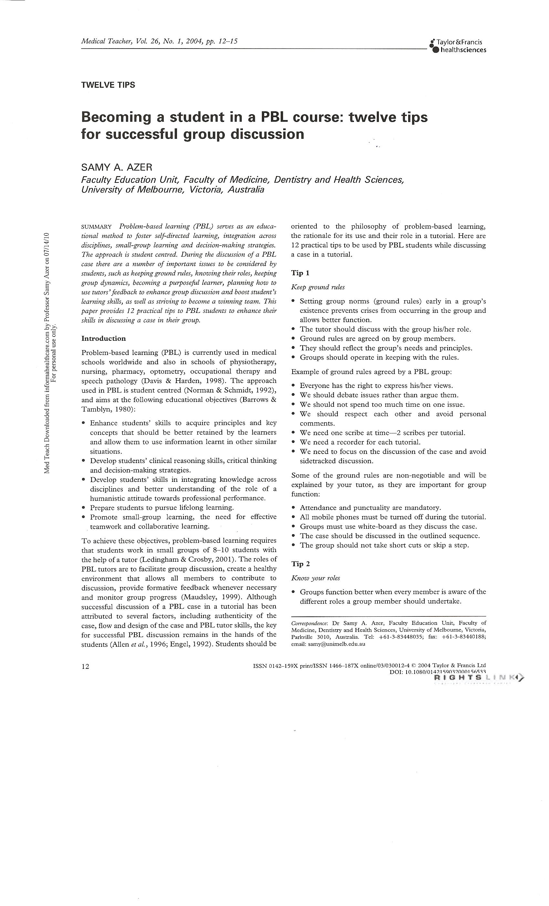
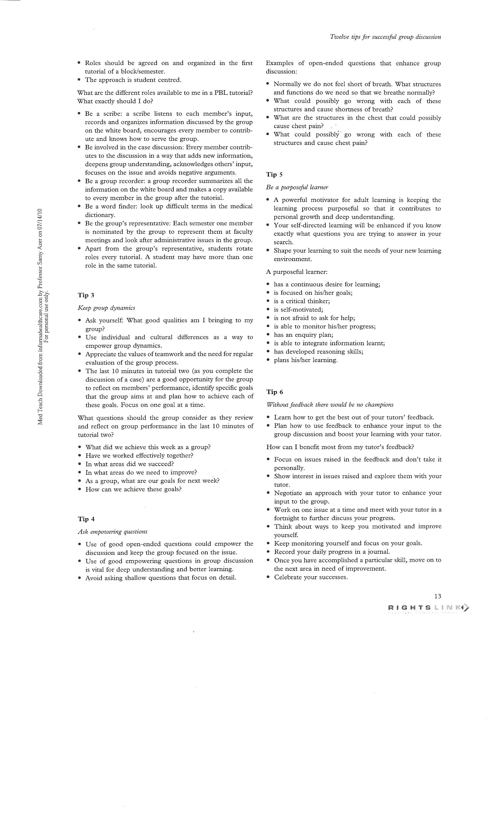
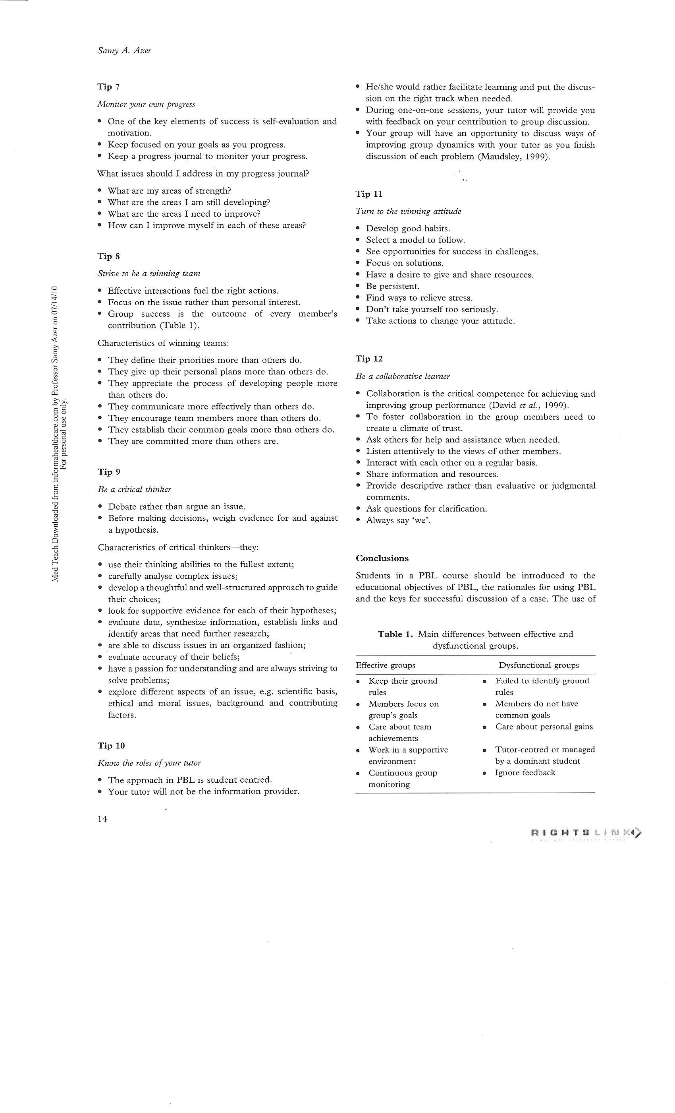
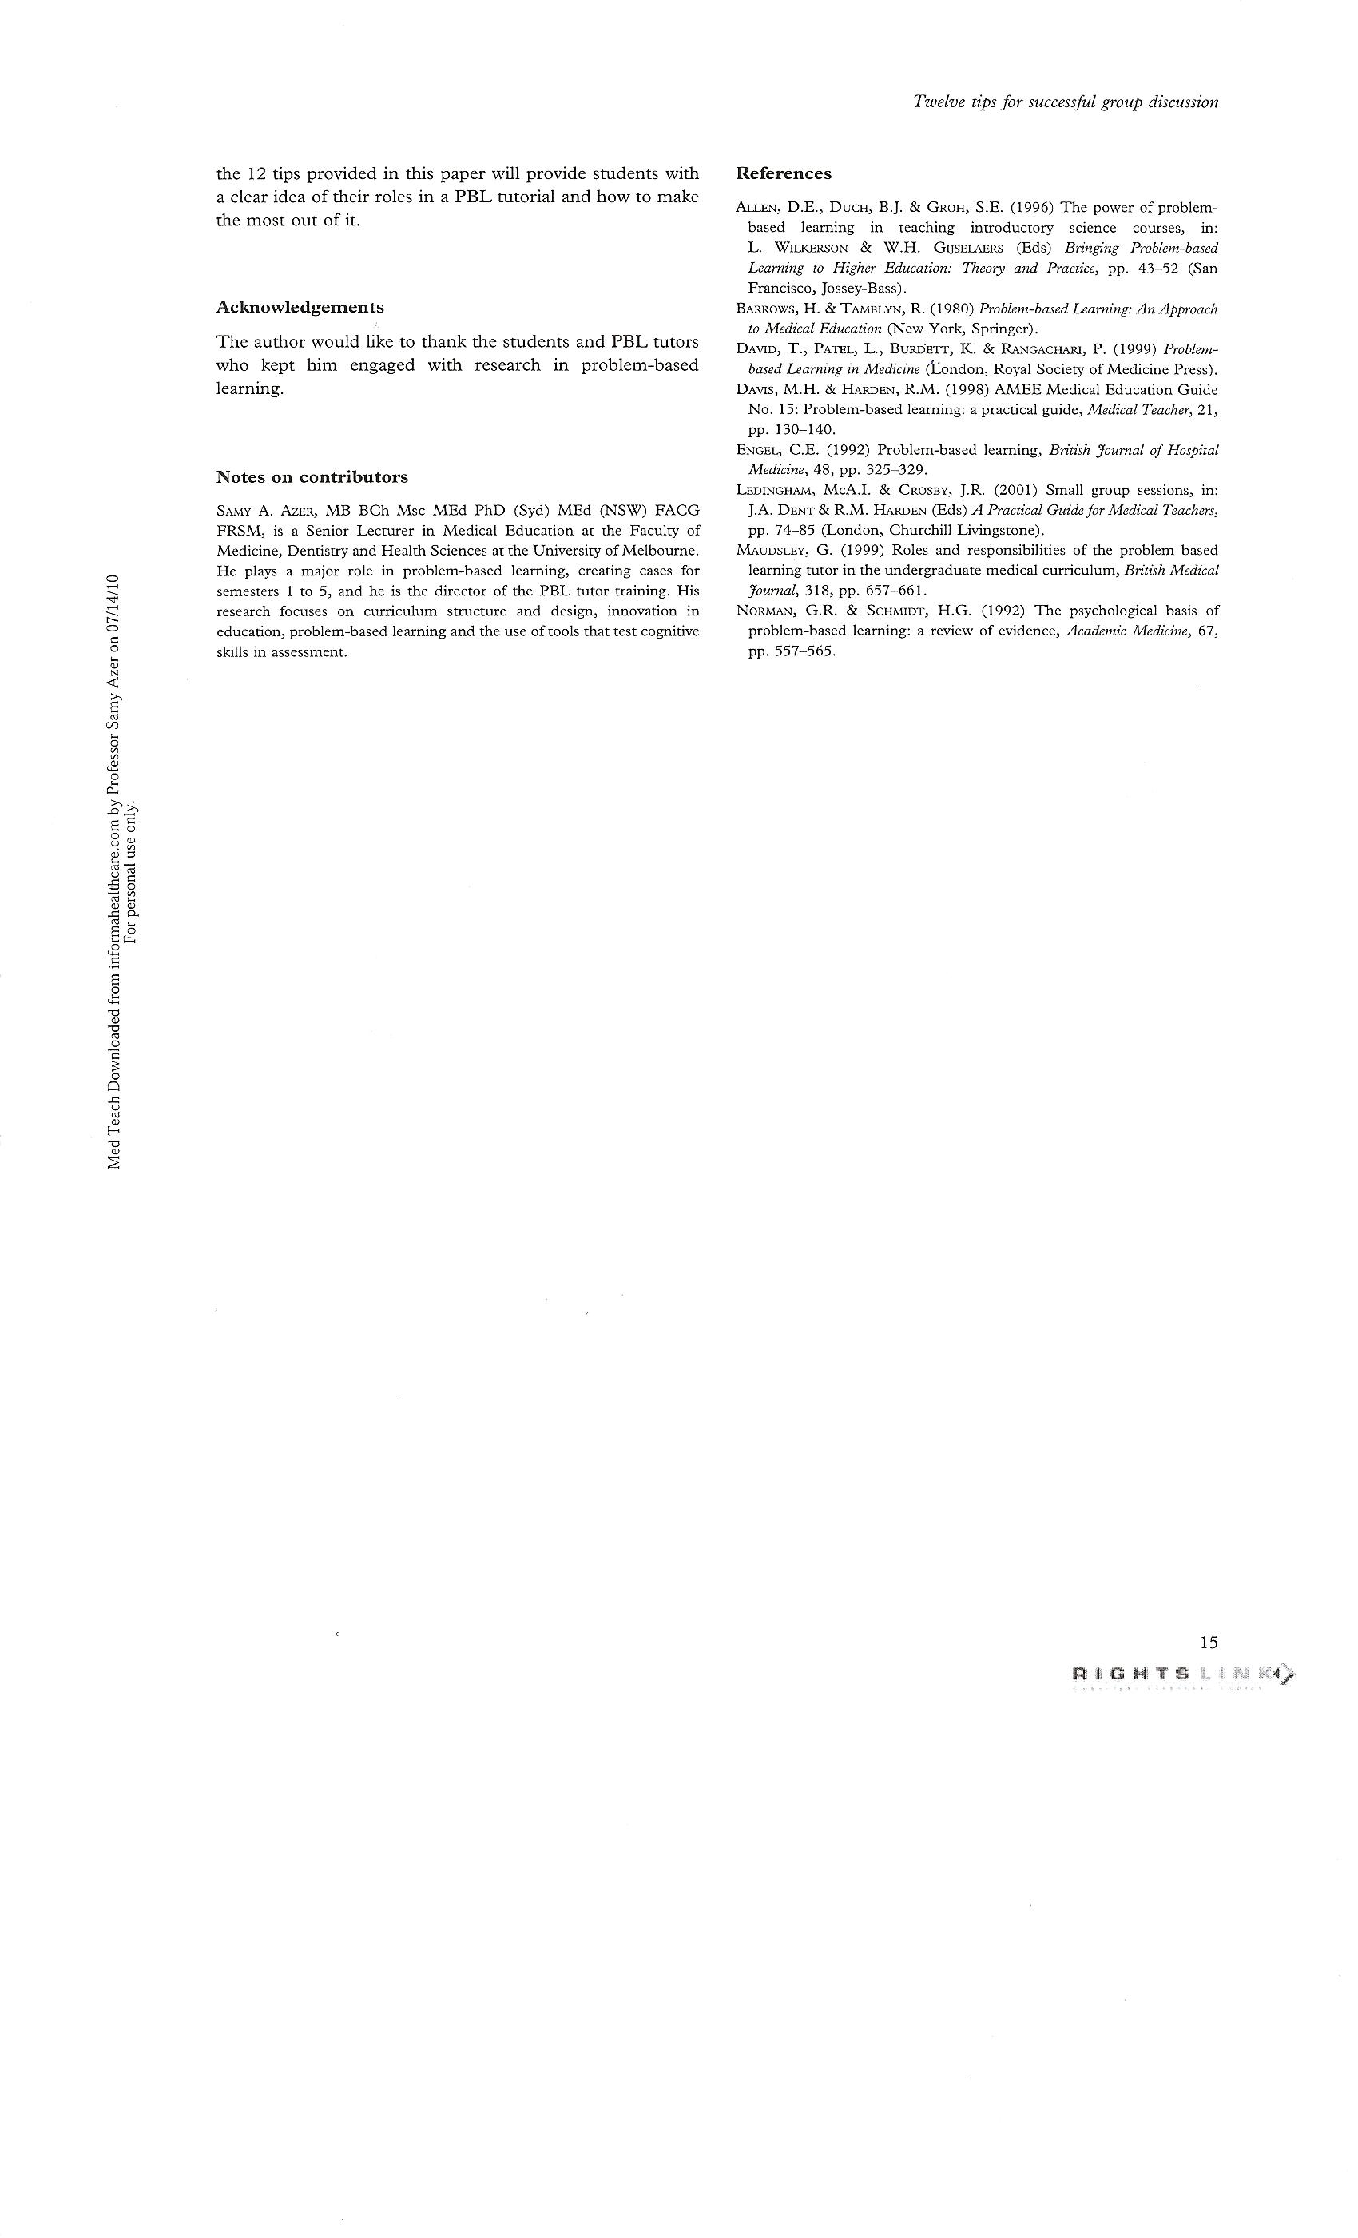
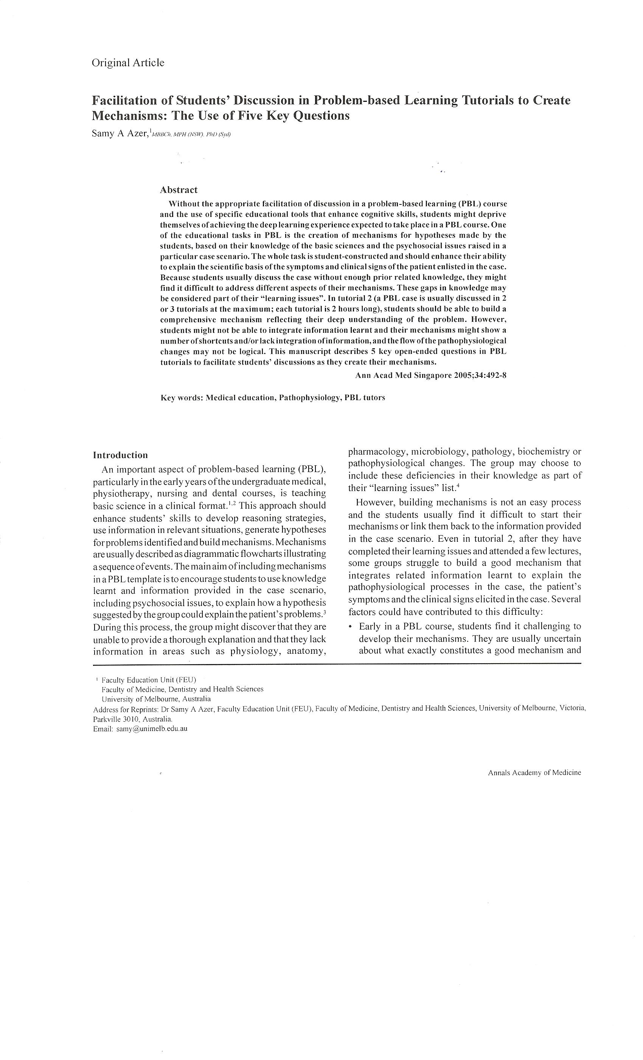
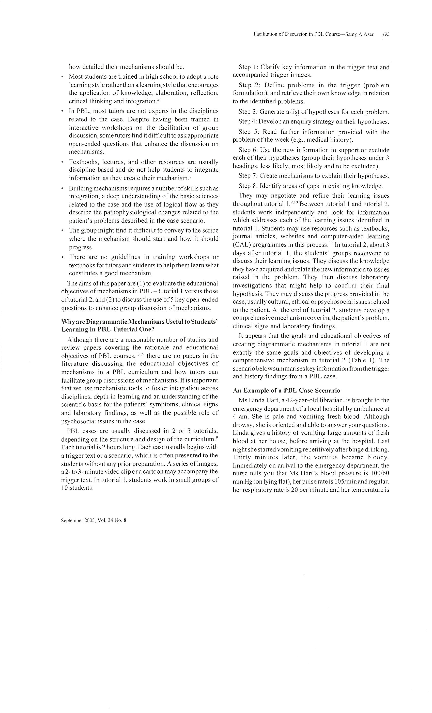
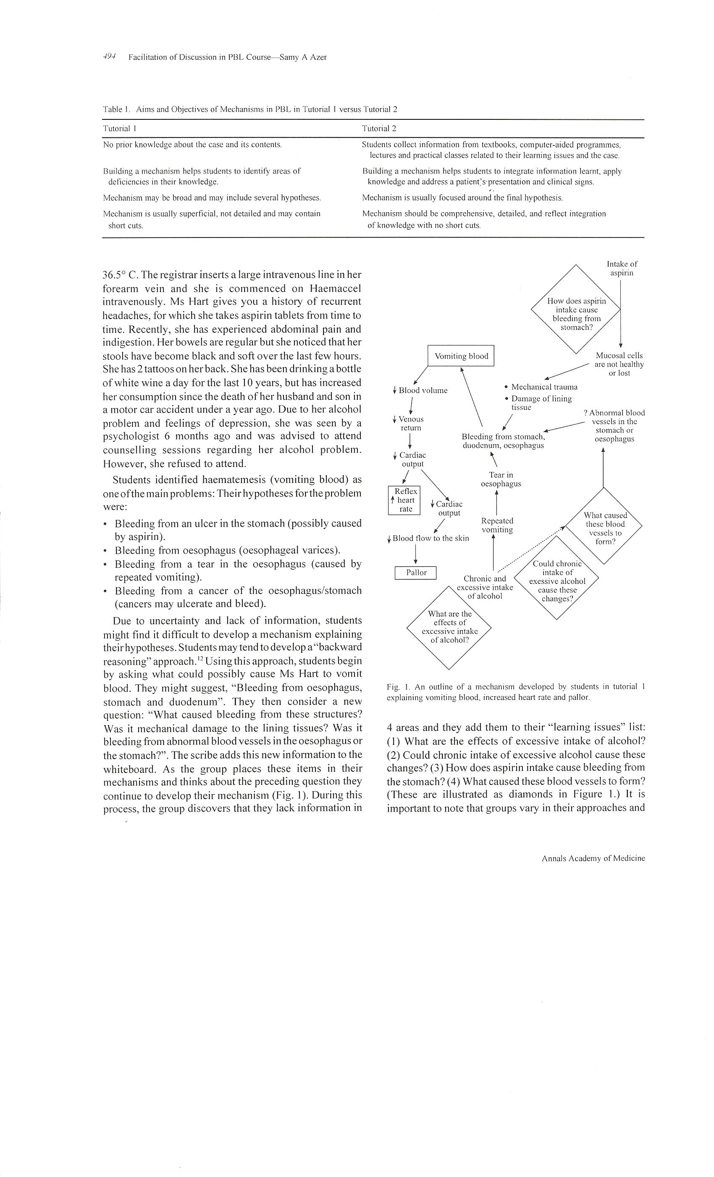
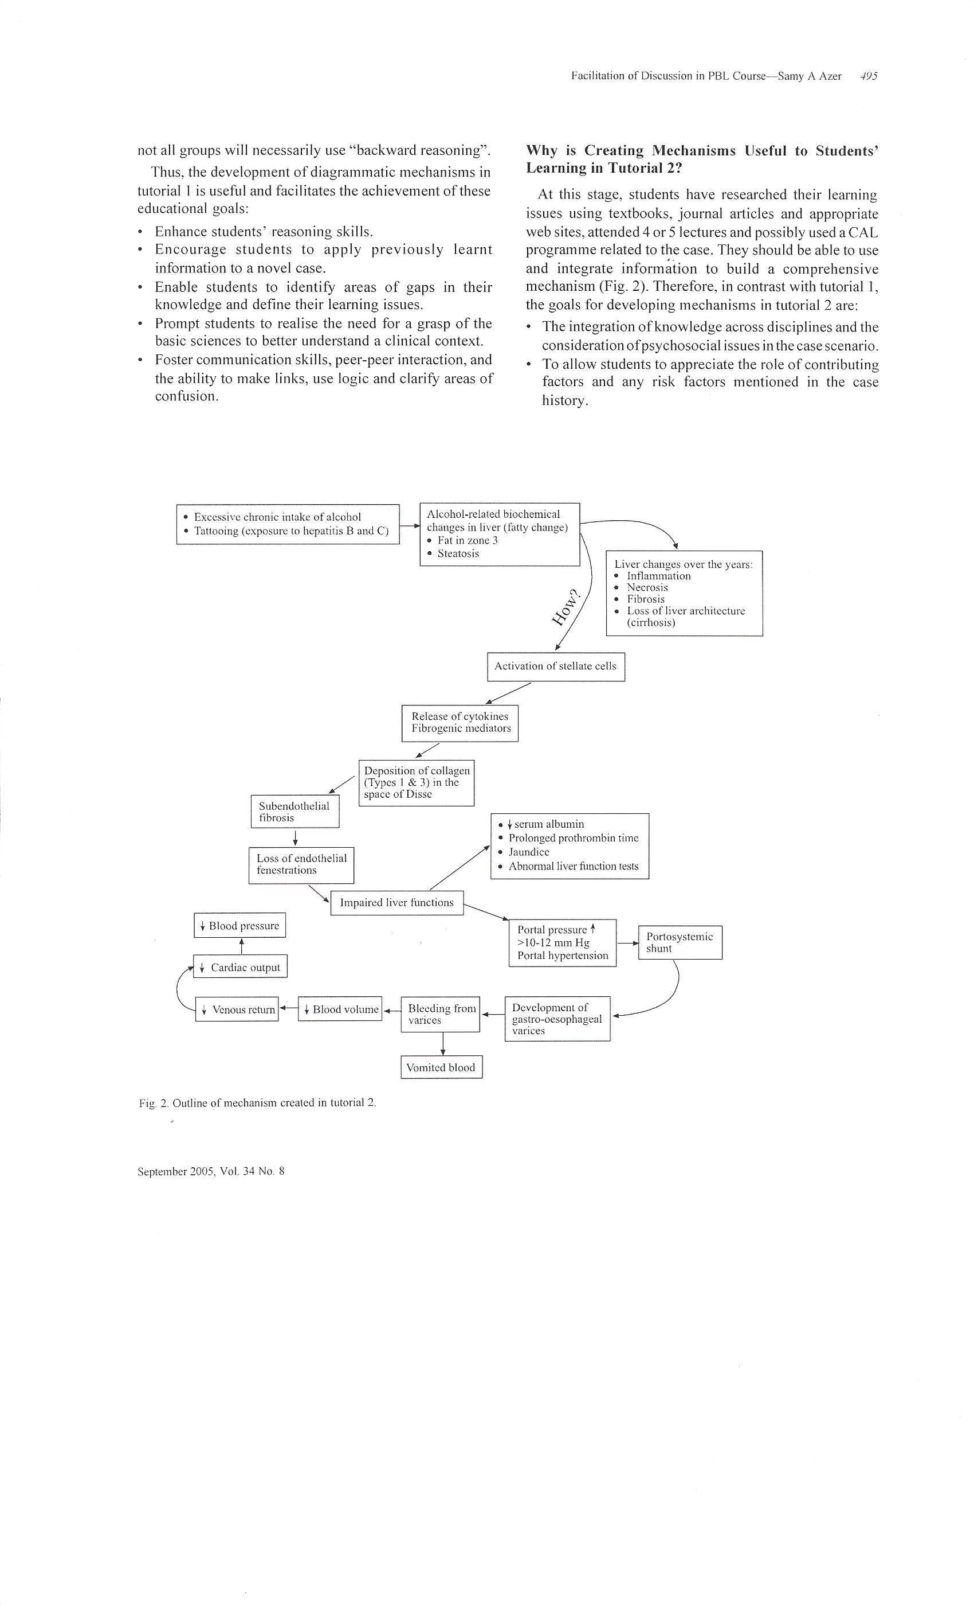
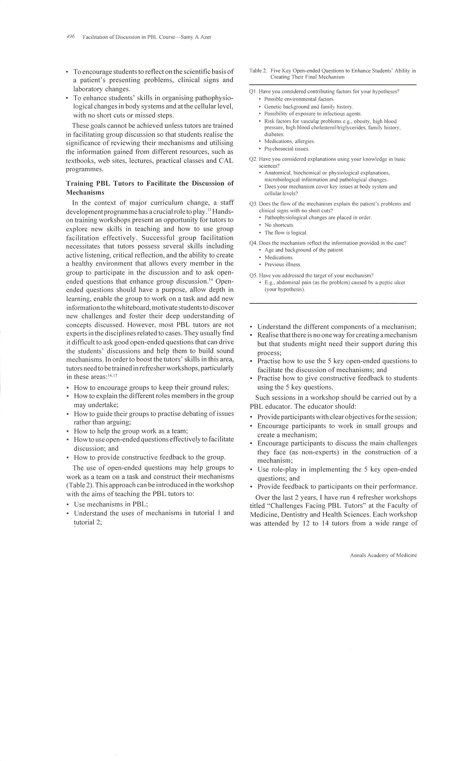
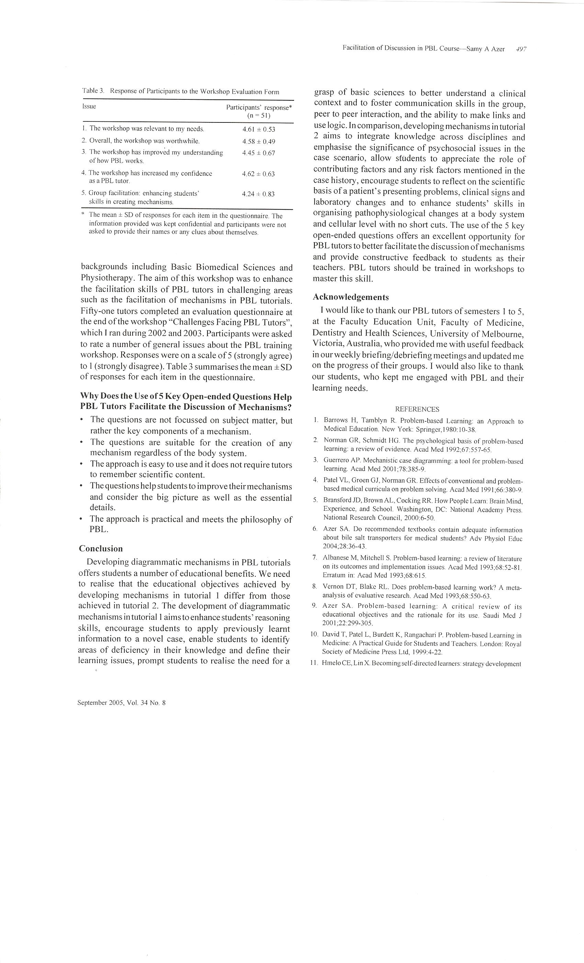

King Saud University
College of Medicine
Medical Education Department

