Malabsorption syndromes
Definition:
Chronic diarrhea with increased fecal excretion of fat (called steatorrhea) with concurrent deficiencies of fat-soluble vitamins, minerals, carbohydrates, and proteins may also occur
Malabsorption may be caused by disorders of:
• intraluminal digestion—assisted by, for example, gastric juices and pancreatic digestive enzymes (these are necessary for breakdown of macromolecules)
• intraluminal solubilization—liver secretes bile acids required for solubilization and absorption of fats
• terminal digestion—enzymes located on the brush border of the small intestinal mucosa hydrolyse large molecules for absorption, especially complex sugars (e.g. sucrase for sucrose and lactase for lactose)
• transepithelial transport—mucosa is specialized for absorption. Transverse mucosal folds and finger-like villi provide a vast surface area.
Systemic effects of the malabsorption syndromes:
• Weight loss and anorexia
• Abdominal distension and borborygmi (increased bowel sounds)
• Diarrhoea (loose, bulky stools)
• Steatorrhoea—malabsorption of fat, producing pale, foul-smelling stools that characteristically float in water
• Muscle wasting

Classification of malabsorption syndromes

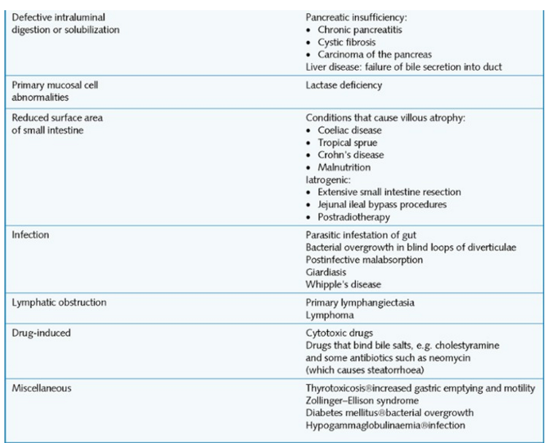

Coeliac disease
This is caused by a chronic inflammatory response to the protein gliadin, a component of gluten (found in wheat, oats, barley and rye). Atrophy of small intestinal villi and crypt hyperplasia are the result. It affects about 1 per 1000 in most Caucasian populations of Western Europe; it is rare in other ethnic origins.
It can present at any age but it is an important cause of failure to thrive in infants and children.
Antigliadin antibodies are present in the majority of cases, although anti-endomyseal antibodies have a greater sensitivity and specificity as a diagnostic aid. Other tests that may be used are small-bowel biopsy and a gluten challenge, in which symptoms improve on a gluten-free diet, but relapse once this is stopped.
There is an increased incidence of disease in first-degree relatives of those affected. It sometimes occurs concurrently with dermatitis herpetiformis (itchy, blistering skin disease).

A characteristic itchy, blistering skin lesion, dermatitis herpetiformis, can be present in as many as 10% of patients.
Macroscopically, the luminal surface becomes flattened, developing a mosaic-like pattern of crypt openings
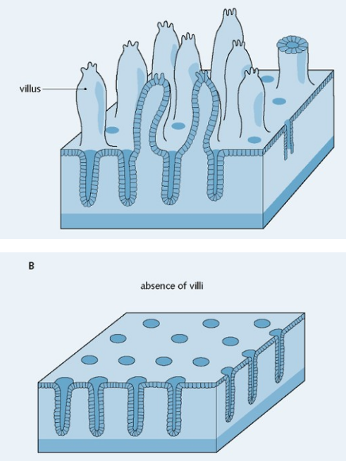
Microscopically there is:
- mucosal inflammation with lymphocytic infiltration
- loss of villous architecture ranging from blunting (partial villous atrophy) to complete flattening (total villous atrophy) due to a high rate of cell loss
- increase in the depth of crypts with epithelial cell hyperplasia to compensate for those lost through damage.
Long-term complications are:
- chronic ulceration of the small intestine—may lead to strictures
- development of primary T-cell lymphoma of the small intestine
- development of adenocarcinoma (rare).
Management is by the complete withdrawal of gliadin from the diet (i.e. a gluten-free diet), which leads to gradual recovery of the villous structure. This may be partial or complete.

Tropical sprue
This chronic and progressive malabsorption syndrome without a definable cause is seen in patients who live or have lived in the tropics, and in the absence of other intestinal disease or parasites. The disease occurs mainly in the West Indies and Asia.
Aetiology is unclear; however, the condition is thought to be infective, probably toxigenic Escherichia coli.
Clinical features and histological appearances resemble those of coeliac disease. However, a gluten-free diet has little beneficial effect.

Whipple disease
Whipple disease is a multisystem disorder involving malabsorption, weight loss, lymphadenopathy and joint pain. The causative agent is the Gram-positive bacillus Tropheryma whippelii. This rare condition is characterized by tissue infiltration with foamy macrophages that are periodic acid-Schiff (PAS) reagent positive.

Bacterial overgrowth syndrome
In this syndrome, there is malabsorption secondary to excessive bacteria in the small intestine, usually the jejunum.
Causes of small intestinal bacterial overgrowth are:
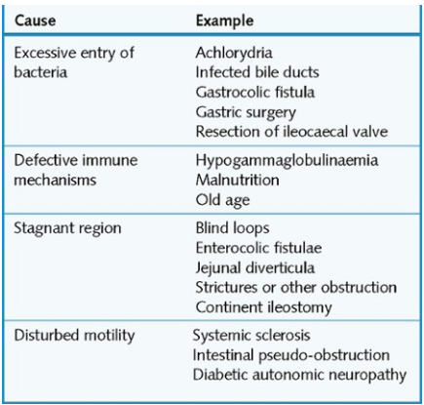
Malabsorption is as a result of:
- deconjugation of bile salts by the bacteria, hence steatorrhoea
- damage to the small intestinal mucosa, probably by bacterial products
- binding of vitamin B₁₂ by bacteria, hence vitamin B₁₂ deficiency.
Diarrhoea is both secretory (due to bacterial products affecting mucosa) and osmotic (due to unabsorbed products and deficiency of disaccharidases because of mucosal damage).
Clinical features are weight loss, diarrhoea and anaemia (due to vitamin B₁₂ deficiency).
Management is by antibiotic therapy and surgical resection for a localized abnormality, e.g. stricture, fistula.

Disaccharidase deficiency
The most important disaccharidase is lactase, which is essential for the digestion of milk sugar (lactose). All babies have lactase in their intestines but the enzyme disappears later in life in about 10% of northern Europeans, 40% of Greeks and Italians, and 80% of Africans and Asians. The presence of undigested lactose in the small intestine (following consumption of raw milk) causes diarrhoea and abdominal pain.

General screening tests for fat malabsorption:
- Quantitative stool for fat
72-Hour collection of stool
Positive test >7 g fat/24 hours
- Xylose screening test
Xylose does not require pancreatic enzymes for absorption.
Lack of absorption of orally administered xylose indicates small bowel disease
- Tests to evaluate pancreatic insufficiency
Serum Trypsin is specific for the pancreas.
Concentration is decreased in chronic pancreatitis and increased in early cystic fibrosis
- Tests for bile salt/acid deficiency
Total serum bile acids are decreased in liver disease (e.g., cirrhosis).
- Tests for bacterial overgrowth:
  - ¹⁴C-xylose: Most sensitive/specific test measures ¹⁴CO₂ in the breath
  - Lactulose-H₂ measures H₂ in the breath
  - Bile breath test (oral radioactive test): Radioactive cholylglycine is converted by bacteria into radioactive CO₂ which is increased in the breath.

