

**King Saud University**

**College of Medicine**

**Department of Pathology**

**Clinical Biochemistry Unit**

**Biochemistry Practical Class**

**Glucose Estimation**

**in BLOOD and URINE**

2017

**2nd Year, Endocrine System Block**



KING SAUD UNIVERSITY

College of Medicine

Department of Pathology

Clinical Chemistry Unit

**Endocrine Block**

**Biochemistry Practical**

Practical biochemistry sessions are designed to teach the fundamental techniques used in biochemistry to medical students. In this session the students will have hands-on training in estimating glucose in blood and urine. This will enable them to understand how biochemical data is collected, analyzed and interpreted.

**Plan of work:**

1. Handouts will be distributed and a presentation on glucose estimation in blood and urine will be given for 15 minutes.
2. Hands-on practical session using the Glucometer and wet practical will be conducted following the presentation.

**Measurement of Blood Glucose Level Using Glucometer**



**Instructions:**

1. Attach the test tip to the glucometer as shown above.

2. The meter will read “OK” indicating that it is working properly.

3. Disinfect your fingertip using an alcohol swab. Let it dry.

4. Prick the finger using the lancing device.

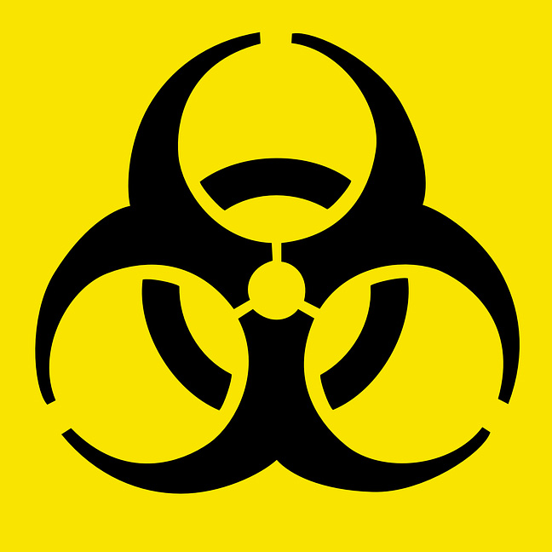**BIOHAZARD! The lancet in the lancing device is for single use only. Discard it after use.**

5. Draw up blood until the glucometer beeps.

6. Wait for 10 seconds until results are displayed.

7. Results can be read as mmol/L or mg/dL.

8. Interpret your results.

**Estimation of Glucose in Urine (using dipstick):**

**Principle:**

* Dipsticks are plastic strips impregnated with chemical reagents that react

with specific substances in the urine to produce color-coded visual results.

* They provide quick determination of pH, protein, glucose and ketones.
* The depth of color produced is directly proportional to the concentration

of the substance in urine.

* Color controls are provided against which the actual color produced by the urine sample can be compared. The reaction times of the impregnated chemicals are standardized.

**Procedure:**

* Dip the dipstick in the urine sample provided and remove it immediately.
* Wipe off the excess urine and keep the strip in a horizontal position.
* Read the color produced within 30-60 seconds (Color changes after 2 minutes are of no significance).
* Match the color changes to the color scale provided.

**Test Results and Interpretation**

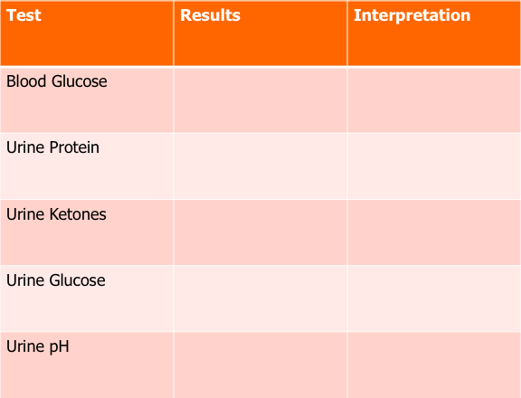

**American Diabetes Association Criteria**

**for the Diagnosis of Diabetes (2017)**

