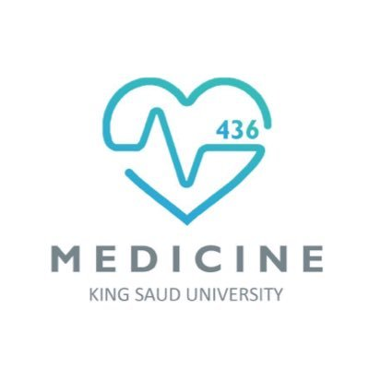
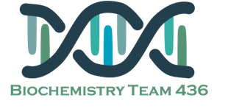
Biochemistry team flash cards
Vitamin A Alzheimer disease

Vitamin A sources are divided into 2 parts:
- Animal source (preform):
Which are called “Retnoids”:
1-Retinol 2-retinal or retinaldehyde
3-retinoic acid.
- Planet source (provitamin):
Beta- carotene

Biochemical markers correlated to degree of dementia include:
1-Loss of choline acetyltransferase
2-Synaptophysin immunoreactivity
3-Amyloid burden

Excessive amount of Vitamin A leads to toxicity, decreasing leads to multiple diseases and severe decrease leads to blindness.
Rhodopsin and Iodopsin are light sensitive pigments
Vitamin A is stored in the liver as Retinyle palmitate.

The Microscopic findings of Alzheimer’s disease are:
1- Neuritic Plaques:
The dominant component of the plaque core is Aβ, a peptide derived from a larger molecule, amyloid precursor protein (APP)
2- Neurofibrillary tangles: which contains TAU protein.
3- Amyloid Angiopathy.

Dark adaptation time
The time required to synthesize rhodopsin in the dark.

Pathogenesis of cerebral infarction
The brain is highly susceptible to ROS- induced damage because of
1-High concentrations of peroxidisable lipids
2-Low levels of protective antioxidants
3-High oxygen consumption
4-High levels of iron (acts as pro-oxidants under pathological conditions)
5-The occurrence of reactions involving dopamine & Glutamate oxidase in the brain

Biochemistry team flash cards FINAL
Vitamin B6 & B12 Cerebrospinal fluid

Blood & Hemoglobin pigments in CSF:
A-Traumatic tap: 1-Bright red color.
2-RBCS in decreasing number as the fluid is sampled
B-Subarachnoid hemorrhage (SAH):
Xanthochromia (hemoglobin breakdown pigments) = RBCs lysis & metabolism previously occurred (at least 2 hours earlier)

In viral meningitis CSF [glucose] is usually normal
↓CSF [glucose]:
A-Disorder in carrier-mediated transport:
e.g. TB meningitis, sarcoidosis
B-Active metabolism of glucose by cells or organisms:
e.g. acute purulent, amebic, & fungal meningitis
C-Increased metabolism by the CNS:
e.g. by CNS neoplasm

Forms of Vitamin B12:
1-Cyanocobalamine 2-Hydroxycobalamine
3-Adenosylcobalamine 4-Methylecobalamine
Cobalamin is essential for:
1-RBC maturation 2- normal nervous system function

Reaction that requires Vitamin B12:
1-Methylmalinyl- CoA mutase which helps in:
Conversion of methylmalonyl-CoA to Succinyle CoA.
2-Methionase Synthase which helps in:
Conversion of homocysteine to methionine.

Homocysteine re-methylation reaction is the only pathway where N₅-methyl TH4 can be returned back to tetrahydrofolate pool

The active form of Vitamin B6 is Pyridoxal phosphate.
Isoniazid treatment of TB causes Vitamin B6 deficiency.

