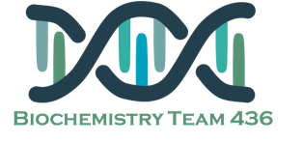Biochemistry team flash cards

Sphingolipidoses

Niemann-pick disease :

The deficient enzyme:

**Sphingomyelinase**

The accumulated lipid

**Sphingomyelin**

**Clinical features :** It has two types (A & B)

A : Fatal disease where enzyme activity is reduced

B : “Chronic” less severe and has later onset

Sphingolipidoses

Tay-sachs disease :

The deficient enzyme:

**β-Hexosaminidase (α subunit)**

The accumulated lipid

**Gangliosides (Gm2)**

**Clinical features :** Blindness, muscular weakness & seizures .

Sphingolipidoses

Gaucher disease :

The deficient enzyme:

**β-glucosidase (glucocerebrosidase)**

The accumulated lipid

**Glucocerebrosides**

**Clinical features :** Hepatosplenomegaly, Osteoporosis of long bones and some other features

Sphingolipidoses

Lysosomal lipid storage diseases ,, When the degradation of specific sphingolipid is defected it accumulates at the organ

Usually only a single sphingolipid accumulates in the involved organs in each disease

Sphingolipidoses

Diagnosed by :

1. **measuring the enzyme activity** :

Cultured fibroblasts or peripheral leukocytes Cultured aminocytes ( Prenatal )

2. **Histological examination**

3. **DNA analysis**

Myelin

Composed mostly of lipids and some proteins ..

Produced by

Schwann cells in **peripheral nerves**.

Oligodendrocytes **within CNS**.

Sphingolipids

Is essential component of membranes and plays a role in growth regulation and cell transformation.

Sphingosine is the backbone of sphingolipids