Cell injury

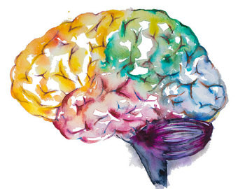

Objectives:
1- Understand the role of the different constituents of Central nervous system (CNS) cells in the disease status.
2- Understand the “injury” concept.
3- Explain the basic pathological descriptive terms used in CNS cellular injury.
3- Correlate the different patterns of cellular injury with some important clinical examples.
4- Understand the concept of reaction of neurons, astrocytes and other glial cells to injury.
5- Recognize the axonal injury in both CNS and Peripheral nervous system as well as the consequences and the pathological findings.

Black: Doctor’s slides.
Red or black bold: important!
Green: Doctor’s notes.
Grey: Extra.
Italic black: New terminology.

Key principles to be discussed:
The definition of and an example for each of the following terms:
1- Markers of CNS Neuronal Injury: Acute neuronal injury, red neurons, intracellular
inclusions and dystrophic neurites.
2- Cerebral edema, definition and types.
3- Marker of Axonal injury: CNS - spheroids and central chromatolysis, Peripheral nervous
system- Wallerian degeneration and segmental demyelination.
4- Marker of Astrocytes reaction to injury: gemistocytic astrocytes, fibrillary astrocytes,
Rosenthal fibers and Corpora amylacea.
5- Other cells reaction to injury: Oligodendrocytes, Ependymal and Microglia (microglial
nodules and neuronphagia).

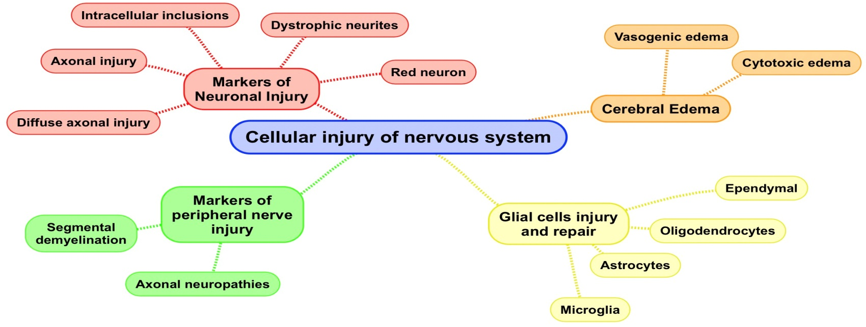
Lecture outlines:

- Markers of Neuronal Injury:
1- Red neuron: RED NEURON is an feature of ischemia.
Within 12 hours of an irreversible hypoxic/ischemic insult, acute neuronal injury becomes evident even on routine hematoxylin and eosin (H & E) staining which shows:
⦁ Hypoxic: not enough oxygen coming to the brain. ⦁ Ischemic: Decrease (not stop) of blood supply.
A. Shrinkage of the cell body.
B. Pyknosis of the nucleus.
C. Disappearance of the nucleolus.
In case of stroke, the brain tissue react to show different features, at the beginning maybe nothing > then edema > then within 12 hours we’ll have Red neuron.

D. Loss of Nissl substance. Which we usually see it in cytoplasm.
E. Intense eosinophilia of the cytoplasm ("red neurons“).
Why do we call it red neurons? Because when we do the hematoxylin and eosin H&E staining, the organelles which will be condensed they will not take the blue (the hematoxylin ), they take the eosin which is red. That’s why we call it “eosinophilia”, philia means there is chemistry between them.
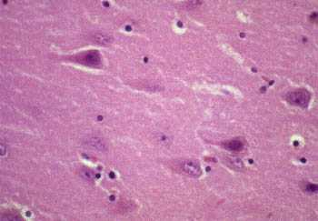
- Acute injuries typically result in breakdown of the blood-brain barrier and variable degrees of cerebral edema.

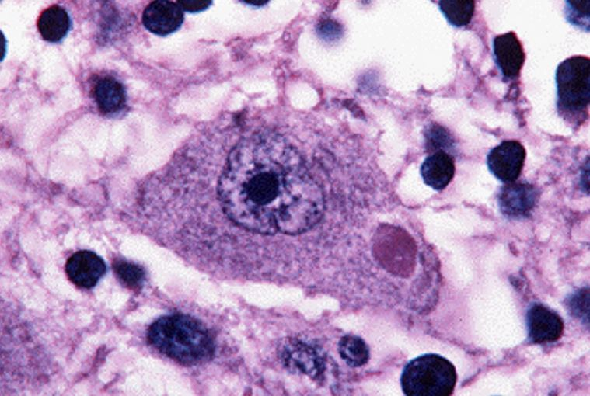
2- Intracellular inclusions: is an example of cell reaction to an injury.
Nuclear or cytoplasmic aggregates of stainable substances usually proteins.
Example: Negri bodies in rabies.

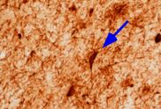
3- Dystrophic neurites:
A neurite refers to any projection from the cell body of a neuron.
This projection can be either an axon or a dendrite. Dystrophic neurites is Not inflammation Example: Alzheimer disease.

- In some neurodegenerative diseases, neuronal processes become thickened and tortuous; these are termed dystrophic neurites.

4- Axonal injury:
Injured axons undergo swelling (called spheroids) and show disruption of axonal transport.
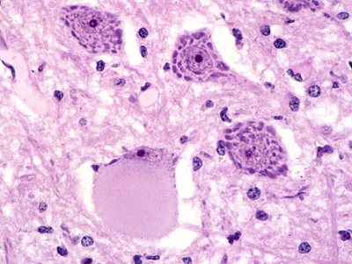
Evidence of injury can be highlighted by silver staining or immunohistochemistry for axonally transported proteins such as amyloid precursor protein.
- Axonal injury also leads to cell body enlargement and rounding, peripheral displacement of the nucleus, enlargement of the nucleolus (remember! Here is the difference in red neurons it disappears), and dispersion of Nissl substance (from the center of the cell to the periphery, so-called central chromatolysis).
Spheroids are detected in axons. Chromatolysis is detected in cell body.

5- Diffuse axonal injury:
Diffuse axonal injury (DAI) because of trauma can lead to coma. (May be associated with blood in brain and may not).

As many as 50% of patients who develop coma shortly after trauma, even without cerebral contusions, are believed to have white matter damage and diffuse axonal injury. ‘Both’

How diffuse axonal injury happens?
For example if someone got in a very strong car accident, the brain will go and come back rapidly and hits the skull, this movement will cause the diffuse injury.

Widespread injury to axons within the brain can be very devastating.
The movement of one region of brain relative to another is thought to lead to the disruption of axonal integrity and function.

Diffuse axonal injury is characterized by the wide but often asymmetric distribution of axonal swellings that appears within hours of the injury and may persist for much longer.
Some areas may be affected more than others, depending on what? جهة الصدمة (من حادث مثلاً) يمين أو يسار.

- These are best demonstrated with silver stains or by immunohistochemistry for proteins within axons.
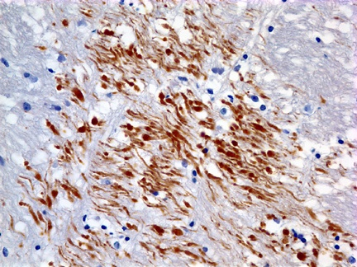
Immunostains with antibodies to Beta Amyloid Precursor Protein (BAPP) can detect the axonal lesions in 2-3 hours after the injury (diffuse axonal injury)

If the immunostain is positive = brown color. If the immunostain negative = blue color. *positive when we have BAPP*
- BAPP: Is a normal protein in the body but here it’s congested due to injury.

How to differentiate between the silver stain (or any stain) and the immunohistochemistry?
Immunohistochemistry (IHC) involves the process of selectively imaging antigens (e.g. proteins) in cells of a tissue section by exploiting the principle of antibodies binding specifically to antigens in biological tissues.
ويبيّن الـcoloration اللي حطيناها معه. بينما الـStain هي صبغه بتصبغ فقط.

- Cerebral Edema:
Is the accumulation of excess fluid within the brain parenchyma.
- Two types, which often occur together particularly after generalized injury:
A) Vasogenic edema: Related to blood vessels. | B) Cytotoxic edema: Due to infection, tumor, toxins.
The integrity of the normal blood-brain barrier is disrupted, allowing fluid to shift from the vascular compartment into the extracellular spaces of the brain.  - It can be either localized (e.g., increased vascular permeability due to inflammation or in tumors) or generalized. | An increase in intracellular fluid secondary to neuronal and glial cell membrane injury, as might follow generalized hypoxic-ischemic insult or after exposure to some toxins.

Edema: Increase volume in the brain > Herniation > It will go and compress the brainstem > *what do we have in brainstem? Reticular formation in midbrain* Respiratory and cardiovascular areas will be affected > Cardiac respiratory arrest.
So, we have to open the brain immediately (فتحة صغيرة بس عشان يطلع الدم, مو كل الراس ) to make the blood go out and save her\his life. There is No time for investigations because He\She will be dead by that time.

- Astrocytes in Injury and Repair: All glial cells react with GFBA stain.
Astrocytes are the principal cells responsible for repair and scar formation in the brain, a process termed gliosis.
- In response to injury:

  - Astrocytes undergo both hypertrophy and hyperplasia.
  - The nucleus enlarges and becomes vesicular, and the nucleolus is prominent.
  - The previously scant cytoplasm expands to a bright pink, somewhat irregular swath around an eccentric nucleus, from which emerge numerous stout, ramifying processes (gemistocytic astrocyte).
  - In settings of long-standing gliosis, astrocytes have less distinct cytoplasm and appear more fibrillar (fibrillary astrocytes).
There is minimal extracellular matrix deposition: Unlike the repair after injury elsewhere in the body, fibroblasts participate in healing after brain injury only to a limited extent (usually after penetrating brain trauma or around abscesses).
Do we have fibrosis in the brain? No. There’re two situations where you can have fibrosis in the brain: 1) Penetrating injury > surgery in the frontal lobe. 2) Abscess > because of the destruction of blood-brain barrier.

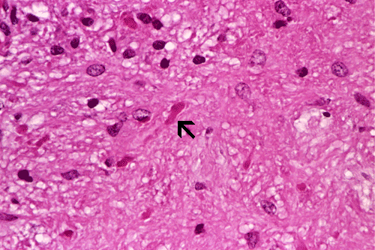
Rosenthal fibers are thick, elongated, brightly eosinophilic protein aggregates that can be found in astrocytic processes in chronic gliosis and in some low-grade gliomas. Which tumor exhibits Rosenthal fibers? Pilocytic astrocytoma.

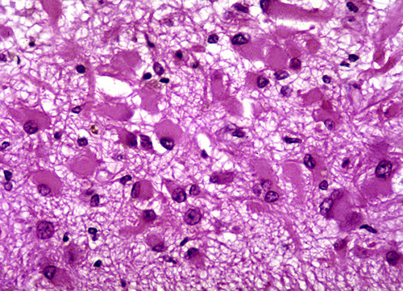
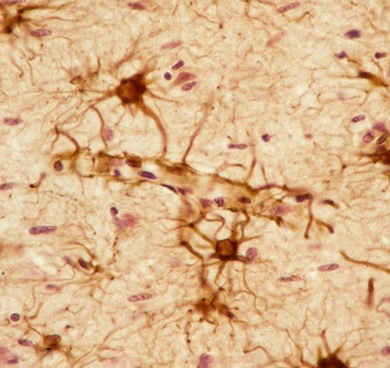
It looks like tumer! So how do we differentiate? we have to know the history of the patient.

Glial fibrillary acidic protein (GFAP) ‘immunostain’
Gemistocytic gliosis

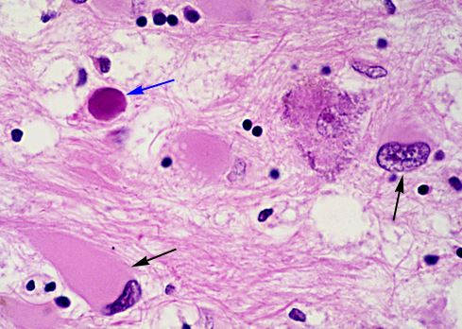
- Oligodendrocytes in Injury and Repair:
- Produce myelin.

- Exhibit a limited spectrum of specific morphologic changes in response to various injuries.

- In progressive multifocal eukoencephalopathy, viral inclusions can be seen in oligodendrocytes, with a smudgy, homogeneous-appearing enlarged nucleus.

- Ependymal cells in Injury and Repair:
- Line the ventricular system and the central canal of the spinal cord.

- Certain pathogens, particularly cytomegalovirus (CMV), can produce extensive ependymal injury, with typical viral inclusions. Choroid plexus is in continuity with the ependyma, and its specialized epithelial covering is responsible for the secretion of cerebrospinal fluid (CSF).
- Microglia in Injury and Repair:
- Bone marrow-derived cells
- Function as the phagocytes of the CNS
- When activated, they proliferate and become more evident
- They may be recognizable as activated macrophages in areas of:

    - Demyelination.
    - Organizing infarct.
    - Hemorrhage.
    - They develop elongated nuclei (rod cells) in neurosyphilis or other infections.
- When these elongated microglia form aggregates at sites of tissue injury, they are termed microglial nodules.
- Similar collections can be found congregating around portions of dying neurons, termed neuronophagia (e.g. viral encephalitis).
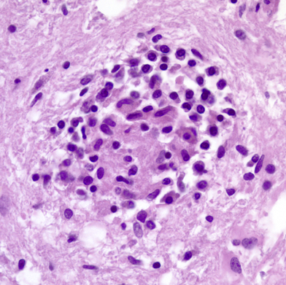
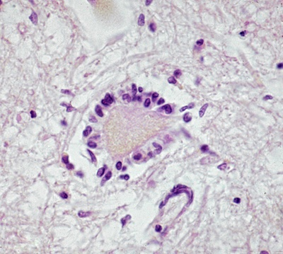

Microglial nodule
Neuronophagia

- Markers of peripheral nerve injury:
Most peripheral neuropathies can be subclassified as either axonal or demyelinating, even though some diseases exhibit mixed features.

1- Axonal neuropathies:
Dr. Hala: مهم تفرّقون بين Wallerian degeneration and Segmental demylination.
  - Caused by insults that directly injure the axon.
  - The entire distal portion of an affected axon degenerates. (كيف تحفظون انه ديستال؟ لأنه باختصار لما يصير له ريجنريشن لازم الأساس اللي هو البروكسيمال يكون موجود و يرجع يعوض الجزء اللي انفقد اللي هو الديستال).
  - Axonal degeneration is associated with secondary myelin loss a process sometimes referred to as Wallerian degeneration.
  - Regeneration takes place through axonal regrowth and subsequent remyelination of the distal axon.
  - The morphologic hallmark of axonal neuropathies is a decrease in the density of axons, which in electrophysiologic studies correlates with a decrease in the strength of amplitude of nerve impulses.

2- Segmental demyelination: سيقمنت منيح وسيقمنت مش منيح
  - Demyelinating neuropathies are characterized by damage to Schwann cells or myelin with relative axonal sparing, resulting in abnormally slow nerve conduction velocities. "هنا جالس يقولك انه المايلين يتكسر و لكن الآكسون يبقي مثل ما هو ، و من الطبيعي انه النوع الأول يكون الأكثر ضررا"
  - Demyelination typically occurs in individual myelin internodes randomly; this process is termed segmental demyelination.
  - Morphologically, demyelinating neuropathies show a relatively normal density of axons and features of segmental demyelination and repair recognized by the presence of axons with abnormally thin myelin sheaths and short internodes.
When the axon injured Myelin affected too. This degeneration called: Wallerian degeneration.
Axon here not affected.
Myelin injury
Axonal injury ‘worse’
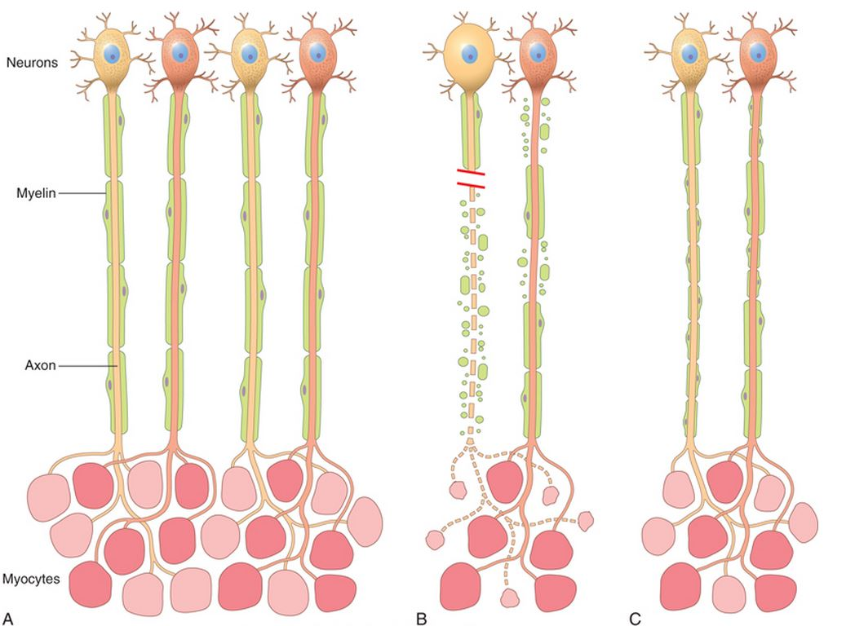

Injury

Regeneration
*Homework
- Define Corpora amylacea?
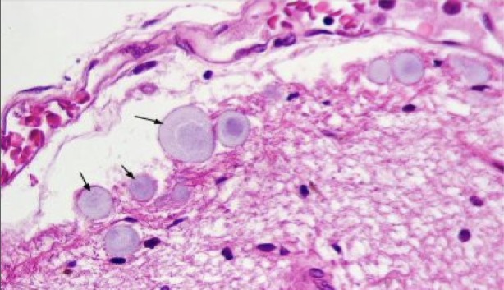
Corpora amylacea are small hyaline masses of unknown significance found in the prostate gland, pulmonary alveoli and neuroglia.
- Where and when they are deposited in the CNS?
In the brain, corpora amylacea are contained in foot processes of astrocytes and are usually present in subpial (under the pia matter) location and around blood vessels. They are derived from degenerate cells or thickened secretions and occur more frequently with advancing age. While their significance is unknown, they can be used to identify these organs microscopically.

*Questions:
Q1: When the injured axons undergo swelling it’s called?

A- Dystrophic neuritis. B- Central chromatolysis. C- Spheroids. D- Negri bodies.

(C) Is the correct answer.

Q2: In astrocyte injury, the nucleolus is:
A- Prominent. B- Unaffected. C- Disappeared. D- Enlarged.
(A) Is the correct answer.

Q3: Normally, astrocyte’s cytoplasm is……….., during injury it becomes…………?

A- Abundant, less. B- Scarce, even less. C- Scant, expand. D- None of the above.

(C) Is the correct answer.

Q4: Rosenthal fibers can be found in:
A- Chronic gliosis. B- Low-grade gliomas. C- Multifocal eukoencephalopathy. C- Both A & B.
(D) Is the correct answer.

Q5: Oligodendrocytes is responsible to produce ………?
A- Myelin in CNS. B- Myelin in PNS. C- Both.
(A) Is the correct answer.

Q6: The termed referred to a collection of microglial cells found congregating around portions of dying neuron in:
A- Microglial nodules. B- Neuronophagia.
(A) Is the correct answer.

Q7: Ependymal cells line in …..
A- Central canal & ventricular system. B- Bone marrow. C- Both.
(A) Is the correct answer.

Q8: The morphological part of axonal neuropathies?
A- Increase in density of axons. B- Decrease in dencity of axons.
C- Increase in axonal velocity. D- Decrease in axonal velocity.
(B) Is the correct answer.

Q9: What is the significance of Corpora amylacea?
A- They Enhance the neuron’s function.
B- They are used to identify the organs they grow on microscopically.
C- They calcificate and cause further impairment of the neurons.
(B) Is the correct answer.

Q10: Axonal degeneration that is associated with secondary myelin loss is called?
A- Kaplin’s degeneration. B- Wallerian’s degeneration.
C- Henry’s degeneration. D- Secondary degeneration.
(B) Is the correct answer.
Marks of neurological injury
Summary
*indicated to : acute neuronal injury (breakdown of BBB)  *due to : ischemic insult  * detected by : ( H and E ) staining  * morphological changes : cell bode shrinkage – nucleus pyknosis  Disappearance – Nissl substance loss –eosinophilic cytoplasm nucleolus |  |  |  | Red neuron
*consist of : protein (usually )  * found in : nucleus or cytoplasm  *EX: Negri bodies |  |  |  | Intracellular inclusion
Refers to : thickened and tortuous process *  *due to : neurodegenerative diseases |  |  |  | Dystrophic neuritis
*detected in axon : spheroid ( swelling of axon )  * detected in cell body : chromatlysis ( dispersion of Nissl substance )  * detected by : silver stain + immunohistochemistry to BAPP |  |  |  | Axonal injury
*caused by : trauma  *may lead to : coma  * becomes worse when : involves brain axons  Associated with white matter damage * |  |  |  | Diffuse axonal injury
Cerebral edema
Cytotoxic |  | Vasogenic
*defect in : neuronal or glial cell membrane  *fluid found in : Intracellular spaces |  | *defect in : BBB  *fluid found in : extracellular spaces
Astrocytes injury and repair (responsible for repair in brain)
Morphological changes | In response to injury
*(acute ) : gemistocytic astrocytes.  * ( long standing gliosis): Fibrillary astrocytes  * detected by : immunostain for GFAP | *undergo: hypertrophy and hyperplasia  *participation of fibroblast : limited  * exhibition of : Rosenthal fibers
Oligodendrocytes injury
* due to : progressive multifocal leukoencephalopathy
* exhibition of : viral inclusion + homogeneous enlarged nucleus
Ependymal cells injury
*due to : cytomegalovirus infection
* exhibition of : viral inclusion
Microglia in injury ( activated microglia )
* proliferate
* develop rod cells :
1) microglial nodules ( at the site of tissue injury )
2) neuronophagia (around portions of dying neuron )
Peripheral nerve injury
Segmental demyelination |  |  | Axonal neuropathy
*due to : damage of Schwan cells or myelin *associated with : segmental demyelination + normal density of axon |  |  | *due to: injury of axon  * associated with : wallerian degeneration + regeneration + decrease in density of axon  *Diagnosed by : electrophysiological studies
Remyelination in both situations characterized by : thin myelin sheath + short internodes *
"اللهم لا سهل إلا ما جعلته سهلًا و أنت تجعل الحزن إذا شئت سهلًا"
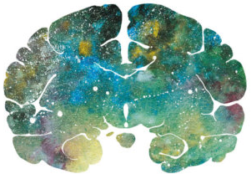

Editing File
Email: pathology436@gmail.com Twitter: @pathology436
For your suggestions & complaints

References: Doctor’s slides, Robbins basic pathology ninth edition.
القادة
نوره السهلي طراد الوكيل
الأعضاء
وئام بابعير لمى التميمي
رزان العتيبي حنين السبكي
سمر القحطاني سارة الشمراني
رنيم الغامدي

Could be an infectious material or biochemical materials, Could be anything.
Negro=Black. It’s found in cytoplasm.
داء الكلب. مرض مميت.
متعرج
فتاق
Glial fibrillary acidic protein.
Few.
Ribbon-shaped.
Firm.
Branches.
Have a large cytoplasmic mass, long, branching processes, it could be reactive to infection, infarction, tumer .. etc
Reaction of glial cells in response to damage.
(PML) is a rare and usually fatal viral disease characterized by progressive damage (-pathy) or inflammation of the white matter (leuko-) of the brain (-encephalo-) at multiple locations (multifocal).
بقعة
Phagia: eating, engulf

