CNS tumors

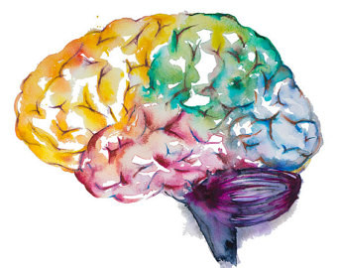

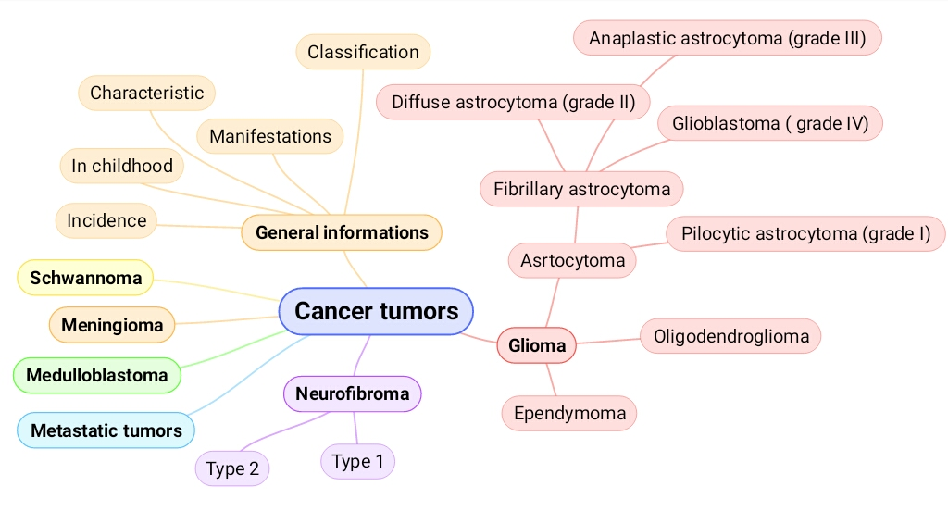
Lecture outlines:
Objectives:
1- Appreciate how the anatomy of the skull and the spinal column influences the prognosis of both benign and malignant primary CNS tumors.
2- List the principal clinicopathological features of some of the main types of tumors that can arise within the central and the peripheral nervous systems.
Key principles to be discussed:
1-CNS tumors incidence and classification, with special consideration of the general differences between the pediatric and the adult population.
2- The unique characteristics that set CNS tumors apart from neoplastic processes elsewhere in the body.
3- The incidence, common clinical presentation, location, macroscopic appearances, microscopic features, pattern of spread and prognosis of the following neoplasms will be explained and discussed: • Astrocytic neoplasms: Pilocytic astrocytoma, diffuse astrocytoma, anaplastic astrocytoma and gliobastoma • Oligodendroglioma • Ependymoma • Medulloblastoma • Meningioma • Metastatic tumors • Peripheral nerve sheath tumors: schwannoma and neurofibroma.
Black: Doctor’s slides.
Red or black bold: important!
Green: Doctor’s notes.
Grey: Extra.
Italic black: New terminology.
CNS
- Incidence:
- The annual incidence of tumors of the CNS ranges from:
  - 10 to 17 per 100,000 persons for intracranial tumors.
  - 1 to 2 per 100,000 persons for intraspinal tumors.
- About half to three-quarters are primary tumors, and the rest are metastatic.
- Childhood:
Why? Because of BBB which protect the brain from metastatic tumors.
- Tumors of the CNS are a large proportion of cancers of childhood, accounting for as many of 20% of all tumors.
- CNS tumors in childhood differ from those in adults both in histologic subtype and location.
- In childhood, tumors are likely to arise in the posterior fossa (infratentorial), while in adults they are mostly supratentorial.
Location only.
- General characteristics: In the brain tumors usually, there is no staging. There is grading and
  - The anatomic site of the neoplasm can have lethal consequences irrespective of histological classification (i.e. benign tumors can be fatal in certain locations)
Examples on such locations? Imp. Brainstem.
If the patient had a small tumor in the brain canals “between ventricles” or brain stem he may die. But, if the patient had a large tumor in his frontal lobes, he may not feel it!

  - These tumors do not have detectable premalignant or in situ stages comparable to those of carcinomas.
but the tumor may progress from low grade to high grade.

  - The pattern of spread of primary CNS neoplasms differs from that of other tumors:
    - Rarely metastasize outside the CNS.
Inside the CNS
    - The subarachnoid space does provide a pathway for spread.
What are the layers that surround subarachnoid space?
Subarachnoid space is located between the arachnoid mater and the pia mater. It contains blood vessels & CSF making metastases within the CNS possible.

- Even low-grade lesions may infiltrate large regions of the brain, leading to serious clinical deficits, nonresectability, and poor prognosis.

- General manifestations:
Depends on location.
- Seizures, headaches, vague symptoms.
- Focal neurologic deficits related to the anatomic site of involvement.
- Rate of growth may correlate with history.
Like when we have one month history we should be worried!

- Classification:
May arise from:
  - Cells of the coverings (meningiomas).
  - Cells intrinsic to the brain (gliomas, neuronal tumors, choroid plexus tumors).
  - Other cell populations within the skull (primary CNS lymphoma, germ-cell tumors).
  - They may spread from elsewhere in the body (metastases).
1- Gliomas:
Gliomas are type of CNS tumors arising from the glial cells. They’re classified as:
- Astrocytoma: arising from the astrocytes.
There is no Microglioma.

- Oligodendrogliomas: arising from the oligodendrocytes.
- Ependymomas: arising from the ependymal cells.

a) Astrocytomas:
Classification depends on appearance.
K
- Fibrillary | - Pilocytic
4th to 6th decade ‘Adults’ | Children and young adults
Commonly cerebral hemisphere  “Supratentorial” | Commonly cerebellum  “Infratentorial”
Variable grades:  - Diffuse astrocytoma (Grade II )  - Anaplastic astrocytoma (Grade III )  - Glioblastoma ( Grade IV ) | - (Grade I)  - Relatively benign  May have cystic component.

- Fibrillary Astrocytoma:
Well differentiated | Less differentiated (higher-grade)
diffuse astrocytoma (WHO grade II) | Anaplstic astrocytoma (WHO grade III) | Glioblastoma (WHO grade IV)
Static or progress slowly (mean survival of more than 5 years) | - | With treatment, mean survival of 8-10 months
Moderate cellularity | More cellular | All the features of anaplastic astrocytoma, plus: Necrosis and/or vascular or endothelial cell proliferation
- Variable nuclear pleomorphism. | - Greater nuclear pleomorphism.  - Mitosis.
ممكن تصير على طول هاي قريد قلايوبلاستوما أو تتحوّل من قريد أقل.

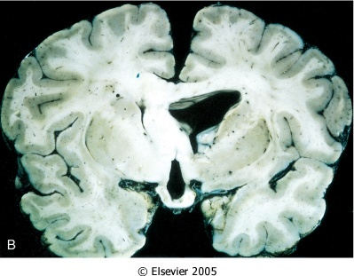
Crosses the midline ‘butterfly appearance.
Note that diffuse astrocytoma are poorly demarcated.

Because cells of malignant astrocytes sneak out between normal cells.

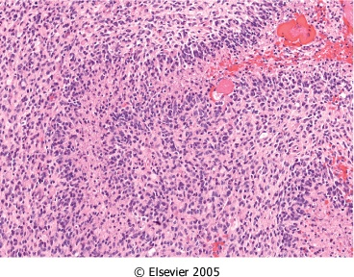
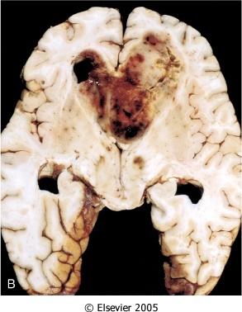
GBM “Glioblastoma Multiforme”: 1- Pseudopalisading necrosis AND/OR 2- Vascular proliferation.

- Mutations that alter the enzymatic activity of two isoforms of the metabolic enzyme isocitrate dehydrogenase (IDH1 and IDH2) are common in lower-grade astrocytomas.
- Secondary* glioblastomas share p53 mutations that characterized low-grade gliomas.
- While primary** glioblastomas are characterized by amplification of the epidermal growth factor receptor (EGFR) gene.
* Secondary glioblastoma better prognosis ‘comes from low grade astrocytoma’.
** من الأول هاي قريد
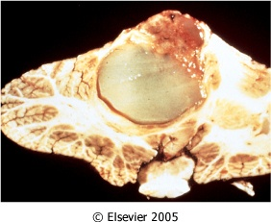
- Pilocytic Astrocytoma:

- Often cystic, with a mural nodule.
- Well circumscribed.
- "Hairlike’’ pilocytic processes that are GFAP positive.
- Rosenthal fibers & hyaline granular bodies are often present.
- Necrosis and mitoses are typically absent.

⦁ Only Grade II and Grade III. ⦁ Only in adults.
b) Oligodendrogliomas:
- The most common genetic findings are loss of heterozygosity for chromosomes 1p and 19q.
- Fourth and fifth decades.
- Cerebral hemispheres mainly in frontal and temporal lobes, with a predilection for white matter.
- Better prognosis than do patients with astrocytomas (5 to 10 years with Rx).
- Anaplastic form prognosis is worse.
- Imaging reveals: Calcified tumor in white matter. may present with seizures
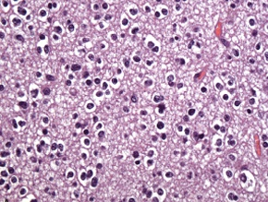
Morphology:
- In oligodendroglioma tumor cells have round nuclei, often with a cytoplasmic halo (Fried egg pattern).
- Blood vessels in the background are thin and can form an interlacing pattern (Chicken wire pattern).
What additional features are needed for anaplastic oligodendroglioma?

Necrosis, mitosis.
c) Ependymomas: (Malignant tumor)
- Most often arise next to the ependyma-lined ventricular system including the central canal of the spinal cord. So, may present with hydrocephalus
- Occurs in the first two decades of life, they typically occur near the fourth ventricle.
- In adults, the spinal cord is their most common location. Children brain.
Morphology:
- Tumor cells may form round or elongated structures (rosettes, canals)
- perivascular pseudo-rosettes.

What a rosette? Tumor cells form round elongated structures that resemble the embryologic ependymal canal, with long , delicate processes extending into a lumen.
- Anaplastic ependymomas: show increased cell density, high mitotic rates, necrosis and less evident ependymal differentiation.

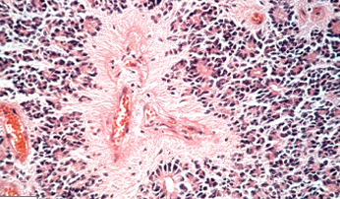

Perivascular pseudo-rosettes don’t have a central canal, if it has a canal we call it True rosette.

        - Meningioma:
- Predominantly benign tumors of adults.
- Origin: meningothelial cell of the arachnoid.
⦁ Could happen in children but rarely
⦁ We can see it grossly as a mass attached to the dura and it’s well-demarcated

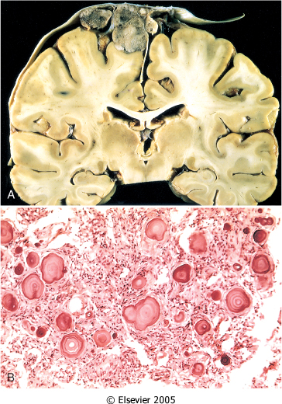
Morphology:
- Well demarcated.
- Attached to the dura with compression of underlying brain.
- Whorled pattern of cell growth and psammoma bodies. ○

- Main subtypes:
- Also note:
  - Atypical meningiomas.
  - Anaplastic (malignant) meningiomas.

  - Syncytial.
Grade II
  - Fibroblastic.
Grade III
Grade I
  - Transitional.

- Although most meningiomas are easily separable from underlying brain, some tumors infiltrate the brain.
- The presence of brain invasion is associated with increased risk of recurrence.
⦁ Primitive, Round small blue cell appearance.
⦁ Grade IV.
3- Medulloblastoma:
- Commonly affect children and exclusively in the cerebellum.
- Neuronal and glial markers may be expressed, but the tumor is often largely undifferentiated.
- The tumor is highly malignant, and the prognosis for untreated patients is dismal; however, it is exquisitely radiosensitive.
- With total excision and radiation, the 5-year survival rate may be as high as 75%.
- Tumors of similar histologic type and a poor degree of differentiation can be found elsewhere in the nervous system, where they are called primitive neuroectodermal tumors (PNETs).
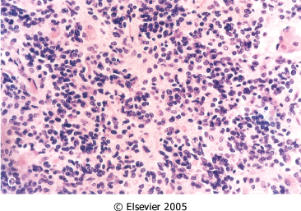
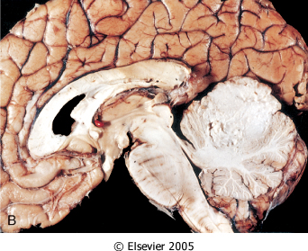
Morphology:

- Extremely cellular, with sheets of anaplastic ("small blue") cells
- Small, with little cytoplasm and hyperchromatic nuclei; mitoses are abundant.
- Sagittal section of brain showing medulloblastoma with destruction of the superior midline cerebellum.

○ Large irregular mass in cerebellum.

4- Schwannoma:
⦁ Grade I. ⦁ Could happen outside the CNS.

- Benign.
- In the CNS, they are often encountered within the cranial vault in the cerebellopontine angle, where they are attached to the vestibular branch of the eighth nerve (tinnitus and hearing loss).
Mutations in this lecture are very imp.

Sporadic schwannomas are associated with mutations in the NF2 gene. | Bilateral acoustic schwannoma is associated with NF2.

- Attached to the nerve but can be separated from it.
- Affected patients carry a dominant loss of function mutation of the Merlin gene on chromosome 22. Merlin is a cytoskeletal protein that functions as a tumor suppressor. Some cases have recently been linked to loss-of-function mutations in a tumor suppressor gene on chromosome 22 that encodes a protein that regulates chromatin structure. “Robbins”
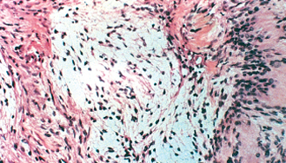
Morphology:

- Gross:

- Most schwannomas appear as circumscribed masses abutting an adjacent nerve.

- Microscopic:

- (Antoni A) pattern is more cellular than (Antoni B)
- Nuclear-free zones of processes that lie between the regions of nuclear palisading are termed Verocay bodies.

- Axons are largely excluded from the tumor.
- Thick-walled hyalinized vessels often are present.
- Hemorrhage or cystic change is also seen sometimes.
5- Neurofibroma:
- Examples: (cutaneous neurofibroma) or in peripheral nerve (solitary neurofibroma).
- These arise sporadically or in association with type 1 neurofibromatosis, rarely malignant.
- plexiform neurofibroma, mostly arising in individuals with NF1, potential malignancy.
- Neurofibromas cannot be separated from nerve trunk (in comparison to schwannoma).
- Three important subtypes are recognized: The table below from “Robbins : page 107”
Subtypes | Growth | Characteristic
1-Localized cutaneous | Superficial nodular or polypoid tumors. | These occur either as solitary sporadic lesions or as often multiple lesions in the context of neurofibromatosis type 1 (NF1).
2-Plexiform | Diffusely within the confines of a nerve or nerve plexus. | ⦁ Surgical enucleation of such lesions is therefore difficult and is often associated with lasting neurologic deficits.  ⦁ These tumors are associated with a small but real risk of malignant transformation.
3-Diffuse | Infiltrative proliferations. | ⦁ Can take the form of large, disfiguring subcutaneous masses.  ⦁ These also are often associated with NF1.
6- Metastatic tumors:
- Very common in brain (About 50% of CNS tumors).
- Multiple.
- Well-defined.
- About half to three-quarters of brain tumors are primary tumors and the rest are metastatic.

- The most common primary sites are ‘from most to least common’ Lung, Breast, Skin (melanoma), Kidney, Gastrointestinal tract.
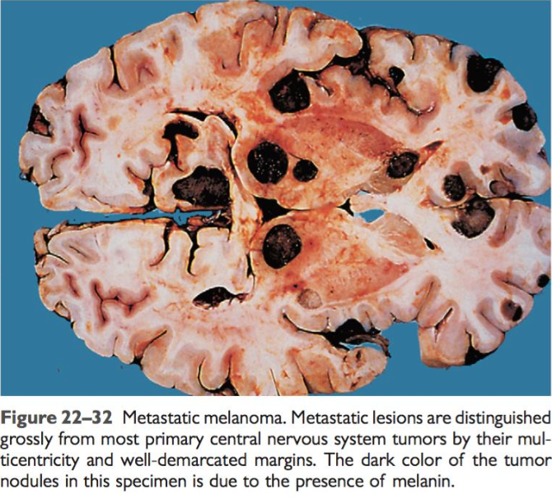
Sharply demarcated masses with edema.

Neurofibromatosis is a genetic disorder that carries a high risk to tumors formation particularly in the nerve tissues.

*Homework (FAMILIAL TUMOR SYNDROMES)

Q1) Describe the inheritance pattern and the main features of:

Inheritance pattern | Type 1 Neurofibromatosis: | Type 2 Neurofibromatosis:
 | NF1 is an autosomal dominant disorder caused by mutations in the tumor suppressor neurofibromin, encoded on the long arm of chromosome 17 (17q). | Dominant loss of function mutation of the merlin gene on chromosome 22.
Main features | 1- Learning disabilities.  2- Seizures.  3- Skeletal abnormalities.  4- Vascular abnormalities with arterial stenosis.  5- Pigmented nodules of the iris (Lisch nodules).  6- Pigmented skin lesions (axillary freckling and café au lait spots) in various degrees. | 1- Unilateral or, frequently, bilateral vestibular schwannomas leading to tinnitus, hearing loss, and/or problems with balance.  2- Meningiomas.

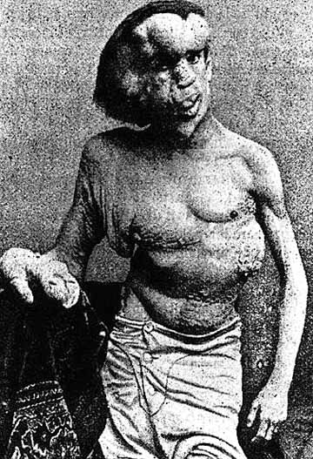
Q2) Which one of these two syndromes has a propensity for the neurofibromas to undergo malignant transformation at a higher rate than that observed for comparable tumors in the general population? Neurofibromatosis Type 1.

*Questions:
Q1: The neoplasm that most frequently occurs in the fourth ventricle is:
A- Oligodendroglioma. B- Ependymoma. C- Medulloblastoma. D- Neuroblastoma.
(B) Is the correct answer.

Q2: Loss of heterozygosity for chromosomes 1p and 19q is the most common genetic finding in:
A- Medulloblastoma. B- Astrocytoma. C- Meningioma. D- Oligodendroglioma.
(D) Is the correct answer.

Q3: A biopsy was taken from a patient and it showed whorled pattern of growth and psammoma bodies. What is the most likely diagnosis:
A- Medulloblastoma. B- Glioblastoma. C- Meningioma. D- Pilocytic astrocytoma
(C) Is the correct answer.

Q4: Bilateral acoustic schwannoma is associated with​:
A- NF1. B- NE2. C- NF2. D- IDH1
(C) Is the correct answer.

Q5: In meningioma presence of brain invasion is associated with:
A- Decreased risk of recurrence. B- Increased risk of recurrence. C- It has no effect.
(B) Is the correct answer.

Q7: A 5-year- old boy has complained of headaches for the past week. His gait has
become ataxic. After sudden onset of vomiting, he is brought to the emergency
department, where he becomes comatose. On physical examination, he is afebrile. CT
scan of the head shows the presence of a 4-cm mass in the cerebellar vermis and
dilation of the cerebralventricles. A lumbar puncture is done. Cytologic examination of
the CSF shows small cells with dark blue nuclei and scantcytoplasm. What neoplasm
would most likely explain these findings?
A- Schwannoma. B- Ependymoma. C- Glioblastoma multiforme.
D- Medulloblastoma. E- Metastatic carcinoma.
(D) Is the correct answer.

Q8: A 41-year- old woman has had diminished hearing for the last 4 months. On physical examination, she has decreased hearing on the left. Sound lateralizes to the right ear on the Weber tuning fork test. CT scan of the head shows a sharply circumscribed, 4-cm mass adjacent to the left pons that extends toward the left inferior cerebellar hemisphere. What neoplasm is most likely to be present in this patient?
A- Meningioma. B- Astrocytoma. C- Schwannoma. D- Medulloblastoma.
E- Ependymoma
(C) Is the correct answer.
*Summary

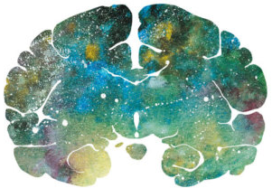
"اللهم لا سهل إلا ما جعلته سهلًا و أنت تجعل الحزن إذا شئت سهلًا"

Editing File
Email: pathology436@gmail.com Twitter: @pathology436
For your suggestions & complaints

القادة
نوره السهلي طراد الوكيل
الأعضاء
عبدالعزيز القرموشي عبدالعزيز الجاسر
إبراهيم الديري عبدالله العيدان
مبشر الاسمري سالم العماري

References: Doctor’s slides, Robbins basic pathology ninth edition.

Cerebellum
Tentorium is a pleura that separates the cerebellum from the occipital lobe
Staging refers to the extent or spread of cancer
The grade of a tumor refers to the way the cells look under a microscope The pathologist gives the cancer a grade based on how different they look from normal cells (differentiation)
Made up of cells look like fibers ‘hair-like’ when viewed under a microscope. و لأن الفايبرز رفيعة نربطها بالأطفال لأنهم أرفع من الكبار فيجيهم هذا النوع من التيومرز.
Glial Fibrillary Acidic Protein (GFAP) is a protein that is encoded by the GFAP gene in humans. Glial fibrillary acidic protein is an intermediate filament (IF) protein that is expressed by numerous cell types of the central nervous system (CNS) including astrocytes and ependymal cells.
وحدة منهم نورمال و وحدة لا
Prescription
Is a condition in which there is an accumulation of CSF within the brain , and it increases the pressure inside the skull. In babies ; there may be a rapid increase in head size. In adults , it may cause headache , double vision and poor balance.
extremely
It’s the place between pons , medulla and cerebellum
Neurofibromatosis Type 2
An admixture of dense and loose areas referred to as Antoni A and B.
Merlin is a cytoskeletal protein that functions as a tumor suppressor by facilitating E-cadherin– mediated contact inhibition.

