Multiple sclerosis

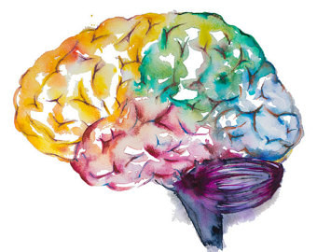

Objectives:
1- Appreciate the critical role of myelin in maintaining the integrity of the CNS system.
2- Understand the pathogenesis and the clinic-pathological features of multiple sclerosis as the classical and the commonest example of CNS demyelinating diseases.

Key principles to be discussed:

1- Myelin function
2- The differences between CNS and PNS Myelin
3- Primary Demyelinating disease classification
4- Multiple sclerosis: definition, epidemiology, pathogenesis and clinicopathological features; with special emphasis on CSF analysis findings, morphology and distribution of MS plaques.
Black: Doctor’s slides.
Red or black bold: important!
Green: Doctor’s notes.
Grey: Extra.
Italic black: New terminology.
- Myelin:
It isolates & maintains homogenous environment for axons.
Myelin consists of multiple layers of the specialized plasma membrane of oligodendrocytes (in the CNS), with most of the cytoplasm excluded.
Although myelinated axons are present in all areas of the brain, they are the dominant component in the white matter; therefore, most diseases of myelin are primarily white matter disorders.
What is the function of myelin? Improving the speed and efficiency of conduction.
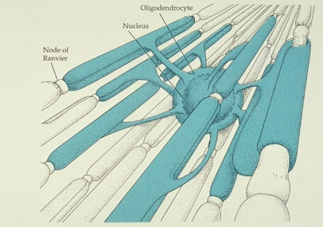
- An oligodendrocyte extends processes toward many different axons and wraps a segment of roughly a few hundred microns of axon.
(Schwan cells wraps around one axons only).
- Each of these segments is called an internode, and the gaps between internodes are known as nodes of Ranvier.
Schwan cells serve one cell : Oligodendrocytes serve many cells.

- The differences between CNS and PNS:
CNS | PNS
myelin is made by oligodendrocytes | myelin is made by Schwann cells
many internodes comes from a single oligodendrocyte | each cell contributes to only one internode

- The myelin in peripheral nerves is similar to the myelin in the CNS but:
  - The specialized proteins and lipids are also different.
  - Most diseases of CNS myelin do not significantly involve the peripheral nerves, and vice versa.

The natural history (course) of demyelinating diseases is determined, in part, by the limited capacity of the CNS to regenerate normal myelin and by the degree of secondary damage to axons that occurs as the disease runs its course.

What is “natural history of a disease”?

The natural history of disease is the course a disease takes in individual from its pathological onset (inception) until its eventual resolution through complete recovery or death.
- Primary Demyelinating disease general classification:
Two broad groups:
Demyelinating diseases of the CNS: | Dysmyelinating diseases of the CNS:
Once normal myelin, then it’s damaged. ما في مشكلة بتصنيع المايلين بالبداية بس خرب بعدين  ⦁ Acquired conditions characterized by preferential damage to previously normal myelin.  ⦁ Commonly result from immune-mediated injury.  ⦁ Also viral infection of oligodendrocytes as in progressive multifocal leukoencephalopathy.  ⦁ Drugs and other toxic agents. | The myelin itself is abnormal. “Genetic or familial” من البداية ما تسوّى المايلين كويّس  ⦁ Myelin is not formed properly or has abnormal turnover kinetics.  ⦁ Associated with mutations affecting the proteins required for formation of normal myelin or in mutations that affect the synthesis or degradation of myelin lipids.  ⦁ The other general term for these diseases is leukodystrophy.
This Video was included in the slides

https://www.youtube.com/watch?v=qgySDmRRzxY
- Multiple sclerosis:
https://www.youtube.com/watch?v=Naecv3h868c
MS is an autoimmune demyelinating disorder characterized by distinct episodes of neurologic deficits, separated in time, attributable to white matter lesions that are separated in space.
- The most common demyelinating disorders (prevalence of 1 per 1000 persons in most of the United States and Europe).

- Incidence:
It becomes clinically apparent at any age, although onset in childhood or after age 50 years is relatively rare. Women are affected twice as often as men.
- In most individuals with MS the illness shows relapsing and remitting episodes of neurologic deficits. The frequency of relapses tends to decrease during the course of the illness, but there is a steady neurologic deterioration in a subset of patients.
(الإنتكاسات تقل كل ما يتقدم بالعمر لكن مع كل انتكاسة رح تصير يتأثر بها المريض و تتدهور حالته أكثر من قبل)
⦁ Relapsing: attack by lymphocyte. ⦁ Remitting: regeneration by the body (renewing of myelin).

- Pathogenesis:
Like other autoimmune diseases, MS is believed to be caused by a combination of environmental and genetic factors (certain HLA DR2; increases the risk) that result in a loss of tolerance to self-proteins. (In this case these self-protiens are: myelin antigens) و بالتالي يبدأ الجسم يحارب الميلانين حقته!
While MS is characterized by the presence of demyelination out of proportion to axonal loss, some injury to axons does occur. Toxic effects of lymphocytes, macrophages, and their secreted molecules have been implicated in initiating the process of axonal injury, sometimes even leading to neuronal death.
يعني موب دائمًا يصير فيه إنفولفمنت للآكسونز لكن أحيانًا يصير فيه إنجري للآكسون و مرات للخلية بكبرها! و يصير عندي Cell death and neurological deficit.
(A central role for CD4 T cells has been suggested, with an increase in T_{H}17 AND T_{H}1 CD4 cells thought to be a critical component of the injury of myelin. CD8 T cells and B cells also contribute.)
- Experimental allergic encephalomyelitis:
Is an animal model of MS in which demyelination and inflammation occur after immunization with myelin, myelin proteins, or certain peptides from myelin proteins.
In this model, the lesions are caused by a T cell-mediated delayed type hypersensitivity “type 4” reaction to myelin proteins, and the same immune mechanism is thought to be central to the pathogenesis of MS.

- Risk factors:
- The risk of developing MS is 15-fold higher when the disease is present in a first-degree relative.
- The concordance rate for monozygotic twins is approximately 25%, with a much lower rate for dizygotic twins.
- A significant fraction of the genetic risk for MS is attributable to HLA-DR variants, the DR2 allele being the one that most significantly increases the risk for developing MS.
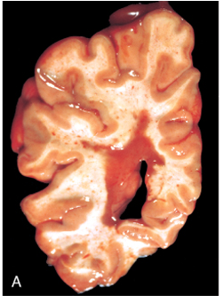
- Morphology:
Gross:
- MS is a white matter disease.
- Affected areas show multiple, well-circumscribed, slightly depressed, glassy, gray-tan, irregularly shaped lesions, termed plaques. ○
- They occur beside ventricles and they are frequent in the optic nerves (leads to diplopia due to disrupted conjugation of brainstem’s eye movement control center) and chiasm, brain stem, ascending and descending fiber tracts, cerebellum and spinal cord.

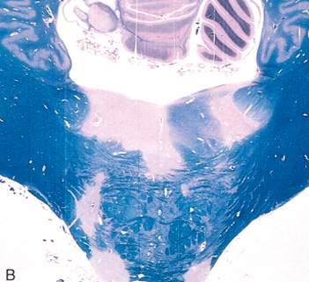
Microscopic:
The lesions have sharply defined borders.

Luxol fast blue stain is commonly used to observe myelin under light microscope.

Active plaque (In case with the relapse) | Inactive plaques (quiescent)
⦁ There is evidence of ongoing myelin breakdown with abundant macrophages containing myelin debris. الماكروفيجز ياكلوا المايلين اللي هاجمته الليمفوسايت  ⦁ Lymphocytes and monocytes are present, mostly as perivascular cuffs.  ⦁ Axons are relatively preserved, although they may be reduced in number. Specially by time.  There are 4 types of active plaques:  Type 1: macrophages infiltrate with sharp margins.  Type2: similar to 1 but with complement deposition.  Type3: less defined borders with oligodendrocyte apoptosis.  Type4: nonapoptotic oligodendrocyte loss). | ⦁ The inflammation mostly disappears, leaving behind little to no myelin.  ⦁ Instead, astrocytic proliferation and gliosis are prominent.

- Clinical Features:
- The course of MS is variable. MS lesions can occur anywhere in the CNS may induce a wide range of clinical manifestations.
- Commonly there are multiple episodes of new symptoms (relapses) followed by episodes of recovery (remissions); typically, the recovery is not complete.
- The consequence of this pattern of relapsing-remitting disease is the gradual, often stepwise, accumulation of increasing neurologic deficits.
Certain patterns of neurologic symptoms and signs are commonly observed (depending on the location of plaques):
  - Unilateral visual impairment (diplopia because of disruption of brainstem) occurring over the course of a few days is a frequent initial manifestation of MS (due to involvement of the optic nerve “optic neuritis”).
    - When this occurs as the first event, only a minority (10% to 50%) go on to develop full-blown MS.
  - Involvement of the brain stem produces cranial nerve signs and ataxia, and can disrupt conjugate eye movements. Cranially affected.
  - Spinal cord lesions give rise to motor and sensory impairment of trunk and limbs, spasticity, and difficulties with the voluntary control of bladder function.
(Urine incontinence)

  - Changes in cognitive function can be present, but are often much milder than the other findings. لكن مش مثل مرضى الزهايمر!
Ex: Balance problems.
  - In any individual patient it is hard to predict when the next relapse will occur; most current treatments aim at decreasing the rate and severity of relapses rather than recovering lost function.
⦁ Less frequent in males but worst prognosis. ⦁ More frequent in females but better prognosis. This is the way it is :)

- CSF findings:
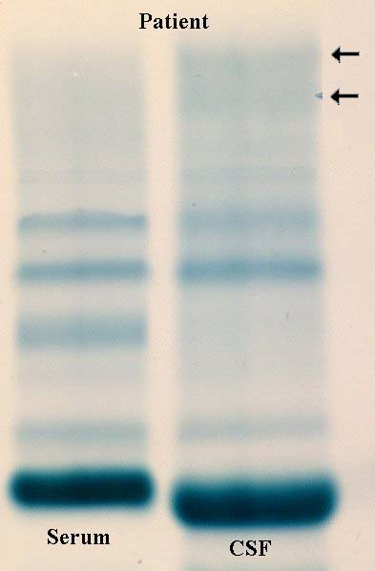
  - It shows mildly elevated protein level with an increased proportion of γ-globulin.
  - In one-third of cases there is moderate pleiocytosis.
  - When the immunoglobulin is examined further, most MS patients show oligoclonal bands, representing antibodies directed against a variety of antigenic targets. These antibodies constitute a marker for disease activity.

*Questions:
Q1: The word "demyelinating" means?
- The process of myelinating done by Schwann cells or oligodendrocyts.
- Preferential damage to previously normal myelin.
- When Myelin is not formed properly.
- The nerves which have no myeline.

(B) Is the correct answer.

Q2: What kind of disease is MS?
A. Infectious. B. Viral. C. Autoimmune. D. Blood.
(C) Is the correct answer.

Q3: The clear cause of MS remains unknown, though ____________ may be important factors?
- Environment, viruses, and genetics.
- High blood pressure.
- Diet and antibiotic resistance.
- Emotional health.

(A) Is the correct answer.

Q4: Which of the following are true about MS?
- It is more common in women than men.
- It commonly occurs after 50 yrs. of age.
- It is known to be associated with vitamin D deficiency.
- It is associated with DRB1 locus.

(A) Is the correct answer.

Q5: Cells involved in destruction in MS is/ are?
A. T_{H}1 cells. B. T_{H}17 cells. C. B cells. D. All above.
(D) Is the correct answer.

Q6: The common symptom in MS is?
- Exercise induced weakness.
- Bilateral optic neuritis.
- Paresthesia.
- Sensory loss.

(B) Is the correct answer.

Q7: Symptoms of multiple sclerosis include?
- Numbness.
- Difficulty with walking.
- Problems with urination.
- All of them.

(D) Is the correct answer.
*Summary

CNS Myelin | PNS Myelin
made by oligodendrocytes | made by Schwann cells
many internodes comes from a single oligodendrocyte | each internode comes from a single oligodendrocyte
specialized proteins and lipids are different
Most diseases are different

Demyelinaing | Dysmyelinaing
acquired  (damage to previously normal myelin) | myelin is not formed properly  (has abnormal turnover kinetics)
commonly → immune-mediated injury | mutations
Less commonly → viral infection | Other term $→$ leukodystrophy.

Multiple sclerosis
Definition | It is an autoimmune demyelinating disorder characterized by distinct episodes of neurologic deficits, separated in time, attributable to white matter lesions
Epidemiology | At any age (childhood , +50 →rare)
Pathogenesis | factors | environmental |  |  | Both result in a loss of tolerance to self-proteins
genetic
Familial, monozygotic twins higher rate than dizygotic twins, HLA-DR, DR2.
 | -Toxic effects of lymphocytes and macrophages→ axonal injury
 | - T cell-mediated delayed type hypersensitivity “type 4”
clinical features | can occur anywhere in the CNS → wide range of clinical manifestations
 | - Relapsing & remitting.
 | optic nerve  “optic neuritis” |  | →Unilateral visual impairment
 | brain stem |  | →CNS signs and ataxia - conjugate eye movements
 | Spinal cord |  | →motor and sensory impairment of trunk and limbs - difficulty control bladder function
morphology | - plaques  usually in ventricles |  | active plaque | Macrophages, Lymphocytes
 |  |  |  | ongoing myelin breakdown, ↓num. of axons
 |  |  | inactive plaques | astrocytic proliferation and gliosis
 |  |  |  | No inflammation, no myelin
 | - microscopic → sharply defined
CSF analysis findings | -↑ protein level (γ- globulin)  - pleiocytosis  - oligoclonal bands
"اللهم لا سهل إلا ما جعلته سهلًا و أنت تجعل الحزن إذا شئت سهلًا"
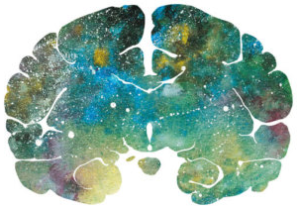

Editing File
Email: pathology436@gmail.com Twitter: @pathology436
For your suggestions & complaints

القادة
نوره السهلي طراد الوكيل
الأعضاء
وئام بابعير مها الغامدي
لمى التميمي ريما الشايع
غادة المزروع

References: Doctor’s slides, Robbins basic pathology ninth edition.

Progressive multifocal leukoencephalopathy (PML) is a rare and usually fatal viral disease characterized by progressive damage (-pathy) or inflammation of the white matter (leuko-) of the brain (-encephalo-) at multiple locations (multifocal).
مُتعلِّق بـ
انتكاس
To restore to a former condition or position.
An increased cell count. تنوّع بأشكال الخلايا
Immunoglobulin G antibodies, associated with a more severe course.

