Neurodegenerative

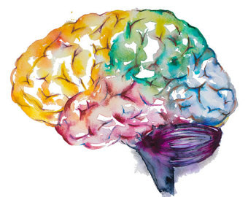

Objectives:

1- Explain the basic pathological concepts of neurodegenerative disease, using Alzheimer’s and Parkinson disease as a classical example.
2- Know the definition of “dementia” syndrome.
3- List the possible causes of dementia.
4- Explain the basic pathological concepts of a neurodegenerative disease, using Alzheimer’s disease as a classical example.
5- Understand the major clinic-pathological features of Alzheimer’s disease.
6- Hypothesize the possible etiologies of Alzheimer’s disease.
7- List the causes of Parkinsonism.
8- Understand the major clinical and pathological feature of Parkinson disease.
9- Hypothesize the possible etiologies of Parkinson disease.
Key principles to be discussed:
1- Neurodegenerative diseases definition.
2- The definition and etiology of dementia.
3- Alzheimer disease: o Definition. o Clinical findings including age of onset and progression pattern. o Morphologic abnormalities including the gross brain changes, neurofibrillary tangles, and neuritic plaques deposition.
4- Parkinsonism: definition and etiology.
5- Parkinson disease: definition, epidemiology, pathogenesis and clinicopathological features.
Black: Doctor’s slides.
Red or black bold: important!
Green: Doctor’s notes.
Grey: Extra.
Italic black: New terminology.
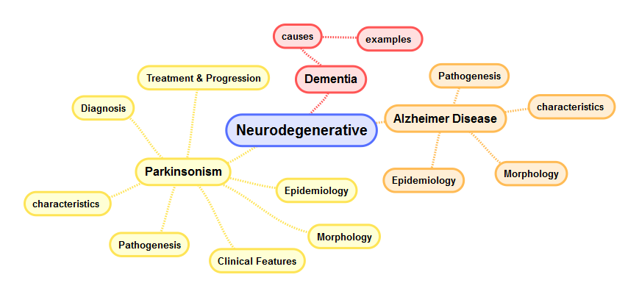
Lecture outlines:

- Degenerative brain disease:
Neuronal disease. E.g. Alzheimer & Parkinson disease.

The term “Degenerative” refers to an underlying cellular degeneration of neurons within the cortex of the brain; often due to accumulation of proteins.
- The caused symptoms depend on the pattern of involvement of the brain.

- Dementia:
As a syndrome.
Is the development of memory impairment, begins with recent memory loss and progresses to long term memory loss, and other cognitive deficits with preservation of a normal level of consciousness.
Dementia is a memory problem, especially short-term memory.
Does every old person have to be demented? No, it’s abnormal condition although elderly population can have some memory problems but it’s not to the degree of dementia.

  - One of the most important public health issues in the industrialized world.
  - There are many causes of dementia.
  - Regardless of etiology, dementia is not part of normal aging and always represents a pathologic process.
Major cause of dementia | Examples
Primary Neurodegenerative Disorders | ⦁ Alzheimer disease.  ⦁ Lewy body dementia.  ⦁ Huntington disease.
Infections | ⦁ Prion-associated disorders (e.g. Creutzfeldt-Jakob disease).  ⦁ HIV encephalopathy (AIDS dementia complex).  ⦁ Progressive multifocal leukoencephalopathy.
Vascular and Traumatic Diseases | ⦁ Multi-infarct dementia.  ⦁ Global hypoxic-ischemic brain injury.  ⦁ Chronic subdural hematomas.
Metabolic and Nutritional Diseases | Thiamine deficiency (Wernicke-Korsakoff syndrome).
Miscellaneous | ⦁ Brain tumors.  ⦁ Neuronal storage diseases.  ⦁ Toxic injury (e.g. mercury).

So remember!
While Alzheimer's disease is considered as "degenerative"-that is reflecting an underlying cellular degeneration of neurons in the brain- not all forms of dementia are degenerative. vascularممكن

- Alzheimer Disease:
Alzheimer is usually linked to dementia. Dementia does not equal Alzheimer, Alzheimer is only one cause.

- The most common cause of dementia in the elderly.
- The disease usually becomes clinically apparent as insidious impairment of higher intellectual function, with alterations in mood and behavior. They become aggressive.
- Later, severe cortical dysfunction:
- Progressive disorientation.
- Memory loss.
OSMOSIS: Alzheimer’s Disease
- Aphasia.
- Over the next 5 to 10 years, the patient becomes profoundly disabled, mute, and immobile.
- Death usually occurs from intercurrent pneumonia or other infections.
*Respiratory infections* + Urinary tract infections.

- Epidemiology:
- When considered by age groups, the incidence of Alzheimer disease:
- 3% for individuals 65 to 74 years old.
- 19% for 75 to 84 years.
- 47% for 85 years or more.

- This increasing incidence with age has given rise to major medical, social, and economic problems in countries with a growing number of elderly.

Although pathologic examination of brain tissue remains necessary for the definitive diagnosis of Alzheimer disease, the combination of clinical assessment and modern radiologic methods allows accurate diagnosis in 80% to 90% of cases. Not 100%
- Most cases are sporadic. At least 5% to 10% are familial.
- In general, patients rarely become symptomatic before 50 years of age, but early onset can be seen with some of the heritable forms.

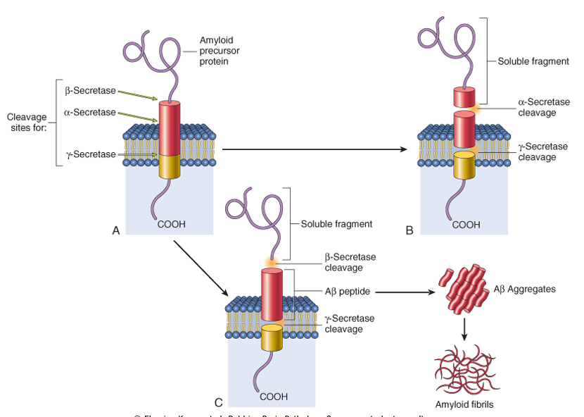

- Pathogenesis:
Evidence from familial forms of the disease indicates that the accumulation of a peptide (β amyloid, or Aβ) in the brain initiates a chain of events that result in the morphologic changes of Alzheimer disease and dementia.
Soluble Normal

- Aβ is peptide derived from a larger membrane protein known as amyloid precursor protein (APP), which is processed in either of two ways:
  - It can be cleaved by two enzymes, α-secretase and γ-secretase, in a process that prevents formation of Aβ.
The cleavage here forms a soluble fragments NO Alzheimer NO amyloid fibrils.

  - It can be cut by β-site APP-cleaving enzyme and γ-secretase to generate Aβ.
The Aβ deposits formed by the β, γ-secretase are insoluble, meaning they are not soluble in blood and cannot be secreted in the urine, and will aggregate in the brain.

- Generation and accumulation of Aβ occur slowly with advancing age.
- Mutations in APP or in components of γ-secretase (presenilin-1 or presenilin-2) lead to early onset familial Alzheimer disease by increasing the rate at which Aβ accumulates.
So, mutation in γ-secretase (presenilin-1 or presenilin-2) or in APP itself, you link it with early onset familial Alzheimer.

APP
Aβ
يعني #الزبدة: أنا عندي ميمبرين بروتين إسمه هذا البروتين طبيعيًا لازم يتكسّر و نتخلص منه عشان نمنع تكوّن ببتايد معيّن إسمه و هذي عملية التكسير"الطبيعية" تتم عن طريق إنزايمز معيّنة اللي هي ألفا و قاما. كذا حلوين؟ طيب وش يصير بالزهايمر؟ الملقوف ببتايد اللي ما نبغاه يتكوّن يبدأ يتراكم! طيب كيف؟ بمساعدة إنزايمز تكسير بعد اللي هي بيتا و قاما. هنا قاما خانت الألفا و حاست الدنيا:) فتراكمت عندنا الأمايلويد فيبريلز اللي ما نبيها:(.

Aβ

- Alzheimer disease occurs in almost all patients with trisomy 21 (Down syndrome)-where the gene encoding APP is located-who survive beyond 45 years (due to APP gene dosage effects).
The search for genes associated with typical, sporadic Alzheimer disease is beginning to identify genetic associations that may provide new clues about the pathogenesis of the disease:
  - An allele of apolipoprotein, called ε4 (ApoE4)*, is associated with as many as 30% of cases, and is thought to both increase the risk and lower the age of onset of the disease.
    - ApoE4 may contribute to the deposition of Aβ, but how it does so is not known.
  - Another gene, called SORL1*, has recently been found to also be associated with late-onset Alzheimer disease.
    - Deficiency of the SORL1 protein may alter the intracellular trafficking of APP, shuttling it to a compartment where the Aβ peptide is generated by enzymatic cleavage, the net result being increased generation of this pathogenic peptide.
*Both help formation of Aẞ amyloid protein.
Early onset sporadic = ε4 (ApoE4)
Late onset sporadic = SORL1

⟣ Accumulation of Aβ has several effects on neurons and neuronal function:
Small aggregates of Aβ: | Larger deposits:
Can alter neurotransmission, and the aggregates can be toxic to neurons and synaptic endings. | Form of plaques, also lead to neuronal death, elicit a local inflammatory response that can result in further cell injury, and may cause altered region-to-region communication through mechanical effects on axons and dendrites. Because there is no good synapsis.

- The presence of Aβ also leads neurons to hyperphosphorylate the microtubule binding protein “tau”:

- With this increased level of phosphorylation, tau redistributes within the neuron from the axon into dendrites and cell body and aggregates into tangles*.
*Intracellular.
- This process also results in neuronal dysfunction and cell death.

- The anatomic distribution of these changes, which occur roughly in parallel, are responsible for the clinical signs and symptoms; they appear to develop well in advance of clinical presentation.

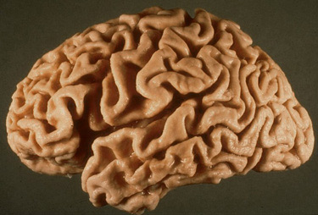
- Morphology:
Macroscopic:
- A variable degree of cortical atrophy with widening of the cerebral sulci that is most pronounced in the frontal, temporal, and parietal lobes. Except the Occipital lobe.
- With significant atrophy, there is compensatory ventricular enlargement (hydrocephalus ex vacuo).
Because of the emptiness in the brain the ventricle will grow bigger.

Microscopic:
- Plaques* (a type of extracellular lesion)
- neurofibrillary tangles (a type of intracellular lesion)
Tangles = Tau
Tangles الوصف:
Hyperphosphorylated tau التركيب:
Extracellular اذا ماتت الخلة ممكن يصير -

*It’s an aggregate (accumulation) of APP.
Plaques الوصف:
APPالتركيب:

Because these may also be present to a lesser extent in the brains of elderly nondemented individuals, the current criteria for a diagnosis of Alzheimer disease are based on a combination of clinical and pathologic features.
There is a fairly constant pattern of progression of involvement of brain regions pathologic changes: Earliest in the entorhinal cortex then spread through the hippocampal formation and isocortex then extend into the neocortex
- Silver staining methods or immunohistochemistry are extremely helpful in assessing the true burden of these changes in a brain.

What is immunohistochemistry? Microscopic localization of specific antigens in tissues by staining with antibodies labeled with fluorescent or pigmented material.
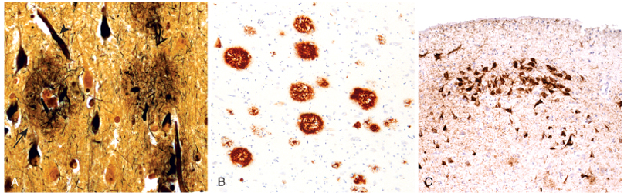

Neuritic plaques: | Neurofibrillary tangles:
⦁ Focal, spherical collections of dilated, tortuous, silver-staining neuritic processes (dystrophic neurites), often around a central amyloid core.  ⦁ Plaques can be found in the hippocampus and amygdala as well as in the neocortex, although there is usually relative sparing of primary motor and sensory cortices until late in the course of the disease.  ⦁ The amyloid core contains Aβ.  ⦁ Aβ deposits can also be found that lack any surrounding neuritic reaction, termed diffuse plaques. | ⦁ Bundles of paired helical filaments visible as basophilic fibrillary structures in the cytoplasm of the neurons that displace or encircle the nucleus.  ⦁ Tangles can remain after neurons die, then becoming a form of extracellular pathology.  التانقلز اساسًا موجودة انتراسيليولار لكن لمن تموت النيورونز تصير اكستراسيليولار بس لما تنسألون عنها المقصود:  Early => Intacellular!  ⦁ They are commonly found in cortical neurons, especially in the entorhinal cortex, as well as in other sites such as pyramidal cells of the hippocampus, the amygdala and the basal forebrain.  ⦁ A major component of paired helical filaments is abnormally hyperphosphorylated forms of the protein tau.  ⦁ Tangles are not specific to Alzheimer disease, being found in other degenerative diseases as well.
Tau and the accumulation of beta-Amyloid are not specific for Alzheimer, but they’re a characteristic for Alzheimer disease.
- Parkinsonism:
OSMOSIS: Parkinson’s Disease
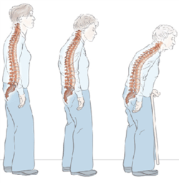
A clinical syndrome characterized by:
*
- Diminished facial expression (masked facies).
- Stooped posture.*
- Slowness of voluntary movement. (bradykinesia)
- Festinating gait (progressively shortened, accelerated steps).
- Rigidity.
Normal posture stooped posture
- "pill-rolling" tremor.

#So, motor disturbance that is seen in a number of conditions that share damage to dopaminergic neurons of the substantia nigra (in midbrain) or their projection to the striatum (caudate nucleus +putamen).

Parkinsonism can be induced by:
Etiology | Comment
Drugs that affect the neurons | Particularly dopamine antagonist and toxins
Post-encephalitic parkinsonism | Associated with the influenza pandemic
Idiopathic Parkinson's disease | The most common neurodegenerative disease associated with parkinsonism
Other neurodegenerative diseases | -
Head trauma – stroke | Rare

- Parkinson's disease:
- Diagnosis:
- Progressive parkinsonism.
- Absence of a toxic or other known underlying etiology.
- Clinical response to l-dihydroxyphenylalanine (l-DOPA) treatment.
At the beginning they response (l-DOPA) but with time they resist and do not respond.

- Epidemiology:
- 6-8 decades. ⦁ More than 2% in North America develop disease.
- Men more than women. ⦁ 22/100,000 = crude prevalence rate in Saudi population.
- Pathogenesis:
While most Parkinson disease is sporadic, there are both autosomal dominant and recessive forms of the disease.
- Genetic analysis has identified specific causal mutations, For example α-synuclein mutations cause autosomal dominant Parkinson disease as can gene duplications and triplications.
α-synuclein = is the chemical structure.
Lewy body = is what we’ll see under the microscope.

- Even in cases of Parkinson disease not caused by mutations in this gene, the diagnostic feature of the disease “the Lewy body” is an inclusion containing α-synuclein*.
*In the cytoplasm of the neurons of the substantia nigra.

- This is a widely expressed neuronal protein that is involved in synaptic transmission and other cellular processes.

- How the alterations in sequence or protein levels result in disease is unclear.

- The presence of α-synuclein in the Lewy bodies has suggested that defective degradation of the protein in the proteasome might play a role.

- This is supported by the identification of two other genetic loci for Parkinson disease:

- Which involve genes encoding parkin (an E3 ubiquitin ligase).
- UCHL-1 (An enzyme involved in recovery of ubiquitin from proteins targeted to the proteasome).
*In summary: Extra
α-synuclein
(normal protein )
The mutant genes could be:
*The gene which produce the protein itself:
α-synuclein gene
Or
*Those genes which participate in protein (α-synuclein) degradation in proteasome :
1) Parkin gene (E3 ubiquitin ligase).
2) UCHL-1.

Get mutated
(Loss the ability to be degraded)

α-synuclein will aggregate to insoluble fibers (lewy bodies)

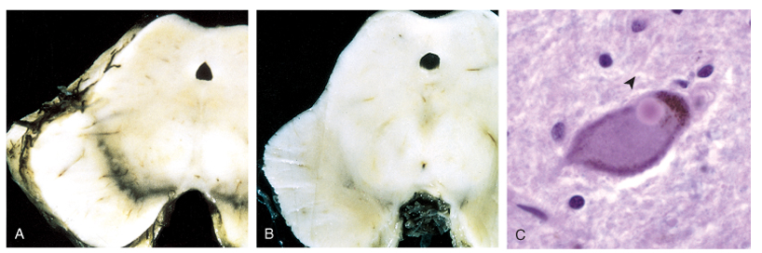
- Morphology:

- Macroscopic: pallor (بطّلت تصير سوداء و صارت باهتة)of the substantia nigra and locus ceruleus.

- Microscopic:
- Loss of the pigmented, neurons in these regions.
- Associated with gliosis.
- Lewy bodies may be found in some of the remaining neurons.

- Lewy bodies:
- Single or multiple, intracytoplasmic, eosinophilic, round to elongated inclusions that often have a dense core surrounded by a pale halo.
- Ultrastructurally, Lewy bodies are composed of fine filaments, densely packed in the core but loose at the rim.
- These filaments are composed of α-synuclein, along with other proteins.

- Clinical Features:
- Usually progresses over 10 to 15 years.
- Eventual severe motor slowing to the point of near immobility.
- About 10% to 15% of individuals with Parkinson disease develop dementia, the incidence increasing with advancing age.
⟣ Characteristic features of this disorder include a fluctuating course and hallucinations.
- While many affected individuals also have pathologic evidence of Alzheimer disease, the dementia in other Parkinson disease patients is attributed to widely disseminated Lewy bodies in the cerebral cortex. اللوي بوديز بتصير متوزعة بكل الكورتكس و ليس فقط في السبستينشيا نايقرا.

- When dementia arises within 1 year of the onset of motor symptoms, it is referred to Lewy body dementia. Because there is deposition of lewy bodies everywhere in the neurons.

(When there is an advanced motor area problems, there will be autonomic dysfunction behavior disorders. Dementia with mildly fluctuating course and hallucinations, is attributed to involvement of cerebral cortex, this dementia is referred to as Lewy body dementia).

- Treatment & Progression:
L-DOPA therapy is often extremely effective in symptomatic treatment, but it does not significantly alter the progressive nature of the disease. (As the patients develop resistance over years)
- Over time, L-DOPA becomes less effective at providing the patient with symptomatic relief and begins to cause fluctuations in motor function on its own.
Death is usually the result of intercurrent infection or trauma from frequent falls caused by postural instability.

  - Parkinson disease has been targeted for many novel therapeutic approaches.
  - Currently used neurosurgical approaches to Parkinson disease include the placement of lesions in the extrapyramidal system to compensate for the loss of nigrostriatal function or placement of stimulating electrodes - deep brain stimulation.

*Questions:

Q1: “Degenerative brain disease” refers to degeneration of:
A. Astrocytes. B. Microglial cell. C. Neurons.
(C) Is the correct answer.

Q2: Which of the following are the classic pathological features of Alzheimer's disease?
A. Hirano bodies. B. Lewy bodies. C. Neurofibrillary tangles and senile plaques.
(C) Is the correct answer.

Q3: One of the most well-documented genetic risk factors for Alzheimer's disease is:
A. The e4 allele of the apolipoprotein E.
B. The e3 allele of the apolipoprotein E.
C. Fragmented chromosomes 19 and 20.
D. Prions.
(A) Is the correct answer.

Q4: Which one of these enzymes degrades APP and prevents formation of Aβ?
A. α-secretase and γ-secretase. B. β-site APP-cleaving enzyme and γ-secretase.
(A) Is the correct answer.

Q5: Which type of neurons will be affected in case of parkinsonism :
A. GABAnergic neurons. B. Serotonergic neurons. C. Dopaminergic neurons.
(C) Is the correct answer.

Q6: Which of the following is a symptom of Parkinsonism?
A. Tingling. B. festinating gait. C. Nystagmus.
(B) Is the correct answer.

Q7: Parkinson's disease is associated with mutation of which gene:
A. α-synuclein. B. ApoE4. C. SORL1.
(A) Is the correct answer.

*Summary | Alzheimer Disease | Parkinsonism
characterized by | - Impairment of higher intellectual function  - Alterations in mood and behavior.  - Progressive disorientation.  - Memory loss.  - Aphasia.  - The next 5 to 10 y the patient becomes profoundly disabled, mute, and immobile.  - Cause of death is pneumonia and infections | - Diminished facial expression (masked facies).  - Stooped posture.  - Slowness of voluntary movement.  - Festinating.  - Rigidity.  - "pill-rolling" tremor.
Pathogenesis | Accumulation of a peptide (β amyloid, or Aβ), due to the cleavage of APP by the β and γ-secretase. | The presence of α-synuclein in the Lewy bodies.
Mutations | - In APP or in components of γ-secretase (presenilin-1 or presenilin-2).  - Patients with trisomy 21 (Down syndrome).  - An allele of apolipoprotein, called ε4 (ApoE4),.  - Another gene, called SORL1. | - α-synuclein mutations.  - Parkin (an E3 ubiquitin ligase).  - UCHL-1.
Morphology | - Macroscopic:  1-Atrophy in gyri with widening of the cerebral sulci.  2- Ventricular enlargement (hydrocephalus ex vacuo).  - Microscopic:  1- Plaques (a type of extracellular lesion)  2- Neurofibrillary tangles (a type of intracellular lesion) | - Macroscopic:  Pallor of the substantia nigra and locus ceruleus.  - Microscopic:  1- Loss of the pigmented, neurons in these regions.  2- Associated with gliosis.  3- Lewy bodies may be found in some of the remaining neurons
Stains | - Silver staining.  - Immunohistochemistry.
Clinical Features |  | - Usually progresses over 10 to 15 years.  - Severe motor slowing to the point of near immobility.  - 10% to 15% develop dementia, the incidence increasing with advancing age.
Treatment |  | - L-DOPA.  - Stimulating electrodes.
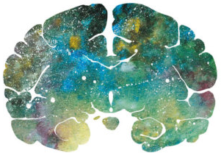
"اللهم لا سهل إلا ما جعلته سهلًا و أنت تجعل الحزن إذا شئت سهلًا"

Editing File
Email: pathology436@gmail.com Twitter: @pathology436
For your suggestions & complaints

References: Doctor’s slides, Robbins basic pathology ninth edition.
القادة
نوره السهلي طراد الوكيل
الأعضاء
نوف العماري ليلى البريكان
رنيم الغامدي مها الغامدي
وجدان الزيد سمر القحطاني

Unknown cause.
Is a fatal genetic disorder that causes the progressive breakdown of nerve cells in the brain which causes uncontrolled movements, emotional problems, and loss of thinking ability (cognition).
Protien found in the brain.
(CJD) is a universally fatal brain disorder. Early symptoms include memory problems, behavioral changes, poor coordination, and visual disturbances. Later dementia. Is believed to be caused by a protein known as a prion. Caused by eating cow meat.
(PML) is a rare and usually fatal viral disease characterized by progressive damage (-pathy) or inflammation of the white matter (leuko-) of the brain (-encephalo-) at multiple locations (multifocal). أتوقع طفشتوا من كثر ما ينعاد و إلا؟
متنوّع
Proceeding in a gradual, subtle way, but with very harmful effects.
Loss of ability to understand or express speech due to brain damage.
أخرس
مُتعرج
Unknown cause.
الدفيوز يكون كور من الأمايلويد لكن ما في حوالينها بروسيسز بينما البلايك تكون حوالينها نيورونال بروسيسيز.
Resting tremor of the thumb and fingers seen in Parkinson disease. كأن معه مسبحة)) (pill-rolling tremor video).
Parkinsonism vs. Parkinson's disease: Parkinsonism is a general term that refers to a group of neurological disorders that cause movement problems similar to those seen in Parkinson’s disease, such as tremors, slow movement and stiffness. But Parkinson’s disease is a neurodegenerative brain disorder that progresses and its symptoms includes the Parkinsonism .
Prodrug of dopamine.
A protein complex which degrades unneeded or damaged proteins by proteolysis.
This gene plays a critical role in ubiquitination -the process whereby molecules are covalently labelled with ubiquitin (Ub) and directed towards degradation in proteasomes-.

