Congenital malformation & hydrocephalus

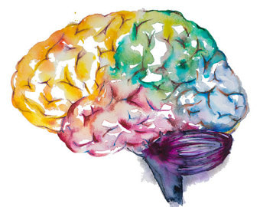

5- Pathogenesis with special emphasis on the role of folate and alpha fetoproteins and their clinical significance.
6- Definition and pathological changes in posterior fossa anomalies: Arnold Chiari malformation.
7- Hydrocephalus: Definitions of normal pressure hydrocephalus, noncommunicating hydrocephalus and communicating hydrocephalus - Pathophysiology and etiology.
Objectives:
1- Know the common types of congenital malformations of the CNS and have a basic knowledge of their pathological features.
2- Correlate CNS normal development with the classification of congenital CNS malformations.
3- Appreciate the role of folate deficiency as an etiological factor in neural tube defects and understand the role of Alpha fetoprotein measurement and ultrasound in antenatal diagnosis of neural tube defects.
4- Understand the various mechanisms that lead to the development of hydrocephalus.
5- List and classify the main causes of hydrocephalus.
Key principles to be discussed:
1- CNS congenital malformation incidence and introduction to the basic concepts behind the pathogenesis. These include genetic and environmental factors and the role of the stage of gestation development.
2- Definition and pathological changes in forebrain anomalies:
3- Megalencephaly, microencephaly and lissencephaly, Microencephaly causes.
4- Definition and pathological changes in neural tube defects
Black: Doctor’s slides.
Red or black bold: important!
Green: Doctor’s notes.
Grey: Extra.
Italic black: New terminology.
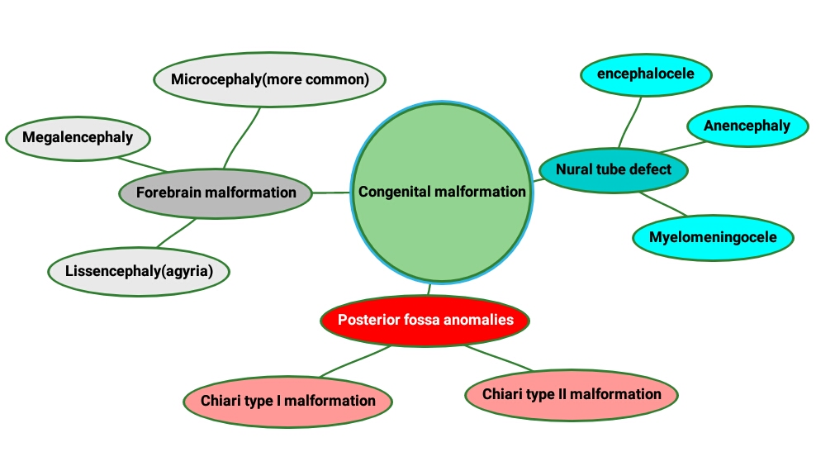
Lecture outlines:

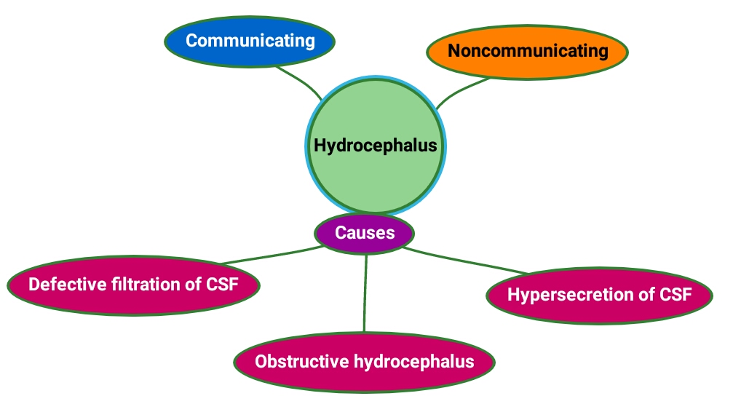

Congenital malformations:
The incidence of CNS malformations, giving rise to mental retardation, cerebral palsy, or neural tube defects, is estimated at 1% to 2%.
- Malformations of the brain are more common in the setting of multiple birth defects Because different parts of the brain develop at different times during gestation (and afterwards), the timing of an injury will be reflected in the pattern of malformation.
If one baby has a defect usually there is another defect.

- Prenatal or perinatal insults may either cause:
  - Failure of normal CNS development.
  - Tissue destruction. It can be due to infection or toxins.

⟣ Although the pathogenesis and etiology of many malformations remain unknown, both genetic and environmental factors are clearly at play:
⟣ CNS malformation can be caused by Mutations affecting molecules in pathways of neuronal and glial:
⦁ Development. ⦁ Migration. ⦁ Connection.

- Toxic compounds and Infectious agents have teratogenic effects.

A) Forebrain Malformations:
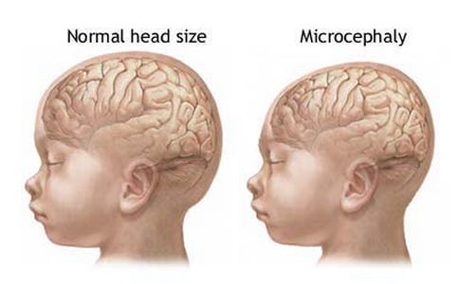
The volume of brain may be:
- Abnormally large (Megalencepahly).
- Small (Microencephaly, more common). Microencephaly, is usually associated with a small head as well.

They can occur in a wide range of clinical settings, including:
  - Chromosomal abnormalities.
  - Fetal alcohol syndrome.
  - Human immunodeficiency virus 1 (HIV-1) infection acquired in utero.

All causes are associated with:
- A decreased number of neurons destined for the cerebral cortex.
- Disruption of normal neuronal migration and differentiation during development can lead to a disruption of the normal gyration and six-layered neocortical architecture.

- Lissencephaly (Agyria): كلها سموث مافي قايراي بالمرة
Is characterized by an absence of normal gyration and a smooth-surfaced brain or, in case of more patchy involvement, (pachygyria). بعضها
  - The cortex is abnormally thickened and is usually only four-layered.
The normal is six-layers.

  - Single-gene defects have been identified in some cases of lissencephaly.
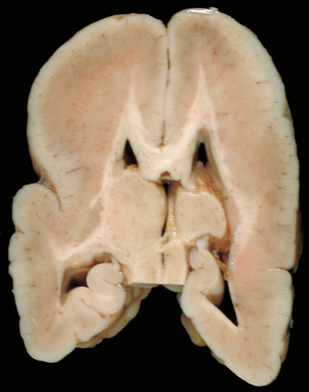
- Morphology:
- Cortical sulci are absent except, usually, for the Sylvian fissure.
- The cortex is thick and consists of the molecular and three neuronal layers.
- The deepest of these layers is also the thickest and most cellular, presumably comprised of neurons that migrated a certain distance from the ventricles but failed to reach their normal destinations.
- There is a small amount of myelinated white matter between the abnormal cortex and the ventricles.

- Lack of sulci.
- Thick cortex and flat surface.
- Loss of sulci and gyri contour.

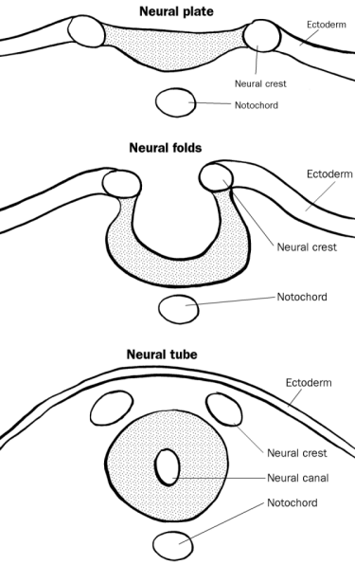
B) Neural tube defect:
The ectoderm did not close.
Among the earliest stages in brain development is the formation of the neural tube, the inside of which will become the ventricular system and the wall of which will become the brain and spinal cord.
Failure of a portion of the neural tube to close, or reopening after successful closure, may lead to one of several malformations. All are characterized by abnormalities involving some combination of neural tissue, meninges, and overlying bone or soft tissues. Collectively, neural tube defects are the most frequent CNS malformations.
Every word is important!

- Folate deficiency during the initial weeks of gestation is a risk factor; prenatal vitamins are aimed, in part, at reducing this risk.
Pregnant woman must take Folic acid.

- The combination of ultrasound and maternal screening for elevated α- fetoprotein has increased the early detection of neural tube defects.
يرتفع هذا البروتين بدم الأم إذا كان البيبي عنده هذا النوع من الديفيكتس.
- The overall recurrence risk in subsequent pregnancies is 4% to 5%.

Diseases associated with Neural Tube defects:

1- Myelomeningocele is an extension of CNS tissue through a defect in the vertebral column.
- They occur most commonly in the lumbosacral region.
- Patients have motor and sensory deficits in the lower extremities and problems with bowel and bladder control.
- The symptoms derive from the abnormal spinal cord in this region, and are often compounded by infections extending from thin or ulcerated overlying skin.

2- Anencephaly: is a malformation of the anterior end of the neural tube, with absence of the brain and top of skull. (At the other end of the developing brain)
3- Encephalocele: is a diverticulum of malformed CNS tissue extending through a defect in the cranium
It can happen in small openings in the nose and around the ear.

  - It most often involves the occipital region or the posterior fossa.

Myelomeningocele
Encephalocele (Extra)
Anencephaly

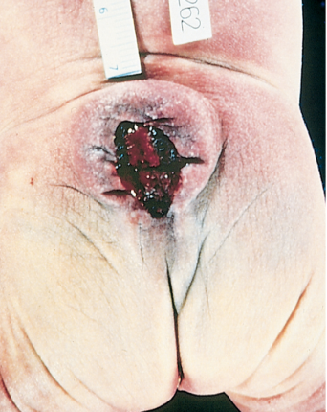
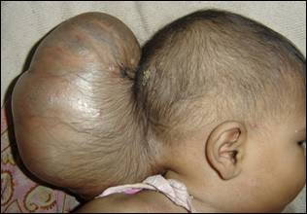
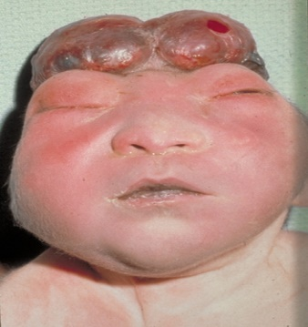

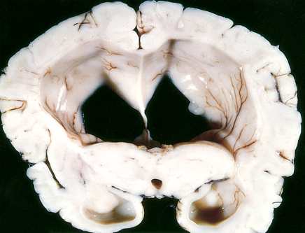
c) Posterior Fossa Anomalies: Could be: 1- Enviromintal. 2- Genetics.
The most common malformations in this region of the brain result in either misplaced or absent cerebellum. Typically, these are associated with hydrocephalus.
The Arnold-Chiari malformation:
Chiari type II malformation Most common | Chiari type I malformation (Extra)
Consist of:  عادتها الدكتورة ألف مرة:)!  ⦁ A small posterior fossa.  ⦁ A misshapen midline cerebellum.  ⦁ Downward extension of vermis through the foramen magnum.  ⦁ Hydrocephalus. (because it close or Obstruct the aqueduct)  ⦁ A lumbar myelomeningocele. | ⦁ Low-lying cerebellar tonsils extend through the foramen magnum at the base of the skull.  ⦁ This can lead to obstruction of CSF flow and compression of the medulla, resulting in symptoms of headache or cranial nerve deficits.  ⦁ Increasing the space for the tissue through neurosurgery can alleviate the symptoms.

Hydrocephalus: Hydro: water. Cephalus: in the brain.
Is the accumulation of excessive CSF within the ventricular system.

- Most cases occur as a consequence of impaired flow or impaired resorption of CSF.
*تنسأل كثير!

- In rare instances (e.g., tumors of the choroid plexus), overproduction of CSF may be responsible.

- When hydrocephalus develops in infancy before closure of the cranial sutures enlargement of the head. Which will lead to Macrocephaly, because they have flexible sutures.

- Hydrocephalus developing after fusion of the sutures expansion of the ventricles and increased intracranial pressure, without a change in head circumference.
ما يكبر الهيد هنا لأن السوتشرز سكّروا خلاص.

Extra
Extra
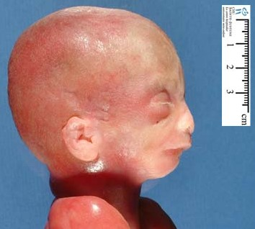
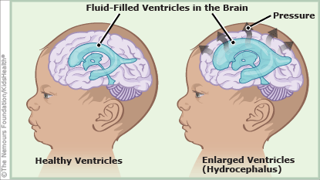

- Physiology of CSF:
- After being produced by the choroid plexus within the ventricles, cerebrospinal fluid (CSF) circulates through the ventricular system and exits through the foramina of Luschka and Magendie.
- CSF fills the subarachnoid space around the brain and spinal cord, contributing to the cushioning of the nervous system within its bony confines.
- The arachnoid granulations are responsible for the resorption of CSF.
- The balance between CSF generation and resorption keeps the volume of this fluid stable.

- Types of hydrocephalus:
Focal. مطرح إنلارجد و مطرح لا، يعني فوق كبير و تحت لا
a) Noncommunicating hydrocephalus:
If there is an obstacle to the flow of CSF within the ventricular system, then a portion of the ventricles enlarges while the remainder does not.
- Most commonly seen with masses at the foramen of Monro or aqueduct of Sylvius.
يعني تسكّر التدفق من اللاتيرال فينتركلز لتحت و نسمّيه عادةً “Flow abnormality”

Enlarged كله
b) Communicating hydrocephalus:
All of the ventricular system is enlarged; here the cause is most often reduced resorption of CSF.

What can cause hydrocephalus?
- Hypersecretion of CSF: e.g. choroid plexus tumor.
- Obstructive hydrocephalus:
*Very common, benign but can obstruct foramina of monro and lead to Death.
  - Obstruction of the foramina of Monro e.g. colloid cyst*.
  - Obstruction of the third ventricle e.g. pilocytic astrocytoma.
  - Obstruction of the aqueduct e.g. aqueductal stenosis or atresia and posterior fossa tumors.
  - Obstruction of the foramina of Luschka or impairment of flow from the fourth ventricle (Chiari malformation Type II, meningitis, subarachnoid hemorrhage, posterior fossa tumors).
  - Fibrosis of the subarachnoid space e.g. meningitis, subarachnoid hemorrhage, meningeal dissemination of tumors.
- Defective filtration of CSF: postulated for low-pressure hydrocephalus.
CSF is not absorbed, usually seen in patients in ICU.

*Homework
- Define:
- Meningocele:
Protrusion of the membranes of the brain or SC through a defect in the cranium or spinal column.

- Polymicrogyria:
Characterized by increased number of irregularly formed gyri that result in a bumpy surface.

- hydrocephalus ex vacuo:
An enlargement of cerebral ventricles and subarachnoid spaces, and is usually due to brain atrophy (as it occurs in dementias).

- What is the difference between microcephaly and microencephaly?
Microcephaly: Small head (skull).
Microencephaly: Small brain.

*Questions:

Q1: Myelomeningocele is mainly a defect associated with:
A. Spinal cord. B. Choroid plexus. C. Vertebral column.
D. Anterior end of neural tube.

(C) Is the correct answer

Q2: A pregnant female comes to you for her ultrasound. On the screen you can see that the brain is shrunken compared to the size it should be at this point of her pregnancy. You run an HIV test and it is (negative -). You revise the history and it turns out that she “enjoys” the occasional evening drink after work. Which of the following based upon this case would you expect to see within the fetus’ brain:

A. Spina bifida. B. Decrease in the number of neurons.
C. Hydrocephalus. D. Anencephaly.

(B) Is the correct answer

Q3: What is the most sever neural tube defects?
A. Anencephaly. B. Meningocele. C. Encephalocele. D. Hydrocephalus.

(A) Is the correct answer

Q4: Colloid cyst tumor can cause which of the following conditions:
A. Communicating hydrocephalus. B. Non-Communicating hydrocephalus.
C. Defective of filtration of CSF. D. Hypersecretion of CSF.

(B) Is the correct answer

Q5: If hydrocephalus develops in adults will lead to:
A. Head shrinkage. B. Head enlargement.
C. Narrowing of the ventricles. D.Increased intracranial pressure.

(D) Is the correct answer

Q6: What malformation can be associated with lumbar spina bifida?
A. Anencephaly. B. Encephalocele. C. Arnold-chiari Type II. D. Arnold-chiari Type I.

(C) Is the correct answer

Q7: Neural tube defects are associated with an increase in which of the following proteins in maternal serum?
A. S100 protein. B. Alpha-Fetoprotein. C. Beta-Fetoprotein. D. Gamma-Fetoprotein.

(B) Is the correct answer

Q8: All of the following are causes that could lead to obstructive Hydrocephalus except?
A. Low-pressure hydrocephalus. B. Meningitis. C. Subarachnoid hemorrhage. D. Pilocytic astrocytoma.

(A) Is the correct answer
*Summary

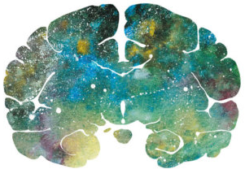
"اللهم لا سهل إلا ما جعلته سهلًا و أنت تجعل الحزن إذا شئت سهلًا"

Editing File
Email: pathology436@gmail.com Twitter: @pathology436
For your suggestions & complaints

القادة
نوره السهلي طراد الوكيل
الأعضاء
سعد القحطاني عبدالرحمن الراشد
فارس الجعفر عبدالله هاشم
عبدالعزيز القرموشي مبشر الأسمري
سارة الشمراني

References: Doctor’s slides + notes, Robbins basic pathology ninth edition.

Microencephaly: small brain, Microcephaly: small head
Prepared.
Pregnancy.
Myelo = Spinal cord, Meningo = Meninges, Cele = Herniation فتاق
An abnormal fluid filled sac.
The interventricular foramina (or foramina of Monro) are channels that connect the paired lateral ventricles with the third ventricle at the midline of the brain.
It’s a benign tumor but can cause death of patient.
Absence or abnormal narrowing of an opening.
Because it will cause inflammation, and this inflammation lead to granulation tissue (which is a fibrotic mass).
Assume.

