Meningitis

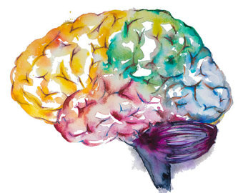

Objectives:
1- Revise the spectrum of organisms that can cause meningitis.
2- Explain the terms used in the description of CNS infections patterns.
3- Understand the pathology of acute bacterial and tuberculous meningitis and the information that can be obtained from investigation of cerebrospinal fluid in suspected meningitis.

Key principles to be discussed:

1- Meningitis and meningoencephalitis: definition and a list of the possible infectious etiologies.
2- Ports of entry of infection into the CNS.
3- Pyogenic meningitis: etiology, clinic-pathological features and CSF findings.
4- Viral (aseptic) meningitis: clinic-pathological features and CSF findings.
5- Tuberculous Meningitis: clinic-pathological features and CSF findings.
6- The definition and pathogenesis of epidural abscess, subdural empyema and brain abscess.
Black: Doctor’s slides.
Red or black bold: important!
Green: Doctor’s notes.
Grey: Extra.
Italic black: New terminology.
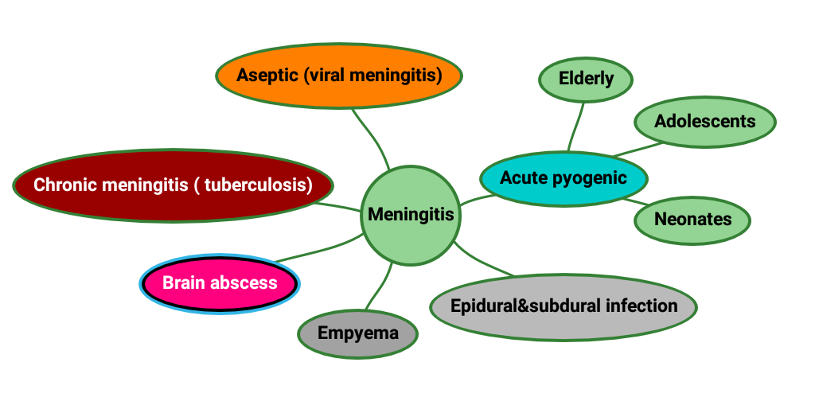
Lecture outlines:

CNS Infections:
Portals of entry of infection into the CNS:
  - Hematogenous spread: {the most common}.
  - Direct implantation: {traumatic or in congenital CNS malformation}.
  - Local extension: {occurs secondary to an established infection in a nearby organ (air sinus, an infected tooth or middle ear)} Ex: Otitis, Sinusitis.
  - Through the peripheral nervous system into the CNS: {certain viruses, such as rabies and herpes zoster}.

1- Meningitis:
An inflammatory process of the leptomeninges and CSF within the subarachnoid space.
Meningoencephalitis The infection when it spreads into the brain then it's called meningoencephalitis. Both brain + meninges.

Chemical meningitis: may occur in response to a nonbacterial irritant introduced into the subarachnoid space.

- Pyogenic meningitis :

- It’s a medical emergency.
The causative microorganisms Imp.
Neonates | Escherichia coli | group B streptococci
Adolescents and young adults | Neisseria meningitidis (Meningococcal meningitis)
Elderly | listeria monocytogenes | Streptococcus pneumoniae

- CSF Findings in spinal tap:

- Cloudy or frankly purulent CSF. Why? Because of WBCs ‘neutrophils’.
- As many as 90,000 neutrophils /mm.
- Raised protein level.
- Markedly reduced glucose content. Logic? Bacteria consume glucose & produce protein.
- Bacteria may be seen on a Gram stained smear or can be cultured, sometimes a few hours before the neutrophils appear.
If not treated will lead to death, that’s why it’s imp.
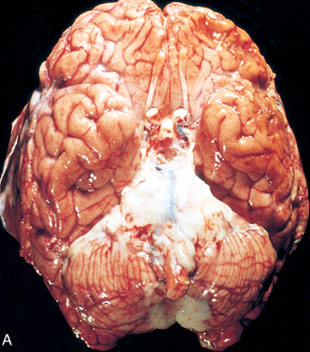
- Meningitis Clinical Features:
- Systemic non-specific signs of infection. Fever.
- Meningeal irritation signs and neurologic impairment:
Headache, photophobia, irritability, clouding of consciousness and neck stiffness.
- If untreated pyogenic meningitis can be fatal.
- Effective antimicrobial agents IV injection markedly reduce mortality associated with meningitis.
Acute meningitis

- Meningitis Complications:
- Phlebitis may venous occlusion hemorrhagic infarction of the underlying brain.
- Leptomeningeal fibrosis hydrocephalus.
- Septicemia hemorrhagic infarction of the adrenal glands and cutaneous petechiae (known as Waterhouse-Friderichsen syndrome, particularly common with meningococcal and pneumococcal meningitis).
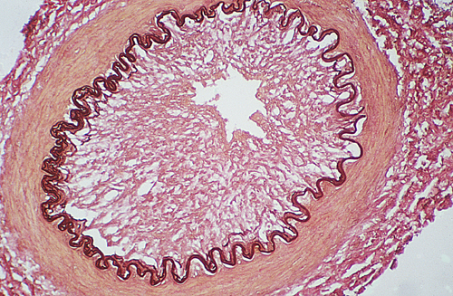
- Focal cerebritis & seizures.
- Cerebral abscess.
*لما الطفل يجيه ميننجايتيس بنلاحظ التغيّر لكنّه بيكون شوي مرة يكاد يكون غير مُلاحَظ.
- Cognitive deficit*.
- Deafness.
What is this complication?

- Meningeal vessels are engorged and prominent.

- The adrenal glands hemorrhagic infarction is bilateral.

B) Aseptic Meningitis (Viral Meningitis): The most common, more light.
- Aseptic meningitis is a misnomer.
- It is a clinical term for an illness comprising meningeal irritation, fever, and alterations of consciousness of relatively acute onset without recognizable organisms.
- The clinical course is less fulminant than in pyogenic meningitis, is usually self-limiting, and most often is treated symptomatically.

- The CSF: No bacteremia in fluid culture. أهم شيء تعرفونه بهذي المحاضرة هو الفايندينقز!
- Increased number of lymphocytes (pleiocytosis).
- Protein elevation is only moderate. Could be normal.
- Glucose content is nearly always normal. (because viruses don’t need energy)

- In approximately 70% of cases, a pathogen can eventually be identified, most commonly an enterovirus.
- There are no distinctive macroscopic characteristics except for brain swelling, seen in only some instances.

- On microscopic examination, there is either:

- No recognizable abnormality. (because you need electron microscope to see viruses).
- A mild to moderate infiltration of the leptomeninges with lymphocytes. (Because viral lymphocytes will deal with it).

2- Tuberculosis: Caseous type of necrosis. “Specific infection”.
- The subarachnoid space contains a fibrinous exudate (fluid full of protein), most often at the base of the brain. It may form something called: Tuberculoma.
- Tuberculoma is well-circumscribed intraparenchymal mass Not neoplastic it’s due to infection.
  - Rupture of tuberculoma into subarachnoid space results in tuberculous meningitis. (not tuberculoma itself because it is a mass not meningitis yet unless in case of rapture)
  - A tuberculoma may be up to several centimeters in diameter before, causing significant mass effect. (depending on the structure it is pressing on)
  - Always occurs after hematogenous dissemination of organism from primary pulmonary infection.
تجي التيوبركلوما من الهيماتوجينس سبريد صح؟ فعادةً تكون فالبيشنتس اللي عندهم:
1- Miliary TB. 2- Primary pulmonary infection.

- On microscopic examination, there is usually a central core of caseous necrosis surrounded by a typical tuberculous granulomatous reaction. With Giant cells.
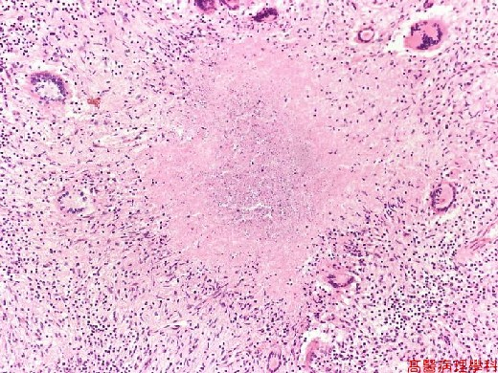
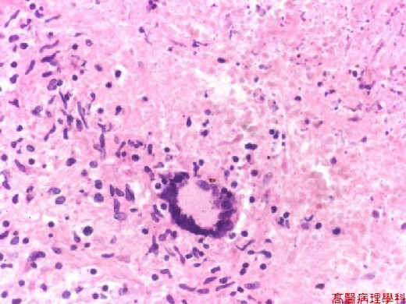

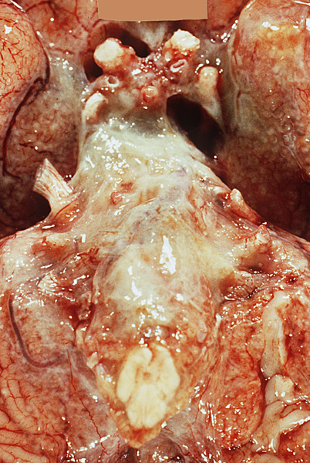
- CSF in TB:

- There is only a moderate increase in cellularity of the CSF (pleiocytosis) made up of mononuclear cells (mainly), or a mixture of polymorphonuclear and mononuclear cells.
- The protein level is elevated.
- The glucose content typically is moderately reduced or normal*. (because bacteria need energy)
TB meningitis: Exudate at the base of the brain.
*Why? Because TB is intracellular bacteria. ما هي برا عشان تأكل الجلوكوز.
3- Brain abscess: (within the brain tissue)
- Streptococci and staphylococci are the most common organisms identified in non-immunosuppressed populations.
- Predisposing conditions:
  - Acute bacterial endocarditis (usually give multiple microabscesses).
  - Cyanotic congenital heart disease in which there is a right-to-left shunt.
  - Loss of pulmonary filtration of organisms (e.g, bronchiectasis)
- Most common on cerebral hemispheres.

- Morphologically:
  - In the center Liquefactive necrosis.
  - The surrounding brain is edematous, congested & contains reactive astrocytes & perivascular inflammatory cells.
- Present clinically with progressive focal neurologic deficits in addition to the general signs of raised intracranial pressure.
- The CSF:
⦁ Contains only scanty cells.
⦁ increased levels of protein.
⦁ Normal level of glucose. Why? Because bacteria not in the CSF. It’s in the abscess Only!

- Complications of Brain abscess:
○ Herniation. Occurs because of increased intracranial pressure.
○ Rupture of abscess into subarachnoid space or ventricle.

4- Epidural and Subdural Infections:
These spaces can be involved with bacterial “usually” or fungal infections, usually as a consequence of direct local spread.
- Epidural abscess, commonly associated with osteomyelitis, arises from an adjacent focus of infection, such as sinusitis or a surgical procedure.
Because it close to it أكيد الإيبيدورال بتصير بالأوستيومايلايتس

- When the process occurs in the spinal epidural space, it may cause spinal cord compression and constitute a neurosurgical emergency.
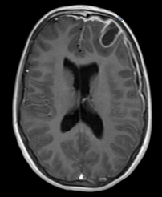
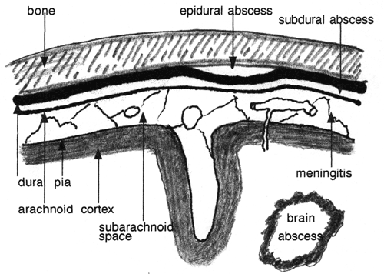

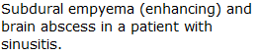
Where it happened انتبهوا كل وحدة

5-Empyema: We will have a cavity filled with Pus not Blood.
Infections of the skull or air sinuses may also spread to the subdural space, producing subdural empyema. Be aware it has nothing to do with epidural area.
Subdural Infection it spreads. Subdural Empyema it forms a collection.

- The underlying arachnoid and subarachnoid spaces are usually unaffected, but a large subdural empyema may produce a mass effect.
- In addition, thrombophlebitis* may develop in the bridging veins that cross the subdural space, resulting in venous occlusion and infarction of the brain.
*أكثر شيء يخوّف!

○ Symptoms include those referable to the source of the infection. Most patients are febrile, with headache and neck stiffness, and if untreated may develop focal neurologic signs, lethargy, and coma.
○ With treatment, including surgical^ drainage, resolution of the empyema occurs from the dural side; if resolution is complete, a thickened dura may be the only residual finding. With prompt treatment, complete recovery is usual. Antibiotics may not heal!
*Homework VERY VERY IMPORTANT
- Create a table of CSF findings in Meningitis, aseptic meningitis, TB meningitis, Brain abscess and multiple sclerosis.
CSF findings | Meningitis | Aseptic meningitis | TB meningitis | Brain abscess | MS
Cellular infiltration | polymorphs | Pleiocytosis MOSTLY lymphs |  | Scanty cells | -Pleiocytosis  - increased IgG
Protein | Increased | Moderate increase | Increased | Increased | Normal or slightly increased (oligoclonal bands of gamma globulins)
Glucose | Markedly decreased | Normal | Normal or slight decrease | Normal

*Questions:
Q1: A 65 years old patient admitted to ER suffering from very severe headache and witnessed tonic-clonic seizure, further investigation revealed that she had a medical history of sinusitis. What could we find in this case?

A. Presence of scanty cells in CSF. B. Thrombophlebitis of subdural veins.
C. leptomeninges with lymphocytes.
(B) Is the correct answer

Q2: What’s the most common rote of infections in CNS?

A. Hematogenous spread. B. Trauma. C. Through the peripheral nervous system.
D. local extension.
(A) Is the correct answer

Q3: Rupture in tuberculoma will lead to:

A. Subarachnoid meningitis. B. Dura meningitis. C. Subdural meningitis. D. Epidural meningitis.
(A) Is the correct answer

Q4: What is the most common organism in aseptic meningitis?

A. HIV Virus. B. Herpes zoster. C. Enterovirus. D. Rabies virus.
(C) Is the correct answer

Q5: What is the most common organism in Brain abscess?

A. Streptococci. B. Staphylococci. C. E.coli. D. A and B.
(D) Is the correct answer

Q6: What is the level of glucose in TB meningitis?

A. Low. B. Normal. C. High. D. Very high.
(B) Is the correct answer

Q7: Typical signs and symptoms of meningitis include all of these EXCEPT:
h
A. Headache. B. Stiff neck. C. Fever. D. RBCs in CSF.
(D) Is the correct answer

Q8: Life is not threatened by which of the following?

A. Bacteria. B. Fungi. C. Virus. D. Amoeba.
(C) Is the correct answer

*Summary
Pyogenic meningitis | Aseptic meningitis | Tuberculosis
*Causative organism:  - Neonates: E.coli + Group B streptococci.  - Adolescents: Neisseria meningitides.  - Elderly: listeria monocytogenes + strept. Pneuomoniae.  *Clinical features:  Headache, photophobia, neck stiffness.  *Complications:  Hydrocephalus, Waterhouse-friderichsen syndrome, Deafness. | - Viral infection (enterovirus).  - Usually self-limiting.  * Clinical features:  Meningeal irritation, fever, altered consciousness. | - Fibrinous exudate in the base of the brain.  - Tuberculoma:  well-circumscribed intraparenchymal mass, and the rupture of it will lead to tuberculous meningitis.  - Occurs after primary pulmonary infections.  - Granulomatous reactions.

Brain Abscess | Epi&sub-dural infections | Empyema
*Causative organism:  Streptococci & staphylococci.  *Predisposing conditions:  Acute endocarditis & bronchiectasis.  - Liquefactive necrosis.  - The surrounding of the brain is edematous & congested and contains reactive astrocytes. | - Consequence of direct local spread of bacterial or fungal infections.  - May cause spinal cord compression.  - Epidural abscess, commonly associated with osteomyelitis, arises from an adjacent focus of infection, such as sinusitis or a surgical procedure. | - Infections of the skull may spread to the subdural space, producing subdural empyema.  - Thrombophlebitis may develop in the bridging veins that cross the subdural space, infarction  *Symptoms:  headache, lethargy, coma and death.

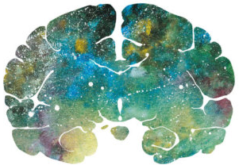
"اللهم لا سهل إلا ما جعلته سهلًا و أنت تجعل الحزن إذا شئت سهلًا"

Editing File
Email: pathology436@gmail.com Twitter: @pathology436
For your suggestions & complaints

القادة
نوره السهلي طراد الوكيل
الأعضاء
عبدالله أبوعمارة ريان القرني
صقر التميمي مبشر الأسمري
سالم العماري إبراهيم الديري

References: Doctor’s slides + notes, Robbins basic pathology 10th edition.

Inflammation of the walls of the veins.
Waterhouse–Friderichsen syndrome (WFS), hemorrhagic adrenalitis or fulminant meningococcemia is defined as adrenal gland failures due to bleeding because of severe infections.
Inaccurate name or a misleading name
Inflammation of bone or bone marrow.

