Neurosychatry Block

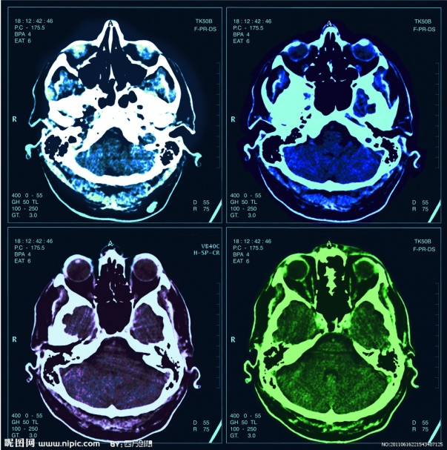
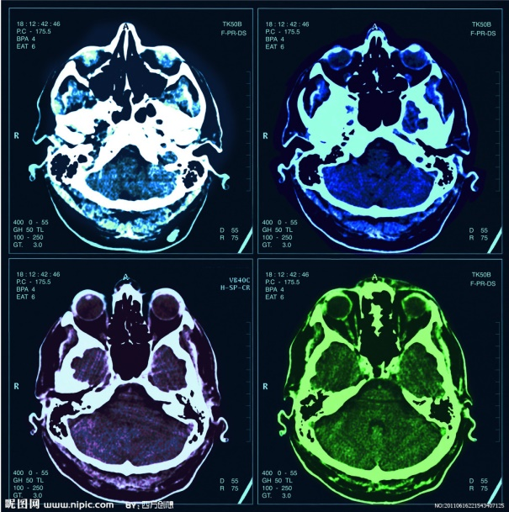
Spinal cord
Lecture one

Objectives:
- Identify and distinguish between common types of radiographic images.
- Recognizing the use, limitations, advantages and disadvantages of the different radiological modalities.
- Recognize the radiological presentation of the common spinal cord diseases and abnormalities.
Red: important
Green: Doctor’s notes
Grey: Extra

You can skip this page if you already know it.

Introduction:
At the beginning we’re going to review some basic concepts.

Body sections:
• Coronal (frontal) plane.
• Midsagittal (median) plane.
• Transverse (horizontal) plane.

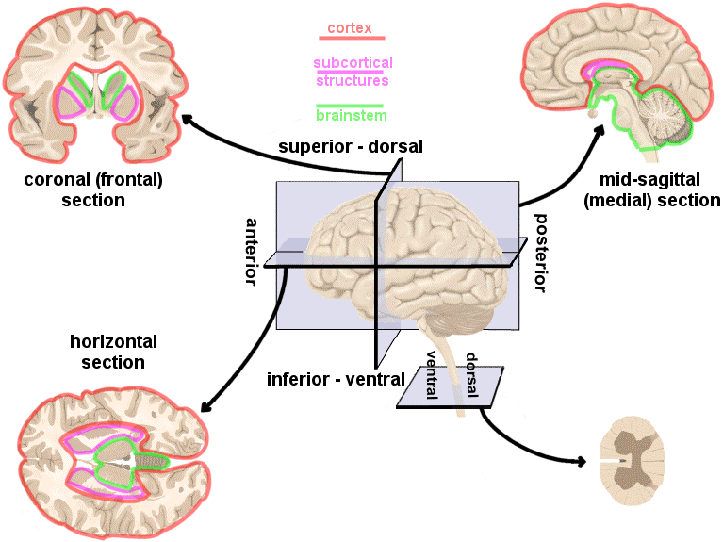
Types of Imaging views:
- PA (posterior-anterior) view.
- AP (anterior-posterior) view.
- Lateral view.
- Open mouth view.

Imaging modalities:
- US (Ultra Sound).
- X-ray (Radiographs).
- Angiography.
- CT scan (Computerized Tomography).
- MRI (Magnetic Resonance Imaging).

Imaging Methods to Evaluate Spinal Cord:

X-ray
CT
MRI

X-Rays (Radiographs)

- Often the first (initial) diagnostic imaging test ordered by physicians.
- Quick and cheap.
- Uses small dose of radiation to visualize the bony parts.
- Can detect:
- Spinal alignment and curvature.
- Spinal instability – with flexion and extension views
- Congenital (birth) defects of spinal column. (like scoliosis).
- Fractures caused by trauma.
- Moderate osteoporosis (loss of calcium from the bone).
- Infections.
- Tumors.
- Important for assessing cervical spine. Has to include all the cervical vertebrae + the junction between C7 and T1.

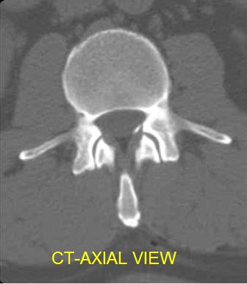
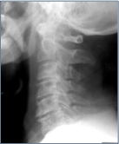
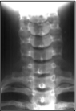
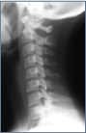
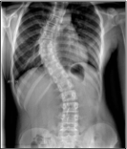
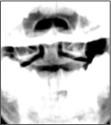
CT Scan (Computerized tomography):
AP view - patient with scoliosis
It’s not an adequate film; because only 6 vertebrae are seen, has to include all the 7 + the junction between C7 & T1.
An adequate AP view
An adequate lateral view
Open mouth view

- Uses ionized radiation.*
- Gold standard of imaging for Bone fractures and traumas. *
- Obtain 2-D images > can be processed to 3-D images.
- Entire spine can be imaged within a few minutes.(5 minutes)*.
- Detailed information regarding bony structures.
- Limited information about spinal cord & soft tissues.
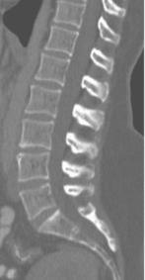
Normal C-spine with CT:
**in *in male`s slides( Uses radiation ).
*only in female`s slides .
*in male`s slides ( few second ).

Sagittal
Coronal
Axial
MAGNETIC RESONANCE IMAGING (MRI):
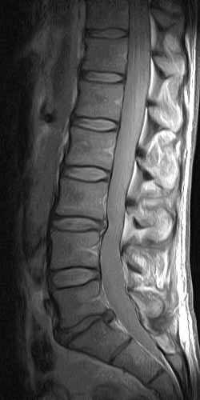
- Gold standard of imaging for spinal cord disorders.
- No radiation
- Can identify abnormalities of bone, soft tissues and spinal cord.
- Limitation: laustrophobic patients, uncooperative and children may need sedation or general anesthesia.
- Contraindications include implanted devices e.g. cardiac pacemakers and electromagnetic devices. (Most of modern artificial joints and advanced cardiac pacemakers are MRI friendly).
- MR vs CT: In MR we see the bone gray and black, where as in CT we can see the bone white

IT has 2 common sequences:
- T1 weighted image. (Fat = light color and CSF = dark color)
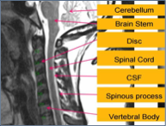
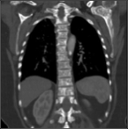
- T2 weighted image. (Fat = dark color and CSF = light color)
T2 WI – sagittal section
T2 WI – coronal section

 | Indications | Advantages | Disadvantages
X-RAY | Trauma  Intra-operative localization | Inexpensive  Widely available  Quick  Portable | Radiation exposure  Difficulty in interpretation  High rate of false-positive findings
CT | Trauma | Visualization of bony structures  Widely available  Quick | Less useful at showing soft tissue structures  Radiation exposure  -Expensive
MRI | Patients with "red flags" (urgent conditions)  Radiculopathy  Tumor  Myelopathy | Visualization of soft tissue structures (e.g. relationship of disc to nerve)  No radiation exposure | Contraindications: presence of ferromagnetic implants, cardiac pacemakers, intracranial clips, Claustrophobia  Availability  -Expensive

Abnormalities of Spinal Cord
What are the differences between X-ray, CT scan and MRI?

- Plain films (X-ray) are usually the first imaging method used in minor trauma.
- If fractures, or other bony defects, are suspected, CT images can provide very detailed information.
- When soft tissue / spinal cord injury is suspected, MRI is the imaging method of choice.
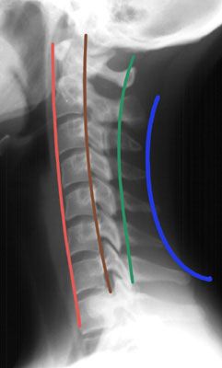
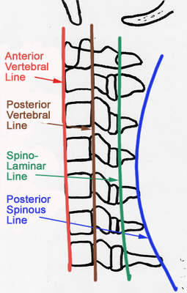
Assess for parallel lines* (imaginary lines):
1. Anterior vertebral line.
2. Posterior vertebral line.
3. Spinolaminar line.
4. Posterior spinous line.

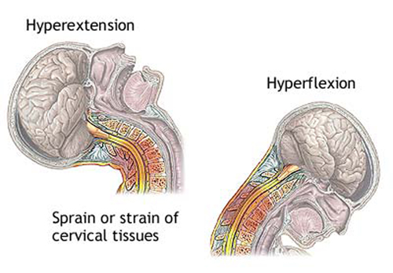
Mechanism of injury:
*This is so important!!! And the divisions depend on anatomy.

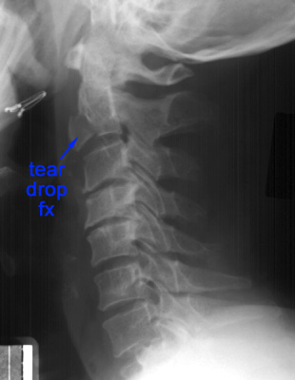
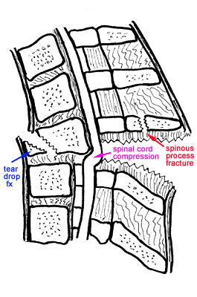
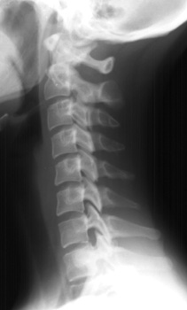
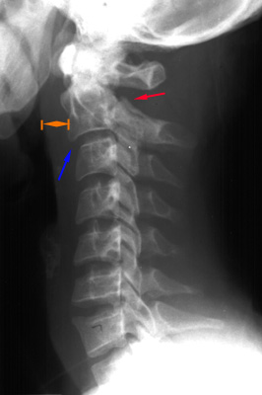
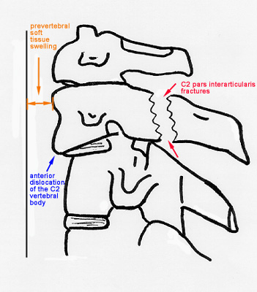
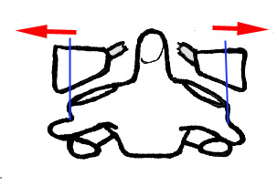
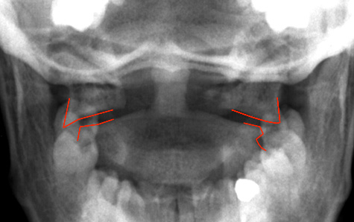
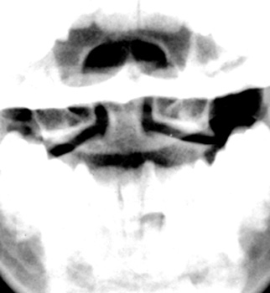
Hangman’s Fracture: result of hyperextension

*all pictures here are X-RAY

Hyperflexion:

Comprission Fructure:

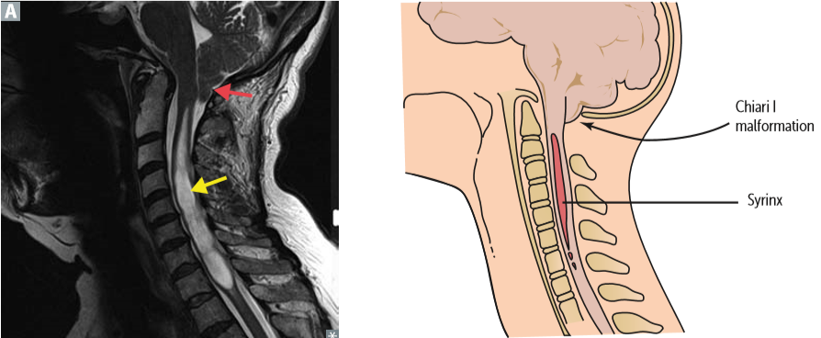
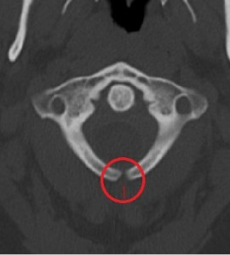
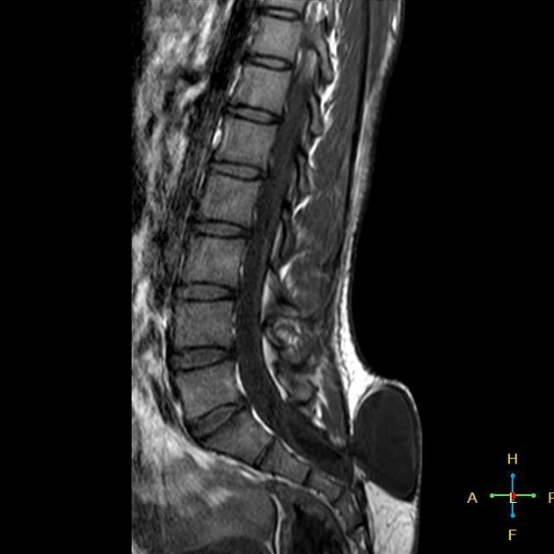
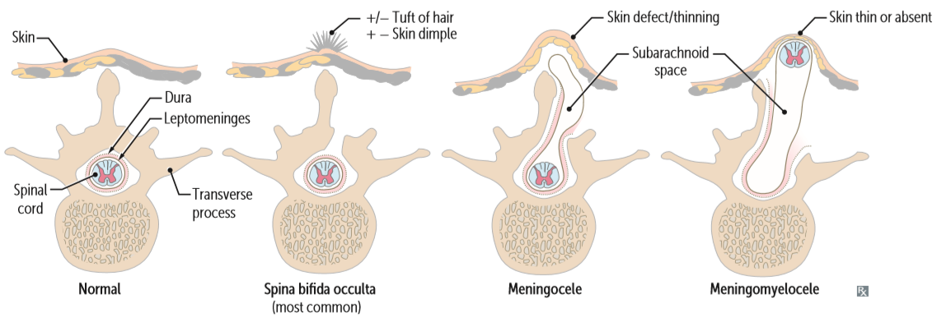
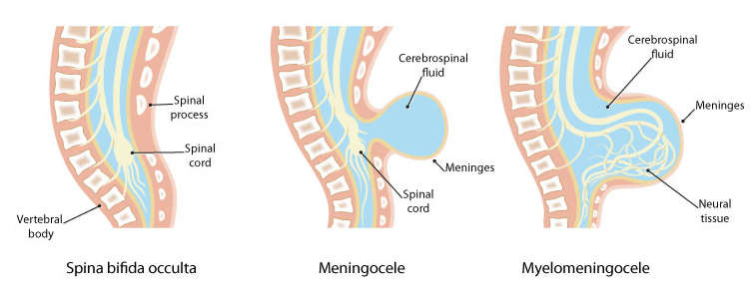
Syringomyelia: is the development of a fluid-filled cyst within the SC

*Notice the missing spinous process.

MR

MR

CT*

Spina bifida:

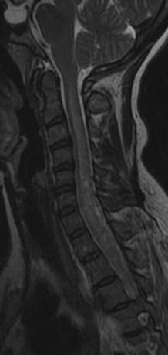
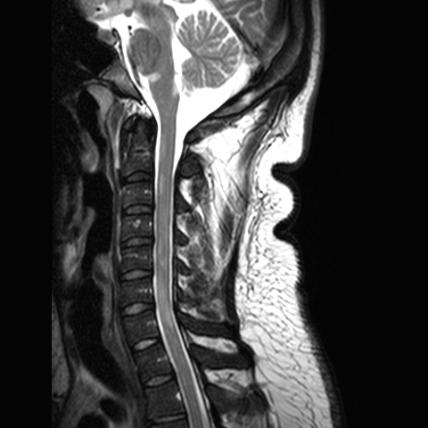
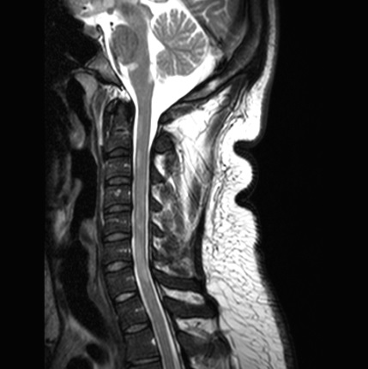
MS lesions in spinal cord are
- More likely multiple.
- focal and peripherally located.(only in female`s slides)
- Don’t cover the entire section on axial images.
- Often < 2 vertebral body heights on sagittal images.
- Are disseminated in time and space.(only in female`s slides)
Transverse myelitis lesions
- Often one big lesion. .(only in male`s slides).
- Extend over >3 vertebral body heights on axial images.
- Often >4 vertebral body heights on sagittal images. .(only in female`s slides)
- No brain lesions.
- Covers entire spinal cord in axial plane. .(only in male`s slides
- Monophasic.(only in male`s slides).
*This is too advanced for you. The most important thing to study is the anatomy.

Inflamed cord of uncertain cause.
- Viral infections.
- Immune reactions.
- Idiopathic.
Myelopathy progressing over hours to weeks.(only in female`s slides)

MS VS TM*:
Transverse Myelitis:

- Multiple sclerosis (MS) is a relatively common acquired chronic relapsing demyelinating disease involving CNS.
- Characteristically disseminated not only in space but also with time.

Multiple Sclerosis:

Classification:
1. Intramedullary lesions (within the substance of spinal cord)
its location is determined within the cord.

2. extramedullary lesions*
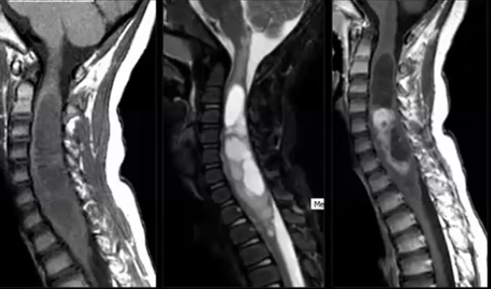
May be related to nerve roots and may extend into the neural foramen Intradural-extramedullary (e.g. schwannomas and neurofibromas) or they may have a broad dural attachment Intradural-extramedullary (e.g. meningiomas).
Astrocytoma: intramedullary tumor
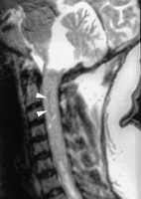
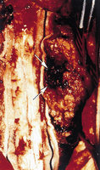
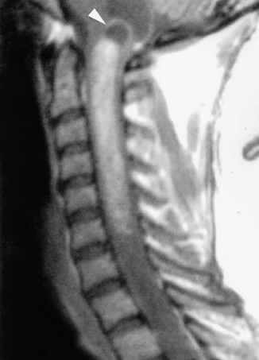
Ependymoma: Intramedullary and the most common in the spinal cord

*It can be divided into: (this part is very important)
1. Intradural-extramedullary (between the spinal cord and the dura),(in the meninges).
2. Extradural (outside the meninges/ dura). The most common between the 3 types, it occurs in the vertebral column and grow either from the bone or disk elements of the spine.

Group Leaders:
Mohammed Alduayj
Hanin Bashaikh

Group Members:
Rayan ALQarni
Abdulrahman Alomrani
Salem basamad
Abdullmajeed Alharbi
Abdullah Hashem
Omar Almugheer

Alanoud Abuhaimed
Aseel Badukhon
Ghaida Alsaeed
Wejdan Azaid

https://www.onlineexambuilder.com/1-spinal-cord/exam-180472https://www.onlineexambuilder.com/1-spinal-cord/exam-180472
https://drive.google.com/open?id=1g-hyfqVPGHCGBE6BBQMU8WsS1HURtzU9FjpCP0KhI18
https://drive.google.com/open?id=1PO3kVWNdOhC4T8eixprwDxFZPSQ_hXoiFt7229xWYDo
@Radiology436
Radiology436@gmail.com
References: male & female doctor slides.
Contact Us:

