

Neurosychatry Block

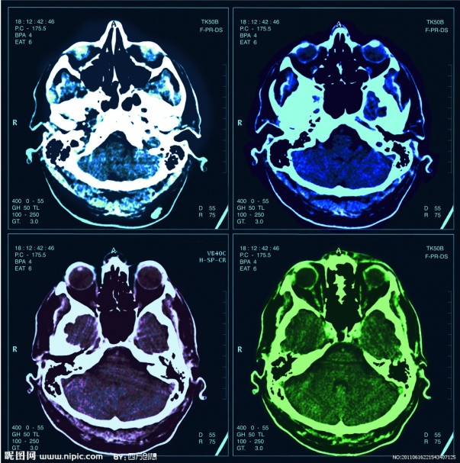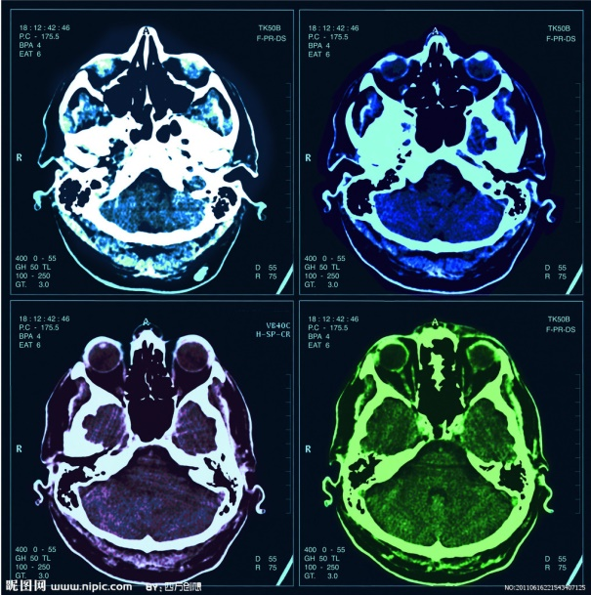

**Brainstem and Cerebellum**

**Lecture two**

**Objectives:**

1. Identify radiological anatomy of brain stem and cerebellum.
2. Compares CT and MRI imaging of brain stem and cerebellum.
3. Recognize the imaging findings in common diseases involving brain stem and cerebellum.

Red: important

Green: Doctor’s notes

Grey: Extra

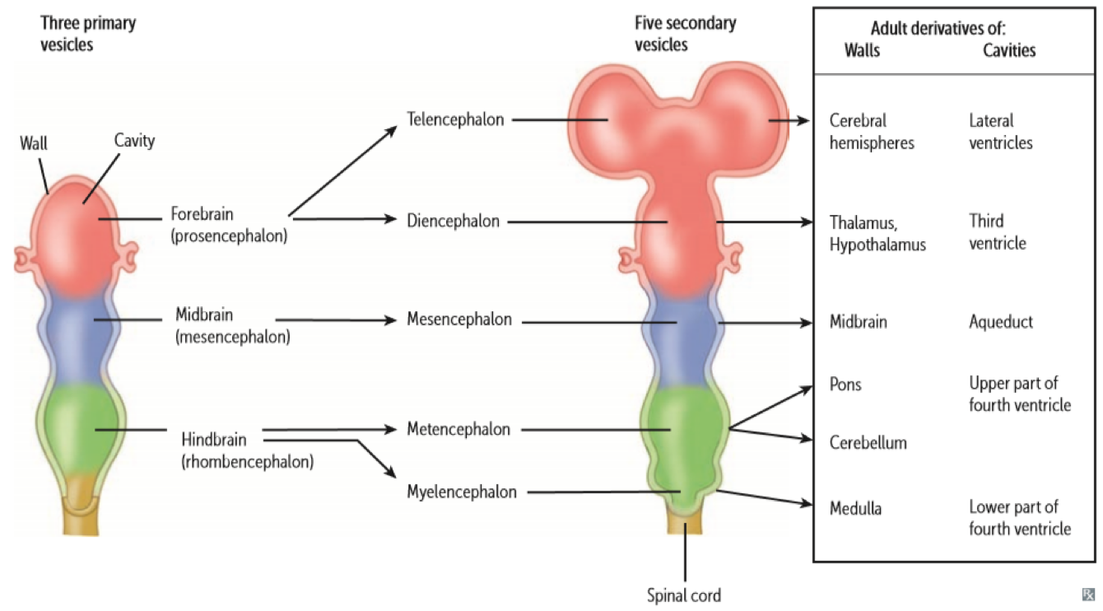**Brain Divisions:**

**Brainstem:**

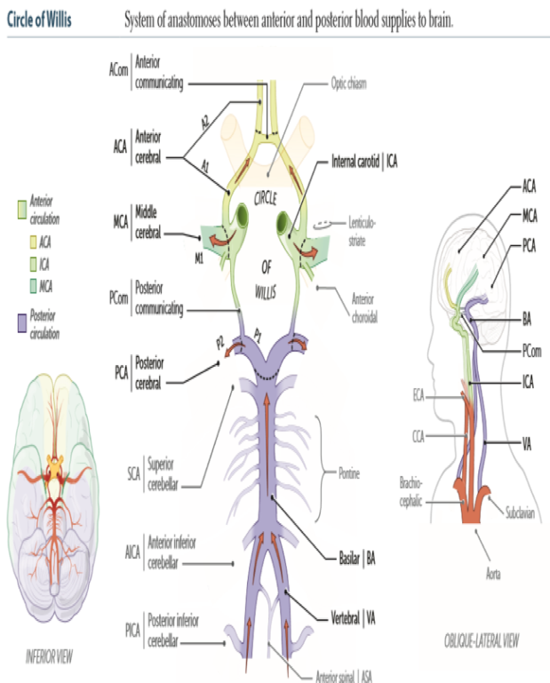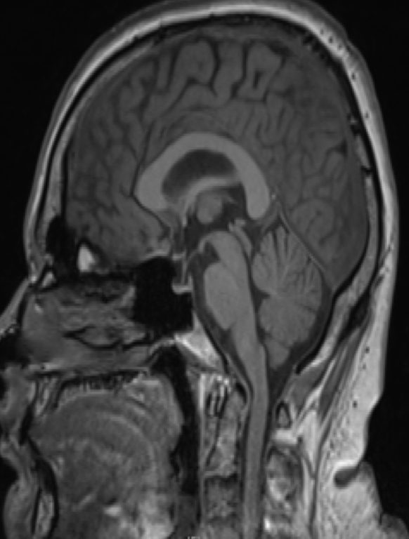

**Three parts from superior to inferior:**

1- Mid brain.

2- Pons (biggest part).

3- Medulla Oblongata.

1

2

3

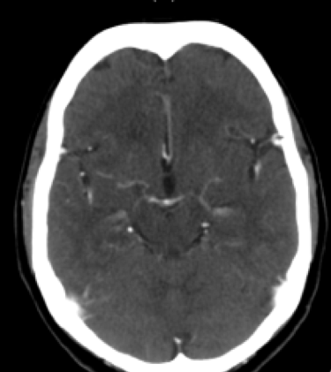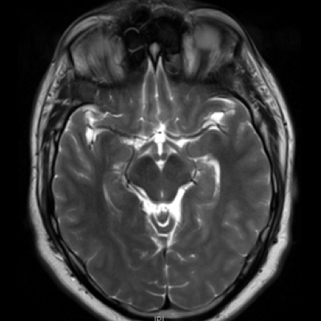**Midbrain:**

**Radiological Features:**

At the level of circle of willis

(circle that feeds the brain) and every structure is important to recognize the level/location.

1. Anteriorly two cerebral peduncles separated by interpeduncular fossa.
2. Posteriorly four rounded prominences (superior and inferior colliculi).

1.Superior colliculus.

2.Inferior colliculus.

(both are more clear in sagittal radiographes)

3.Cerebral peduncle.

4.Interpeduncular cistern.

Peduncle

Superior/inferior Colliculus*

Interpeduncle aqueduct**

MRI T2WI

CT

You have to know the differences between CT and MRI pictures.

MRI: shows the soft tissue clearly and bones appear with grey color.

CT: Bones appear white in color.

* The half circles. ** The small white spot.

Midbrain

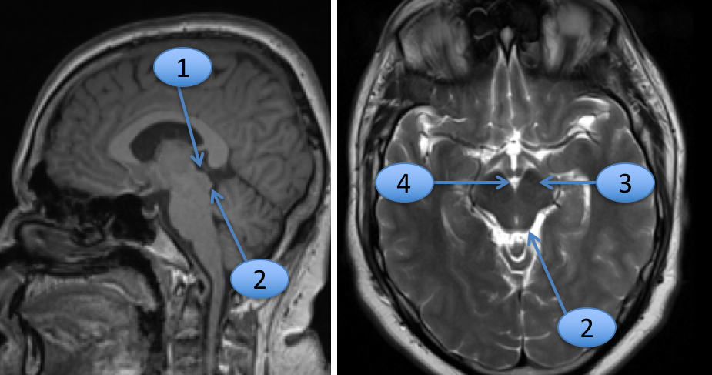

Axial T2WI

Sagittal T1WI

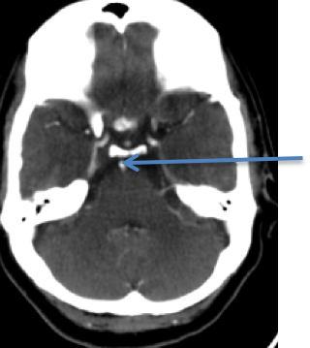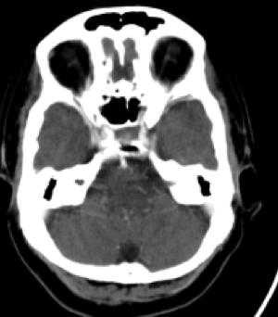**Pons:**

CT+

CT+

Petrous bone

Basilar artery

**Radiological Features:**

Basilar artery (comes from joining 2 vertebral arteries) lies in groove anteriorly.

Posterior surface of the pons forms the upper part of the floor of the 4th ventricle.

Bony anterior relation: clivus* bone centrally and petrous temporal bones laterally.

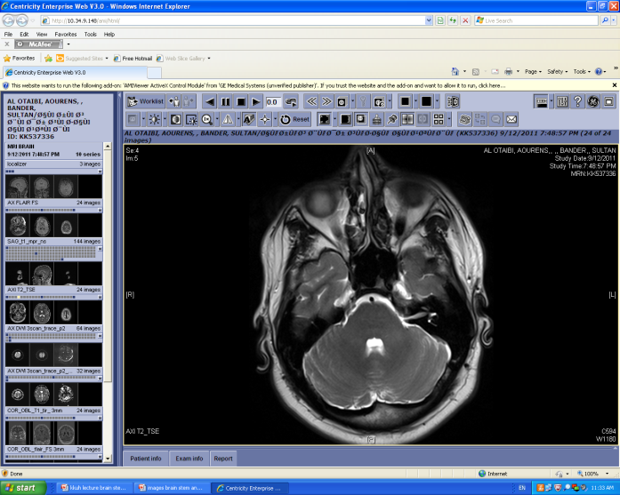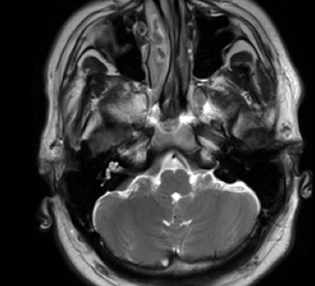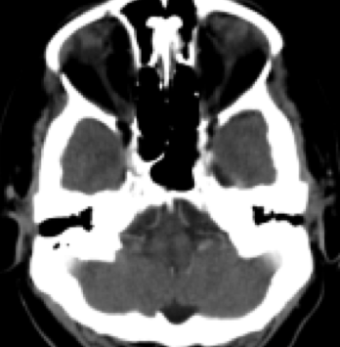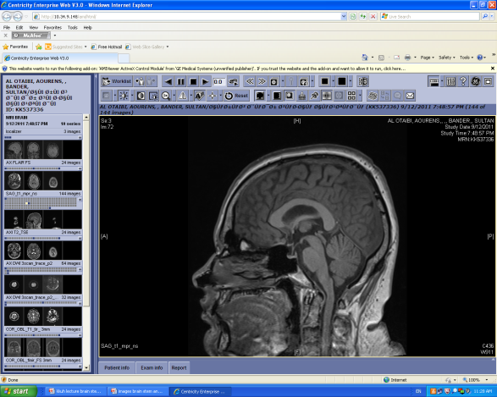**Medulla Oblongata:**

P

p

MRI Axial T2WI

*Behind the puititary gland. ** The black triangle. ***Black spot.

^ To know how to diffrenciate this image of M.O. from the previous one in the pons, you can observe the butterfly-like or diamond like shape inside the circle, which represents the 2 arteries that will unite later to form the basilar artery in the pons.

^

CT+

MRI Sagittal T1WI

MRI Axial T2WI

**Radiological Features:**

1. The ventral median fissure is seen anteriorly with the pyramid laterally
2. The 4th ventricle is seen posteriorly

P pons

1. 4th ventricle**.

2. basilar artery***.

1. middle cerebellar peduncle.

medulla

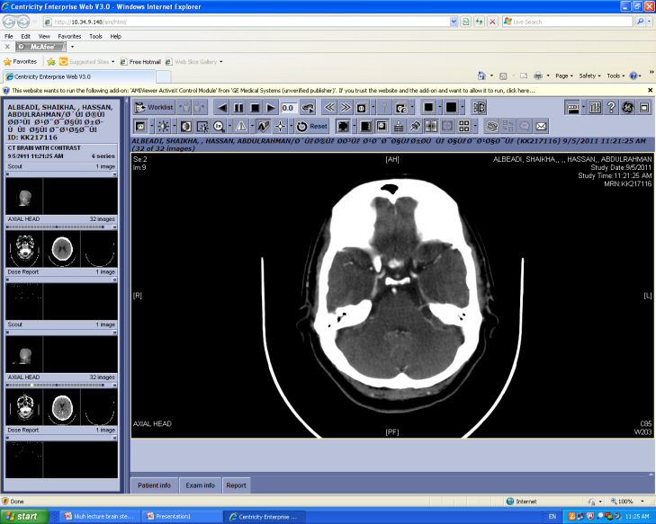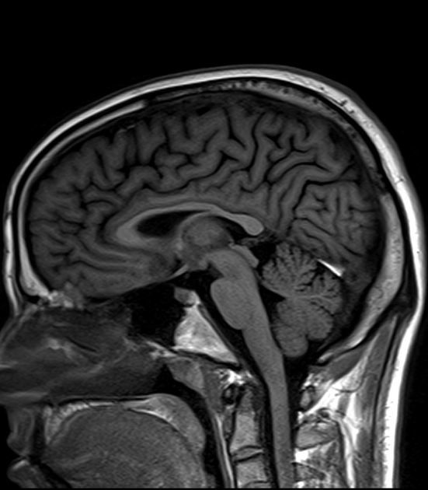**Cerebellum:**

**Radiological Features:**

On axial Ct & MRI the cerebellum is separated from the pons by the 4th ventricle*.

Connected to the pons on each side by middle cerebellar peduncle.

it is bounded anteriorly by petrous temporal bone.

Petrous bone

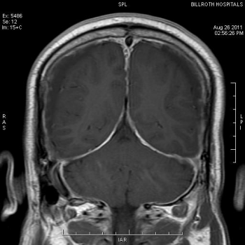

CT+

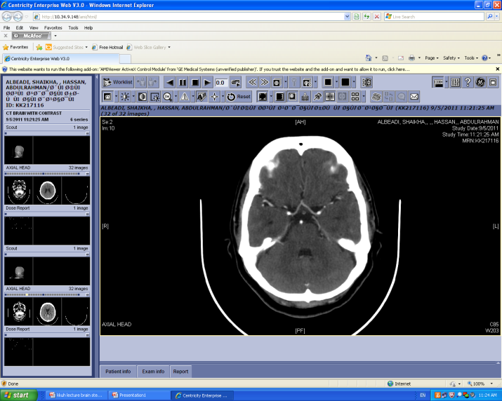

cerebellum

P

*The 4th ventricle is between the pons and cerebellum.

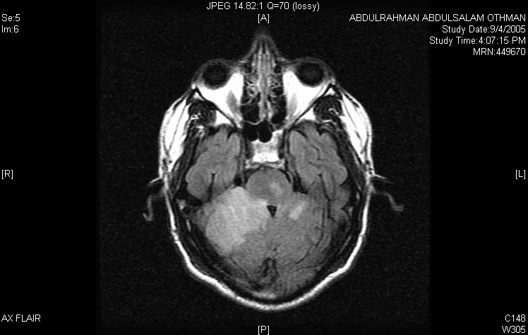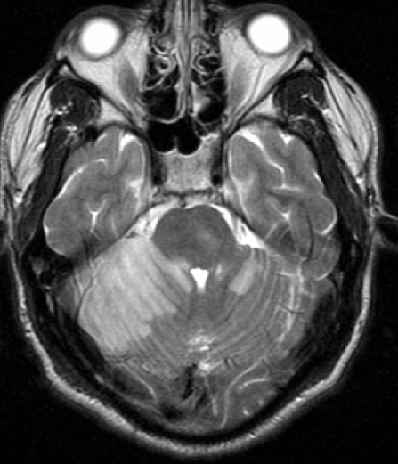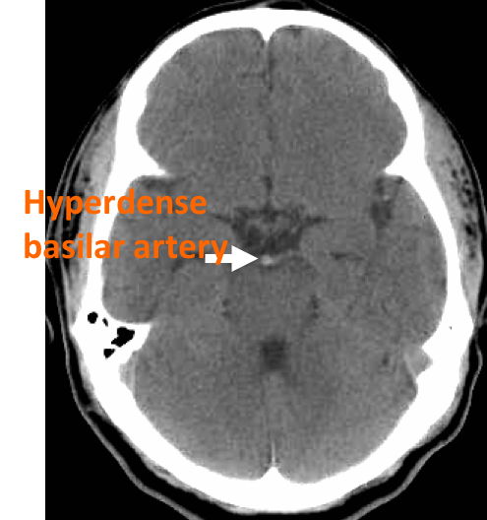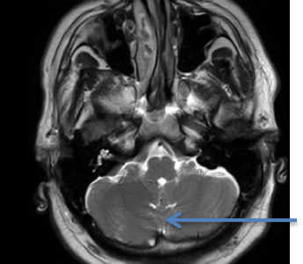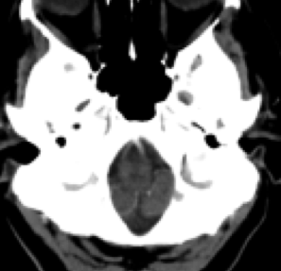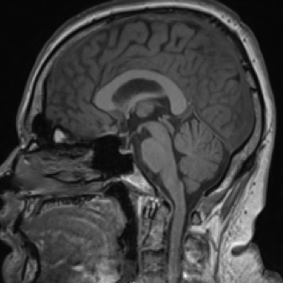

*Doctor note: Pathology is too advanced for you (focus on the anatomy more).

**Hyper-dense=lighter (white) e.g. Skull.

Hypo-dense=darker (black) Brain parenchyma.

1. Acute infarction due to basilar artery thrombosis** ***thrombosis

MRI Axial T2WI

MRI Axial FLAIR

CT

MRI Sagittal T1WI

MRI Axial T2WI

Axial CT

Vermis

Cerebellar Tonsil

**Common Diseases of Brain and Cerebellum\***

**Radiological Features:**

1. Cerebellum is connected to the brainstem by three pairs of cerebellum peduncles:

* Superior: connected to the midbrain.
* Middle: connected to the pons.
* Inferior: connected to medulla oblongata.

Two cerebellar hemisphere with midline vermis (Sulcus between 2 hemispheres)

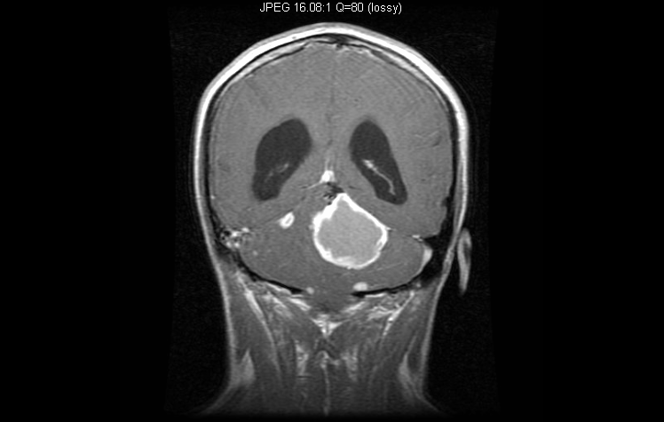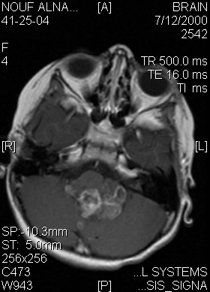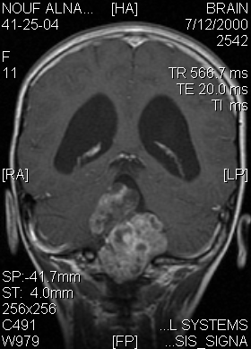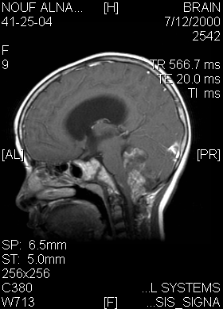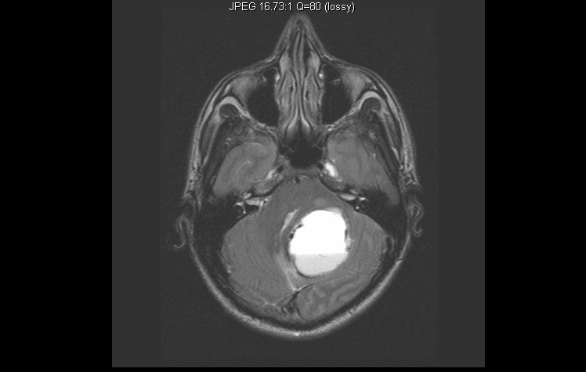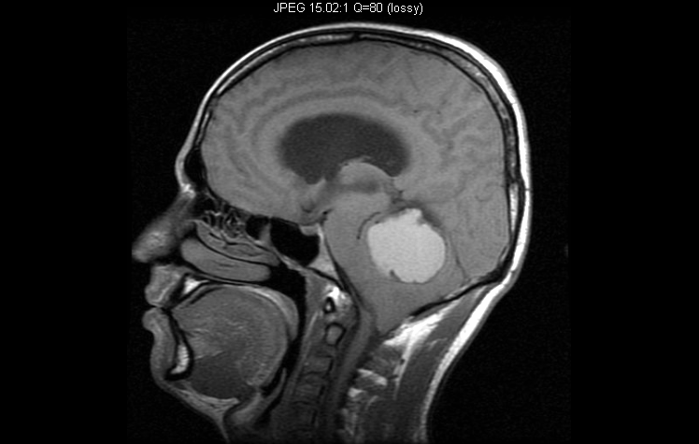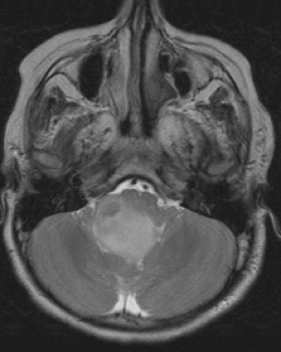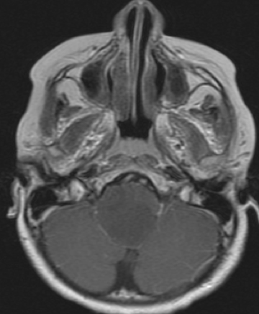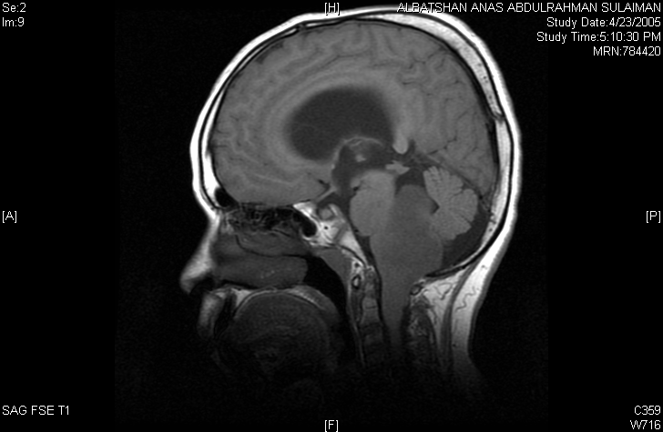

**3. Ependymoma** intramedullary tumor

Coronal MRI T1WI contrast

Axial MRI T2W1

Sagittal MRI T1WI contrast

Axial MRI T1WI contrast

Coronal MRI T1WI contrast

Sagittal MRI T1WI contrast

**2. Brainstem Glioma**

**4. Hemangioblastoma** intramedullary tumor

Axial MRI T2WI

Axial MRI T2WI

Sagittal MRI T1W1

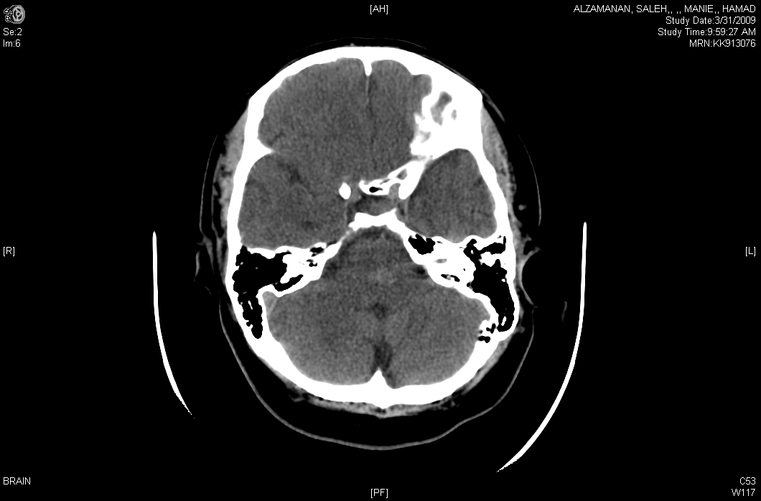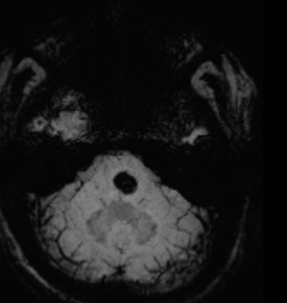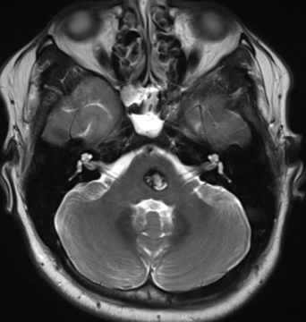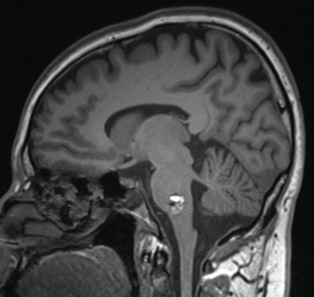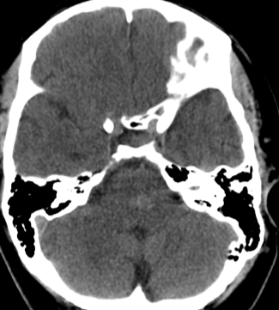

CT

Axial MRI SWI

Axial MRI T2WI

Sagittal MRI T1WI

**5. Cavernous Angioma**

How do we diagnose a patient?

We should do CT scan to see if is there any abnormal changes, and then we do MRI to specify if these changes are acute, subacute or chronic.

**Group** **Leaders:**

**Mohammed Alduayj**

**Hanin Bashaikh**

**Group Members:**

Aseel Badukhon

Ghaida Alsaeed

Lama Altamimi

Leena Alwakeel

Najd Altheeb

[https://www.onlineexambuilder.com/2-brainstem-cerebellum/exam-180217](https://www.onlineexambuilder.com/2-brainstem-cerebellum/exam-180217)

[https://drive.google.com/open?id=1g-hyfqVPGHCGBE6BBQMU8WsS1HURtzU9FjpCP0KhI18](https://drive.google.com/open?id=1g-hyfqVPGHCGBE6BBQMU8WsS1HURtzU9FjpCP0KhI18)

[https://drive.google.com/open?id=1PO3kVWNdOhC4T8eixprwDxFZPSQ_hXoiFt7229xWYDo](https://drive.google.com/open?id=1PO3kVWNdOhC4T8eixprwDxFZPSQ_hXoiFt7229xWYDo)

**References:**

* Stephanie Ryan, “**Anatomy for Diagnostic imaging**”, 2nd Edition, Pages 61-66
* Jamie Weir, Peter Abraham, “**Imaging Atlas of Human Anatomy”** 3rd Edition, Pages 34-41
* Peter Armstrong, “**diagnostic imaging** ”, 5th Edition, Pages (396-404)

**[](https://www.google.com.sa/url?sa=i&rct=j&q=&esrc=s&source=images&cd=&cad=rja&uact=8&ved=0ahUKEwjg4r34jqrWAhWHUBQKHdNaBUQQjRwIBw&url=https://twitter.com/mstreamteam&psig=AFQjCNFtqNWc88raA-zHB69P_ZPY5Y29OA&ust=1505665420472148)[Description: Image result for g mail](https://www.google.com.sa/url?sa=i&rct=j&q=&esrc=s&source=images&cd=&cad=rja&uact=8&ved=0ahUKEwjr1eCVjqrWAhVHfxoKHRiwCK0QjRwIBw&url=https://play.google.com/store/apps/details?id=com.google.android.gm&psig=AFQjCNHP5Krbnj7G-u5TWK07hlMsgiMS_A&ust=1505665206148176)**

**Contact Us:**

@Radiology436

Radiology436@gmail.com