King Saud University
College of Medicine
Department of Medical Education and the Department of Pathology

Integrated Biochemistry & Pathology Practical Class
Liver Function Tests

Year Two, GASTROINTESTINAL & HAEMATOLOGY Block
Student’s Tasks

Copyright Statement

This material is protected by copyright laws. For any other purposes other than teaching and research in the King Saud University, no part may be reproduced or copied in any form or by any means without prior permission of the King Saud University.

© King Saud University, Kingdom of Saudi Arabia (2011).

This Practical Class is Designed and Prepared By:
Professor Samy A. Azer (Medical Education)
Dr. Rana Hasanato (Biochemistry)
Dr. Reem Sallam (Biochemistry)
Dr. Sumbul Fatma (Biochemistry)
Dr. Amer Shafie (Pathology)
Dr. Sayed Al Esawy (Pathology)
Dr. Shaesta Naseem (Pathology)

King Saud University
College of Medicine

Integrated Practical Class- Year 2
Gastrointestinal & Haematology Block
(Department of Medical Education
and the Department of Pathology (Biochemistry and Histopathology Units)

Objectives of the Practical Class
This practical class aims at integration of knowledge from biochemistry and pathology in relation to interpretation of the liver function tests and associated pathological changes in a number of clinical situations. The aim is to enforce deep learning and use task-based learning, and student-centered learning approaches in the design of this practical class. It is expected that by the end of this practical class, students should be able to:

- Understand the scientific basis of the measurement of serum bilirubin and practice the measurement of serum bilirubin by using a biochemical kit and the spectrophotometer.
- Discuss the scientific principles behind the liver function tests with particular emphasis on bilirubin metabolism and application of knowledge.
- Discuss and work on four cases covering interpretation of liver function tests and associated liver pathological changes in each case.

PART 1

Venue: Multipurpose Laboratory,
Medical Biochemistry Unit,
Level 2

Case 1
A 22-year-old science student is travelling to a country in Africa where malaria is endemic. As a prophylaxis for malaria, his general practitioner prescribes him chloroquine tablets. A few days later and before his travel, he develops jaundice, feels tired and fatigued. He also looks pale.
There are no changes in the colour of his urine and he has no fever.
On examination, nothing significant is found apart from jaundice and pallor of his mucous membranes. The results of his blood tests are shown in the tables below:
Complete Blood Count:
Blood Test | Patient’s results | Normal range
Haemoglobin | 8.2 | 11.5-15.5 g/100ml
White blood cell count | 6 x 10⁹ /L | 4-11 x 10⁹/L
Packed cell volume (PCV) | 41 | 37-47%
Mean corpuscular volume (MCV) | 90 | 80-96 fl
Platelet count | 290,000 | 160,000-500,000 mm³
Liver Function Tests
Test | Patient’s Results | Normal Range
Serum bilirubin | 26 | 0-19 µmol/L
Aspartate Aminotransferase (AST) | 35 | 0-40 IU/L
Alanine Aminotransferase (ALT) | 44 | 0-50 IU/L
Alkaline Phosphatase (ALP) | 76 | 0-120 IU/L
Gamma Glutamyltranspeptidase (γ- GT) | 34 | 0-50 IU/L
Serum albumin | 40 | 35-50 g/L
Prothrombin time | 12 seconds | 10-14 seconds
.

Questions
Q1. In the light of his medical history, interpret the results of his complete blood tests and liver function tests.
………………………………………………………………………………………………………………………………………………………………………………………………………………………………………………………………………………………………………………………………………………………………………………………………………………………………………………………………………………………………………………………………………………………………………………………………………………………………………………………………………………………………………………………………………………………………………………………………………………………………………………………………………………………………………………………………………………………………………………………………………………………………………………………………………………………………………………………………………………………………………………………………………………………………………………………………………………………………………………………………………………………………………………………………………………

Q2. What are the most likely causes (hypotheses)
………………………………………………………………………………………………………………………………………………………………………………………………………………………………………………………………………………………………………………………………………………………………………………………………………………………………………………………………………………………………………………………………………………………………………………………………………………………………………………………………………………………………………………………………………………………………………………………………………………………………………………………………………………………………………………………………………………………………………………………………………………………………………………………………………………………………………………………………………………………………………………………………………………………………………………………………………………………………………………………………………………………………………………………………………………

Q3. What are the underlying mechanisms for his jaundice?
………………………………………………………………………………………………………………………………………………………………………………………………………………………………………………………………………………………………………………………………………………………………………………………………………………………………………………………………………………………………………………………………………………………………………………………………………………………………………………………………………………………………………………………………………………………………………………………………………………………………………………………………………………………………………………………………………………………………………………………………………………………………………………………………………………………………………………………………………………………………………………………………………………………………………………………………………………………………………………………………………………………………………………………………………………

Q4. Which one of the following is the most likely liver histological image for this patient? Select one only. Give a justification for your answer.
Image A
Image B
Image C
Image A | Image B
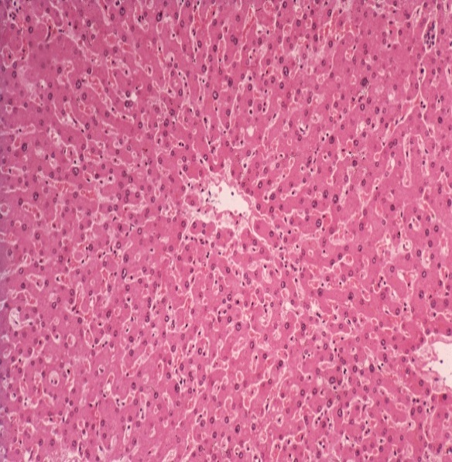
Image C
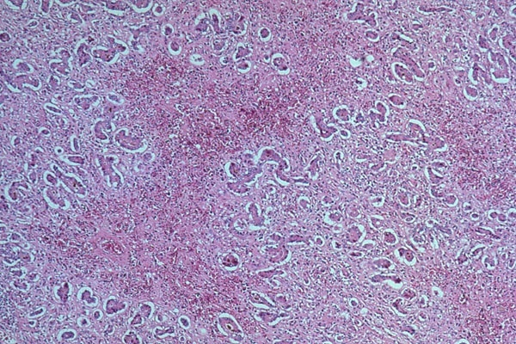
Justification:
………………………………………………………………………………………………………………………………………………………………………………………………………………………………………………………………………………………………………………………………………………………………………………………………………………………………………………………………………………………………………………………………………………………………………………………………………………………………………………………………………………………………………………………………………………………………………………………………………………………………………………
Case 2
An 27 years-old Indian worker who has arrived to Saudi Arabia about two weeks ago to work with a maintenance company, presents to the company doctor because of abdominal pain, loss of appetite, and changes in the colour of his urine for the last 24 -30 hours. His urine is as dark as black tea. He also has loose bowel motions and his stools are pale.
On examination, his body temperature is 38.5 °C (normal range: 36.6-37.2 °C), his pulse rate is 96/min (normal range: 60-100/min), his blood pressure is 120/80 mmHg (normal range: 100/60-135/80 mmHg), and his respiratory rate is 20/min (normal range: 12-16/min). He is jaundiced. There are no palpable lymph nodes. His abdomen is soft but there is tenderness over the right upper abdomen (most likely the liver). Auscultation of the abdomen: normal bowel sounds.
The results of his blood tests are shown the tables below:
Complete Blood Count:
Blood Test | Patient’s results | Normal range
Haemoglobin | 12.4 | 11.5-15.5 g/100ml
White blood cell count | 2 x 10⁹ /L | 4-11 x 10⁹/L
Packed cell volume (PCV) | 48 | 37-47%
Mean corpuscular volume (MCV) | 90 | 80-96 fl
Platelet count | 290,000 | 160,000-500,000 mm³
Liver Function Tests
Test | Patient’s Results | Normal Range
Serum bilirubin | 45 | 0-19 µmol/L
Aspartate Aminotransferase (AST) | 4000 | 0-40 IU/L
Alanine Aminotransferase (ALT) | 5900 | 0-50 IU/L
Alkaline Phosphatase (ALP) | 205 | 0-120 IU/L
Gamma Glutamyltranspeptidase (γ- GT) | 37 | 0-50 IU/L
Serum albumin | 38 | 35-50 g/L
Prothrombin time | 15 seconds | 10-14 seconds
Stool Microscopic Examination:
No pus, no red blood cells, no mucous, no parasites or ova.
Urinalysis:
Bilirubin +++
Questions
Q1. In the light of his medical history, interpret the results of his complete blood tests and liver function tests.
………………………………………………………………………………………………………………………………………………………………………………………………………………………………………………………………………………………………………………………………………………………………………………………………………………………………………………………………………………………………………………………………………………………………………………………………………………………………………………………………………………………………………………………………………………………………………………………………………………………………………………………………………………………………………………………………………………………………………………………

Q2. What are the most likely causes (hypotheses)
………………………………………………………………………………………………………………………………………………………………………………………………………………………………………………………………………………………………………………………………………………………………………………………………………………………………………………………………………………………………………………………………………………………………………………………………………………………………………………………………………………………………………………………………………………………………………………………………………………………………………………………………………………………………………………………………………………………………………………………………………………………………………………………………………………………………………………………………

Q3. What are the underlying mechanisms for his jaundice?
………………………………………………………………………………………………………………………………………………………………………………………………………………………………………………………………………………………………………………………………………………………………………………………………………………………………………………………………………………………………………………………………………………………………………………………………………………………………………………………………………………………………………………………………………………………………………………………………………………………………………………………………………………………………………………………………………………………………………………………………………………………………………………………………………………………………………………………………
Q4. Which one of the following is the most likely liver histological image for this patient? Select one only. Give a justification for your answer.
Image A
Image B
Image C
……………………………………………………………………………………………………………………………………
Image A | Image B
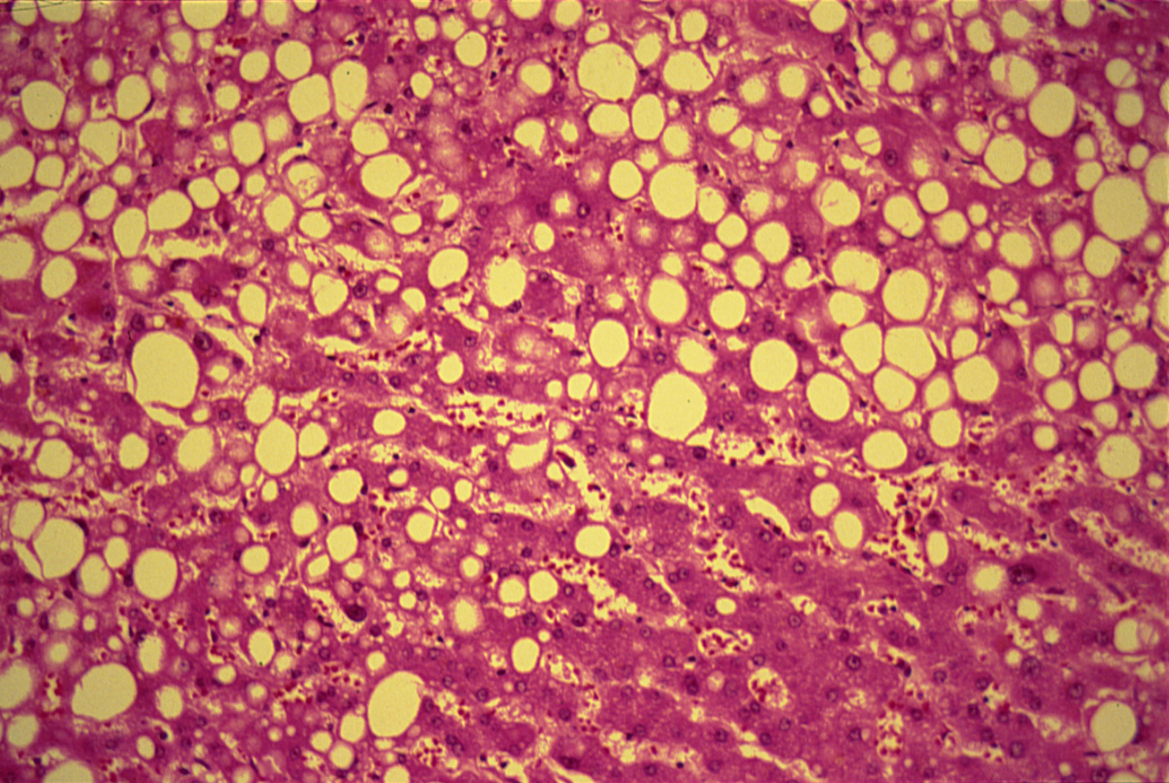
Image C
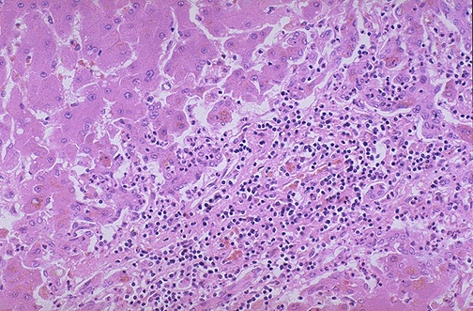

Case 3
A 75 year-old retired worker presents to his general practitioner because of loss of appetite and a loss of 6 kg in his body weight for over the last 6-8 months. Recently he noticed that his urine has become a little dark and his daughter noticed that his eyes are yellow.
On examination, his blood pressure is 130/85 mmHg (normal range: 100/60-135/80 mmHg), his pulse is 90/min (normal range: 60-100/min), his body temperature is 37.1 °C (normal range: 36.6-37.2 °C), and his respiratory rate is 18/min (normal range: 12-16/min). On examination, there is jaundice of his eyes. He looks pale and a rounded mass is felt under the right costal margin. He is referred for blood tests and ultrasound examination of the abdomen.
The ultrasound shows a dilatation of the gallbladder and a mass in the head of the pancreas. The results of his blood tests are shown in the tables below:
Complete Blood Count:
Blood Test | Patient’s results | Normal range
Haemoglobin | 8.2 | 11.5-15.5 g/100ml
White blood cell count | 6 x 10⁹ /L | 4-11 x 10⁹/L
Packed cell volume (PCV) | 42 | 37-47%
Mean corpuscular volume (MCV) | 90 | 80-96 fl
Platelet count | 290,000 | 160,000-500,000 mm³
Liver Function Tests
Test | Patient’s Results | Normal Range
Serum bilirubin | 37 | 0-19 µmol/L
Aspartate Aminotransferase (AST) | 55 | 0-40 IU/L
Alanine Aminotransferase (ALT) | 79 | 0-50 IU/L
Alkaline Phosphatase (ALP) | 980 | 0-120 IU/L
Gamma Glutamyltranspeptidase (γ- GT) | 60 | 0-50 IU/L
Serum albumin | 29 | 35-50 g/L
Prothrombin time | 13 seconds | 10-14 seconds
. Questions
Q1. In the light of his medical history, interpret the results of his complete blood tests and liver function tests.
………………………………………………………………………………………………………………………………………………………………………………………………………………………………………………………………………………………………………………………………………………………………………………………………………………………………………………………………………………………………………………………………………………………………………………………………………………………………………………………………………………………………………………………………………………………………………………………………………………………………………………………………………………………………………………………………………………………………………………………………………………………………………………………………………………………………………………………………………………………………………………………………………………………………………………………………………………………………………………………………………………………………………………………………………………

Q2. What are the most likely causes (hypotheses)
………………………………………………………………………………………………………………………………………………………………………………………………………………………………………………………………………………………………………………………………………………………………………………………………………………………………………………………………………………………………………………………………………………………………………………………………………………………………………………………………………………………………………………………………………………………………………………………………………………………………………………………………………………………………………………………………………………………………………………………………………………………………………………………………………………………………………………………………………………………………………………………………………………………………………………………………………………………………………………………………………………………………………………………………………………

Q3. What are the underlying mechanisms for his jaundice?
………………………………………………………………………………………………………………………………………………………………………………………………………………………………………………………………………………………………………………………………………………………………………………………………………………………………………………………………………………………………………………………………………………………………………………………………………………………………………………………………………………………………………………………………………………………………………………………………………………………………………………………………………………………………………………………………………………………………………………………………………………………………………………………………………………………………………………………………………………………………………………………………………………………………………………………………………………………………………………………………………………………………………………………………………………

Q4. Which one of the following is the most likely liver histological image for this patient? Select one only. Give a justification for your answer.
Image A
Image B
Image C
Image A | Image B
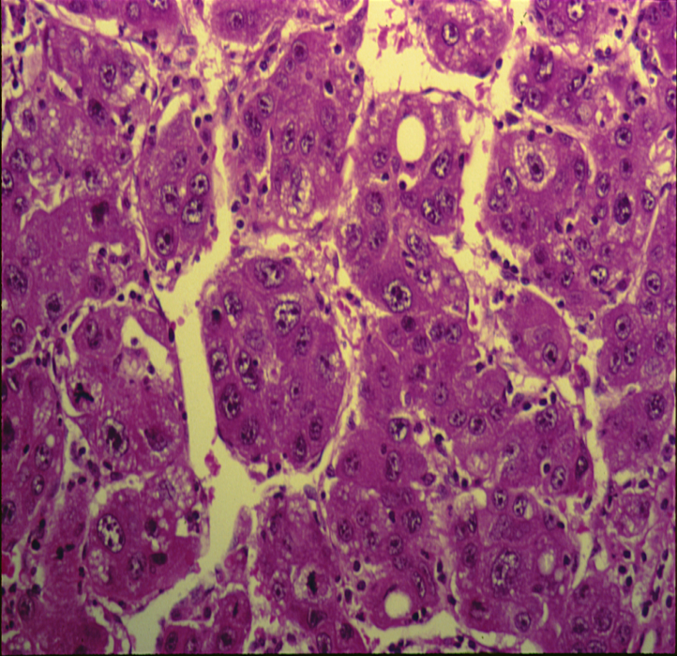 | 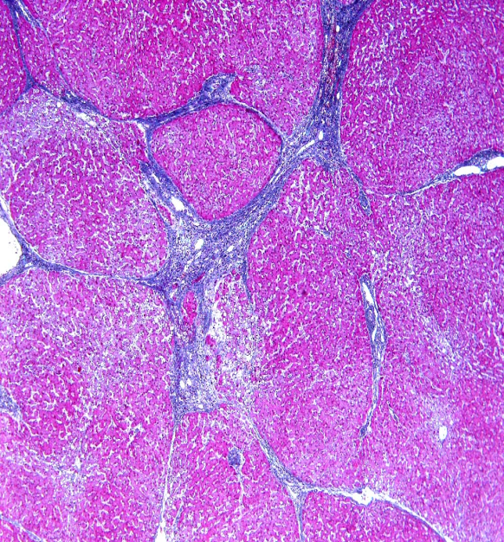
Image C
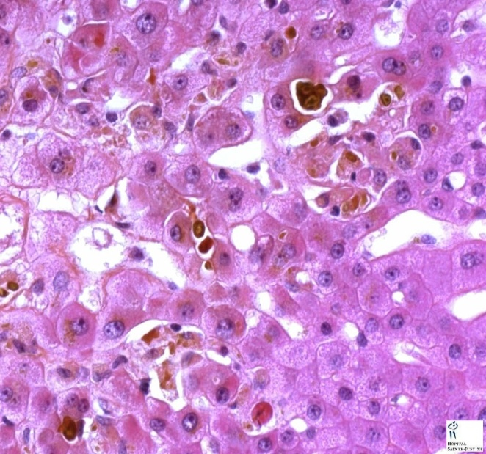
Justification:
………………………………………………………………………………………………………………………………………………………………………………………………………………………………………………………………………………………………………………………………………………………………………………………………………………………………………………………………………………………………………………………………………………………………………………………………………………………………………………………………………………………………………………………………………………………………………………………………………………………………………………
Case 4
A 27-year-old female who has several problems with her family and is depressed for over a year, is brought by the ambulance to the Accident & Emergency Department semiconscious. Her parents say that she swallowed over 20 tablets a few hours ago. The empty package found beside her bed is for paracetamol tablets. On examination, she is semiconscious and has jaundice in her eyes. The emergency registrars do all emergency measures and send blood samples for laboratory tests. Toxicology blood test confirms the presence of paracetamol metabolites in her blood.
Complete Blood Count:
Blood Test | Patient’s results | Normal range
Haemoglobin | 12.0 | 11.5-15.5 g/100ml
White blood cell count | 6 x 10⁹ /L | 4-11 x 10⁹/L
Packed cell volume (PCV) | 35 | 37-47%
Mean corpuscular volume (MCV) | 83 | 80-96 fl
Platelet count | 200,000 | 160,000-500,000 mm³
Liver Function Tests
Test | Patient’s Results | Normal Range
Serum bilirubin | 33 | 0-19 µmol/L
Aspartate Aminotransferase (AST) | 370 | 0-40 IU/L
Alanine Aminotransferase (ALT) | 460 | 0-50 IU/L
Alkaline Phosphatase (ALP) | 260 | 0-120 IU/L
Gamma Glutamyltranspeptidase (γ- GT) | 102 | 0-50 IU/L
Serum albumin | 38 | 35-50 g/L
Prothrombin time | 20 seconds | 10-14 seconds

Questions
Q1. In the light of his medical history, interpret the results of her complete blood tests and liver function tests.
………………………………………………………………………………………………………………………………………………………………………………………………………………………………………………………………………………………………………………………………………………………………………………………………………………………………………………………………………………………………………………………………………………………………………………………………………………………………………………………………………………………………………………………………………………………………………………………………………………………………………………………………………………………………………………………………………………………………………………………………………………………………………………………………………………………………………………………………………………………………………………………………………………………………………………………………………………………………………………………………………………………………………………………………………………

Q2. What are the most likely causes (hypotheses)
………………………………………………………………………………………………………………………………………………………………………………………………………………………………………………………………………………………………………………………………………………………………………………………………………………………………………………………………………………………………………………………………………………………………………………………………………………………………………………………………………………………………………………………………………………………………………………………………………………………………………………………………………………………………………………………………………………………………………………………………………………………………………………………………………………………………………………………………………………………………………………………………………………………………………………………………………………………………………………………………………………………………………………………………………………

Q3. What are the underlying mechanisms for her jaundice?
………………………………………………………………………………………………………………………………………………………………………………………………………………………………………………………………………………………………………………………………………………………………………………………………………………………………………………………………………………………………………………………………………………………………………………………………………………………………………………………………………………………………………………………………………………………………………………………………………………………………………………………………………………………………………………………………………………………………………………………………………………………………………………………………………………………………………………………………………………………………………………………………………………………………………………………………………………………………………………………………………………………………………………………………………………
Q4. Which one of the following is the most likely liver histological image for this patient? Select one only. Give a justification for your answer.

Image A
Image B
Image C
Image A | Image B
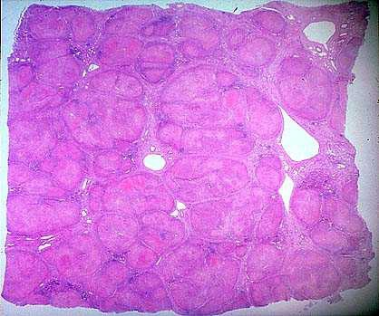 | 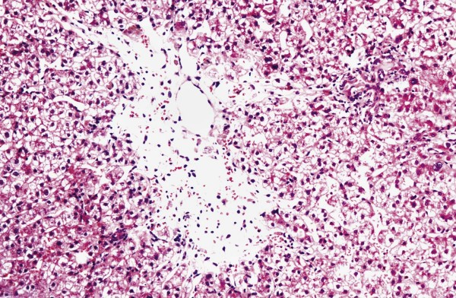
Image C
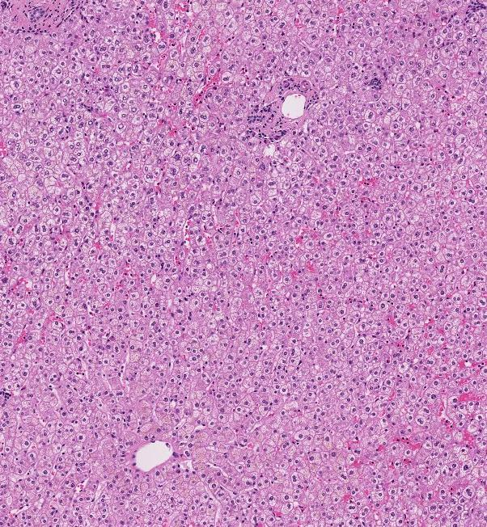
Justification:
………………………………………………………………………………………………………………………………………………………………………………………………………………………………………………………………………………………………………………………………………………………………………………………………………………………………………………………………………………………………………………………………………………………………………………………………………………………………………………………………………………………………………………………………………………………………………………………………………………………………………………

PART 2
Venue: Multipurpose Laboratory,
Medical Biochemistry Unit,
Level 2

Q.1 What are the liver function tests (LFTs)?
………………………………………………………………………………………………………………………………………………………………………………………………………………………………………………………………………………………………………………………………………………………………………………………………………………………………………………………………………………………………………………………………………………………………………………………………………………………………………………………………………………………………………………………………………………………………………………………………………………………………………………

Q.2 What is bilirubin and how is it produced in the body?
………………………………………………………………………………………………………………………………………………………………………………………………………………………………………………………………………………………………………………………………………………………………………………………………………………………………………………………………………………………………………………………………………………………………………………………………………………………………………………………………………………………………………………………………………………………………………………………………………………………………………………
Q3. Which form of bilirubin is carried to the liver and how?
………………………………………………………………………………………………………………………………………………………………………………………………………………………………………………………………………………………………………………………………………………………………………………………………………………………………………………………………………………………………………………………………………………………………………………………………………………………………………………………………………………………………………………………………………………………………………………………………………………………………………………………………………………………………………………………………………………………………………………………………………………………………………………………………………………………………………………………………………………………………………………………………………………………………………………………………………………………………………………………………………………………………………………………………………………………………………………………………………………………………………………………………………………………………………………………………………………………………………………………………………………………………

Q.4
- How and why is bilirubin conjugated?
- On the picture below, mark the intracellular location for the process of conjugation.
- Mention 2 syndromes due to congenital deficiency of the conjugating enzyme (bilirubin glucuronyl-transferase).
…………………………………………………………………………………………………………………………………………………………………………………………………………………………………………………………………………………………………………………………………………………………………………………………………………………………………………………………………………………………………………………………………………………………
………………………………………………………………………………………………………………………………………
Schematic illustration of a hepatocyte
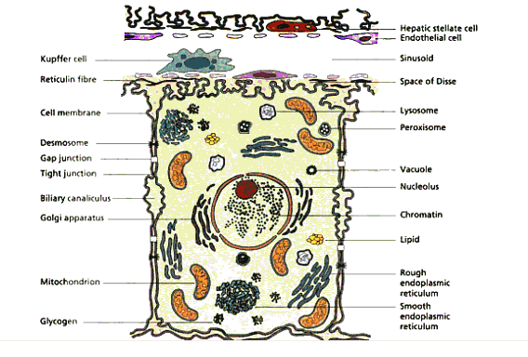Reference: Diseases of the liver and biliary system, by Sheila Sherlock, Sheila Sherlock (Dame.), James Dooley

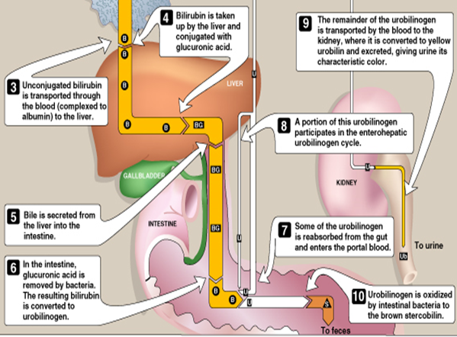

Q. 5A How is bilirubin eliminated from the body?
………………………………………………………………………………………………………………………………………………………………………………………………………………………………………………………………………………………………………………………………………………………………………………………………………………………………………………………………………………………………………………………………………………………………………………………………………………………………………………………………………………………………………………………………………………………………………………………………………………………………………………
Q.5 B What are the fates of bilirubin in the intestine?
………………………………………………………………………………………………………………………………………………………………………………………………………………………………………………………………………………………………………………………………………………………………………………………………………………………………………………………………………………………………………………………………………………………………………………………………………………………………………………………………………………………………………………………………………………………………………………………………………………………………………………

Calculation of total bilirubin concentration

Conc. of serum total bilirubin: A × 185 = …... µmol/L
(Normal range: 2 – 17 µmol/L)

Important Criteria for Diagnostic Laboratory Tests
- Sensitivity
Sensitivity answers the following question:
If a person has a disease, how often will the test be positive (true positive rate)?
i.e.: if the test is highly sensitive and the test result is negative you can be nearly certain that the individuals don’t have disease.
A Sensitive test helps rule out disease (when the result is negative).
Sensitivity rule out or "Snout“
True positives
Sensitivity =
True positive + false negative

Test | Disease
 | + | -
+ | True Positive  (TP) | False Positive  (FP)
- | False Negative  (FN) | True Negative  (TN)
TP
Sensitivity=
TP+ FN

- Specificity

Specificity answers the following question:
If a person does not have the disease how often will the test be negative (true negative rate)?
i.e., if the test result for a highly specific test is positive you can be nearly certain that the individuals actually have the disease.
A very specific test rules in disease with a high degree of confidence (when the result is positive).
Specificity rule in or "Spin"
true negatives
Specificity =
true negatives + false positives

Test | Disease
 | + | -
+ | True Positive  (TP) | False Positive  (FP)
- | False Negative  (FN) | True Negative  (TN)
TN+ FP
TN
Specificity =
An Ideal diagnostic lab test results for many subjects (normal and patients) will identify ALL patients with disease and All subjects without disease 100% of the time. This is shown in the following graph:

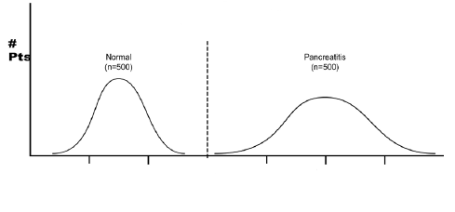
In most diagnostic lab tests this is not the case, and there is some overlap as shown in the following graph:
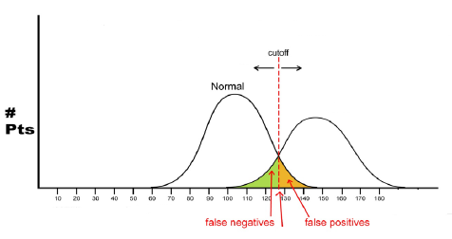
Acute hepatitis
Normal
Disease
Serum bilirubin level

The lab test with the best specificity and sensitivity should be the one requested by physicians.

