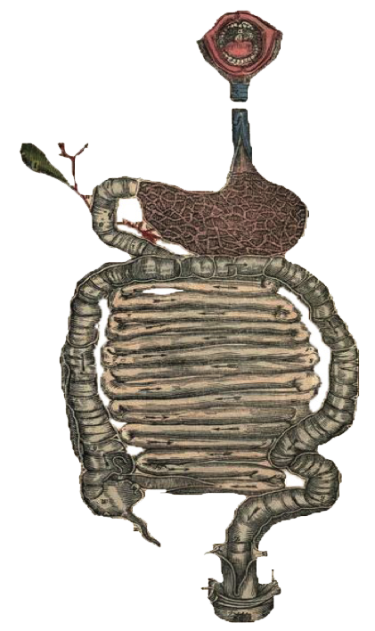
Please note:
This work is based MAINLY on males’ slides
• Black: Doctors’ slides. • Red: Important! • Light Green: Doctors’ notes • Grey: Extra. • Italic black: New terminology.
Gastroesophageal Reflux Disease (GERD) & Peptic Ulcer Disease
Objectives:
Upon completion of GERD lecture the students will be able:
- Define gastroesophageal reflux disease
- Understand the Pathophysiology of reflux esophagitis.
- Know clinical features of reflux esophagitis
- Describe the pathological features of reflux esophagitis
- Know the complications of reflux esophagitis
Upon completion of Peptic Ulcer Disease lecture the students will be able:
- Understand the Pathophysiology of acute and chronic peptic ulcer
- Know the possible causes of gastric and duodenal ulcers with emphasis on most common causes (H pylori and drugs)
- Recognize the gross and microscopic features of peptic ulcer
- Recognize the clinical features and consequences of acute and chronic peptic ulcer

 | Gastroesophageal Reflux (GER) | Gastroesophageal Reflux Disease (GERD)
Definitions | A normal physiological phenomenon experienced intermittently by most people, particularly after a meal.  أغلب الناس يحسون بارتجاع خفيف بعد الأكل  Normal condition no mucosal damage no brining sensation, postprandial | -Occurs when the amount of gastric juice (The acids) that refluxes into the esophagus exceeds the normal limit, causing symptoms تجي بعد الرفلكس  with or without associated esophageal mucosal injury  لو سوينا له إندوسكوبي بنلاقي mucosal erythema وإذا سوينا بيابسي رح نلاقي Inflammation.  يعني المريض يمكن ما يكون عنده Symptoms لكن يكون عنده Mucosal injury!  -According to American college of gastroenterology: symptoms OR mucosal damage OR both produced by the abnormal reflux of gastric content into the esophagus. Often chronic and relapsing. Patients who lack typical symptoms may develop complications.
Differences | Physiologic  - Postprandial (After a meal).  - Short lived.  - Asymptomatic.  - No nocturnal symptoms (At night). | Pathologic  - Symptomatic.  - Mucosal injury.  - Nocturnal symptoms.
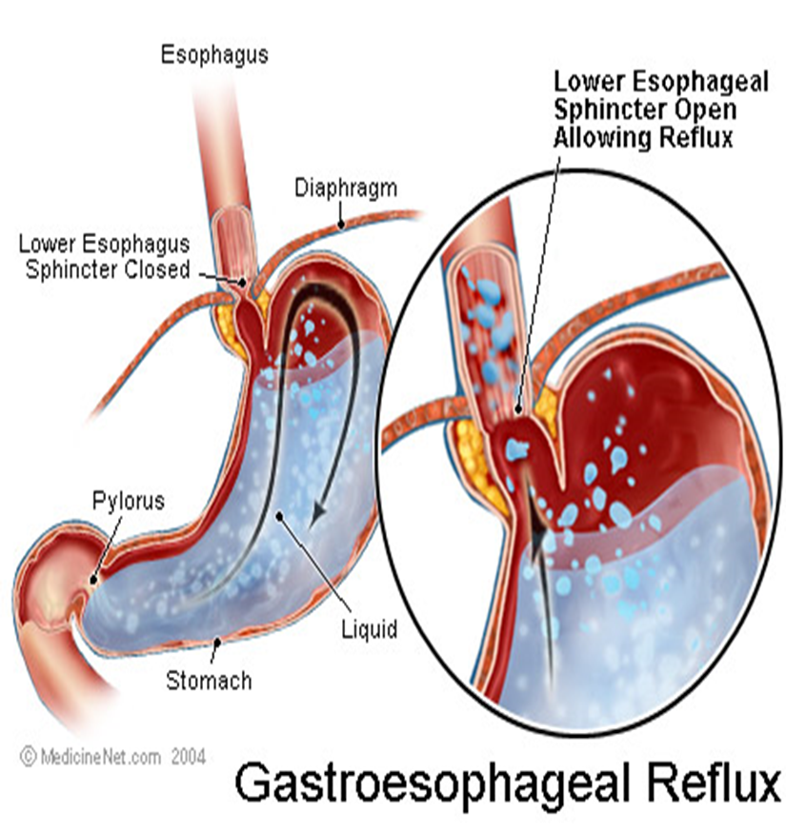
- Define Gastroesophageal Reflux disease.
Gastroesophageal Reflux Disease (GERD)

Figure 2 Anatomic radiographic landmarks of the lower oesophageal sphincter (LES).

Pathophysiology:
- Understand The Pathophysiology Of Reflux Esophagitis.

- Primary barrier to gastroesophageal reflux is the lower esophageal sphincter.
- LES normally works in conjunction with the diaphragm.
- If barrier disrupted, acid goes from stomach to esophagus.
A. Abnormal lower esophageal sphincter | B. Increase abdominal pressure
- The most common causes:  - Functional (frequent transient LES relaxation)  يحدث أثناء الإبتلاع  - Mechanical (hypotensive LES).  دائما مرتخي  - Decrease the pressure of the LES:  - Foods (eg: coffee, alcohol),  - Medications (eg: calcium channel blockers),  - Location: Hiatal hernia the esophagus is up in the chest so the diaphragm can’t aid the sphincter  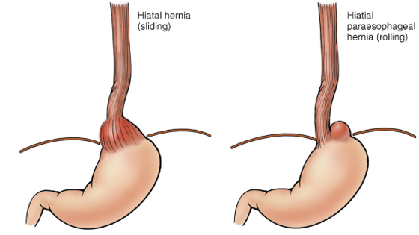 | - Obesity.  - Pregnancy.  - Increased gastric volume. Like eating more food!

Epidemiology: you only need to know that it’s very common even in Saudi Arabia
• About 44% of the US adult population have heartburn at least once a month
When people gain weight, usually they feel the symptoms of GER, once they lose weight the symptoms disappear
• 14% of Americans have symptoms weekly
• 7% have symptoms daily

Clinical Manifestations:
- Know Clinical Features Of Reflux Esophagitis.

- Most common symptoms: Those are typical symptoms and they are diagnostic! There’s no need for investigation
- Heartburn: retrosternal burning discomfort.
- Regurgitation: effortless return of gastric contents into the pharynx without nausea, retching, or abdominal contractions.

- Atypical symptoms: You need diagnosis for it, e.g. a man comes in the ER with chest pain and when you do an ECG it’s normal, thus it means it’s a reflex
- Coughing. Patients may present to a pulmonologist المرضى يجوا محسبين عندهم مشكلة بالجهاز التنفسي
- Chest pain. Patients may present to a cardiologist يحسبوا عندهم مشاكل بالقلب
- Wheezing.
#GERD related chest pain may mimic angina (differential diagnosis).
Diagnostic Evaluation:
If classic symptoms of heartburn and regurgitation exist in the absence of “alarm symptoms” the diagnosis of GERD can be made clinically and treatment can be initiated.
إذا كان عند المريض تِبيكال سمبتمز رح نكتفي بالسمبتمز حقته بالتشخيص
لكن لما يكون المريض عنده آيتيبِكال سمبتمز أو مريض يعاني من chronic reflux رح نسوي لهم إندوسكوبي
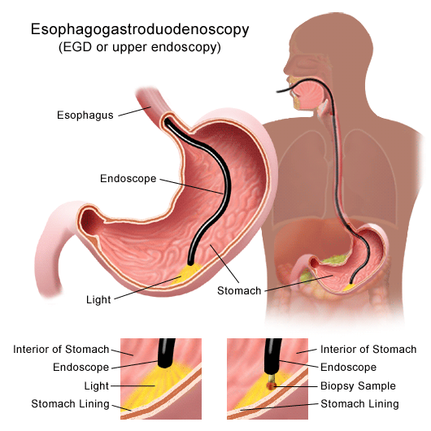
Esophagogastrodudenoscopy:Don’t think it is a hard word it is composed of 3 words with scopy
Endoscopy (with biopsy if needed):
- In patients with alarm signs/symptoms.
- Those who fail a medication trial. Patients who took medication but didn’t improve
- Those who require long-term tx.

PH:
- 24-hour pH monitoring
  - Accepted standard for establishing or excluding presence of GERD for those patients who do not have mucosal changes
  - Trans-nasal catheter or a wireless capsule shaped device

- Describe The Pathological Features Of Reflux esophagitis.
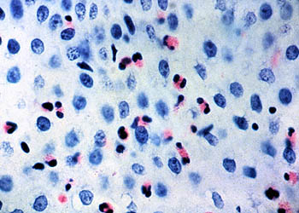
Morphology: (Microscopic features)
- Eosinophils (Most commonly) and neutrophils Nueutrophils = polymorph.
Other deferential diagnosis: Eosinophilic eosophagitis
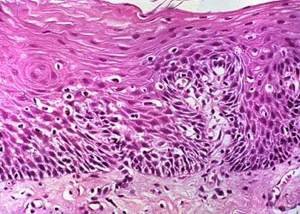
لكن هذا تكون الايوزينوفيلز موجودة على طول الإسوفقس
- Elongation of lamina propria papillae
- Basal zone hyperplasia. (4-5 Blue cells)
Normally the layer should be less than 20%
But here the layer will be thickened = more than 20%

- Know The Complications Of Reflux Esophagitis.

Complications:
• Erosive esophagitis • Stricture •Barrett’s Esophagus

Complications:

- Erosive esophagitis:  Responsible for 40%-60% of GERD symptoms.  Severity of symptoms often fail to match the severity of erosive esophagitis.  المريض يمكن يكون عنده sever symptoms لكن مع الإندوسكوبي ما نلاقي احمرار بنفس الةقت مع البيابسي نلاقي Mild inflammation وأحيانا العكس !  *Females’ slides:  Red mucosa with erosions leading to hematemesis & melena.  Erosive Esophagitis causes Ulcers in esophagus. In this picture the ulcers are superficial. | 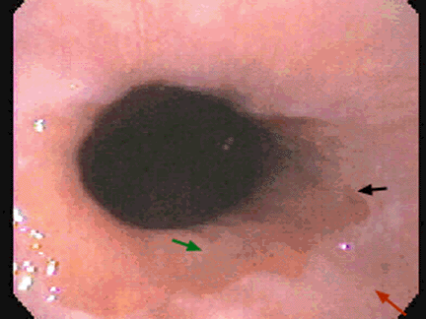  لو ملاحظين هذي الصورة هي نفسها حقت Barret’s  يعني بنشوف نفس الشكل بالمرضين وعشان نفرّق بينهم رح نسوي Biopsy  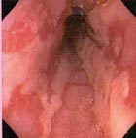
- Stricture:  Results of healing (fibrosis + granulation tissue) of erosive esophagitis & lead to dysphagia.  May need dilation.  After frequent refluxes there will be fibrosis then stricture.  المريض يجيك يقول أحس بصعوبة في البلع (Dysphagia) | 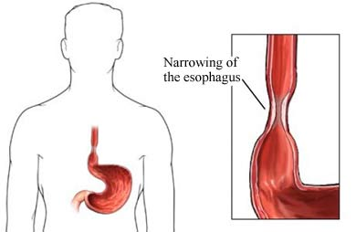
- Barrett’s Esophagus (the most dangerous).  - 8-15%  - Intestinal metaplasia of the esophagus  - Associated with the development of adenocarcinoma (Glands)  - Acid damages lining of esophagus and causes chronic esophagitis  - Damaged area heals in a metaplastic process and abnormal columnar cells replace squamous cells  - This specialized intestinal metaplasia can progress to dysplasia and adenocarcinoma  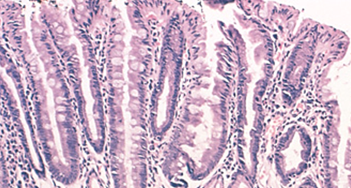  - Many patients with Barrett’s are asymptomatic  Normally esophagus lining is nonkeratinize stratified squamous epithelium. In chronic cases it becomes intestinal epithelium (columnar with goblet cells) | 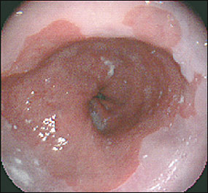  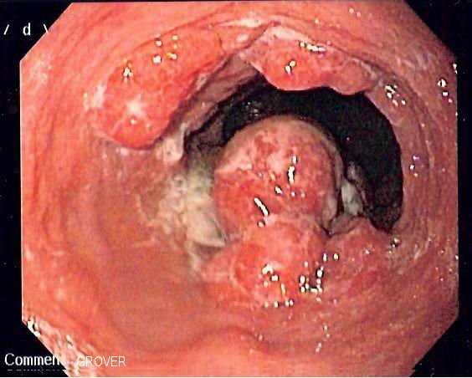

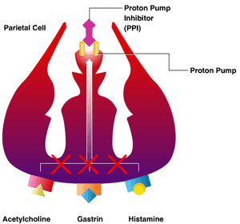
Treatment:
- H 2 receptor Blockers. They both Antacid, reduce gastric acid & relief the symptoms.
- Proton pump inhibitors.
- Antireflux surgery. If the meds didn’t treat the patient
Extra: H2 receptor blocker can prevent the GERD if it was taken 30m before the meal. Proton pump inhibitors is better than H2 receptor blocker, It blocks the production of gastric acidity.

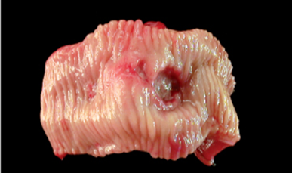
Ulcer:
- Define Peptic Ulcer Disease.
Peptic Ulcer Diseases
Definition: a breach in the mucosa of the alimentary
tract extending through muscularis mucosa into
submucosa or deeper.If the breach is in mucosa we
call it erosion and if it extends to muscularis mucosa it’s called ULCER
Erosion: is a breach in the epithelium of the mucosa only.
- Peptic ulcer (chronic)
- Stress ulcers (acute gastric ulcers)
نوعين تعتبر (ulcer) القرحة : Acute (acute peptic ulcer) and chronic (peptic ulcer disease)

- Understand The Pathophysiology Of Acute & Chronic Peptic Ulcer.
Pathophysiology:
We have aggressive and protective factors in our GIT organs when the imbalance between them will lead to damage in the wall of the organ which will cause ulcer.
Imbalance between:
Aggressive Factors | Defensive Factors
H. pylori *infection* and it’s the most common cause | Mucus
Drugs (NSAIDs) | Bicarbonate
Acid | Blood flow
Pepsin | cell renewal
Bile salts | Prostaglandins
 | Phospholipid
Acute Peptic Ulcer Can be Due to 3 main Causes: multiple and small
Acute response to an irritant 'chemical' injury by drugs e.g. NSAID or alcohol

- As part of an acute gastritis
NSAIDs and alcohol cause irritation of the stomach lining which can lead to acute gastritis and possibly acute ulcers. واحد عنده Acute gastritis رح تتحول إلى Acute ulcer

- Severe burns (Curling's ulcer)
- Major trauma (Stress ulcer) Car accidents
-Cerebrovascular accidents (Cushing ulcer) causes intra cranial hemorrhage

- As a complication of severe
stress response
All will mediate the release of cortisone which will inhibit prostaglandins which have a gastro-protective effect. Prostaglandins causes vasodilation which improves blood supply to the stomach and washes out excess acid and help with cell renewal.

Zollinger-Ellison syndrome. One of the causes of secretory diarrhea

- As a result of extreme hyperacidity
A tumer in duodenum or pancreas produce gastrin hormone which stimulate parietal cells in stomach to secrete high amounts of acid.

It’s a tumor in the gastrin producing cells which will cause an increased production of HCL and causes hyperacidity.

- Know The Possible Cause Of Gastric And Duodenal Ulcer With Emphasis on most common causes (H-Pylori & drugs).
Locations Of peptic Ulcer Disease: (Chronic ulcers)
عددهم 1-3 مب multiple مثل الأكيوت
- May occur in any portion of the GI tract exposed to acidic gastric juices
- 98% located in first portion of duodenum or stomach, ratio = 4:1
- Esophagus, as a result of GERD or acid secretion by ectopic gastric mucosa.
- Gastric mucosa within a Meckel diverticulum can result in peptic ulceration of adjacent mucosa.
Chronic ulcer mostly located in first portion of duodenum then in stomach because stomach has defensive factors.

(We have two types of chronic peptic Ulcers: Gastric and Duodenal Ulcers.):
- Gastric Ulcers:
The mucosal defenses against acid attack consist of:
- Mucus-bicarbonate barrier: Duodeno-gastric reflux (bile).
- The surface epithelium:
- NSAIDs (blocking the synthesis of the prostaglandins). Prostaglandin has defensive effects against acid attack that increases blood flow and protect the epithelium .
- H. pylori infection ( cytotoxins and ammonia).
Thus peptic ulcers in the stomach, breakdown of mucosal defence is much more important than excessive acid production. يعني حتى لو صار عندنا زيادة في الأسد ماعندنا مشكله طالما فيه ميوكوزال دفنس.

- Duodenal ulcers:
الفرق في الباثوفسيولوجي بين gastric ulcer وdeuodenal ulcer ان في الجاستريك المشكلة اننا خسرنا الحماية اللي على جدار المعدة فكمية الأسيد الطبيعية سوت له damage اما في duodenal ulcer المشكلة في الأسيد راح يكون في زيادة فيه وهالشي هو سبب الdamage هنا
Pathophysiology:
باختصار السالفة هنا ان الHelicobacter pylori ما تقدر تسكن في الابيثيليوم الطبيعي تبع الديودينيوم فـ راح تتواجد بس في الPyloric antrum من المعدة (تقدروا تربطوا بينهم بالاسم) وتواجدها بيزيد تصنيع الأسيد من ٢-٦ مرات الطبيعي هذي الحمضية العالية بتؤدي الىGastric metaplasiaهذا التغير في الابيثيليوم بيسمح لهالبكتيريا انها تسكن الديودينيوم وتسبب القرحة
Increased production of acid
Helicobacter P
P

Duodenal ulcers

To Sum up Chronic peptic ulcer:
Hyperacidity
Duodeno-gastric reflux (bile)

H. pylori
NSAIDs

- H pylori infection of the pyloric antrum is present in nearly all patients with chronic duodenal ulcer and approximately 75% of patients with chronic gastric ulcer.
- Although more than 70% of individuals with PUD are infected by H. pylori, fewer than 20% of H. pylori–infected individuals develop peptic ulcer.
لو كلنا عندنا Duodenal ulcer كلنا بيكون عندنا H.Pylori. أما لو كلنا كان عندنا Gastric ulcer فإن 75% منا رح يكون عندهم H.pylori

- Recognize The Gross and Microscopic Features Of Peptic Ulcer.

Gross  More important than microscopic | Microscopic  Not very import, because any ulcer looks the same under the microscope.
- Usually less than 20 mm in diameter but they may > 100 mm in diameter.  - The classic peptic ulcer is a round to oval, sharply punched-out defect.  - In contrast, heaped-up مرتفعة margins are more characteristic of cancers.  We only care about gross to differentiate between it and malignant ulcer by endoscopy.  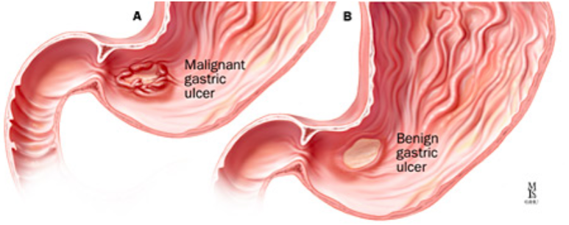 | - the base consists of necrotic tissue and polymorph exudate overlying inflamed granulation tissue which merges with mature fibrous (scar) tissue.*healing process*  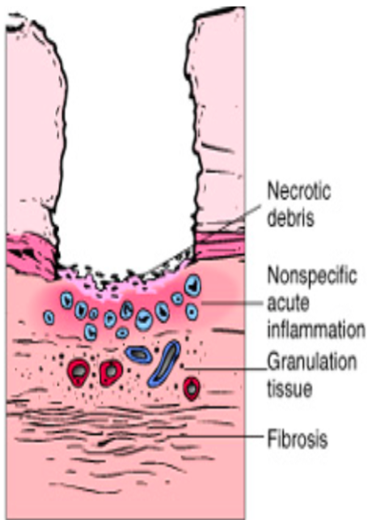  - The presence of neutrophils within the gastric glands signifies active inflammation and, most of the time, the presence of H pylori.

Clinical features:
- Clinical Features And Consequences Of Acute & Chronic Peptic Ulcer.

- Epigastric pain (the most common symptoms)
- Gnawing or Burning sensation.
- Occurs 2-3 hours after meals.
- Relieved by food or antacids.
- Patient awakens with pain at night.
- Some present with complications such as frank & hemorrhage,

Complications : (only in females slides)
- Haemorrhage: Hematemesis & melena.

- Penetration: the ulcer penetrates the full thickness of stomach & duodenal wall, progressing into adherent underlying tissue, e.g. liver or pancreas.

- Perforation: It’ll lead to peritonitis. Peritonitis is the cause of SEVER pain in ulcers condition.

- Fibrous stricture: in stomach, It may cause pyloric stenosis.

- Malignant changes: extremely uncommon.

- Iron deficiency anemia. Because the bleeding of GI.

Therapy: Current therapies for PUD are aimed at

- H. Pylori eradication: Antibiotics. Patient has to take 3 antibiotics at least for 3 weeks.

- Acid suppression:
- H2 receptor blockers (H2R) B) Proton pump inhibitors. (PPI)

Summary
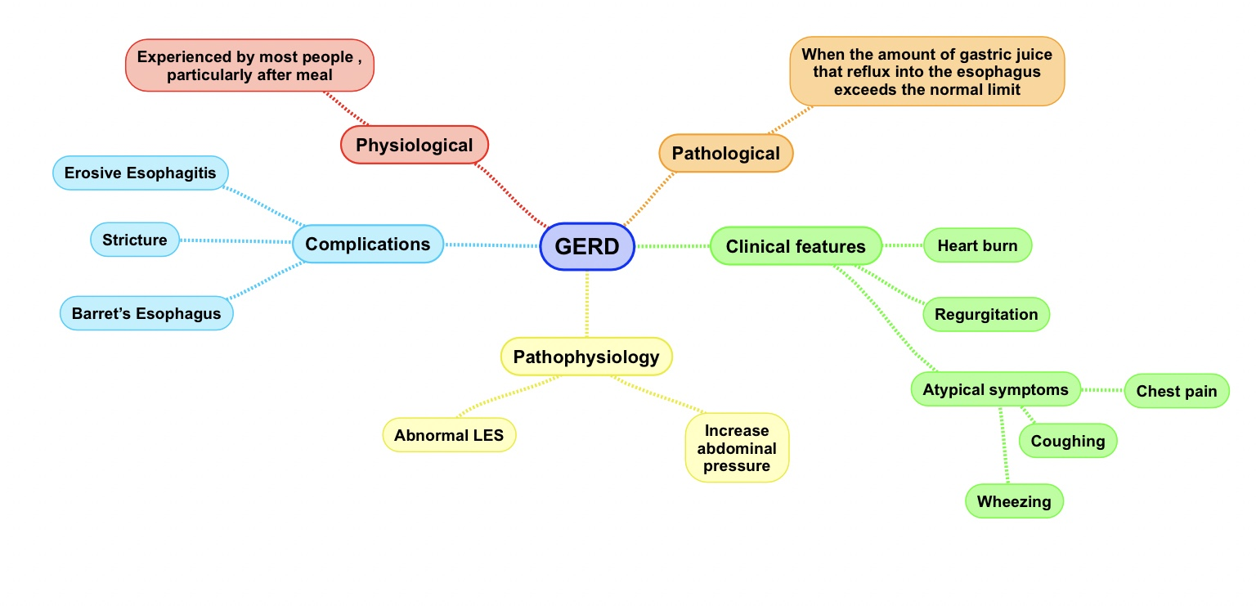

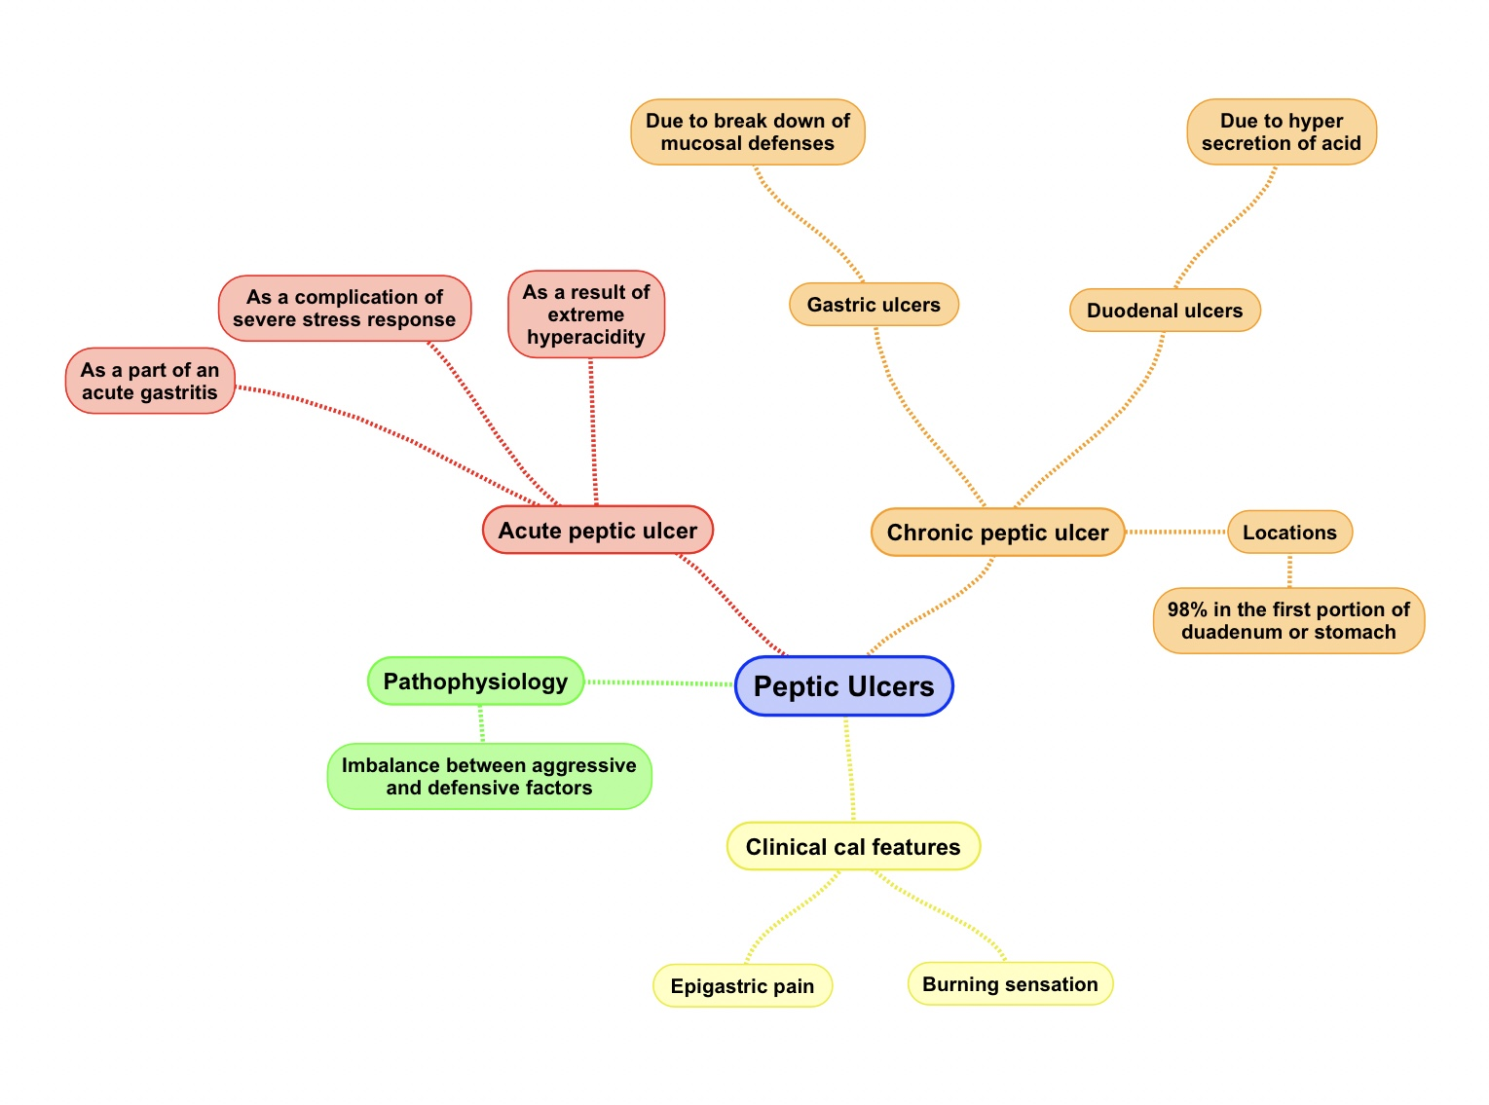

- The patient diagnosed with GERD, which of the following is caused
Questions
by Stricture?
- Hematemesis B. dysphagia C. heartburning D. cough
Ans: B
2. Choose one of the following would relief his symptoms?
- Coffee B. stop eating C. H agonists D. H2 receptor blocker
Ans: D
3. Which of the following is NOT a complication of reflux esophagitis?
A. Erosive esophagitis B. Hemorrhage C. Stricture D. Barrett’s esophagus
Ans: B
4. In barrett’s esophagus what major is the changes happens?
A. disrupted barrier B. erosive esophagitis C. increase abdominal pressure D. Intestinal metaplasia
Ans: D
5. Which one of these acute ulcers is due to hyperacidity ?
A. Sever burns B. Major trauma C. Zollinger-Ellison Syndrome
Ans: C
6. Which one of these precipitates gastritis to Acute ulcers ?
A)NSAID or alcohol B)major trauma (Stress ulcer) C)Zollinger-Ellison
Ans: A
7. What is the main cause if duodenal ulcers ?
A. H.pylori B. Hemorrhage C. Hyper secretion of Acids
Ans: A
8. The pathophysiology of Gastric peptic ulcer lies in ?
A)Hypersecretion of acid B)Break down of mucosal defenses C)Distention of stomach
Ans: B

الأعضاء
- نوف العمَّاري
- نورة السهلي
- أمل القرني
- ابتسام المطيري
- غادة المزروع
- سمر القحطاني
- سمية الغامدي
- جواهر الخيَّال
- دينا الدوسري
- ليلى البريكان
- دعاء وليد
- لمى التميمي

القادة
- مها الغامدي
- حنين السبكي
- عبدالله أبو عمارة

Editing File
Email: pathology436@gmail.com Twitter: @pathology436

حسبي الله لا إله إلَّا هو عليه توكلت وهو رب العرش العظيم.

References: Doctor’s slides + notes, Robbins basic pathology 10th edition.

Lower esophageal sphincter.
اقتران، تزامن
CNS depressants & slow down the digestion system.
The hiatus is an opening in the diaphragm (the muscular wall separating the chest cavity from the abdomen). Normally, the esoph agus (food pipe) goes through the hiatus and attaches to the stomach. In a hiatal hernia the stomach bulges up into the chest through that opening.
To make an effort to vomit.
Unusual.
Is a diagnostic endoscopic procedure that visualizes the upper part of the gastrointestinal tract down to the duodenum.
Dysphagia, odynophagia (painful swallowing), bleeding, anemia and weight loss.
Treatment.
Is a slight bulge in the small intestine present at birth and a vestigial remnant of the omphalomesenteric duct (also called the vitelline duct or yolk stalk).
Is a condition that occurs when bile flows upward (refluxes) from the duodenum into the stomach and esophagus.
Duodenal ulcers is relieved by food because when you eat the duodenum releases HCO3 , so people eat more to relieve the pain . Whereas for gastric ulcers , by eating you release more acids that increases the symptoms
Vomitting of blood .
Dark , black and tarry feces that are associated with upper GIT bleeding .
Inflammation of the peritoneum , the tissue that lines the inner wall of the abdomen .

