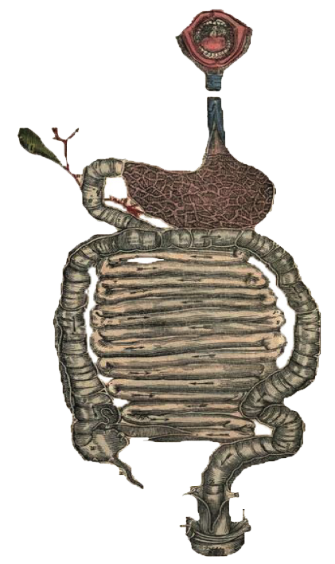
Objectives:-
- Recognize the major complications of cirrhosis.
- Understand the pathogenetic mechanisms underlying the occurrence of the complications.
- Recognize the clinical features inherent to the above mentioned complications.
- Describe the pathological findings of the different complications.

• Black: Doctor’s slides. • Red: Important! • Green: Doctors’ Notes • Grey: Extra. • Italic black: New terminology.
Complications Of Liver Cirrhosis
Complications Of Liver Cirrhosis
- Recognize The Major Complications Of Cirrhosis.

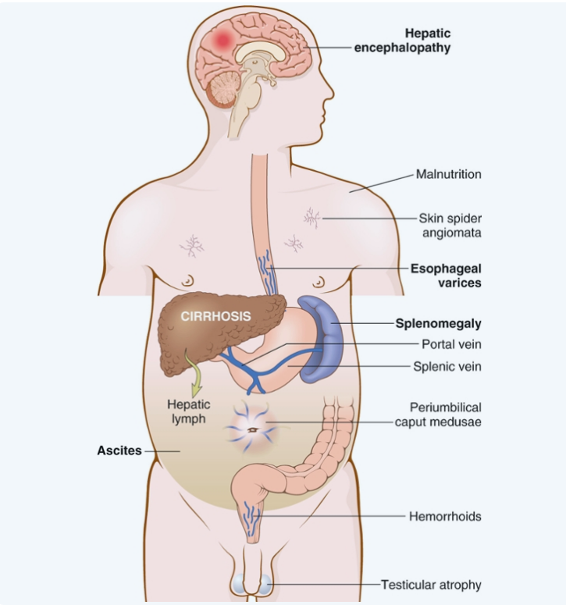
حطوا ببالكم ان هذي المضاعفات ما تطلع بكل الوقت ولا بكل المرضى )يعني تعتمد على COURSE OF THE DISEASE)
Complications of liver cirrhosis:
- Portal hypertension
- Variceal bleeding
- Splenomegaly
- Ascites
- Spontaneous bacterial peritonitis
- Jaundice and cholestasis
- Coagulopathy
- Hepatic encephalopathy
- Hepatorenal syndrome
- Hepatocellular carcinoma
these complications don’t necessarily appear at the same time or in the same patient, it depends on the progression of the disease. Some of these complications represent the end stage of liver cirrhosis if the patient survived enough.

- Understand The Pathogenetic Mechanisms + Recognize The Clinical Features + Describe The Pathological Findings Of The Different Complications.

Portal Hypertension: فرط ضغط الدم البابي
- Resistance to blood flow : prehepatic, intrahepatic, and posthepatic
- The dominant intrahepatic cause is cirrhosis (This is accounting for most cases of portal hypertension)
- Portosystemic shunts التقاء اللستمك مع البورتال develop when blood flow is reversed from the portal to systemic circulation. the portosystemic shunt at the beginning it reliefs the pain and pressure , but after a while it causes dilation of the vessels and then leads to varices
- Recall: Schistosoma can cause portal hyper tension.

Esophageal Varices:دوالي المريء
- Instead of returning directly to the heart, venous blood from the GI tract is delivered to the liver via the portal vein before reaching the inferior vena cava.
- This circulatory pattern is responsible for the first pass effect in which drugs and other materials absorbed in the intestines are processed by the liver before entering the systemic circulation.
- esophageal varices is an emergency situation and might cause death .
- Diseases that impede this flow cause portal hypertension and can lead to the development of esophageal varices, an important cause of esophageal bleeding
Varices happens in the anatomical areas of anastomoses between the systemic and portal circulation.
هذي المناطق ما تتحمل الضغط العالي فيصير لها توسّع( varices) ونسميها تبعا للمكان اللي تحدث فيه

Pathogenesis:
- Portal hypertension results in the development of collateral channels at sites where the portal and caval systems communicate. Although these collateral veins allow some drainage to occur, they lead to development of a congested subepithelial and submucosal venous plexus within the distal esophagus. (varices).
- Varices develop in 90% of cirrhotic patients mostly in association with alcoholic liver disease.
- Hepatic schistosomiasis.
Naming of the varices depends on the place
Portal hypertension → Portosystemic Shunt:(which can happen in the following)
1. Rectum ( hemorrhoids)
2. Cardioesophageal junction(esophagogastric varices)
3. Abdominal wall collaterals (caput medusae)

Morphology:
- Varices can be detected by venogram: tortuous dilated veins lying primarily within the submucosa of the distal esophagus and proximal stomach. Venous channels directly beneath the esophageal epithelium may also become massively dilated.
- Varices may not be grossly obvious in surgical or postmortem specimens, because they collapse in the absence of blood flow .
- Variceal rupture results in hemorrhage into the lumen or esophageal wall, in which case the overlying mucosa appears ulcerated and necrotic. If rupture has occurred in the past, venous thrombosis, inflammation, and evidence of prior therapy may also be present.
Clinical features:
- Asymptomatic or rupture → massive hematemesis.
- Inflammatory erosion of thinned overlying mucosa
- Increased tension in progressively dilated veins
- Increased vascular hydrostatic pressure associated with vomiting are likely to contribute to medical emergency that is treated by any of several methods :
    - Sclerotherapy
    - Endoscopic balloon tamponade
    - Endoscopic rubber band ligation
- Half of patients die from the first bleeding episode eith er as a direct consequence of hemorrhage or following hepatic coma triggered by hypovolemic shock.
- Additional 50% within 1 year.
- Each episode has a similar rate of mortality.
- Over half of deaths among individuals with advanced cirrhosis result from variceal rupture.

Splenomegaly: تضخُّم الطحال
- Long-standing congestion may cause congestive splenomegaly
- (spleen weight may reach up to 1000 gm)
- The massive splenomegaly may induce hematologic abnormalities attributable to hypersplenism, such as thrombocytopenia or pancytopenia

Ascites:الحبن
- Is the accumulation of excess fluid in the peritoneal cavity.(not pus not exudate)
- 85% of cases are caused by cirrhosis
- Serous: less than 3 gm/dL of protein
- Accumulation of pus causes peritonitis

Spontaneous bacterial peritonitis.

Jaundice يرقان and cholestasisركود صفراوي:
- Jaundice and icterus: a yellowish or greenish pigmentation of the skin and sclera of the eyes respectively due to high bilirubin levels.
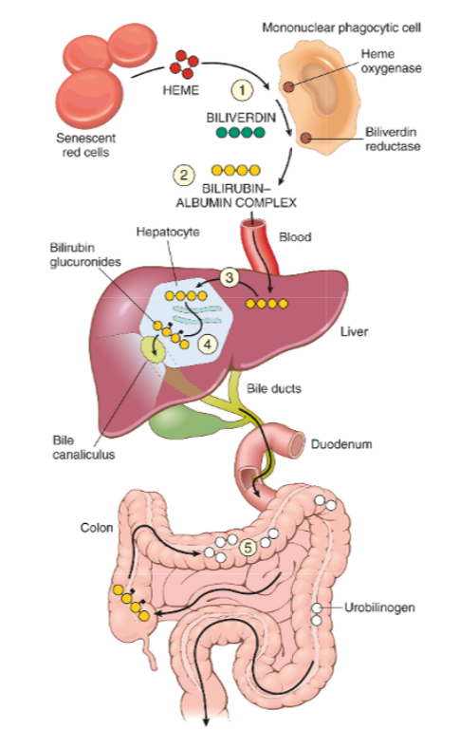
- Cholestasis, characterized by systemic retention of not only bilirubin but also other solutes eliminated in bile.
Bilirubin metabolism and elimination:
Bilirubin metabolism By Armando (8:43 Min)

Jaundice By Osmosis (10:47 Min)
Causes of jaundice:
- Prehepatic causes of jaundice:
Bilirubin over production: due to hemolysis and hematoma resorption, lead to elevated levels of unconjugated (indirect) bilirubinلما نسوي تحليل الدم نلاقي:.
(Basically something in the RCs mainly because it contains most of the bilirubin in hemoglobin)
- Intrahepatic disorders:
can lead to unconjugated or conjugated hyperbilirubinemia. The conjugated (direct) bilirubin level is often elevated by alcohol, infectious hepatitis, drug reactions, and autoimmune disorders.
3. Posthepatic disorders (Obstruction of the flow of bile):
Also can cause conjugated hyperbilirubinemia. Gallstone formation is the most common post hepatic process that causes jaundice; however, the differential diagnosis also includes serious conditions such as biliary tract infection, pancreatitis, and malignancies
These features presents the disease mainly at the beginning , if the disease is progressed it might be a mixed type of the features

Coagulopathyاعتلال في التخثُّر:
The liver is the source of a number of coagulation factors that decline in the face of liver failure, leading to easy bruising and bleeding.

Hepatic encephalopathy الاعتلال الدماغي الكبدي
:(Cause neurological disturbance )
- spectrum of disturbances in consciousness ranging from subtle behavioral abnormalities, to confusion and stupor, to coma and death.(because of ammonia accumulation)
- may develop over days, weeks, or a few months
- Due to elevated ammonia levels in blood and the central nervous system and brain edema.
Explanation by the doctor: The signs doesn’t appear early because the liver compensates how ever when it reaches the decompensation phase (late phase). It will lead to inconvenient filtration which leads to blood regurgitation back in the body which will cause accumulation of toxic substances like (ammonia)

Hepatorenal syndrome:متلازمة الكبدية الكلوية
(Simply it is a renal failure due to hepatic failure once u correct the hepatic failure it will end)
- Appearance of renal failure in individuals with severe chronic liver disease --- no intrinsic morphologic or functional causes for the renal failure.
- The incidence of this syndrome is about 8% per year among patients who have cirrhosis and ascites.(not common)
- Decreased renal perfusion pressure due to systemic vasodilation
- activation of the renal sympathetic nervous system with vasoconstriction of the afferent renal arterioles
- Increased synthesis of renal vasoactive mediators, that decrease glomerular filtration.
اللي يصير هنا ان الفشل الكلوي يعتبر SECONDARY TO CIRRHOSIS DUE TO VASODIALATION\CONSTRICTION TO THE ENTIRE BODY WHICH EFFECTS THE KIDNIES بحيث لو عالجنا الكبد رح تتعالج معها الكلية.
أما لو واحد تعرّض لتوكسن وأثّر على الكبد و الكلية فهذا ما يعتبر HEPATORENAL SYNDROME لأني لو عالجت الكبد ماراح تتعالج معها الكلية لأن الكلية تأثرت بسبب التوكسن مب بسبب تأثُّر الكبد!

Hepatocellular Carcinoma:سرطان خلايا الكبد (next lecture)
IF PATIENT SURVIEVED ENOUGH HE CAN DEVELOP HCC

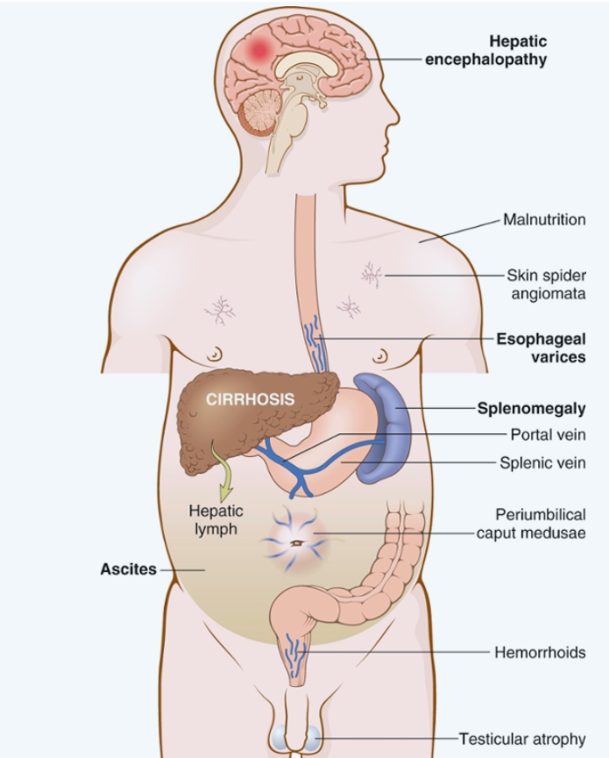

 Conclusion
Summary
- One The complication of liver cirrhosis is portal hypertension which can lead to portosystemic shunt (when blood flow from portal to systemic) and may result in esophageal varices or hemorrhoids or caput medusae .
- Portal hypertension results in the development of collateral channels .
- Varices develop in patient with cirrhosis association with alcoholic liver disease , and can be see in HEPATIC SCHISTOSOMIASIS.
- The clinical feature of esophagus varices is massive hematemesis and it can lead to die due to hemorrhage or hypovolemic shock.
- Other complication of liver cirrhosis is splenomegaly due to thrombocytopenia or pancytopenia .
- ASCITES is accumulation of fluid in the peritoneal cavity caused by cirrhosis.
- Jaundice and icterus : yellowish or greenish pigment of the skin and sclera of the eye due to high bilirubin level , there is three cause of jaundice prehepatic(bilirubin overproduction), intrahepatic, posthepatic(obstruction of the flow of bile ) .
- Hepatic encephalopathy the patient develop behavioral abnormalities due to increase ammonia level in the blood .
- Hepatorenal syndrome : the patient develop renal failure after chronic liver disease this can revers by treating the cause, there is decrease in the GFR due to afferent arterioles constriction.
- The last complication of liver cirrhosis is developing hepatocellular carcinoma .

Questions

- Portosystemic shunt refers to which of the following?
- Systemic->portal blood flow.
- Portal->systemic blood flow.
- Splenomegaly.
- Hepatocellular injury.
ANS: B
- A 54-year-old lady has a long history of chronic hepatitis B infection and has had increasing malaise for the past year. She was hospitalized 1 year ago because of upper gastrointestinal hemorrhage. Physical examination now shows a firm nodular liver. Laboratory findings show a serum albumin level of 2.5 g/dL and prothrombin time of 28 seconds. Which of the following additional physical examination findings is most likely to be present in this woman?
- Splenomegaly.
- Distended jugular vein.
- Papilledema.
- Splinter hemorrhage.
ANS: A
- Which of the following is the process of Q2 complication?
- Long standing congestion.
- Increased Red blood cells in the circulation.
- Malaria.
- Heart failure.
ANS: A
- A 49-year-old gentleman was diagnosed with cirrhosis. 2 days later he came to the ER with hypovolemic shock and multiple organ failures. Which of the following is the most likely cause?
- Hemorrhoids.
- Hepatic encephalopathy.
- Sepsis.
- Esophageal varices.
ANS: D
- Which of the following might prevent similar episodes in the previous patient?
- Anticoagulants.
- Coagulants.
- Sclerotherapy.
- Resection of the hemorrhagic portion.
ANS: C

- What is the cause of increased prothrombin time in cirrhotic patients?
- Decreased Iron stores.
- Dysfunction of the liver.
- Splenomegaly leading to thrombocytopenia.
- Increased vitamin K.
ANS: B
- A 37-year-old lady presented with jaundice, distended abdomen, and pain in the upper abdomen. Two hours later she became confused and aggressive. What is the cause of her change of mood?
- Increased bilirubin levels.
- Increased Alpha fetoprotein levels.
- Decreased bilirubin levels.
- Increased Ammonia.
ANS: D
- A 42-year-old lady with severe liver disease was diagnosed with renal failure with no apparent causes for it. Which of the following is true in her case?
- Renal failure is resolved with liver resolution.
- Renal failure was caused by increased renal perfusion.
- The patient should not have ascites.
- Renal failure is unrelated to her liver disease.
ANS: A

الأعضاء
- عبدالكريم الحربي
- عمر المغير
- مبشر الاسمري

حسبي الله لا إله إلِّا هو عليه توكلت وهو رب العرش العظيم

القادة
- مها الغامدي
- حنين السبكي
- عبدالله أبو عمارة

Editing File
Email: pathology436@gmail.com Twitter: @pathology436
References: Doctor’s slides + notes, Robbins basic pathology 10th edition.

A condition in which a person’s body has too few red blood cells, white blood cells, and platelets.

