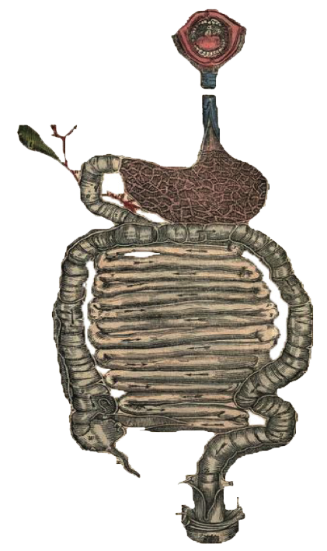

**Objectives**:

* Recognize the predisposing factors of gall stones and cholecystitis.
* Describe the different types of cholecystitis.
* Understand the pathogenesis of acute and chronic cholecystitis.

Pathology And Pathogenesis Of Cholecystitis

**•** Black: Doctor’s slides. **•** Red: important! **•** Green: Doctor’s notes. **•** Grey: Extra. **•** *Italic black: New terminology.*

* Recognize the predisposing factors of gall stones and cholecystitis

**Pathology And Pathogenesis Of Cholecystitis**

* Majority of gallstones (>80%) are "silent," and most individuals remain free of biliary pain or stone complications for decades.
* There are two main types of gallstones:

1. Cholesterol Stones: (Most common)
   * + about 80% are cholesterol stones
     + containing more than 50% of crystalline cholesterol monohydrate (it contains calcium too)
2. Pigment Stones
   * + composed predominantly of unconjugated bilirubin calcium salts

**Prevalence and Risk Factors of gallstones:**

|  |  |
| --- | --- |
| **Age and gender:** | * The prevalence of gallstones increases throughout life.more in urban areas * The prevalence in **women** of all ages is about twice as high as in men. |
| **Ethnicandgeographic:** | * Cholesterol gallstone prevalence approaches 50% to 75% in certain Native American populations (Pima, Hopi, and Navajo), seems to be related to biliary cholesterol hypersecretion. |
| **Heredity:** | * A positive family history imparts increased risk, associated with impaired bile salt synthesis and secretion. |
| **Environment:** | * Estrogens increase hepatic cholesterol uptake and synthesis, leading to excess biliary secretion of cholesterol. (oral contraceptive use and with pregnancy). * Obesity, rapid weight loss, and treatment with the hypocholesterolemic agent are strongly associated with increased biliary cholesterol secretion |
| **Acquired disorders:** | * Any condition in which gallbladder motility is reduced predisposes to gallstones, such as pregnancy, rapid weight loss, and spinal cord injury.   And Bile acids metabolism problems and hyperlipidemia |

|  |  |  |
| --- | --- | --- |
|  | **Cholesterol Stones** | **PigmentStones** |
| **Demography:** | Northern Europe, North and South America, Native Americans, Mexican Americans **في المجتمعات الغنية** | Asian more than Western, rural more than urban **في المجتمعات الفقيرة غالبا** |
| Diseases: | Obesity and insulin resistance | Chronic hemolysis (e.g., sickle cell anemia, hereditary spherocytosis) excesive unconjugated bilirubin |
| Gallbladder stasis | Biliary infection [1] |
| Inborn disorders of bile acid metabolism | Gastrointestinal disorders: ileal disease (e.g., Crohn disease), ileal resection or bypass, cystic fibrosis with pancreatic insufficiency |
| Dyslipidemia[2] syndromes |
| General: | Advancing age |  |
| Female sex hormones:   * Female gender * Oral contraceptives[3] * Pregnancy [4] |
| Rapid weight reduction |

**[](https://www.youtube.com/watch?v=UPw3ot1M_o0)**

**Gallstones (cholelithiasis) By Osmosis (8:12 Min)**

|  |  |  |
| --- | --- | --- |
| **Pathogenesis** | | |
| **2. Pigment Stones** | | 1. **Cholesterol Stones** |
| * Pathogenesis of pigment stones is based on the presence of unconjugated bilirubin (which is poorly soluble in water) in the biliary tract and precipitation of calcium bilirubin salts. * Thus, the likelihood of pigment stone formation increases with infection of the biliary tract as by:  1. *Escherichia coli*. 2. *Ascaris lumbricoides.* 3. the liver fluke *Opisthorchis sinensis*, **لانها تأثر على الكونجقيشن**  * Chronic hemolytic conditions also promote formation of **unconjugated** bilirubin in the **biliary tree**.and gallbladder | | * Cholesterol is *rendered*[5] soluble in bile by aggregation with water-soluble bile salts and water-insoluble lecithins[6], both of which act as detergents[7]. * When cholesterol concentrations exceed the solubilizing capacity of bile (super-saturation☹), cholesterol can no longer remain dispersed[8] and nucleates into solid cholesterol monohydrate crystals.cholestrol starts to precipitate and high viscosity layers of cholesterol salts will appear   #Cholesterol gallstone formation involves three simultaneous[9] defects:   1. ***Supersaturation of bile with cholesterol:*** the result of hepatocellular hypersecretion of cholesterol. 2. ***Gallbladder hypomotility****:* [10]It promotes nucleation typically around a calcium salt crystal nidus[11]. 3. ***Mucus hypersecretion in the gallbladder:*** This traps the crystals, permitting their aggregation into stones. |
| **Morphology** | | |
| S01871-018-f051   1. They are black and brown. 2. "Black" pigment stones are found in sterile gallbladder. 3. "Brown" pigment stones are found in infected intrahepatic or extrahepatic bile ducts. 4. Both are soft and usually multiple. 5. Brown stone are greasy. 6. Because of calcium carbonates and phosphates, **approximately 50% to 75% of black stones are radio-opaque.** | * S01871-018-f050It arise exclusively in the gallbladder and are composed of cholesterol ranging from 100% pure (which is rare) down to around 50%. * Pale yellow, round to ovoid to faceted, and have a finely granular, hard external surface. * **Stones composed largely of cholesterol are radiolucent; only 10% to 20% of cholesterol stones are radio-opaque.** **More is radio lucent which means doesn’t show on X-ray due to low calcium concentration .** | |

**Cholestrolosis:**

An incidental finding , is cholestrolosis . cholesterol hypersecretion by the liver promotes excessive accumulation of cholesterol esters within the lamina propria of the gallbladder . the mucosal surface is studded with minute yellow flecks , producing the “strawberry gallbladder” clinically not important

**Clinical features of gallstones:**

70-80% of patients are asymptomatic.

**Symptoms:**

* Spasmodic or “colicky”**مغص** right upper quadrant pain , which tends to be excruciating . It is usually due to obstruction of bile ducts by passing stones .

**Complications:**

* Empyema , [12]perforation , fistulae , inflammation of the biliary tree (cholangitis) if it ascends to liver we call it ascending cholangitis(fatal condition) , pancreatitis represent stones out of the gallbladder(smallstones), obstructive cholestasis and gallbladder carcinoma .
* Obstructive Cholestasis ; The larger the canaliculi the less likely they are to enter the cystic or common ducts to produce obstruction . The most dangerous stones tends to be very small or “gravel” . Occasionally a large stone may erode directly into an adjacent loop of small bowel , generating intestinal obstruction “Gall stone ileus”
* Gall bladder carcinoma , is the most important risk factor associated with Cholethiasis (gall stones ) , which are present on 95% of the cases .

**Cholecystitis:التهاب المرارة**

* Describe The Different Types Of Cholecystitis + Their Pathogenesis
* Inflammation of the gallbladder may be acute, chronic, or acute superimposed on chronic.
* It almost always occurs in association with gallstones.

[](https://www.youtube.com/watch?v=Ih2mEsh46Ug)**Acute Cholecystitis:**

**Acute cholecystitis By Meditoons (1:12 Min) RECOMENDED**

(Two types)

1. **Acute calculous** cholecystitis is an acute inflammation of the gallbladder. 90% Precipitated by **obstruction of the neck or cystic duct.** emergency condition

* It is the primary complication of gallstones and the **most common** reason for emergency cholecystectomy.
* Pathogenesis: Acute calculous cholecystitis results from chemical irritation and inflammation of the obstructed gall bladder . these events occur in the absence of bacterial infection ; only later in the course may bacterial infection contamination develop .

1. **Acute acalculous** cholecystitis: occurs in the absence of gallstones, generally in severely ill patient. Due to severe underlying condition. Less common

Most of cases occur in the following circumstances:

-the postoperative state after major, nonbiliary surgery

-severe trauma (motor vehicle accidents, war injuries)

-severe burns

-multisystem organ failure eg. Severe shock=failure of kidney,liver,gallbladder,etc

-sepsis **تسمم في الدم ويوصل الى المرارة**

-prolonged intravenous hyperalimentation

-the postpartum state (after giving birth)

N.B Acute acalculusis more dangerous because the patient is present with another main complications so when he has cholecystitis it will be masked by the features of the main disease .

|  |
| --- |
| **MOROHOLOGY** |
| * **الحالتين تتشابه في الشكل اللي يفرق بينهم وجود ستونز او لا** * Gallbladder is usually enlarged and tense. * Bright red to green-black. * Serosal covering is frequently layered by fibrin in severe cases is by exudate. * There are no morphologic differences between acute acalculous and calculous cholecystitis, except for the absence of **macroscopic stones** in the former.   In the latter instance, an **obstructing stone** is usually present in the neck of the gallbladder or the cystic duct.   * Lumen is filled with a (cloudy or turbid (bile that may contain fibrin and frank pus + hemorrhage. * When the contained exudate is virtually   Pure pus, the condition is referred to as **empyema[13]** of the gallbladder.   * Mild cases (most common)gallbladder wall is thickened, edematous, and hyperemic.   Severe cases, it is transformed to green-black necrotic organ termed **gangrenous cholecystitis**, with small-to-large perforations.(usually seen more in chronic) |

**Clinical features :**

* Progressive right upper quadrant or epigastric pain.
* Mild fever.
* Anorexia.
* Tachycardia.
* Sweating.
* Nausea and vomiting.
* Upper abdomen is tender.
* Most patients are free of jaundice.
* Acute **calculous cholecystitis** may appear with remarkable suddenness and constitute an acute surgical emergency or may present with mild symptoms that resolve without medical intervention.

Underlying chronic inflammation before the acute attack **معظم المرضى يكون عندهم**

* Clinical symptoms of **acute acalculous** cholecystitis tend to be more **insidious**, since symptoms are obscured ‘masked’ by the underlying conditions precipitating the attacks. A higher proportion of patients have no symptoms referable to the gallbladder. The incidence of gangrene and perforation is much higher than in **calculous cholecystitis.**

**[](https://www.youtube.com/watch?v=aU1lWPzUZgY)Chronic cholecystitis:**

**Chronic cholecystitis By Osmosis (4:00 Min)**

* Chronic cholecystitis may be a sequel to repeated bouts of mild to severe acute cholecystitis, but in many instances, it develops in the apparent absence of antecedent attacks.
* It is associated **with *cholelithiasis***[14] in over 90% of cases.
* The symptoms of calculous chronic cholecystitis are similar to those of the acute form and range from biliary colic to indolent right upper quadrant pain and epigastric distress.
* Patients often have intolerance to fatty food, belching and postprandial epigastric distress, sometimes include nausea and vomiting. Vague symptoms not very clear

**Morphology:**

* The morphologic changes in chronic cholecystitis are extremely variable and sometimes minimal.

**Gross**: Gall bladder may be; contracted (**fibrosis**), normal in size or enlarged (from obstruction), the wall is variably thickened or very thin, stones are frequent.

Histology:

* The degree of inflammation is variable.
* Outpouchings of the mucosal epithelium through the wall (*Rokitansky-Aschoff* *sinuses[15]*)looks like heration in muscular wall may be quite prominent.
* Extensive dystrophic calcification within the gallbladder wall may yield a porcelain gallbladder, occur **rarely**, notable for a markedly increased incidence of associated cancer.
* Xanthogranulomatous cholecystitis foamy macrophages engulfing lipids and cholesterol is also a rare condition in which the gallbladder is shrunken, nodular, fibrosed and chronically inflamed with abundant lipid filled macrophages.
* Hydrops of the gallbladder an atrophic, chronically obstructed gallbladder may contain only clear secretions

Rokitansky-Aschoff sinuses

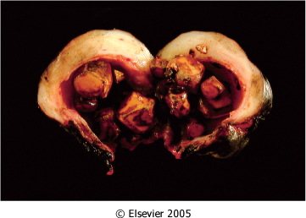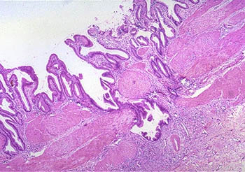

* multi faceted cholesterol stones
* some small stones erode the fibrotic wall

**تنزل للأمعاء وتأثر على حركتها**

**Complication of Acute and chronic cholecystitis :**

* Bacterial superinfection with ascending cholangitis or sepsis.
* GB perforation & local abscess formation.empyema
* GB rupture with diffuse peritonitis
* Biliary enteric (*cholecystoenteric*) See extra pic fistula with drainage of bile into adjacent organs, and potentially gallstone-induced intestinal obstruction (ileus).
* Aggravation of pre-existing medical illness, with cardiac, pulmonary, renal, or liver decompensation.

**Extra pic:**

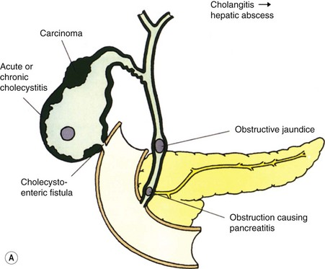

**Summary**

* Disorders of the Gallbladder : Cholelithiasis (Gallstones) ; composed of Cholestrol stones and pigment stones.
* Cholesterolosis Is "strawberry gallbladder” which is excessive accumulation of cholesterol esters within the lamina propria.
* Cholecystitis: Inflammation of the gallbladder may be acute, chronic, or acute superimposed on chronic. It almost occurs with gallstones.
* Chronic hemolytic syndromes could cause increase in unconjugated bilirubin level in plasma, in the end It’ll cause pigment stones.
* Cholesterol is rendered soluble in bile by aggregation with hydrophilic bile salts and hydrophobic lecithins.
* Cholesterol gallstone formation involves four simultaneous defects: 1-Supersaturation of bile with cholesterol 2-Gallbladder stasis 3-Cholesterol nucleation 4-Mucus hypersecretion in gallbladder.
* "Black" pigment stones in sterile gallbladder. While "Brown" pigment stones in infected intrahepatic or extrahepatic bile ducts.
* Acute calculous cholecystitis & chronic Cholecystitis are the only two who have specific symptoms, epigastric pain, frequently associated with mild fever, anorexia, tachycardia, sweating, and nausea and vomiting, usually they are free of jaundice.
* In chronic Cholecystitis, Patients often have intolerance to fatty food, and a sence of fullness after eating butter.
* Acute calculous is aseptic, just a chemical irritation while acute acalculous could be due to sepsis.
* In acute cholecystitis, the serosal covering is frequently layered by fibrin and, in severe cases, by exudate.

**Questions**

**Q1: Which of the following is not a complication of cholecystitis?**

1. Bacterial superinfection with cholangitis or sepsis.
2. Alzheimer
3. GB perforation & local abscess formation.
4. GB rupture with diffuse peritonitis

Answer: B

**Q2- Patient presents to the hospital with a long history of intolerance to fatty food, saying they get a sense of fullness specially after they eat butter. Histological findings include Rokitansky-Aschoff sinuses. What is most likely the diagnosis?**

1. Acute cholecystitis
2. Chronic cholecystitis
3. Adenocarcinoma of the gallbladder

Answer: B

**Q3: Female patient who known have sickle cell anemia come to the hospital with right upper pain and a black color stones was found. What is of the following is right?**

1. The stones found in sterile gallbladder.
2. The stones found in infected intrahepatic or extrahepatic bile ducts.
3. The stones are radio-opaque.
4. The stones are radio-lucent.
5. Both A&C.

answer: E

**Q4: Presence of unconjugated bilirubin in the biliary tract indicates which of the following?**

A. Pigment stones

B. Cholesterol stones

C. Chronic Cholecystitis

D. Cholesterolosis

answer: A

**Q5: Cholesterol gallstone formation involves which of the following?**

1. Unsaturation of bile with cholesterol.
2. Gallbladder hypermotility.
3. Mucus hypersecretion in the gallbladder.
4. Mucus hyposecretion in the gallbladder.

answer: C

**إن أصبنا فمن الله وحده، وإن أخطأنا فمن أنفسنا والشيطان. وصلى الله على نبينا محمد وعلى آله وصحبه أجمعين.**

**الأعضاء**

* **شروق الصومالي**
* **نورة السهلي**
* **فاطمة الطاسان**
* **سمر القحطاني**
* **دعاء وليد**
* **أمل القرني**
* **ابتسام المطيري**

**القادة**

* **مها الغامدي**
* **حنين السبكي**
* **عبدالله أبو عمارة**

[**Editing File**](https://onedrive.live.com/view.aspx?resid=E0947849CE6A90D1!120&ithint=file%2cpptx&app=PowerPoint&authkey=!ALNSNNVHKfyykhY)

**Email:** pathology436@gmail.com **Twitter:** @pathology436

**References:** Doctor’s slides + notes, Robbins basic pathology 10th edition.

* **عبدالمجيد العمَّار**
* **خالد العيدان**
* **عمر تركستاني**
* **طلال العنزي**
* **ريان القرني**
* **عبدالرحمن الراشد**
* **عمر المغير**
* **صقر التميمي**
* **عبدالكريم الحربي**
* **مساعد النويصر**
* **حسام المطيري**
* **محمد اليوسف**
* **مبشر الأسمري**
* **ابتسام المطيري**
* **أمل القرني**
* **فاطمة الطاسان**
* **دينا الدوسري**
* **رنيم الغامدي**
* **سمر القحطاني**
* **نورة السهلي**
* **دعاء وليد**
* **غادة المزروع**
* **سميَّة الغامدي**
* **بشرى قوقندي**
* **ليلى البريكان**
* **شروق الصومالي**
* **نوف العمَّاري**
* **لمى التميمي**
* **جواهر الخيَّال**

**]A very big thank you for all your hard work and a big well done to our Pathology members[**

1. Secretes enzymes that affect the conjugation .
2. abnormality in, or abnormal amounts of, lipids and lipoproteins in the blood
3. Oral contraceptives are medicines taken by mouth to help prevent pregnancy
4. High Estrogen is always related to altering the synthesis and secretion of cholesterol .
5. **قابل للذوبان**
6. Another term for phosphatidylcholine.
7. Any additive with a similar action to a detergent to make the substance more soluble.
8. **تشتت، تفتت**
9. **متزامنة**
10. **كالسيوم نيوكليس يترسب حولها الكولسترل**
11. A place where the disease process originates or develops.
12. Collection of puss .
13. Suppurative infection in which the gallbladder fills with purulent material
14. the presence or formation of **gallstones**
15. Also known as **entrapped epithelial crypts**, are [pseudodiverticula](https://en.wikipedia.org/w/index.php?title=Pseudodiverticula&action=edit&redlink=1) or pockets in the wall of the [gallbladder](https://en.wikipedia.org/wiki/Gallbladder). They may be microscopic or macroscopic.