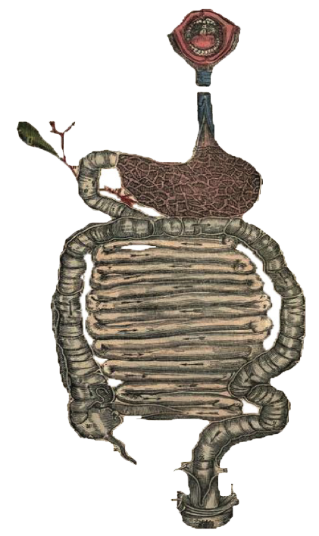
• Black: Doctor’s slides. • Red: important! • Green: Doctor’s notes.
• Grey: Extra. • Italic black: New terminology.
Acute And Chronic Pancreatitis
Objectives:
At the end of this lecture the student will be able to:
  - Recognize the predisposing factors of pancreatitis.
  - Describe the different types of pancreatitis.
  - Understand the pathogenesis of acute and chronic pancreatitis.

Pancreatitis:
- Describe The Different Types Of Pancreatitis.

Acute And Chronic Pancreatitis
- Inflammation of the pancreas.
- The clinical manifestations can range in severity from a mild (Silent, Subclinical), self-limited disease to a life threatening acute inflammatory process
- The duration of the disease can range from a transient attack to an irreversible loss of function.
- Acute or chronic
- In acute pancreatitis, gland can return to normal if underlying cause of the pancreatitis is removed.
- By contrast, chronic pancreatitis is defined by irreversible destruction of exocrine pancreatic parenchyma.(Depend on Duration And how many attacksGradual loss of tissue and function)

Acute Pancreatitis By osmosis (10 min)
Acute pancreatitis:
- Acute pancreatitis is a group of reversible lesions characterized by inflammation of the pancreas ranging in severity from edema and fat necrosis to parenchymal necrosis with severe hemorrhage.
- 80% of cases in western countries are associated with one of two conditions: biliary tract disease or alcoholism. (alcoholism is more in western countries because they drink a lot but in Saudi Arabia there are none alcoholic so gull stones is more common)
- Gallstones are present in 35% to 60% of cases of acute pancreatitis.
- More characteristics : inflammatory infiltrate, chemotaxis, aggregation of inflammatory cells and other features of acute inflammation ( hallmark: fat necrosis + if severe attack : severe haemorrhage )
- Why is it dangerous? Because of auto digestion which caused by pancreatic enzymes
- Gallstones can cause pancreatitis due to obstruction (more likely small stones –sand stones- > goes to bile duct > pancreatic duct -> pancreatitis)

Causes:
- Recognize The Predisposing Factors Of Pancreatitis.

- Metabolic • Mechanical
- Vascular • Infections(most likely viral diseases)

- Metabolic | - Alcoholism  - Hyperlipoproteinemia  - Hypercalcemia (calcification)  - Drugs (eg; thiazide diuretics)  - Genetic
- Mechanical | - Trauma(Epigastric area)  - Gallstones (Small stones are more dangerous than big stones because big stones are stuck in gall bladder but small ones gets stuck in pancreas causing pancreatitis)  - iatrogenic Injury(during surgery)  - Perioperative injury  - Endoscopic procedures with dye injection
- Vascular  (Anything leads to ischemia) | - Shock (Generalized vasodilation)  - Atheroembolism(embolism)  - Polyarteritis nodose(Vasculitis)
- Infectious | - Mumps  - Coxsackievirus  - Mycoplasma pneumoniae

Acute pancreatitis:
- Obstruction of the pancreatic duct system
  - eg. periampullary tumors, congenital cystic dilatation of the common bile duct, biliary "sludge," and parasites (particularly Ascariasis lumbricoides and Clonorchis sinensis organisms)
- Medication
  - More than 85 drugs have been reported to cause acute pancreatitis. e.g . thiazide diuretics, estrogens, etc
- Metabolic disorders
  - Including hypertriglyceridemia, hyperparathyroidism, and other hypercalcemic states (Sweets consumption will increase risks of hypertriglyceridemia which triggers pancreatitis)
- Acute ischemia
  - Vascular thrombosis, embolism, vasculitis and shock
- Trauma:
  - Blunt trauma
  - Iatrogenic injury during surgery or endoscopic retrograde cholangiopancreatography(ERCP)
Morphology:
The morphology of acute pancreatitis ranges from inflammation and edema to severe extensive necrosis and hemorrhage.
The basic alterations are:
- Microvascular leakage causing edema
- Necrosis of fat by lipolytic enzymes e.g. lipase
- An acute inflammatory reaction
- Proteolytic destruction of pancreatic parenchyma (e.g. protease enzyme causes destruction of soft and connective tissues.)
- Destruction of blood vessels with subsequent interstitial hemorrhage (e.g. elastase causes haemorrhage)
• Fat necrosis results from enzymatic destruction of fat cells. The released fatty acids combine with calcium to form insoluble salts that precipitate.
(Fat necrosis + calcium salt = calcifications (dystrophic calcifications))
- Understand The Pathogenesis Of Acute And Chronic Pancreatitis.

Pathogenesis:
Extra pic
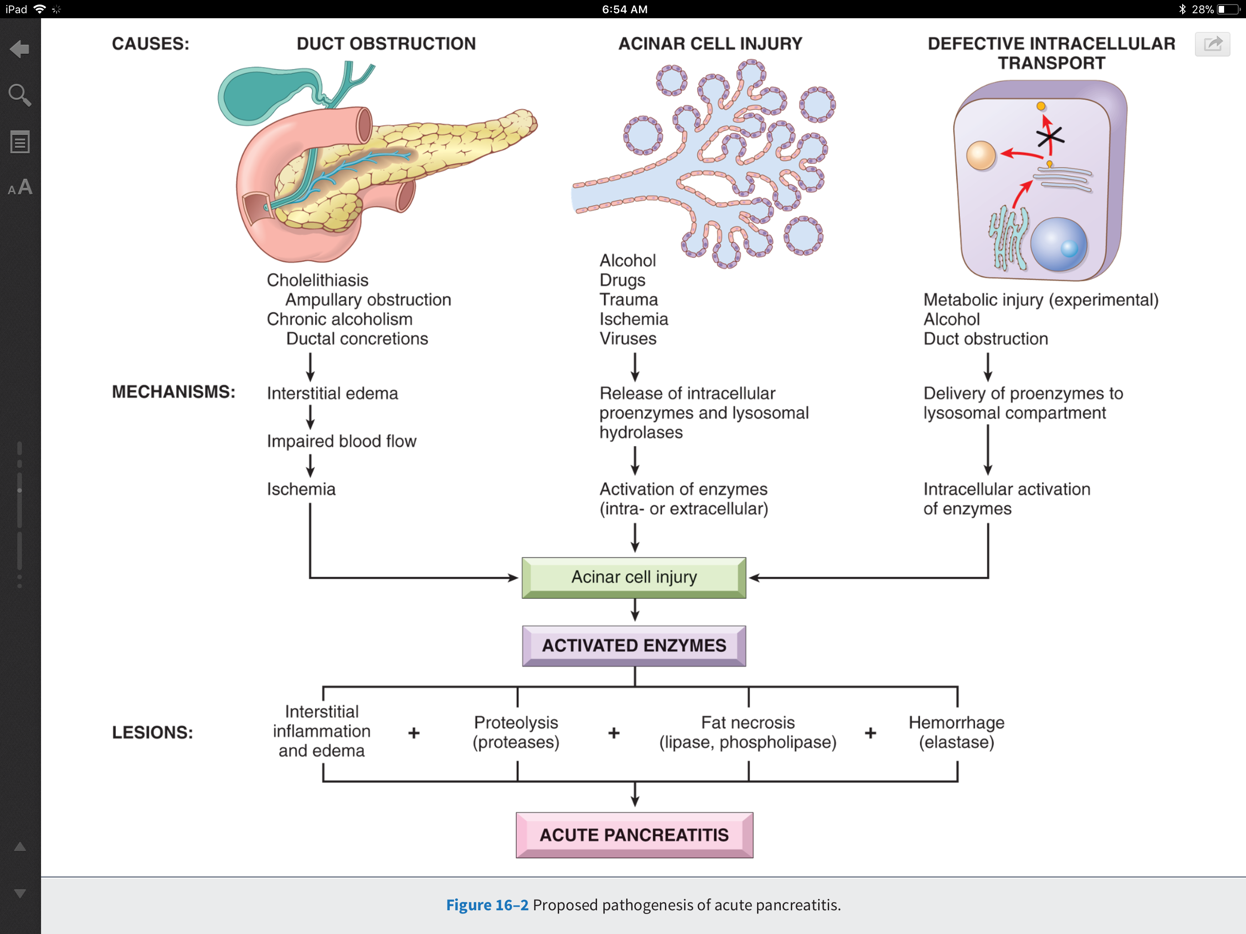
Autodigestion of the pancreatic substance by inappropriately activated pancreatic enzymes.
-Activation of trypsinogen is an important triggering event in acute pancreatitis because when it get activated it will activate other pancreatic zymogens
(Pancreatic enzymes in acinar cells are inactive. They become activated when they reaches small intestine. Early activation causes auto digestion of pancreas (pro enzymes > enzymes)

Clinical Features:
- Abdominal pain (e.g. epigastric pain) is the cardinal manifestation of acute pancreatitis
- Full-blown acute pancreatitis is a medical emergency.
- These patients usually have the sudden onset of an "acute abdomen“
- Characteristically, the pain is constant and intense and is often referred to the upper back.
- (Blood results ) There is leukocytosis, hemolysis, disseminated intravascular coagulation, fluid sequestration, acute respiratory distress syndrome (Lungs filled with fluids), and diffuse fat necrosis.
- Peripheral vascular collapse and shock with acute renal tubular necrosis may occur
- Acute pancreatitis can cause multiorgan failure
Laboratory findings
First marked elevation of serum amylase levels during the first 24 hours, followed within 72 to 96 hours by a rising serum lipase level. Amylase is the first enzyme get elevated but lipase is more specific
Management:
- The key to the management is "resting" the pancreas by total restriction of food and fluids and by supportive therapy >>>>>>> Make the patient on N.P.O (nothing per oral) and on pain management (pain killers)
- Most patients recover fully. About 5% die from shock during the first week of illness. Acute respiratory distress syndrome and acute renal failure are fatal complications.
- In surviving patients, sequelae include a sterile pancreatic abscess and a pancreatic pseudocyst.
- Describe The Different Types Of Pancreatitis.

Chronic Pancreatitis
By osmosis (9 min)
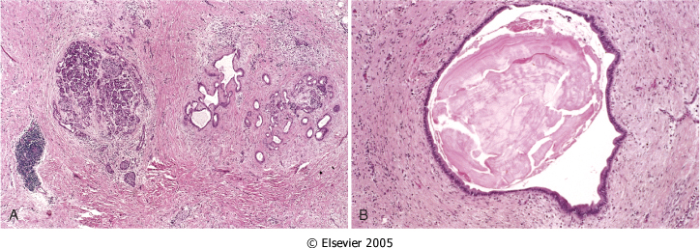
Chronic pancreatitis:
- Chronic pancreatitis is characterized by inflammation of the pancreas with destruction of exocrine parenchyma, fibrosis, and, in the late stages, the destruction of endocrine parenchyma>> islet of Langerhans destruction is the last thing is affected.
- The chief distinction between acute and chronic pancreatitis is the irreversible impairment in pancreatic function that is characteristic of chronic pancreatitis.
- Dilated ducts with inspissated esonophlic concertion
- Islet of Langerhans
- Fibrosis
Causes:
There is significant overlap in the causes of acute and chronic pancreatitis. By far the most common cause of chronic pancreatitis is long-term alcohol abuse and biliary tract disease, and these patients are usually middle-aged males.
You first lose the secretory function of pancreas *digestive enzymes* then enter pancreatic insufficiency.
Less common causes of chronic pancreatitis include the following: All of which cause Repetitive injuries also can to the pancreas
- Hypercalcemia, hyperlipidemia.
- Long-standing obstruction of the pancreatic duct by pseudocysts, calculi, trauma, neoplasms (By narrowing the ducts), or pancreas divisum.
- Tropical pancreatitis, which is a poorly characterized disease seen in Africa and Asia. It has been attributed to malnutrition.
- Hereditary pancreatitis
- Idiopathic chronic pancreatitis.
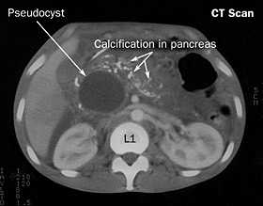
Morphology:
Chronic pancreatitis is characterized by parenchymal fibrosis, reduced number and size of acini with relative sparing of the islets of Langerhans, and variable dilation of the pancreatic ducts
These changes are usually accompanied by a chronic inflammatory infiltrate around lobules and ducts.
Grossly: gland is hard, sometimes with extremely dilated ducts and visible calcifications dystrophic calcification!
Extra pic

Clinical Features:
- Silent or repeated attacks of abdominal pain, or persistent abdominal and back pain.
- Attacks may be precipitated by alcohol abuse, overeating (which increases demand on the pancreas), or the use of opiates and other drugs
- During an attack of abdominal pain, there may be mild fever and mild-to-moderate elevations of serum amylase.
- Calcifications can be seen within the pancreas by CT scan and ultrasonography.
Complications:
- Severe pancreatic exocrine insufficiency.
- Chronic malabsorption. will cause weight loss
- Diabetes mellitus (due to destruction of islets of Langerhans). (Flows the malabsorption and malnutrition)
- Severe chronic pain. UNCONTROLED PAIN!!
- Pancreatic pseudocysts.
Pseudocysts of Pancreas:
Pseudocysts are localized collections of necrotic-hemorrhagic material rich in pancreatic enzymes. Such cysts lack an epithelial lining (hence the prefix "pseudo"), and they account for majority of cysts in the pancreas.
Pseudocysts usually arise after an episode of acute pancreatitis, or of chronic alcoholic pancreatitis.

Morphology:
Pseudocysts are usually solitary. Pseudocysts can range in size from 2 to 30 cm in diameter.
While many pseudocysts spontaneously resolve, they may become secondarily infected, and larger pseudocysts may compress or even perforate into adjacent structures.
They can produce abdominal pain and predispose to intraperitoneal hemorrhage or peritonitis
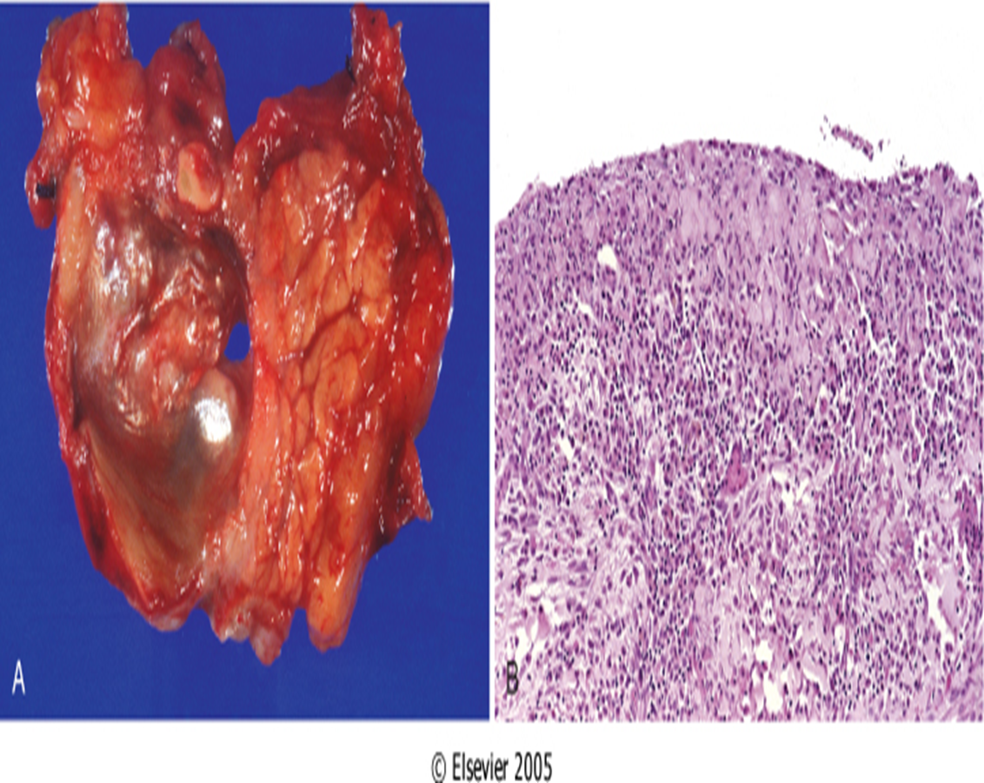
MOST important thing is to differentiate it from neoplasm (like adenocarcinoma of pancreas)

Pancreatic pseudocyst. A, Cross-section through this previously bisected lesion revealing a poorly defined cyst with a necrotic brown-black wall. B, Histologically, the cyst lacks a true epithelial lining and instead is lined by fibrin and granulation tissue.

- Pancreatitis is inflammation of the pancearis
Summary
- It's divided into acute and chronic depends on the severity
- Acute pancreatitis is characteristic by (Edema - sever hemorrhage - fat necrosis -distrophic calcification)
- Acute pancreatitis associated with bile tract disease (gallstone) and alcoholism
- The most common cause of AP is metabolic (alcoholism) and mechanical (gallstone) and vascular( atheroembolism) and viral infection and some drug like thiazides.
- The pathogenesis : is activation of trypsinogen which will lead to autodigestion of pancreas
- Clinical features are Epigastric pain that radiate to back
- Complications of Acute pancreatitis are Acute Respiratory distress syndrome and Renal failure
- Laboratory findings are increases in serum Amylase the first 24 hours followed by increase in serum Lipase within 72 hours
- Chronic pancreatitis characterized by irreversible destruction of the exocrine paranchyma and fibrosis then endocrine paranchyma
- The most common cause of chronic pancreatitis are long term Alcholism and Billary duct disease
- Tropical pancreatitis due to Malnutrition.
- Islet of langerhans are spared in case of Chronic pancreatitis and last thing to be fibrosed and can lead to D.M.
- Grossly appearance of Chronic pancreatitis are hard gland , dilated duct and Calcification
- Complications of Chronic pancreatitis are Chronic malabsorption, Diabetes mill it us and Pancreatic pseducyst
- Pancreatic pseducyst has no lining epithelium
- Complication of pancreatic pseducyst is intraperiotenial hemorrhage or peritonitis Under the microscope there will be Granulation tissue.

Questions
- Which of the following is true about acute pancreatitis?
- Silent or repeated attacks of abdominal and back pain.
- Mild elevation of serum amylase.
- Reversible Lesion.
- Irreversible Lesion.
ANS:C
- Which of the following enzymes causes Dystrophic calcification?
- Proteases
- Amylases
- Lipases
- Nucleases
ANS:C
- A 38-years-old Lady presents to the hospital with acute abdominal pain, the patient had elevated serum lipases. Which of the following is a sign of worse prognosis?
- Hypoalbuminemia.
- Hyperbilirubinemia.
- Hypocalcemia.
- Hyperalbuminemia.
ANS:C
- A 42-year-old gentleman with history of gallbladder disease had an acute episode of abdominal pain, he had edema, and tenderness in the upper abdomen. Which of the following tests is the most helpful for diagnosis of his disease?
- Bilirubin serum levels.
- Ammonia serum levels.
- CT scan.
- Amylase serum levels.
ANS:D
- A 47-year-old gentleman with history of travel to Asian countries and he usually ate fresh vegetables. He presented to the emergency room for severe abdominal pain. Laboratory tests revealed High lipases levels and leukocytosis with eosinophilia. Which of the following is the most likely cause of his condition?
- Alcoholism.
- Gallstones.
- Thiazides.
- Parasites.
ANS:D

- Saponification refers to which of the following?
- Necrosis of Pancreatic parenchyma.
- Fat necrosis.
- Destruction of blood vessels with subsequent interstitial hemorrhage.
- Combination of fatty acids and calcium.
ANS:D
- A 23-year-old lady has 6 months of repeated episodes of moderate abdominal pain. In the next few years he develops steatorrhea. CT scan shows calcification if the abdomen.
Loss of inhibition of which of the following is the most likely cause of the disease?
- Amylase.
- Lipase.
- Trypsin.
- Calcium.
ANS:C
- Management of Acute pancreatitis is done through which of the following?
- Pancreatectomy.
- Drugs.
- Supportive therapy.
- Chemotherapy.
ANS:C
- A 34-years-old alcoholic lady with history of 3 years of abdominal pain episodes. CT scan revealed calcification in the pancreas. Biopsy shows parenchymal fibrosis and relative sparing of islets of Langerhans. Which of the following complications is not expected if she undergoes treatment.
- Chronic malabsorption.
- Pseudocysts of pancreas.
- Pancreatic exocrine Insufficiency.
- Diabetes mellitus.
ANS:D

- Which of the following is wrong about pseudocysts of pancreas?
- They are lined by epithelium.
- Account for majority of pancreas cysts.
- Arise after alcoholic pancreatitis.
- Resolve spontaneously.
ANS:A
_{1.}
حسبي الله لا إله إلِّا هو عليه توكلت وهو رب العرش العظيم
الأعضاء
- صقر التميمي
- عبدالمجيد العمار
- محمد اليوسف
- خالد العيدان
- عبدالكريم الحربي
- طلال العنزي

القادة
- مها الغامدي
- حنين السبكي
- عبدالله أبو عمارة

Editing File
Email: pathology436@gmail.com Twitter: @pathology436

References: Doctor’s slides + notes, Robbins basic pathology 10th edition.

