Diarrhea

&

Malabsorption

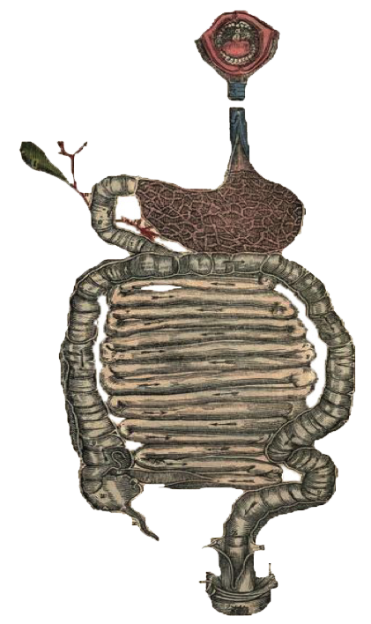

**•** Black: Doctor’s slides. **•** Red: important! **•** Light Green: Doctors’ notes **•** Grey: Extra. **•** *Italic black: New terminology.*

**Objectives**:

Upon completion of **Diarrhea** lecture the students will be able:

* Understand the physiology of fluid in small intestine
* Describe the pathophysiology and causes of various types of diarrhea ( Secretory, osmotic, Exudative, Motility-related )
* Define acute diarrhea and enumerate its common causes
* Define chronic diarrhea and enumerate its common causes

Upon completion of **Malabsorption** lecture the students will be able:

* Understand that the malabsorption is caused by either abnormal digestion or small intestinal mucosa
* Know that malabsorption can affect many organ systems (alimentary tract, hematopoietic system, musculoskeletal system, endocrine system, epidermis, nervous system)
* Concentrate on celiac disease and lactose intolerance as two examples of malabsorption syndrome.

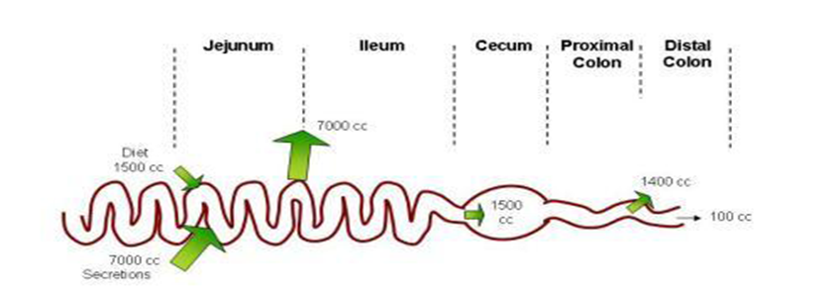**Fecal osmolality :**

**Diarrhea**

* Understand the physiology of fluid in small intestine

*Approximately 8500 mL of fluid flow into the intestine daily :

1- from diet (1500mL).

2- Secretions (7000mL), EX (salivary, gastric, biliary, pancreatic, intestinal secretions).

3- Approximately (7000 mL) will be absorbed in the small intestines (most of the volume will be absorbed in the small intestines due to weaker tight junctions between enterocytes).

4- Approximately (1500 mL) cross the ileocecal valve.

5- The colon reabsorbed most of this fluid most of the fluid (1400 mL, but less than small intestines due to stronger tight junctions).

6- Finally, only (100mL) lost in the stool.

As stool leaves the colon, fecal osmolality is equal to the serum osmolality i.e. 290 mosm/kg. when the osmolality increase the fecal osmotic gap increase.

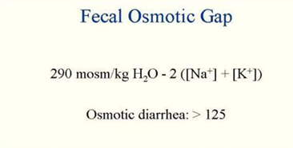Under normal circumstances, the major osmoles which create the osmotic effect are Na+, K+, Cl–, and HCO3 –.

Formula used to assess the fecal osmolality

In case of osmotic diarrhea the gap will be high due to abnormal increase in osmoles ** which in turn leads to osmotic diarrhea.

|  |  |  |  |  |
| --- | --- | --- | --- | --- |
| **Introduction to diarrhea** | | | | |
| **Importance** | | | **CLASSIFICATION**  (Based on duration!) | **DEFINITION** |
| **Mortality** | **Prognosis** | **What happens** |
| More than 70 % of almost 11 million child deaths every year are attributable to 6 causes:   1. **Diarrhea.** 2. Malaria. 3. neonatal infection. 4. Pneumonia. 5. preterm delivery. 6. lack of oxygen at birth.   UNICEF | Easy to treat but if untreated, may lead to death especially in children  Due to dehydration | The loss of fluids through diarrhea can cause dehydration and electrolyte imbalances. | * **Acute :**   **2 weeks**  Most common\Could be viral or food poisoning(M)   * **persistent :**   **2 – 4 weeks**   * **chronic :**  1. **weeks in duration** | * World Health organization: 3 or more loose or liquid stools per day. increased frequency * Abnormally high fluid content of stool.   (> 200-300 gm/day). decreased consistency |

* Describe the pathophysiology and causes of various types of diarrhea ( Secretory, osmotic, Exudative, Motility-related )

**Pathophysiology Categories of diarrhea:** (Based on pathophysiology!)

1. **Secretory:**

* There is an increase in the active secretion. Active Secretion more than 7000cc.
* High stool output.
* Lack of response to fasting. Even if the patient is fasting he will still have diarrhea.( **(لان المشكلة في الالكترولايت اللي تطلع منّا مش اللي بالأكل)**
* Normal stool osmotic gap < 100 mOsm/kg. (Isotonic stool)
* The most common cause of this type of diarrhea is a **bacterial toxin (E. coli, cholera)** that stimulates the secretion of anions.  **(سموم هذي البكتيريا تدمر الناقل الطبيعي للالكترولايت وتعكس اتجاه نقله**) not the bacteria itself but it’s toxin.
* Also seen in Endocrine tumors.Zollinger-Ellison syndrome secrets secretin and gastrin hormones which stimulate diarrhea.

**في هذا النوع يتم اخراج الالكترولايت بسبب سموم البكتيريا المذكورة من الجسم لintestinal lumen وكـ تسلسل طبيعي الماء راح يتبع الالكترولايت ومن هنا جا اسم secretory=water secretion**

* Excess amount of poorly absorbed substances that exert osmotic effect 🡪 water is drawn into the bowels 🡪diarrhea.

**(هنا مافي امتصاص للمواد اللي احنا اكلناها أساسا فالماء اللي في الأمعاء ما راح يُمتص وممكن يطلع من الماء اللي في جسمنا بعد بس فرقه عن النوع الأول بـ سبب خروج الماء! )** Osmolality in small intestine is higher than that of serum water go from serum to small intestine!

* **Stool output is usually not massive.**
* **Fasting improve the condition.(لان المشكلة أساسا من الاكل اللي قاعد يسحب الماء)**
* **Stool osmotic gap is high, > 125 mOsm/kg.** Due to increase concentration.
* **Can be the result of :**

1. Malabsorption in which the nutrients are left in the lumen to pull in water e.g. lactose intolerance
2. Osmotic laxatives. Used for constipation but then the patient starts having diarrhea
3. **Osmotic:**
4. **Exudative (inflammatory):**

* Results from the outpouring of blood protein, or mucus from an inflamed or ulcerated mucosa
* Presence of blood and pus in the stool. But not massive

مب على كل حال يجيك المرض ويقول فيه دم بالستول لكن لما تسوي Stool analysis بتلاقي RBCS+WBS (pus cells )

* **Persists on fasting** (because the problem here from the damaged mucosa NOT the food)
* Occurs with inflammatory bowel diseases, and invasive (Parasites) infections, ulcer

(As the name suggests it happens in conditions cause inflammation which results in damage in mucosa so we see blood, pus and there will be decrease in absorption due to lake of absorptive area)

* Caused by the rapid movement of food through the intestines (hypermotility hyper-peristalsis).
* **Irritable bowel syndrome (IBS)** القولون العصبي – a motor disorder that causes abdominal pain and altered bowel habits with diarrhea predominating

1. **Motility-related**

**(كل شي طبيعي هنا مافي مشاكل بالميوكوزا أو الكاريرز تبع الالكترولايت بس حركة الأمعاء زادت وقل وقت وجود الكايم في الأمعاء بالتالي قلت قدرة الأمعاء على الامتصاص)**

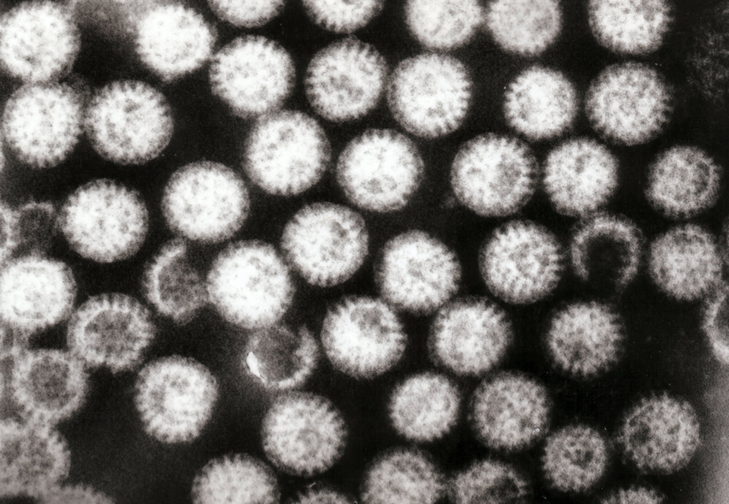**Etiology of acute diarrhea:**

* Define Acute Diarrhea And Enumerate Its Common Causes

|  |  |
| --- | --- |
| **Infections** | Approximately 80% of acute diarrheas are **due to infections (viruses**, bacteria, helminths, and protozoa). Example, traveler’s diarrhea (3-7d) is caused by infections.  **Rotavirus** the cause of nearly 40% of hospitalizations from diarrhea in children under 5. Peak in Winter. |
| **Viruses** | Viral gastroenteritis (viral infection of the stomach and the small intestine) is the most common cause of  acute diarrhea worldwide.  **Rotavirus** the cause of nearly 40% of hospitalizations from diarrhea in children under 5. Peak in Winter. |
| **Food poisoning** | Toxic or uncooked food like uncooked eggs, not washing hands before eating. |
| **Drugs** | Antibiotic, antidepressant, antacids. |
| **Others** | Crohn’s disease, celiac disease, diabetes |

**Rotavirus** the cause of nearly 40% of hospitalizations from diarrhea in children under 5, Peaks in winter❄ Child get hospitalized because we need to put him in IV line (rehydration)

**Antibiotic-Associated Diarrheas:**

Acute Diarrhea occurs in 20% of patients receiving **broad-spectrum antibiotics**; about 20% of these diarrheas are due to **Clostridium difficile**. How does Antibiotics cause Diarrheal? Antibiotic can kill Flora in gut which help in digesting & synthesising B12 & K vit, but also give a chance of Clostridium difficile to overgrowth.

**Tests useful in the evaluation of acute diarrhea:**

Suggests colonic mucosa damage caused by invasion

1. shigellosis, salmonellosis, *Campylobacter* or *Yersinia* infection, amebiasis)

2. toxin (*C difficile, E coli*).

3. Inflammatory bowel diseases

Suggests a small bowel source

Or colon but **without** mucosal injury

**Etiology of chronic diarrhea:**

* Define Chronic Diarrhea And Enumerate Its Common Causes

**Infection e.g.** *Giardia lamblia* [1] In duodenum. AIDS often have chronic infections of their intestines that cause diarrhea.

**Post-infectious.** Following acute viral, bacterial or parasitic infections

A child with acute diarrhea caused by viral لو طوَّلت معاه بتتحوَّل إلى Post-infectious (chronic) لأن الفيروس يبدأ يأثِّر علىى Brush border فيقوم يسبب Malabsorption

Malabsorption

Endocrine diseases.

Colon cancer

Inflammatory bowel disease (IBD)

Irritable bowel syndrome

**Complications:**

1. Fluids loss 🡪 Dehydration.
2. Electrolytes loss 🡪 Electrolytes imbalance
3. Sodium bicarbonate loss 🡪 Metabolic acidosis.
4. If persistent 🡪 Malnutrition.

**Tests useful in the evaluation of chronic diarrhea: أهم شيْ نستبعد الانفكشن بعده المالنيوترشن!**

* Understand That The Malabsorption Is Caused By Either Abnormal Digestion Or Small Intestinal Mucosa

**Malabsorption**

**Malabsorption Syndrome:**

* Inability of intestine to absorb nutrients adequately into the bloodstream.
* Impairment can be of single or multiple nutrients depending on the abnormality.

**Physiology:**

The main purpose of the gastrointestinal tract is to digests and absorbs nutrients (fat, carbohydrate, and protein), micronutrients (vitamins and trace minerals), water, and electrolytes.

**Mechanisms and Causes of Malabsorption Syndromes:**

1. **Inadequate small intestine**

* Intestinal resection
* Crohn's disease
* Mesenteric vascular disease with infarction
* Jejunoileal bypass

**Inadequate digestion or small intestine abnormalities = MALABSORBTION**

**4. Lymphatic obstruction**

* Intestinal lymphangiectasis
* Malignant lymphoma
* Macroglobulinemia

1. **Inadequate digestion**

* Post gastrectomy
* Deficiency of pancreatic lipase
* Chronic pancreatitis
* Cystic fibrosis
* Pancreatic resection
* Zollinger-Ellison syndrome

**Deficient bile salt**

* Obstructive jaundice
* Bacterial overgrowth
* Stasis in blind loops, diverticula
* Fistulas
* Hypomotility states (diabetes)
* Terminal ileal resection
* Crohns' disease
* Precipitation of bile salts (neomycin)

1. **Primary mucosal abnormalities**

* Celiac disease
* Tropical sprue
* Whipple's disease
* Amyloidosis
* Radiation enteritis
* Abetalipoproteinemia
* Giardiasis

**Pathophysiology:** The Pancreas, Bile & mucosa are the most common causes.

|  |  |
| --- | --- |
| 2- Small intestine abnormalities | |
| * Mucosa   They can ask: (Which of the following effects mucosa of the small intestine) | * Celiac disease * Tropical sprue * Whipple's disease   type of inflammatory bowel disease (chronic) it will affect small intestine > inadequate absorption   * Giardiasis |
| * Inadequate small intestine | * Intestinal resection * Crohn's disease |
| * Lymphatic obstruction | * Intestinal lymphangiectasia * Malignant lymphoma |

|  |  |
| --- | --- |
| 1. Inadequate digestion | |
| * Stomach | * Postgastrectomy |
| * Pancreas | * Deficiency of pancreatic lipase usually congenital * Chronic pancreatitis * Cystic fibrosis * Pancreatic resection e.g in case of pancreatic tumor |
| * Bile | * Obstructive jaundice   Usually associated with steatorrhea.   * Terminal ileal resection   bile cycle : liver 🡪gall bladder 🡪 duodenum 🡪 terminal ileum 🡪 reabsorbed to liver. |

* Know That Malabsorption Can Affect Many Organ Systems (Alimentary Tract, Hematopoietic System, Musculoskeletal System, Endocrine System, Epidermis, Nervous System)

**Clinical features:**

* There is increased fecal excretion of fat (steatorrhea) and the systemic effects of deficiency of vitamins, minerals, protein and carbohydrates.
* 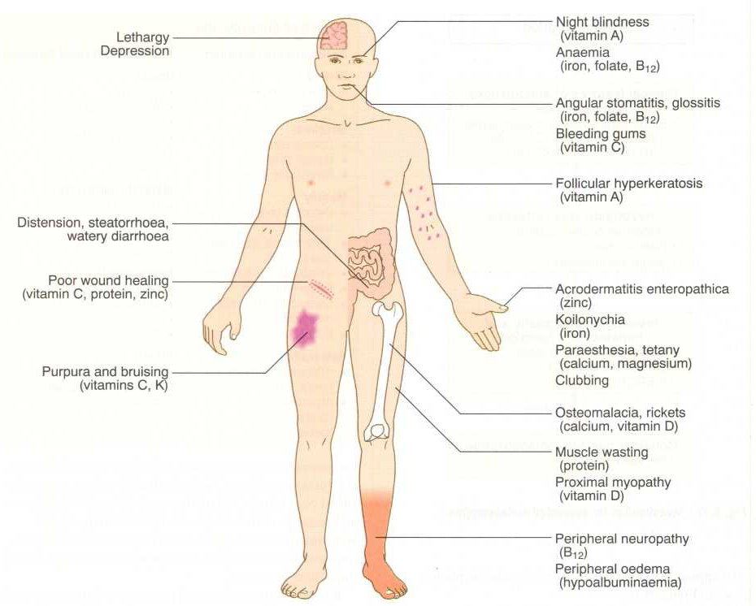Steatorrhea is passage of **soft, yellowish,** greasy stools containing an increased amount of fat. It is diarrhea with fat
* Growth retardation, failure to thrive in children
* Weight loss despite increased oral intake of nutrients.

**Clinical features Depend on the deficient nutrient:**

|  |  |
| --- | --- |
| Protein | -Swelling or oedema |
| B12, folic acid and iron deficiency | **-Anaemia**  **-fatigue and weakness** |
| Vitamin C and calcium | **-Muscle cramp**  **-Osteomalacia and osteoporosis** |
| Vitamin k and other coagulation factors | **-Bleeding tendencies** |

**Diagnosis:**

There is no specific test for malabsorption, Investigation is guided by symptoms and signs.

1. Fecal fat study to diagnose steatorrhea
2. Blood tests
3. Stool studies
4. Endoscopy(Biopsy of small bowel)

* Concentrate On Celiac Disease & Lactose Intolerance As Two Examples Of Malabsorption Syndrome.

[](https://www.youtube.com/watch?v=nXzBApAx5lY)**Celiac disease:** It is One of the causes of anemia

**Celiac Disease By Osmosis: (9:07 min)**

* An immune reaction to gliadin fraction of the wheat protein gluten.
* Usually diagnosed in childhood – mid adult. (but can be diagnosed with elderly)
* Patients have raised antibodies to gluten autoantibodies ( Anti-tissue transglutaminase antibody *Anti-glutin*).
* Highly specific association with class II HLA DQ2 (haplotypes DR-17 or DR5/7) and, to a lesser extent, DQ8 (haplotype DR-4).

**Typical presentation:**

GI symptoms that characteristically appear at age 9-24 months.

**ممكن يكون من قبل بس ما فيه أعراض لأن الطفل ما ياكل قمح**

Symptoms begin at various times after the introduction of foods that contain gluten.

**A relationship between the age of onset and the type of presentation:**

* GI symptoms (Abdominal pain + chronic diarrhea) are more prevalent

**Endoscopy:** You should take biopsy to make sure if it is celiac disease or other diseases

**Celiac disease** Atrophic mucosa (Not specific for celiac as it may be seen in other diseases)

**NORMAL**

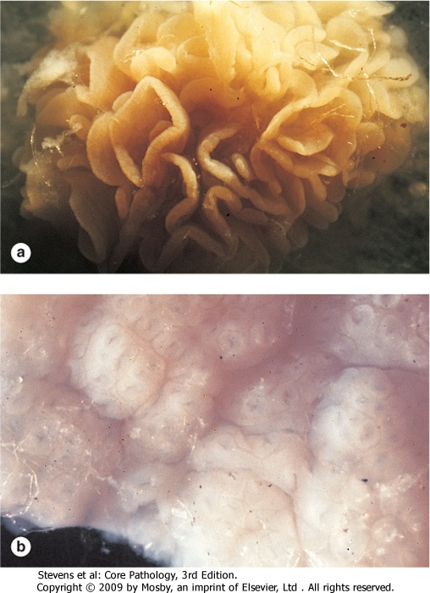



**Histology:**

* Mucosa is flattened with marked villous atrophy. ( Either complete or partial villous atrophy)

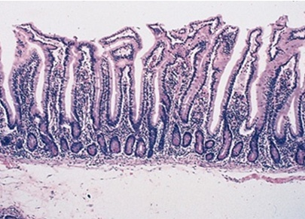 تصير السمول انتستن كأنها القولون

* Increased intraepithelial lymphocytosis.

Normally فيه lymphocytes لكن هنا تكون أكثر

**Diagnosis:** It’s hard to diagnose, you have to keep it in mind so you don’t miss it

Clinical documentations of malabsorption.

Stool: fat

Small intestine biopsy demonstrate **villous atrophy**.

Improvement of symptom and mucosal histology on gluten withdrawal from diet.

حتى مع البَيوبسي والستول أنالسس، ما نقدر نقول انه سيلياك 100% إلا لو قلنا للمريض وقف قمح وتعال بعد 3 شهور ولما تتحسن الأعراض يعني عنده celiac disease

Diet: wheat, barley, flour

Other grains, such as rice and corn flour, do not have such an effect.

-نفس ال Complications لل malabsorption

- Celiac disease has a reversible injury

**Complications:**

* Osteopenia, osteoporosis
* Infertility in women
* Short stature, delayed puberty, anemia,
* Malignancies, intestinal T-cell lymphoma Specific complication for celiac disease
* 10 to 15% risk of developing GI lymphoma.

**Lactose Intolerance:**

**Pathophysiology:**

Glucose + galactose

Lactase

At the brush border of enterocytes

Lactose

*Lactose Intolerance:* describes having low or absent activity of the lactase enzyme. (Lactose intolerance does not cause malnutrition but it causes abdominal pain)

In lactose Intolerance, the lactose is mixed with water in the small intestine, then the bacteria ferment this compound creating gases, organic acids & other osmotically active molecules which in turn cause irritation & increase of motility.

**Causes:**

Example of acquired lactase deficiency :  **Gastroenteritis:** Infectious diarrhea, particularly viral gastroenteritis in younger children, may damage the intestinal mucosa enough to reduce the quantity of the lactase enzyme.

**Clinical:**

Bloating انتفاخات , abdominal discomfort, and flatulence.

Appear 1 hour to a few hours after ingestion of milk products.

Lactose is digested then will be fragmented by bacteria which will secret acid leading to irritation (Gases)!

**Diagnosis:**

* Empirical treatment with a lactose-free diet, which results in resolution of symptoms.
* Hydrogen breath test.

لما يشرب المريض الحليب بيجيه انتفاخات فنقول له وقف الحليب ولما يوقف نلاحظ انه ارتاح

**Hydrogen breathe test:**

* An oral dose of lactose is administered
* The sole source of H2 is bacterial fermentation;
* Unabsorbed lactose makes its way to colonic bacteria, resulting in excess breath H2. Coming from bacterial fragmentation.
* Increased exhaled H2 after lactose ingestion suggests lactose malabsorption.

In addition, a 3-week trial of a diet that is free of milk and milk products is a satisfactory trial to diagnose lactose intolerance.

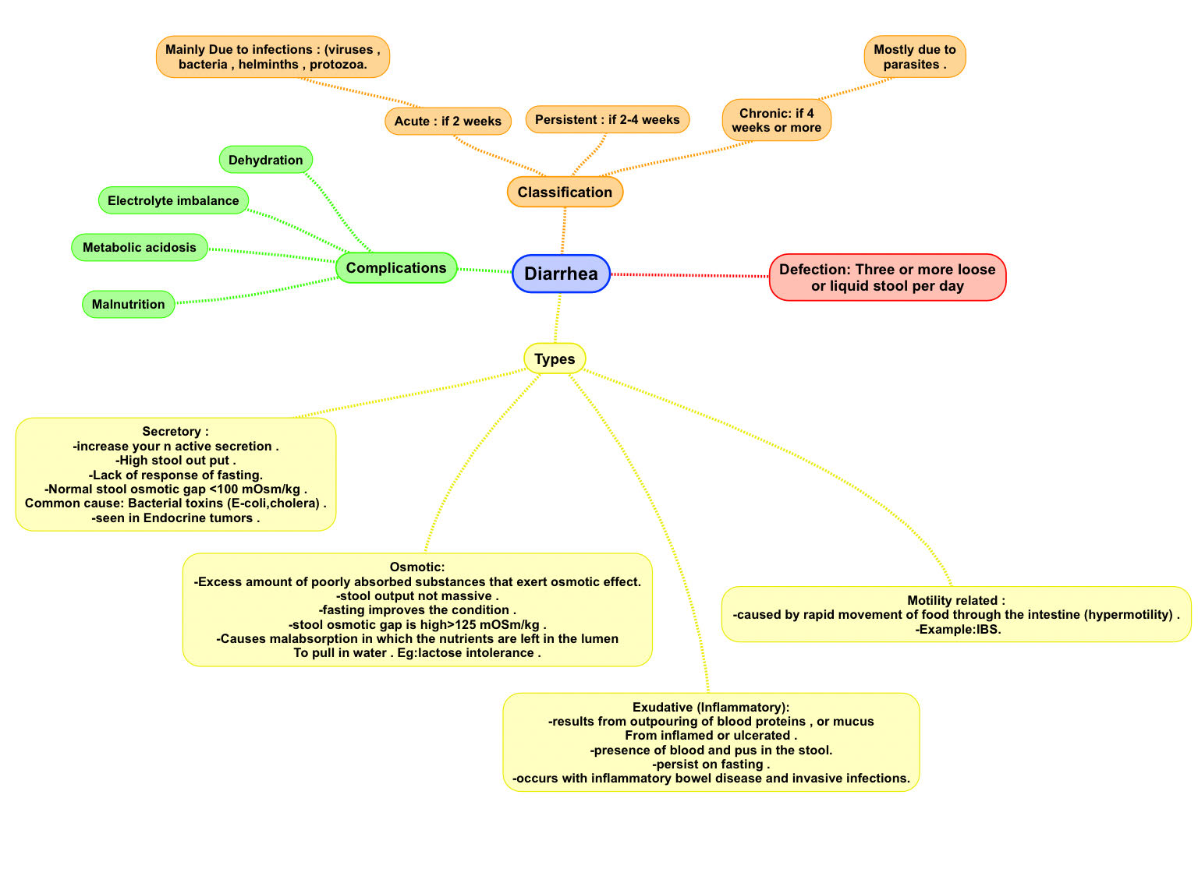**Diarrhea:**

**Summary**

**Malabsorption**

-Pathophysiology of malabsorption is **inadequate digestion** (BILE or PANCREAS ) OR **small intestine abnormalities** ( MUCOSA ) .

2-The most diagnostic feature of malabsorption is **STEATOREHEA** and the clinical feature depend on the deficient nutrient.

3-Celiac disease is **AUTOIMMUNE DISEASE** that caused by producing antibodies against the fraction of GLUTEN ( **GLIADIN** ) by ingestion wheat , barely or flour .

4-CELIAC DISEASE under the microscope there will be **VILLOUS ATROPHY** And **INCREASED INTRAEPITHELIAL LYMPHOCYTOSIS** .

5-The most serious complication of celiac disease is **INTESTINAL T-CELL LYMPHOMA .**

6-LACTOSE INTOLERANCE could be **INHERETED** or **ACQUIRD** .

7-LACTOSE INTOLERANCE is diagnosed by **HYDROGEN BREATH TEST**

Presence of HYDROGEN indicates **BACTERIAL FERMENTATION** .

**Lactose Intolerance**

* Deficiency/absence of the enzyme lactase in the brush border of the intestinal mucosa → Maldigestion and malabsorption of lactose.
* Unabsorbed lactose draws water in the intestinal lumen
* In the colon, lactose is metabolized by bacteria to organic acid, CO2 and H2; acid is an irritant and exerts an osmotic effect
* Causes diarrhea, gaseousness, bloating and abdominal cramps.

**Which one of the following associated with high osmotic gap:**

**Questions**

1. Secretory diarrhea
2. Osmotic diarrhea
3. Exudative diarrhea

Ans:B

**Which one of the following considered as a major osmole determines the fecal osmolality :**

1. K
2. Mg
3. Ca

Ans:A

**If there is a patient suffers from diarrhea for last 3 weeks , we can classify this condition as :**

1. Chronic diarrhea
2. Acute diarrhea
3. Persistent diarrhea

Ans:C

**The most common etiology of chronic diarrhea?**

1. Infection.
2. Colon cancer.
3. Electrolytes imbalance.

Ans:A

**Patient came with chronic diarrhea. Stool analysis was positive (which indicate presence of parasites, ova) which represent?**

1. Malabsorption.
2. Infection.
3. inflammatory diarrhea.

Ans:B

**A 30 year old male was diagnosed with cholera What is the type of his diarrhea?**

1. A. osmotic
2. B. motility related diarrhea
3. C. secretary
4. inflammatory

Ans: C

**What is the characteristics of his stool?**

1. bloody
2. contain pus
3. hypotonic
4. isotonic

Ansr: D

**A patient was diagnosed with salmonella infection what is the most likely symptoms that he has?**

1. watery diarrhea
2. bloody diarrhea
3. not massive diarrhea
4. massive diarrhea

Ans: B

**A 25-year-old lady has episodes of abdominal bloating, flatulence, and explosive diarrhea on Fridays. Laboratory tests show normal stool without blood, ova, or parasite. Stool culture is negative. Which of the following is the most likely diagnosis?**

1. Cystic fibrosis.
2. Chronic pancreatitis.
3. Celiac disease.
4. Disaccharidase deficiency.

Ans: D, Disaccharidase deficiency refers to lactase deficiency or what’s referred to as lactose intolerance.

**A 48-year-old alcoholic gentleman with history of 2 years of moderate episodic abdominal pain that radiates to the back. He visited a doctor because of weight loss of 6Kg over the last 2 months that he can’t gain back. Stool analysis shows soft yellowish stool. Which of the following nutrients is expected to be deficient in his case?**

1. Lipid soluble vitamins.
2. Folic acid deficiency.
3. Carbohydrates.
4. Vitamin B12.

Ans: A, this patient has chronic pancreatitis which led to exocrine deficiency which resulted in decreased metabolism of fat and thus reduction if the absorption of lipid soluble vitamins.

**Malabsorption Diagnosis is difficult due to which of the following?**

1. Different presentation from patient to another.
2. Difficult and invasive tests.
3. Low sensitivity of the tests.
4. Uncooperative patients.

Ans: A

**A 52-year-old lady presents to the hospital with visible jaundice of one week which she had noticed to be deepening in color. She was diagnosed with obstructive jaundice. Which of the following is most likely to be true in her case?**

1. She gained 4Kg in the last couple of days.
2. Her stool is yellowish, greasy, and floats to the top.
3. She has increased metabolism of fat.
4. She has Iron deficiency.

Ans: B

**Which of the following is diagnostic for celiac disease?**

1. Increased fat in stool.
2. Detection of antibodies against gliadin.
3. Small intestine biopsy with villous atrophy.
4. Improvement with gluten free diet.

Ans: D

**Which of the following complications are associated with celiac disease but not other malabsorption diseases?**

1. Osteoporosis.
2. Short stature.
3. Anemia.
4. Malignancies.

Ans: D

**A 23-year-old gentleman developed episodes of Bloating, flatulence, and abdominal discomfort following a viral enteric infection. Which of the following is the most likely diagnosis of his symptoms?**

1. Celiac disease.
2. Ulcerative colitis.
3. Cystic fibrosis.
4. Acquired lactase deficiency.

Ans: D

**A 4-year-old child presented with his parents in the hospital with GI symptoms and failure to thrive. After clinical examination and lab studies the doctor decides to take a biopsy of the upper jejunum. After reviewing the biopsy, the doctor instructs the family to give the child a gluten free diet. Later the child improved. What did the doctor see in the biopsy?**

1. Transmural ulcers.
2. Villous blunting and flattening.
3. Granulomas.
4. Polyps.

Ans: B

**الأعضاء**

* **رنيم الغامدي**
* **دينا الدوسري**
* **ابتسام المطيري**
* **نورة السهلي**
* **أمل القرني**
* **فاطمة الطاسان**
* **غادة المزروع**
* **سميَّة الغامدي**
* **صقر التميمي**
* **ريَّان القرني**
* **عبدالرحمن الراشد**
* **عبدالكريم الحربي**
* **طلال العنزي**
* **خالد العيدان**
* **عمر تركستاني**
* **محمد اليوسف**



**القادة**

* **مها الغامدي**
* **حنين السبكي**
* **عبدالله أبو عمارة**



[**Editing File**](https://onedrive.live.com/view.aspx?resid=E0947849CE6A90D1!120&ithint=file%2cpptx&app=PowerPoint&authkey=!ALNSNNVHKfyykhY)

**Email:** pathology436@gmail.com **Twitter:** @pathology436

**References:** Doctor’s slides + notes, Robbins basic pathology 10th edition.

**حسبي الله لا إله إلِّا هو عليه توكلت وهو رب العرش العظيم**

1. also known as ***Giardia intestinalis***, is a [flagellated](https://en.wikipedia.org/wiki/Flagellate) [parasite](https://en.wikipedia.org/wiki/Parasite) that colonizes and reproduces in the small intestine, causing [giardiasis](https://en.wikipedia.org/wiki/Giardiasis).